FULL PLANNING PERMISSION - CASE OFFICER REPORT

APPLICATION REFERENCE: | PL/2026/01461
APPLICATION TYPE: | FUL
SITE ADDRESS: | New Manor Farm, Upper South Wraxall, Bradford On Avon, BA15 2SQ.
DEVELOPMENT DESCRIPTION: | Two new roofs to cover external cow yards.
RECOMMENDATION: | Approve with Conditions.

PROPOSAL
The proposal seeks Planning Permission for the construction of a roof structure that would bridge and enclose the gap between two existing barns, effectively creating a cattle holding area within an established farmyard, at New Manor Farm.

SITE DESCRIPTION/CONTEXT
The site is an established dairy farm at New Manor Farm, South Wraxall, Bradford on Avon, the site is an existing farm holding comprising of existing barn structures and surrounding open land. Access is gained from the main spinal route running through the village, to the immediate west of the site, with public footpath reference SWRA10 being located to the north and a further footpath reference SWRA20 to the immediate east. The site occupies a rural and comparatively secluded out of settlement location, characterised by detached dwellings set within spacious plots, significant tree cover, hedgerows and an overall low-density pattern of development. The site is within Green Belt land and is not in a Conservation Area; it falls within the Bath and Bradford on Avon Bat SAC.

RELEVANT PLANNING HISTORY
Proposal / Summary
N/A

RELEVANT POLICIES AND GUIDANCE

Wiltshire Core Strategy:

- Core Policy 57 Ensuring High Quality Design and Place Shaping
- Core Policy 50: Biodiversity and Geodiversity
- Core Policy 51: Landscape
- Core Policy 58: Ensuring the Conservation of the Historic Environment
- Core Policy 61: Transport and New Development
- Core Policy 64: Demand Management
- Core Policy 67: Flood Risk

Green Belt Land.

Wiltshire Design Guide: Appendix D – Design Guidance for Householder extensions

The National Planning Policy Framework (NPPF Revised on 17.08.2026)

The Planning Practice Guidance

National Design Guide

Emerging Wiltshire Local Plan:
At Full Council on 19 May 2026, the elected members of Wiltshire Council agreed to withdraw the emerging Wiltshire Local Plan. The said Plan has no material weight for the purposes of the application.

In accordance with Regulation 19 of the Town and Country Planning (Local Planning) (England) Regulations 2026, on 30th June 2026 Wiltshire Council published a notice of intention to prepare a new local plan for Wiltshire. The next stage is a Scoping Consultation which commences on 2nd September 2026. This plan is at a very early stage and currently carries no weight for decision making.

CONSULTATION RESPONSES
South Wraxall Parish Council: No objections.

Archaeology: No objections.

Rights of Way: No response.

REPRESENTATIONS
No comments were received.

PRINCIPLE OF THE PROPOSAL.
The principle of the proposed scheme is acceptable for the reasons as discussed below.

ASSESSMENT
Section 38(6) of the Planning and Compulsory Purchase Act 2004 states:

"If regard is to be had to the development plan for the purposes of any determination to be made under the planning Acts, the determination must be made in accordance with the plan unless material considerations indicate otherwise."

In accordance with this statutory requirement, this application has been assessed against the relevant policies of the Development Plan.

Design and Impact upon the upon the character and context of the area

Core Policy 57 - Ensuring High Quality Design and Place Shaping of the Wiltshire Core Strategy seeks to ensure that all new development is of high design quality, reflecting local context, character, and distinctiveness. The proposals can be viewed within the plan snippets taken from the submitted plans:

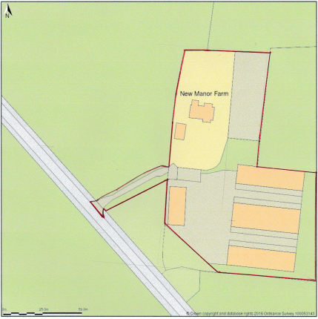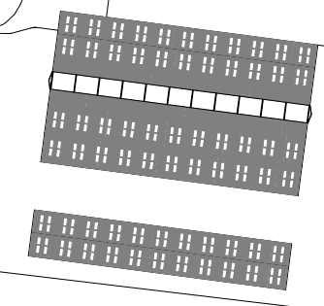
Location Plan Proposed Site Plan

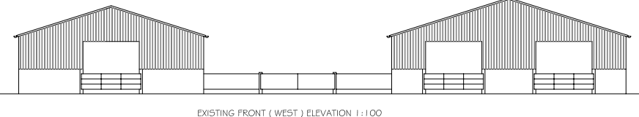
Existing Front Elevations.

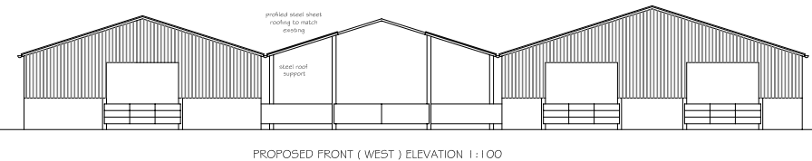
Proposed Rear Elevations.

The proposal would see the area in between the two barns infilled with a supported roof structure, the materials would match that as existing and would consist of profiled steel sheets, the two ends would remain open and the use of the space would be for the safe keeping of cattle during inclement weather. The ground surface consists of concreted area.

Given that the proposal would have matching materials to the two existing barns, and that the roof height and pitch would match that as existing, the proposal would be visually in keeping with that as existing and would not appear out of place, the scheme is appraised as being acceptable and being in accordance with the appropriate design policy.

Amenity
Point vii of Core Policy 57 - Ensuring high-quality Design and Place Shaping of the Wiltshire Core Strategy seeks to ensure that developments do not adversely affect neighbouring properties.
At the national level, Policy DP3 of the National Planning Policy Framework requires development proposals to respond positively to their context and integrate with and enhance their surroundings. Development should also reflect, where relevant, the principles of liveability, climate resilience, nature, movement, built form, public space and local identity

The proposal would be located within the established farmyard area of the site, therefore in visual amenity terms, the proposal would be in keeping with the established form and setting of the agricultural enterprise. The site is in a rural location and there are no immediate neighbours, so consequently there would be no overlooking or otherwise harmful impact on neighbours.

The proposal therefore accords with Core Policy 57 point vii. in respect of safeguarding residential amenity and Appendix D of the Wiltshire Design Guide.

Highway Matters.
Core Policy 57 (xiv) of the Wiltshire Core Strategy seeks to ensure that development must meet the requirements of Core Policy 61. This policy requires proposals to be capable of being served by safe access to the highway network. Core Policy 64 seeks to ensure compliance with parking standards set out in the Local Transport Plan.

NPPF Policy TR6 confirms that development should be refused where it would result in a severe adverse impact on the transport network or an unacceptable impact on highway safety after consideration of any mitigation measures.

In this instance, the proposed development would continue to use the established site access which would not be altered and would not have any adverse impact on highway safety. Adequate parking and turning provision are provided within the site and such access arrangements are acceptable.

The proposal is therefore considered to comply with Core Policies 57 (xiv), 61 and 64 of the Wiltshire Core Strategy, the NPPF, and the Wiltshire Local Transport Plan.

Green Belt. The site lies within Green Belt land and there are no relevant WCS development plan policies relating to the Green Belt, therefore the NPPF provides the policy direction. The recently revised NPPF sets out within Section 13 that the Government attaches great importance to Green Belt land, with its fundamental aim being to prevent urban sprawl by keeping this land permanently open. The essential characteristics of Green Belt land is their openness and their permanence. Openness is the absence of development and section GB1 within the Framework sets out its five key purposes, one of which is to safeguard the open countryside from encroachment. The NPPF also explains how to treat proposals within the Green Belt.

Section GB6 of the NPPF states inappropriate development is, by definition, harmful to the Green Belt and should not be approved except in very special circumstances. The two key characteristics of the Green Belt are its openness and its permanence.

Section GB7 sets out the categories of development which are ‘not inappropriate’ in the Green Belt and which would not be regarded as harmful or be required to demonstrate very special circumstances.

The proposal qualifies for not being inappropriate within policy GB71(a) which allows for development within agriculture. In this instance the development consists of an extension to the existing barns by the inclusion of a roof, which would create an enclosed cattle retention area, therefore in accordance with the policy, the works would not result in a disproportionate addition. The works need to be viewed within the context of the existing built farmyard area, which is a developed area and one whereby an addition would not harmfully impact on the Green Belt’s surrounding openness and permanence.

Therefore, for the above stated reasons and because the site is not readily open or isolated due to its existing and surrounding built form, the scheme serves to contribute to the agricultural character of the site and also with the proportionality of the proposed works, such that they fit in and adhere to the context of the surrounding Green Belt.

Cotswolds National Landscape.
The site lies outside of this landscape designation towards its southern aspect. However, for the above discussed reasons relating to the maintained openness and permanence of the Green Belt land it is appraised that there would be no harm inflicted on the nearby open character of the surrounding National Landscape.

Ecology Impact. CP50 requires no net loss of biodiversity on the site. The site is located within the Bath and Bradford on Aon Bat SAC, however, the proposed development because of its limited nature involving the creation of a section of new roofing, serve to be limited alterations which would not directly result in the loss or degradation of ecological features. Accordingly, the proposal is acceptable, and the development complies with Core Policy 50 of the Wiltshire Core Strategy and the relevant provisions of the NPPF.

In terms of BNG, the application falls within the 0.2 hectare area based exemption and so is exempt from the requirement to deliver Biodiversity Net Gain.

CONCLUSION
The proposed development is acceptable in terms of its design, scale, and relationship with the surrounding area. It would not result in any unacceptable harm to the character of the locality, the amenities of neighbouring occupiers, or the interests of highway safety, heritage, or ecology.

The proposal is therefore considered to comply with the relevant policies of the Wiltshire Core Strategy, the Wiltshire Local Plan, and the National Planning Policy Framework. As such, the application is recommended for approval, subject to the conditions set out below.

RECOMMENDATION: Planning Permission be GRANTED subject to conditions.

