APPLICATION FOR ADVERTISEMENT CONSENT
CASE OFFICER REPORT

APPLICATION REFERENCE: | PL/2026/04706
APPLICATION TYPE: | Consent to display an advertisement
SITE ADDRESS: | Cross Manufacturing, Co Ltd, Hopton Road, Devizes, SN10 2EU
DEVELOPMENT DESCRIPTION: | Erection of new illuminated and replacement signage on front elevation
RECOMMENDATION: | Approve with Conditions

SITE DESCRIPTION/CONTEXT

The application site comprises the premises of Cross Manufacturing, a large industrial building located within the established Hopton Industrial Estate. The principal elevation faces west into the industrial estate, whilst the rear elevation faces towards the A361. The site is situated within a predominantly commercial and industrial setting characterised by large-scale buildings of a similar scale and appearance, together with the Council's adjacent recycling facility.

The building is set back approximately 42 metres from Hopton Road, with a customer and staff car park located to the front of the premises. The frontage to both the car park and Hopton Road benefits from established landscaping, including a mixture of mature trees and hedgerows, which softens views of the building from the public realm, as illustrated in the photographs below.

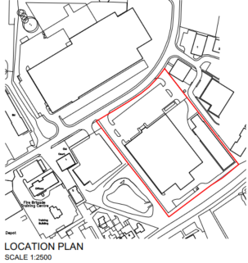

Site Location Plan

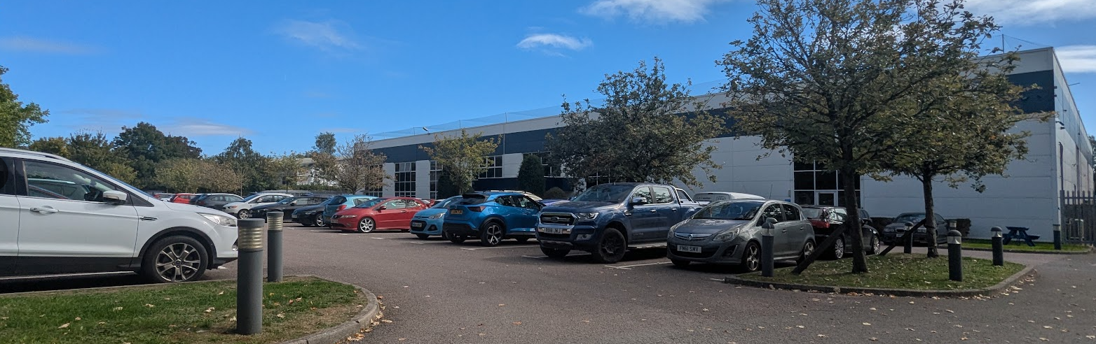

Site visit photo of the existing elevation

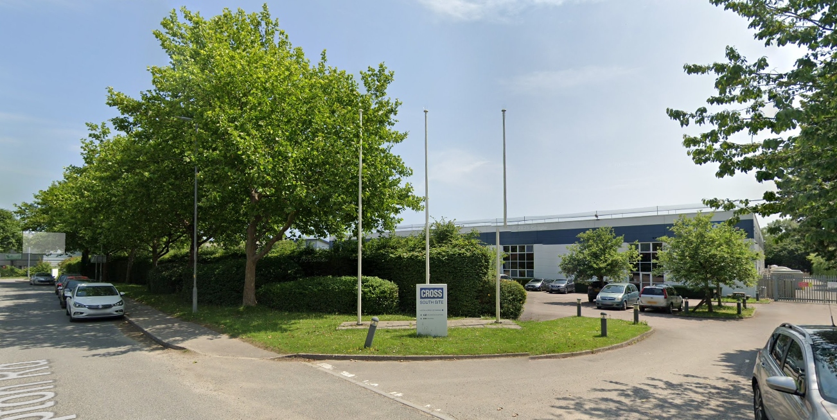

Google June 2025 Street View Image of the Site

There is one existing non-illuminated sign on the front elevation.

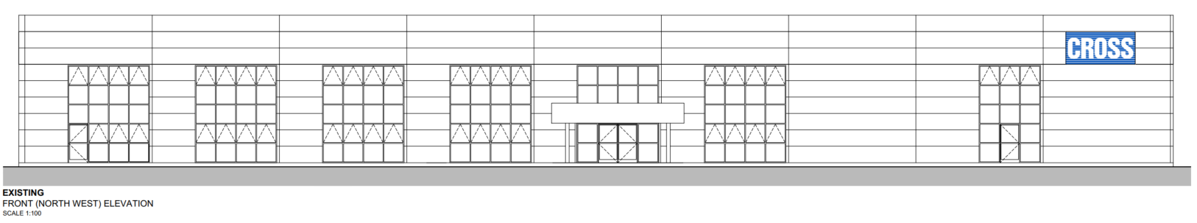

The site is not located within a Special Area of Control of Advertisements.

Where applicable, the stricter controls applicable within such areas have been taken into account in assessing the proposal.

PROPOSAL:

The application seeks advertisement consent for the Erection of new illuminated and replacement signage on front elevation

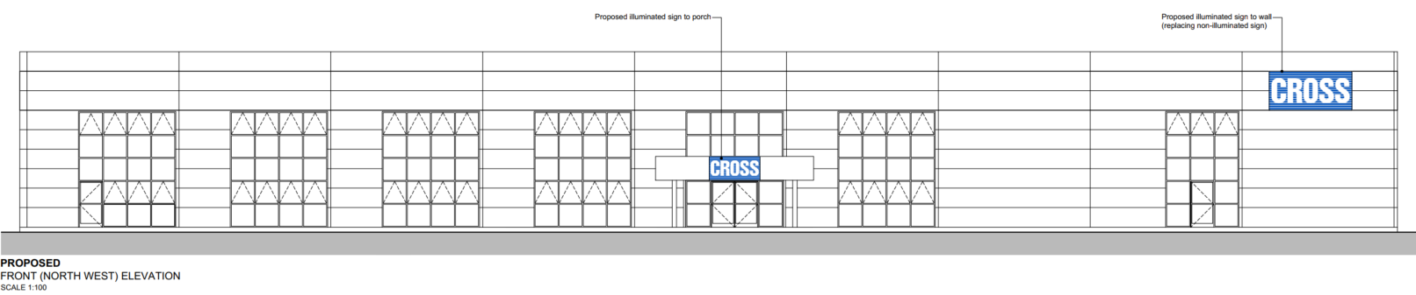

Proposed Elevation

The two signs would have areas of approximately 2.53m² and 6.74m² respectively and both are proposed to have a brightness of 4,000cd/m2.

RELEVANT LEGISLATION, POLICIES AND GUIDANCE

The Town and Country Planning (Control of Advertisements) (England) Regulations 2007

National Planning Policy Framework (NPPF)

Planning Practice Guidance (PPG)
- Advertisements

Wiltshire Core Strategy 2015 (WCS):
- Core Policy 51 Landscape
- Core Policy 57 Ensuring High Quality Design & Space Shaping
- Core Policy 58 Ensuring the Conservation of the Historic Environment
- Core Policy 62 Development Impacts on the Transport Network

Neighbourhood Plan: Devizes Neighbourhood Plan 2015

Supplementary Planning Documents:

Institute of Lighting Professionals: The Brightness of Illuminated Advertisements Including Digital Displays PLG 05/23

RELEVANT PLANNING HISTORY:

There is a lot of planning history on the site but the majority are historic applications and none relate to other advertisement applications on the site.

ISSUES

Advertisement applications are subject to a distinct statutory regime. The Local Planning Authority may only consider the effect of the proposal on amenity and public safety. Other matters, including the content of the advertisement or commercial considerations, are not material to the determination of the application.

CONSULTEE RESPONSES

The views of consultees are material considerations in the determination of the application. However, the decision-maker must exercise their own planning judgement. Where consultees raise concerns or recommend conditions, these have been considered and are addressed within the assessment section of this report.

The following consultees were invited to comment on this application:

Devizes Town Council: No objection

Wiltshire Council’s Highways Engineer: No objection

REPRESENTATIONS

15 Neighbour notification letters were sent out allowing for a 21 day period of consultation.

No comments were received.

ASSESSMENT
Regulation 3 of The Town and Country Planning (Control of Advertisements) (England) Regulations 2007 requires that local planning authorities exercise their powers in relation to the display of advertisements in the interests of amenity and public safety, taking into account the provisions of the development plan, in so far as they are material, and any other relevant factors.

In considering illuminated advertisements, Schedule 3 Part 2 Paragraph 2 of the Regulations identifies luminance levels of 600 cd/m² for illuminated advertisements of less than 10m² and 300 cd/m² for illuminated advertisements exceeding 10m². These levels are reproduced within the latest Institution of Lighting Professionals guidance, PLG 05/23: The Brightness of Illuminated Advertisements Including Digital Displays, which provides the current industry standard for assessing the visual impact of illuminated advertisements.

Impact on Amenity:
Policy Context
"Amenity" is not exhaustively defined in the Town and Country Planning (Control of Advertisements) (England) Regulations 2007, but is generally understood to include both visual and aural amenity. Factors relevant to amenity include the general characteristics of the locality, including features of historic, architectural, cultural or landscape interest.

CP57 requires a high standard of design in all proposals, including (x) the sensitive design of advertisements and signage.

Policies DP1-DP4 of the NPPF require development to contribute positively to the quality of places, respond appropriately to local character and context, and achieve a high standard of design. Whilst advertisement applications are determined primarily with regard to amenity and public safety, these policies provide useful context when assessing the impact of signage upon the character and appearance of an area.

Assessment

The site is located within an established industrial and commercial area characterised by large-scale industrial buildings, associated infrastructure and existing artificial lighting. The building itself is set well back from Hopton Road behind a sizeable forecourt and car parking area and benefits from a degree of screening provided by existing trees and hedgerows. The wider industrial estate is visually spacious in character, with generous building separations, areas of landscaping and wide carriageways. Consequently, the proposed advertisements would be viewed within a commercial environment rather than a sensitive townscape or residential setting.

The site is not located within a Conservation Area, National Landscape or other designated landscape area and there are no listed buildings whose setting would be affected by the proposal. As such, no heritage or landscape constraints are considered to arise.

Regulation 3 of the Town and Country Planning (Control of Advertisements) (England) Regulations 2007 requires local planning authorities to exercise their powers in relation to the display of advertisements in the interests of amenity and public safety. Schedule 3 Part 2 Paragraph 2 of the Regulations identifies permitted luminance levels for illuminated advertisements within Classes 4B and 5 as 600 cd/m² where the illuminated area does not exceed 10m² and 300 cd/m² where the illuminated area exceeds 10m². These levels are reflected within the Institution of Lighting Professionals publication PLG 05/23: The Brightness of Illuminated Advertisements Including Digital Displays and provide a useful benchmark when assessing illuminated commercial signage.

The application form states that both signs would be illuminated to a luminance level of 4,000 cd/m². Having regard to the size of the proposed advertisements and the character of the area, this level of illumination would be excessive and significantly greater than the levels generally considered acceptable for illuminated business signage. As submitted, a luminance level of 4,000 cd/m² would result in an unduly prominent and visually intrusive form of illumination that would be harmful to the visual amenity of the locality.

Following discussions with the applicant's agent, it has been agreed that the luminance of the advertisements can be restricted by condition to a maximum of 600 cd/m². This accords with the luminance levels identified within Schedule 3 Part 2 Paragraph 2 of the Regulations for illuminated advertisements of this scale and is considered appropriate having regard to the commercial character of the locality, the spacious nature of the industrial estate and the set-back and landscaping associated with the site.

Subject to this restriction, the advertisements would be viewed in the context of a large industrial building within a visually spacious and effectively landscaped industrial estate. The signs would not appear unduly prominent, would not result in material visual clutter and would not adversely affect the character or appearance of the area. Furthermore, no concerns are raised regarding public safety.

Having regard to the character of the area, the design, scale, siting and illumination of the proposed advertisements, and subject to the recommended luminance condition, it is considered that the proposal would not cause harm to visual amenity or public safety and would therefore comply with the requirements of the Town and Country Planning (Control of Advertisements) (England) Regulations 2007.

Impact on Public Safety:
Policy Context
“Public safety” is not exhaustively defined in the Town and Country Planning (Control of Advertisements) (England) Regulations 2007, but it generally refers to the potential impact of a development or advertisement on the safe use and operation of public spaces, including roads, footpaths, and other areas accessible to the public.

In assessing public safety, the Local Planning Authority (LPA) may consider:
- Whether the proposal would obstruct visibility for road users or pedestrians;
- Whether it could distract, confuse, or mislead drivers, particularly near junctions or crossings;
- Whether it interferes with traffic signs, signals, or street lighting;
- Whether it poses a physical hazard, such as through poor structural integrity or inappropriate siting.

The NPPF supports the creation of safe environments and the protection of public safety. In the context of advertisement control, particular regard should be had to the effect of the advertisement on highway safety and the safe movement of pedestrians and vehicles.

CP62 advises that proposals should provide appropriate mitigating measures to offset any adverse impacts on the transport network at both the implementation and operational stages.

Assessment

The proposed advertisements would be mounted on an existing industrial building and are set well back from the public highway. The signs would not obstruct visibility for road users or pedestrians, interfere with any traffic signs, signals or highway infrastructure, nor would they result in any physical hazard by virtue of their siting or design.

Whilst the application proposes illuminated signage, the advertisements would be internally illuminated and static in nature, with no flashing, intermittent or moving elements. Furthermore, the luminance of the signs would be restricted by condition to a maximum of 600 cd/m², ensuring that they would not appear excessively bright or distracting to road users.

The site is located approximately 42 metres from Hopton Road and is separated from the highway by parking and landscaped areas. As such, the advertisements would not be experienced in close proximity to highway users and are not considered likely to distract drivers or otherwise prejudice highway safety.

The Council's Highways Officer has been consulted and raises no objection to the proposal.

Having regard to its siting, scale, illumination and relationship with the surrounding highway network, it is considered that the proposal would not result in an unacceptable impact on public safety, either individually or cumulatively, and would therefore satisfy the relevant provisions of the Town and Country Planning (Control of Advertisements) (England) Regulations 2007.

Public Sector Equality Duty (PSED):

In reaching this decision, due regard has been had to the Public Sector Equality Duty under Section 149 of the Equality Act 2010. This requires the Local Planning Authority to have regard to the need to eliminate discrimination, advance equality of opportunity and foster good relations between persons who share a protected characteristic and those who do not.

The Local Planning Authority is satisfied that the proposal would not result in any unlawful discrimination and that any impacts on protected groups have been appropriately considered as part of this assessment.

CONCLUSION:

The proposed advertisement has been assessed in accordance with the relevant provisions of the Town and Country Planning (Control of Advertisements) (England) Regulations 2007.

It is considered that the advertisement, by reason of its design, scale, siting, and method of illumination, would not result in harm to the visual amenity of the area, including the setting of any nearby heritage assets. Furthermore, the proposal is not considered to pose a risk to public safety, either individually or cumulatively with other signage in the vicinity.

Subject to the recommended conditions, the proposal is therefore considered acceptable and it is recommended that advertisement consent be granted.

RECOMMENDATION:
It is recommended that advertisement consent be GRANTED subject to condition(s).

All conditions imposed have been assessed against the tests set out in Policy DM6 of the NPPF and are considered to be necessary, relevant to planning, relevant to the development to be permitted, enforceable, precise and reasonable in all other respects.

