Bartlett Tree Experts

Planning Permission Application
Property Address: The Old Rectory, Main Road, CHERHILL, Wiltshire SN11 8UX.
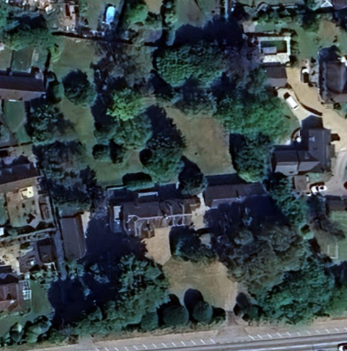
T1

Species: | Specification: | Photo:
T1: Pine (Ivy Cladded) | Remove to ground level | 