APPLICATION FOR FULL-PLANNING PERMISSION (MINOR DEVELOPMENT)
CASE OFFICER REPORT

APPLICATION REFERENCE: | PL/2026/03752
APPLICATION TYPE: | Full planning permission
SITE ADDRESS: | North Lodge, 19 Heytesbury Park, Heytesbury, Warminster, BA12 0HG
DEVELOPMENT DESCRIPTION: | Construct an additional block of stables and associated hardstanding
RECOMMENDATION: | Approve with Conditions

SITE DESCRIPTION/CONTEXT

North Lodge is a detached two storey dwelling located in open countryside to the north of the A36. It therefore lies to the north of (and outside) the limits of development boundary of Heytesbury which is designated as a large village in the Wiltshire Core Strategy. The residential curtilage of North Lodge is clearly defined by a hedgerow which separates it from open countryside/paddock land to which the existing stable block is then located. The stable is accessed via its own access gate off East Hill Road which serves both North Lodge and the stable.

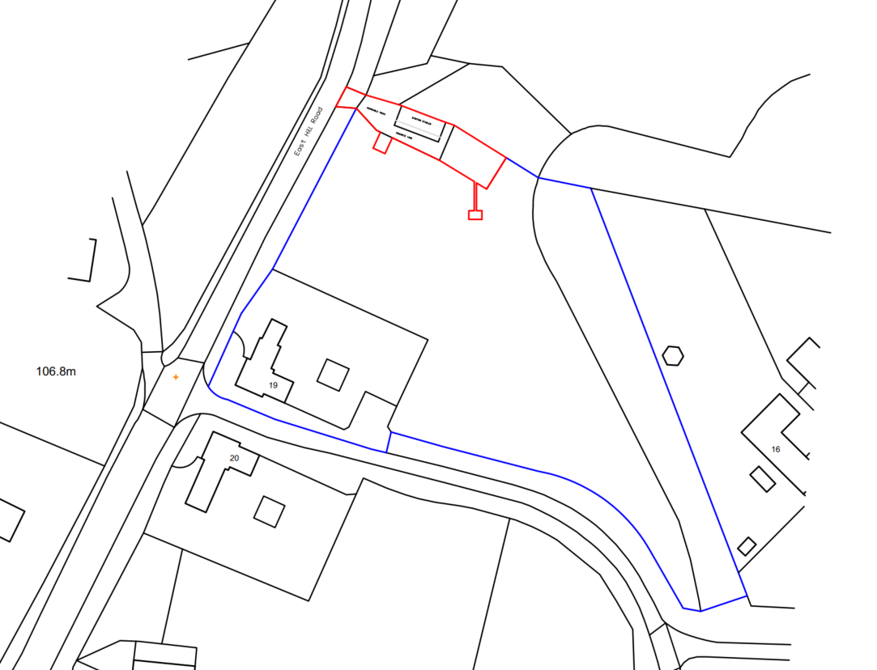

Site Location Plan

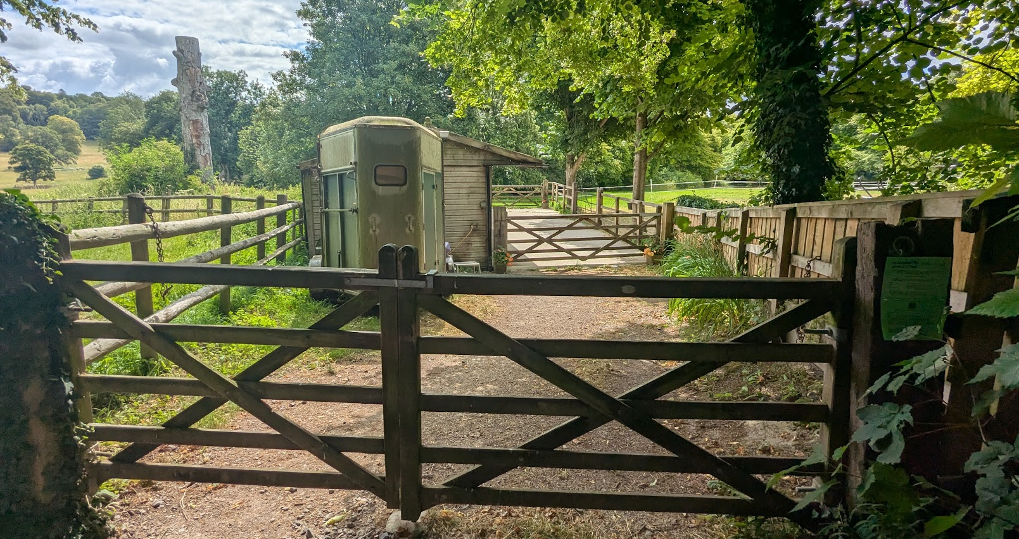

View of Stable from East Hill Road

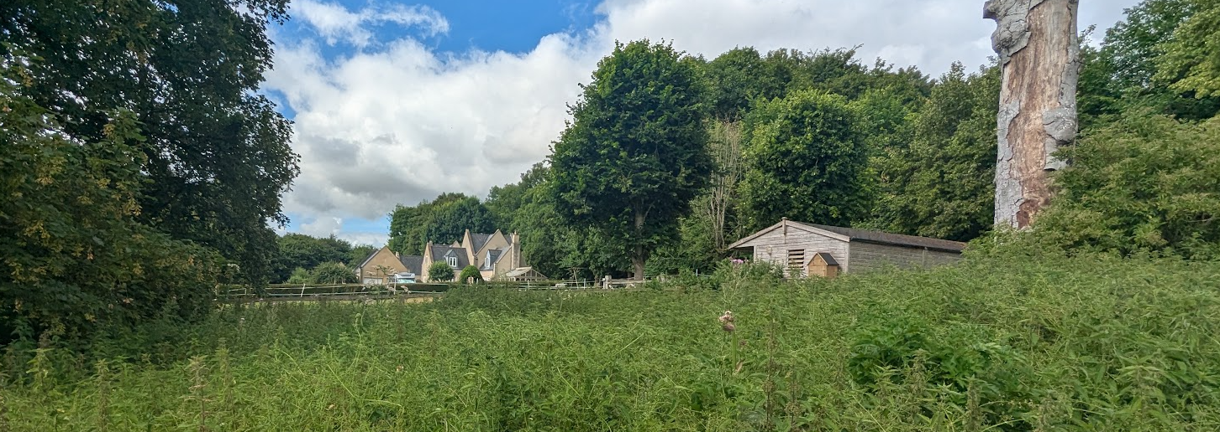

View from the north of the existing stable with North Lodge in the background

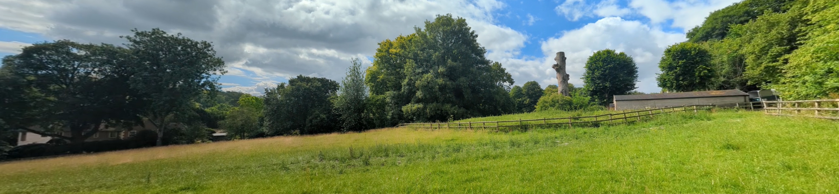

Additional view from the north of the existing stable with Winterbourne House (left)

The site is subject to the following key constraints and designations:

- Heytesbury House is a grade II* listed building (approximately 190m to the east)
- There are two further grade II structures within the grounds of Heytesbury House
- There are Wiltshire & Swindon Historic Environment Records (HER) records for parkland around Heytesbury House but there is no Registered Historic Park and Garden designation by Historic England
- The 1996 and 1997 applications included a s106 agreement (see planning history)
- The site is within the 6.4km Buffer Zone of the Salisbury Plain Special Protection Area
- Within the River Avon Catchment Area

It is also worth noting that the site is within flood zone 1 and not subject to any ground or surface water flood risk. It is also outside the Heytesbury Conservation Area. It is not within a National Landscape or any other ecological or landscape designation.

PROPOSAL

This is a full planning application for the construction of an additional block of stables and associated hardstanding at North Lodge, 19 Heytesbury Park.

The proposal is for a simple stable construction measuring 9.6m long, 4.8m wide and 3.2m high ridge sloping to 2.1m at eaves. It would have a felt shingle roof and shiplap cladding walls.
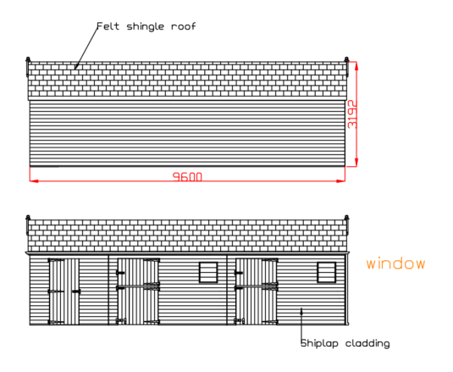
Proposed Elevations

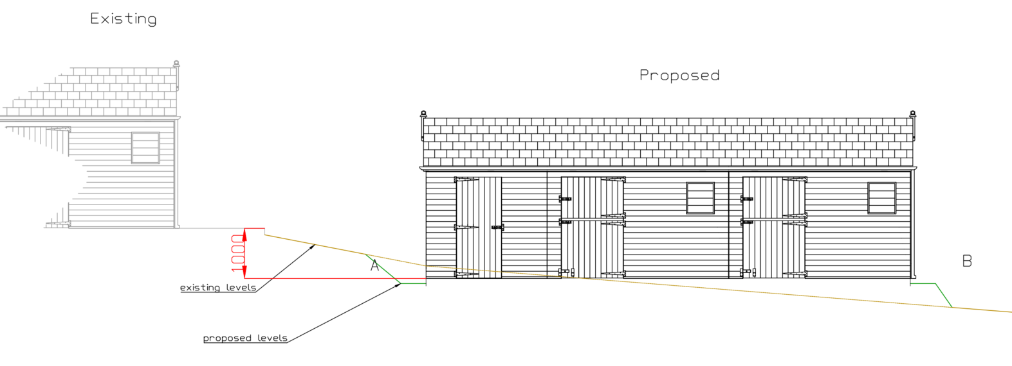
Proposed Cross Section

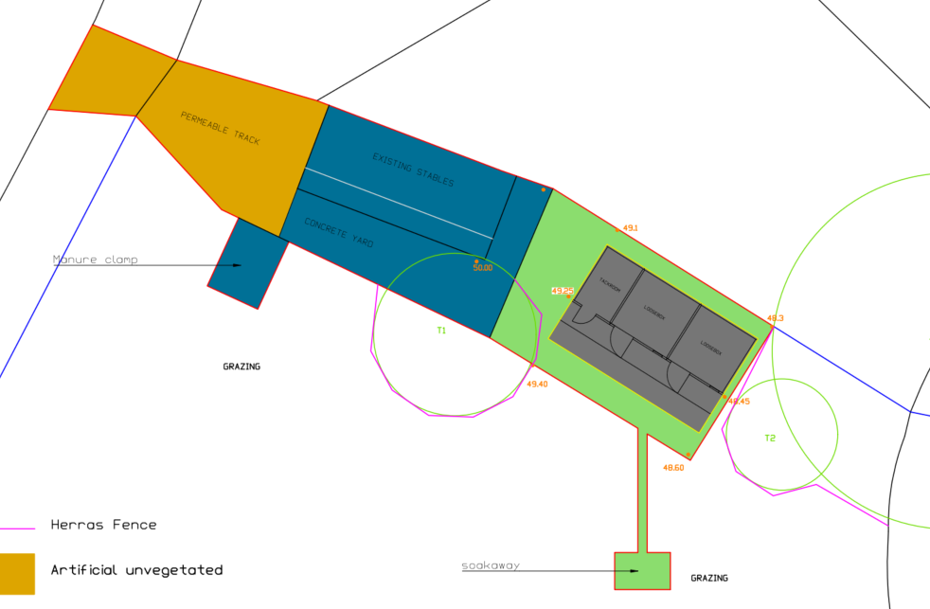
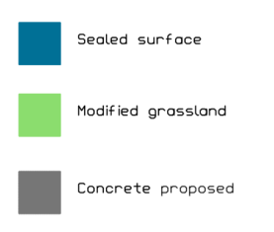

Proposed Block Plan

Due to the sloping ground levels across the site, as illustrated in the site photographs and cross-section plan, the proposed stable would be situated approximately 1 metre lower than the existing stable and associated hardstanding. The proposed hardstanding would not be physically connected to the existing hardstanding; instead, the two areas would remain separate and be divided by a retaining wall. No detailed information has been provided in relation to the retaining wall, although the cross-section plan indicates that it would be approximately 1 metre in height.

Although the submitted plans indicate that the proposed stable, hardstanding and modified grassland levels would be located outside the Root Protection Areas (RPAs) of the Lime tree (T2) and the large Sycamore tree (T3), the accompanying Arboricultural Method Statement acknowledges that there would be limited encroachment into the outer extent of the RPA associated with T2. The report also confirms that the works would fall within the RPA of a further Lime tree (T1), although this tree is already situated adjacent to the existing hardstanding. Both the plans and the supporting arboricultural information demonstrate that the proposed works would remain outside the RPA of T3.

PLANNING HISTORY

Proposal / Summary
W/96/1046/FUL - Full planning permission Decision - Approve with Conditions Date: 28/8/1997 – Erection of two lodge houses
W/96/01044/FUL - Full planning permission Decision - Approve with Conditions Date: 28/8/1997 – Conversion of stable block to two dwellings and coach house to one dwelling and erect garage block
W/96/01045/LBC - Listed building consent Decision - Approve with Conditions Date: 16/5/1997 – Conversion of main house to two dwellings servants wing to four dwellings stable block to two dwellings and coach house to one dwelling demolition of detached game store and four extensions to servants quarter
W/97/1102/FUL - Full planning permission Decision - Approve with Conditions Date: 17/12/1997 – Two lodge houses - amendment to W96/1046
W/98/00184/FUL - Full planning permission Decision - Approve with Conditions Date: 2/4/1998 – Two detached dwellings at park entrance (revised design)
W/09/01623/FUL - Full planning permission Decision - Approve with Conditions Date: 24/7/2009 – Change of use of land/erection of stable block

Application W/96/01046/FUL was subject to a Section 106 Agreement dated 27 August 1997, which was subsequently varied by a Supplemental Agreement under application W/97/01102/FUL. The agreement tied the enabling development, including the lodge houses, walled garden dwellings, glade dwelling and stable yard dwelling, to the phased restoration of Heytesbury House. It required specified restoration works to be completed prior to the disposal of successive development plots.

The agreement also imposed ongoing management obligations in respect of land defined within the agreement as "parkland". These included requirements that:

- the parkland should not be incorporated into the residential curtilage of any of the approved dwellings;
- no shelter, animal pen, horse jump or similar structure should be erected on the parkland without the express written agreement of the Local Planning Authority; and
- the parkland should be maintained by means of normal pasture management.

The restoration obligations appear to have been substantially complied with, although no formal discharge of the agreement has been identified within the Council's records.

The agreement defines the parkland as land shown edged green on a separate plan. However, whilst the executed agreement has been located, the referenced plan defining the extent of the parkland has not been identified within the available Council records. Consequently, it has not been possible to conclusively verify whether the application site falls wholly or partly within the area subject to the parkland obligations.

The application site is likely to form part of the historic parkland associated with Heytesbury House and is recorded within the Wiltshire and Swindon Historic Environment Record. However, no evidence has been identified that the site forms part of a Registered Park and Garden. The principal heritage significance of the land therefore derives from its contribution to the setting of the Grade II* listed building and the surviving historic parkland landscape.

Notwithstanding the above, the agreement does not prohibit equestrian use outright and expressly anticipates circumstances where the Local Planning Authority may provide written agreement for structures associated with the management of the parkland (such as the previous W/09/01623/FUL permission). Therefore, even if the application site were shown to fall within the defined parkland area, the proposal falls to be considered on its individual planning merits having regard to the landscape, heritage and other material planning considerations relevant to the site.

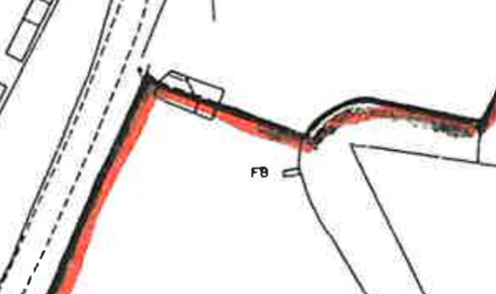

Extract of s106 agreement where some of the application site would be within the s106 plan

RELEVANT LEGISLATION, POLICIES AND GUIDANCE

Statutory Legislation:

The Town and Country Planning Act 1990

Section 66 of the Planning (Listed Buildings and Conservation Areas) Act 1990 requires ‘special regard’ to be given to the desirability of preserving a listed building or its setting.

National Planning Policy:

- National Planning Policy Framework (NPPF)
- DP3: Key principles for well-designed places
- TR3: Location development in sustainable locations
- TR4: Street design, access and parking
- P3: Living conditions and pollution
- N2: Improving the natural environment
- HE4: Securing the conservation of heritage assets
- HE5: Assessing effects on heritage assets
- HE6: Proposals affecting designated heritage assets
- HE7: Decisions on non-designated heritage assets
- Planning Practice Guidance (PPG)

Development Plan:

The development plan for Wiltshire comprises the Wiltshire Core Strategy (WCS) (adopted January 2015) and any made neighbourhood plans, which remains the principal statutory planning document guiding development across the county. In line with Section 38(6) of the Planning and Compulsory Purchase Act 2004, planning decisions must be made in accordance with the development plan unless material considerations indicate otherwise.

Though the development plan is considered as a whole, those parts deemed to be particularly relevant to this application are listed below:

The adopted Wiltshire Core Strategy (WCS), with particular regard to:

- Core Policy 50 Biodiversity and Geodiversity;
- Core Policy 51: Landscape;
- Core Policy 57 Ensuring High Quality Design and Place Shaping;
- Core Policy 58 Ensuring the Conservation of the Historic Environment;
- Core Policy 61 Transport and new development;
- Core Policy 64 Demand management

West Wiltshire District Plan 1st Alteration 2004 - Saved policy E10 – Horse Related Development

Proposals for equestrian facilities and changes of use will be required to have regard to minimising their effects on the appearance of the countryside and to highway implications. All such building proposals should have special regard to siting, design materials and construction to ensure they blend in with their surroundings and do not have an adverse impact on the countryside and the natural environment including the water environment.

Neighbourhood Plan:

Heytesbury does not have a Neighbourhood Plan or Area Designation.

ISSUES

The main issues that need to be addressed in this case include:

- Whether the scheme constitutes high quality design (CP 57)
- Whether the scheme would have an acceptable impact upon the reasonable living conditions of the adjoining occupants (CP 57)
- Whether the scheme would have an acceptable impact on the natural environment (CP 51)
- Whether the scheme would preserve or enhance the historic environment (CP 58)
- Whether the proposal would have a negative effect upon highway safety, including if there is sufficient parking for the proposed development (CP 61 and 64)
- Whether there would be any harmful impacts upon protected species or priority habitats (CP 50)

CONSULTATION RESPONSES

The views of consultees are material considerations in the determination of the application. However, the decision-maker must exercise their own planning judgement. Where consultees raise concerns or recommend conditions, these have been considered and are addressed within the assessment section of this report.

Heytesbury, Imber and Knook Parish Council – No objection

Wiltshire Council Tree Officer – No objection subject to condition

Wiltshire Council Ecology Officer – No objection subject to condition

The consultee responses have been carefully considered. Whilst significant weight is afforded to specialist technical advice, the decision remains a matter for the Local Planning Authority and the officer assessment below reaches an independent planning judgement on the issues raised.

REPRESENTATIONS

In accordance with the requirements of the Town and Country Planning (Development Management Procedure) (England) Order 2015 (as amended), the application was publicised by way of:

- 3 Neighbour notification letters sent to adjoining and nearby properties;
- A site notice displayed near the site;

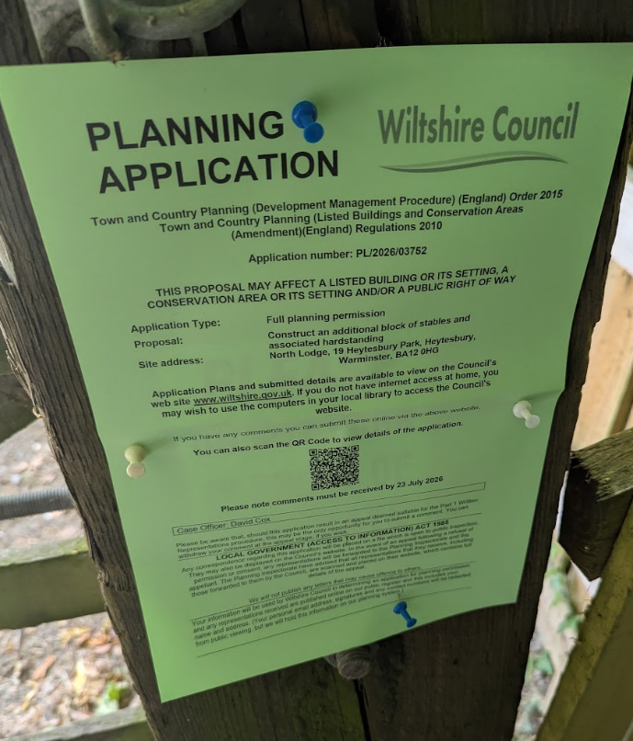

Photo of site notice
These methods were used to inform interested parties and provide a period of 21 days for comments to be submitted.

No comments were received.

ASSESSMENT

Section 38(6) of the Planning and Compulsory Purchase Act 2004 states:

"If regard is to be had to the development plan for the purposes of any determination to be made under the planning Acts, the determination must be made in accordance with the plan unless material considerations indicate otherwise."

In accordance with this statutory requirement, this application has been assessed against the relevant policies of the Development Plan, including the Wiltshire Core Strategy (2015) and, where applicable, any made Neighbourhood Plans. Consideration has also been given to the policies of the NPPF (NPPF) as a material consideration in the assessment.

The assessment below considers each of the main issues identified above. Each topic is assessed in turn with reference to the relevant policy context, the evidence submitted, consultee responses, and all other material considerations, before a conclusion is reached.

Principle of Development

Policy Context

There is no specific policy within the Wiltshire Core Strategy which directly relates to equestrian development. Such proposals are therefore generally assessed against the relevant development management policies relating to matters such as design, landscape impact, biodiversity, highway safety and residential amenity. In particular, Core Policies 51 (Landscape) and 57 (Ensuring High-Quality Design and Place Shaping) may be relevant depending on the circumstances of the proposal.

However, the Wiltshire Core Strategy confirms that saved Policy E10 of the former West Wiltshire District Plan 1st Alteration 2004 continues to apply.

Planning History

The planning history of the site has been reviewed. The two lodges were approved in the late 1996 and 1997 applications as enabling development to facilitate the restoration of Heytesbury House and was subject to the legal agreement as set out in the planning history section. The existing stable was approved in 2009.

Assessment

There is no objection in principle to the continued equestrian use of the site. The proposal relates to a modest stable building associated with the existing equestrian use of the land and is located within the countryside where such facilities are commonly found.

The most directly relevant policy is saved Policy E10 of the former West Wiltshire District Plan 1st Alteration 2004 which requires horse related development to minimise its effects on the appearance of the countryside and to have regard to highway implications. The policy further requires buildings to be carefully sited and designed so that they blend into their surroundings and do not have an adverse impact on the countryside or natural environment.

In this case, the stable would be positioned adjacent to an existing hedgerow which assists in integrating the development into the wider landscape. The building has a low overall profile and utilises materials that are traditional and appropriate to its equestrian function. Therefore, the structure would be read as a typical rural stable building and would not appear visually intrusive within the surrounding countryside. The proposal would therefore minimise its impact upon the character and appearance of the rural area and would accord with the aims of saved Policy E10 of the former West Wiltshire District Plan.

Any impact upon the setting of the Grade II* listed Heytesbury House and the wider historic parkland landscape is considered separately within the heritage section of this report.

The proposal would not result in any material intensification of traffic movements and would utilise the existing access arrangements. Consequently, no adverse highway safety implications have been identified, and the proposal complies with the highway requirements of Policy E10.

Whilst the site is likely to form part of the wider historic landscape associated with Heytesbury House, the proposal represents a limited form of development that would sit comfortably within its rural context. The principle of development is therefore considered acceptable and compliant with saved Policy E10, together with the relevant objectives of Core Policies 51 and 57 of the Wiltshire Core Strategy.

Conclusion

The proposal represents an appropriate form of equestrian development within the countryside. The scale, design, siting and materials would ensure that the development integrates satisfactorily into its surroundings, minimises its effect on the appearance of the countryside and would not result in any adverse highway impacts.

The development would not harm the setting of the Grade II* listed Heytesbury House or the character of the wider historic landscape. Accordingly, the proposal accords with saved Policy E10 of the former West Wiltshire District Plan together with Core Policies 51 and 57 of the Wiltshire Core Strategy.

The principle of development is therefore considered acceptable.

Impact on Heritage Assets

Policy Context
Policies HE4-HE7 of the NPPF recognise heritage assets as an irreplaceable resource and require proposals affecting heritage assets to be assessed having regard to their significance and the contribution made by their setting.

Assessment
In assessing this aspect of the proposal, regard has been had to the site context, the details of the proposed development, the relevant development plan policies, and all other material considerations. The key considerations are set out below.

The site lies within the wider setting of the Grade II* listed Heytesbury House and forms part of the historic landscape associated with that property. The surrounding land retains elements of the former parkland and contributes to the rural setting of the listed building.

The proposal consists of a modest stable building associated with an established equestrian use. The structure would be of a scale and appearance typical of rural equestrian development and would be positioned adjacent to an existing hedgerow where it would be viewed in the context of existing field boundaries and agricultural/equestrian land uses.

Whilst the stable would be located within the wider setting of Heytesbury House, it would be situated a considerable distance from the principal listed building and would be separated from it by existing buildings, mature vegetation and intervening areas of woodland. As a result, the stable would not compete with, dominate or detract from the appreciation of the listed building or its historic setting.

The building's low profile, simple form and use of appropriate materials would ensure that it appears as a subordinate rural structure. It would not interrupt key views of the listed building, erode its prominence within the landscape or diminish the ability to appreciate its significance as a Grade II* listed country house.

The site is also likely to form part of the wider historic parkland landscape associated with Heytesbury House. Whilst the precise extent of the parkland referred to within the 1997 Section 106 Agreement cannot be conclusively verified as the referenced plan has not been located, the site nevertheless contributes to the rural setting of the Grade II* listed building and the surviving historic parkland landscape. The proposal represents a limited intervention that would sit comfortably within its rural context and would not materially alter the historic character of the landscape. The stable would not introduce urbanising features or domestic paraphernalia of a scale that would adversely affect the significance of the heritage asset or its setting.

Given the scale, siting and nature of the proposal, and the absence of any identified harm to significance or setting, consultation with Historic England or the Council's Conservation Officer was not considered necessary. The stable would be located a substantial distance from the principal heritage asset and would be separated from it by existing buildings, mature vegetation and woodland, which collectively provide effective visual and spatial separation. The proposal has nevertheless been assessed having regard to the statutory duties and relevant heritage policies and is considered to preserve both the significance of the listed building and its wider historic setting.

In accordance with the heritage policies of the NPPF, any harm to the significance of a heritage asset must be clearly identified and assessed. In this instance, no harm has been identified. The proposal would preserve the significance of the Grade II* listed building, preserve its setting and would not adversely affect the character of the wider historic landscape.

Conclusion
Having regard to the above, it is considered that the proposal would preserve the significance and setting of the Grade II* listed Heytesbury House. The scale, siting, design and materials of the proposed stable ensure that it would remain a subordinate feature within the landscape and would not erode the character or appreciation of the heritage asset.

The substantial distance between the development and the listed building, together with the presence of intervening buildings, mature vegetation and woodland, provides adequate separation such that no adverse impact upon the significance or setting of the heritage asset would arise.

Accordingly, the proposal would result in no harm to the significance or setting of any designated heritage asset and accords with the statutory duties of Sections 16 and 66 of the Planning (Listed Buildings and Conservation Areas) Act 1990, Section 20 of the NPPF and Core Policy 58 of the Wiltshire Core Strategy.

Amenity

Policy Context
Core Policy 57 (Point vii) of the Wiltshire Core Strategy requires development to respect the amenity of existing occupants and ensure appropriate amenity levels for future residents.

Policy P3 of the NPPF requires development to be appropriate for its location, taking account of its likely effects on health, living conditions and the environment. In particular, Policy P3(2)(b) requires development to avoid giving rise to unacceptable impacts on the living conditions of neighbouring residents and occupiers. In assessing amenity impacts, regard should be had to matters including daylight and sunlight, outlook, privacy, overbearing impacts and other effects on residential amenity.

These policies guide the assessment of amenity impacts. Each of the below matters has been assessed having regard to the specific site context and layout of the proposal.

Assessment

The application site is located within open countryside and is physically separated from nearby residential properties. The proposed stable building would be positioned adjacent to the applicant's existing equestrian land and immediately adjoining land within the applicant's wider ownership, as identified by the blue line application boundary.

Given the nature of the proposal, its siting and the absence of any immediately adjoining residential occupiers, the development would not give rise to any material overlooking or loss of privacy. Similarly, due to the modest scale of the building and the substantial separation distances involved, the proposal would not result in any unacceptable loss of light, overshadowing, overbearing impact or sense of enclosure.

The proposal comprises a small-scale equestrian stable associated with an existing equestrian use. No significant increase in activity is anticipated and the proposal would not generate noise, disturbance, odour or other amenity impacts of a level that would adversely affect neighbouring occupiers. The use would remain consistent with the established rural and equestrian character of the area.

As the application relates solely to the erection of an additional stable building, matters relating to internal and external residential space standards are not relevant in this instance.

Conclusion

Having regard to the above, it is considered that the proposal would not result in any unacceptable impact upon the living conditions of neighbouring occupiers in terms of privacy, outlook, light, overbearing impact, noise, disturbance or odour.

The proposal therefore accords with Core Policy 57 of the Wiltshire Core Strategy and policy P3 of the NPPF.

Highways Impacts and Parking

Policy Context
Policies TR3-TR4 of the NPPF seek to ensure that development is supported by safe, suitable and sustainable transport arrangements. Development should provide appropriate access, promote sustainable travel choices where possible and avoid unacceptable impacts on highway safety and the operation of the transport network.

Core Policies 61 and 64 of the Wiltshire Core Strategy require development to provide safe access, promote sustainable transport, minimise transport impacts and provide appropriate parking arrangements.

Assessment
Given the limited scale of the proposal and the absence of any alterations to the existing access arrangements, the Highway Authority was not consulted on this application.

The proposal relates to the construction of an additional stable positioned to the rear of the existing approved stable block. No new vehicular access is proposed, and the development would continue to be served by the existing field access and stable access from East Hill Road.

The proposed stable is intended to operate as part of the existing equestrian use and is not considered likely to generate any material increase in vehicle movements. Horses would continue to be brought to and from the site using the existing access arrangements and it is reasonable to expect that feed, bedding and other equestrian equipment would similarly be taken through the existing stable area. Consequently, the proposal would not result in any significant intensification of the lawful use of the site.

There is an existing gated access into the field at the rear of the existing hardstanding. Although the proposed retaining wall would alter the immediate relationship between the existing hardstanding and the field, there remains sufficient space for the access arrangement to be adjusted or retained to allow ongoing access into the paddock area if required. The proposal therefore does not prejudice the future management or use of the wider landholding.

No concerns have been identified in relation to visibility, access geometry, parking provision or the safe operation of the local highway network. The proposal would continue to utilise an established access serving the existing equestrian use and would not introduce any highway safety concerns.

Conclusion
Having regard to the above, it is considered that the proposal would not result in any unacceptable impact upon highway safety or the operation of the local highway network. The development would be served by existing access arrangements and is not expected to generate any material increase in vehicular movements.

Accordingly, the proposal is considered to accord with policies T3 and TR4 of the NPPF and Core Policies 61 and 64 of the Wiltshire Core Strategy.

Ecology and Biodiversity

Policy Context
Core Policy 50 of the Wiltshire Core Strategy requires development to protect and, where appropriate, enhance biodiversity and geodiversity interests.

Policy N2 of the NPPF seeks to conserve and enhance biodiversity, support nature recovery, protect habitats and species, and strengthen ecological networks.

Where relevant, proposals should assess impacts upon protected species, habitats, ecological networks and green and blue infrastructure and demonstrate that any adverse impacts can be appropriately avoided, mitigated or compensated for.

Biodiversity Net Gain (BNG) is mandatory for most development and proposals should demonstrate compliance with the statutory requirements unless an exemption applies.

Assessment
The Council's Ecology Officer has reviewed the application and raises no objection subject to conditions. A completed Biodiversity Net Gain Metric and supporting information were submitted and assessed as part of the application.

The application site lies within the catchment of the River Avon Special Area of Conservation (SAC). However, as the proposal would not result in any increase in overnight accommodation or wastewater generation, the development can be screened out of Appropriate Assessment in respect of nutrient neutrality. It has therefore been concluded that the proposal would not result in an adverse effect on the integrity of the River Avon SAC.

The site also lies within the 6.4km zone of influence of the Salisbury Plain Special Protection Area (SPA). The proposal has been considered in the context of the Council's strategic Appropriate Assessment and associated mitigation strategy. Given that the strategic mitigation measures remain in place and continue to be supported by Natural England, it has been concluded that the proposal would not adversely affect the integrity of the Salisbury Plain SPA or its qualifying features.

In relation to Biodiversity Net Gain, a completed statutory metric has been submitted and accepted by the Council's Ecology Officer. The submitted metric identifies a baseline habitat value of 0.04944 habitat units and demonstrates a final biodiversity gain of 0.00495 habitat units, equating to a net gain of approximately 10.002%. The mandatory 10% Biodiversity Net Gain requirement is therefore achieved. The metric confirms that there is no habitat unit deficit and that the relevant trading rules have been satisfied.

The submitted metric shows that the required gain is achieved through a combination of on-site habitat retention and off-site habitat creation secured through an identified off-site biodiversity gain site. The Ecology Officer advises that confirmation of the final Biodiversity Gain Plan is a post-determination matter and that the statutory Biodiversity Gain Plan condition will apply automatically should planning permission be granted.

Subject to the recommended ecological conditions controlling implementation of the Arboricultural Method Statement and any external lighting, no unacceptable ecological impacts have been identified.

Conclusion
Having regard to the submitted ecological information, consultation response and Biodiversity Net Gain Metric, it is considered that the proposal would not result in unacceptable harm to protected sites, habitats or species. The proposal would not adversely affect the integrity of the River Avon SAC or Salisbury Plain SPA and achieves the statutory Biodiversity Net Gain requirement of at least 10%.

Accordingly, the proposal accords with Core Policy 50 of the Wiltshire Core Strategy and the biodiversity objectives of the NPPF.

Trees and Arboricultural Impact

Policy Context
Core Policy 51 of the Wiltshire Core Strategy seeks to protect and enhance landscape character, including important trees and woodland features.

Policy N2 of the NPPF requires decision-makers to consider the environmental qualities of land proposed for development and to conserve and enhance existing natural features of visual, historic or nature conservation value, including established trees and hedgerows where possible. The policy also seeks to ensure that landscaping and natural features are used to help integrate development into its surroundings.

Assessment
The application site contains a number of mature trees in proximity to the proposed development, including Lime trees (T1 and T2) and a Sycamore tree (T3), together with existing hedgerow boundaries. The application was accompanied by an Arboricultural Method Statement which has been reviewed by the Council's Tree Officer.

The submitted plans demonstrate that the proposed stable building, hardstanding and associated level changes would be located outside the Root Protection Area of the Sycamore tree (T3). Whilst the Arboricultural Method Statement acknowledges limited encroachment into the outer extent of the Root Protection Area associated with Lime tree T2, it concludes that the proposed works can be undertaken without unacceptable harm to the retained trees, subject to appropriate protection measures being implemented. The report also notes that part of the works would occur within the Root Protection Area of Lime tree T1, which is already influenced by the presence of the existing hardstanding and stable area.

The Council's Tree Officer raises no arboricultural objection subject to a condition that the development is undertaken in full accordance with the requirements of the Arboricultural Method Statement and tree protection plan.

Subject to the implementation of appropriate tree protection measures during construction, it is considered that the proposal would retain the existing trees and would not result in unacceptable harm to their health, longevity, amenity value or contribution to the character of the area.

Conclusion
It is considered that the proposal would not result in unacceptable harm to trees of amenity value, subject to conditions requiring the submission of a Tree Protection Plan and compliance with the approved Arboricultural Method Statement.

Accordingly, the proposal accords with Core Policy 51 of the Wiltshire Core Strategy and the relevant provisions of the NPPF relating to the protection and retention of existing trees and landscape features.

Public Sector Equality Duty (PSED)
In reaching this decision, due regard has been had to the Public Sector Equality Duty under Section 149 of the Equality Act 2010. This requires the Local Planning Authority to have regard to the need to eliminate discrimination, advance equality of opportunity and foster good relations between persons who share a protected characteristic and those who do not.

The Local Planning Authority is satisfied that the proposal would not result in any unlawful discrimination and that any impacts on protected groups have been appropriately considered as part of this assessment.

CONCLUSION

The proposed development is considered acceptable in planning terms. Having regard to the Development Plan, the NPPF and all other material considerations.

Accordingly, planning permission should be granted.

RECOMMENDATION:
That Planning Permission be GRANTED, subject to conditions

All conditions imposed have been assessed against the tests set out in Policy DM6 of the NPPF and are considered to be necessary, relevant to planning, relevant to the development to be permitted, enforceable, precise and reasonable in all other respects.

