APPLICATION FOR HOUSEHOLDER PLANNING PERMISSION
DELEGATED REPORT

APPLICATION REFERENCE: | PL/2026/04914
APPLICATION TYPE: | Householder planning permission
SITE ADDRESS: | 43 Tyning Road, Winsley, Bradford on Avon, BA15 2JN
DEVELOPMENT DESCRIPTION: | Single Storey Rear Extension
RECOMMENDATION: | That Planning Permission be GRANTED

PROPOSAL

The proposal seeks householder planning permission for a single storey extension on the rear elevation of the host dwelling.

SITE DESCRIPTION/CONTEXT
This application relates to a detached dwelling, 43 Tyning Road, located within an established residential area in Winsley. The host dwelling benefits from an off-road parking area to the front elevation and an attached garage. The application site sits within the Bath and Bradford on Avon Special Area of Conservation for bats.

PLANNING HISTORY
N/a

RELEVANT POLICIES AND GUIDANCE
The Wiltshire Core Strategy (WCS) 2015
Core Policy 2 Delivery Strategy
Core Policy 7 – Spatial Strategy for the Bradford on Avon Community Area
Core Policy 50 – Biodiversity and Geodiversity
Core Policy 57 - Ensuring High-Quality Design and Place Shaping
New Wiltshire Local Plan
At Full Council on 19 May 2026, the elected members of Wiltshire Council agreed to withdraw the emerging Wiltshire Local Plan. The said Plan has no material weight for the purposes of the application.
In accordance with Regulation 19 of the Town and Country Planning (Local Planning) (England) Regulations 2026, on 30th June 2026 Wiltshire Council published a notice of intention to prepare a new local plan for Wiltshire. The next stage is a Scoping Consultation which commences on 2nd September 2026. This plan is at a very early stage and currently carries no weight for decision making.
Bath and Bradford on Avon SAC Guidance September 2015
Wiltshire Design Guide: Appendix D – Design Guidance for Householder extensions
The National Planning Policy Framework (NPPF) 2026
The Planning Practice Guidance
National Design Guide
CONSULTATION RESPONSES
Winsley Parish Council: No objection

REPRESENTATIONS
No comments were received.

ASSESSMENT
Section 38(6) of the Planning and Compulsory Purchase Act 2004 states:

"If regard is to be had to the development plan for the purposes of any determination to be made under the planning Acts, the determination must be made in accordance with the plan unless material considerations indicate otherwise."

In accordance with this statutory requirement, this application has been assessed against the relevant policies of the Development Plan, including the adopted Wiltshire Core Strategy (2015) and, where applicable, any made Neighbourhood Plans.

Design and Impact upon the character and context of the area
Core Policy 57 - Ensuring High-Quality Design and Place Shaping of the Wiltshire Core Strategy seeks to ensure that all new development is of high design quality, reflecting local context, character, and distinctiveness.

Policies DP3 and DP4 of the National Planning Policy Framework require development to achieve a high standard of design that responds positively to local character and context. In assessing design quality, regard should be had to matters including scale, siting, form, appearance, materials and the relationship of development to its surroundings.

The applicant seeks to insert a flat roof extension on the rear of the host dwelling. The extension would span across the width of the rear elevation, extending into the area behind the existing attached garage to the rear. The extension would sit at a height of 3m and would introduce an overhang on the rear elevation. Patio doors and a window would be inserted on the rear elevation and windows inserted on the side elevation.

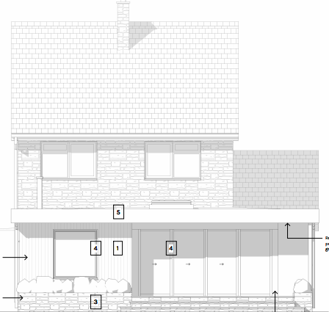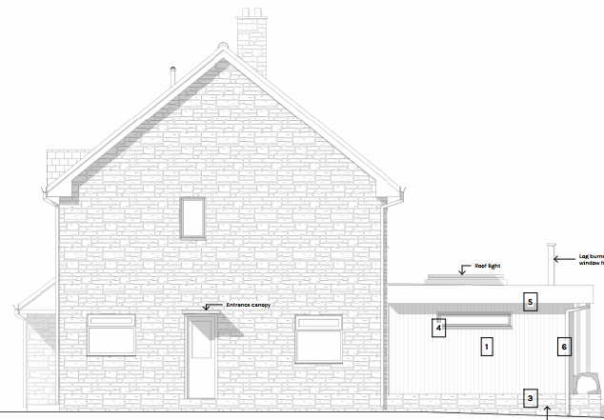
Proposed rear and side elevation of the host dwelling
The applicant seeks to utilise a bath stonework plinth topped with vertical timber cladding and white render on the elevations with grey fenestration. It is considered that the extension would by virtue of its height, scale and design constitutes a complementary addition to the host dwelling that would appear commensurate to the size of the property and plot.

Having regard to the above, the proposal complies with the design principles set out in Core Policy 57 of the Wiltshire Core Strategy, Appendix D of the Wiltshire Design Guide and the NPPF.

Amenity
Point vii of Core Policy 57 - Ensuring High-Quality Design and Place Shaping of the Wiltshire Core Strategy seeks to ensure that developments do not adversely affect neighbouring properties.

Policy P3 of the National Planning Policy Framework requires development to be appropriate for its location, taking account of its likely effects on health, living conditions and the environment. In particular, Policy P3(2)(b) requires development to avoid giving rise to unacceptable impacts on the living conditions of neighbouring residents and occupiers. In assessing amenity impacts, regard should be had to matters including daylight and sunlight, outlook, privacy, overbearing impacts and other effects on residential amenity.

The proposed development has been assessed in terms of its potential impact on the residential amenity of neighbouring properties, with particular regard to loss of light, overshadowing, loss of privacy, and overbearing effects.

The proposal relates to a single storey extension of limited height and scale positioned on the rear elevation of a detached dwelling. Given the single storey nature of the build and separation distances to neighbouring occupiers no concerns are raised in regard to any adverse overlooking, overbearing or overshadowing impacts.

The proposal therefore accords with Core Policy 57 point vii in respect of safeguarding residential amenity, Appendix D of the Wiltshire Design Guide and the NPPF.

Ecology Impact
Core Policy 50 of the Wiltshire Core Strategy seeks to protect and enhance biodiversity and geodiversity, including through ensuring that development avoids harm to protected species and habitats.

Policy N2 of the NPPF seeks to conserve and enhance biodiversity and support nature recovery. Development proposals should minimise impacts on habitats and species and, where relevant, demonstrate that appropriate mitigation measures are secured where harm cannot be avoided.

The application site sits within the Bath and Bradford on Avon Special Area of Conservation for bats and as this application involves disturbance within the application site due consideration has to be given to the potential disturbance of any bats because of the proposed development.

The proposed development comprises an extension of existing residential development consisting of limited built form close to the existing dwelling which does not involve works to the roof. Given the established high density residential nature of the location, it is considered highly unlikely that any bats would be affected and significant effects relating to the disturbance to bats can be ruled out.

As a precautionary measure an informative would be added to any decision that in event any evidence of bat activity is detected that the applicant should follow the advice of a professional ecologist or contact Natural England.

As such, the development complies with Core Policy 50 of the Wiltshire Core Strategy and the relevant provisions of the NPPF.

Biodiversity Net Gain
Householder planning applications are exempt from the requirement to deliver Biodiversity Net Gain under Schedule 7A, Section 4(2)(a) of the Town and Country Planning Act 1990, as inserted by the Environment Act 2021.

Public Sector Equality Duty (PSED)
In reaching this decision, due regard has been had to the Public Sector Equality Duty under Section 149 of the Equality Act 2010. This requires the Local Planning Authority to have regard to the need to eliminate discrimination, advance equality of opportunity and foster good relations between persons who share a protected characteristic and those who do not.

The Local Planning Authority is satisfied that the proposal would not result in any unlawful discrimination and that any impacts on protected groups have been appropriately considered as part of this assessment.

CONCLUSION
The proposed development is considered to be acceptable in terms of its design, character and appearance, and would not result in any unacceptable harm to the amenities of neighbouring occupiers.

Furthermore, the proposal would not result in any unacceptable impacts in respect of any other material planning considerations.

The proposal is therefore considered to comply with the relevant policies of the Wiltshire Core Strategy, the National Planning Policy Framework and all other relevant material considerations. As such, the application is recommended for approval, subject to conditions.

RECOMMENDATION: That Planning Permission be GRANTED subject to conditions.

