APPLICATION FOR VARIATION/REMOVAL OF CONDITION
CASE OFFICER REPORT

APPLICATION REFERENCE: | PL/2026/02835
APPLICATION TYPE: | Removal/variation of conditions
SITE ADDRESS: | 3 Lowbourne, Melksham, SN12 7DZ
DEVELOPMENT DESCRIPTION: | Variation of condition 2 (plans) of planning consent PL/2024/03424 - This application seeks to vary the approved drawings (Condition 2) to remove the second floor accommodation, dormer windows, and rear Velux windows. These changes will result in a reduction in ridge height of 1.45m. There is also a proposed end gable window in plot nine. Removal condition 8 attached to the parent permission, as the Velux windows are no longer required to implement the development.
RECOMMENDATION: | Approve subject to conditions

SITE DESCRIPTION/CONTEXT

The site is located within the limits of development of Melksham. The building subject of this application is located in a conservation area nearby to several listed buildings.

PROPOSAL

This report considers a Section 73 application for the variation/removal of condition(s) imposed on planning permission PL/2024/03424. The application relates to the site at 3 Lowbourne in Melksham, and seeks to vary condition 2 relating to drawing numbers and remove condition 8 in relation to rooflights.

The approved scheme permitted:

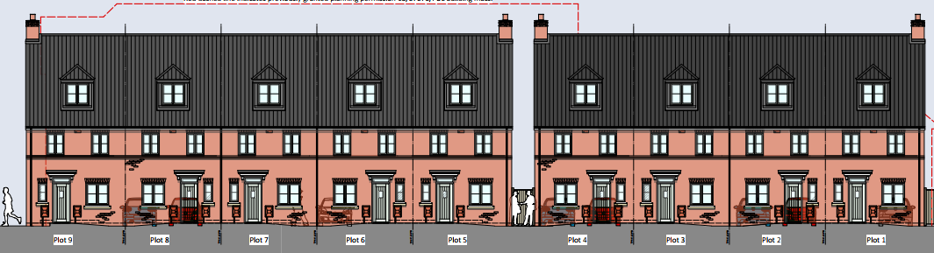

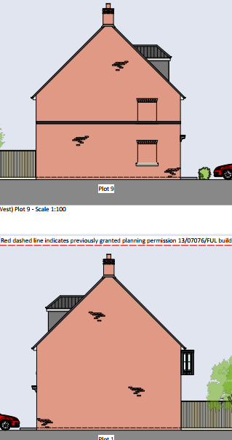

The current proposal seeks:

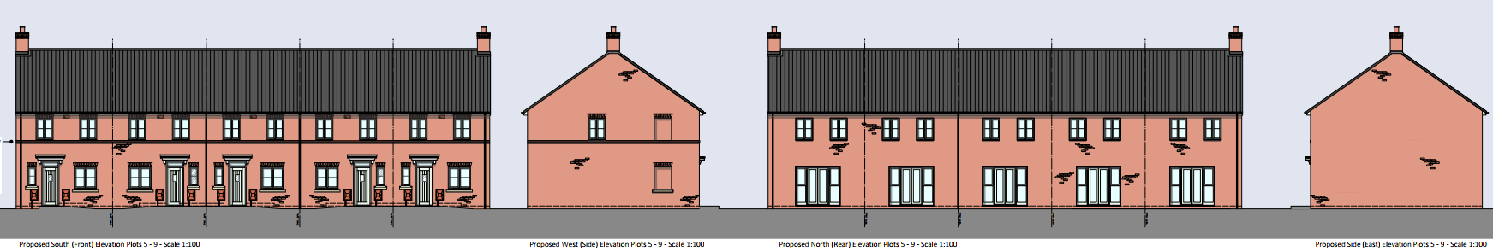

The principal changes comprise:

- Remove the second floor which would also remove the dormer windows and velux windows
- Reduction in ridge height of 1.45m
- End gable window proposed in plot 9
- Double windows on the rear elevation at first floor level instead of one for plots 2-4

The assessment below considers both the proposed amendment and the acceptability of the development as amended.

RELEVANT PLANNING HISTORY

Proposal / Summary
PL/2022/01197 - Removal/variation of conditions Decision - Approve with Conditions Date: 6/3/2023 – Variation of condition 19 of 13/07076/FUL (Demolition of existing building and erection of 17 flats and associated works) to allow for an amended building footprint
PL/2023/09683 - Approval of details reserved by a condition Decision - Approve Date: – Discharge of Conditions 3,5 and 6 and partial discharge of condition 4 on PL/2023/05617 - Proposed erection of 9No. dwellings at the former site of the Labour Club, Melksham and associated works.
PL/2023/05617 - Full planning permission Decision - Approve with Conditions Date: 26/9/2023 – Proposed erection of 9No. dwellings at the former site of the Labour Club, Melksham and associated works.
13/07076/FUL - Full planning permission Decision - Approve with Conditions Date: 16/1/2015 – Demolition of existing building and erection of 17 flats and associated works
18/00651/CLE - Lawful development: Existing use Decision - Approved Date: 18/4/2018 – Certificate of lawfulness for existing use of office to residential use
PL/2021/10410 - Approval of details reserved by a condition Decision - Approve Date: 10/2/2022 – Discharge of conditions 3, 5 and 9 of 13/07076/FUL
PL/2022/08340 - Full planning permission Decision - Approve with Conditions Date: 14/7/2023 – Demolition of existing restaurant and erection of nine flats
PL/2026/02835 - Removal/variation of conditions – Variation of condition 2 (approved plans) of planning consent PL/2023/05617 to remove the second floor accommodation, dormer windows, and rear Velux windows. These changes will result in a reduction in ridge height of 1.45m. There is also a proposed end
W/09/03700/FUL - Full planning permission Decision - Approve with Conditions Date: 11/2/2010 – Erection of three dwellings (terrace block) associated works including vehicular access restriction off urban street (car free development)

RELEVANT LEGISLATION, POLICIES AND GUIDANCE

Town and Country Planning Act. 1990 (as amended)

Section 73 of the Town and Country Planning Act. 1990 (as amended) relates to the determination of applications to develop land without compliance with conditions previously attached. It states that:

(2) On such an application the local planning authority shall consider only the question of the conditions subject to which planning permission should be granted, and—

- if they decide that planning permission should be granted subject to conditions differing from those subject to which the previous permission was granted, or that it should be granted unconditionally, they shall grant planning permission accordingly, and

- if they decide that planning permission should be granted subject to the same conditions as those subject to which the previous permission was granted, they shall refuse the application.

The National Planning Practice Guidance (PPG) states the following:

- Nature of the Application: A Section 73 application is treated as a new planning permission, although it does not alter the original permission itself. The original permission remains intact and can still be implemented unless it has expired or been superseded.
- Limitations:
  - Section 73 cannot be used to change the description of development or the operative part of the permission (e.g. the nature or extent of the approved use).
  - It cannot be used to extend the time limit for implementing the original permission.
  - If the proposed changes go beyond what can reasonably be considered under Section 73, a new planning application under Section 70 would be required.
- Decision-making: The local planning authority must consider the application only in relation to the conditions subject to which the original permission was granted. However, it may impose new or revised conditions if granting a new permission.

National Planning Policy:
- National Planning Policy Framework (NPPF)
- Planning Practice Guidance (PPG)
- National Design Guide
Development Plan:
The development plan for Wiltshire comprises the Wiltshire Core Strategy (WCS) (adopted January 2015) and any made neighbourhood plans, which remains the principal statutory planning document guiding development across the county. In line with Section 38(6) of the Planning and Compulsory Purchase Act 2004, planning decisions must be made in accordance with the development plan unless material considerations indicate otherwise.

When determining a Section 73 application, the Local Planning Authority must consider the development plan and all other material considerations at the time of determination. This includes considering whether any changes in planning policy, guidance, site circumstances, consultation responses or technical evidence affect the acceptability of the development as amended.

Though the development plan is considered as a whole, those parts deemed to be particularly relevant to this application are listed below:

The adopted Wiltshire Core Strategy (WCS), with particular regard to:

- Core Policy 1 Settlement Strategy;
- Core Policy 2 Delivery Strategy;
- Core Policy 15 Spatial Strategy Melksham
- Core Policy 57 Ensuring High Quality Design and Place Shaping;
- Core Policy 58 Ensuring the Conservation of the Historic Environment;
- Core Policy 60 Sustainable Transport;
- Core Policy 61 Transport & Development;
- Core Policy 64 Demand Management

Draft Wiltshire Local Plan Policies
At Full Council on 19 May 2026, the elected members of Wiltshire Council agreed to withdraw the emerging Wiltshire Local Plan. The said Plan has no material weight for the purposes of the application.

In accordance with Regulation 19 of the Town and Country Planning (Local Planning) (England) Regulations 2026, on 30th June 2026 Wiltshire Council published a notice of intention to prepare a new local plan for Wiltshire. The next stage is a Scoping Consultation which commences on 2nd September 2026. This plan is at a very early stage and currently carries no weight for decision making.

Neighbourhood Plan: Melksham Neighbourhood Plan

Supplementary Planning Documents and other Guidance:
- Wiltshire Design Guide (adopted April 2024)
- Wiltshire Local Transport Plan 2011-2026, adopted 2015 - including the Car Parking Strategy and Cycling Strategy, adopted 2015
- Wiltshire Council’s Waste Core Strategy, adopted July 2009

ISSUES

The key considerations in the assessment of this application are as follows:

- Determining whether the proposed amendments fall within the scope of Section 73 of the Town and Country Planning Act 1990 which allows for the variation or removal of conditions attached to an existing planning permission.
- Assessing whether the development, as amended, remains in accordance with the relevant policies and provisions of the development plan, and whether the changes materially alter the nature or impacts of the approved scheme.

CONSULTATION RESPONSES
The views of consultees are material considerations in the determination of the application. However, the decision-maker must exercise their own planning judgement. Where consultees raise concerns or recommend conditions, these have been considered and are addressed within the assessment section of this report.
WC Highways: No objection

WC Conservation: Object

WC Public Protection: No objection

Melksham Town Council: No objection

REPRESENTATIONS
In accordance with the requirements of the Town and Country Planning (Development Management Procedure) (England) Order 2015 (as amended), the application was publicised by way of:

- Neighbour notification letters sent to adjoining and nearby properties;
- A site notice displayed near the site;
- An advertisement placed in the local press

These methods were used to inform interested parties and provide a period of 21 days for comments to be submitted.

Below is a summary of the representations received during the consultation period. Only material planning considerations have been taken into account in the assessment of this application. Non-material issues, such as property values or private legal disputes, cannot be considered in the determination process.

No third party objections were received.

ASSESSMENT
Section 38(6) of the Planning and Compulsory Purchase Act 2004 states:

"If regard is to be had to the development plan for the purposes of any determination to be made under the planning Acts, the determination must be made in accordance with the plan unless material considerations indicate otherwise."

In accordance with this statutory requirement, this application has been assessed against the relevant policies of the Development Plan, including the Wiltshire Core Strategy (2015) and, where applicable, any made Neighbourhood Plans. Consideration has also been given to the policies of the National Planning Policy Framework (NPPF) as a material consideration in the assessment.

Principle of the Development – Do the proposed amendments fall within the scope of s73?

The proposed amendments have been reviewed and are considered to fall within the scope of Section 73 of the Town and Country Planning Act 1990. The changes do not result in a fundamentally different development from that originally approved, nor do they seek to alter the description of development or extend the time limit for implementation. As such, the application is valid under Section 73 and can be determined as a variation of condition(s) attached to the original planning permission.

Changes in Circumstances - Has anything changed since the original permission?

Since the grant of planning permission PL/2024/03424, consideration has been given to:

- changes in development plan policy – Local Plan has been withdrawn;
- updates to national policy - NPPF
- consultation responses;
- where relevant, whether Policy S5 of the NPPF is engaged due to an identified unmet housing need and whether this materially affects the planning balance.

Officers conclude that these changes do not materially affect the acceptability of the amended development as the site is located within the limits of development of Melksham and the number of dwellings remains the same as previously approved.

Compliance with the Development Plan - Is the development as amended still acceptable?

The red line and number of dwellings remains the same as previously approved. The reduction in ridge height could be considered as an improvement as it would be less imposing than previously approved and would provide a benefit to nearby neighbours. The addition of a landing window to the end of plot 9 by reason of its associated would use would result in transient overlooking but would overlook an existing parking area and as such would be considered acceptable. The addition of a first floor window on the rear elevation of Plots 2-4 are angled as previously proposed and as such would reduce any overlooking to the neighbouring rear gardens.

When initially submitted, the proposal also saw the removal of chimneys to which the Conservation Officer objected as it was dumbing down the scheme. They have since been reinstated and the proposed development would be considered acceptable in the context of the setting of the Conservation Area.

It is therefore considered that the development as amended would still be acceptable.

Assessment of Conditions

Condition 1- timeline would remain as per the previous decision notice
Condition 2 – the drawings would be updated to reflect the plans submitted under this reference number
Condition 3- development to be carried out in strict accordance with the CEMP – this would remain the same
Condition 4 - development to be carried out in accordance with the archaeological investigation and shall not be first occupied until the results have been submitted to and approved by the LPA – this would remain the same
Condition 5 – missing from the previous decision
Condition 6 – development to be carried out in accordance with the approved materials – would remain the same
Condition 7 - development to be carried out in accordance with the ground floor slab levels – would remain the same
Condition 8 – Access, parking and turning to be completed – would remain the same
Condition 9 - rooflights to be obscure glazed – can be removed due to no rooflights being proposed
Condition 10 – hours of construction would remain the same
Condition 11 – delivery hours would remain the same
Condition 12 – restricting burning on site would remain the same
Condition 13 – removal of PD for openings on the rear elevation would remain the same

Public Sector Equality Duty (PSED)
In reaching this decision, due regard has been had to the Public Sector Equality Duty under Section 149 of the Equality Act 2010. This requires the Local Planning Authority to have regard to the need to eliminate discrimination, advance equality of opportunity and foster good relations between persons who share a protected characteristic and those who do not.
The Local Planning Authority is satisfied that the proposal would not result in any unlawful discrimination and that any impacts on protected groups have been appropriately considered as part of this assessment.
PLANNING BALANCE AND CONCLUSION
In determining this application under Section 73 of the Town and Country Planning Act 1990, the Local Planning Authority has first considered whether the proposed amendments fall within the lawful scope of Section 73.

Where the proposed amendments are considered capable of being determined under Section 73, the Local Planning Authority must then consider whether planning permission should be granted subject to revised conditions.

In this case, the proposed changes do not alter the description of development and do not result in a fundamentally different form of development to that previously approved. Accordingly, the proposals can be determined through the Section 73 process.

The proposed amendments have been assessed against the relevant policies of the Wiltshire Core Strategy, any applicable Neighbourhood Plan, and the National Planning Policy Framework. Consideration has also been given to whether the development, as amended, would materially alter the nature or planning impacts of the approved scheme and whether any changes in planning policy or other material considerations since the grant of the original permission affect the acceptability of the proposal.

Significant weight is afforded to the extant planning permission, which remains capable of implementation. The assessment has therefore focused on whether the proposed amendments would give rise to any material planning impacts beyond those previously considered and accepted.

The proposed variation of condition(s) is considered acceptable. The benefits of the proposal, including [insert key benefits], are judged to outweigh any identified harms, which can be appropriately mitigated through planning conditions or other controls. The proposal remains in accordance with the development plan, the National Planning Policy Framework, and all other relevant material considerations.

RECOMMENDATION:
That Planning Permission be GRANTED subject to the following conditions

All conditions imposed have been assessed against the tests set out in Policy DM6 of the NPPF and are considered to be necessary, relevant to planning, relevant to the development to be permitted, enforceable, precise and reasonable in all other respects.

