APPLICATION FOR HOUSEHOLDER PLANNING PERMISSION
DELEGATED REPORT

APPLICATION REFERENCE: | PL/2026/04477
APPLICATION TYPE: | Householder planning permission
SITE ADDRESS: | 26 The Park, Erlestoke, Devizes, SN10 5TY
DEVELOPMENT DESCRIPTION: | Installation of 11 solar panels on the roof
RECOMMENDATION: | That Planning Permission be GRANTED

PROPOSAL

The proposal seeks planning permission for the Installation of 11 solar panels on No 26 The Park Erlestoke.

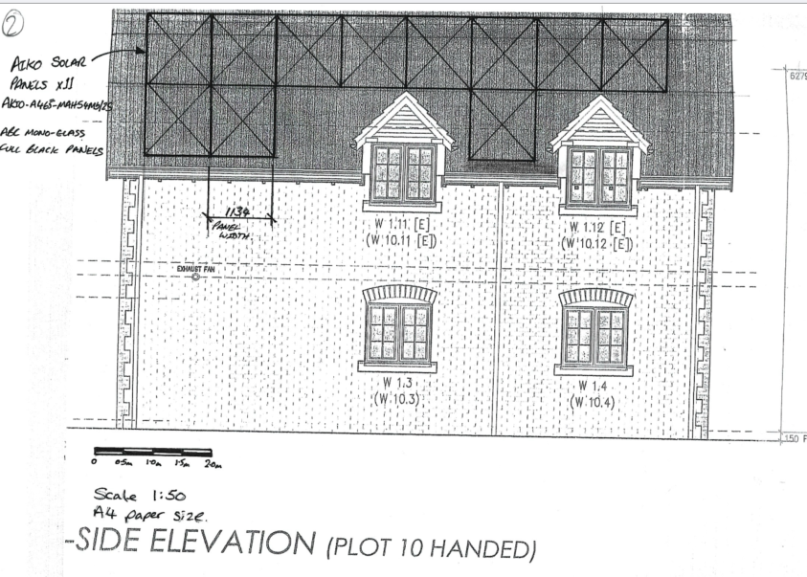

Proposed South Side Elevation

SITE DESCRIPTION/CONTEXT

No. 26 is a detached two-storey dwelling located within the Erlestoke Conservation Area. The principal elevation fronts the main road, although the building is characterised by substantial side elevations due to its orientation and elongated form. One of these side elevations (the south elevation, to which the solar panels would be erected) is prominently visible from the public realm, overlooking the adjacent highway, children's play area and open recreation ground, thereby contributing to the site's presence within the wider street scene.

The site is also located within a heritage context. Approximately 113 metres to the south lies the Grade II listed Church of the Holy Saviour, together with two associated Grade II listed structures comprising a memorial and gate piers within the churchyard. A further two Grade II listed monuments are situated approximately 67 metres to the east within the graveyard, beyond which is the village hall. These designated heritage assets form part of the historic environment surrounding the application site.

The application site is subject to the following planning policy constraints:

- Erlestoke Conservation Area
- Grade II listed buildings
- Erlestoke Ancient Woodland approximately 70m to the west (but outside the 15m buffer)
- Sailsbury Plain Special Protection Area 6.4km buffer

The listed building description for the church reads on reads:

Anglican parish church, 1880 by G.E. Street for Lady Hannah Watson- Taylor of Erlestoke Park. Ashlar with plain tile roofs and coped gables. Perpendicular style. Nave, chancel, north chapel and organ chamber, south porch tower, transept and vestry. 4-light west window, 3-window nave with buttresses between. South side has 2 windows and then projecting 3-stage tower with 2-light bell openings, embattled parapet and pyramid roof. East side stair tower up to second stage. Moulded pointed south doorway. To right transept gable with 2-light flat-headed window. Lean-to vestry with door and flat-headed window. One chancel south wall window. Five-light east window. Chancel north side has one window then north chapel gabled each end with 3-light flat-headed east window. Nave north side has 3 windows. Ashlar lined interior with hammerbeam nave roof and arch-braced chancel roof. Continuously moulded chancel arch and arch to north chapel, 4-centred arch to south transept. Chancel has east window and south window glass by Kempe 1880 and c1887. In nave C16 oak pulpit. In north chapel brass to E. Axford died 1726 and plaque to J. Tilly died 1750. In south transept 4 reset armorial plaques. In porch and nave 3 short Norman columns and half-columns, said to come from previous church, though this was apparently aisleless. (N. Pevsner, Wiltshire, 1975 240-1).

And for the “Gate Piers formally to Erlestoke Park adjoining churchyard”:

Two gate piers, late C18, Coade stone, repaired c1944 in ashlar. Two large piers with vermiculated rustication, fluted friezes, moulded cornices and heavy square caps carrying urns. Left pier has ashlar cornice and cap, right pier has ashlar frieze, cornice, cap and most of urn. Piers were repaired c1944 by Italian prisoners of war. (C.L. Seaborne, Erlestoke Park House and its Associations, 1975, unpub.)

For the avoidance of doubt, the park is not a designated heritage asset and is not included on the Register of Parks and Gardens of Special Historic Interest. Furthermore, the historic extent of the former parkland is not clearly understood. Whilst the surviving gate piers are indicative of a former entrance to the park, suggesting that the parkland likely extended to the east, it is uncertain whether the present recreation ground formed part of the historic park or represents a later adaptation of that land. In any event, the construction of the modern housing estate, including the application site, has fundamentally altered the historic landscape and effectively severed any historic functional relationship between the site and the former parkland.

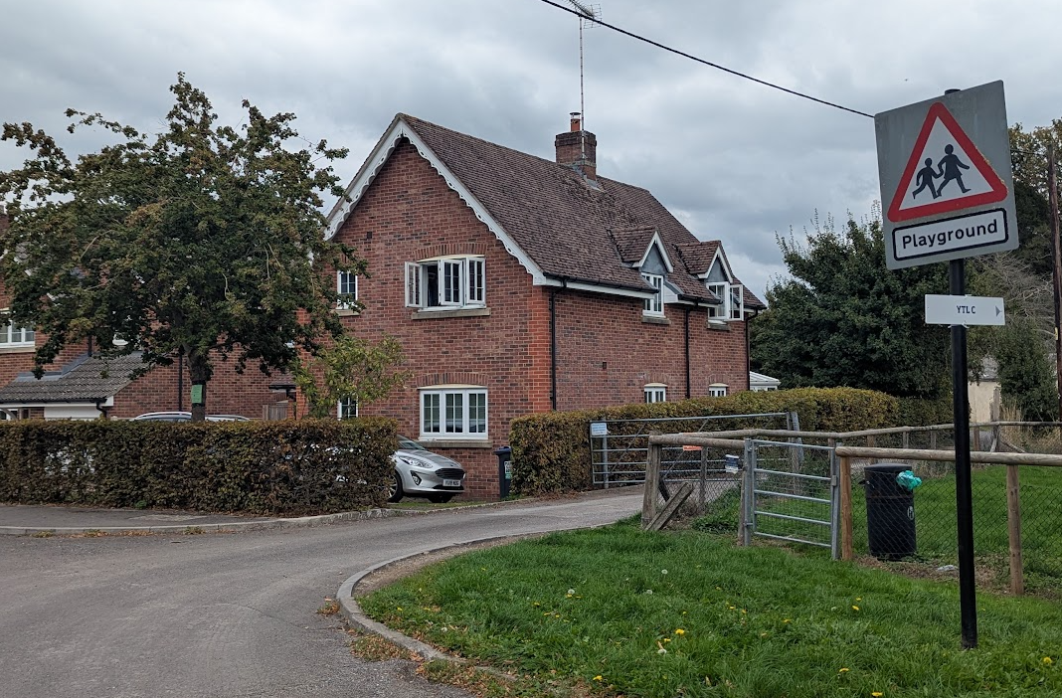

No 26 – south elevation on the right roof slope

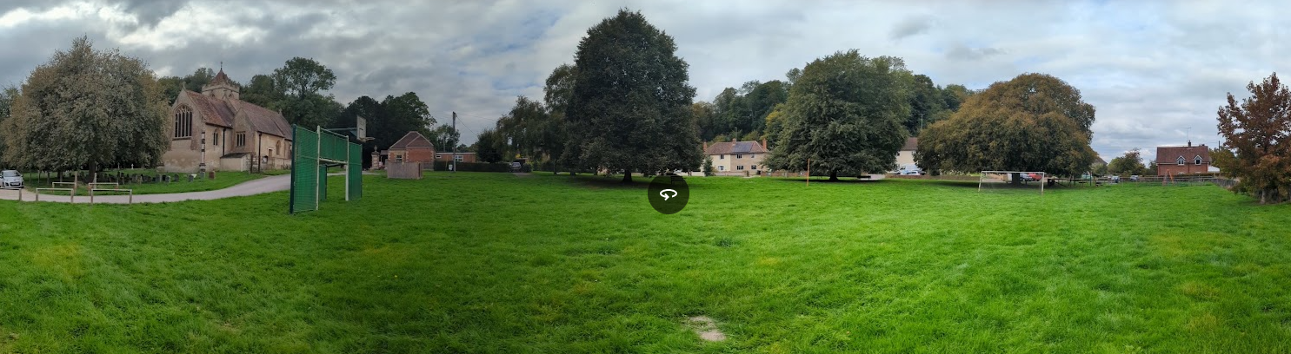

Panorama view from recreation field – church on left – application site on the right

It is noted that the application form confirms that relatives of the applicants are employed by Wiltshire Council in various roles. The Council's Constitution contains specific provisions relating to planning applications submitted by, or connected to, elected Members, senior officers and planning officers. Under Part 3 Section D3 (Scheme of Delegation Specific to Planning), an application will only be referred to Planning Committee where it is a private application made by an elected Member, a planning officer, the Chief Executive, a Director or Corporate Director (or their close relations), and objections raising material planning considerations have been received.

In this instance, the related family members are not elected Members, planning officers, nor officers at Director or Corporate Director level. As such, the requirements for mandatory committee determination do not apply and the application may be determined under delegated powers. Furthermore, no objections raising material planning considerations have been received and therefore, even if one of the specified categories had applied, the circumstances that would trigger committee determination are not present.

PLANNING HISTORY

Whilst there is planning history on the application site none of it is relevant to this application.

RELEVANT POLICIES AND GUIDANCE

National Context:

The National Planning Policy Framework (NPPF)

Policies HE4-HE10 of the National Planning Policy Framework recognise heritage assets as an irreplaceable resource and require proposals affecting heritage assets to be assessed having regard to their significance and the contribution made by their setting.

The Planning Practice Guidance

Section 66(1) of the Planning (Listed Buildings and Conservation Areas) Act 1990 requires special regard to be given to the desirability of preserving listed buildings, their settings and any features of special architectural or historic interest which they possess.

Section 72(1) of the same Act requires special attention to be paid to the desirability of preserving or enhancing the character or appearance of Conservation Areas.

Local Context:

Wiltshire Core Strategy:

- Core Policy 50: Biodiversity and Geodiversity
- Core Policy 57 Ensuring High Quality Design and Place Shaping
- Core Policy 58: Ensuring the Conservation of the Historic Environment

Core Policy 58 of the Wiltshire Core Strategy seeks to conserve and, where appropriate, enhance the significance of designated and non-designated heritage assets and their settings. Core Policy 57 requires development to respond positively to local character and historic context through high quality design.

Erlestoke does not have a Neighbourhood Plan or Area Designation.

Wiltshire Design Guide: Appendix D – Design Guidance for Householder extensions

CONSULTATION RESPONSES

Erlestoke Parish Council: No comments received.

REPRESENTATIONS

2 Neighbour notification letters were sent out and a site notice erected on site allowing for 21 days of public consultation.

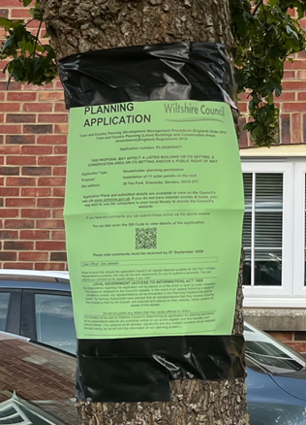

No comments were received.

ASSESSMENT

Section 38(6) of the Planning and Compulsory Purchase Act 2004 states:

"If regard is to be had to the development plan for the purposes of any determination to be made under the planning Acts, the determination must be made in accordance with the plan unless material considerations indicate otherwise."

In accordance with this statutory requirement, this application has been assessed against the relevant policies of the Development Plan, including the adopted Wiltshire Core Strategy (2015) and, where applicable, any made Neighbourhood Plans.

Design and Impact upon the character and context of the area

Core Policy 57 - Ensuring High Quality Design and Place Shaping of the Wiltshire Core Strategy seeks to ensure that all new development is of high design quality, reflecting local context, character, and distinctiveness.

Policies DP3 and DP4 of the National Planning Policy Framework require development to achieve a high standard of design that responds positively to local character and context. In assessing design quality, regard should be had to matters including scale, siting, form, appearance, materials and the relationship of development to its surroundings.

Given the orientation of the property and its position within the street scene, the proposed panels would be visible from public viewpoints, including the adjacent highway and recreation ground. However, the panels would be installed flush to the existing roof slope and would not materially alter the form, scale or roof profile of the dwelling. The proposal would therefore remain clearly subordinate to the host building.

The proposed array would occupy a visible part of the southern roof slope and would introduce a noticeable contemporary element. Nevertheless, the panels would form a compact and regular group, positioned below the ridge and within the roof edges. Subject to compliance with the approved drawing and specification, their dark, planar and low-profile appearance would allow the overall form of the dwelling and roof to remain legible. The resulting visual change would be limited and would not cause material harm to the character or appearance of the dwelling or wider street scene.

The proposal would retain the overall character and appearance of the dwelling and, by virtue of its scale, siting and design, would not adversely affect the character or visual amenities of the surrounding area. Furthermore, the provision of renewable energy infrastructure is supported as part of the transition towards a low-carbon future and can be accommodated in this instance without detriment to local character or visual amenity.

Having regard to the above, the proposal complies with the design principles set out in Core Policy 57 of the Wiltshire Core Strategy, Appendix D of the Wiltshire Design Guide and the NPPF.

Amenity

Point vii of Core Policy 57 - Ensuring High Quality Design and Place Shaping of the Wiltshire Core Strategy seeks to ensure that developments do not adversely affect neighbouring properties.

Policy P3 of the National Planning Policy Framework requires development to be appropriate for its location, taking account of its likely effects on health, living conditions and the environment. In particular, Policy P3(2)(b) requires development to avoid giving rise to unacceptable impacts on the living conditions of neighbouring residents and occupiers. In assessing amenity impacts, regard should be had to matters including daylight and sunlight, outlook, privacy, overbearing impacts and other effects on residential amenity.

The proposed development has been assessed in terms of its potential impact on the residential amenity of neighbouring properties, with particular regard to loss of light, overshadowing, loss of privacy, and overbearing effects.

The proposal would not alter the building’s mass or affect daylight, outlook or privacy. Limited reflections may occur under particular sunlight and viewing conditions, but these would be transient. Having regard to the domestic scale of the array, its roof-mounted position and the open character of the adjoining recreation ground, the proposal would not cause an unacceptable effect on neighbouring occupiers, highway users or users of the public open space.

The proposal therefore accords with Core Policy 57 point vii in respect of safeguarding residential amenity, Appendix D of the Wiltshire Design Guide and the NPPF.

Heritage Impact

The church is an impressive Grade II listed building whose setting is experienced from all four elevations. Of particular relevance to this proposal, views of the church extend across the recreation ground and towards the application site. The proposed solar panels would be installed on the southern roof slope facing the recreation ground and would therefore be visible within part of the church's wider setting. As a result, the development would give rise to a minor change within that setting.

However, the recreation ground is already characterised by modern features including children's play equipment, football goals and other recreational infrastructure. Consequently, the setting of the church is not experienced as an undeveloped or wholly historic landscape. In this context, the introduction of 11 roof-mounted solar panels on an existing dwelling would represent a modest and visually recessive addition that would not detract from the ability to appreciate the church as a designated heritage asset. The proposal is therefore considered to preserve the setting of the Church of the Holy Saviour.

The Grade II listed gate piers similarly derive significance from their evidential and historic association with the former park entrance. It is acknowledged that the historic extent of the former parkland is not fully understood and that any surviving relationship between the application site and the former park has been substantially altered by later development. Furthermore, the dwelling known as No. 6 Lower Lodge has been constructed immediately adjacent to the gate piers and lies directly between them and the application site. As a result, the proposed solar panels would have no meaningful effect on the setting of the gate piers or the appreciation of their significance.

In considering the significance of the heritage assets more generally, it is evident that the former parkland setting has been fundamentally altered over time through the creation of the recreation ground, the introduction of recreational infrastructure, and the development of the modern cul-de-sac housing estate within which the application site is located. Consequently, any historic relationship between the site and the former parkland has largely been eroded. Against this backdrop, the installation of solar panels on the roof of an existing dwelling would not result in harm to the significance of either the church or the gate piers.

Accordingly, by virtue of its scale, siting and design, the proposal is considered to preserve the character and appearance of the Erlestoke Conservation Area and preserve the settings of the nearby listed buildings. The development would not result in harm to the significance of any designated heritage asset.

Giving special regard to the desirability of preserving the settings of the nearby listed buildings, and special attention to preserving or enhancing the character or appearance of the Erlestoke Conservation Area, the proposed array would result in a limited visible change but would not harm the significance of those designated heritage assets. The proposal therefore accords with Core Policy 58 of the Wiltshire Core Strategy, Sections 66 and 72 of the Planning (Listed Buildings and Conservation Areas) Act 1990, and the relevant heritage provisions of the National Planning Policy Framework.

Ecology Impact
Core Policy 50 of the Wiltshire Core Strategy seeks to protect and enhance biodiversity and geodiversity, including through ensuring that development avoids harm to protected species and habitats.

Policy N2 of the NPPF seeks to conserve and enhance biodiversity and support nature recovery. Development proposals should minimise impacts on habitats and species and, where relevant, demonstrate that appropriate mitigation measures are secured where harm cannot be avoided.

The Council’s Ecology Officer has not been consulted on this application, but the application site is within the 6.4km zone of influence of the Salisbury Plain SPA and in light of the HRA for the Wiltshire Core Strategy and the HRA for the Wiltshire Housing Site Allocations Plan it is screened into Appropriate Assessment due to the potential impact of recreational pressure on stone curlew in combination with other plans and projects.

A strategic Appropriate Assessment (AA) has been prepared pertaining to development within the 6.4 km zone of influence that could result in a likely significant effect on the SPA as a result of an increase in recreational / visitor pressure. The AA reached a conclusion of no adverse effects on the integrity of the SPA or its qualifying features provided that the council’s mitigation strategy continues to be implemented. Annual stone curlew monitoring and protection measures continue to be secured by the Council.

In January 2026 Natural England (NE) confirmed that the 2025 strategic AA for Salisbury Plain SPA continues to be supported by NE.

The works are confined to the existing roof and would not result in habitat loss, tree works or external lighting. No specific impact pathway affecting protected species or the nearby ancient woodland has been identified. Although the site lies within the identified zone of influence for Salisbury Plain SPA, the proposal would not create an additional dwelling, increase residential occupancy or generate additional recreational pressure. No likely significant effect on the SPA has therefore been identified, either alone or in combination with other plans or projects.

The application site is not subject to any other statutory or non-statutory ecological designations, and the scale and nature of development is such that significant harm to biodiversity is unlikely. No objections have been raised by the Council’s Ecologist.

As such, the development complies with Core Policy 50 of the Wiltshire Core Strategy and the relevant provisions of the NPPF.

Biodiversity Net Gain

Householder planning applications are exempt from the requirement to deliver Biodiversity Net Gain under Schedule 7A, Section 4(2)(a) of the Town and Country Planning Act 1990, as inserted by the Environment Act 2021.

Public Sector Equality Duty (PSED)
In reaching this decision, due regard has been had to the Public Sector Equality Duty under Section 149 of the Equality Act 2010. This requires the Local Planning Authority to have regard to the need to eliminate discrimination, advance equality of opportunity and foster good relations between persons who share a protected characteristic and those who do not.

The Local Planning Authority is satisfied that the proposal would not result in any unlawful discrimination and that any impacts on protected groups have been appropriately considered as part of this assessment.

CONCLUSION

The proposal would deliver a modest renewable-energy benefit. This benefit is weighed against the visible change to the southern roof slope. Owing to the array’s compact layout, position within the roof plane and low-profile appearance, that visual change would be limited. No harm has been identified to the significance of the designated heritage assets, and no material amenity or ecological harm would arise. The proposal therefore accords with the development plan when read as a whole.

Although the array would be visible from the highway and recreation ground, its compact layout, low-profile mounting and position within the existing roof plane would limit its visual effect. The development would preserve the character and appearance of the Erlestoke Conservation Area and the settings of the nearby listed buildings. It would not cause material harm to amenity, ecology or any other identified planning interest. The proposal accords with the development plan when read as a whole, and no material consideration indicates that permission should be withheld.

RECOMMENDATION: That Planning Permission be GRANTED subject to conditions.

