APPLICATION FOR THE DISCHARGE OF PLANNING CONDITION(S)
CASE OFFICER REPORT

APPLICATION REFERENCE: | PL/2026/02614
APPLICATION TYPE: | Approval of details reserved by a condition
SITE ADDRESS: | 34 High Street, Warminster, BA12 9AF
PROPOSAL: | Discharge of conditions 2 (Sample Materials), 3 (Sample Render) and 10 (Contamination Remediation Strategy) relating to application W/07/01949/FUL
RECOMMENDATION: | To discharge conditions 2, 3 and partial discharge of condition 10

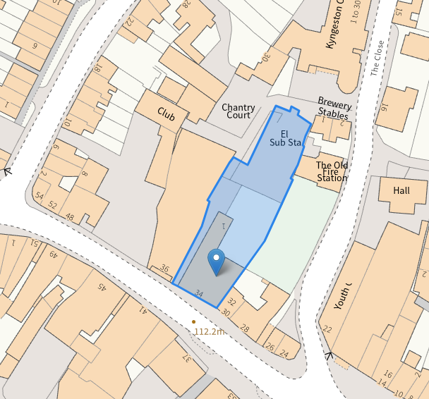

PROPOSAL

This report has been prepared to support the application for the discharge of conditions attached to planning permission granted at 34 High Street, Warminster, BA12 9AF. Planning permission was granted under reference W/07/01949/FUL for the change of use of The Chantry to offices and three dwelling units, and the construction of six new dwelling units to the rear together with associated works. This application seeks to discharge Conditions 2 (Sample Materials), 3 (Sample Render) and 10 (Contamination Remediation Strategy) attached to that permission.

Condition 2 (Sample Materials):

No development shall take place until samples of the materials to be used in the construction of the external surfaces of the development hereby permitted have been submitted to and approved in writing by the Local Planning Authority. Development shall be carried out in accordance with the approved details.

REASON: To ensure that the development harmonises with its setting and that the character and fabric of the listed building is protected.

Condition 3 (Sample Render):

A sample wall panel, not less than 1 metre square, of the render finish to the new dwellings shall first be constructed on site and approved by the Local Planning Authority before construction proceeds. The panel shall then be left in position for comparison while the development is carried out. The development shall be carried out in accordance with the approved sample.

REASON: To protect the setting of the listed building and ensure that the development harmonises with its setting.

Condition 10 (Contamination Remediation Strategy):

Prior to the commencement of any development the site of the new build residential development shall be subject to: (i) site investigation and risk assessment works for chemical contamination; (ii) works to remediate any chemical contamination identified, that is unacceptable in the context of the approved development and its environmental setting, as identified by the site investigation and risk assessment work; and (iii) remediation validation works, the above to be carried out to the satisfaction of the Local Planning Authority.

REASON: To ensure that any contamination present on the site is appropriately investigated and remediated in the interests of human health and environmental protection.

This report assesses the submitted details and supporting documentation and considers whether the requirements of the above conditions have been satisfactorily addressed.

CONSULTATION

Public Protection (Wiltshire Council) – Partial Objection
Public Protection reviewed the submitted Phase 1 Environmental Report, Phase 2 Environmental Investigation, Remediation Strategy Verification Plan and associated Addendum Statement. They confirmed that the submitted investigation work had identified elevated concentrations of lead within areas of made ground and were broadly satisfied that the proposed remediation strategy is appropriate to address the identified contamination risks and make the site suitable for its intended use. However, Public Protection advised that whilst the remediation strategy and verification plan are acceptable, the remediation works and validation measures have not yet been undertaken and therefore consider the requirements of Condition 10 have not been fully satisfied. As such, they raised no objection to the proposed remediation methodology but advised that the remaining remediation and validation works must be completed to the satisfaction of the Local Planning Authority.

ASSESSMENT

Condition 2 - Materials

Condition 2:

No development shall take place until samples of the materials to be used in the construction of the external surfaces of the development hereby permitted have been submitted to and approved in writing by the Local Planning Authority. Development shall be carried out in accordance with the approved details.

REASON: To ensure that the development harmonises with its setting and that the character and fabric of the listed building is protected.

Submitted Details:

- On-site sample brick panel.
- Product information and imagery for proposed slate roofing material.

The application site occupies a backland setting characterised by a mixture of traditional built form, former commercial structures, garage and warehouse-style buildings, corrugated roof finishes and the rear elevations of historic High Street properties. As such, the surrounding townscape displays a varied palette of materials and architectural styles rather than a singular, uniform character.

A sample brick panel has been inspected on site and comprises a traditional red brick and mortar finish. Red brick is a dominant material throughout the surrounding area and is particularly reflective of the former industrial and commercial character evident within the locality. The proposed brickwork would therefore assimilate comfortably within its surroundings and would not appear incongruous.

The applicant has additionally provided details of a natural slate roofing product. Whilst clay roof coverings are present within the wider area, natural slate is not uncommon within historic settlements and is considered to represent a high-quality roofing material. Given its muted appearance and traditional character, the proposed slate roof finish would integrate satisfactorily within the varied townscape context and would complement the proposed brickwork. The use of slate would provide an appropriate degree of visual variation whilst maintaining a coherent and attractive appearance across the development.

Accordingly, the submitted materials are considered acceptable and satisfy the requirements of Condition 2.

Decision:

The submitted information is considered to satisfy the requirements of Condition 2 of planning permission W/07/01949/FUL and the condition is hereby discharged.

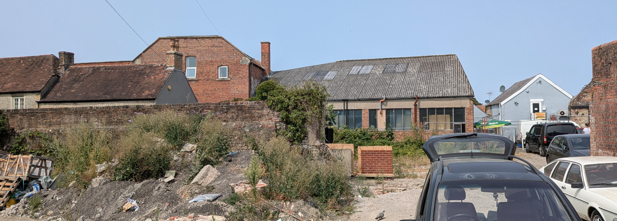
Site Visit Image

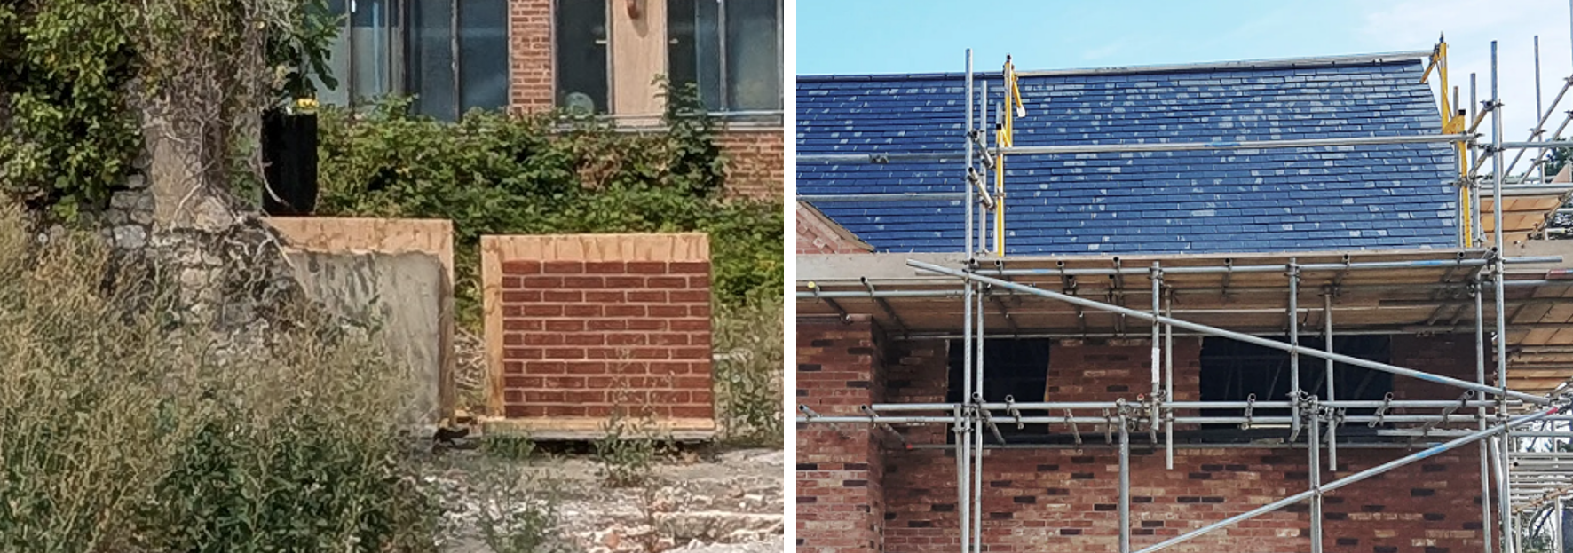
Proposed External Materials

Condition 3 - Sample Render Panel

Condition 3:

A sample wall panel, not less than 1 metre square, of the render finish to the new dwellings shall first be constructed on site and approved by the Local Planning Authority before construction proceeds. The panel shall then be left in position for comparison while the development is carried out. The development shall be carried out in accordance with the approved sample.

REASON: To protect the setting of the listed building and ensure that the development harmonises with its setting.

Submitted Details:

- On-site sample render panel.

The submitted render sample panel has been inspected on site and comprises an off-white render finish. The proposed colour is neutral and restrained in appearance and is reflective of finishes present on a number of surrounding buildings within the wider town centre environment.

Given the mixed character of the locality, which contains both exposed brickwork and rendered buildings, the proposed render finish is not considered to appear visually intrusive or out of keeping with the surrounding context. The muted tone avoids undue prominence and provides an appropriate contrast to the proposed red brick elements of the development.

The submitted render sample is therefore considered to achieve a satisfactory balance between visual interest and contextual integration and would preserve the character of the area and the setting of nearby heritage assets.

Accordingly, the Local Planning Authority is satisfied that the submitted render sample accords with the requirements of Condition 3.

Decision:

The submitted information is considered to satisfy the requirements of Condition 3 of planning permission W/07/01949/FUL and the condition is hereby discharged.

Condition 10: Contamination

Prior to the commencement of any development the site of the new build residential development shall be subject to:

i) site investigation and risk assessment works for chemical contamination;

ii) works to remediate any chemical contamination identified, that is unacceptable in the context of the approved development and its environmental setting, as identified by the site investigation and risk assessment work;

iii) remediation validation works the above to be carried out to the satisfaction of the Local Planning Authority.

Site investigation works shall be carried out in line with the main procedural requirements of BS10175:2001 - Investigation of Potentially Contaminated Sites - Code of Practice. Where a requirement for quantitative risk assessment is identified, the assessment works shall be carried out in line with the requirements of the UK Contaminated Land Exposure Assessment (CLEA) guidelines, for assessment of human health risks.

Also for ground and surface water risk assessment the Environment Agency R&D Publication 20 "Methodology for the Derivation of Remedial Targets for Soil and Groundwater to Protect Water Resources" protocol shall be utilised.

Submitted Details:

- Phase 1 Environmental Report (2419-P1E-1)
- Phase 2 Environmental Investigation (Ref. 2419-P2E-1-B)
- Remediation Strategy & Verification Plan (Ref. 2419-P3E-1-D)
- Addendum Statement & Method Statement dated 13 August 2026

The submitted information has been reviewed by Public Protection who confirm that the investigation work has identified elevated concentrations of lead within areas of made ground and that the proposed remediation strategy is appropriate to address the identified contamination risks and make the site suitable for its intended use. The submitted information is therefore considered sufficient to satisfy the requirements of part (i) of the condition relating to site investigation and risk assessment works and establishes an acceptable methodology for the remediation works required under part (ii).

It is recognised that the remediation works and subsequent validation measures required by parts (ii) and (iii) of the condition have not yet been undertaken on site. Accordingly, whilst the Local Planning Authority is satisfied with the submitted remediation methodology, the physical remediation and validation works remain outstanding and must be completed to the satisfaction of the Local Planning Authority prior to the commencement of any above-ground construction works.

Decision:

The submitted information is considered sufficient to partially discharge Condition 10 insofar as it relates to the site investigation, risk assessment and approval of the remediation methodology. The requirements of parts (ii) and (iii) of Condition 10 remain applicable and shall be complied with in full, including completion of the approved remediation works and submission of satisfactory validation evidence to the Local Planning Authority.

CONCLUSION

The submitted information has been reviewed by the Local Planning Authority together with the comments of Public Protection. The submitted contamination reports, remediation strategy, verification plan and associated methodology are considered sufficient to demonstrate that an appropriate investigation and risk assessment has been undertaken and that an acceptable remediation strategy has been established for the site. The submitted materials, render sample and roofing details are likewise considered acceptable and appropriate having regard to the character of the surrounding area and the setting of nearby heritage assets. Conditions 2 and 3 are therefore considered to be satisfactorily addressed and are discharged in full. In respect of Condition 10, the Local Planning Authority is satisfied that the requirements relating to site investigation, risk assessment and the remediation methodology have been addressed. However, the approved remediation works and subsequent validation measures remain to be undertaken and must be carried out to the satisfaction of the Local Planning Authority in accordance with the approved details prior to the commencement of any above-ground construction works. Condition 10 is therefore partially discharged as set out above.

RECOMMENDATION

To discharge Conditions 2 (Sample Materials) and 3 (Sample Render) and to partially discharge Condition 10 (Contamination Remediation Strategy) of planning permission W/07/01949/FUL.

In respect of Condition 10, the submitted information is considered sufficient to satisfy the requirements relating to the site investigation, risk assessment and approval of the remediation methodology. However, the approved remediation works and subsequent validation measures have not yet been undertaken and therefore the requirements of parts (ii) and (iii) of the condition remain applicable and shall be complied with in accordance with the approved remediation strategy and verification plan prior to the commencement of any above-ground construction works.

