APPLICATION FOR VARIATION/REMOVAL OF CONDITION
CASE OFFICER REPORT

APPLICATION REFERENCE: | PL/2026/04295
APPLICATION TYPE: | Removal/variation of conditions
SITE ADDRESS: | Well Cottage, 166A Short Street, Chapmanslade, Westbury, BA13 4AA
DEVELOPMENT DESCRIPTION: | Variation of condition 2 (approved plans) on PL/2025/06110 to allow for modest increase in footprint of extension and layout changes
RECOMMENDATION: | That Planning Permission be GRANTED

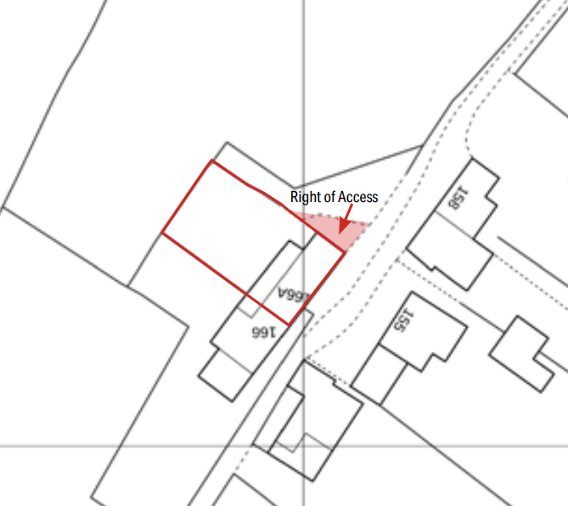

SITE DESCRIPTION/CONTEXT

The application site comprises a semi-detached dwelling known as Well Cottage, 166A Short Street, Chapmanslade, together with its associated residential curtilage. The property is located within the open countryside outside of any defined settlement boundary and is characterised by a rural setting comprised of residential properties, agricultural land and associated countryside features. The dwelling displays traditional materials and detailing reflective of the locality, with surrounding development generally consisting of modest rural dwellings and ancillary structures. The site is subject to a number of planning constraints including its location within the Salisbury Plain Special Protection Area buffer, the 4km Core Bat Roost Buffer, Flood Zone 1, an area identified as being at risk from groundwater emergence, and the Chapmanslade Greensand Ridge Special Landscape Area. Planning permission was granted under application reference PL/2025/06110 for extensions and alterations to create a garden room and first floor extension, which forms the basis of the current Section 73 application.

PROPOSAL

This report considers a Section 73 application seeking the variation of Condition 2 (Approved Plans) attached to planning permission PL/2025/06110 for proposed extensions and alterations to create a garden room and first floor extension. The approved scheme comprises a two-storey side extension and single-storey rear garden room extension. The current application seeks to substitute the approved Proposed Floor and Roof Plans and Proposed Elevations and Block Plan with amended versions to facilitate a modest increase in the footprint of the approved rear extension. The amendment provides additional internal accommodation including a boot room, revised internal layout arrangements and a study area. Externally, the principal changes occur on the north-east and north-west elevations through the elongation of the rear extension and a revised roof design incorporating a central gabled section within the previously approved flat roof arrangement. The south-east elevation and south-west party wall elevation remain unchanged from the approved scheme. All external materials are proposed to remain as previously approved and the overall nature and purpose of the development remain unchanged.

RELEVANT PLANNING HISTORY

Proposal / Summary
W/74/00615/HIS - Historic apps 1974 to 1983 Decision - Approved Date: 24/7/1974 – Extension to existing dwelling house
PL/2025/06110 - Householder planning permission Decision - Approve with Conditions Date: 22/9/2025 – Proposed extension and alterations to create garden room and first floor extension.
PL/2026/04295 - Removal/variation of conditions – Variation of condition 2 (approved plans) on PL/2025/06110 to allow for modest increase in footprint of extension and layout changes

RELEVANT LEGISLATION, POLICIES AND GUIDANCE

Town and Country Planning Act. 1990 (as amended)

Section 73 of the Town and Country Planning Act. 1990 (as amended) relates to the determination of applications to develop land without compliance with conditions previously attached. It states that:

(2) On such an application the local planning authority shall consider only the question of the conditions subject to which planning permission should be granted, and—

- if they decide that planning permission should be granted subject to conditions differing from those subject to which the previous permission was granted, or that it should be granted unconditionally, they shall grant planning permission accordingly, and

- if they decide that planning permission should be granted subject to the same conditions as those subject to which the previous permission was granted, they shall refuse the application.

The National Planning Practice Guidance (PPG) states the following:

- Nature of the Application: A Section 73 application is treated as a new planning permission, although it does not alter the original permission itself. The original permission remains intact and can still be implemented unless it has expired or been superseded.
- Limitations:
  - Section 73 cannot be used to change the description of development or the operative part of the permission (e.g. the nature or extent of the approved use).
  - It cannot be used to extend the time limit for implementing the original permission.
  - If the proposed changes go beyond what can reasonably be considered under Section 73, a new planning application under Section 70 would be required.
- Decision-making: The local planning authority must consider the application only in relation to the conditions subject to which the original permission was granted. However, it may impose new or revised conditions if granting a new permission.
- Legal Agreements: Because a Section 73 application results in a new permission, any existing Section 106 agreement may need to be varied or replaced via a deed of variation to ensure obligations continue to apply to the new permission.

National Planning Policy:
- National Planning Policy Framework (NPPF)
- Planning Practice Guidance (PPG)
- National Design Guide
Development Plan:
The development plan for Wiltshire comprises the Wiltshire Core Strategy (WCS) (adopted January 2015) and any made neighbourhood plans, which remains the principal statutory planning document guiding development across the county. In line with Section 38(6) of the Planning and Compulsory Purchase Act 2004, planning decisions must be made in accordance with the development plan unless material considerations indicate otherwise.

When determining a Section 73 application, the Local Planning Authority must consider the development plan and all other material considerations at the time of determination. This includes considering whether any changes in planning policy, guidance, site circumstances, consultation responses or technical evidence affect the acceptability of the development as amended.

Though the development plan is considered as a whole, those parts deemed to be particularly relevant to this application are listed below:

The adopted Wiltshire Core Strategy (WCS), with particular regard to:

- Core Policy 1 Settlement Strategy;
- Core Policy 2 Delivery Strategy;
- Core Policy 31 Spatial Strategy: Warminster Community Area;
- Core Policy 50 Biodiversity and Geodiversity;
- Core Policy 51 Landscape;
- Core Policy 57 Ensuring High-Quality Design and Place Shaping;
- Core Policy 60 Sustainable Transport;
- Core Policy 61 Transport and Development;
- Core Policy 64 Demand Management;
- Core Policy 67 Flood Risk

New Wiltshire Local Plan

At Full Council on 19 May 2026, the elected members of Wiltshire Council agreed to withdraw the emerging Wiltshire Local Plan. The said Plan has no material weight for the purposes of the application.

In accordance with Regulation 19 of the Town and Country Planning (Local Planning) (England) Regulations 2026, on 30th June 2026 Wiltshire Council published a notice of intention to prepare a new local plan for Wiltshire. The next stage is a Scoping Consultation which commences on 2nd September 2026. This plan is at a very early stage and currently carries no weight for decision making.

Supplementary Planning Documents and other Guidance:
- The National Planning Policy Framework (NPPF)
- The Planning Practice Guidance (PPG)
- Wiltshire Design Guide - Appendix D – Design Guidance for Householder extensions
- The Wiltshire Local Transport Plan 2011 – 2026: Car Parking Strategy (March 2015).
- The Wiltshire Local Transport Plan 4 (LTP4) (March 2025)

ISSUES

The key considerations in the assessment of this application are as follows:

- Whether the proposed amendments fall within the scope of Section 73 of the Town and Country Planning Act 1990.
- Whether any material changes in planning policy, site circumstances or other relevant considerations have occurred since the grant of planning permission PL/2025/06110.
- Whether the amended development remains acceptable in design terms and continues to preserve the character and appearance of the dwelling and surrounding rural area.
- Whether the amendments result in any additional impact upon neighbouring residential amenity.
- Whether the development as amended continues to accord with the relevant policies of the Development Plan and other material considerations.

CONSULTATION RESPONSES

Chapmanslade Parish Council – No objection

Wilshire Council Highways – No objection

REPRESENTATIONS

Third-party Representation – 3 letters of support have been received

ASSESSMENT

Section 38(6) of the Planning and Compulsory Purchase Act 2004 states:

"If regard is to be had to the development plan for the purposes of any determination to be made under the planning Acts, the determination must be made in accordance with the plan unless material considerations indicate otherwise."

In accordance with this statutory requirement, this application has been assessed against the relevant policies of the Development Plan, including the Wiltshire Core Strategy (2015) and, where applicable, any made Neighbourhood Plans. Consideration has also been given to the policies of the National Planning Policy Framework (NPPF) as a material consideration in the assessment.

Principle of the Development – Do the proposed amendments fall within the scope of s73?

The proposed amendments have been reviewed and are considered to fall within the scope of Section 73 of the Town and Country Planning Act 1990. The application seeks only to vary Condition 2 relating to the approved plans and does not seek to alter the description of development or extend the time limit for implementation. The approved development comprises extensions and alterations to the dwelling and this remains unchanged.

The proposed amendments are limited to a modest enlargement of the approved single-storey rear extension together with associated revisions to the roof form and internal layout. Whilst the changes result in a slightly larger footprint and amended elevations to the north-east and north-west sides of the extension, they do not fundamentally alter the nature, scale, function or appearance of the approved development. The proposal therefore remains recognisably the same development as that previously granted permission under application reference PL/2025/06110 and can be lawfully considered through the Section 73 process.

Whilst the proposed amendment forms the basis of this application, the Local Planning Authority must consider the acceptability of the development as amended and the planning impacts arising from the scheme as a whole.

Changes in Circumstances - Has anything changed since the original permission?

Since the grant of planning permission PL/2025/06110, consideration has been given to any changes in development plan policy, national planning policy, site circumstances and other material considerations relevant to the determination of this application.

The original planning permission was granted in September 2025 and there have been no material changes to the site circumstances. In terms of policy, since the grant of the previous proposal on this site (PL/2025/06110) there has been a change to national planning policy, with a new iteration of the NPPF published in August 2026. Officers have considered the new NPPF in the determination of this s73 application and there are no policies that would alter the conclusions reached within the original assessment.

The site remains in residential use, and the proposed amendments are limited to revisions to the approved design of the rear extension. No new technical constraints have been identified and the development remains household development associated with an existing dwelling.

Given the limited scope of the amendments and the relatively recent grant of the original planning permission, officers conclude that no material changes have arisen since the original decision which would affect the acceptability of the amended development.

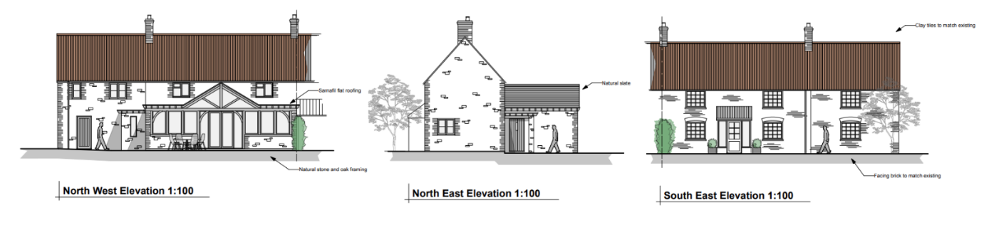
Elevations as approved under PL/2025/06110

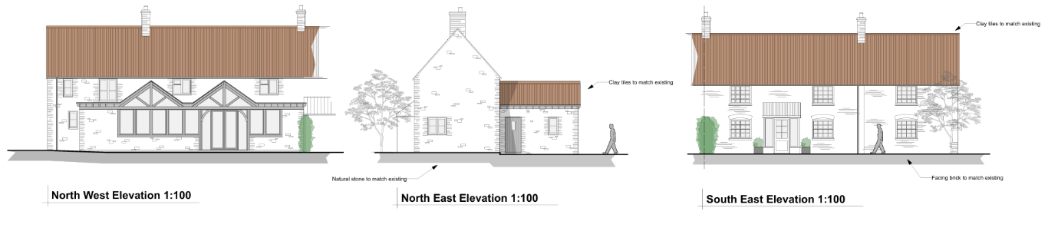
Elevations as proposed

Compliance with the Development Plan - Is the development as amended still acceptable?

Design, Character and Landscape: Core Policies 51 and 57 of the Wiltshire Core Strategy require development to respect local character, respond positively to its surroundings and achieve a high standard of design.

The approved scheme was previously considered acceptable in design terms, comprising a two-storey side extension and a contemporary rear garden room extension. The current amendments retain the overall design approach previously approved whilst making modest changes to the footprint and roof form of the rear extension.

The elongation of the rear extension remains subordinate to the host dwelling and is limited in scale. The revised roof arrangement introduces a central gabled feature between flat roof sections, creating a more articulated roof form whilst maintaining the contemporary character already established by the approved design. The materials remain unchanged from the approved scheme, ensuring consistency with both the host dwelling and the permission previously granted.

The amendments primarily affect the north-east and north-west elevations, with the south-east and south-west elevations remaining unchanged. Officers consider that the revised design represents a logical and sympathetic progression of the approved scheme and does not materially alter its appearance when viewed in the context of the existing dwelling.

The increased footprint is limited in extent and contained within the established residential curtilage. The propose amendments would not materially alter the landscape effects of the previously approved development on the site and thus would preserve the character of the Chapmanslade Greensand Ridge Special Landscape Area.

Accordingly, the amended development remains compliant with Core Policies 51 and 57 of the Wiltshire Core Strategy and the design principles contained within the Wiltshire Design Guide.

Residential Amenity: The original permission concluded that the development would not result in unacceptable impacts upon neighbouring residential amenity and officers have reviewed the proposed amendments against those conclusions.

The increased footprint of the rear extension is modest and occurs to the rear of the dwelling in a location where no significant additional overlooking, overshadowing or overbearing impacts would arise. No substantive changes are proposed to the south-east elevation facing neighbouring properties, whilst the amendments to the north-east and north-west elevations do not introduce any materially different relationships with adjoining occupiers.

Given the limited nature of the enlargement and the absence of any significant new openings or changes in orientation, it is considered that the proposal would not result in any harm to neighbouring living conditions beyond that already assessed and accepted under the original permission.

The development as amended therefore remains compliant with Core Policy 57 of the Wiltshire Core Strategy.

Ecology: In terms of ecology, the amendments do not seek to significantly increase the scale or nature of development to an extent that would alter the conclusions of the original application. Having regard to the site's location within the Salisbury Plain SPA buffer and Core Bat Roost Buffer, officers are satisfied that the proposed amendments would not give rise to any additional ecological impacts beyond those previously considered and accepted.

Assessment of Conditions

The application seeks to vary Condition 2 (Approved Plans) attached to planning permission PL/2025/06110 in order to substitute the approved Proposed Floor and Roof Plans and Proposed Elevations and Block Plan with amended versions.

The proposed variation is considered reasonable and necessary to facilitate the revised footprint and roof design associated with the rear extension. The amendments do not require any substantive changes to the remaining conditions attached to the original permission.

It is noted that development pursuant to planning permission PL/2025/06110 has commenced and building works are well underway. As such, the time limit for commencement imposed by Condition 1 of the original permission has already been satisfied and no longer serves a planning purpose. Accordingly, it is neither necessary nor reasonable to re-impose this condition on any planning permission granted under Section 73.

As the development remains acceptable in planning terms, it is considered appropriate to reimpose the remaining relevant conditions from the original permission, with Condition 2 updated to reference the amended plans submitted as part of this application.

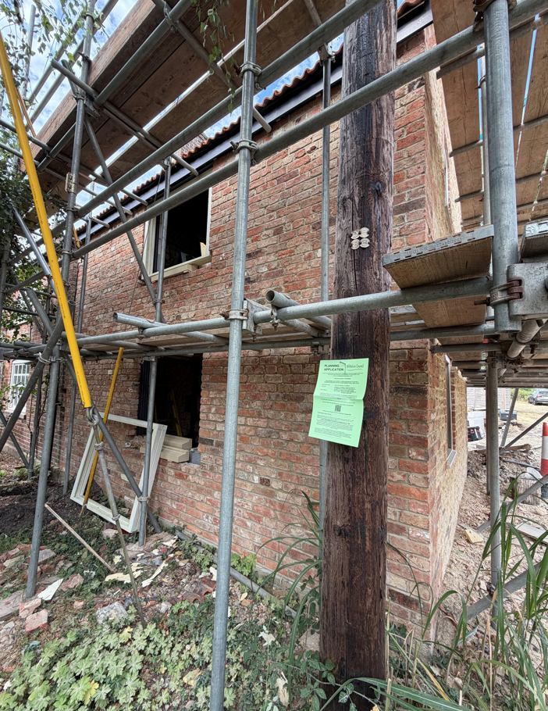
Site Image

Other Material Considerations/Issues

No objections have been identified in relation to the amended development. The proposal retains the same use, materials and overall design approach previously approved. The amendments are considered minor in nature and do not introduce any planning impacts beyond those previously assessed and accepted.

The comments submitted in support of the application and the supporting Planning Statement have been considered as part of the assessment. Officers agree that the amendments represent a modest alteration to the approved development which improves the functionality of the internal accommodation whilst maintaining the character and appearance of the approved scheme.

Public Sector Equality Duty (PSED)
In reaching this decision, due regard has been had to the Public Sector Equality Duty under Section 149 of the Equality Act 2010. This requires the Local Planning Authority to have regard to the need to eliminate discrimination, advance equality of opportunity and foster good relations between persons who share a protected characteristic and those who do not.
The Local Planning Authority is satisfied that the proposal would not result in any unlawful discrimination and that any impacts on protected groups have been appropriately considered as part of this assessment.

PLANNING BALANCE AND CONCLUSION

In determining this application under Section 73 of the Town and Country Planning Act 1990, the Local Planning Authority has first considered whether the proposed amendments fall within the lawful scope of Section 73.

The proposed changes do not alter the description of development and do not result in a fundamentally different form of development to that previously approved. The application can therefore be determined through the Section 73 process.

Significant weight is afforded to the extant planning permission PL/2025/06110, which remains capable of implementation. The assessment has focused on whether the proposed revisions would give rise to any material planning impacts beyond those already considered and accepted.

The principal benefits identified are the improved functionality and flexibility of the approved accommodation, a more efficient internal layout incorporating a boot room and study area, and a revised architectural form which remains sympathetic to the approved design and host dwelling. No material planning harms have been identified.

Having weighed these considerations in the round, and taking account of the extant planning permission as a material consideration, it is concluded that the proposed amendments would not result in any unacceptable impacts and that the development remains acceptable in planning terms. The proposal continues to accord with the relevant policies of the Wiltshire Core Strategy and all other material considerations. Accordingly, planning permission should be granted subject to the re-imposition of the original conditions and an updated approved plans condition.

RECOMMENDATION: That Planning Permission be GRANTED subject to conditions

