APPLICATION FOR FULL-PLANNING PERMISSION
CASE OFFICER REPORT

APPLICATION REFERENCE: | PL/2026/03638
APPLICATION TYPE: | Full planning permission
SITE ADDRESS: | 2a Valldata House, Valldata, Halifax Road, Bowerhill, SN12 6YY
DEVELOPMENT DESCRIPTION: | Erection of a first-floor extension to the north of the site and a three-storey side extension on the western elevation, with new access arrangements and associated works
RECOMMENDATION: | Approve with conditions

SITE DESCRIPTION/CONTEXT

The site is situated within the Bowerhill Industrial Estate, bordering the roundabout intersection between Halifax Road and Lancaster Road. The property is a predominantly brick structure, constructed around the 1970s. The surrounding context to the north, west & south features commercial buildings consisting of brick, glass & metal cladding. The boundary treatments are a combination of masonry walls, grassland, wire-mesh fences and trees.

There is vehicular access to the property from Halifax Road and multiple pedestrian entries from the north, northeast and east. The site currently provides 56 off-street parking space

The site is not under any landscape, ecology or drainage designation. There are no heritage assets within the immediate area.

The materials would be matching brick and grey or green cladding.

Fig. 1: Existing and Proposed North Elevations
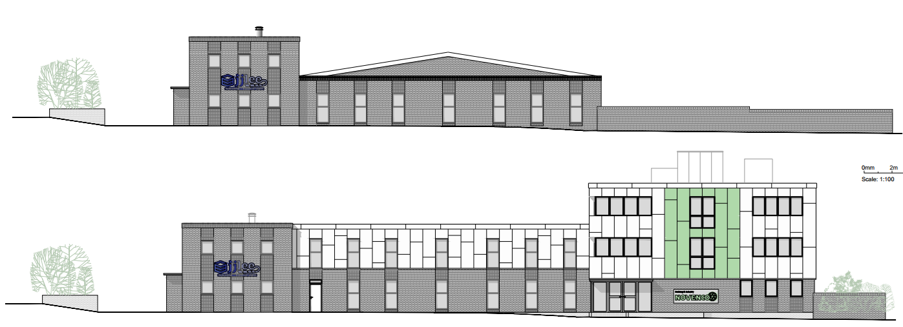

The access and parking would remain the same. There is a bus stop immediately to the east of the site on the main road.

PROPOSAL

The proposal seeks the erection of a first-floor extension to the north of the site and a three-storey side extension on the western elevation, with new access arrangements and associated works.

The application follows a planning approval (PL/2024/09977) for a very similar development which sought two storey extensions. The current application differs in that the currently proposed western extension would have three storeys rather than the previously approved two storeys and be larger in footprint (compare Fig. 1 above and Fig. 2 below) to accommodate further business space.

Fig. 2: Approved north elevation under PL/2024/09977
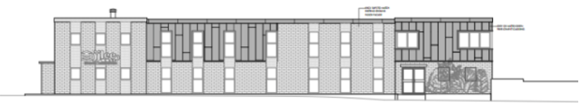

PLANNING HISTORY

Proposal / Summary
PL/2024/04498 - Full planning permission Decision - Refuse Date: 24/7/2024 – Enlargement of the office space to the North of the plot, with the addition of a first-floor extension and a new two-storey space to the West side. Adaptation of the land to the North of the plot to provide 23 new parking spaces, facilitated by new vehicular access to the adjacent road (Lancaster Road).
PL/2024/09977 - Full planning permission Decision - Approve with Conditions Date: 13/12/2024 – The office space to the north of the plot is to be enlarged, with the addition of a first-floor extension and a new two-storey space to the west side. The land to the north of the plot is to be adapted, providing new walkway access to the north pavement and the existing northeast site access.

RELEVANT LEGISLATION, POLICIES AND GUIDANCE

National Planning Policy:
- National Planning Policy Framework (NPPF)
- Planning Practice Guidance (PPG)
- National Design Guide
Development Plan:
The development plan for Wiltshire comprises the Wiltshire Core Strategy (WCS) (adopted January 2015) and any made neighbourhood plans, which remains the principal statutory planning document guiding development across the county. In line with Section 38(6) of the Planning and Compulsory Purchase Act 2004, planning decisions must be made in accordance with the development plan unless material considerations indicate otherwise.

Though the development plan is considered as a whole, those parts deemed to be particularly relevant to this application are listed below:

The adopted Wiltshire Core Strategy (WCS), with particular regard to:

- Core Policy 1 Settlement Strategy;
- Core Policy 2 Delivery Strategy;
- Core Policy 3 Infrastructure Requirements;
- Core Policy 15 Spatial Strategy Melksham Community Area
- Core Policy 35 Existing Employment Land
- Core Policy 41 Sustainable Construction and Low-Carbon Energy;
- Core Policy 50 Biodiversity and Geodiversity;
- Core Policy 52 Green Infrastructure
- Core Policy 57 Ensuring High Quality Design and Place Shaping;
- Core Policy 60 Sustainable Transport;
- Core Policy 61 Transport & Development;
- Core Policy 62 Development Impacts on the Transport Network;
- Core Policy 63 Transport Strategies
- Core Policy 64 Demand Management
- Core Policy 67 Flood Risk;
- Core Policy 68 Water Resources;

Emerging Local Plan paragraphs:

At Full Council on 19 May 2026, the elected members of Wiltshire Council agreed to withdraw the emerging Wiltshire Local Plan. The said Plan has no material weight for the purposes of the application.

In accordance with Regulation 19 of the Town and Country Planning (Local Planning) (England) Regulations 2026, on 30th June 2026 Wiltshire Council published a notice of intention to prepare a new local plan for Wiltshire. The next stage is a Scoping Consultation which commences on 2nd September 2026. This plan is at a very early stage and currently carries no weight for decision making.

Neighbourhood Plan:

Joint Melksham Neighbourhood Plan 2 2020-2038 (Made August 2025) (JMNP2)
- Policy 10: Employment Sites

Supplementary Planning Documents and other Guidance:
- Wiltshire Design Guide (adopted April 2024)
- Wiltshire Local Transport Plan 2011-2026, adopted 2015 - including the Car Parking Strategy and Cycling Strategy, adopted 2015
- Wiltshire Council’s Waste Core Strategy, adopted July 2009
- Wiltshire Council’s Waste Storage and Collection: Guidance for Developers Supplementary Planning Document, January 2017
- A Green & Blue Infrastructure Strategy for Wiltshire: Wiltshire’s Natural Environment Plan 2022-2030
- Wiltshire Local Cycling and Walking Infrastructure Plan (LCWIP)
- Active travel infrastructure design standards 2022
- Active travel parking standards and design guide 2022
- LTN1/20 – Cycle Infrastructure Design (July 2020)

ISSUES

The main issues that need to be addressed in this case include:

- Whether the development is acceptable in principle (CP 1 and 2)
- Whether the scheme constitutes high quality design (CP 57)
- Whether the scheme would have an acceptable impact upon the reasonable living conditions of the adjoining occupants (CP 57)
- Whether the proposal would have a negative effect upon highway safety, including if there is sufficient parking for the proposed development (CP 61 and 64)
- Whether the site can be adequately drained without increasing flood risk elsewhere (CP 67)
- Whether there would be any harmful impacts upon protected species or priority habitats (CP 50)
- Are there any other planning issues raised by the development?

CONSULTATION RESPONSES

The views of consultees are material considerations in the determination of the application. However, the decision-maker must exercise their own planning judgement. Where consultees raise concerns or recommend conditions, these have been considered and are addressed within the assessment section of this report.

WC Highways: Requested further information regarding parking numbers.

Officer note: The requested information was received from applicant. Highways are aware of the application extension of time deadline and have not commented further.

WC Archaeology: No objection.

WC Ecology: “A BNG small sites metric has been submitted and there are no other obvious ecology issues on this application.”

WC Drainage: No objection subject to conditions.

WC Arboricultural Officer: No objection subject to conditions.

Parish Council: Supports the scheme, requests a bird management strategy. They reiterate their view that enhanced pedestrian links should be sought.

REPRESENTATIONS
In accordance with the requirements of the Town and Country Planning (Development Management Procedure) (England) Order 2015 (as amended), the application was publicised by way of:

- Neighbour notification letters sent to adjoining and nearby properties;
- A site notice displayed near the site;

These methods were used to inform interested parties and provide a period of 21 days for comments to be submitted.

Below is a summary of the representations received during the consultation period. Only material planning considerations have been taken into account in the assessment of this application. Non-material issues, such as property values or private legal disputes, cannot be considered in the determination process.

One representation was received making the following comments:

“I object on the grounds that a 3 storey extension is out of character with other buildings on the Estate and will overshadow my building Premier Form Tools Ltd which immediately adjoins it.”

Each material planning issue raised is addressed within the assessment below.

ASSESSMENT
Section 38(6) of the Planning and Compulsory Purchase Act 2004 states:

"If regard is to be had to the development plan for the purposes of any determination to be made under the planning Acts, the determination must be made in accordance with the plan unless material considerations indicate otherwise."

In accordance with this statutory requirement, this application has been assessed against the relevant policies of the Development Plan, including the Wiltshire Core Strategy (2015) and, where applicable, any made Neighbourhood Plans. Consideration has also been given to the policies of the National Planning Policy Framework (NPPF) as a material consideration in the assessment.

The assessment below considers each of the main issues identified above. Each topic is assessed in turn with reference to the relevant policy context, the evidence submitted, consultee responses, and all other material considerations, before a conclusion is reached.

Principle of Development
Policy Context
Core Policy 1: Settlement Strategy of the WCS establishes a hierarchy of settlements to guide where development should be focused. The policy prioritises growth in:
- Principal Settlements (e.g., Salisbury, Chippenham, Trowbridge) – main focus for strategic growth.
- Market Towns – support local services and employment; suitable for sustainable development.

Core Policy 2: Delivery Strategy of the WCS sets out how development will be distributed and delivered across Wiltshire. The policy emphasises:
- Sustainable patterns of growth, reducing the need to travel and supporting local services.
- Development should be plan-led, aligning with the settlement strategy and supported by infrastructure.

Together, CP1 and CP2 ensure that new development is strategically located, sustainable, and supports the character and function of Wiltshire’s communities.

NPPF

National decision-making policies

E2: Meeting the need for business land and premises

1. To support business growth, substantial weight should be given to:

a. The economic benefits of proposals for commercial development which allow businesses to invest, expand and/or adapt; especially where this would support the economic vision and strategy for the area, the implementation of the Industrial Strategy, support improvements in freight and logistics and/or reflect proposals for Industrial Strategy Zones and AI Growth Zones;

L2: Making effective use of land

1. Substantial weight should be given to the benefits where a development proposal would achieve one or more of the following:

a. Remediating despoiled, degraded, derelict, contaminated or unstable land;

b. Making better use of vacant and underutilised land and buildings (such as: by bringing back into residential use empty homes and other suitable buildings; converting space above shops; redeveloping underutilised retail and business sites; and building on or above service yards, lock-ups, car parks and other transport infrastructure which are no longer required);

c. Making effective use of previously developed land and buildings through temporary uses, in situations where alternative development is anticipated within a reasonable period (including as a result of the land being allocated for an alternative purpose in the development plan); or

d. Creating additional homes or floorspace within settlements by using the airspace above existing residential and commercial premises, or through sensitive redevelopment or additional development within existing plots (including, but not limited to, the addition of mansard roofs, proposals to fill gaps in the existing roof line, the introduction of higher buildings at street corners and additional units within residential curtilages). Such proposals should:

i. Be consistent with the overall street scene, other than where: it is appropriate to have larger buildings (such as at street corners, or where building upwards would not cause substantial harm to the character of a building and its surroundings); the development would not be visible from the street frontage; or where specific changes are provided for through a design code which forms part of the development plan;

ii. Maintain safe access and egress for occupiers and users, and acceptable living standards for residents and neighbours in terms of access to daylight, sunlight, privacy and external amenity space;

Assessment

CP35 of the WCS states that within principal employment areas proposals for renewal and intensification of employment uses will be supported.

Policy 10 of the JMNP2 supports the expansion of existing commercial businesses on existing employment sites.

The site is within an established commercial and employment area (Bowerhill) and the extension of an existing employment building is supported in principle.

The proposed extension would create an effective use of land by expanding the commercial floorspace above existing floors and creating a new extension. This is given substantial weight in the NPPF and therefore the extension complies with national policy.

Design and Impact on the Character and Appearance of the Area
Policy Context
Core Policy 57 of the WCS requires high-quality design that:
- Enhances local character.
- Responds to the natural, historic, and built environment.
- Retains important features (e.g., trees, hedges).
- Supports sustainable construction and compatibility with surrounding uses.
- Creates safe, legible, and accessible spaces.

The Wiltshire Design Guide encourages sensitivity to local character, materials, and architectural styles and supports modern living standards while maintaining aesthetic and functional quality.

Building for a Healthy Life Framework promotes healthy, inclusive, and sustainable places. The document encourages:

- Walkability.
- Access to green space.
- Active design principles for well-being.

Assessment
In assessing this aspect of the proposal, regard has been had to the site context, the details of the proposed development, the relevant development plan policies, and all other material considerations. The key considerations are set out below.

Fig. 1 shows the north elevation, which is the elevation that would be most visible due to the arrangement of the building on site, and would be the focus of the extension.

The existing building with a shallow pitched roof does appear to a be a dated design and not one that needs to be protected. There is already a flat roofed two storey elements to the existing design, and the proposed design takes this as a cue and replicates this, in an updated manner, for the length of the extension. This is considered to be an acceptable approach and the resulting design would be a successful addition within the area.

The expansion of businesses in these employment areas is supported by policy, however this does lead to the issue that some businesses would need to extend upwards, given there is only a finite site area. Each such proposal is treated on its own merits. The proposed three-storey western addition is considered to be complementary to the overall building and its relationship with neighbouring buildings.

The materials would match and otherwise be complementary, and therefore the materials are considered to be suitable.

The proposed extension would not result in harm to the visual amenity of the area for the above reasons.

Amenity
Policy Context
Core Policy 57 (Point vii) of the Wiltshire Core Strategy requires development to respect the amenity of existing occupants and ensure appropriate amenity levels for future residents.

The policy guides the assessment of amenity impacts. Each of the below matters has been assessed having regard to the specific site context and layout of the proposal.

The nearest neighbouring residential properties are over 50m to the east of the site – the proposed extensions involve the north and west of the site. So any impact on residential properties would be very limited if any at all.

There is a business premises to the west of the site. The proposed western extension would come within 7.5m of that building. However that building sits forward of the proposed extension, and that building only has windows in its front section.

Overlooking / loss of privacy

There would be no additional windows in the side elevations of the proposed extensions, and therefore there would be no impact on overlooking or loss of privacy to either residential or commercial neighbours.

Loss of light / overshadowing / overbearing impact

The western extension would cause some loss of light in the morning to the east facing windows of the neighbouring business. However, this is a business and not a residential use, and the business also has windows on the north (front) elevation which seems to serve the same room as the east facing windows.

Therefore, the impact caused to the neighbouring business is not considered to rise to the level where a refusal would be warranted.

Highways Impacts and Parking
Policy Context
Transport implications are a key factor in assessing planning applications, especially for larger developments. Proposals must demonstrate:
- Safe and suitable access for all users, including pedestrians, cyclists, and those with mobility impairments.
- No severe residual impacts on the surrounding highway network.
- Promotion of sustainable travel, reducing reliance on private vehicles.
- Adequate parking and cycle provision, in line with adopted standards.
- Protection and enhancement of public rights of way and active travel routes.

Relevant policies include Core Policies 60–64 of the Wiltshire Core Strategy, supported by the Wiltshire Local Transport Plan, Car Parking Strategy, and Cycling Strategy. The Local Cycling and Walking Infrastructure Plan (LCWIP) and LTN 1/20 (DfT) provide further design guidance for active travel infrastructure.

Proposals must also ensure safe access for refuse collection vehicles and comply with the Wiltshire Council Waste Storage and Collection SPD (2017).

The NPPF policies TR2, TR3, TR4 and TR6 are relevant to the proposal.

Assessment
In assessing this aspect of the proposal, regard has been had to the site context, the details of the proposed development, the relevant development plan policies, and all other material considerations. The key considerations are set out below.

There would be a loss of car parking due to the proposed extension. The Council’s Highways officer sought additional information regarding the potential loss of parking spaces. The applicant supplied the requested information as follows:

“In terms of the floor areas, the other uses on the site were not included in the application form as the focus was on the additional office floor space for the new unit. However, we appreciate that, as part of highways assessment, the floor area of the entire site is required.
“Therefore, please find below a summary of the existing and proposed floor areas for the two companies that will be operating within the site. Please note that as the ground floor of the proposed extension would be used as a warehouse (B2/B8 use), the total office floor areas have been adjusted accordingly.
 | EXISTING |  |  | PROPOSED
 | E(g)(i) Area | B2/B8 Area | Total | E(g)(i) Area | B2/B8 Area | Total
J.J. Lee | 350 m² | 950 m² |  | 515 m² | 950 m²
Novenco | 320 m² | - |  | 950 m² | 155 m²
Total | 670 m² | 950 m² | 1,620 m² | 1,465 m² | 1,105 m² | 2,570 m²

“Regarding the loss of car parking, although there are 67no. parking spaces as shown in the site plan, only 56no. spaces are accessible as noted on the application form. This is because some spaces are occupied by shipping containers and other facilities that are currently used as a temporary storage area.”

The Wiltshire Local Transport Plan 2011-2026 Appendix C gives the maximum parking standards for various uses. Business use on a business park shows a ratio of 1 space per 35m² of floorspace. Applying this to the above floorspace figures would result in 73 parking spaces.

However, it must be noted that these are maximum standards. The application proposes 45 parking spaces. This is below the maximum standard and so we must consider the context of the site and whether this proposed number is acceptable.

Immediately to the east of the site is a set of bus stops adjacent to site, approximately 30m from the site entrance. This provides easy access to public transport and therefore the ability of employees to commute in this manner without relying on the private car.

Fig. 3: Position of bus stops
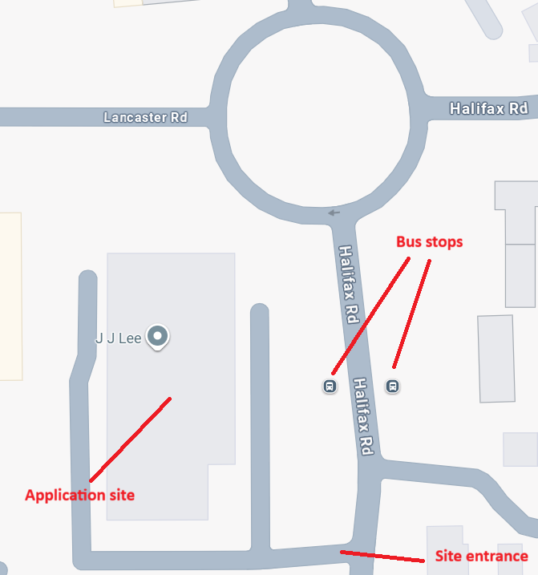

Moreover, the application site is on the edge of the business park, with large housing areas immediately to the east. In addition, Melksham lies to the north and north west with extensive housing areas as shown in Fig. 4 below.

Fig. 4: Proximity of application site to housing areas
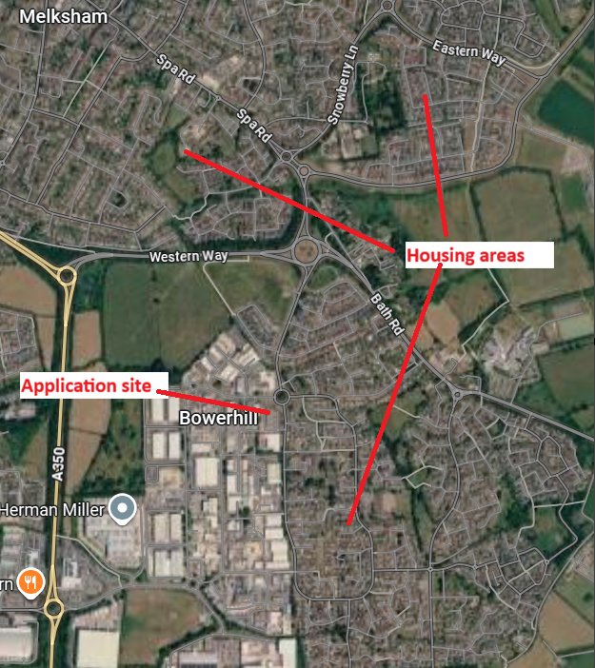

This demonstrates that there is a significant local population within walking and cycling distance to the application site.

The Council’s Highways officer found no harm to highway safety due to the extension itself.

The NPPF policy TR3 encourages development in sustainable locations. This site is already an established business park with public transport links and pedestrian access from a range of established residential areas. Consequently, priority is given to pedestrians and public transport as per NPPF TR4.

In applying policy TR6, it is not considered that the development would have a severe adverse impact on the transport network, nor an unacceptable impact on highway safety, due to the reasoning above.

Conclusion
Having regard to the above, it is considered that the reduction in parking spaces, below the maximum parking standards, is acceptable given the immediate surroundings of the site, comprising large areas of housing as well as bus stops right outside the application site. There are ample opportunities for employees to commute to work by foot, cycle and bus, without the need for a private car.

Ecology and Biodiversity
Policy Context
The ecological impact of development is a key planning consideration, especially for larger schemes. Proposals must assess and address potential effects on:

- Protected species
- Priority habitats
- Ecological networks
- Green and blue infrastructure

Core Policy 50 of the Wiltshire Core Strategy requires development to:

- Avoid harm to ecological assets.
- Deliver measurable Biodiversity Net Gain (BNG), in line with the Environment Act 2021.
- Support habitat restoration and connectivity.
- Integrate biodiversity into site design.

The Green & Blue Infrastructure Strategy (2022–2030) promotes nature recovery, ecosystem services, and habitat connectivity through development.

Unless exempt, National policy requires a minimum of 10% Biodiversity Net Gain (BNG) for major developments, demonstrated via:

- Biodiversity Metric calculations
- Ecological assessments (e.g. PEAs, Phase 1 surveys, protected species surveys)

Assessment
In assessing this aspect of the proposal, regard has been had to the site context, the details of the proposed development, the relevant development plan policies, and all other material considerations. The key considerations are set out below.

The application is supported by a BNG Metric which confirms that more than 10% BNG would be created by the proposal.

The Council’s ecology team confirm that there are no other ecological issues or sensitivities on the site.

Trees and Arboricultural Impact
Policy Context
Core Policy 51 of the Wiltshire Core Strategy seeks to protect and enhance landscape character, including important trees and woodland features.

Assessment
There is no arboricultural objection to this application, however the trees outside of the site need an element of protection during construction. This issue can be safeguarded through adding a Tree Protection Plan to the Construction Method Statement condition. This has been agreed with the applicant.

Flood Risk and Drainage
Policy Context
Core Policy 67 of the Wiltshire Core Strategy and NPPF paragraphs 170–182 require:
- Avoidance of increased flood risk.
- Use of appropriate mitigation measures.
- Application of the sequential and exception tests for developments in Flood Zones 2 or 3.

Assessment
In assessing this aspect of the proposal, regard has been had to the site context, the details of the proposed development, the relevant development plan policies, and all other material considerations. The key considerations are set out below.

From the Council Drainage team:

“The Wiltshire Council Strategic Flood Risk Assessment, SFRA Data Explorer, has indicated that the site is located within Flood Zone 1 and has a low level of risk from fluvial flooding.

“The site has a low level of risk from surface water flooding, with only minor section of the road located in front of the site falling within the 1 in 1000-year flood extent.

“The site has a low level of risk from ground water flooding.

“The applicant is proposing to manage surface water flows through the provision of a below ground attenuation tank, which will discharge to an existing surface water sewer at a restricted rate. We are happy that the proposed discharge rate to the existing sewer is in accordance with Wiltshire Council’s betterment policy.”

The Drainage team go on to say that they want the scheme to accord with the National Standards for SuDS, and therefore have requested a pre-commencement condition for a surface water drainage strategy.

However, the SuDS standards are guidance in England rather than policy, and this application is for an extension to an established existing commercial site. It is considered that to require compliance with guidance for an extension is unreasonable in this case, especially given that the surface water drainage details given in the submitted Drainage Strategy (June 2026) and drawing ref. 1668GE D01 Rev A has been accepted by the Council’s Drainage team.

Other Issues

The connectivity request from the Parish Council is noted, however the extension of this commercial building does not trigger the need for a new footpath, or contribution to such. The increase in staffing numbers does not result in an increase in demand such that a contribution to the path would be reasonable. Therefore, the request would not meet the tests for the imposition of obligations/conditions.

In addition, the request would not be compliant with the CIL regulations. There are other funding streams available via CIL through new local development if this is identified as desirable to the local community.

The site has ample parking and is immediately adjacent to bus stops. The roads have pavements that connect to the local residential areas and beyond. Therefore, the site is already integrated into the area in terms of travel connectivity and staff have a range of options available.

The request for a bird management strategy is also noted. However, this is an existing building that whilst being extended, only the western extension creates additional roof footprint. The previous scheme, PL/2024/09977, which created new roof footprint but not as large as the current scheme, did not have a bird management strategy condition. Given the existing nature of the majority of the roof footprint it is considered unreasonable to impose such a condition on this scheme.

Pre-commencement Condition Agreement

This recommendation includes pre-commencement planning condition(s) relating to a construction method statement. In accordance with Section 100ZA of the Town and Country Planning Act 1990 and the Town and Country Planning (Pre-commencement Conditions) Regulations 2018, the Local Planning Authority formally notified the applicant/agent of the proposed condition(s) and sought their agreement. Written confirmation of agreement was received from the applicant’s agent on 27th August 2026.

Public Sector Equality Duty (PSED)
In reaching this decision, due regard has been had to the Public Sector Equality Duty under Section 149 of the Equality Act 2010. This requires the Local Planning Authority to have regard to the need to eliminate discrimination, advance equality of opportunity and foster good relations between persons who share a protected characteristic and those who do not.

The Local Planning Authority is satisfied that the proposal would not result in any unlawful discrimination and that any impacts on protected groups have been appropriately considered as part of this assessment.

PLANNING BALANCE AND CONCLUSION
In reaching a decision, all identified harms and benefits must be weighed in the overall planning balance, having regard to Section 38(6) of the Planning and Compulsory Purchase Act 2004 and the provisions of the National Planning Policy Framework.

The principle of development is considered acceptable when assessed against the settlement strategy of the Wiltshire Core Strategy and the NPPF.

The proposal is broadly compliant with relevant local and national planning policies in respect of design, scale, amenity, highway safety, flood risk and drainage, ecology and biodiversity, subject to the recommended conditions.

The number of parking spaces being reduced has been justified given the site context and that the parking standards are a maximum rather than minimum.

The development would deliver clear benefits, including the expansion of local business that would input more into the economy and create jobs which weigh positively in the overall planning balance.

No material considerations have been identified that would significantly and demonstrably outweigh these benefits or indicate that permission should be refused, having regard to the assessment above and the representations received.

Accordingly, the proposal is considered acceptable in planning terms and in accordance with the Wiltshire Core Strategy, the National Planning Policy Framework, and all other relevant material considerations.

RECOMMENDATION:
That Planning Permission be GRANTED, subject to conditions

All conditions imposed have been assessed against the tests set out in policy DM6 of the National Planning Policy Framework and are considered to be necessary, relevant to planning, relevant to the development to be permitted, enforceable, precise and reasonable in all other respects.

