APPLICATION FOR HOUSEHOLDER PLANNING PERMISSION
DELEGATED REPORT

APPLICATION REFERENCE: | PL/2026/04836
APPLICATION TYPE: | Householder Planning Permission
SITE ADDRESS: | 115 Station Road, Westbury, BA13 4HN
DEVELOPMENT DESCRIPTION: | Proposed Replacement Single Storey Rear/Side Extension
RECOMMENDATION: | That Planning Permission be GRANTED

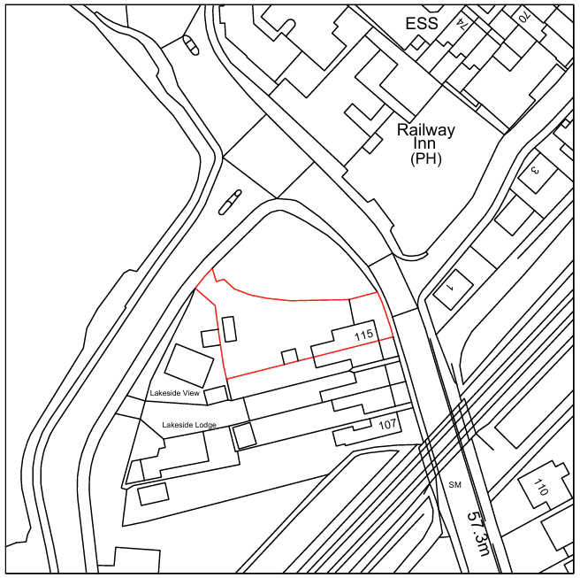
PROPOSAL

The application seeks planning permission for the replacement of an existing single-storey porch/conservatory-style extension located between the rear elevation of the dwelling and the existing two-storey side extension. The existing structure, comprising primarily uPVC framing above a low brick wall with a lightweight pitched roof, would be removed and replaced with a more substantial single-storey rear extension projecting approximately 1 metre further from the rear elevation. The proposed extension would incorporate red brick elevations, a pitched roof finished with Redland Regent tiles, white uPVC windows and rainwater goods, anthracite aluminium doors, rooflights and associated fenestration alterations to facilitate internal remodelling works. The development would create an enlarged open-plan kitchen and dining area through the reconfiguration of existing internal accommodation.

SITE DESCRIPTION / CONTEXT

The application site relates to No. 115 Station Road, a two-storey dwelling situated within an established residential area of Westbury characterised by a mix of detached and semi-detached dwellings of varying ages and designs. The property lies within the Westbury Settlement Boundary, where residential development is supported in principle subject to detailed planning considerations. The site is located within the Salisbury Plain SPA 6.4km Buffer, the Bath and Bradford-on-Avon Bats SAC Core Roost Buffer and the Trowbridge and Westbury Bat Mitigation Strategy Grey Zone. The Council's Strategic Flood Risk Assessment identifies the site as being at negligible risk from surface water and groundwater flooding, while the land is located within Flood Zone 1. The application relates solely to works within the existing residential curtilage.

PLANNING HISTORY

Reference No. | Proposal / Summary | Decision
PL/2026/00222 | Proposed New Dwelling & Associated Landscaping | Approved

RELEVANT LEGISLATION, POLICIES AND GUIDANCE

Wiltshire Core Strategy:

Core Policy 1 Settlement Strategy;
Core Policy 2 Delivery Strategy;
Core Policy 32 Spatial Strategy: Westbury Community Area;
Core Policy 50 Biodiversity and Geodiversity;
Core Policy 51 Landscape;
Core Policy 57 Ensuring High-Quality Design and Place Shaping;
Core Policy 60 Sustainable Transport;
Core Policy 61 Transport and Development;
Core Policy 64 Demand Management;
Core Policy 67 Flood Risk;

Westbury Neighbourhood Plan 2023-2036

The National Planning Policy Framework (NPPF) and The Planning Practice Guidance (PPG)

Wiltshire Design Guide - Appendix D – Design Guidance for Householder extensions

The Wiltshire Local Transport Plan 2011 – 2026: Car Parking Strategy (March 2015).

The Wiltshire Local Transport Plan 4 (LTP4) (March 2025)

New Wiltshire Local Plan

At Full Council on 19 May 2026, the elected members of Wiltshire Council agreed to withdraw the emerging Wiltshire Local Plan. The said Plan has no material weight for the purposes of the application.

In accordance with Regulation 19 of the Town and Country Planning (Local Planning) (England) Regulations 2026, on 30th June 2026 Wiltshire Council published a notice of intention to prepare a new local plan for Wiltshire. The next stage is a Scoping Consultation which commences on 2nd September 2026. This plan is at a very early stage and currently carries no weight for decision making.

CONSULTATION RESPONSES

Westbury Town Council – No Objection

REPRESENTATIONS

No comments received.

ASSESSMENT

Section 38(6) of the Planning and Compulsory Purchase Act 2004 states:

"If regard is to be had to the development plan for the purposes of any determination to be made under the planning Acts, the determination must be made in accordance with the plan unless material considerations indicate otherwise."

In accordance with this statutory requirement, this application has been assessed against the relevant policies of the Development Plan, including the adopted Wiltshire Core Strategy (2015) and, where applicable, any made Neighbourhood Plans.

The application relates to the alteration and extension of an existing dwellinghouse within the established residential settlement boundary of Westbury. The proposal would provide improved residential accommodation through the replacement and enlargement of an existing single-storey extension and does not involve the creation of a new dwelling or any change of use. As a form of domestic householder development within an established residential curtilage, the principle of development is considered acceptable, subject to the proposal's compliance with relevant design, amenity, environmental and technical planning considerations, which are assessed below.

Design and Impact the upon the character and context of the area

Core Policy 57 of the Wiltshire Core Strategy seeks to secure high-quality design which responds positively to local character and distinctiveness. At the national level, Policy DP3 of the National Planning Policy Framework requires development proposals to respond positively to their context and integrate with and enhance their surroundings. Development should also reflect, where relevant, the principles of liveability, climate resilience, nature, movement, built form, public space and local identity. Assessment of design quality therefore requires consideration of the scale, appearance, massing, materials, layout and relationship of the proposal with both the host site and the wider character of the surrounding area.

The proposed development is considered acceptable in design terms. The extension would replace an existing conservatory-style structure which has a lightweight and somewhat dated appearance with a more permanent and cohesive addition that better reflects the character of the host dwelling. The use of brick elevations and tiled roofing would integrate more successfully with the existing building, while the modest increase in footprint and continued single-storey form ensures the proposal remains clearly subordinate to the principal dwelling. The proposed materials and detailing are considered appropriate to the character of the property and the wider residential area, resulting in a visual improvement over the existing arrangement.

Having regard to the above, the proposal complies with the design principles set out in the NPPF Policy DP3, Core Policy 57 of the Wiltshire Core Strategy, and Appendix D of the Wiltshire Design Guide.

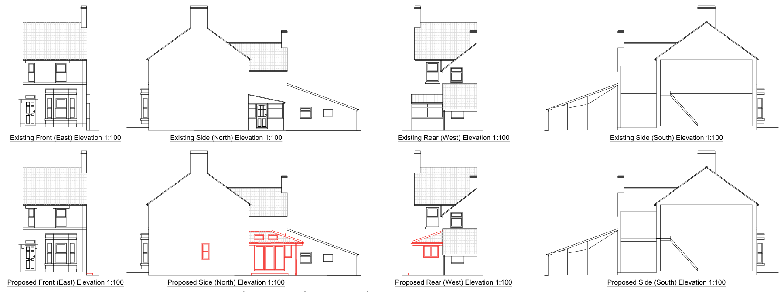
Existing and Proposed Elevations

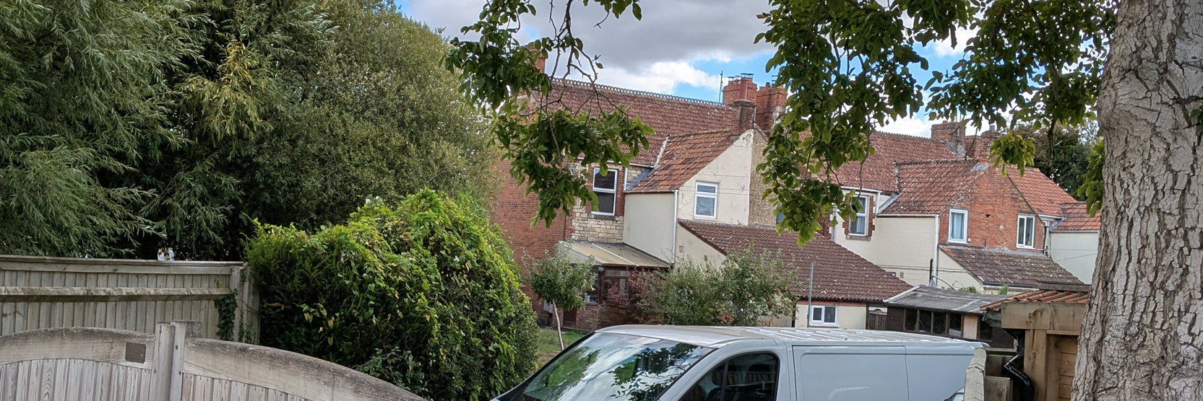
Site Visit (Rear Elevation)

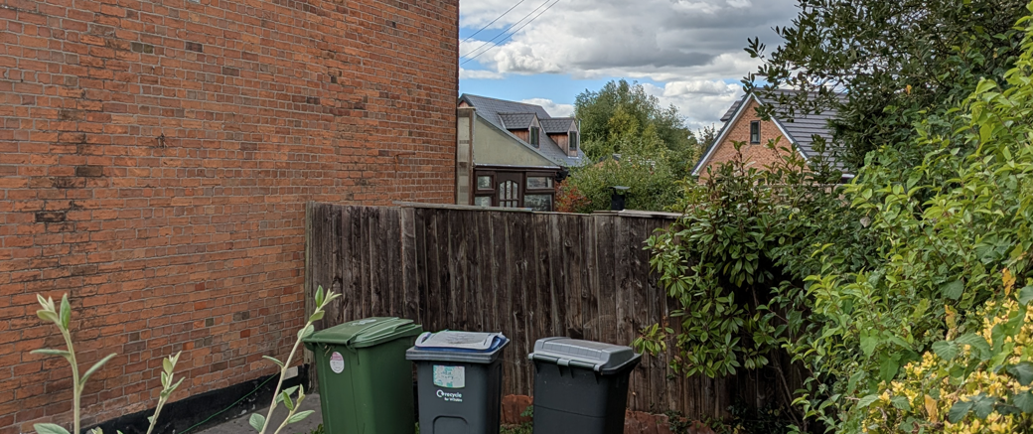
Site Visit (Front Elevation)

Amenity

Core Policy 57 criterion vii seeks to ensure development does not have an unacceptable impact upon the amenities of neighbouring occupiers. Nationally, Policy P3 requires development proposals to provide healthy living conditions for occupiers and users and to avoid unacceptable impacts arising from loss of light, outlook, privacy, noise, disturbance or other forms of pollution. Policy DP3 additionally requires development to create liveable and attractive places for existing and future users. Accordingly, the assessment below considers the effect of the proposal upon neighbouring occupiers and whether acceptable living conditions would be maintained.

The proposal would not result in any unacceptable impacts upon the living conditions of neighbouring occupiers. The extension is wholly single-storey in scale and would be positioned on the side of the dwelling where there are no neighbouring residential properties. As such, its limited height and modest projection would not give rise to material overlooking, overshadowing or overbearing effects. The proposed windows, doors and rooflights would principally serve the applicant's own property and garden areas and would not introduce opportunities for harmful loss of privacy. It is therefore considered that the development would preserve the amenity of surrounding residents.

The proposal therefore accords with Core Policy 57 point vii in respect of safeguarding residential amenity and Appendix D of the Wiltshire Design Guide.

Transport and Highways

Core Policies 60, 61 and 64 of the Wiltshire Core Strategy seek to promote sustainable transport, secure safe access arrangements and ensure adequate parking provision. Nationally, Policies TR3 and TR4 of the National Planning Policy Framework require development to be located in sustainable locations where appropriate, provide safe access arrangements, prioritise walking, wheeling and cycling, and provide suitable parking provision having regard to the nature and location of the development. Policy TR6 confirms that development should be refused where it would result in a severe adverse impact on the transport network or an unacceptable impact on highway safety after consideration of any mitigation measures.

The proposed development would not adversely affect highway safety or parking provision. The application relates solely to alterations and extensions to an existing dwelling and would not create any additional residential units or bedrooms that would increase parking demand. No changes are proposed to the existing access arrangements, parking areas or vehicle movements associated with the site. Accordingly, the proposal is considered acceptable from a highways perspective.

Ecology

Core Policy 50 of the Wiltshire Core Strategy seeks to protect and enhance biodiversity interests and ensure development avoids unacceptable harm to ecological assets. National policy is set out within Policies N2 and N6 of the National Planning Policy Framework. These policies require development proposals to minimise impacts upon biodiversity, protect important habitats and species, and secure opportunities for biodiversity enhancement where appropriate. Where significant harm to biodiversity cannot be avoided, adequately mitigated or compensated for, development should be refused. Biodiversity Net Gain (BNG) was established as a mandatory aspect of planning evaluation through Schedule 7A of the Town and Country Planning Act 1990 (as amended by the Environment Act 2021 Schedule 14). Householder development is exempt from the statutory Biodiversity Net Gain requirements introduced through Schedule 7A of the Town and Country Planning Act 1990 (as amended). Nevertheless, proposals should seek to avoid ecological harm and incorporate biodiversity enhancements where appropriate.

The site falls within a number of ecological consultation zones, including the Bath and Bradford-on-Avon Bats SAC Core Roost Buffer and the Trowbridge and Westbury Bat Mitigation Strategy Grey Zone. However, the proposal involves the replacement of an existing domestic conservatory-style extension within an established residential curtilage and does not entail the loss of habitats of known ecological value. The works would represent a replacement of an existing built form with a similarly positioned extension and there is no evidence to indicate likely significant effects on protected species, the SAC or other designated ecological interests. Having regard to the nature and scale of the proposal, the development is considered acceptable in ecology terms.

Flooding and Drainage

Core Policy 67 of the Wiltshire Core Strategy seeks to ensure that development is directed away from areas at greatest risk of flooding and is designed to minimise vulnerability to flooding whilst avoiding any increase in flood risk elsewhere. National planning policy relating to flood risk and drainage is contained within Policies F4 to F8 of the National Planning Policy Framework. Collectively, these policies establish a risk-based approach to the location and assessment of development proposals. The Framework requires flood risk to be properly assessed where necessary, seeks to direct development towards areas at the lowest risk of flooding through the application of the sequential approach where applicable, and ensures that development remains safe for its lifetime without increasing flood risk elsewhere. The policies also support the incorporation of sustainable drainage measures where appropriate in order to manage surface water runoff and reduce the potential for flooding.

The site is located within Flood Zone 1 and is identified by the Council's Strategic Flood Risk Assessment as being at negligible risk of surface water and groundwater flooding. The development would largely replace an existing built structure and associated hard surfacing, with only a modest increase in the overall footprint of development. Given the limited scale of the proposal and its domestic nature, it is not considered that the works would materially increase flood risk on or off site or give rise to adverse drainage impacts. The proposal is therefore acceptable with regard to drainage and flood risk considerations.

CONCLUSION

The proposed replacement extension represents a modest and sympathetic form of domestic development that would improve the appearance of the existing dwelling while providing enhanced internal living accommodation. The development would preserve the character of the area, would not result in unacceptable impacts on neighbouring amenity, highway safety, ecology, drainage or flood risk, and is considered to accord with the relevant provisions of the development plan. Accordingly, the application is recommended for approval subject to appropriate planning conditions.

RECOMMENDATION: That Planning Permission be GRANTED subject to conditions

