Development Management,
Wiltshire Council,
Bythesea Road
Trowbridge
Wiltshire
BA14 8JN

Dear Sirs,

RE: VARIATION OF CONDITION No. 1 ATTACHED TO PLANNING PERMISSION
No. 20/06783/FUL – CHANGE OF USE OF LAND TO USE AS A GYPSY
CARAVAN SITE
LAND AT TRICKYS PADDOCK, BRICKWORTH ROAD, WHITEPARISH

Please find enclosed completed planning application forms, plans and requisite fee in respect of the above-mentioned proposal.
PLANNING STATEMENT

Planning History

Planning permission was granted on appeal, on 04 November 2022, under application No. 20/06783/FUL, for the material change of use of land to use as a residential gypsy and traveller site for two pitches, each pitch accommodating two caravans, including no more than one static caravan/mobile home, and a dayroom, together with the laying of hardstanding and installation of a package sewage treatment plant.
Condition No.1 attached to the planning permission reads as follows:
- The development hereby permitted shall be carried out in accordance with the following
approved plans:
• DWG No: 19/TRICK/01 Site Location Plan Date Received 10.08.20
• DWG No: 19/TRICK/05 Proposed Site Layout Plan/Landscaping Plan
Date Received 10.08.20
• DWG No: 19/TRICK/04 Rev Existing and Proposed Streetscene/Sections
Date Received 10.08.20

• DWG No: 19/TRICK/03 Rev A Proposed Dayrooms Elevations and Floor
Plans Date Received 10.08.20
Proposed Development
The proposed variation of condition 1 is to substitute an amended Site Layout Plan for that originally approved (DWG No: 19/TRICK/05). The amended site layout does not change the description of development or its scale but, alters the layout of caravans and dayrooms to accommodate larger dayroom buildings.
The number and size of pitches is exactly the same as previously approved and, therefore, would maintain the pattern of development found to be acceptable by the appeal Inspector.
The proposed variation of Condition 1 would also include substituting new drawings of the dayroom buildings for those originally approved (DWG No: 19/TRICK/03 Rev A). The approved dayrooms measured approximately 9.1 metres x 6.0 metres and, had a ridge height of 4.0 metres. The dayrooms that have actually been built measure 12.4 metres x 9.3 metres and, have a ridge height of 4.65 metres.
Biodiversity Net Gain
Planning Practice Guidance – Biodiversity Net Gain makes clear in paragraph 003 that : Biodiversity net gain does not apply to:

- retrospective planning permissions made under section 73A; and

- section 73 permissions where the original permission which the section 73 relates to was either granted before 12 February 2024 or the application for the original permission was made before 12 February 2024.

The development in this case is both retrospective (the dayrooms have already been built) and, involves the carrying out of development without complying with a planning condition. The original planning application was submitted on 04 November 2022, i.e. prior to 12 February 2024, and this application seeks permission to carry out development without complying with Condition 1

attached to an extant planning permission. The statutory BNG provisions do not, therefore, apply.
Planning Considerations

Section 73 of the Town and Country Planning Act - Determination of applications to develop land without compliance with conditions previously attached – states as follows:
(1) This section applies, subject to subsection (4), to applications for planning permission for the development of land without complying with conditions subject to which a previous planning permission was granted.
(2) On such an application the local planning authority shall consider only the question of the conditions subject to which planning permission should be granted, and—
(a) if they decide that planning permission should be granted subject to conditions differing from those subject to which the previous permission was granted, or that it should be granted unconditionally, they shall grant planning permission accordingly, and
(b) if they decide that planning permission should be granted subject to the same conditions as those subject to which the previous permission was granted, they shall refuse the application.

In the 2022 appeal the Inspector identified the following main issues:

• the effects of the proposal on the character and appearance of the area;
• the effects on the Solent and Southampton Water Protected Sites;
• the need for traveller pitches;
• personal circumstances; and
• if harm is identified, whether this would be outweighed by other
considerations that indicate permission should be granted.

The current proposal would not make any change to the effect on the Solent and Southampton Water protected sites, or on the need for traveller sites. The applicant’s personal circumstances have only changed in that the extended

family’s space requirements have increased as children have grown older. Extra space is required for socialising, private study and play.

The only harm identified by the Inspector was with regards to the effect on the character and appearance of the area:

“41. There would be harm to the character and appearance of the area which brings the development into conflict with the development plan, when considered as a whole. However, the harm identified above would be reduced over time through appropriate landscape mitigation secured by condition”.

A landscaping scheme has subsequently been approved by the Council and, implemented.

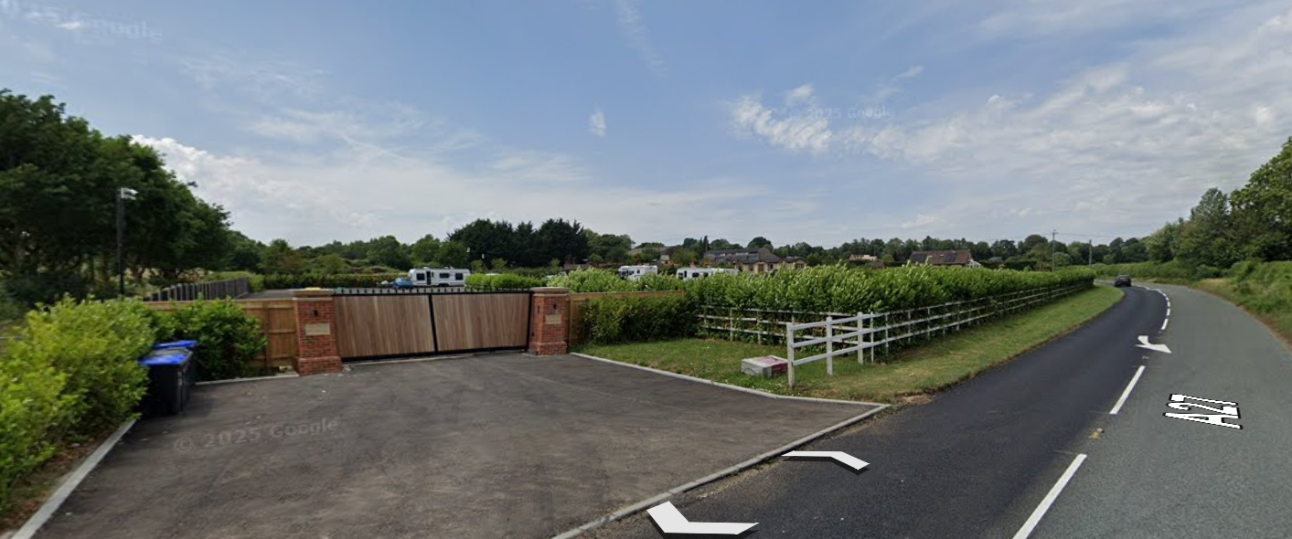

Figure 1: View from the A27 looking west

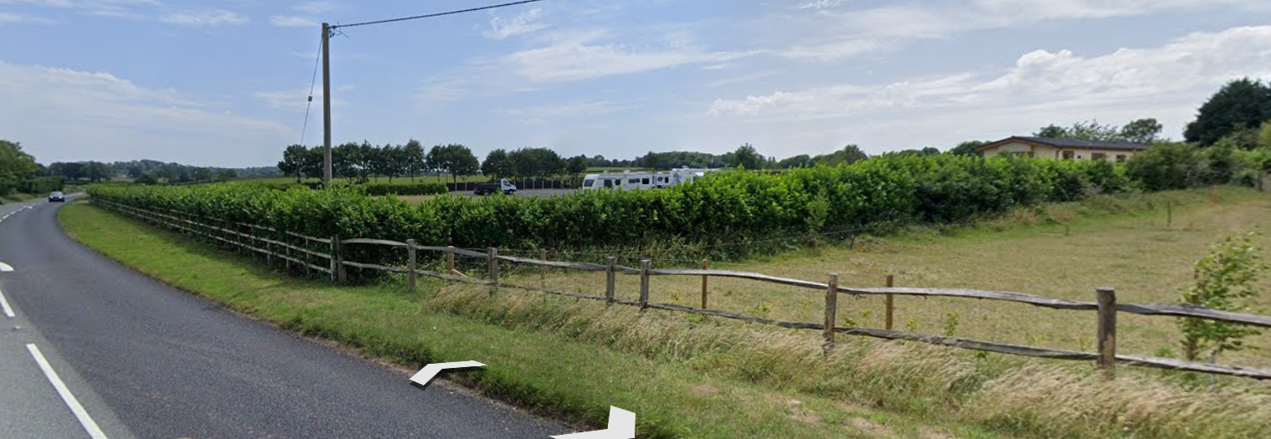

Figure 2: View from the A27 looking east

The applicant’s field is now surrounded by evergreen hedging which has already attained a height of about 2 metres along the road frontage. The images shown in figures 1 and 2 are photographed at a height of 2.5 metres above the level of the road. From the perspective of an ordinary car driver or passenger, it will only be the roofs of the mobile homes and dayrooms that will be visible to passers-by, seen in the context of trees and taller buildings on the higher ground to the south-west.

The proposed dayrooms, though 650mm taller than the approved dayrooms and with a larger footprint, would be built using dark materials, less obvious than the white caravans shown on figures 1 and 2 and, more easily assimilated into the countryside.

Notwithstanding this, the Council’s latest GTAA, published in 2024 before the change in definition of Gypsy and Traveller, estimates a “cultural” need for the provision of 299 permanent pitches in the period 2024 – 2038. In the absence of a development plan document allocating land for traveller sites it is axiomatic that the Council is unable to identify a five-year supply.

Policy S3 of the NPPF sets out the presumption in favour of sustainable development which, for sites outside of existing settlements, means compliance with Policy S5. Policy S5 allows for development in the countryside which would address an evidenced unmet need for gypsy, traveller or travelling showpeople accommodation, provided it meets the criteria in policy HO12. In these circumstances, proposals for new traveller sites should be approved, unless the benefits of doing so would be substantially outweighed by any adverse effects, when assessed against the national decision-making policies in this Framework.

In this case, there is an identified need for traveller pitches and, the application site is not located within any of the national designations set out in footnote ²⁴ of the NPPF. The site provides a settled base from which the site residents can access education, welfare and health services, thereby satisfying the criteria in Policy HO12. The “tilted” balance therefore applies (whereas it did not in 2022) by which planning permission should be granted unless the benefits of providing appropriate living accommodation for the site residents would be substantially outweighed by the marginal increase in the impact of the proposed dayrooms on the character and appearance of the countryside, when compared with the approved dayrooms.

The harm to the character and appearance of the countryside was found to be outweighed in 2022 by the benefits of the scheme. It is inconceivable that the proposed increase in the size of the proposed dayrooms would be sufficient to now elevate the level of harm such that it would substantially outweigh the benefits.

For the above-mentioned reasons, it is respectfully requested that planning permission be granted.

Kind regards,

Philip Brown BA (Hons) Urban and Regional Planning

