APPLICATION FOR LISTED BUILDING CONSENT
OFFICER DELGATED REPORT

APPLICATION REFERENCE: | PL/2026/03070
APPLICATION TYPE: | Listed building consent (Alt/Ext)
SITE ADDRESS: | The White Hart Inn, Ford, Chippenham, SN14 8RP
DESCRIPTION OF WORKS: | Repair and reinstatement works to the entrance porch, façade and internal fabric following accidental vehicle impact
RECOMMENDATION: | Approve with Conditions

SITE DESCRIPTION/CONTEXT
The subject property, built originally as a residential dwelling, is now a Public House, with
rubble stone front elevations, and a traditional porch, which was the point of impact of a car traffic accident, effectively the crumple zone protecting the dwelling behind.

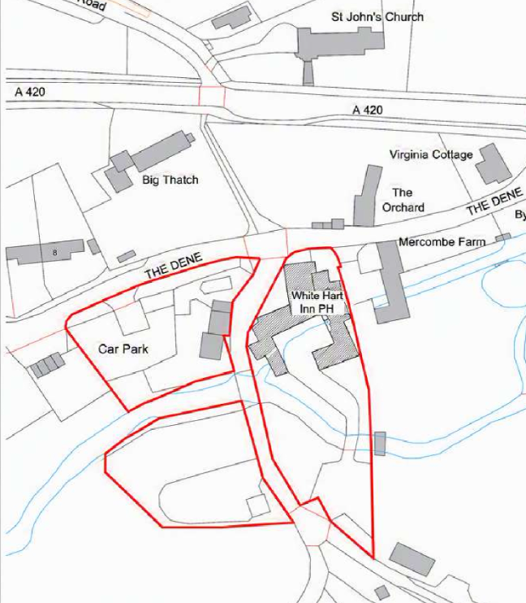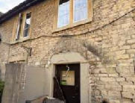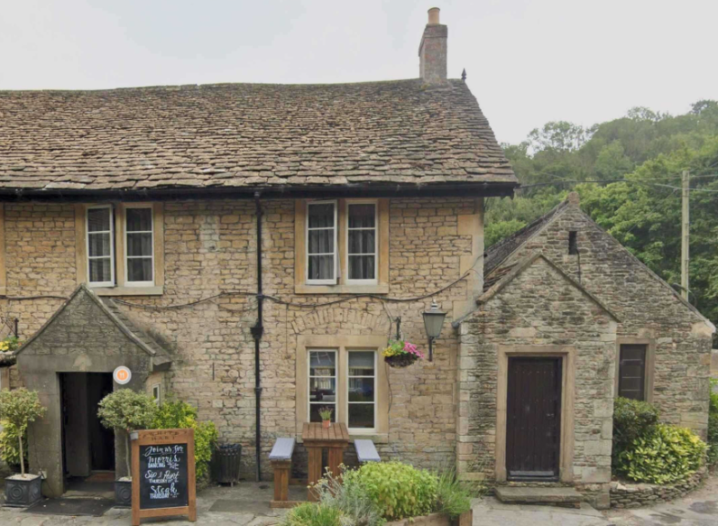
Location Plan and Site Photo of front elevation as existing and prior to collision

The collision caused the walls to shear in a horizontal plane, moving the stone opening surround, and stone front elevation, back by 100mm near the site of impact. There is stone lintel beneath a stress-relieving arch, which has also cracked. The substructure appears intact, but excavation will require some removal of the surrounding crazy paving.

The Historic England listing states the building is a C17 inn, with a C19 south range. Built of rubble stone, squared and coursed with stone tiled roofs, both the C19 right side projecting ashlar coped gabled porch, and a central door in a gabled stone porch are mentioned.

The building is a prominent landmark, occupying a large corner plot within the village of Ford, critical to its historic use as a coaching inn on a route to London, and is central to the Long Dean/Ford/Slaughterford Conservation Area.

PROPOSAL
The proposal seeks permission for urgent repair works and to rebuild the porch and its substructure, taking the opportunity for improvements, such as replacing the concrete mix blockwork, rubble-effect finish, and cement pointing with local rubble stone, but with a slightly proposed increased width to accommodate these material improvements, taking design details from the neighbouring porch and enabling a wider hardwood-framed opening, with only a single opening out ledge and brace door for improved accessibility.

Design details include concrete blockwork, internal face rendered, locally sourced/reclaimed bath/Cotswold stone facing, large stones as quoins, uncoursed, as existing, stone roof slates, uniform or diminishing sizes, with twice-weathered stone copings, and corbel, single glazed, painted hardwood window with top opening sash within natural stone surround opening, ledged and braced hardwood door.

The proposal also seeks permission to replace Internal timber beams on a like for like basis, and repairs to lath and plaster ceiling.

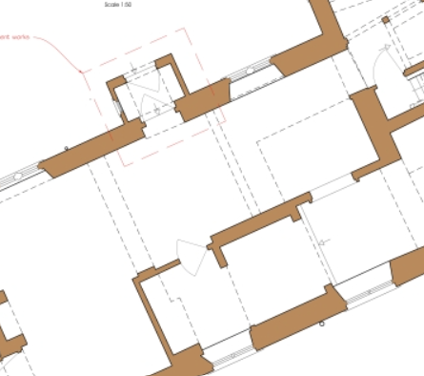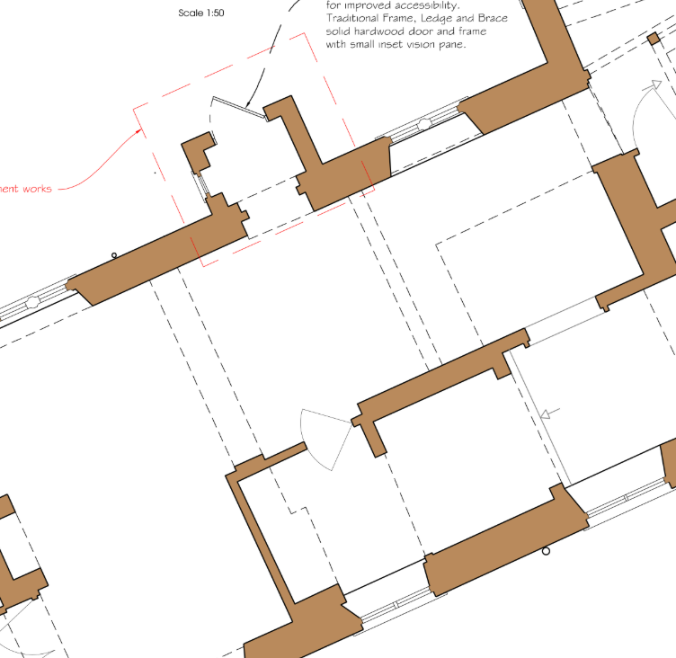
Existing and Proposed Partial Ground Floor Plan

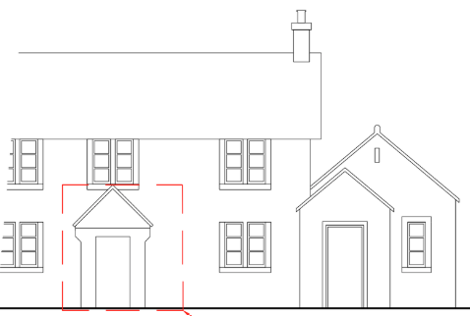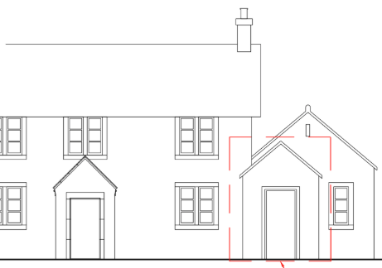
Front elevation as existing, highlighting extent of rebuilding works, and front elevation as proposed, with existing elements of adjacent projection as precedent.

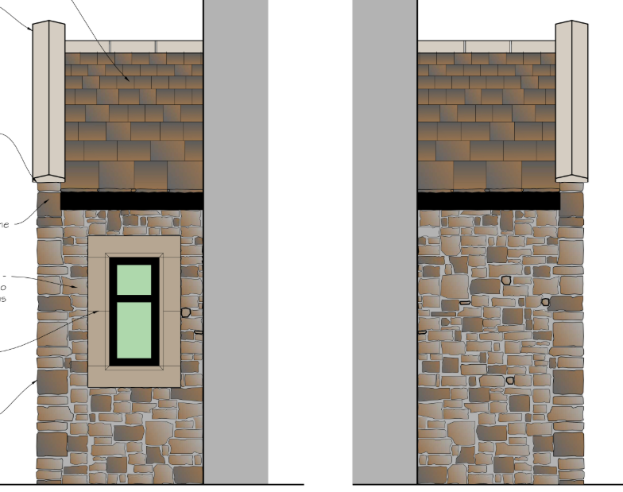
Proposed Side Elevations

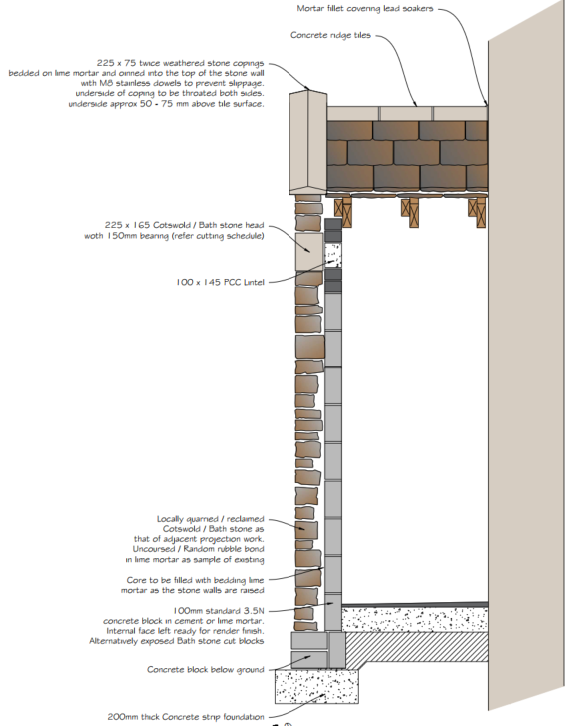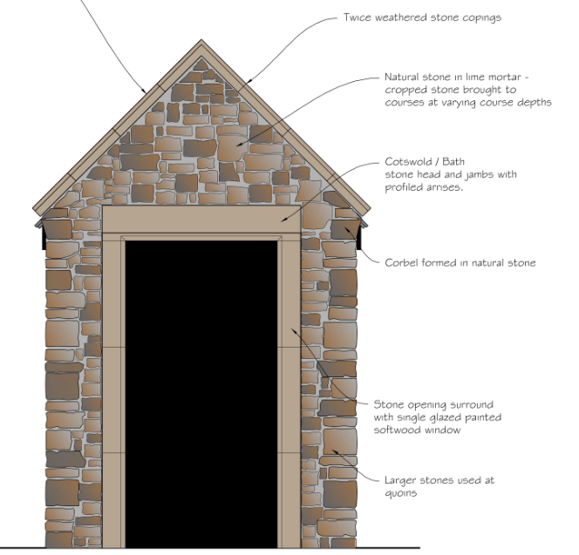
Proposed Section and Front Elevation

RELEVANT PLANNING HISTORY
N/91/02370/LBC - Listed building consent Decision - Approve with Conditions Date: 28/1/1992 – NEW CELLAR/STORE BUILDING
N/03/03190/LBC - Listed building consent Decision - Approve with Conditions Date: 22/1/2004 – INTERNAL ALTERATIONS TO EXTEND KITCHEN
N/90/02552/FUL - Full planning permission Decision - Approve with Conditions Date: 12/2/1991 – EXTENSION OF EXISTING STORE- ROOM AND ROOF TO CREATE NEW BEDROOM AND BATHROOM
N/96/01653/LBC - Listed building consent Decision - Approve with Conditions Date: 4/3/1997 – INTERNAL AND EXTERNAL ALTERATIONS AND PARTIAL DEMOLITION AND REBUILD INTERNAL/EXTERNAL ALTERATIONS
N/92/02204/FUL - Full planning permission Decision - Withdrawn Date: 22/6/1993 – TRADE KITCHEN EXTENSION TO PUBLIC HOUSE WITH ACCOMMODATION OVER KITCHEN EXTN WITH ACCOMM OVER
N/91/02369/FUL - Full planning permission Decision - Approve with Conditions Date: 28/1/1991 – EXTENSION TO FORM CELLAR AND STORE FACILITIES
N/03/03191/LBC - Listed building consent Decision - Approve with Conditions Date: 22/1/2004 – INTERNAL ALTERATIONS TO FORM W.C.
N/97/00048/FUL - Full planning permission Decision - Approve with Conditions Date: 18/4/1997 – CONSTRUCTION OF NEW STORES AT LOWER GROUND FLOOR LEVEL AND ROOFING TO ADJOINING AREAS AT REAR OF PREMISES (WITH PARTPITCHED ROOFS) NEW STORES/ROOFING
N/97/00049/LBC - Listed building consent Decision - Approve with Conditions Date: 18/4/1997 – CONSTRUCTION OF NEW STORES AT LOWER GROUND FLOOR LEVEL AT REAR OF PREMISES AND ROOFING TO ADJOINING AREAS (WITH PART PITCHED ROOFS) NEW STORES/ROOFING
N/13/00423/LBC - Listed building consent Decision - Approve with Conditions Date: 29/4/2013 – Internal Alterations, Refurbishment and Repairs Following Flood Damage.
PL/2025/09999 - Full planning permission Decision - Approve with Conditions Date: 10/2/2026 – Alterations including replacement and addition of internal doors within living area and replacement of sliding doors to garden
PL/2026/00131 - Listed building consent (Alt/Ext) Decision - Approve with Conditions Date: 10/2/2026 – Alterations including replacement and addition of internal doors within living area and replacement of sliding doors to garden
N/82/00266/F - Historic apps 1974 to 1983 Decision - Approve with Conditions Date: 15/7/1982 – ALTERATIONS AND BAY WINDOW EXTENSION TO PUBLIC HOUSE WITH ERECTION OF BARBEQUE
N/82/00374/LB - Listed building consent (Alt/Ext) Decision - Approve with Conditions Date: 15/7/1982 – ERECTION OF BARBEQUE WITHIN THE CURTILAGE OF AND ALTERATIONS AND BAY WINDOW EXTENSION TO GRADE II LISTED BUILDING
N/82/00749/F - Historic apps 1974 to 1983 Decision - Approve with Conditions Date: 12/7/1982 – CHANGE OF USE OF BARN AND EC=XTENSION THERETO TO FORMER EXTENSION TO PUBLIC HOUSE AND PROVIDE ADDITIONAL RESIDENTIAL ACCOMMODATION, ERCETION OF DOMESTIC GARAGE/STORE AND CONSTRUCTION OF DRIVE AND BRIDGE
N/85/00421/LB - Listed building consent (Alt/Ext) Decision - Approve Date: 30/4/1985 – ALTERATIONS AND UPGRADING OF GRADE II LISTED BUILDING
N/96/02036/FUL - Full planning permission Decision - Approve with Conditions Date: 14/1/1997 – RECONSTRUCTION OF TOILET EXTENSION DEMOLISH/TOILET EXTENSION
N/96/02037/LBC - Listed building consent Decision - Approve with Conditions Date: 14/1/1997 – DEMOLITION AND RECONSTRUCTION OF EXISTING TOILET EXTENSION DEMOLITION/TOILET EXTENSION

RELEVANT LEGISLATION, POLICIES AND GUIDANCE

Legislation
From the point of view of the historic environment the main statutory tests are set out within the Planning (Listed Building and Conservation Areas) Act 1990. Section 16 requires that special regard be given to the desirability of preserving listed buildings, their settings or any features of special architectural or historic interest which they possess.

Section 72(1) of the Planning (Listed Building and Conservation Areas) Act 1990 also requires the Council to pay special attention to the desirability of preserving or enhancing the character or appearance of designated Conservation Areas.

National Policy and Guidance
The National Planning Policy Framework (NPPF) August 2026 sets out government policy, including in respect of the historic environment.

Chapter 20 - Conserving and enhancing the historic environment, recognises heritage assets as an irreplaceable resource. Heritage assets should be conserved in a manner appropriate to their significance, with harm avoided unless there is a clear and convincing justification. Decision-makers are required to apply a balanced approach, giving substantial weight to the conservation of heritage assets and weighing any harm to significance against the public benefits of the proposal.

Chapter 5 of the NPPF sets out policies for Meeting the challenge of climate change and gives substantial weight to the benefits of improving the energy efficiency of existing buildings and/or drawing energy from district heat networks, renewable and low carbon sources (including through the installation of heat pumps and solar panels where these do not already benefit from permitted development rights).

National Planning Practice Guidance provides guidance on interpreting the NPPF.

Historic England’s Conservation Principles, Policies and Guidance (2008) provides policy and guidance for the “sustainable management of the historic environment”.

Additional guidance on the application of policies set out in the NPPF is contained within their publications:
- Historic Environment Good Practice Planning Advice Note 2 – Managing Significance in Decision-Taking in the Historic Environment (2015)
- Historic Environment Good Practice Planning Advice Note 3 – The Setting of Heritage Assets 2nd edition (2017)
- Historic England Advice Note 2 – Making changes to Heritage Assets (2025)
- Historic England Advice Note 18 – Adapting Historic Buildings for Energy and Carbon Efficiency (2026)
- Traditional Windows: their care, repair and upgrading (2017)

Wiltshire Core Strategy:
Whilst not directly relevant to listed building consent applications, the below policies give an indication of the Council’s approach to development affecting heritage assets:

- Core Policy 57 ‘Ensuring high-quality design and place shaping’: A high standard of design is required in all new developments, including extensions, alterations, and changes of use of existing buildings. Development is expected to create a strong sense of place through drawing on the local context and being complementary to the locality.

- Core Policy 58 ‘Ensuring the conservation of the historic environment’ requires that “designated heritage assets and their settings will be conserved, and where appropriate enhanced, in a manner appropriate to their significance.”

ISSUES
Impact upon the preservation of the listed building or any features of special architectural and/or historic interest.

CONSULTATION RESPONSES
North Wraxall Parish Council – no objection.

REPRESENTATIONS
In accordance with the requirements of Section 5(1) of the Planning (Listed Buildings and Conservation Areas) Regulations 1990 (as amended) the application for listed building consent was publicised by way of:

- A site notice displayed near the site;
- An advertisement placed in the local press.

These methods were used to inform interested parties and to allow a statutory consultation period of 21 days for representations to be submitted.

No comments were received.

ASSESSMENT
In accordance with Section 16(2) of the Planning (Listed Buildings and Conservation Areas) Act 1990, special regard has been given to the significance of the listed building, including its architectural and historic interest, and the desirability of preserving both the building and its setting. Relevant policies within the National Planning Policy Framework (NPPF), particularly Section 20: Conserving and Enhancing the Historic Environment, have also been taken into account. These policies require that any harm to the significance of a designated heritage asset must be clearly justified and weighed against the public benefits of the proposal.

In order to be acceptable, the application needs to be assessed against the following criteria:

Information considered/submitted
Section HE5 of the NPPF requires that ‘Development proposals affecting heritage assets should be accompanied by an assessment of the significance of the assets affected (including any contribution made by their setting) and of the potential effect of the proposal on their significance.’

The application is supported by a Planning Heritage, Design and Access Statement which adequately identifies the significance of the listed building and impact by the proposed works.

Assessment of significance:
The NPPF defines significance as:

The value of a heritage asset to this and future generations because of its heritage interest. The interest may be archaeological, architectural, artistic or historic. Significance derives not only from a heritage asset’s physical presence, but also from its setting.’

Historic England categorises significance into four key values:

- Evidential – the potential of the asset to yield evidence about past human activity.
- Historic – the ways in which the asset illustrates aspects of history.
- Aesthetic – the sensory and design qualities of the asset.
- Communal – the meanings and associations attached to the asset by people.

In this case the significance of the building lies largely with its age, scale, layout, form and use as an historic inn, use of local materials, vernacular design and detailing, all of which have significant aesthetic and architectural interest, and which contributes to the character of the Conservation Area.

The central porch however, by submitted map and historic planning application details, is C20, confirmed by details of materials identified during opening up following the collision, and an uncovered segmented stone arch beneath, and as such the porch has no intrinsic historic value.

It is noted that this modern porch appears to have been designed to echo that of the right porch, retaining vernacular scale and design but inferior to surrounding elements and clearly of modern materials, abutting the relieving arch beneath.

The splintered beams and damaged lath and plaster ceilings, appear original and as such contribute hugely to the significance of the building.

The stonework of the front elevation is clearly original, the porch abutting rather than being structurally tied in. The accident has led to the bowing out of these walls, smashed mortar joints and loss of internal finishes, harming the significance of the listed building. The submitted heritage statement noting that the external face has been compacted, and the internal face having shattered.

Impact of proposals on the significance and setting of the building/structure:
Understanding the impact of proposed works on a listed building requires a careful and proportionate assessment of how those changes affect the asset’s heritage significance and its setting. This includes both the physical alterations to the building itself and any changes to its spatial or visual relationship with surrounding structures or spaces.

The significance of a heritage asset is not static; it is shaped by its architectural, historic, and communal values, and by how these are experienced in context. Therefore, any intervention must be considered in light of the asset’s identified significance, with attention given to both potential harm and benefits. Benefits may include repairs that support the long-term conservation of the building, improved energy performance, or enhanced public access and understanding.

This assessment is grounded in the statutory duty under Section 16 of the Planning (Listed Buildings and Conservation Areas) Act 1990, which requires special regard to be given to the desirability of preserving the building and its features of special interest. It is also informed by national policy, particularly section 20 of the National Planning Policy Framework (NPPF), and relevant local heritage policies and guidance.

The rebuilding of a replacement porch, taking the opportunity to improve materiality, scale and accessibility, would preserve the special character of the listed building, replicating a porch, albeit modern, and retaining the legibility of the front elevation, and as such is uncontroversial. Proposed design and material details are considered appropriate, ensuring successful integration, such that the proposed works would have a neutral impact on the significance of the budling.

The repair of stonework is essential. A method statement is not included, and extent of works may alter following internal structural works. As such a method statement is required to fully describe proposed works and impact to historic fabric. The proposed works would enable the conservation of the listed building and its long-term viable use such that any harm arising from interventions is considered to be outweighed by public benefits of retaining structural integrity and long-term viable use as an inn.

The splintered beams will require repair to ensure structural stability. The application includes no details other than ‘replacement on a like for like basis.’ Given the location and size of these beams, a condition is considered necessary for a method statement, which should consider options for engineering support or localised timber repairs rather than wholesale replacement. Repair would mean a level of intervention to the original beams, but with the public benefit of ensured structural stability and public safety, continued viable use of the Public House, and retention of maximum historic fabric.

The replacement of damaged areas of lath and plaster is unavoidable, and it is expected for properties of this age, that areas of repair will be required.

CONCLUSION
The NPPF confirms that when considering the impact of a proposed development on the significance of a designated heritage asset, great weight should be given to the asset’s conservation (and the more important the asset, the greater the weight should be). It makes clear that any harm to a designated heritage asset requires clear and convincing justification.

The overall impact of the proposals on heritage assets will be neutral depending upon the submission of further information regarding method of repair. On this basis no specific justification is required in light of the obvious need, however it is considered the works will assist in securing the future use of a heritage asset in support of its long-term conservation. The requirements of current conservation legislation, policy or guidance are considered to be met.

RECOMMENDATION:
That Listed Building Consent be GRANTED, subject to conditions.

