

Visual impact and Glint and Glare Statement

Proposal: Installation of a ground-mounted solar photovoltaic array.
Site: Land East of Cadley Farmhouse,
Chute Cadley, Andover, SP11 9EB
Applicant: Gordon White

Prepared by:
Equestrian Blueprint
enquiries@equestrianblueprint.co.uk
https://equestrianblueprint.co.uk/
September 2026

Contents
1 Introduction 3
2 Proposed Development 3
3 Site and Landscape Context 3
4 Assessment Method 4
5 Visual Effects 4
6 Glint and Glare 5
7 Mitigation and Design Considerations 6
8 Conclusion 7
9 Photographic Assessment 7

1 Introduction
This Visual Impact and Glint and Glare Statement accompanies an application for a small ground-mounted solar photovoltaic array on land east of Cadley Farmhouse, Chute Cadley.
The statement considers:
- the potential visibility and landscape effects of the proposed array;
- its potential effect upon nearby residents, highway users and other visual receptors; and
- whether reflected sunlight could result in a material glint or glare effect.
The assessment is proportionate to the limited scale of the proposal and is informed by the application drawings, technical information, aerial mapping, site photographs and observations made from publicly accessible locations around the village.
The photographic assessment demonstrates that the proposed array would have a very restricted visual envelope. No location has been identified from which the development would give rise to a materially harmful landscape, visual, glint or glare effect.

2 Proposed Development
The proposal comprises 24 ground-mounted solar photovoltaic panels arranged in three banks of eight. The array would occupy an area approximately 9.1 metres by 15.25 metres and would have a maximum height of approximately 1.65 metres above ground level.
The panels would be fixed in position and supported on a lightweight frame secured by driven posts. No concrete foundations, external lighting, security fencing or other prominent infrastructure is proposed around the array.
The location has been deliberately selected to take advantage of the enclosure provided by the surrounding vegetation, buildings and local landform. The array would be positioned within an existing paddock at the eastern edge of the village rather than within an exposed part of the adjoining agricultural landscape.

3 Site and Landscape Context
Chute Cadley is a small rural settlement occupying relatively low and enclosed ground. The village is strongly influenced by mature trees, hedgerows, small fields, narrow lanes and dispersed buildings. These features create a visually contained landscape in which views are generally short and filtered.
The application site lies at the outer eastern edge of the village. Although the site itself occupies relatively elevated ground, it is enclosed to the north, west and south by established trees, hedges, buildings and changes in level. Open agricultural land lies to the east and southeast, but there are no identified public access points or nearby residential properties within that open land.
The public highway to the north is at a lower level than the application site. An intervening bank, mature trees and dense vegetation prevent views of the proposed array from the road. Access to the site is otherwise limited to the applicant’s private driveway and the immediately adjoining field gates. There are no public footpaths or other public viewpoints within or immediately adjoining the application site.

4 Assessment Method
The assessment has concentrated on locations from which people could reasonably experience the development, including:
- the public highway to the north;
- the village and approaches to the site;
- the entrance to Cadley Farmhouse;
- the nearest neighbouring property to the east;
- properties occupying relatively higher ground to the north;
- the adjoining agricultural land; and
- land to the south of the proposed array.
Photographs were taken from the site and from available surrounding locations. A wider inspection was also undertaken from different parts of the village and around adjoining properties. No publicly accessible location was identified from which the proposed array would be clearly visible.
The assessment is qualitative and proportionate to the modest scale of the development. It does not constitute a full Landscape and Visual Impact Assessment or computer-modelled solar reflection study, neither of which is considered necessary given the size of the array, its contained location and the absence of an unobstructed visual relationship with any sensitive receptor.

5 Visual Effects
Views from the East
Figure 1 shows the view towards the site from the east across the adjoining agricultural field. The proposed array would be positioned beyond the field boundary and within the enclosed paddock at the edge of the village.
Views are interrupted by the boundary hedge, trees and other vegetation surrounding the paddock. The dark, low-profile panels would not break the skyline and would be seen, if at all, against the backdrop of established vegetation rather than in an exposed position.
There is no public right of access across the adjoining agricultural field. Any limited view from this direction would therefore principally be experienced by agricultural workers rather than members of the public.
Public Highway to the North
Figure 2 shows the view from the public highway to the north. The road lies at a lower level than the application site, with an intervening bank, fencing and dense mature vegetation.
The application site and proposed array are not visible from the highway. Figure 7, looking north from within the site, further demonstrates the depth and height of the intervening vegetation. Although seasonal variation may reduce leaf cover, the combined effect of the bank, tree trunks, understorey and difference in levels would continue to provide substantial screening throughout the year.
The development would consequently have no material visual effect upon users of the northern highway.
Views from the Village and Driveway
Figures 3 and 4 show views from within the village and from the entrance to the applicant’s driveway. These views are contained by existing houses, outbuildings, hedges and mature trees.
The proposed array would be located beyond the intervening built development and vegetation. It would not be visible as a prominent feature from the village street or entrance and would not alter the established rural character of these views.
Woodruft to the East
Woodruft is the closest neighbouring property to the east. Figures 5 and 6 demonstrate the physical and visual separation provided by the high boundary treatment, mature hedge and established trees between the property and the proposed array.
These intervening features prevent a clear and open view between the dwelling and the array site. Any limited seasonal glimpse would be filtered, oblique and experienced in the context of substantial existing vegetation. The proposal would therefore not result in an overbearing or visually intrusive effect upon the occupants of Woodruft.
Homestead and Properties to the Northwest
Homestead and the other properties occupying relatively higher ground to the northwest are considerably farther from the application site. There is substantial intervening vegetation, together with the enclosing landform and built fabric of the village.
No clear view of the proposed array was identified from these locations. Distance and intervening screening would ensure that the small, low-level installation would not appear as a prominent or readily distinguishable feature.
Views to the South
Figures 8 and 9 demonstrate the absence of nearby residential or public receptors to the south of the array. The land in this direction is predominantly agricultural, with the closest settlement being Chute Forest at a considerable distance.
The array would be viewed against surrounding vegetation and would not interrupt the skyline. Given the separation distance, intervening field boundaries and absence of nearby public viewpoints, no material visual effect is anticipated from the south.

6 Glint and Glare
Glint is a brief, concentrated reflection of sunlight, while glare is a more sustained reflection that may cause visual discomfort or distraction. Photovoltaic panels are designed principally to absorb solar energy rather than reflect it, although a degree of reflection remains possible under particular combinations of sunlight, panel angle and receptor position.
For a material effect to occur, there must ordinarily be:
- a geometrically possible reflection towards a receptor;
- a clear or sufficiently open line of sight between the panels and that receptor; and
- sufficient intensity and duration for the reflection to cause distraction or loss of amenity.
The proposed panels would be fixed rather than fitted with tracking equipment. Consequently, their angle would not change during the day to follow the movement of the sun.
The principal potentially sensitive receptors are considered below.
Highway Users
The public highway to the north is screened from the array by a raised bank, fencing and mature vegetation. The site is not visible from the road, as demonstrated by Figure 2. There is therefore no effective visual pathway by which a reflection from the proposed panels could materially affect highway users.
No other nearby highway has been identified as having a clear view of the array. A harmful glint or glare effect upon road users is therefore not anticipated.
Neighbouring Dwellings
Woodruft is screened by a high boundary treatment, hedging and mature trees. More distant properties, including Homestead, are separated from the site by distance, vegetation, buildings and the local landform.
No neighbouring dwelling has been identified as having a clear, direct and unobstructed view of the proposed panels. On that basis, there is no credible pathway for a sustained or materially harmful reflected-light effect upon residential amenity.
Public Rights of Way and Other Public Viewpoints
There are no identified public rights of way or other public access points within or immediately adjoining the application site. Access is limited to the private driveway and adjoining field gates.
No public viewpoint has been identified from which the array would be both clearly visible and positioned so that reflected sunlight could result in a material effect.
Receptors to the South
There are no nearby dwellings, highways or other sensitive receptors to the south of the proposed installation. The nearest settlement in that direction is at considerable distance, with agricultural land, vegetation and field boundaries intervening.
The absence of a nearby receptor substantially limits the potential for a material reflected-light effect in this direction.

7 Mitigation and Design Considerations
The proposal incorporates mitigation through its siting and design:
- the array is small and limited to 24 panels;
- its maximum height is approximately 1.65 metres;
- it is positioned below the surrounding tree canopy;
- it would not break the skyline;
- established trees, hedges, boundary treatments and landform would be retained;
- the panels would be fixed rather than tracking;
- no external lighting is proposed; and
- the development would be reversible.
The chosen location provides substantially greater containment than a more exposed position within the adjoining agricultural fields. No additional landscape planting or artificial screening is considered necessary.

8 Conclusion
The proposed solar array is modest in scale and has been deliberately positioned within a visually enclosed paddock at the edge of Chute Cadley.
The photographic evidence confirms that the site is screened from the public highway to the north and from the principal approaches through the village. The nearest neighbouring property to the east is separated from the site by a high boundary treatment, mature hedging and trees. More distant properties are screened by the village landform, buildings and established vegetation. There are no nearby residential or public receptors to the south.
The array would not break the skyline or appear as a prominent feature within the wider landscape. Its visual influence would be highly localised and, from most surrounding locations, absent altogether.
The same screening, separation and absence of clear sightlines mean that there is no credible pathway for reflections from the panels to cause a material glint or glare effect upon highway users, neighbouring residents or users of public rights of way.
The proposal would therefore have no significant adverse landscape or visual effect and would not give rise to an unacceptable glint or glare impact.

9 Photographic Assessment
To be viewed in conjunction with drawing VIP Visual Impact Photo Key.

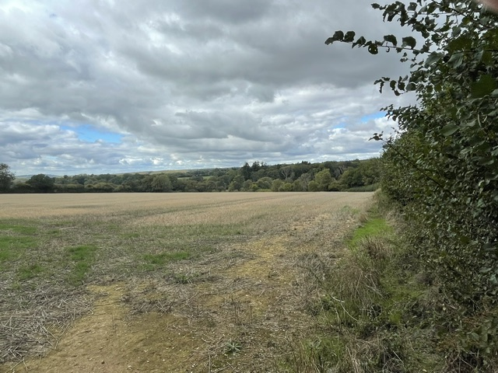
Figure 1 From the east

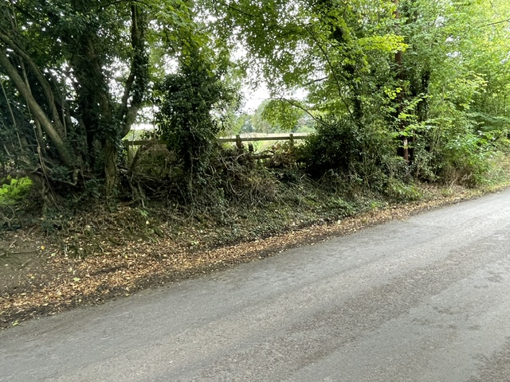
Figure 2 From the highway to the north

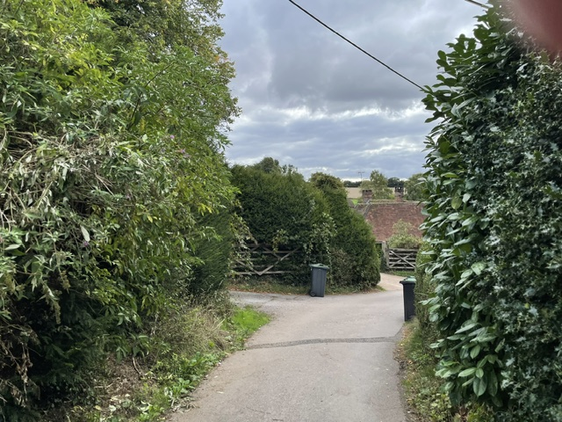
Figure 3 Looking southeast from the village

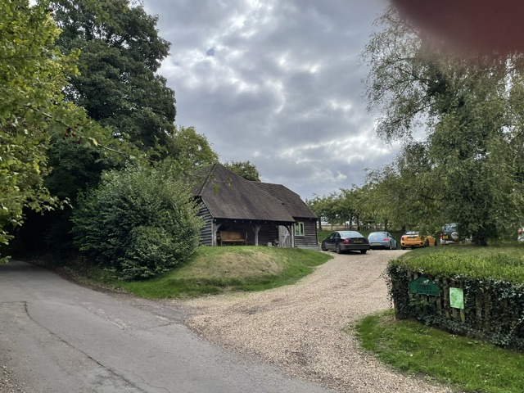
Figure 4 Looking south east from the entrance to the driveway

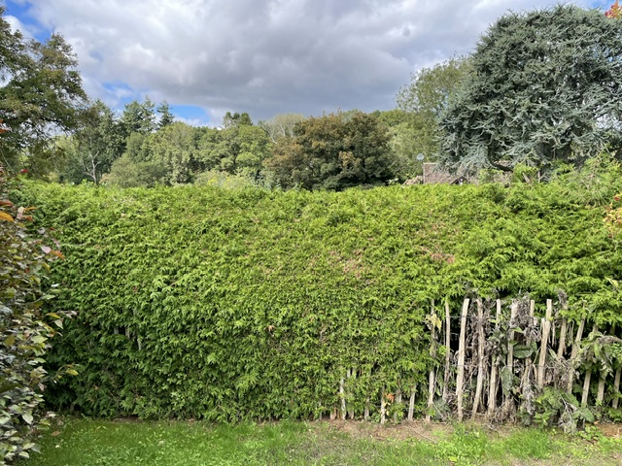
Figure 5 Looking towards Woodruft demonstrating intervening hedgerow and trees for screening

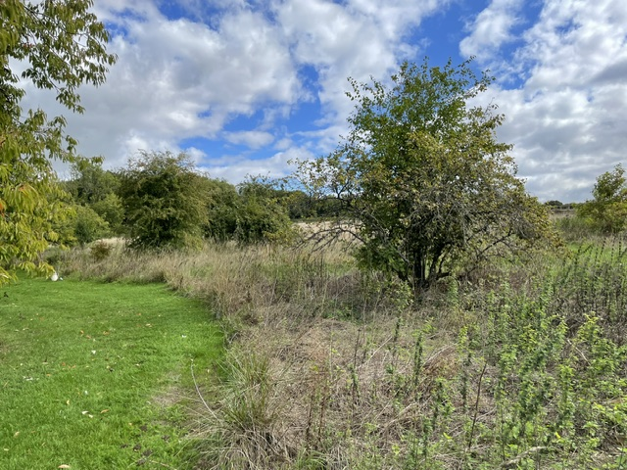
Figure 6 Looking east from the hedge at Woodruft

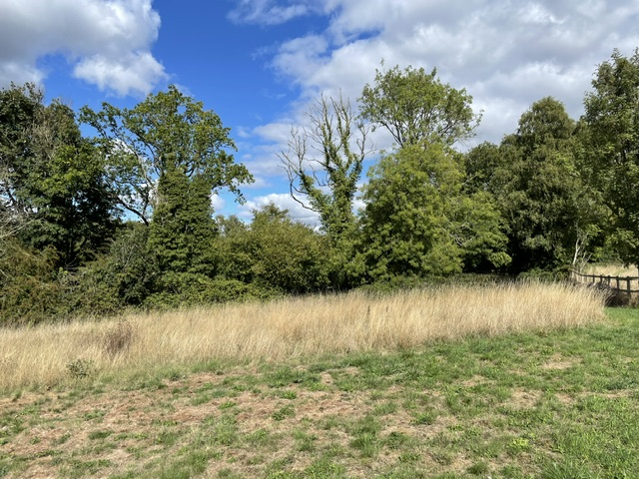
Figure 7 Looking north towards the highway

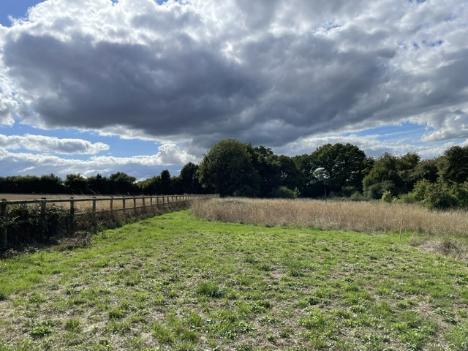
Figure 8 Looking south

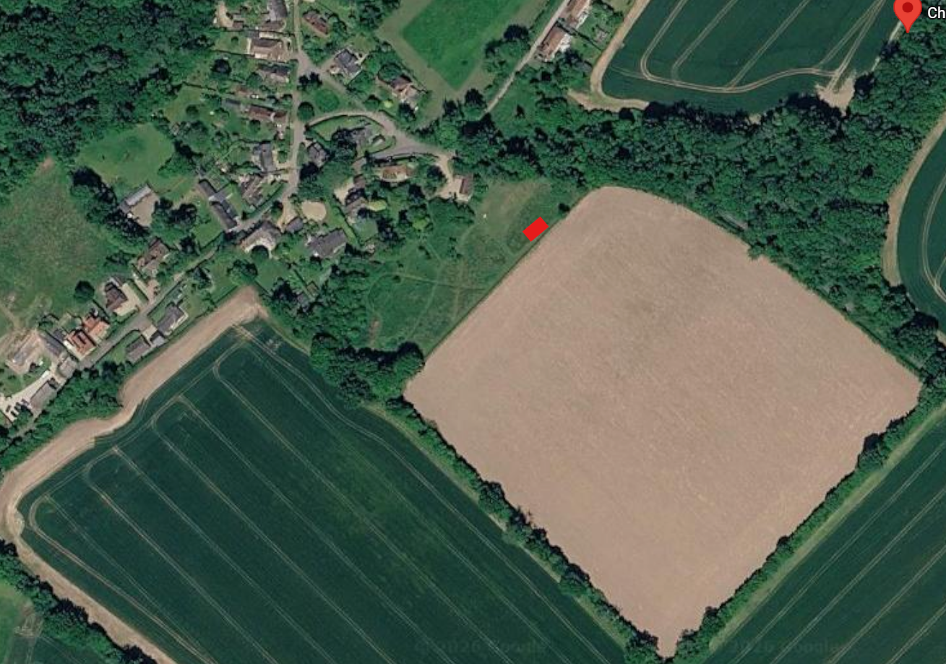
Figure 9 Solar array annotated by the red block, note the lack of receptors to the south

