APPLICATION FOR FULL PLANNING PERMISSION
DELEGATED REPORT

APPLICATION REFERENCE: | PL/2025/09906
APPLICATION TYPE: | Full Planning Permission
SITE ADDRESS: | The Old Paddock, Winsley, Wiltshire, BA15 2LN
DEVELOPMENT DESCRIPTION: | Proposal for x1 self-build dwelling and associated works.
RECOMMENDATION: | That Planning Permission be GRANTED

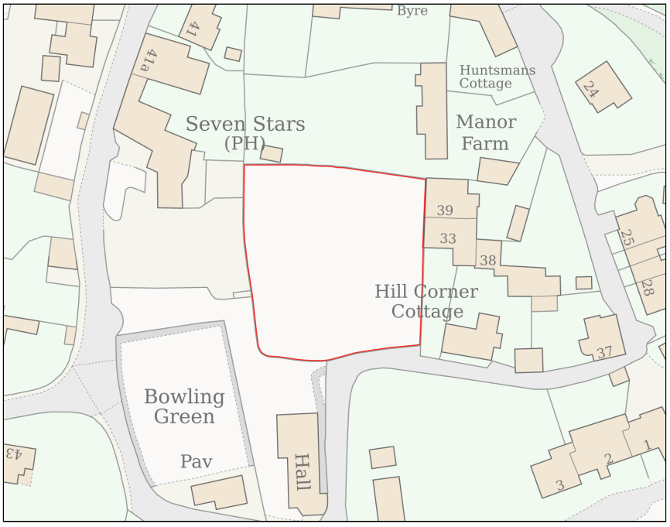

PROPOSAL

The proposal seeks the construction of a single self‑build dwelling within The Old Paddock at Winsley, together with a range of associated works. The scheme comprises a 1.5‑storey three‑bedroom dwelling with an attached triple garage, designed in a U‑shaped layout and positioned centrally within the site. Access would be created via a new gated entrance along the southern boundary, with the existing access point removed and reinstated as stone walling. The development includes the repair and partial rebuilding of the site’s existing dry‑stone boundary walls, the installation of roof‑mounted solar panels, and the provision of landscaping throughout the plot, including new tree planting and permeable surfacing for the driveway. Surface water drainage is proposed via soakaways, and foul drainage would connect to the mains system. The proposal also incorporates a range of ecological and tree‑related mitigation and enhancement measures as identified in the supporting assessments.

SITE DESCRIPTION / CONTEXT

The site comprises an undeveloped paddock located within the Settlement Boundary of the large village of Winsley and lies inside the Winsley Conservation Area. It is bounded by Bradford Road to the south, an unclassified highway, and is surrounded by a mix of residential and community uses. Several designated heritage assets sit in close proximity, including the Grade II listed Seven Stars Inn immediately to the west, Manor Farmhouse directly to the north, Bleak House approximately 30 metres to the north, and The Manor House around 40 metres to the southeast.

The land also falls within the Southern Fringes of the Cotswolds Special Landscape Area and forms part of a Defined Area of Minimum Change as set out in the former West Wiltshire District Plan. Ecological designations apply at a wider landscape scale, with the site lying within multiple core roost and SAC parcel buffers for Bechstein’s and Greater and Lesser Horseshoe bats, and a Priority Habitat located approximately 58 metres to the northeast. The paddock itself is enclosed by stone boundary walls and contains scattered trees and hedgerows, reflecting its semi-rural character despite its position within the built form of the village.

The application site is subject to the following planning policy constraints:

- Winsley Conservation Area (CA/W/229)
- The Seven Stars Inn – Grade II (1364051) immediately adjacent to the West
- Manor Farmhouse – Grade II (1021915) immediately adjacent to the North
- Bleak House – Grade II (1021916) 30m North
- The Manor House – Grade II (1364074) 40m southeast
- Bechstein 1.5km SAC Parcel Buffer
- GHS 4km Core Roost Buffer
- GHS 4km SAC Parcel Buffer
- LHS 2km Core Roost Buffer
- LHS 2km SAC Parcel Buffer
- Unclassified Highway – Bradford Road
- Special Landscape Area – SLA7 Southern Fringes of the Cotswolds
- Defined Area of Minimum Change (West Wiltshire District Plan)
- Priority Habitat 58m northeast
- Within the Winsley Settlement Boundary (Large Village)

PLANNING HISTORY

Reference No. | Proposal / Summary | Decision
W/03/02035/LBC | Extension and alterations to existing house | Approved
W/03/02034/FUL | Extension and alterations to existing house | Approved

RELEVANT LEGILSATION, POLICIES AND GUIDANCE

Wiltshire Core Strategy:

Core Policy 1 Settlement Strategy;
Core Policy 2 Delivery Strategy;
Core Policy 7 Spatial Strategy: Bradford on Avon Community Area;
Core Policy 50 Biodiversity and Geodiversity;
Core Policy 51 Landscape;
Core Policy 57 Ensuring High-Quality Design and Place Shaping;
Core Policy 58 Ensuring Conservation of the Historic Environment;
Core Policy 60 Sustainable Transport;
Core Policy 61 Transport and Development;
Core Policy 64 Demand Management;
Core Policy 67 Flood Risk;

The National Planning Policy Framework (NPPF) and The Planning Practice Guidance (PPG)

Wiltshire Design Guide

The Wiltshire Local Transport Plan 2011 – 2026: Car Parking Strategy (March 2015).

The Wiltshire Local Transport Plan 4 (LTP4) (March 2025)

West Wiltshire District Plan (June 2004) Saved Policies

Policy C3 Special Landscape Areas
Policy H18 Areas of Minimum Change

New Wiltshire Local Plan

At Full Council on 19 May 2026, the elected members of Wiltshire Council agreed to withdraw the emerging Wiltshire Local Plan. The said Plan has no material weight for the purposes of the application.

In accordance with Regulation 19 of the Town and Country Planning (Local Planning) (England) Regulations 2026, on 30th June 2026 Wiltshire Council published a notice of intention to prepare a new local plan for Wiltshire. The next stage is a Scoping Consultation which commenced on 2nd September 2026. This plan is at a very early stage and currently carries no weight for decision making.

CONSULTATION RESPONSES

Winsley Parish Council – No Objection (subject to condition)
Requested that if permission is granted, conditions be imposed to tightly manage construction traffic in order to minimise impacts on the local community, and that the applicant reconsider the inclusion of three rooflights due to potential adverse effects on bats known to forage within the area.

Local Highway Authority (Wiltshire Council) – No Objection (subject to conditions and informative)
The Highway Authority raises no objection to the amended scheme, noting improved on-site vehicle manoeuvring, appropriate off-street parking provision and an acceptable ungated access with suitable visibility. No objection is raised subject to conditions securing visibility splays, access surfacing, surface water control, parking and turning provision, closure of the existing access, and the submission of a Construction Management Statement in the interests of highway safety.

Ecology (Wiltshire Council) – No Objection (subject to condition)
The Council’s Ecologist raises no objection to the amended proposal subject to conditions, concluding that the development is unlikely to have adverse effects on protected species or the Bath and Bradford on Avon Bats SAC, and that no Appropriate Assessment is required. Conditions are recommended to secure compliance with the submitted ecological assessments, sensitive external lighting to protect bat foraging and commuting routes, and the delivery of biodiversity enhancements.

Conservation (Wiltshire Council) – Objection
Following the submission of revised plans, the Conservation Officer has maintained their objection on the grounds that the proposal would result in the loss of a historically open post-medieval paddock which makes a significant positive contribution to the character and appearance of the Winsley Conservation Area and the setting of several Grade II listed buildings. They conclude that the resulting harm—through the erosion of this rare green space, suburbanisation from new access and development, and loss of historic enclosure—is unjustified, represents permanent less-than-substantial harm, and is not outweighed by any public benefits, leading to a recommendation for refusal.

Archaeology (Wiltshire Council) – No Objection (subject to condition)
The site lies within the medieval core of Winsley, where although it has long functioned as a paddock, earlier phases of settlement may have left buried archaeological remains. As groundworks could expose such features, the archaeologist advises that all intrusive works be monitored by a qualified archaeologist, secured through a standard pre‑commencement archaeological condition.

Arboriculture (Wiltshire Council) – No Objection (subject to condition)
The Council’s Arboricultural Officer advises that trees on the site require protection during construction. A condition is therefore recommended to secure appropriate tree protection measures and working methods in accordance with BS5837 to safeguard their retention.

REPRESENTATIONS

A total of 22 third-party representations were received, comprising 12 comments in support and 10 objections. Supporters consider the proposal to be a well-designed and proportionate infill development that reflects local character through its scale, materials and siting. Many identify the applicants’ stewardship of Manor Farm as evidence that the scheme would be delivered sensitively, with particular support expressed by immediate neighbours who raise no concerns regarding amenity impacts. The repair of existing dry-stone walls, proposed landscaping and biodiversity enhancements are frequently referenced as positive elements, and several comments note that a single dwelling represents a preferable outcome to potential future redevelopment of the site.

Those objecting place significant weight on the paddock’s historic, landscape and ecological value as an undeveloped green space at the heart of the Winsley Conservation Area. Objectors consider the loss of this post-medieval pasture to result in permanent harm to the character and appearance of the Conservation Area and the setting of nearby listed buildings, with insufficient public benefit to justify that harm. Concerns are also raised regarding the scale and design of the dwelling, increased traffic along narrow lanes, pedestrian safety, biodiversity impacts and the precedent that development on the site might set.

ASSESSMENT

Section 38(6) of the Planning and Compulsory Purchase Act 2004 states:

"If regard is to be had to the development plan for the purposes of any determination to be made under the planning Acts, the determination must be made in accordance with the plan unless material considerations indicate otherwise."

In accordance with this statutory requirement, this application has been assessed against the relevant policies of the Development Plan, including the adopted Wiltshire Core Strategy (2015) and, where applicable, any made Neighbourhood Plans.

Principle of Development

Core Policy 1 (Settlement Strategy) and Core Policy 2 (Delivery Strategy) of the Wiltshire Core Strategy direct the majority of new development to within defined settlement boundaries in order to support sustainable patterns of growth. The application site lies within the settlement boundary of Winsley, a Large Village, and as such the principle of new residential development in this location is supported in broad policy terms.

However, the site is also located within an area identified as an Area of Minimum Change under saved Policy H18 of the West Wiltshire District Plan. This policy seeks to resist new housing development within such areas in order to protect important open spaces within villages, including paddocks and other undeveloped land which contribute to the character and spatial form of the settlement. The application site, forming an undeveloped paddock within the Conservation Area, falls within this category and the proposal is therefore in conflict with Policy H18.

Notwithstanding this conflict, it is recognised that Policy H18 forms part of a superseded development plan and must be afforded weight in accordance with its consistency with the National Planning Policy Framework. Whilst the objective of protecting important open spaces within settlements remains consistent with national policy, the restrictive nature of the policy, which seeks to prevent development in principle, is considered to carry reduced weight in the current policy context, particularly in circumstances where the Council cannot demonstrate a five-year housing land supply.

It is also noted that somewhat recent decisions within the locality, including planning permission ref. 16/06851/FUL, have accepted residential development within similar Areas of Minimum Change where the development was considered to be contextually appropriate and where the Council’s housing land supply position weighed in favour of sustainable development. Whilst that proposal related to garden land rather than a paddock and therefore is not directly analogous, it nevertheless demonstrates that Policy H18 is not applied as an absolute constraint and must be considered within the overall planning balance.

In this context, whilst the proposal conflicts with Policy H18, the principle of residential development on the site is not precluded. Instead, the acceptability of the development turns on the extent to which it would preserve or enhance the character and appearance of the Conservation Area, having regard to the statutory duties under the Planning (Listed Buildings and Conservation Areas) Act 1990, and whether the identified harm is outweighed by the public benefits of the proposal. These matters are considered in detail in the following sections of this report.

Conservation and Heritage

Core Policy 58 of the Wiltshire Core Strategy requires that designated heritage assets and their settings are conserved and, where appropriate, enhanced in a manner proportionate to their significance. In addition, Section 66(1) of the Planning (Listed Buildings and Conservation Areas) Act 1990 requires that special regard is given to the desirability of preserving the setting of listed buildings, whilst Section 72(1) requires that special attention is paid to the desirability of preserving or enhancing the character or appearance of Conservation Areas.

The application site lies within the Winsley Conservation Area and comprises an undeveloped paddock. Whilst the Conservation Area Appraisal does not identify the site specifically, it does highlight the importance of the historic spatial form of the village, including the relationship between buildings and open spaces, in contributing to its special character. In this context, the site is considered to form part of the network of incidental open spaces that contribute to the character and appearance of the Conservation Area.

The Council’s Conservation Officer advises that the paddock makes a positive contribution to the character of the area through its open and undeveloped nature and provides an area of green relief within a relatively closely arranged pattern of development. It is further considered to contribute to the wider setting of nearby heritage assets. The proposed development would introduce built form into this open space, resulting in a degree of domestication and erosion of its current character.

The introduction of the proposed dwelling would therefore alter the presently open character of the site and interrupt views across it from the adjacent lane. It is acknowledged that this would result in harm to the character and appearance of the Conservation Area, particularly through the reduction of openness and the change in the spatial relationship between built form and open land.

However, the extent of that harm must be carefully considered. The proposal would occupy only a proportion of the paddock, with the majority of the site remaining open. Whilst the land would function as domestic curtilage, the open character of the space would largely be retained, and visual permeability across the majority of the site would remain possible. The paddock is also experienced within a semi-enclosed context, being bounded by existing residential development and associated uses, and does not form part of a wider, uninterrupted rural landscape.

Furthermore, the proposed dwelling has been designed with clear reference to the prevailing character of the area, drawing on local building forms and materials, including those of nearby heritage assets such as Manor Farmhouse. The use of traditional materials, simple massing and the retention of existing boundary features ensures that the development would integrate sympathetically with its surroundings and would not introduce an overly suburban character into the Conservation Area.

Taking these factors into account, whilst it is accepted that the proposal would result in the loss of part of an open space that contributes positively to the Conservation Area, that space would not be wholly lost and its key characteristics, including its openness and role as visual relief, would continue to be experienced to a moderate degree; subject to suitable conditions which would prevent future permitted development rights concerning outbuildings or boundary treatments. The harm arising from the development is therefore considered to be less than substantial harm at a moderate level to the significance of the Conservation Area.

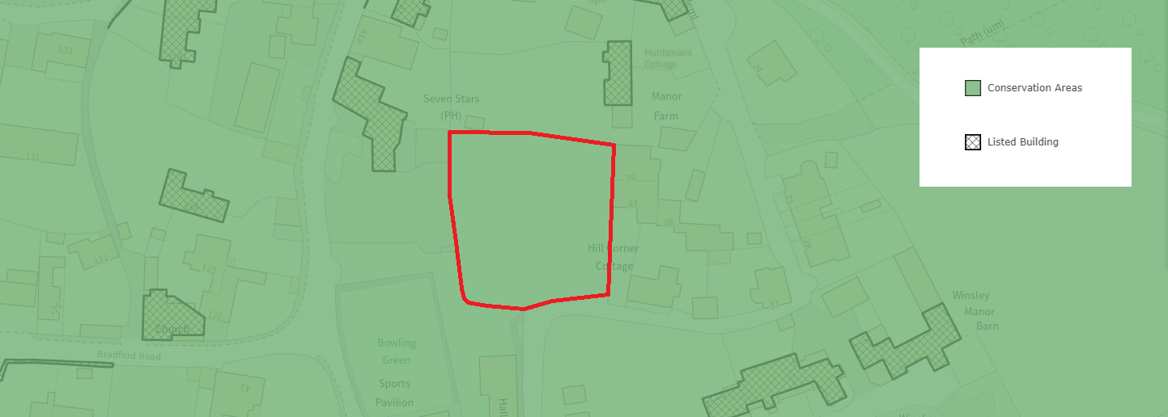
Listed Buildings and Conservation Area

The submitted Historic Environment Desk Based Assessment identifies the potential for archaeological remains within the site, given its historical use as part of the settlement pattern, although it concludes that any such remains are unlikely to be of sufficient significance to preclude development. The Council’s Archaeologist raises no objection in principle, subject to a condition securing a programme of archaeological investigation and recording. This approach is considered reasonable and proportionate and would be required in conjunction with any subsequent approval.

Design and Impact upon the upon the character and context of the area

Core Policy 57 of the Wiltshire Core Strategy seeks to secure high-quality design which responds positively to local character and distinctiveness. At the national level, Policy DP3 of the National Planning Policy Framework requires development proposals to respond positively to their context and integrate with and enhance their surroundings. Development should also reflect, where relevant, the principles of liveability, climate resilience, nature, movement, built form, public space and local identity. Assessment of design quality therefore requires consideration of the scale, appearance, massing, materials, layout and relationship of the proposal with both the host site and the wider character of the surrounding area.

The proposal comprises a 1.5-storey dwelling with accommodation partly within the roofspace, reaching approximately 6.9m to ridge height and 3.7m to eaves. The principal elevation adopts a symmetrical arrangement, with two evenly spaced gabled wall dormers extending through the eaves line and forming prominent vertical elements within the roof slope. To the rear, a projecting wing creates a broadly T-shaped plan form, adding articulation to the building. A subservient pitched-roof garage is attached to the western elevation, and a small oak-framed porch projects from the principal elevation.

The overall form, scale and height of the proposed dwelling closely reflect those of neighbouring properties within the immediate context. The ridge height broadly aligns with adjacent dwellings, including No. 38, and the separation distances to neighbouring buildings are consistent with the established pattern of development, thereby maintaining the prevailing density and spatial rhythm along this part of the village. The use of gabled wall dormers extending through the eaves line is also a feature evident within the surrounding area, most notably at Manor Farmhouse, and therefore represents a continuation of the established architectural approach rather than a departure from it. In reaching this conclusion, significant weight has been afforded to the amended plans which include the annotation "existing topography lowered by 300mm to reduce height of building in context". The assessment of the proposal has therefore been undertaken on the basis of the submitted levels information and amended street scene drawings, which demonstrate that the height of the proposed dwelling would closely align with the adjoining built form, including No. 38, and would not appear unduly prominent within the established building line. Accordingly, the acceptability of the scheme in design and visual terms is dependent upon the development being carried out in accordance with the approved plans and levels as submitted.

The surrounding part of Winsley is characterised by modest-scale dwellings constructed primarily of natural stone with slate roofs, arranged informally along a looped lane. A number of nearby properties incorporate similar design features, including gabled wall dormers, quoin detailing and traditional materials. The proposed dwelling draws directly from this established palette and architectural language.

In terms of materials and detailing, the dwelling would be constructed from rubble stone with natural slate roofing, and would incorporate ashlar quoins, stone lintels and cills, timber window frames and cast metal rainwater goods. The scheme also includes conservation-style rooflights across multiple elevations and a flue projecting above the ridge line. Whilst these elements reflect a traditional design approach, precise details of materials have not been provided and, given the site’s location within the Conservation Area, would need to be secured by condition.

The proposal includes photovoltaic panels on the southern roof slope of the garage. Whilst such features are not widely characteristic of the immediate Conservation Area, limited examples are present within the wider locality. Due to the garage’s set-back position and relatively low height, visibility of the panels would be limited in wider views, although they may be more apparent along a short stretch of the lane when approaching from the west. Overall, their visual impact is considered to be localised and relatively modest, particularly when balanced against wider sustainability objectives.

The flue, which projects above the ridge line, would form a minor vertical element within the overall composition. Although not a dominant feature locally, similar examples do exist within the area and, given its limited scale and visual prominence, it is not considered to result in any significant visual harm.

Core Policy 51 of the Wiltshire Core Strategy seeks to protect and enhance existing landscape features, including trees, recognising their contribution to local character and amenity. The site contains existing trees which form part of its wider setting, and the Council’s Arboricultural Officer has identified the need for appropriate protection during construction to ensure their retention. As such, a condition requiring a Tree Protection Plan and Arboricultural Method Statement in accordance with BS5837 is considered necessary and appropriate to safeguard these features throughout the development process.

Overall, the proposal demonstrates a well-considered and contextually informed design, drawing upon the prevailing materials, detailing and built form found within the surrounding area. The scale, height and spatial relationship of the dwelling reflect the established pattern of development, and the use of traditional architectural features, including gabled wall dormers, reinforces this approach. Whilst minor contemporary elements are introduced, these are limited in scope and do not detract from the overall character of the proposal. The development is therefore considered to accord with Core Policy 51 and 57 of the Wiltshire Core Strategy.

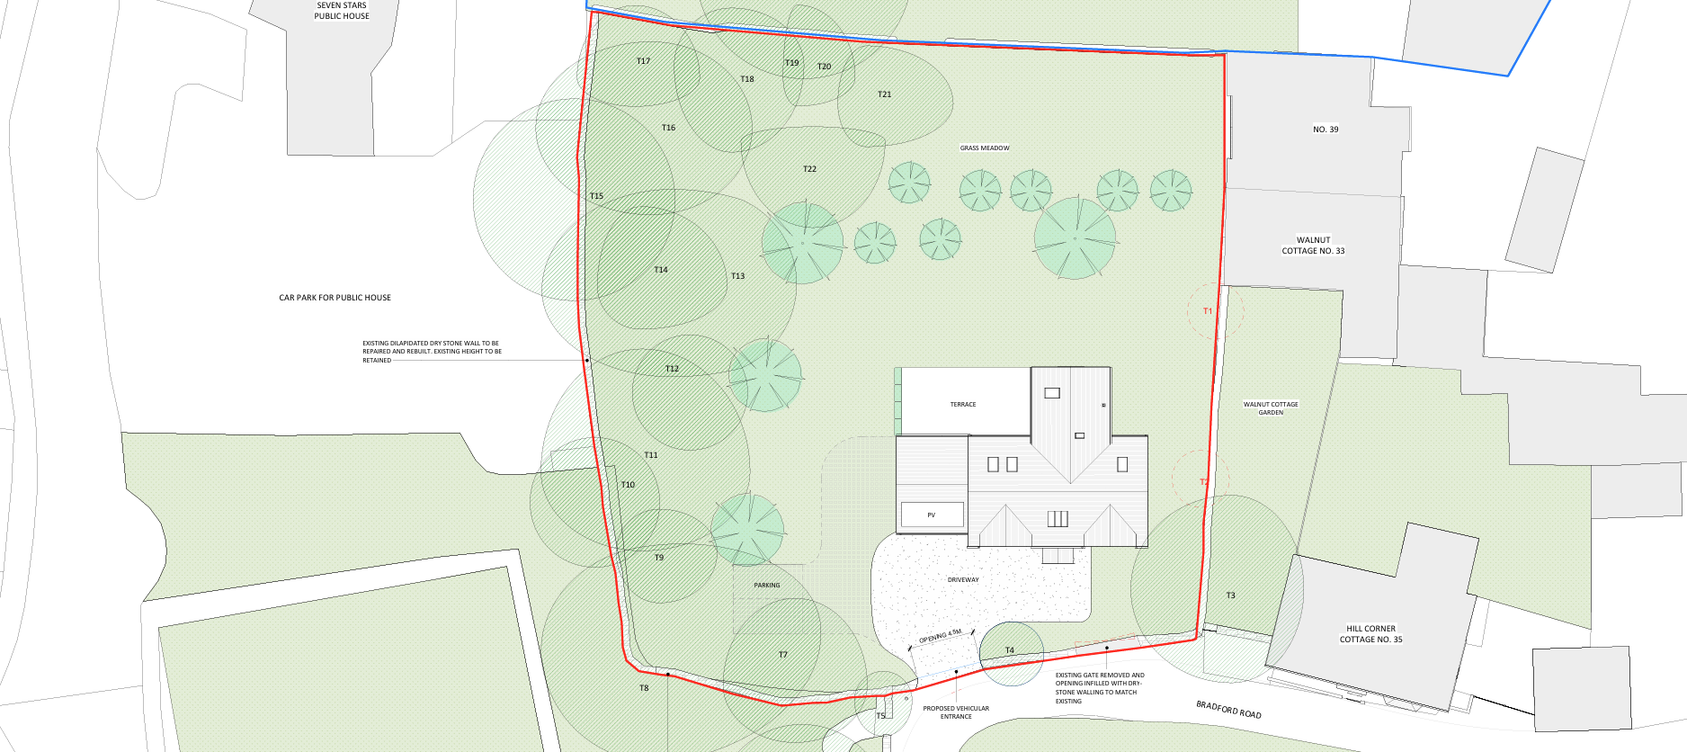
Proposed Site Plan

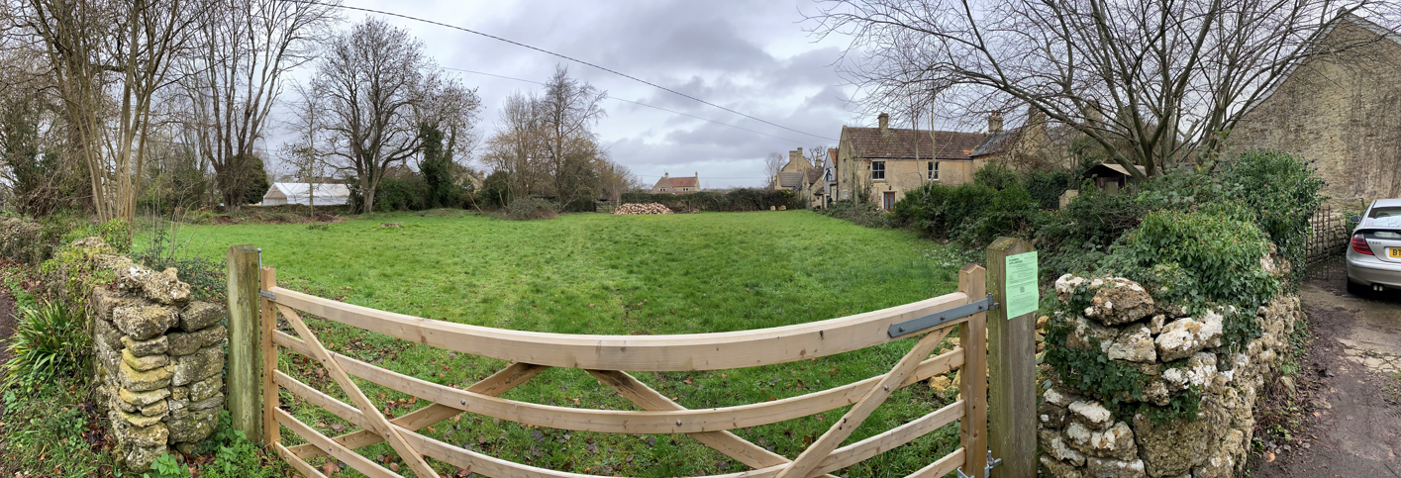
Site Visit (Panoramic Image)

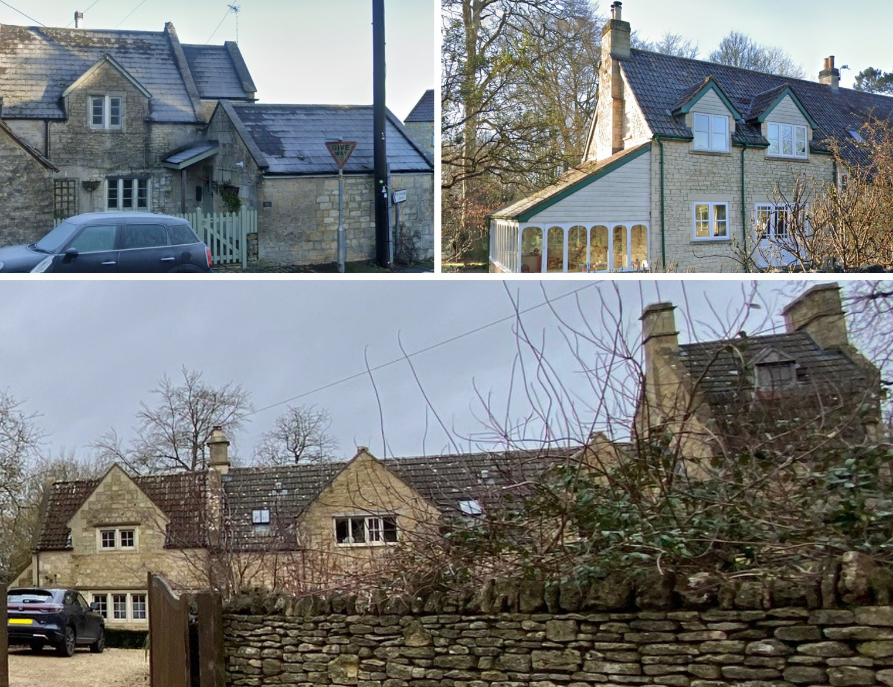
Local Dwelling Design 155 Winsley, 32 Winsley, and Manor Farmhouse

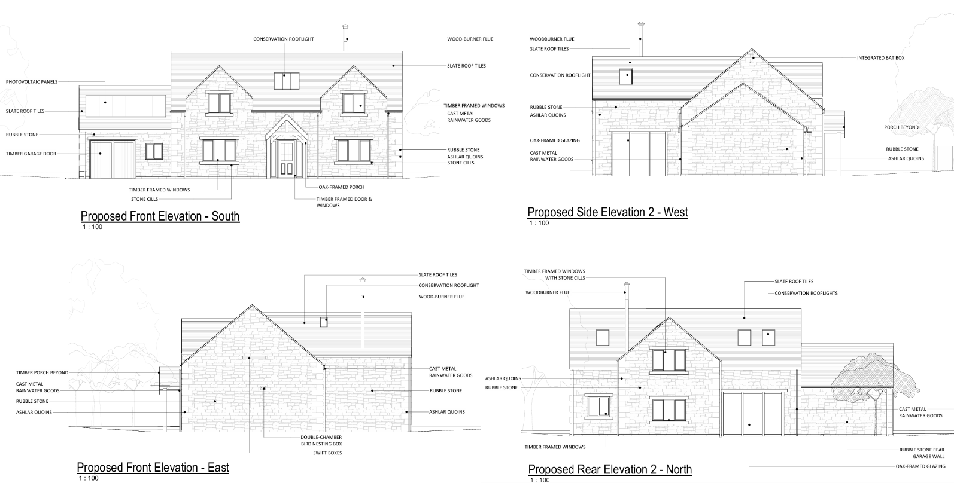
Proposed Elevations

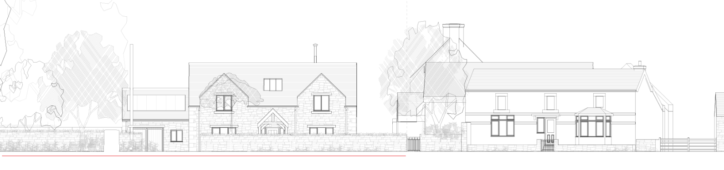
Proposed Street Elevations

Having regard to the above, the proposal complies with the design principles set out in Core Policy 57 of the Wiltshire Core Strategy and Appendix D of the Wiltshire Design Guide.

Amenity

Core Policy 57 criterion vii seeks to ensure development does not have an unacceptable impact upon the amenities of neighbouring occupiers. Nationally, Policy P3 requires development proposals to provide healthy living conditions for occupiers and users and to avoid unacceptable impacts arising from loss of light, outlook, privacy, noise, disturbance or other forms of pollution. Policy DP3 additionally requires development to create liveable and attractive places for existing and future users. Accordingly, the assessment below considers the effect of the proposal upon neighbouring occupiers and whether acceptable living conditions would be maintained.

The proposed dwelling would be positioned approximately 4.5 metres from the boundary with No. 38 and would have a ridge height of 6.9 metres, comparable to No. 38 and only marginally higher than No. 35. In this context, the relationship between the proposed dwelling and neighbouring properties reflects the established pattern of development in the locality, where buildings of a similar scale and height are situated in relatively close proximity. As such, it would be difficult to conclude that the proposal would result in a materially overbearing form of development without implying that the existing relationship between neighbouring dwellings is itself harmful. Whilst it is acknowledged that the development would introduce an increased sense of enclosure to the garden of No. 38, the retention of a 4.5 metre separation gap maintains a clear north–south corridor through the site, preserving a degree of openness and preventing the development from appearing unduly dominant or oppressive when viewed from adjoining properties.

In respect of privacy, the proposed eastern elevation facing towards No. 38 does not include any windows, thereby avoiding direct overlooking into neighbouring habitable rooms or private garden areas. Combined with the separation distance and intervening boundary treatment, the proposal would not give rise to a harmful loss of privacy. With regard to daylight and sunlight, shadow modelling indicates that some increased overshadowing would occur to No. 38, particularly during the winter months when late afternoon shadowing would extend across parts of the dwelling and a proportion of the garden. However, this impact is limited in duration, occurring predominantly towards the end of the day, and diminishes significantly through the spring and summer months, where effects are largely confined to the garden for a relatively short period. Given the orientation of the site and the seasonal nature of the impacts, the proposal would not result in a material loss of natural light to habitable rooms.

Overall, whilst there would be some change to the current open outlook and a degree of additional enclosure and shadowing experienced by neighbouring occupiers, these impacts are not considered to be so significant as to result in demonstrable harm to residential amenity sufficient to justify refusal.

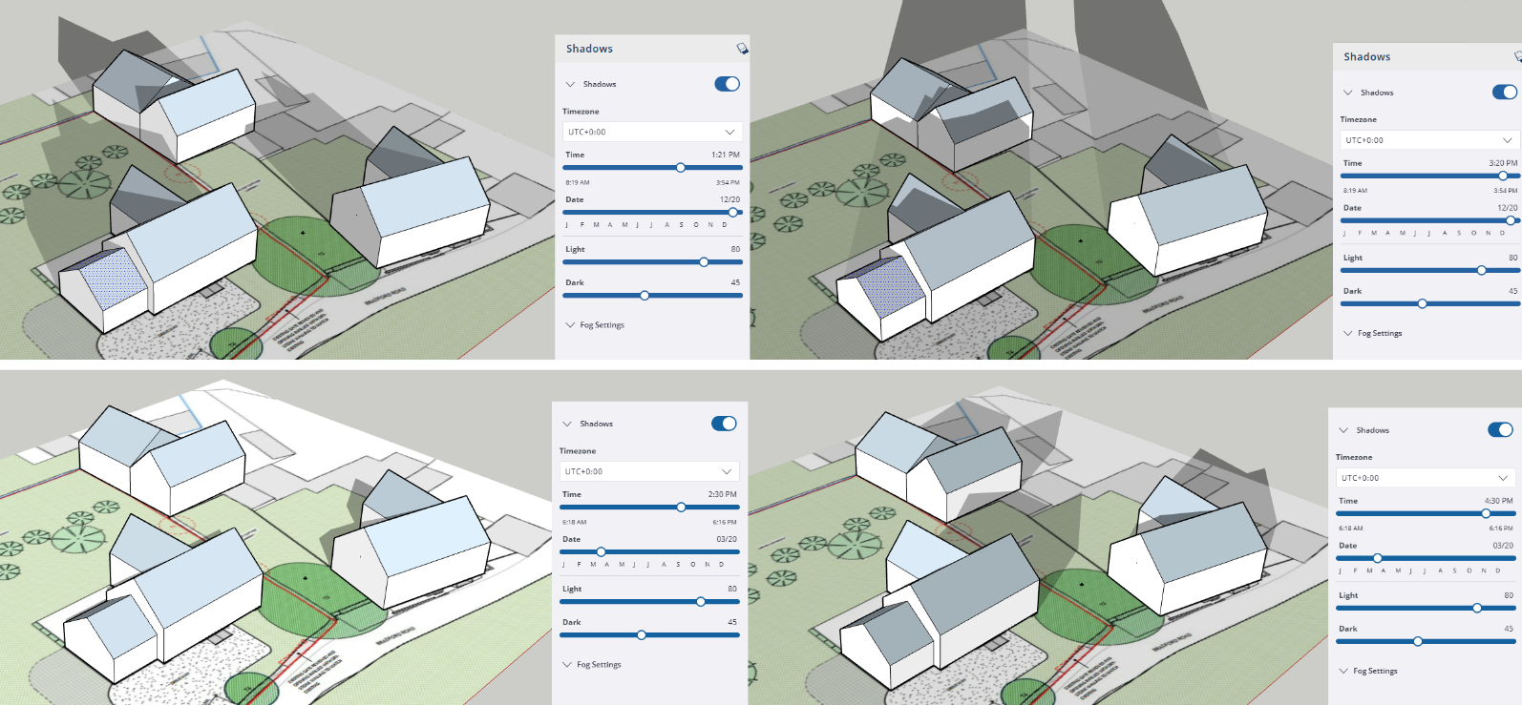
Shadow Mapping (Top: December 20 1:20pm and 3:20pm; Bottom: March 20 2:30pm and 4:30pm)

The proposal is appropriately sited, designed, and oriented to ensure that it would not result in unacceptable impact upon/to the amenities or living conditions of neighbouring residential occupiers, particularly in terms of outlook, privacy, or access to natural light.

The proposal therefore accords with Core Policy 57 point vii in respect of safeguarding residential amenity and Appendix D of the Wiltshire Design Guide.

Transport and Highways

Core Policies 60, 61 and 64 of the Wiltshire Core Strategy seek to promote sustainable transport, secure safe access arrangements and ensure adequate parking provision. Nationally, Policies TR3 and TR4 of the National Planning Policy Framework require development to be located in sustainable locations where appropriate, provide safe access arrangements, prioritise walking, wheeling and cycling, and provide suitable parking provision having regard to the nature and location of the development. Policy TR6 confirms that development should be refused where it would result in a severe adverse impact on the transport network or an unacceptable impact on highway safety after consideration of any mitigation measures.

Core Policy 64 of the WCS sets out the requirement for development to meet appropriate parking standards, as further detailed within the Wiltshire Local Transport Plan and the Car Parking Strategy. In this instance, the proposal comprises a three‑bedroom dwelling, which typically requires a minimum of two off‑street parking spaces. The submitted plans demonstrate provision for three spaces (one within the garage and two on the driveway), and the Highway Authority is satisfied that this level of provision is appropriate and policy compliant.

The proposal involves the formation of a revised vehicular access along the southern boundary, replacing the existing gated agricultural access. The Highway Authority has confirmed that visibility splays, as shown on the submitted plans, are acceptable, noting that they have been drawn from the carriageway edge which is considered appropriate in this low‑speed environment. The Authority also confirmed that internal vehicle manoeuvring has been improved compared to the previous scheme and is now acceptable.

It is noted that the site is served by a narrow, largely single‑track lane bounded by stone walls, with limited opportunity for passing. However, observations during the site visit indicate very low traffic volumes, with minimal vehicle movements and no conflict observed between users. The constrained nature of the road geometry is such that vehicle speeds are inherently low, which in turn reduces the likelihood and severity of potential conflicts. In this context, and given the proposal relates to a single dwelling generating a limited number of additional trips, it is not considered that the development would give rise to an unacceptable impact on highway safety or result in severe residual cumulative impacts, in accordance with paragraph 116 of the NPPF.

The Highway Authority raises no objection to the development subject to a number of planning conditions. These include requirements for the provision and ongoing retention of visibility splays; consolidation and surfacing of the first 5 metres of the access; implementation of measures to prevent surface water discharge onto the highway; retention of the ungated access; closure of the existing access; and provision of the access, parking and turning areas prior to first occupation. In addition, a Construction Management Statement is required to control construction traffic, parking, loading, dust, hours of operation and protection of the highway and surrounding environment.

These conditions are considered to satisfy the tests set out in paragraph 56 of the NPPF, in that they are necessary to ensure highway safety, directly relevant to the development, enforceable, precise, and reasonable in all other respects. Subject to the imposition of these conditions, the proposal is considered to comply with Core Policies 60, 61 and 64 of the Wiltshire Core Strategy and the relevant provisions of the NPPF.

Ecology

Core Policy 50 of the Wiltshire Core Strategy seeks to protect and enhance biodiversity interests and ensure development avoids unacceptable harm to ecological assets. National policy is set out within Policies N2 and N6 of the National Planning Policy Framework. These policies require development proposals to minimise impacts upon biodiversity, protect important habitats and species, and secure opportunities for biodiversity enhancement where appropriate. Where significant harm to biodiversity cannot be avoided, adequately mitigated or compensated for, development should be refused. Biodiversity Net Gain (BNG) was established as a mandatory aspect of planning evaluation through Schedule 7A of the Town and Country Planning Act 1990 (as amended by the Environment Act 2021 Schedule 14).

The application site is located within a number of ecologically sensitive designations at a wider landscape scale, including the Bath and Bradford on Avon Bats SAC consultation zones, as well as core roost and SAC parcel buffers for Bechstein’s, Greater Horseshoe and Lesser Horseshoe bats. A Priority Habitat is also located approximately 58 metres to the north‑east. These designations highlight the importance of the surrounding landscape for bat foraging and commuting. Notwithstanding this, the submitted Ecological Appraisal identifies that the application site itself comprises predominantly grassland of moderate ecological value, with important boundary features including trees and hedgerows, particularly along the western boundary, which are to be retained.

The Council’s Ecologist has reviewed the submitted information, including the Ecological Appraisal and Addendum, and raises no objection subject to conditions. It is concluded that, given the scale and nature of the development, there is no mechanism for significant adverse effects on the Bath and Bradford on Avon Bats SAC and the proposal has been screened out of Appropriate Assessment. Subject to the retention of key boundary features and the implementation of a sensitive external lighting strategy, the development is not expected to adversely affect bat foraging or commuting routes. Conditions are recommended to secure compliance with the ecological assessments, the delivery of biodiversity enhancements (including bat and bird boxes), and the submission and approval of an external lighting scheme to avoid harm to protected species.

With regard to Biodiversity Net Gain, the applicant has confirmed that the development constitutes self‑build/custom housebuilding and therefore seeks exemption from the mandatory BNG requirement. The Council’s Ecologist has assessed the proposal on this basis and raises no objection, subject to confirmation that the development meets the relevant exemption criteria. In order to ensure compliance with the statutory framework, it is necessary to secure the self‑build nature of the development through a legal agreement (Unilateral Undertaking). Should the development fail to meet the exemption criteria, a biodiversity gain plan would be required.

Overall, whilst the site lies within an ecologically sensitive landscape, the development footprint is limited and largely confined to lower value grassland, with important ecological features retained. Subject to the recommended conditions and the securing of the self‑build exemption, the proposal is considered to comply with Core Policy 50 of the Wiltshire Core Strategy and relevant provisions of the NPPF.

Flooding and Drainage

Core Policy 67 of the Wiltshire Core Strategy seeks to ensure that development is directed away from areas at greatest risk of flooding and is designed to minimise vulnerability to flooding whilst avoiding any increase in flood risk elsewhere. National planning policy relating to flood risk and drainage is contained within Policies F4 to F8 of the National Planning Policy Framework. Collectively, these policies establish a risk-based approach to the location and assessment of development proposals. The Framework requires flood risk to be properly assessed where necessary, seeks to direct development towards areas at the lowest risk of flooding through the application of the sequential approach where applicable, and ensures that development remains safe for its lifetime without increasing flood risk elsewhere. The policies also support the incorporation of sustainable drainage measures where appropriate in order to manage surface water runoff and reduce the potential for flooding.

The application site lies within Flood Zone 1 and is not identified as being at risk from fluvial, surface water or groundwater flooding. As such, the principle of residential development in this location is acceptable in flood risk terms. The proposal would introduce a relatively limited increase in impermeable area, comprising approximately 200sqm associated with the dwelling and courtyard, within a wider site area of approximately 1914sqm. The driveway and parking area, which account for a further area of hardstanding, are capable of being constructed using permeable materials and can be secured as such by condition.

Given the scale and nature of the development, and the absence of any identified flood risk constraints, it is considered that the proposal would not give rise to an increased risk of flooding either on‑site or elsewhere, subject to the implementation of an appropriate drainage strategy. It is therefore reasonable and proportionate to secure full details of surface water drainage, including the use of infiltration methods where feasible, via a pre‑commencement condition. Foul drainage is proposed to connect to the mains sewer and raises no objection in principle.

Subject to the imposition of a condition requiring the submission and approval of a surface water drainage scheme prior to the commencement of development, together with details of permeable surfacing, the proposal is considered to comply with Core Policy 67 of the Wiltshire Core Strategy and the relevant provisions of the NPPF.

Planning Balance

Policy S3 of the National Planning Policy Framework establishes a presumption in favour of sustainable development. For proposals within settlements, Policy S4 applies and states that development proposals should be approved unless the benefits of doing so would be substantially outweighed by any adverse effects when assessed against the national decision-making policies of the Framework as a whole.

The application site lies within the defined settlement boundary of Winsley, a Large Village, and therefore falls squarely within the scope of Policy S4. The proposal would deliver a single self-build dwelling in a sustainable location with access to existing services, facilities and infrastructure. Substantial weight is afforded to the provision of additional housing in accordance with Policy HO7 of the Framework, particularly in the context of the Council's acknowledged housing land supply shortfall. The proposal would also provide an additional self-build dwelling, contributing to housing choice and diversity within the district. No technical objections have been raised by the Highway Authority, Ecologist, Arboricultural Officer or Archaeologist, subject to conditions, and the design of the scheme is considered to respond appropriately to its context.

These benefits must be balanced against the adverse effects of the development. The proposal conflicts with saved Policy H18 of the West Wiltshire District Plan due to its location within an Area of Minimum Change and would result in less than substantial harm, at a moderate level, to the significance of the Winsley Conservation Area through the partial loss and domestication of an open paddock which contributes positively to its character and appearance. In accordance with Policy HE6 of the Framework, considerable importance and weight is attached to this identified harm.

In applying Policy S4(2), it is noted that the site is not safeguarded or allocated for a specific use, does not comprise existing recreational land or facilities, is not designated as Local Green Space, is not located within a Protected Landscape, and is not an area of particular importance for biodiversity or geodiversity as defined by Policy N6. The proposal would not result in the loss of land used for burial grounds, water storage or flood risk management purposes. Furthermore, the development does not engage any of the national decision-making policies within the Framework that require development to be refused in specific circumstances. Of particular relevance, the proposal would not result in substantial harm or total loss of a designated heritage asset, would not have an unacceptable impact on highway safety, and would not result in unacceptable ecological impacts.

The identified heritage harm is nevertheless a matter of significant weight. However, that harm falls within the less than substantial category, would affect only part of the paddock, and would not wholly remove the site's contribution to the character of the Conservation Area. The majority of the paddock would remain open, visual permeability across the site would be retained to a meaningful degree, and the dwelling has been carefully designed to reflect the established character of the area and nearby heritage assets.

Taking all matters into account, whilst the proposal gives rise to conflict with Policy H18 and causes moderate less than substantial harm to the Conservation Area, these adverse effects are not considered to substantially outweigh the benefits of the development when assessed against the national decision-making policies of the Framework taken as a whole. The proposal therefore accords with Policy S4 and the presumption in favour of sustainable development. Planning permission should therefore be granted.

CONCLUSION

The proposal is considered to be acceptable and in accordance with the relevant policies and guidance outlined above.

RECOMMENDATION: That Planning Permission be GRANTED subject condition, and the successful completion of a legal agreement to secure the self-build nature of the scheme

