APPLICATION FOR HOUSEHOLDER PLANNING PERMISSION
DELEGATED REPORT

APPLICATION REFERENCE: | PL/2026/03612
APPLICATION TYPE: | Householder Planning Permission
SITE ADDRESS: | 2 Piplar Ground, Bradford On Avon, BA15 1XF
DEVELOPMENT DESCRIPTION: | Construction of workshop building, replacement wall, alterations to main building, enclosure of front porch, change of garage door to window.
RECOMMENDATION: | That Planning Permission be GRANTED

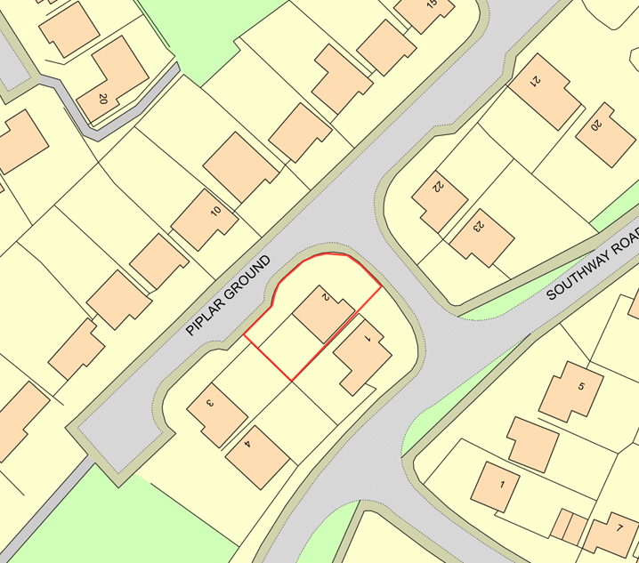

PROPOSAL

The application seeks planning permission for the adaptation of the existing integral garage to provide a study, utility room and toilet, together with the erection of a single storey side lean-to extension to be used as a workshop and storage area. The proposal also includes the relocation of the existing rear garden boundary wall to align with the side extension, thereby extending the existing garden area. The development would utilise materials to match the host dwelling, including matching brickwork, roofing materials and fenestration, and incorporates two rooflights within the roof slope of the proposed side extension.

SITE DESCRIPTION / CONTEXT

The application site relates to a detached dwelling situated within a planned residential estate developed during the late 1970s pursuant to planning permission W/78/00127/FUL. The estate is characterised by relatively low-density detached housing of consistent architectural appearance, predominantly comprising buff brick elevations, concrete tiled roofs and white uPVC windows and doors. The surrounding area contains generous landscaped areas, mature trees, hedgerows and residential planting which collectively contribute positively to the character of the locality. The site lies within the Bradford on Avon settlement boundary, within Flood Zone 1, and the Council's Strategic Flood Risk Assessment identifies the area as having a negligible risk of flooding from surface water or groundwater sources. The site is also located within the Greater Horseshoe Bat SAC consultation buffers and associated core roost zones.

PLANNING HISTORY

Reference No. | Proposal / Summary | Decision
W/78/00127/FUL | 23 dwellings | Approved

RELEVANT LEGISLATION, POLICIES AND GUIDANCE

Wiltshire Core Strategy:

Core Policy 1 Settlement Strategy;
Core Policy 2 Delivery Strategy;
Core Policy 7 Spatial Strategy: Bradford on Avon Community Area;
Core Policy 50 Biodiversity and Geodiversity;
Core Policy 51 Landscape;
Core Policy 57 Ensuring High-Quality Design and Place Shaping;
Core Policy 60 Sustainable Transport;
Core Policy 61 Transport and Development;
Core Policy 64 Demand Management;
Core Policy 67 Flood Risk;

Bradford on Avon Neighbourhood Plan 2013-2026

The National Planning Policy Framework (NPPF) and The Planning Practice Guidance (PPG)

Wiltshire Design Guide - Appendix D – Design Guidance for Householder extensions

The Wiltshire Local Transport Plan 2011 – 2026: Car Parking Strategy (March 2015).

The Wiltshire Local Transport Plan 4 (LTP4) (March 2025)

New Wiltshire Local Plan

At Full Council on 19 May 2026, the elected members of Wiltshire Council agreed to withdraw the emerging Wiltshire Local Plan. The said Plan has no material weight for the purposes of the application.

In accordance with Regulation 19 of the Town and Country Planning (Local Planning) (England) Regulations 2026, on 30th June 2026 Wiltshire Council published a notice of intention to prepare a new local plan for Wiltshire. The next stage is a Scoping Consultation which commences on 2nd September 2026. This plan is at a very early stage and currently carries no weight for decision making.

CONSULTATION RESPONSES

Bradford on Avon Town Council – Objects
Bradford on Avon Town Council objects to the proposal on the grounds that the extension and associated loss of the open green area would diminish the character and openness of the estate and have a harmful impact on the streetscene.

Local Highway Authority (Wiltshire Council) – No Objection (subject to condition)
A condition is requested to ensure that the proposed additional parking provision is completed prior to the use of the new extension.

REPRESENTATIONS

Two letters of objection were received, including one from the Bradford on Avon Preservation Trust. The objections raise concerns with the proposed relocation of the boundary wall and encroachment and positioning of the lean-to into the existing green verge. It is argued that the loss of this open landscaped area would erode the character, openness and visual amenity of the Southway Park estate, adversely affect the streetscene, result in the loss of existing planting, create an incongruous boundary alignment, and harm neighbouring residents' outlook. Objectors also note that previous similar proposals have been resisted and contend that the proposal is contrary to the original layout and design principles of the cul-de-sac.

ASSESSMENT

Section 38(6) of the Planning and Compulsory Purchase Act 2004 states:

"If regard is to be had to the development plan for the purposes of any determination to be made under the planning Acts, the determination must be made in accordance with the plan unless material considerations indicate otherwise."

In accordance with this statutory requirement, this application has been assessed against the relevant policies of the Development Plan, including the adopted Wiltshire Core Strategy (2015) and, where applicable, any made Neighbourhood Plans.

The principal issue in respect of the proposal relates to the status of the land situated between the side elevation of the dwelling and the highway frontage which is proposed to be enclosed within the private rear garden of the host dwelling. Objections have been received on the basis that the land forms part of the original open landscaped areas associated with the Southway Park estate and should therefore remain undeveloped. In response to these concerns, the Council has reviewed the historic planning records, estate layout plans and the associated Section 52 Agreement relating to planning permission W/78/00127/FUL. Having undertaken this review, no conclusive evidence has been identified demonstrating that the application site forms part of any protected amenity land or is subject to a legal restriction preventing its incorporation into the enclosed garden area of the property.

The Council has also carefully considered the objections raised concerning Condition 3 attached to the original estate permission which restricted permitted development rights with regard to extension and other development forward of the front elevations. The existence of that condition demonstrates that the original planning authority attached importance to maintaining the character and appearance of the estate and sought to retain control over development occurring beyond the principal built form of the dwellings. However, the condition did not impose an absolute prohibition on future development. Rather, it removed permitted development rights and required proposals of this nature to be the subject of a planning application. The submission of the current application is therefore in accordance with the process envisaged by that condition and the proposal must be assessed on its individual planning merits. The existence of the condition is therefore afforded weight as a material consideration, but it does not in itself establish that the principle of development is unacceptable.

It is important to distinguish between private land which contributes to local character and land which benefits from specific planning or legal protection as part of the public open space provision of the estate. Whilst concern has been raised regarding the loss of informal open land, the area of land is maintained by the occupiers of the host property as part of the unenclosed front and side garden. The ownership certificate indicates that all of the land is within the applicant’s ownership and no representations to the contrary have been submitted. As the available evidence indicates that the application site remains within private ownership and there is no evidence before the Council that the land serves a public function or forms designated public open space maintained by either the local authority or management company. In the absence of any identified restriction preventing its enclosure, this factor alone is not sufficient to render the principle of development unacceptable. It is acknowledged that the land does make a modest contribution to the open character of the estate layout and the effect of the proposal is considered in detail within the design assessment below.

The existence of a materially similar development within the immediate vicinity at 22 Piplar Ground, which was granted planning permission in 2023 (ref PL/2023/03184) is a material consideration which is given significant weight in consideration of the local context. Whilst each application must be considered on its own merits, that recent decision was assessed under the current development plan policy and demonstrates that a comparable form of development has previously been found acceptable within this established residential context. On balance, it is considered reasonable to regard the application site as forming part of the established residential curtilage and the issue for consideration is the placement of the boundary to the private amenity space rather than the change of use or status of the land. In principle, the proposal therefore represents an acceptable form of domestic development within the settlement boundary of Bradford on Avon, subject to consideration of the detailed impacts assessed below.

Design and Impact the upon the character and context of the area

Core Policy 57 of the Wiltshire Core Strategy seeks to secure high-quality design which responds positively to local character and distinctiveness. At the national level, Policy DP3 of the National Planning Policy Framework requires development proposals to respond positively to their context and integrate with and enhance their surroundings. Development should also reflect, where relevant, the principles of liveability, climate resilience, nature, movement, built form, public space and local identity. Assessment of design quality therefore requires consideration of the scale, appearance, massing, materials, layout and relationship of the proposal with both the host site and the wider character of the surrounding area.

The proposed garage conversion, side extension and associated boundary alterations are modest in scale and remain clearly subordinate to the host dwelling. The lean-to form reflects a traditional ancillary addition and its limited height ensures that the existing dwelling remains the dominant built form on the site. The submitted plans confirm that external materials will match those of the existing dwelling and, as such, the development would integrate satisfactorily with the character and appearance of both the host property and the wider estate. Whilst the inclusion of rooflights differs slightly from the previously approved development at No. 22 Piplar Ground, examples of similar rooflights are evident elsewhere within the immediate street scene, including on properties directly opposite the site, thereby providing an established local precedent.

Objections have been raised by the Town Council and local amenity groups regarding the perceived encroachment into open frontage areas and the resulting impact on the character of the estate. Whilst the contribution made by these open areas to the verdant character of the locality is acknowledged, the extent of land affected is limited and the proposal would not result in the loss of any significant trees, important landscape features or established active frontage and the land is not part of the defined public open space. The development would primarily replace a relatively small area of grassed land and reposition the garden wall by approximately 3 metres, increasing the enclosed rear garden by around 52 square metres. Given the modest scale of the enclosure, the limited visual intrusion of the extension itself and the absence of any specific designation or protection applying to the land, it is not considered that the proposal would result in such significant harm to the street scene or estate character as to warrant refusal. Accordingly, the proposal is considered to accord with the design and character objectives of the development plan.

Having regard to the above, the proposal complies with the design principles set out in the NPPF Policy DP3, Core Policy 57 of the Wiltshire Core Strategy, and Appendix D of the Wiltshire Design Guide.

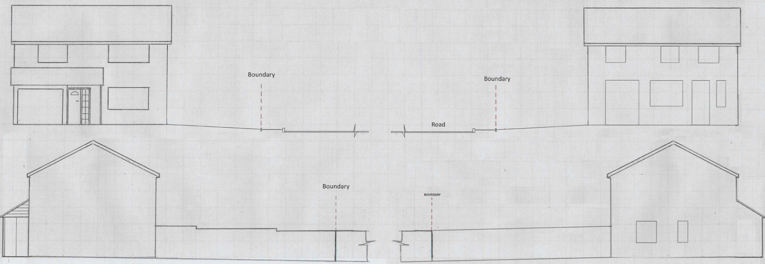
Existing Elevations

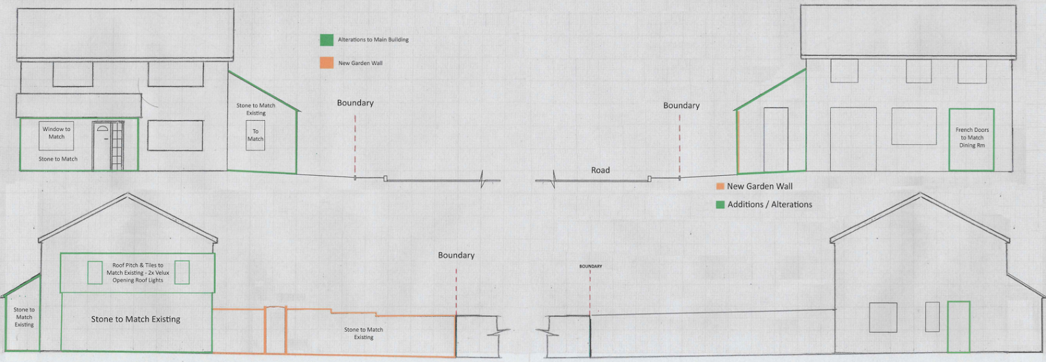
Proposed Elevations

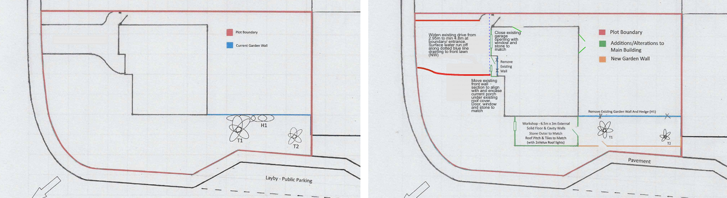
Existing and Proposed Block Plan

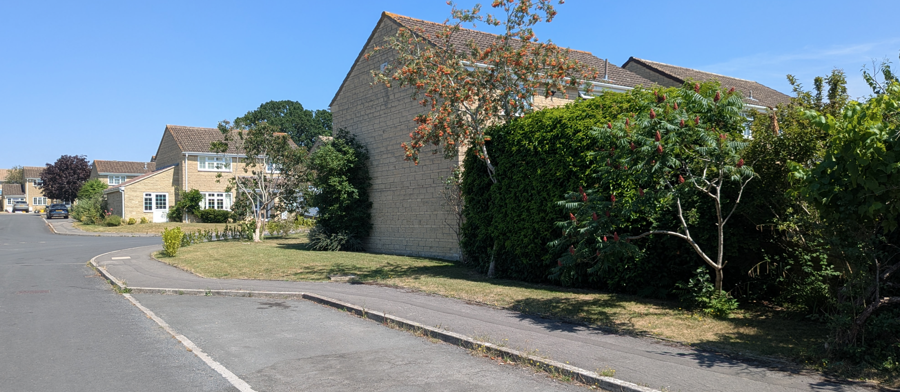
Site Image

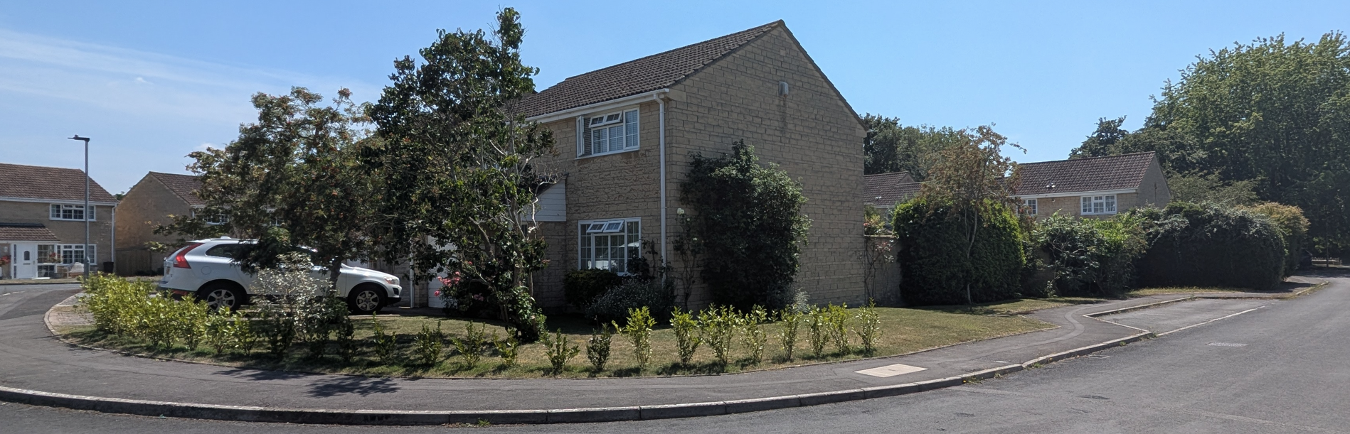
Site Image

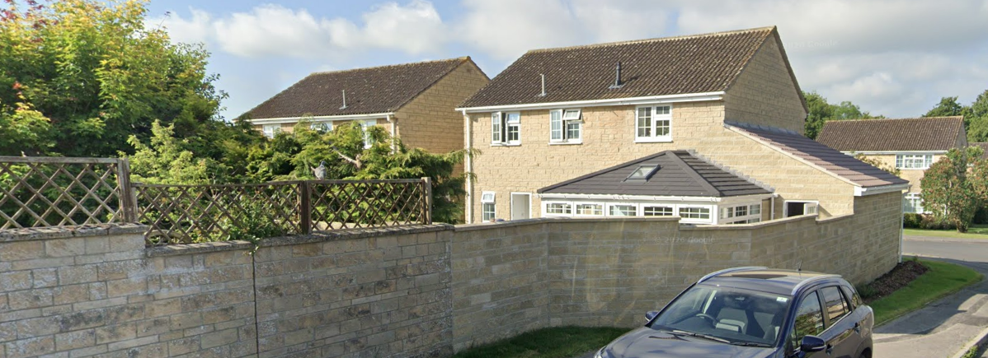
22 Piplar Ground (PL/2023/03184)

Amenity

Core Policy 57 criterion vii seeks to ensure development does not have an unacceptable impact upon the amenities of neighbouring occupiers. Nationally, Policy P3 requires development proposals to provide healthy living conditions for occupiers and users and to avoid unacceptable impacts arising from loss of light, outlook, privacy, noise, disturbance or other forms of pollution. Policy DP3 additionally requires development to create liveable and attractive places for existing and future users. Accordingly, the assessment below considers the effect of the proposal upon neighbouring occupiers and whether acceptable living conditions would be maintained.

The replacement window within the former garage opening and the window serving the proposed side extension would both face towards the public realm and would not give rise to overlooking of neighbouring private amenity areas. Similarly, the proposed rooflights and rear access door associated with the extension would not introduce opportunities for harmful overlooking or loss of privacy. The side extension is modest in scale, single storey in form and physically separated from neighbouring dwellings by the adjacent highway and intervening distances. Given its limited height and siting adjacent to the existing dwelling, the proposal would not appear overbearing, nor would it result in any significant loss of daylight or overshadowing to neighbouring properties. Indeed, owing to the orientation of the site and the fact that any shadowing effects would largely be contained within the shadow envelope already created by the host dwelling, the development is not considered to materially affect neighbouring living conditions. Accordingly, the proposal complies with the residential amenity objectives of the development plan.

The proposal therefore accords with Core Policy 57 point vii in respect of safeguarding residential amenity and Appendix D of the Wiltshire Design Guide.

Transport and Highways

Core Policies 60, 61 and 64 of the Wiltshire Core Strategy seek to promote sustainable transport, secure safe access arrangements and ensure adequate parking provision. Nationally, Policies TR3 and TR4 of the National Planning Policy Framework require development to be located in sustainable locations where appropriate, provide safe access arrangements, prioritise walking, wheeling and cycling, and provide suitable parking provision having regard to the nature and location of the development. Policy TR6 confirms that development should be refused where it would result in a severe adverse impact on the transport network or an unacceptable impact on highway safety after consideration of any mitigation measures.

The proposal originally raised concerns regarding the loss of the garage parking space and the resulting adequacy of off-street parking provision. During the course of the application, amended plans were submitted demonstrating an enlarged driveway capable of accommodating two vehicles side-by-side. These amendments were reviewed by the Council's Highway Officer, who subsequently confirmed that no highway objection is raised subject to a condition requiring the access and parking area to be appropriately surfaced prior to first use. Whilst the Town Council maintained its objection following reconsultation, the Council's Specialist Highway Officer is satisfied that adequate parking and manoeuvring provision can be achieved and that the proposal would not result in any unacceptable impact upon highway safety. The development is therefore considered compliant with the requirements of the adopted parking standards and relevant transport policies.

Ecology

Core Policy 50 of the Wiltshire Core Strategy seeks to protect and enhance biodiversity interests and ensure development avoids unacceptable harm to ecological assets. National policy is set out within Policies N2 and N6 of the National Planning Policy Framework. These policies require development proposals to minimise impacts upon biodiversity, protect important habitats and species, and secure opportunities for biodiversity enhancement where appropriate. Where significant harm to biodiversity cannot be avoided, adequately mitigated or compensated for, development should be refused. Biodiversity Net Gain (BNG) was established as a mandatory aspect of planning evaluation through Schedule 7A of the Town and Country Planning Act 1990 (as amended by the Environment Act 2021 Schedule 14).

The site lies within several bat consultation zones associated with the Bath and Bradford on Avon Bats Special Area of Conservation. Notwithstanding these constraints, the proposal is limited in scale and does not involve alterations to the existing roof structure, removal of mature trees, loss of significant hedgerows or disturbance to habitats likely to support protected species. The development would result primarily in the loss of a small area of managed grass and ornamental planting which is considered to have low ecological value. Given the nature and scale of the proposed works, it is not considered that the development would give rise to any significant adverse effects on protected species, ecological networks or the integrity of designated habitats. Accordingly, the proposal can be screened out of the requirement for Appropriate Assessment under the Habitats Regulations.

Flooding and Drainage

Core Policy 67 of the Wiltshire Core Strategy seeks to ensure that development is directed away from areas at greatest risk of flooding and is designed to minimise vulnerability to flooding whilst avoiding any increase in flood risk elsewhere. National planning policy relating to flood risk and drainage is contained within Policies F4 to F8 of the National Planning Policy Framework. Collectively, these policies establish a risk-based approach to the location and assessment of development proposals. The Framework requires flood risk to be properly assessed where necessary, seeks to direct development towards areas at the lowest risk of flooding through the application of the sequential approach where applicable, and ensures that development remains safe for its lifetime without increasing flood risk elsewhere. The policies also support the incorporation of sustainable drainage measures where appropriate in order to manage surface water runoff and reduce the potential for flooding.

The application site lies within Flood Zone 1 and is not identified as being subject to any significant flood risk constraints. Whilst the proposal will increase the extent of impermeable surface coverage through the side extension and enlarged curtilage, the increase is relatively minor in scale and relates to a small domestic development of approximately 52 square metres. Given the scale of the development and the absence of any known drainage constraints affecting the site, it is not considered that the proposal would materially increase flood risk either on-site or elsewhere. The proposal is therefore considered acceptable from a drainage and flood risk perspective.

CONCLUSION

The proposal represents a modest and well-contained form of residential development that would be sympathetic to the character and appearance of the host dwelling and wider estate. Having carefully considered the concerns raised regarding the status of the land and its contribution to local amenity, no substantive evidence has been identified to demonstrate that the land benefits from specific protection preventing its incorporation into the enclosed part of the property’s residential curtilage. The development would result in only limited visual change, would not cause harm to neighbouring residential amenity, highway safety, ecology or drainage interests, and mirrors a form of development previously approved within the immediate vicinity. Accordingly, the proposal is considered to accord with the relevant provisions of the development plan and there are no material considerations which indicate that planning permission should be withheld.

RECOMMENDATION: That Planning Permission be GRANTED subject to conditions

