APPLICATION FOR FULL PLANNING PERMISSION CASE OFFICER REPORT

APPLICATION REFERENCE: | PL/2026/03006
APPLICATION TYPE: | Full planning permission
SITE ADDRESS: | Land adjacent to no 35 Beaulieu Road, Amesbury, Salisbury, SP4 7PD
DEVELOPMENT DESCRIPTION: | Erection of a four-bedroom detached dwellinghouse with detached double garage and associated works including landscaping, boundary treatment, parking, drainage and renewable energy installations.
RECOMMENDATION: | Approve with Conditions

SITE DESCRIPTION/CONTEXT

The application site relates to land adjacent to No. 35 Beaulieu Road and currently forms part of the residential curtilage associated with that property. The site is irregular in shape, with a narrow frontage onto Beaulieu Road which widens towards the rear. The site lies within the settlement boundary of the Market Town of Amesbury, as identified by WCS policies CP1 (Settlement Strategy), CP2 (Delivery Strategy) and CP4 (Amesbury Community Area). The site lies within an established residential housing estate, that was originally built by the MoD but has since been sold off to the individual homeowners. Properties within the estate are characterised predominantly by two-storey detached and semi-detached dwellings set within linear plots. The surrounding properties are generally constructed of brick elevations beneath pitched tiled roofs with off-street parking provision. The site is bounded by other residential properties to the north, east and south; with a block of garages with parking located to the west.

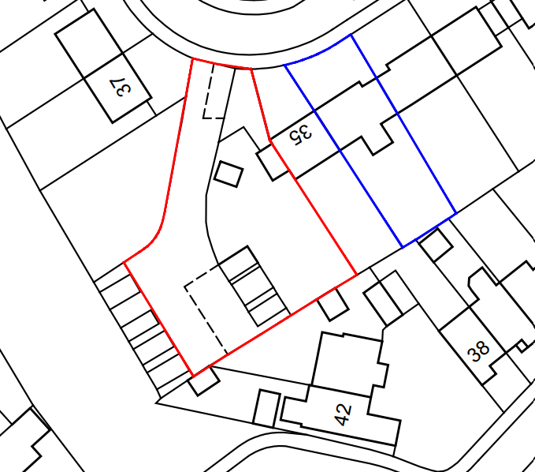

Whilst the site is some distance from the river it is in Flood Zone 1; and is in an area that is at low risk of Ground Water flooding (Groundwater levels are between 0.5m and 5m below the ground surface, there is a risk of flooding to subsurface assets, but surface manifestation of groundwater is unlikely), it is situated within the catchment of the River Avon Special Area for Conservation (SAC). The site is not located within a conservation area and there are no listed buildings on or immediately adjacent to the site. The site also lies within the 6.4km zone of influence of the Salisbury Plain SPA.

PROPOSAL

This is a full application proposing the subdivision of the existing residential curtilage at 35 Beaulieu Road and the erection of a detached four-bedroom dwelling together with a detached double garage, parking, landscaping, boundary treatments and associated works. The proposed dwelling would be two storeys and part single storey in height and of an L-shaped form. Vehicular access would be obtained from the existing shared driveway serving the site from Beaulieu Road. The existing garage/outbuildings on site will be demolished.

Existing and proposed site plan

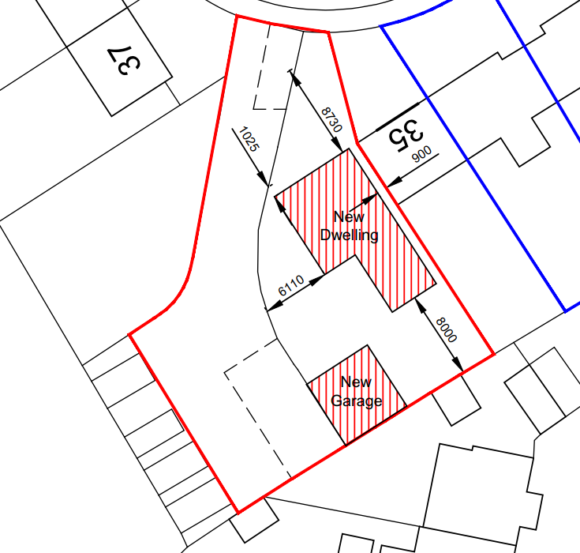

Proposed plans

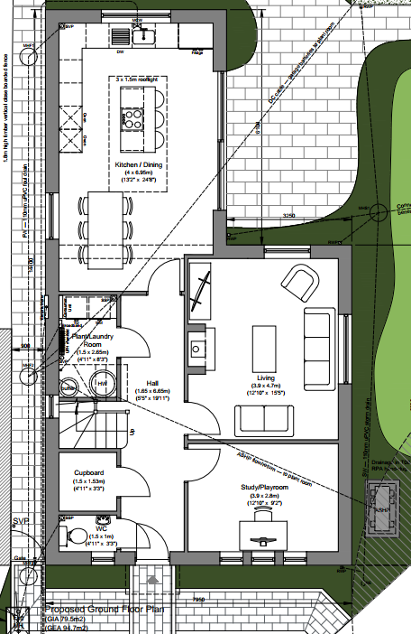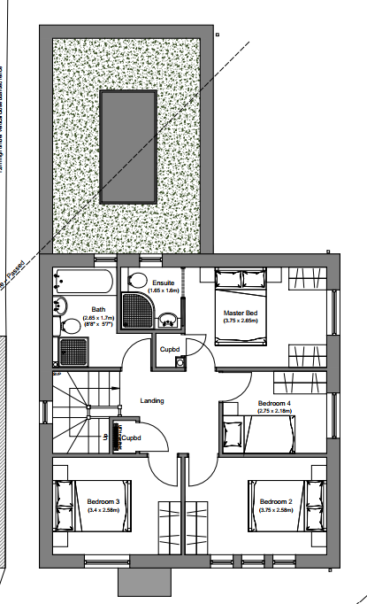

Proposed elevations
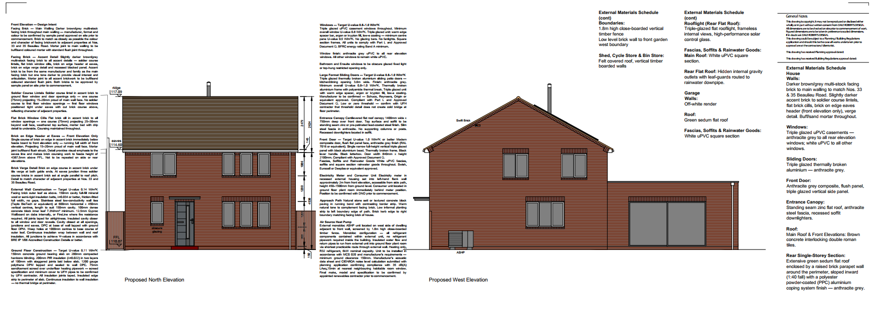
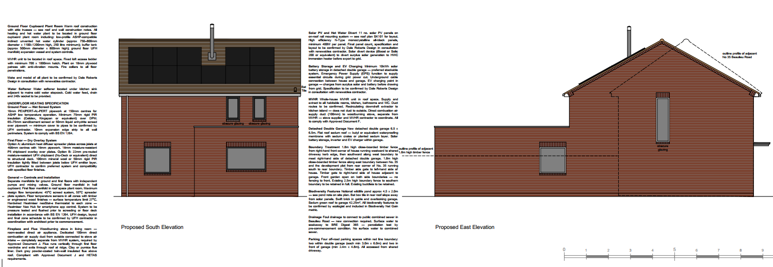

During the course of the application, amended plans were received to make design changes in relation to fenestration on the rear elevation, internal reconfiguration and to reduce the rear projection from two storey to single storey.

PLANNING HISTORY

Proposal / Summary
PL/2025/08345 - Outline planning permission: Some matters reserved Decision - Withdrawn by Applicant Date: 2/3/2026 – Erection of two semi-detached three-bedroom dwellings on land adjacent to 35 Beaulieu Road

RELEVANT LEGISLATION, POLICIES AND GUIDANCE

Statutory Legislation:

National Planning Policy:
- National Planning Policy Framework (NPPF)
- Planning Practice Guidance (PPG)

Development Plan:

The development plan for Wiltshire comprises the Wiltshire Core Strategy (WCS) (adopted January 2015) and any made neighbourhood plans, which remains the principal statutory planning document guiding development across the county. In line with Section 38(6) of the Planning and Compulsory Purchase Act 2004, planning decisions must be made in accordance with the development plan unless material considerations indicate otherwise.

Though the development plan is considered as a whole, those parts deemed to be particularly relevant to this application are listed below:

The adopted Wiltshire Core Strategy (WCS), with particular regard to:

Core Policy 1: Settlement Strategy
Core Policy 2: Delivery Strategy
Core Policy 3: Infrastructure Requirements
Core Policy 4: Spatial Strategy for the Amesbury Community Area
Core Policy 45: Meeting Wiltshire’s Housing Needs
Core Policy 50: Biodiversity and Geodiversity
Core Policy 51: Landscape
Core Policy 57: Ensuring High Quality Design and Place Shaping
Core Policy 58: Heritage
Core Policy 60 -64: Transport
Core Policy 69: Protection of the River Avon SAC

Draft Wiltshire Local Plan
At Full Council on 19 May 2026, the elected members of Wiltshire Council agreed to withdraw the emerging Wiltshire Local Plan. The said Plan has no material weight for the purposes of the application.

In accordance with Regulation 19 of the Town and Country Planning (Local Planning) (England) Regulations 2026, on 30th June 2026 Wiltshire Council published a notice of intention to prepare a new local plan for Wiltshire. The next stage is a Scoping Consultation which commences on 2nd September 2026. This plan is at a very early stage and currently carries no weight for decision making.

Supplementary Planning Documents and other Guidance:
- Wiltshire Design Guide (adopted April 2024)
- National Design Guide
- Creating Places Design Guide
- Wiltshire Council’s latest published Housing Land Supply Statement
- Wiltshire Local Transport Plan 2011-2026, adopted 2015 - including the Car Parking Strategy and Cycling Strategy, adopted 2015

ISSUES

Principle of Development
Design and Impact on the Character and Appearance of the Area
Amenity
Highways
Ecology
Trees
Archaeology

CONSULTATION RESPONSES

Town Council: Support

Highways: No objection subject to condition

Trees: No objection subject to condition

Ecology: No objection subject to condition

Archaeology: No objection subject to condition

REPRESENTATIONS

None received

ASSESSMENT

Section 38(6) of the Planning and Compulsory Purchase Act 2004 states:

"If regard is to be had to the development plan for the purposes of any determination to be made under the planning Acts, the determination must be made in accordance with the plan unless material considerations indicate otherwise."

In accordance with this statutory requirement, this application has been assessed against the relevant policies of the Development Plan, including the Wiltshire Core Strategy (2015) and, where applicable, any made Neighbourhood Plans. Consideration has also been given to the policies of the NPPF (NPPF) as a material consideration in the assessment.

The assessment below considers each of the main issues identified above. Each topic is assessed in turn with reference to the relevant policy context, the evidence submitted, consultee responses, and all other material considerations, before a conclusion is reached.

Principle of Development

The application site lies within the settlement boundary of Amesbury, a Market Town identified under Core Policies CP1, CP2 and CP4 of the Wiltshire Core Strategy. These policies support sustainable residential development within the limits of development where it would help meet housing needs and make efficient use of land.

The proposal would involve the subdivision of an existing residential curtilage and the erection of one additional dwelling within an established residential area. The site is surrounded by existing residential development and has convenient access to services, facilities and public transport opportunities within Amesbury.

The proposal would make a modest contribution towards housing delivery in a sustainable location. This attracts weight in favour of the development, particularly given the Council's current housing land supply position. The principle of residential development is therefore considered acceptable, subject to compliance with all other relevant policies of the Development Plan.

The NPPF also contains national policies relating to the location of development. Policies S3-S5 distinguish between development within settlements and development in the countryside, support sustainable patterns of growth, and require decisions to have regard to the role and function of settlements, accessibility to services and facilities, and other site-specific considerations.

The principle of development should be assessed having regard to the Development Plan as a whole, the NPPF and all other material considerations. The weight afforded to individual policies will depend upon the nature, scale and location of the development proposed.

Policy HO7 of the NPPF recognises the importance of delivering homes which contribute towards meeting the evidenced accommodation needs of the community and states that substantial weight should be given to the benefits of providing such homes.

The principle of residential development within the settlement boundary is acceptable, subject to the details of the scheme itself and other material considerations which include character, design, highway safety/parking, amenity, ecology and impact on nearby trees.

5 Year Housing Land Supply

The Council's latest Housing Land Supply Statement provides the most up-to-date position regarding the availability of deliverable housing land within Wiltshire and is a material consideration in the determination of planning applications.

The NPPF requires local planning authorities to identify and maintain a supply of specific deliverable housing sites. Housing need, housing requirements, and the supply of deliverable sites are addressed through Policies HO1 to HO6 (for plan-making) and HO7 to HO13 (for decision taking) and Annex D of the NPPF. Annex D sets out the methodology for calculating housing need, assessing land supply, the application of housing land supply buffers using the latest Housing Delivery Test results, and establishing a five-year supply of deliverable housing sites.

The Council's current housing land supply position demonstrates a supply of 2.8 years of deliverable housing land against the relevant housing requirement. This position is a material consideration when assessing proposals for residential development. Where a shortfall exists, this indicates that the Council is unable to demonstrate a full five-year supply of deliverable housing sites and this is capable of attracting significant weight in favour of proposals which would contribute towards meeting identified housing needs. Conversely, where a five-year supply can be demonstrated, this is also a material consideration to be afforded appropriate weight in the overall planning balance.

In determining this application, regard has been had to the Council's current housing land supply position, the relevant housing policies of the development plan, the housing objectives of the NPPF, and all other material considerations. The extent to which the Council's housing land supply position affects the weight to be afforded to housing delivery and other material considerations has been considered as part of the planning balance set out below.

The contribution that this proposal would make towards meeting housing needs, together with any other benefits and harms arising from the development, is assessed within the overall planning balance and conclusion sections of this report.

Design and Impact on the Character and Appearance of the Area

Core Policy 57 of the Wiltshire Core Strategy requires development to achieve a high standard of design that responds positively to local character, context and distinctiveness.

Policies DP1-DP4 of the NPPF seek to ensure that development is well-designed, visually attractive, sustainable and responsive to its surroundings. Development should contribute positively to local character, create high quality places and support healthy and inclusive communities.

The Wiltshire Design Guide provides further guidance on achieving high quality, context-led design and should be taken into account where relevant.

The application site is somewhat unusual in its shape and configuration, comprising an irregularly shaped plot with a relatively narrow frontage onto Beaulieu Road which widens significantly towards the rear. The proposal seeks to subdivide the existing residential curtilage associated with No.35 and erect a detached four-bedroom dwelling with a detached double garage and associated works. Notwithstanding the site's irregular shape, it is considered to be of sufficient size to accommodate the proposed development whilst retaining appropriate levels of private amenity space, parking provision and landscaping. The resulting plot would not appear overly cramped in this context or represent an overdevelopment of the site.

The surrounding area is characterised predominantly by two-storey detached and semi-detached dwellings set within residential plots of varying sizes. Whilst there is no uniform pattern of development within the estate, the prevailing character is distinctly residential in nature. The proposed dwelling would sit comfortably within this established context and would remain visually and functionally related to the surrounding built form. As such, the proposal would not appear isolated, incongruous or out of keeping with the character of the wider area.

The proposal includes the demolition of the existing garages and outbuildings located within the site as shown in the photo below. These structures are functional in appearance, make little positive contribution to the visual character of the locality and are not considered to be of architectural merit. Their removal raises no concerns and will be an enhancement to the locality

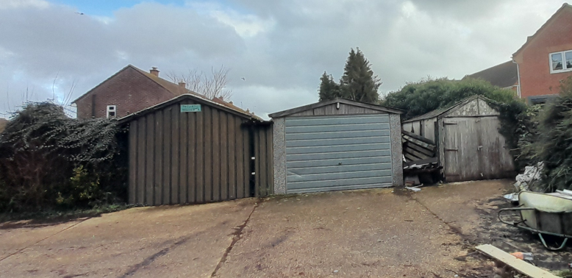

In terms of scale and form, the proposed dwelling would comprise a predominantly two-storey building with a single-storey rear projection arranged in an L-shaped configuration. The overall scale, height, massing and proportions of the dwelling are considered comparable to surrounding residential properties and reflective of the prevailing domestic character of the estate. The dwelling would sit comfortably within the plot and would not appear unduly dominant or visually intrusive within the street scene or wider townscape.

Photo below of the street scene with the applicants proposed streetscene elevation below for comparison.
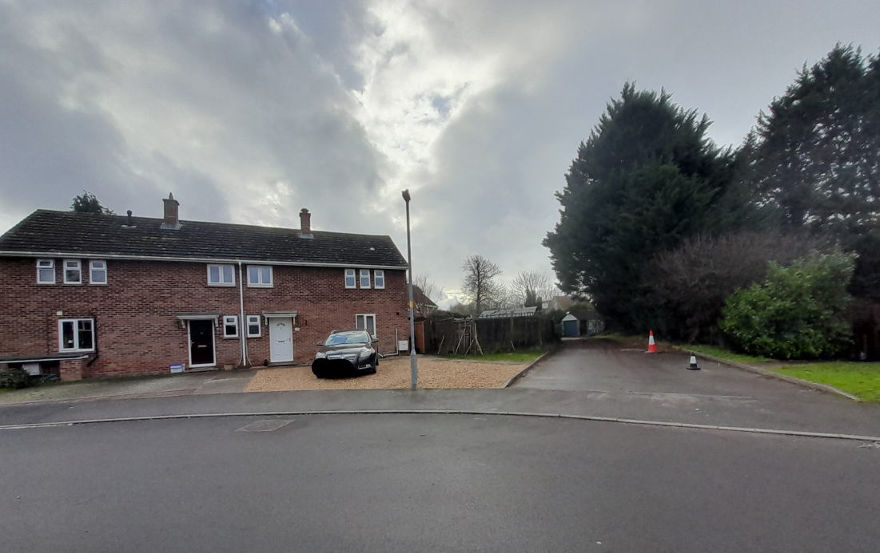
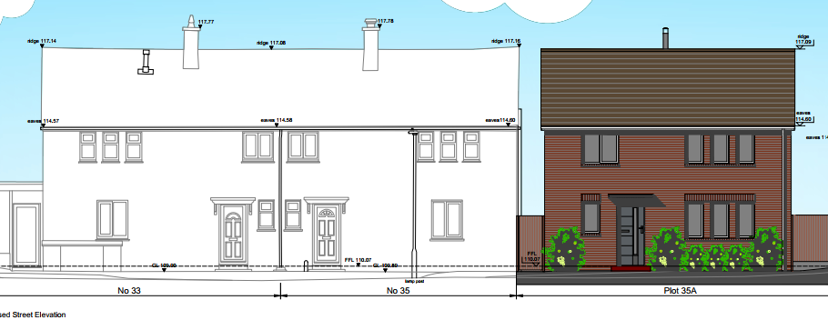

The proposed materials comprise brick elevations beneath a tiled roof, reflecting the prevailing material palette found throughout the surrounding estate. The proposed dwelling would predominantly incorporate white uPVC windows, with anthracite grey frames limited to the rear elevation. Given the limited extent of this variation and the otherwise in keeping appearance of the dwelling, the proposal is considered sympathetic to the character of the area and would not result in any unacceptable visual harm.

The proposed single-storey rear element and detached garage incorporate flat roof forms. Whilst these are not considered to be the particularly attractive in terms of design, they are subservient to the main dwelling and would be positioned towards the rear of the site where they would have very limited visibility from the public realm. Consequently, they would not materially detract from the overall appearance of the development or the character of the surrounding area.

Overall, the proposal is considered to represent an appropriate form of residential development that would integrate satisfactorily with its surroundings in terms of its layout, scale, massing, appearance and materials. The development would make efficient use of land within the settlement boundary whilst respecting the established character of the area and would not result in an incongruous form of development. The proposal therefore accords with Core Policy 57 of the Wiltshire Core Strategy, the design objectives of the NPPF and the guidance contained within the Wiltshire Design Guide.

Amenity

Core Policy 57 (Point vii) of the Wiltshire Core Strategy requires development to respect the amenity of existing occupants and ensure appropriate amenity levels for future residents.

Policy P3 of the NPPF requires development to be appropriate for its location, taking account of its likely effects on health, living conditions and the environment. In particular, Policy P3(2)(b) requires development to avoid giving rise to unacceptable impacts on the living conditions of neighbouring residents and occupiers. In assessing amenity impacts, regard should be had to matters including daylight and sunlight, outlook, privacy, overbearing impacts and other effects on residential amenity.

These policies guide the assessment of amenity impacts. Each of the below matters has been assessed having regard to the specific site context and layout of the proposal.

The application site is located within an established residential area and is surrounded by existing dwellings. The properties most likely to be affected by the proposal are No.35 Beaulieu Road, from whose residential curtilage the application site is formed, together with the dwellings to the rear at Nos. 38-42 Blackcross Road.

In respect of No.35 Beaulieu Road, the proposed dwelling would be positioned adjacent to the existing dwelling and would project beyond its rear elevation. However, during the course of the application the scheme was amended to replace the original two-storey rear element with a single-storey addition. The single-storey element incorporates a flat roof design, which assists in reducing its overall height and visual presence. The submitted plans demonstrate that the proposed two-storey element would remain outside a 45-degree line taken from the nearest ground-floor rear window serving No.35. Whilst the assessment does not extend to the first-floor window, the relationship nevertheless assists in demonstrating that the development would not result in an unacceptable loss of light or outlook.
.

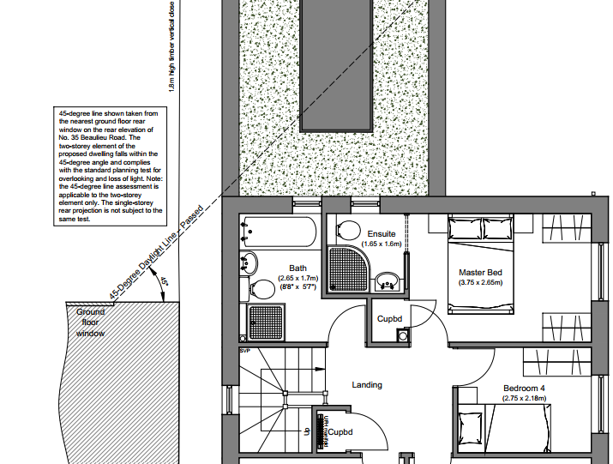
Whilst there will inevitably be some change to the outlook currently experienced from No.35, it is not considered that the scale, siting or design of the development would result in an unacceptable overbearing impact or significant loss of light to neighbouring occupiers.

With regard to privacy, the proposed dwelling includes a first-floor stairwell window within the eastern elevation facing towards No.35. This window can be secured as obscure glazed and fixed shut by condition. The remaining side-facing ground floor window serves a habitable room but, by virtue of its position at ground-floor level and the presence of boundary treatment, would not result in harmful overlooking. Subject to appropriate conditions securing obscure glazing to the identified windows, the proposal would not create unacceptable loss of privacy for the occupiers of No.35.

In relation to the properties to the rear at Nos.38-42 Blackcross Road as shown in the photo below, sufficient separation distances would be maintained between the proposed dwelling and existing neighbouring properties to avoid unacceptable overbearing, overshadowing or loss of light impacts. Furthermore, the rear elevation contains only first-floor bathroom windows facing towards these properties. These windows can be secured as obscure glazed and restricted opening by condition and would therefore not result in unacceptable overlooking or loss of privacy

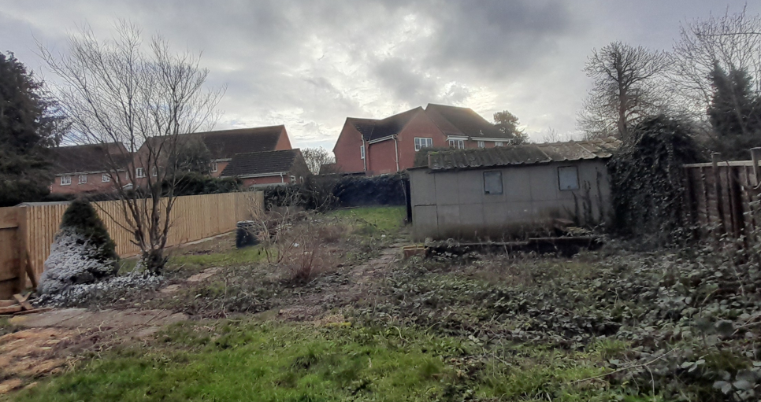

The first-floor windows within the western elevation would primarily overlook the existing parking area and garages to the west of the site. Owing to the layout of the surrounding development and the offset relationship between neighbouring plots, these windows would not result in any material overlooking of neighbouring residential properties.

With regard to future occupiers of the proposed dwelling, the development would provide a good-sized rear garden together with appropriately sized internal living accommodation. The submitted floor plans demonstrate that the dwelling would exceed the minimum gross internal floor area required for a four-bedroom dwelling under the Nationally Described Space Standards (NDSS), and all bedrooms would meet the relevant minimum size requirements. The proposal would therefore provide an acceptable standard of accommodation and amenity for future occupiers.

Taking all matters into account, the proposal would not result in unacceptable harm to the amenities of neighbouring occupiers and would provide a satisfactory living environment for future residents. The development is therefore considered to comply with Core Policy 57 of the Wiltshire Core Strategy and the relevant provisions of the NPPF

Highways Impacts and Parking

Policies TR3-TR8 of the NPPF seek to ensure that development is supported by safe, suitable and sustainable transport arrangements. Development should provide appropriate access, promote sustainable travel choices where possible and avoid unacceptable impacts on highway safety and the operation of the transport network.

Core Policies 60-64 of the Wiltshire Core Strategy require development to provide safe access, promote sustainable transport, minimise transport impacts and provide appropriate parking arrangements.

Where relevant, regard should also be had to the Wiltshire Local Transport Plan, the Council's parking standards and any applicable Local Cycling and Walking Infrastructure Plans (LCWIPs).

Current parking policy, and the terms and conditions for Wiltshire’s resident parking permit schemes, are presented in ‘LTP3’, which is the third evolution of the Wiltshire Local Transport Plan. LTP3 sets out the Council’s objectives, implementation plans and targets for transport in Wiltshire for the period from 2011 to 2026.

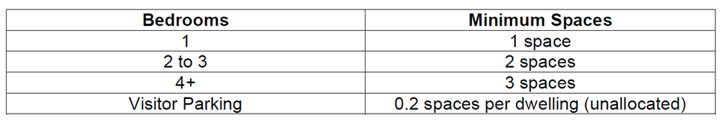
The proposed new dwelling is a four bed dwelling and therefore is required to provide three off road parking spaces to comply with the above guidance. The proposal provides four off-street parking spaces, comprising two garage spaces and two external spaces. Vehicular access would be taken from the existing shared driveway serving the site, with four off-street parking spaces and covered cycle storage provided within the site, the Highway Authority has raised no objections accordingly subject to conditions.

Ecology and Biodiversity

Core Policy 50 of the Wiltshire Core Strategy seeks to protect, conserve and enhance biodiversity and geodiversity interests. Core Policy 69 provides specific protection for the River Avon Special Area of Conservation (SAC) and requires development proposals to demonstrate that they would not adversely affect the integrity of the SAC.

Policies N2 and N3 of the NPPF similarly seek to protect and enhance biodiversity, conserve designated sites and ensure that development does not result in unacceptable harm to habitats or species.

The application site lies within the catchment of the River Avon SAC and within the 6.4km zone of influence of the Salisbury Plain SPA. The Council's Ecologist has reviewed the proposal and raises no objection subject to planning conditions.

In respect of the Salisbury Plain SPA, the proposal falls within the scope of Wiltshire Council's strategic Appropriate Assessment and mitigation strategy for recreational pressure. Natural England has confirmed its continued support for this approach and, subject to the ongoing implementation of the Council's mitigation strategy, the proposal would not result in an adverse effect on the integrity of the SPA.

In relation to the River Avon SAC, the proposed dwelling would generate additional wastewater and an associated phosphorus burden. The submitted nutrient budget has been reviewed and accepted by the Council's Ecologist, who confirms a phosphorus budget of 0.11kg TP/year. Whilst a bespoke Appropriate Assessment has been prepared by the Council's Ecologist in respect of the proposal, Wiltshire Council currently operates a strategic nutrient mitigation scheme for development within the River Avon SAC catchment which has been agreed with Natural England and remains in place until March 2027. The proposal is capable of being appropriately mitigated through this established strategic approach and, accordingly, a Grampian condition is recommended to prevent commencement of development until evidence of compliance with the Council's mitigation scheme, or an alternative mitigation package approved by the Local Planning Authority and Natural England, has been submitted to and approved in writing by the Local Planning Authority.

It is considered that there would be no likely significant effect arising from the issuing of a decision at this stage, as the proposed development cannot lawfully commence until nutrient mitigation has been secured through the recommended Grampian condition. The phosphorus budget has been agreed by the Council's Ecologist, and the condition provides an effective mechanism to ensure nutrient neutrality is secured prior to the commencement of development.

The Ecologist has also recommended a condition requiring the dwelling to achieve a maximum water consumption rate of 110 litres per person per day in accordance with the Council's nutrient mitigation strategy.

In relation to Biodiversity Net Gain, the proposal is subject to the statutory requirement to achieve a minimum 10% biodiversity net gain. A Small Sites Metric has been submitted and accepted by the Council's Ecologist. The statutory Biodiversity Gain Plan condition will apply automatically to any planning permission granted.

Subject to the recommended planning conditions, including the Grampian condition securing nutrient neutrality prior to commencement of development, the proposal is not considered likely to result in adverse effects on the integrity of the River Avon SAC or Salisbury Plain SPA and is therefore considered to comply with Core Policies 50 and 69 of the Wiltshire Core Strategy and the relevant provisions of the NPPF

Trees and Arboricultural Impact

Core Policy 51 of the Wiltshire Core Strategy seeks to protect and enhance landscape character, including important trees and woodland features.

Policy N2 of the NPPF requires decision-makers to consider the environmental qualities of land proposed for development and to conserve and enhance existing natural features of visual, historic or nature conservation value, including established trees and hedgerows where possible. The policy also seeks to ensure that landscaping and natural features are used to help integrate development into its surroundings.

Whilst there are no trees on the application site, there are trees in close proximity to the west of the site. These trees are under the ownership of a third party but the canopy and root protection area have the potential for being affected by the proposed development.

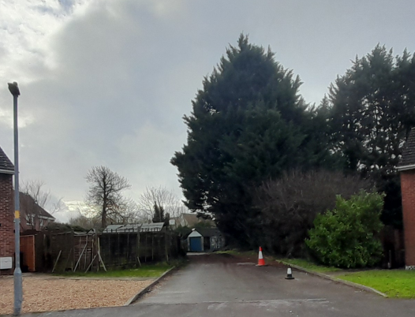

In order to properly assess any potential impact, the applicant was requested to provide a Tree Survey, Constraints Plan and Impact Assessment in accordance with BS5837:2012. Following the submission of the required detail, the Council’s tree officer raised no objection subject to the trees being protected in accordance with the Tree Report; a condition will be added to any permission accordingly.

Archaeology

Wiltshire’s Historic Environment Record (HER) shows that No. 35 Beaulieu Road lies on the western limb of a rectangular enclosure recorded on aerial photographs. The HER notes ‘A possible rectilinear enclosure of unknown date, defined by a single ditch 63 metres by 54 metres, is visible as a cropmark on one early aerial photograph dating to the 1920s or 1930s. The enclosure has been mapped by English Heritage's Stonehenge World Heritage Site Mapping Project’. The enclosure was not subject to any archaeological investigations when the housing along Beaulieu Road was constructed, unlike the recent housing development to the south where extensive archaeological investigations revealed the buried remains of a Romano-British village. The nature, date and significance of this enclosure is therefore currently unknown.

The HER also notes that the property may lie within the area of a former WWII depot, that was demolished prior to the construction of the current housing. The presence of any former WWII structures within the red line boundary of this property is uncertain.

The Council's Archaeology Officer has reviewed the proposal and advises that, whilst the development is relatively modest in scale, the site lies within an area of archaeological interest where previously unrecorded remains may survive. No objection is therefore raised subject to a programme of archaeological investigation secured by condition

CIL

The proposed development may be liable for CIL as set out in the Wiltshire CIL Charging Schedule dated May 2015. This is a charge that local authorities can impose on new developments in their area. The money generated through the levy will contribute towards the funding of infrastructure to support growth and is payable upon commencement of development.

PLANNING BALANCE AND CONCLUSION

Section 38(6) of the Planning and Compulsory Purchase Act 2004 requires planning applications to be determined in accordance with the Development Plan unless material considerations indicate otherwise. This application has therefore been assessed against the policies of the development plan as a whole, together with the provisions of the NPPF and all other material considerations.

The application site lies within the settlement boundary of Amesbury where the principle of residential development is supported by Core Policies CP1, CP2 and CP4 of the Wiltshire Core Strategy. The proposal would provide an additional dwelling within a sustainable location with access to services, facilities and public transport opportunities. The proposal would therefore make a modest contribution towards meeting housing needs and housing delivery objectives. This attracts weight in favour of the development, particularly in the context of the Council's current housing land supply position of 2.8 years.

The proposed development would make efficient use of land within an established residential area and would result in a dwelling of an appropriate scale, design and appearance that would respect the character of the surrounding area. The proposal would not result in harm to the character and appearance of the locality and is considered to accord with the requirements of Core Policy 57 and the design objectives of the NPPF.

The proposal would not create any unacceptable impacts on the amenities of neighbouring occupiers and would provide a satisfactory standard of accommodation and amenity for future residents. Furthermore, no objections have been raised by the Council's specialist consultees in respect of highways, ecology, trees or archaeology, subject to appropriate planning conditions, including a Grampian condition requiring nutrient neutrality mitigation to be secured before development commences. Subject to those safeguards, the development would accord with the relevant provisions of the Wiltshire Core Strategy and the NPPF.

Having carefully considered all material planning considerations, it is concluded that the benefits of the proposal, including the provision of an additional dwelling within a sustainable location and its contribution towards housing delivery, outweigh any limited adverse impacts associated with the development. The proposal accords with the Development Plan when read as a whole and there are no material considerations that indicate planning permission should be withheld.

RECOMMENDATION: That Planning Permission be GRANTED, subject to conditions

1. The development hereby permitted shall be begun before the expiration of three years from the date of this permission.

REASON: To comply with the provisions of Section 91 of the Town and Country Planning Act 1990 as amended by the Planning and Compulsory Purchase Act 2004.

2. The development hereby permitted shall be carried out in accordance with the following approved plans:

Application form received 11/05/2026
Site location plan Drg no 25016 / P001 received 11/05/2026
Proposed site plan Drg no 25016 / P011C received 29/07/2026
Proposed floor plans Drg no 25016 / P100E received 29/07/2026
Proposed elevations Drg no 25016 / P110C received 29/07/2026
Tree survey - BS5837:2012 Trees in relation to demolition, design and construction report by Bawden Tree Care including Appendix A and Appendix B received 29/07/2026
Tree Protection Plan by Bawden Tree Care received 29/07/2026
Noise impact assessment received 11/05/2026
Proposed garage plan elevations & section Drg no 25016 / P113 received 11/05/2026
Existing & proposed street elevations Drg no 25016 / P112 received 11/05/2026

REASON: For the avoidance of doubt and in the interests of proper planning

3. The external materials used in the development shall be carried out in accordance with the materials specified on the approved plans and application form.

REASON: In the interests of visual amenity and the character and appearance of the area

4. The development should be carried out strictly in accordance with the Tree survey - BS5837:2012 Trees in relation to demolition, design and construction report by Bawden Tree Care including Appendix A and Appendix B and Tree Protection Plan received 29/07/2026. The trees must be protected in accordance with the agreed report and plans throughout the period of development, unless the Local Planning Authority has given its prior written consent to any variation.

REASON: To comply with the duties indicated in Section 197 of the Town and Country Planning Act 1990, so as to ensure that the amenity value of the trees, shrubs and hedges growing within or adjacent to the site is adequately protected during the period of construction.

5. No development shall commence within the area indicated by application PL/2026/03006 until:
a) A written programme of archaeological investigation, which should include on-site work and off-site work such as the analysis, publishing and archiving of the results, has been submitted to and approved by the Local Planning Authority; and
b) The approved programme of archaeological work has been carried out in accordance with the approved details.
REASON: To enable the recording of any matters of archaeological interest.

6. No part of the development hereby permitted shall be occupied until the parking spaces [minimum 3] have been completed in accordance with the details shown on the approved plans. The areas shall always be maintained for those purposes thereafter and maintained free from the storage of materials.
REASON: In the interests of highway safety.

7. No construction shall take place on Sundays or Public Holidays or outside the hours of 08:00 to 18:00 Monday to Friday and 08:00 to 13:00 on Saturdays.

REASON: To minimise disturbance to nearby residents during the construction

8 Notwithstanding the provisions of the Town and Country Planning (General Permitted Development) (England) Order 2015 (as amended by the Town and Country Planning (General Permitted Development) (Amendment) (No.3) (England) Order 2020 (or any Order revoking or re-enacting or amending those Orders with or without modification), no development within Part 1, Classes A, B, C, or E shall take place on the dwellinghouse hereby permitted or within the curtilage.

REASON: In the interests of the amenity of the area and to enable the Local Planning Authority to consider individually whether planning permission should be granted for additions, extensions or enlargements.

9. Notwithstanding the provisions of the Town and Country Planning (General Permitted Development) (England) Order 2015 (or any Order revoking or re-enacting or amending that Order with or without modification), no additional windows, doors or other openings shall be inserted in the east and south elevations above ground floor ceiling level of the proposed dwelling hereby permitted.

REASON: In the interests of residential amenity and privacy.

10. Before the development hereby permitted is first occupied the windows in the south elevation at first floor serving the bathroom/ensuite shall be glazed with obscure glass only to an obscurity level of no less than level 5 and fixed with a ventilation stay restricting the opening of the windows; and the window serving the stairs in the east elevation shall be glazed with obscure glass only to an obscurity level of no less than level 5 and fixed shut. The windows shall be maintained with obscure glazing, restricted opening or fixed shut for the lifetime of the development.

REASON: In the interests of residential amenity and privacy.

11. The development hereby permitted shall not commence until evidence of compliance to the Wiltshire Council River Avon Special Area of Conservation Mitigation scheme, or an alternative approved mitigation package addressing the additional nutrient input arising from the development, has been submitted to, and approved in writing by the Local Planning Authority.

REASON: To accord with the Conservation of Habitats and Species Regulations 2017, and Wiltshire Core Strategy Core Policy 69

12. The dwelling hereby approved shall be designed to ensure it does not exceed 110 litres per person per day water consumption levels (which includes external water usage)

REASON: To ensure compliance with the prevailing mitigation strategy for nutrient neutrality in the water catchment within which this development is located

13. The detached double garage hereby approved shall be retained solely for the parking of motor vehicles at all times and shall not be used as habitable accommodation or commercial use or for any purpose which would prevent the garage from being available for the parking of vehicles.

REASON: To ensure the retention of adequate off-street parking provision in the interests of highway safety and in the interests of amenity.

Informatives

1. BNG required

The effect of paragraph 13 of Schedule 7A to the Town and Country Planning Act 1990 is that planning permission granted for the development of land in England is deemed to have been granted subject to the condition “(the biodiversity gain condition”) that development may not begin unless: (a) a Biodiversity Gain Plan has been submitted to the planning authority, and (b) the planning authority has approved the plan.

The planning authority, for the purposes of determining whether to approve a Biodiversity Gain Plan if one is required in respect of this permission would be Wiltshire Council. There are statutory exemptions and transitional arrangements which mean that the biodiversity gain condition does not always apply. For further information on exempt developments please refer to: https://www.gov.uk/guidance/biodiversity-net-gain-exempt-developments

Based on the information available this permission is considered to be one which will require the approval of a biodiversity gain plan before development is begun because none of the statutory exemptions or transitional arrangements are considered to apply. Irreplaceable habitat If the onsite habitat includes irreplaceable habitat (within the meaning of the Biodiversity Gain Requirements (Irreplaceable Habitat) Regulations 2024) there are additional requirements for the content and approval of Biodiversity Gain Plans.

The Biodiversity Gain Plan must include, in addition to information about steps taken or to be taken to minimise any adverse effect of the development on the habitat, information on arrangements for compensation for any impact the development has on the biodiversity of the irreplaceable habitat.

The planning authority can only approve a Biodiversity Gain Plan if satisfied that the adverse effect of the development on the biodiversity of the irreplaceable habitat is minimised and appropriate arrangements have been made for the purpose of compensating for any impact which do not include the use of biodiversity credits.

2. Party wall

The applicant is requested to note that this permission does not affect any private property rights and therefore does not authorise the carrying out of any work on land outside their control. If such works are required it will be necessary for the applicant to obtain the landowners consent before such works commence.
If you intend carrying out works in the vicinity of the site boundary, you are also advised that it may be expedient to seek your own advice with regard to the requirements of the Party Wall Act 1996.

3. Archaeology

The monitoring work is to be carried out following the standards and guidelines set out by the Chartered Institute for Archaeologists (CIfA) as well as those set out in the document 'Standards and Guidance for Archaeological Assessment and Fieldwork in Wiltshire and Swindon Borough', issued by WCAS. The costs of any work are to be borne by the applicant.

4. Hampshire Avon Phosphorus Mitigation

Evidence of compliance to the Wiltshire Council River Avon Special Area of Conservation Mitigation Scheme means the certificate of allocation of credits and confirmation of financial contribution to the scheme. An alternative mitigation package must be approved by the local planning authority and Natural England with evidence of allocation to the scheme.

5. Building Regulations

Any alterations to the approved plans, brought about by compliance with Building Regulations or any other reason must first be agreed in writing with the Local Planning Authority before commencement of work

6. CIL

The applicant is advised that the development hereby approved may represent chargeable development under the Community Infrastructure Levy Regulations 2010 (as amended) and Wiltshire Council's CIL Charging Schedule. If the development is determined to be liable for CIL, a Liability Notice will be issued notifying you of the amount of CIL payment due. If an Additional Information Form has not already been submitted, please submit it now so that we can determine the CIL liability. In addition, you may be able to claim exemption or relief, in which case, please submit the relevant form so that we can determine your eligibility. The CIL Commencement Notice and Assumption of Liability must be submitted to Wiltshire Council prior to commencement of development. Should development commence prior to the CIL Liability Notice being issued by the local planning authority, any CIL exemption or relief will not apply and full payment will be required in full and with immediate effect. Should you require further information or to download the CIL forms please refer to the Council's Website:
www.wiltshire.gov.uk/planninganddevelopment/planningpolicy/communityinfrastructurelevy

7. Protected Species

The applicant should note that under the terms of the Wildlife and Countryside Act (1981) and the Conservation of Habitats and Species Regulations 2017 (as amended) it is an offence to disturb or harm any protected species including for example, breeding birds and reptiles. The protection offered to some species such as bats, extends beyond the individual animals to the places they use for shelter or resting. Please note that this consent does not override the statutory protection afforded to any such species. In the event that your proposals could potentially affect a protected species you should seek the advice of a suitably qualified and experienced ecologist and consider the need for a licence from Natural England prior to commencing works. Please see Natural England’s website for further information on protected species.

