CASE OFFICER'S REPORT

Application Reference: | PL/2026/01111
Application Type: | Full planning permission
Consultation ends: | 06 May 2026
Case officer: | Steven Sims

Site Address: | 2 Church Lane, Limpley Stoke, Bath, BA2 7GH
Proposal: | Demolition of existing triple garage and construction of self build dwelling within curtilage of existing house
Recommendation: | Approve with Conditions

PROPOSAL AND SITE DESCRIPTION

The site

The application site lies within the settlement limits of Limpley Stoke which is considered a Small Village in policy terms. Access to the site is off Church Lane. The site is located in a residential area bordered by existing residential development comprising mainly detached dwellings with medium/ large sized gardens. The site slopes downwards to the north/ northeast.

The site is located within the Avon Limestone Valley character area, West Wiltshire Green Belt, Cotswolds National Landscape (formally AoNB) and Bath and Bradford on Avon Bat Special Area of Conservation (SAC). The site is not located in flood zones 2 or 3 or in an area subject to high levels of surface or groundwater flooding.

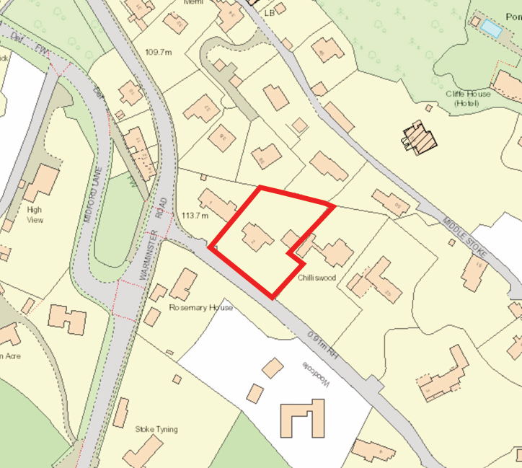
Location plan

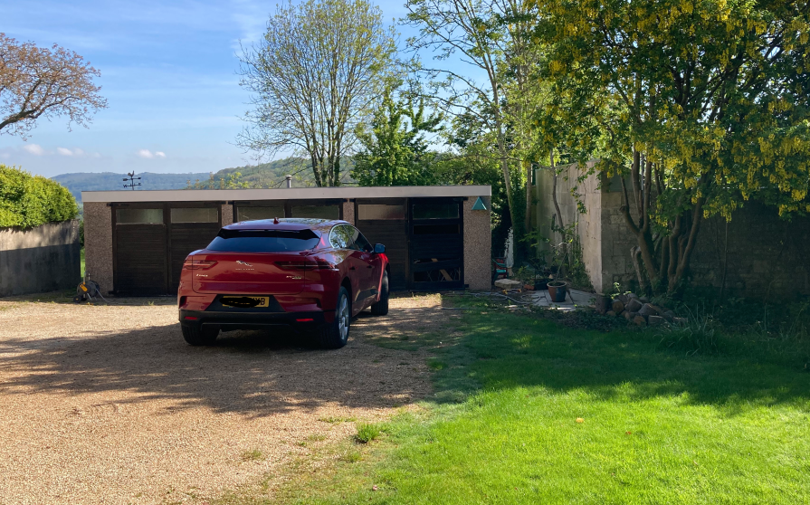
Existing garage to be demolished

The application

This is a full planning application for the demolition of an existing garage and erection of a 2 bedroom dwelling. The dwelling would consist of 2 bedrooms at first floor level and a living/ dining room, study and utility room at ground floor level.

External materials would consist of stone walling and timber cladding with clay roof tiles. It is also proposed to create a new shared driveway with No. 2 onto Church Lane. As detailed in the plans below.

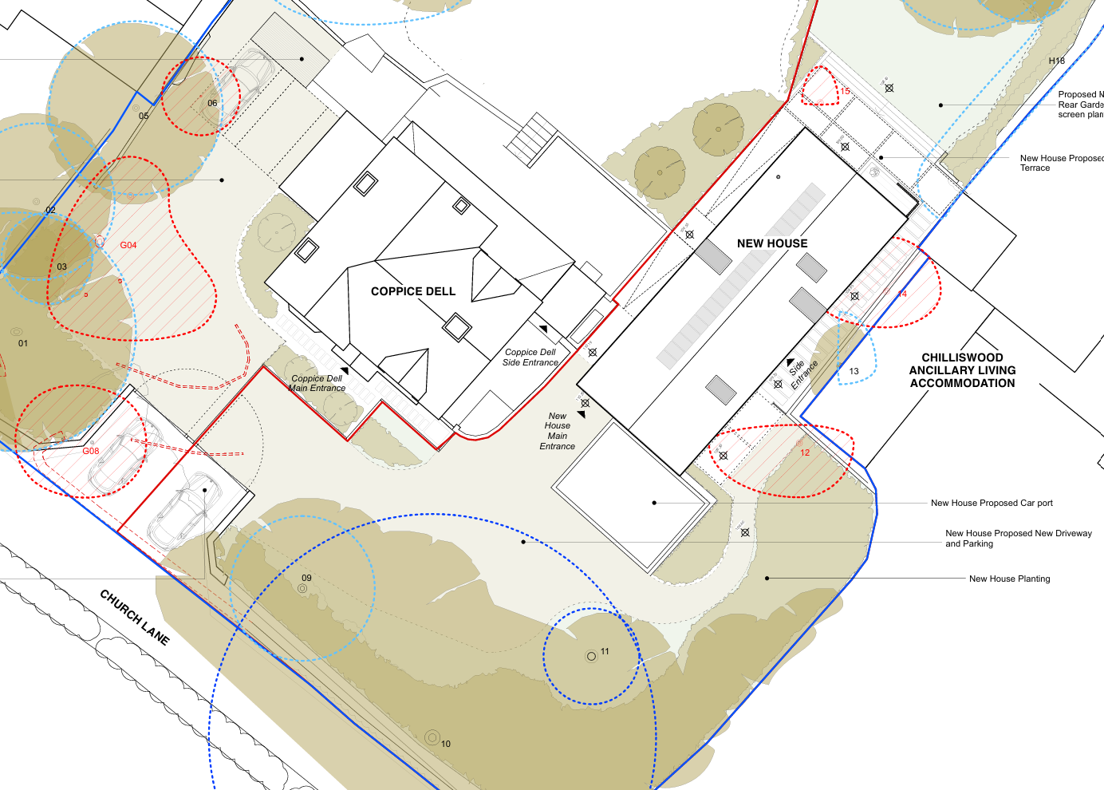
Proposed block plan
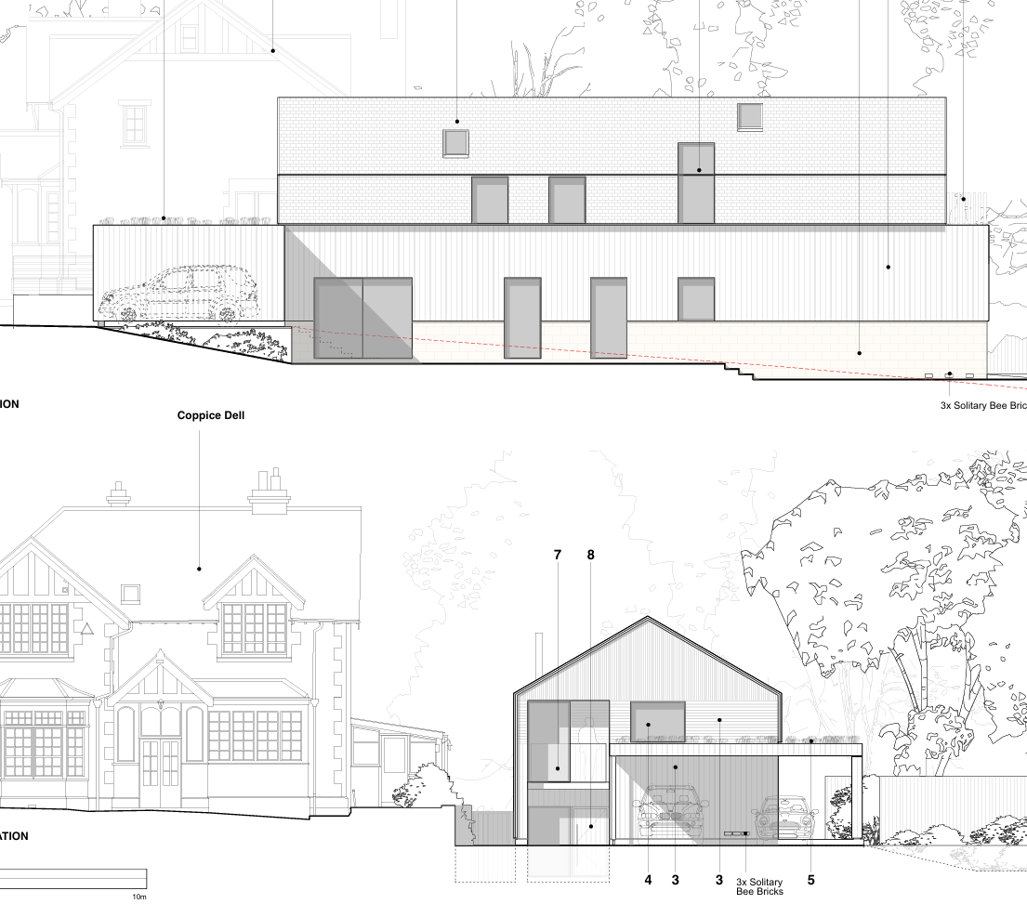
Proposed southeast and southwest elevations

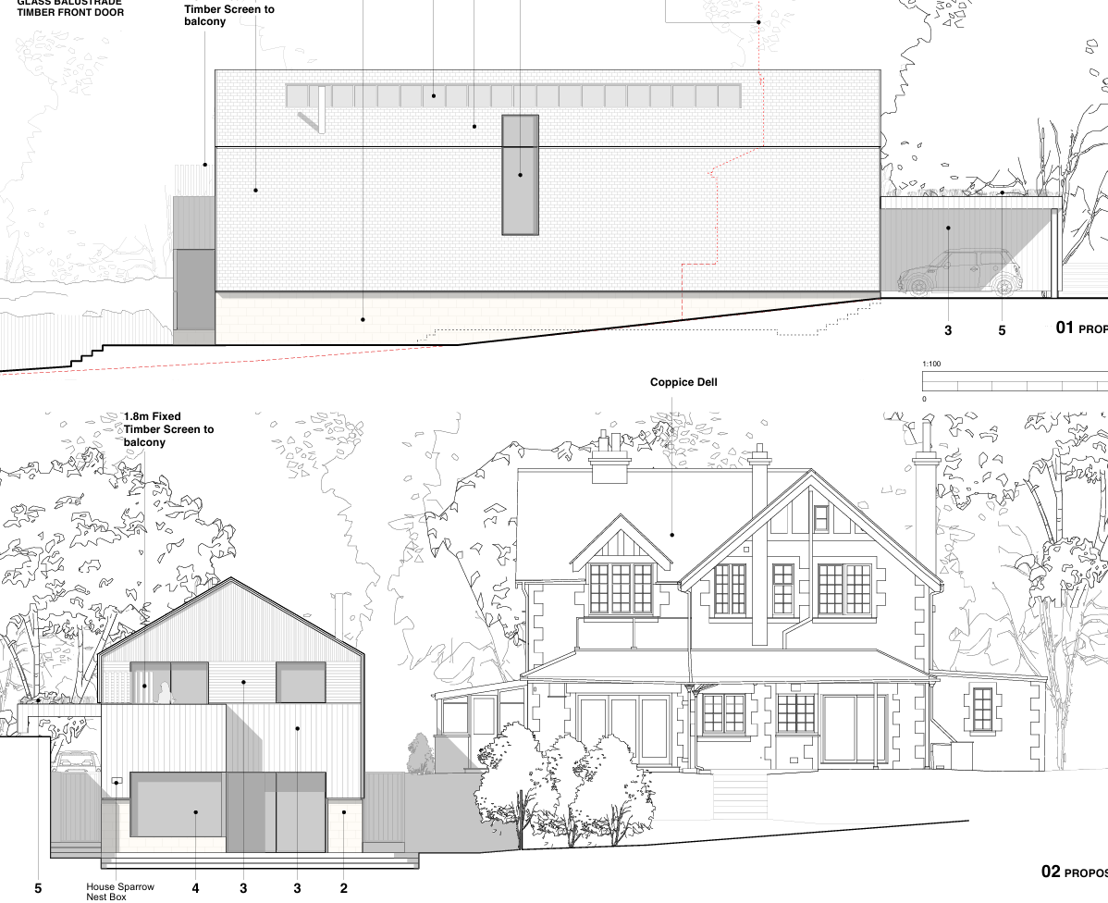
Proposed northwest and northeast elevations

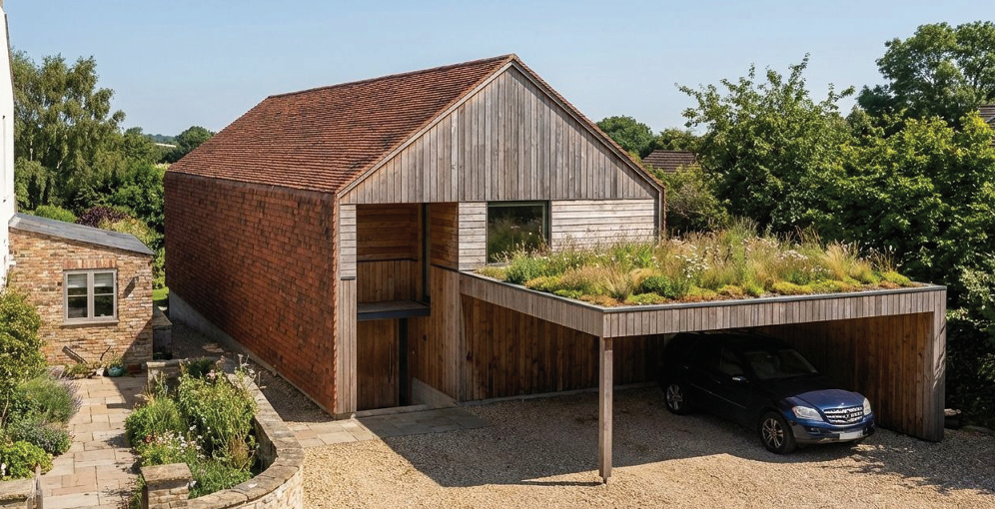
Visual of proposed dwelling, front (southwest) elevation

POLICIES

Wiltshire Core Strategy (WCS) 2015
Core Policy 1: Settlement Strategy; Core Policy 2: Delivery Strategy; Core Policy 7: Spatial Strategy – Bradford om Avon Community Area; Core Policy 41: Sustainable construction and low-carbon energy; Core Policy 50: Biodiversity and Geodiversity; Core Policy 51: Landscape; Core Policy 57: Ensuring High Quality Design and Place Shaping; Core Policy 58: Ensuring the Conservation of the Historic Environment; Core Policy 60: Sustainable transport; Core Policy 61: Transport and Development; Core Policy 64: Demand management; Core Policy 67: Flood Risk

West Wiltshire District Local Plan (1st Alteration) Saved Policies
U1a Foul Water Disposal

National Planning Policy Framework 2026 (The Framework) and Planning Practice Guidance (PPG)

Other
Wiltshire Local Transport Plan 2011 – 2026 (in particular policy PS6: Residential parking standards)
Wiltshire Local Transport Plan 2011 – 2026: Cycling Strategy

Wiltshire Local Transport Plan 2025 – 2038 (endorsed at full council on 11 March 2025)
Wiltshire Design Guide 2024 SPD
Freshford and Limpley Stoke Neighbourhood Plan 2014-2039. In particular – ‘Planning and Development Policy’ and ‘Housing Policy’
Wiltshire Landscape Character Assessment (West Wiltshire District Council) 2006
Cotswolds National Landscape Management Plan 2025-2030 (CNLMP)
Cotswolds AONB Landscape Character Assessment

Wiltshire Council’s Emerging Local Plan (WLP) 2020-2038 – At Full Council on 19 May 2026, the elected members of Wiltshire Council agreed to withdraw the emerging Wiltshire Local Plan. The said Plan has no material weight for the purposes of this appeal.

RELEVANT PLANNING HISTORY

PL/2022/07853 – Demolition of existing triple garage and construction of dwelling within curtilage of existing house – Approved

W/80/00440/HIS – Construction of detached garage block with 3 garages, car port and store and construction of extension to form a studio – Approved

W/80/01036/HIS – Block of three standard Malrley garages (2 with annexes) – Approved

CONSULTATION RESPONSES

Limpley Stoke Parish Council: No comment

Highways Team: No objection

‘I am aware that the repositioning of the access is a betterment in geometry than the existing access; however, if the access was to be used for an additional dwelling, I would look to seek an improvement to the achievable visibility across the site frontage from a 2m set back from the centre line of the access.’

Drainage Team: No objection subject to conditions

Ecology Officer: No objection subject to conditions

Archaeology Officer: No objection

Arboricultural Officer: No objection subject to condition

Wessex Water: No objection

‘There are no known Wessex Water assets located within the proposed site boundary.’

REPRESENTATIONS

Two representations have been received providing the following (summarised) comments –
- Incorrectly labelled drawings
- Loss of privacy/ overlooking
- Drainage / excavation issues
- Pitched roof will be visually prominent
- Risk to boundary hedging

ASSESSMENT

Principle of development

Section 38(6) of the Planning and Compulsory Purchase Act 2004 states:

"If regard is to be had to the development plan for the purposes of any determination to be made under the planning Acts, the determination must be made in accordance with the plan unless material considerations indicate otherwise."

In accordance with this statutory requirement, this application has been assessed against the relevant policies of the Development Plan, including the adopted Wiltshire Core Strategy (2015) and, where applicable, any made Neighbourhood Plans.

The site is located within the settlement of Limply Stoke as such Policy S3 and S4 of the revised NPPF are applicable. Policy S3 states decisions on development proposals should apply a presumption in favour of sustainable development and Policy S4 applies when considering development proposals within settlements. Policy S4 states development proposals within settlements should be approved unless the benefits of doing so would be substantially outweighed by any adverse effects, when assessed against the national decision-making policies in this Framework. This assessment against relevant policies of the Development Plan and NPPF is detailed below.

The principle of development for the erection of a new dwelling on site was also established by the granting of application PL/2022/07853.

5 Years Housing Land Supply (5YHLS)

As a result of recent changes to the way housing need is calculated, the Council is currently able to demonstrate a housing land supply which is calculated at a 2.8 years supply against the requirement for a five-year supply of deliverable housing sites. The contribution of one additional market dwelling would therefore make a positive contribution to this shortfall in housing land supply.

Impact on the openness of the Green Belt

There are no relevant WCS development plan policies relating to the Green Belt, therefore the NPPF provides the policy direction.

The revised NPPF states (Policy GB6(1)) that development in the Green Belt is inappropriate unless it falls within one of the categories listed in policy GB7. These categories include, amongst others, limited infilling in villages lying within the Green Belt (Policy GB7(1)(c)) and the recognition that the site is considered grey belt land (Policy GB7(1)(g)(i)). The proposed development is for one dwelling located within that part of the village of Limpley Stoke that is overlain by the Green Belt. Existing residential development is located to either side of the proposed dwelling off Church Lane as detailed in the site plan above. As such the development can therefore be considered limited infill within the existing village. In addition, the site is considered grey belt land because the development does not undermine the purpose (taken together) of the remaining Green Belt land and does not strongly contribute to any of purposes (a), (b), or (d) of Policy GB2(1).

As such it is considered the development would not result in harm to the openness of the Green Belt.

Impact on the character of the area/ National Landscape

Core Policy 51 of the WCS states development should protect, conserve and where possible enhance landscape character and must not have a harmful impact upon landscape character. Core Policy 57 states applications for new development must respond positively to the existing townscape and landscape features to effectively integrate the building into its setting.

Policy L2 of the revised NPPF states substantial weight should be given to the benefits where a development proposal would achieve, amongst others, making effective use of previously developed land and creating additional homes through sensitive development within existing plots.

Policy N4 of the revised NPPF states development proposals within Protected Landscapes (which includes the Cotswolds National Landscape) should be limited in scale and extent and sensitively located and designed to avoid harm to the statutory purposes and special qualities of the Protected Landscape and substantial weight should be placed on the importance of conserving and enhancing the natural beauty of these areas.

In addition, under Section 85 of the Countryside and Rights of Way Act 2000, as amended by Section 245 of the Levelling-up and Regeneration Act 2023, the local planning authority (LPA) has a statutory duty to seek to further the purpose of conserving and enhancing natural beauty when exercising any function affecting land within a National Landscape.

The site is located within the Avon Limestone Valley character area, and Cotswolds National Landscape (formally AoNB).

The proposed dwelling would be set back on site and screened from the highway by existing hedgerows. In addition, although the dwelling would be 2 storey’s in height, it would be set down at a slightly lower elevation than the existing ground level of the site. Positioned between No. 2 Church Street to the west and Chilliswood to the east, the development would, when viewed from the public realm, be seen as a continuation of this existing built development which would result in the scheme having no materially harmful visual impact.

The design of the dwelling and use of external materials proposed are considered acceptable. The proposed landscaping is also considered acceptable. The proposed development is located within the garden of an existing residential property and within the built-up residential area of Limpley Stoke, following demolition of the existing garage it is therefore considered the scheme would therefore result in some minor enhancement to the natural beauty of the National Landscape.

As detailed above the development is considered acceptable in design terms and would provide a minor enhancement to the natural beauty of the National Landscape. The proposed development would also provide some ecology enhancements. As such it is considered the Local Planning Authority has complied with its duty with regard to the purpose of conserving and enhancing natural beauty when exercising any function affecting land within the National Landscape.

Impact on neighbour amenity/ occupiers amenity

Core Policy 57 of the WCS requires that development have regard to the compatibility of adjoining buildings and uses, and impact on the amenities of existing occupants and ensuring that appropriate levels of amenity are achievable within the development.

There are no ground floor northwest elevation windows. The southwest ground floor windows would result in no overlooking/ loss of privacy to the neighbouring resident due to existing boundary treatment and new hedge planting on the southeast boundary and the existing ancillary accommodation on this boundary obscuring views of the neighbours front garden.

Proposed first floor southeast and northwest facing windows that serve a landing, bathroom and overlook a void will be obscurely glazed. The scheme also includes 1.8m high screen to the northeast facing first floor balcony. The obscured glazing and balcony screening will be conditioned to be implemented prior to occupation.

It is acknowledged that the 2 storey development would be located in close proximity to the northwest boundary of Chilliswood and the ancillary accommodation that sits on this boundary.

The ancillary accommodation is single storey only with windows and doors facing southeast looking over the front garden of Chilliswood. There may be some loss of light to the front facing aspect of the ancillary accommodation in particular during the latter part of the day as the Sun moves east to west, however it is not considered this would be sufficiently harmful to the amenity of occupiers of the accommodation to warrant a recommendation for refusal.

The main dwelling is set back away from the northwest boundary of the site and is considered a sufficient distance from the proposed development for there to be no significantly harmful levels of loss of light to residents of this property.

It is acknowledged that the development would result in some level of overbearing impact with the first-floor and roof element of the new dwelling being visible from the front garden of Chilliswood along an approximate 20 metre section of the boundary, however it is considered this overbearing impact, which would mainly impact the front garden area of Chilliswood, would not be sufficiently harmful to warrant a recommendation for refusal.

The separation distance between the rear (northeast) elevation of the proposed dwelling and the rear (southwest) elevation of no. 47 Middle Stoke would be approximately 30 metres. This separation distance, including consideration of the level changes between properties, would not result in sufficiently harmful levels of overlooking/ loss of privacy to warrant a recommendation for refusal.

The building has been designed to allow sufficient natural light to enter habitable rooms. In addition, sufficient amenity space is proposed for occupiers of the development and sufficient amenity space remains for existing occupiers.

Ecology issues

Core Policy 50 of the Wiltshire Core Strategy requires all development to demonstrate no net loss of local biodiversity resource and to secure the integrity of local ecological networks. Core Policy 50 also requires development to seek opportunities to enhance biodiversity. NPPF Policy N6 requires development to support the conservation of important habitats, species and sites of geodiversity value.

The site is located within the Bath and Bradford on Avon Bat Special Area of Conservation (SAC) and the application is accompanied by a Preliminary Roost Appraisal Report by Stark Ecology Ltd dated Feb 2026 and BNG report and matrix.

The site lies within a 11 roost buffers for Bechstein’s, Lesser Horseshoe and Greater Horseshoe bats associated with the Bath and Bradford-on-Avon Bats SAC. It therefore may have the potential to result in significant adverse impact on the special features of that site. Appropriate Assessment (AA) under Section 63 of the Habitats Regulations must be carried out by the relevant Competent Authority (the LPA) to determine the potential significant effects and the suitability of any measures proposed to avoid or mitigate those effects.

A test of likely significance has been carried out by the relevant Competent Authority (Wiltshire Council) as required by Regulation 63 of the Conservation of Habitats and Species Regulations 2017 (as amended). This concluded that given the scale and nature of the currently proposed development - which does not propose removal of any bat habitat or roosts, and does not propose any additional external lighting - there is no mechanism for adverse impact on the Conservation Objectives of the SAC, and the proposal can be screened out of Appropriate Assessment.

The garage is a single-storey cement-panelled building with a very shallow mono-pitched roof. The roof is corrugated cement fibre which connects to metal fascia boards. Internally, the garage is subject to a high level of (day)light spill and fairly open to the elements. Overall, the garage and adjacent tree were assessed as having negligible potential to host roosting bats, and no further survey is considered necessary.

The tree and nearby scrub may be used by nesting birds. The adults, young, eggs and nests of all species of birds are protected by the Wildlife and Countryside Act 1981 (as amended) while they are breeding. Please be advised that works should not take place that will harm nesting birds (such as vegetation clearance or building demolition) from March to August inclusive. The applicant is advised to check any structure or vegetation capable of supporting breeding birds and delay removing or altering such features until after young birds have fledged.

There do not appear to be any ponds mapped within 250 metres of the site. The habitat surrounding the garage comprises a garden containing individual trees, very small areas of scrub/plantings, mown lawn and hardstanding. These will be of limited value to other protected and notable wildlife, and there will be sufficient opportunities for species to disperse into the surrounding garden areas, if present. In the unlikely event any reptiles, great crested newts or nesting birds are encountered, all works should cease and a professional ecologist contacted for further advice.

The council’s ecologist has requested a condition requiring details of external lighting however no such condition was imposed on application PL/2022/07853 and there is no control over external lighting within the curtilage of the existing property as such it would not be considered reasonable to impose such a condition.

The proposed development is subject to BNG and therefore subject to the biodiversity gain condition. The submitted metric indicates 0.25 biodiversity units or less will be required to meet the 10% BNG requirement and that on-site BNG is not achievable. Off site credits are available to purchase to meet requirements of BNG post determination where it is not achievable on site. However, how the development will achieve BNG is a post-determination matter.

Highway/parking issues

Core Policy 61 of the WCS seeks to ensure that all new developments are capable of being served by safe access to the highway network. Core Policy 64 sets out to manage the demand for parking and sets residential parking standards based on minimum parking standards.

Access to the new dwelling would be via a new shared driveway, with no. 2, off Church Lane. There are no objections to the scheme from the council’s highways officer and it is considered the site can be served by a safe access to the highway and there is sufficient space on site to provide adequate off road parking for residents of the proposed and existing dwelling.

Drainage/ flooding issues

Core Policy 67 of the WCS states all new development will include measures to reduce the rate of rainwater run-off and improve rainwater infiltration to soil and ground (sustainable urban drainage) unless site or environmental conditions make these measures unsuitable.

As set out in the Design & Access Statement, the applicant has proposed surface water collection via rainwater harvesting systems (unspecified) and discharging surface water from the development via a cellular soakaway. It is noted that the submitted Drainage Plan acknowledges that the site-specific infiltration rate is yet to be confirmed. As such it is considered necessary to impose a condition requiring the submission of surface water drainage details.

Other issues

Third parties have raised the issue of land stability of the site. There is no specific policy in the WCS that addresses land stability specifically however Policy P2 of the revised NPPF states, sites proposed for development should be suitable for their proposed use taking into account ground conditions, including any risks arising from land instability. In this case there is no evidence that land stability on site is an issue. In addition, such issues are the responsibility of the landowner and developer, and a review the proposal in terms of its foundations and stability both at the start, during and post-construction would be undertaken by Building Regulations.

CONCLUSION

Planning law requires that applications for planning permission must be determined in accordance with the development plan unless material considerations indicate otherwise.

As a result of recent changes to the way housing need is calculated, introduced by government, the Council is unable to demonstrate a five-year supply of deliverable housing sites and as a consequence, there is a presumption in favour of sustainable development (often referred to as the ‘tilted balance’) applies. When this is assessed against the housing land supply which can be delivered within five years, the recalculation shows a significant reduction in the number of years supply and currently equates to 2.8 years supply for Wiltshire, which is regarded as a very substantial shortfall.

Policy HO7 of the revised NPPF states in applying the policies in this Framework, substantial weight should be given to the benefits of providing homes which will contribute towards meeting the evidenced accommodation needs of the community, as identified through needs assessments prepared for the area of the local planning authority and other relevant evidence. In this case the proposed development would provide one market dwelling, which in housing supply terms, would make a nominal contribution towards addressing the shortfall, but it would nevertheless make a contribution which must be given weight in the planning balance.

In addition, there would be some short-term benefits afforded to the construction phase of the development through direct and indirect job creation. The development would also contribute towards CIL infrastructure funding in the area.

In terms of neutral impacts, officers are satisfied that the proposed development would not harm the openness of the Green Belt and that development would not harm the historical, social, geological or ecological etc features of the Cotswolds National Landscape, and there would be no conflict with the requirements set by the CRoW Act, that seek to further and enhance the natural beauty, heritage and wildlife of the National Landscape.

The development would not result in material harm to the living conditions of local residents. Sufficient off road parking can be provided on site for the new dwelling and existing dwelling and the development would be served by a safe access to the road network. In addition, suitable drainage connections can be made, and the development would cause no harm to local biodiversity interests.

RECOMMENDATION: APPROVE subject to conditions

