APPLICATION FOR FULL PLANNING PERMISSION
DELEGATED REPORT

APPLICATION REFERENCE: | PL/2026/02226
APPLICATION TYPE: | Full planning permission
SITE ADDRESS: | Aldi, Bradley Road, Trowbridge, BA14 0QT
DEVELOPMENT DESCRIPTION: | Extension of existing Class E ALDI foodstore and car park, with associated works.
RECOMMENDATION: | That Planning Permission be GRANTED

PROPOSAL

The proposal seeks full planning permission for an extension to an existing supermarket store. The extension would extend over the footprint of existing car parking spaces, to the northern store front of the building. The existing car park layout would be reconfigured to facilitate the build, however the existing site access area off Bradley Road would be unaffected.

SITE DESCRIPTION/CONTEXT
The proposal relates to a large Aldi supermarket store, located off Bradley Road within central Trowbridge, and sits within the defined settlement boundary of Trowbridge. The application site is positioned within an established residential area with properties to the north, east, south and west of the application site. The application site sits within the Trowbridge and Westbury Bat Mitigation Strategy (TWBMS).

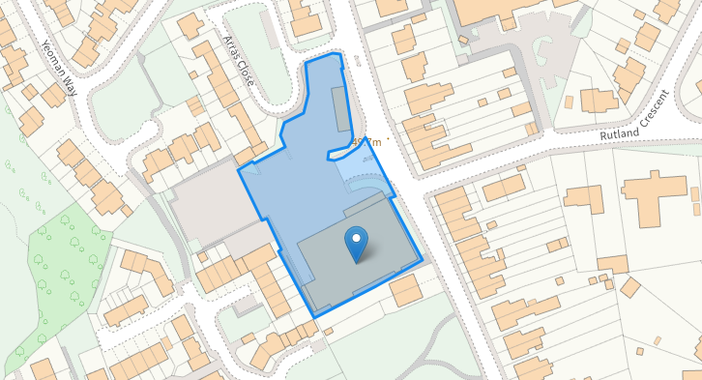

PLANNING HISTORY

Proposal / Summary
W/96/00188/OUT - Outline Planning Decision - Withdrawn Date: 11/6/1996 – Demolition of buildings and dwellings, erection of food store non-food store, residential development and associated access and parking
W/97/00147/FUL - Full planning permission Decision - Approve with Conditions Date: 29/5/1997 – Erection of single storey food retail store and associated car parking
W/97/00817/FUL - Full planning permission Decision - Approve with Conditions Date: 30/7/1997 – Amendment of condition 09 (W97/0147) to allow Saturday opening from 0830 to 1730
W/06/02153/FUL - Full planning permission Decision - Approve with Conditions Date: 4/12/2006 – Extension to retail store, erection of glazed canopy and external alterations
W/12/01397/S73 - Removal/variation of conditions Decision - Approved Date: 4/9/2012 – Amendment of condition 9 (W97/00147) to change opening hours to 0900 to 2100 Monday to Saturdays and 0830 to 1730 on Sundays and Bank Holidays
W/96/00709/FUL - Full planning permission Decision - Refused Date: 12/12/1996 – Food retail store, access and parking
W/11/02860/S73 - Removal/variation of conditions Decision - Approve with Conditions Date: 1/2/2012 – Variation of condition 5 of permission W/06/02153/FUL to facilitate deliveries between 07:00 to 19:00 Monday to Saturday and 10:00 to 16:00 on Sundays and Bank Holidays
W/12/00146/FUL - Full planning permission Decision - Approve with Conditions Date: 19/3/2012 – Installation of solar panels and associated micro-generation equipment
21/01955/VAR - Removal/variation of conditions Decision - Approve with Conditions Date: 18/6/2021 – Variation of condition 2 of W/11/02860/S73 to allow extended delivery hours to between 06:00 – 22:00 Monday – Saturday and 08:00 – 17:00 on Sundays and Bank Holidays.
18/05006/FUL - Full planning permission Decision - Approve with Conditions Date: 3/8/2018 – New external plant and associated plant enclosure (retrospective)
PL/2022/07780 - Removal/variation of conditions Decision - Withdrawn by Applicant Date: 23/2/2023 – Variation of condition 1 (Delivery hours) of planning application 21/01955/VAR to permanently allow extended delivery hours to between 06:00 – 22:00 Monday – Saturday and 08:00 – 17:00 on Sundays and Bank Holidays.

RELEVANT POLICIES AND GUIDANCE

Wiltshire Core Strategy:
Core Policy 1 Settlement Strategy
Core Policy 2 Delivery Strategy
Core Policy 29 Spatial Strategy for the Trowbridge Community Area
Core Policy 38 Retail and Leisure
Core Policy 41 Sustainable Construction and Low Carbon Energy
Core Policy 50 Biodiversity and Geodiversity
Core Policy 57 Ensuring High-Quality Design and Place Shaping
Core Policy 60 Sustainable Transport
Core Policy 61 Transport and Development
Core Policy 64 Demand Management
Core Policy 67 Flood Risk

New Wiltshire Local Plan
At Full Council on 19 May 2026, the elected members of Wiltshire Council agreed to withdraw the emerging Wiltshire Local Plan. The said Plan has no material weight for the purposes of the application. In accordance with Regulation 19 of the Town and Country Planning (Local Planning) (England) Regulations 2026, on 30th June 2026 Wiltshire Council published a notice of intention to prepare a new local plan for Wiltshire. The next stage is a Scoping Consultation which commences on 2nd September 2026. This plan is at a very early stage and currently carries no weight for decision making.

Other
Wiltshire Design Guide SPD 2024
The National Planning Policy Framework (NPPF) August 2026
The Planning Practice Guidance
National Design Guide
Trowbridge and Westbury Bat Mitigation Strategy (TWBMS) 2025
CONSULTATION RESPONSES

Trowbridge Town Council: No objection

Wiltshire Council Public Protection: No objection

Wiltshire Council Ecologist: No objection

Wiltshire Council Highways: No objection

Wiltshire Council Arboricultural Officer: No objection

REPRESENTATIONS
Two letters of objection were received, the points raised will be appraised within the Highway Impact section and Neighbouring Amenity section below.

ASSESSMENT
Section 38(6) of the Planning and Compulsory Purchase Act 2004 states:

"If regard is to be had to the development plan for the purposes of any determination to be made under the planning Acts, the determination must be made in accordance with the plan unless material considerations indicate otherwise."

In accordance with this statutory requirement, this application has been assessed against the relevant policies of the Development Plan, including the adopted Wiltshire Core Strategy (2015) and, where applicable, any made Neighbourhood Plans.

Principle of Development
Trowbridge is identified as a Principal Settlement and a focus for retail, employment and service growth. Core Policy 29 of the WCS supports development that strengthens Trowbridge's role as the county town and principal service centre.

Core Policy 38 (Retail and Leisure) seeks to maintain and enhance the vitality and viability of Wiltshire's centres whilst supporting appropriate retail development in sustainable locations.

The proposal relates to the extension of an existing Aldi foodstore within Trowbridge, a Principal Settlement identified by the Wiltshire Core Strategy. The application would provide additional sales floorspace to improve the operation of an established store.

Having regard to the scale of the extension the proposal is not considered likely to give rise to a significant adverse impact upon the vitality and viability of Trowbridge Town Centre. The proposal is therefore considered to accord with the objectives of Core Policy 38. As such the principle of development is acceptable subject to the following considerations

Design and Impact upon the upon the character and context of the area
Core Policy 57 - Ensuring High Quality Design and Place Shaping of the Wiltshire Core Strategy seeks to ensure that all new development is of high design quality, reflecting local context, character, and distinctiveness.

The proposal relates to an extension to an existing Aldi foodstore to create additional floorspace for retail sales. To facilitate the proposed extension, the existing parking layout will be reconfigured. The store is located to the south of the application site, and site access to the east and car parking areas to the north and west. The site has recently seen the removal of a car wash business from the area which extended the car parking provision on site.

The extension would extend over a footprint of 256m2 to the front north elevation of the existing building, where some car parking spaces currently exist. The extension would project forward from the existing front gable end walls with a flat roof form. A plant room would be positioned centrally on the flat roof, and an overhung canopy would serve the store entrance area.

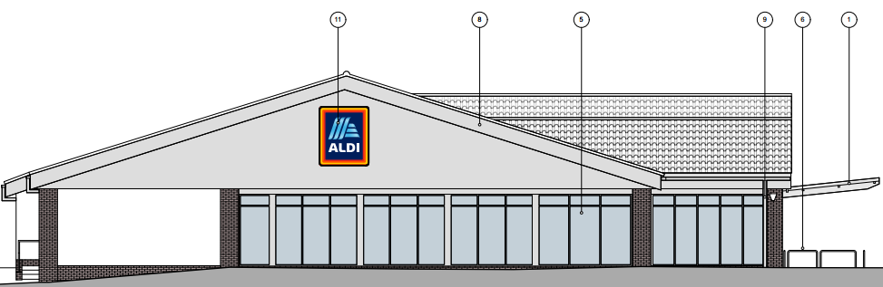

Existing east elevation

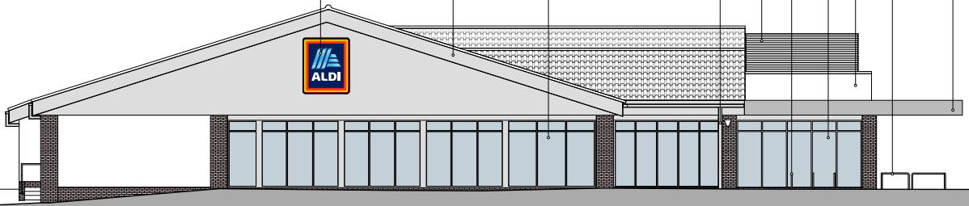
Proposed east elevation

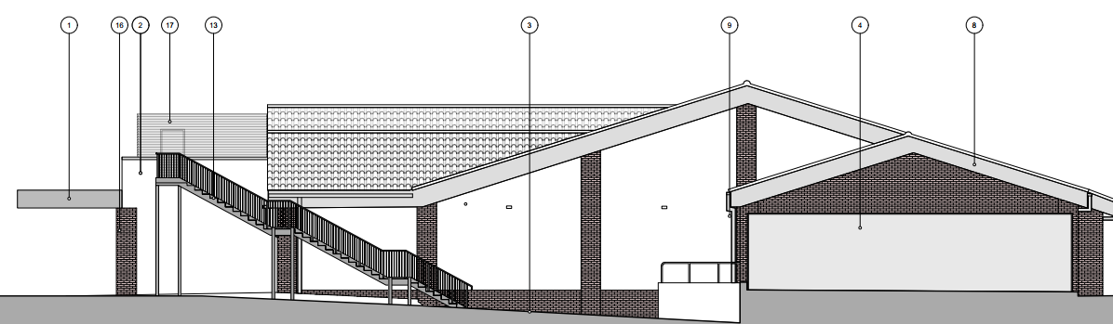
Proposed west elevation

On the west elevation of the building a metal stairway would be erected to access the proposed rooftop plant room. The applicant proposes utilising materials to match existing with render walls and brick piers and a cantilevered single ply canopy roof over the store entrance which would ensure the proposal would integrate into the surrounding setting and existing street scene.

The proposal would be regarded as a proportionate subservient extension to the existing built form on site and would not appear out of character with the existing building or the character and appearance of the surrounding area. It is considered that the extension would by virtue of its height, scale and design constitute a complementary addition to the host building that would appear commensurate to the size of the plot.

Having regard to the above, the proposal complies with the design principles set out in Core Policy 57 of the Wiltshire Core Strategy and the Wiltshire Design Guide.

Amenity
Point vii of Core Policy 57 - Ensuring High-Quality Design and Place Shaping of the Wiltshire Core Strategy seeks to ensure that developments do not adversely affect neighbouring properties.

Core Policy 57 of the Wiltshire Core Strategy seeks to ensure that development achieves a high standard of design and place shaping. Amongst other matters, the policy requires that appropriate levels of amenity are achievable for existing and future occupiers, having regard to potential adverse effects arising from noise, vibration and other forms of pollution.

The National Planning Policy Framework (NPPF), particularly Policy L2 (1)(d)(ii), stresses that substantial weight should be given to the benefits where a development proposal would maintain, amongst others, safe access and egress for occupiers and users, and acceptable living standards for residents and neighbours in terms of access to daylight, sunlight and privacy.

The proposal relates to a subservient extension to an existing food store. Given the nature of the build and detached nature of the host building, and separation distances to the neighbouring properties, no concerns are raised in regard to overlooking, overbearing or overshadowing impacts.

The proposal includes the installation of two refrigeration packs, a gas cooler and four air source heat pumps. The refrigeration plant would be installed within the proposed plant room on the flat roof area to the north of the building and the heating plant installed in the existing south plant area.

Third parties have raised concerns stating that the proposed development would introduce an increase in noise disturbance from proposed plant equipment positioned to the southern boundary of the site. The rear garden of No.4 Bradley Road does lie directly adjacent to the rear boundary of the application site and the properties at Cavell Court are the closest residential dwellings to the proposed heating plant.

The application is accompanied a revised Noise Impact Assessment dated May 2026 by Noise Solutions Ltd. The revised Noise Impact Assessment considers the operational noise associated with the proposed development and concludes that noise levels can be controlled to achieve acceptable impacts at nearby residential receptors. The updated Noise Impact assessment also includes the property at No.4 Bradley Road as a receptor site.

Appendix B of the Noise Impact Assessment identifies No. 4 Bradley Road as Receptors 3 and 4, with an assessment of daytime and night-time noise effects provided within Appendix E. of the impact assessment, which concludes that the predicted noise levels at these receptors fall within the relevant assessment criteria. This finding is consistent with the assessment undertaken for Receptors 1 and 2 at Cavell Court, where noise impacts were similarly found to comply with the applicable standards and thresholds subject to mitigation measures as detailed in the revised Noise Impact Assessment.

The Council’s Public Protection team were consulted on the proposal and following the submission of additional detail (10.09.2026) raised no objection:

“The revised assessment includes the nearest residential receptors, namely R1 and R2 at Cavell Court, together with R3 (4 Bradley Road) and R4 (rear garden of 4 Bradley Road), and predicts compliance with the proposed noise limits subject to the mitigation measures identified within the report.
Having reviewed the additional clarifications provided, I am satisfied that the assessment remains robust and that the conclusions of the report are unaffected. The Public Protection Team, therefore, raises no objection on noise grounds, subject to the development being carried out in accordance with the acoustic mitigation measures detailed within Noise Impact Assessment (Noise Solutions Ltd Ref 93618/NIA Rev 2 dated 19 May 2026)”

The Public Protection officer provided further comments (14.09.2026) in regard to a third party query over some of the noise assessment detail;

‘The noise assessment has been undertaken in relation to replacement plant at the existing store and indicates that the existing plant is being replaced. Section 1.1 states that the assessment relates to "proposed replacement plant serving an existing Aldi store", and Section 2.2 advises that the external plant will comprise two refrigeration packs, one gas cooler and four air source heat pumps (ASHPs). The refrigeration plant is proposed within the roof plant area, with the heating plant located in the south-east plant area. The assessment also states that cumulative plant noise emissions from the proposed plant have been assessed at the nearest sensitive receptors

However, there is no absolute confirmation detailing if all, or some of the plant is being replaced.

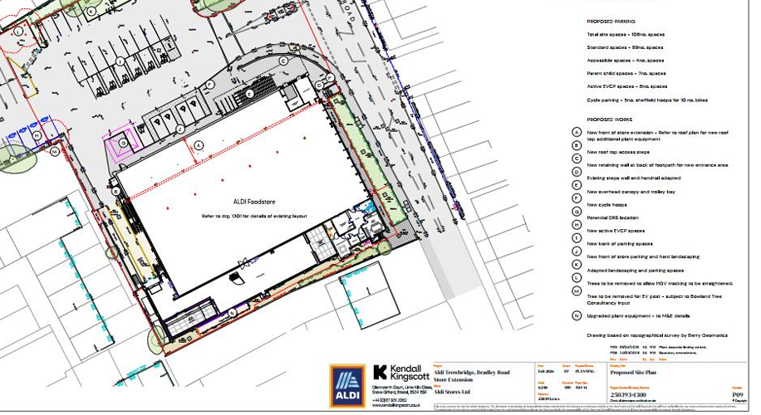

I have not identified any detailed drawings or specifications within the submitted acoustic assessment which confirm the dimensions, height or appearance of the proposed plant equipment. However, this information is not necessary for the Public Protection assessment of noise impacts. The assessment provides predicted noise levels and details of the mitigation measures relied upon to demonstrate compliance with the relevant noise criteria
The assessment proposes plant noise limits of no more than 50dB LAeq within the garden area identified as Receptor R4 (4 Bradley Road). The report notes that, for external amenity areas such as gardens, BS8233 identifies 50dB LAeq as a desirable level, with 55dB LAeq being acceptable in noisier environments. The calculations contained within Appendix E predict a resultant plant noise level of 29dB at Receptor R4, which is significantly below the proposed criterion. The assessment identifies acoustic screening as being provided by the existing building geometry and existing retaining walls. Based on the information submitted, I do not consider that any additional acoustic mitigation specifically for 4 Bradley Road is proposed beyond the mitigation measures already incorporated into the assessment

Appendix E states that retaining walls provide acoustic screening and assumes they will remain in place.

It is not always necessary for detailed drawings or manufacturer specifications to be submitted in support of a noise assessment. The acoustic report provides noise rating levels, predicted noise emissions and details of the mitigation measures relied upon in the assessment, which I consider sufficient for Public Protection to assess the potential noise impact of the proposed plant.

Summary
The acoustic assessment provides predicted noise levels together with the assumptions regarding screening and mitigation. On the basis of the information submitted, I am satisfied that the proposed plant is predicted to comply with the recommended noise criteria and is unlikely to give rise to an adverse noise impact at Receptor R4 (4 Bradley Road).

For completeness, it may be helpful for the applicant or their acoustic consultant to confirm whether all existing plant is being replaced and whether the assessment includes any equipment that will remain operational following the proposed works. This may assist in addressing the resident's concerns regarding the scope of the assessment’

The agent has confirmed that ‘none of the existing plant is proposed to be retained. Currently, refrigeration plant is located to the rear of the store, however, this is being replaced with new, upgraded plant and relocated to the roof where it will sit behind the parapet. New air source heat pumps will be installed to the rear of the store where the existing plant currently is, which is much quieter and more efficient that the refrigeration plant it is replacing’

Given the updated information submitted within the commissioned noise report and further clarification submitted to the public protection team, officers are satisfied that sufficient technical evidence has been submitted to confirm that neighbouring properties would not be unduly affected by the proposed scheme and the noise levels would fall within acceptable parameters in terms of noise pollution, subject to mitigation.

With regard to construction impacts, third party comment are noted. However, construction activity would be temporary in nature and as such not sufficiently harmful to the amenity of neighbouring residents in terms of noise or other disturbances to warrant a recommendation for refusal. However, a condition would be added limiting construction and demolition hours within the site, In the interests of protecting the amenity of nearby residential occupiers from noise and disturbance during the construction phase.

Officers are therefore satisfied that the proposal accords with Core Policy 57 point vii in respect of safeguarding residential amenity and Appendix D of the Wiltshire Design Guide and Policy L2 (1)(d)(ii) of the NPPF.

Highways Impact
Core Policy 57 (xiv) of the Wiltshire Core Strategy seeks to ensure that development must meet the requirements of Core Policy 61. This policy requires proposals to be capable of being served by safe access to the highway network. Core Policy 64 seeks to ensure compliance with parking standards set out in the Local Transport Plan.

The proposal would extend over some existing car parking spaces to the front of the store, reducing the number of spaces within the application site from 112 to 108. However, 8 electric vehicle charging bays would be provided and the parent and child parking would be increased marginally by an additional parking space.

The site access would remain as existing, however due to the extension a revised tracking route would be provided through the removal of a group of trees within the northwestern corner of the site.

The Civic Society have raised concerns that the extended frontage of the store would result in restriction for delivery vehicles to reverse into the delivery bay which could result in highway safety impacts with delivery vehicles parking close to the main access route on Bradley Road.

The comments are duly noted however the commissioned Transport Assessment submitted clearly sets out that the proposed development would not result in any significant alteration to the size, shape or location of the existing service yard. The reconfiguration of the car park would lead to changes in the route taken by servicing vehicles within the site, together with minor alterations to the access arrangements immediately adjacent to the service bay. The applicant has undertaken a swept path analysis based on a 16.5m articulated vehicle to assess the suitability of the revised layout for servicing and refuse collection vehicles.

The submitted assessment demonstrates that servicing and refuse collection vehicles would be able to safely manoeuvre through the site and access the service area without conflict. The tracking information indicates that vehicles would be able to enter, service and exit the site in a forward gear. The proposed servicing arrangements are therefore considered to be acceptable from a highway safety perspective.

The Council highways team were consulted on the proposal and offered the following response.

‘I note the proposed extension to the existing Aldi food store. The proposals will create a net addition of 256m2 of tradeable floor space.
I am aware that the existing access arrangements to the site, both vehicular and pedestrian, will remain unaltered. The existing access arrangements are considered adequate.
However, the proposals will result in alterations to the existing car parking layout to accommodate the extension. The proposals will result in a total loss of 4 car parking spaces across the site, with a total of 104 proposed.

This level of car parking is generally in line with Wiltshire’s Maximum Standard (1 per 14m2) for food retail stores above 1000m2 floor area, and I am also aware that previously, a reduced level of car parking was available for the existing store before the demolition of the car wash facility, which gained demolition consent under PL/2024/10530 and provided an additional 15 car parking spaces for Aldi. Therefore, the proposed level of car parking is accepted in this instance.
A Travel Plan has been submitted in support of the proposals, which is welcomed. However, the Travel Plan must contain targets, measures and monitoring for customers in addition to staff. Monitoring reports should be submitted to Wiltshire Council in years one, three and five. If targets aren’t being met, they should be revised accordingly in agreement with the council. To encourage greater uptake of car sharing, a Guaranteed Lift Home System should be included so if someone is left stranded, they are guaranteed to get home, this could be either using a taxi or another staff member providing a ride home. An updated travel plan can be secured through condition’

The highway officer’s response is duly noted, however officers are cognisant that the proposal represents a modest extension to an existing foodstore which has operated from the site for a number of years. The submitted Transport Statement concludes that the additional floorspace is intended primarily to address existing overtrading and improve the operation of the store, rather than to attract a significant number of additional customers.

Therefore, the development is not anticipated to result in a material increase in vehicle trips to or from the site. On this basis, it is not considered that the proposal would materially alter established customer travel patterns and, therefore, the imposition of measures, targets or monitoring relating to customer travel behaviour would not be proportionate to the scale and nature of the development.

The proposal is therefore considered to comply with Core Policies 57 (xiv), 61 and 64 of the Wiltshire Core Strategy, the NPPF, and the Wiltshire Local Transport Plan.

Ecology Impact
Core Policy 50 of the Wiltshire Core Strategy seeks to protect and enhance biodiversity and geodiversity, including through ensuring that development avoids harm to protected species and habitats.

The National Planning Policy Framework (NPPF 2026) requires that development should minimise any adverse impacts on biodiversity and include features which support priority or threatened species such as swifts, bats and hedgehogs. Development proposals should incorporate integrated nest boxes (commonly known as swift bricks) into their construction unless there are compelling technical reasons which prevent their use or would make them ineffective.

The application site is located within the ‘grey hatched’ recreational zone of the Trowbridge & Westbury Bat Mitigation Strategy (TWBMS) and therefore has potential to result in likely significant effects on the special features of the Bath & Bradford on Avon Bats Special Area of Conservation (SAC).

The Council’s Ecologist was consulted and concluded that ‘as the development proposals are for the extension of an existing food store and car park the LPA can conclude that the application proposals are not likely to have significant effects on the SAC and the proposals are subsequently screened out of Appropriate Assessment’

As a precautionary measure an informative would be added to any decision that in event any evidence of bat activity is detected that the applicant should follow the advice of a professional ecologist or contact Natural England. As such, the development complies with Core Policy 50 of the Wiltshire Core Strategy and the relevant provisions of the NPPF.

Trees
Due to the proposal a revised vehicle tracking route would be provided through the removal of a small group of trees within the northwestern corner of the site and a single tree would be removed to the west of the extended store area to provide an electric vehicle charging point within a car parking space.

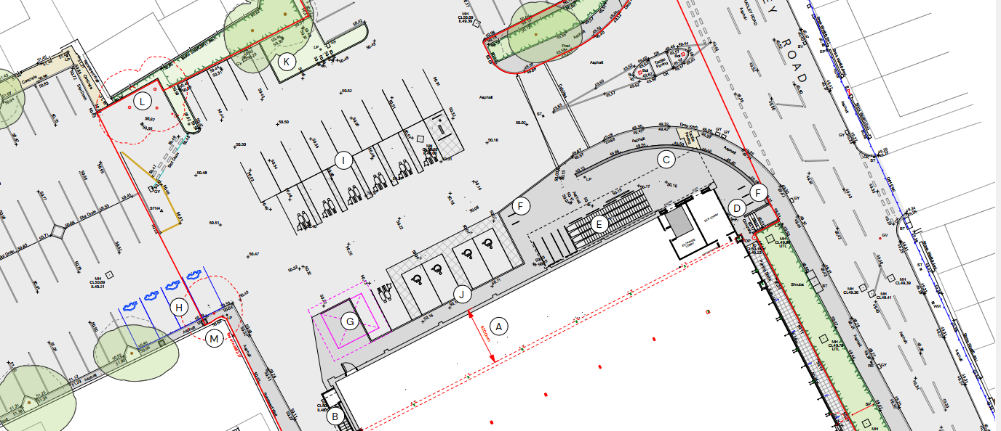
Proposed Site Plan (with areas where trees are to be removed annotated)

The proposal was supported by a submitted Arboricultural Impact Assessment and the Council’s Arborist was consulted on the proposal and raised no objection. However, given the limited information contained within the application submission a condition would be secured to ensure an Arboricultural Method Statement and Tree Protection Plan are submitted prior to commencement of any works.

Drainage and Flood Risk
Policy CP67 of the WCS requires that all new development will include measures to reduce the rate of rainwater runoff and improve rainwater infiltration to soil and ground (sustainable urban drainage.

Policy F7(2) of the 2026 NPPF requires that ‘development proposals should not present a risk from flooding to potential occupiers, users, or visitors, and should not increase flood risk elsewhere. Development must also comply with national policy on flood risk management and drainage design.

The area where the works are to be completed is located within flood zone 1 however it does lie within an area subject to surface water flooding. Therefore, officers need to appraise the development to ensure the development would not increase flooding from surface water.

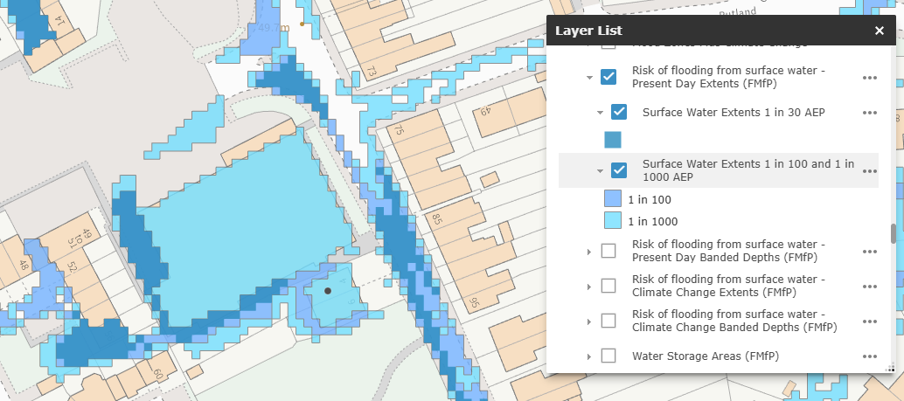

Map insert illustrating the areas susceptible to surface water flooding

The agent has confirmed that the existing plant area to the south elevation sits on a concrete base. The plant is to be replaced, however the new plant will sit on the existing base, without the need for any additional hardstanding.

The proposed stairway, to be erected on the northwest corner of the building, would be installed on an area that is already hard surfaced without any further development proposed in this area. Similarly, the extension to the front elevation of the existing store would extend over an existing hard surfaced area therefore there would not be any change to the impermeable area.
The proposal does not create any additional impermeable ground-level surfaces and would not materially alter existing surface water drainage arrangements. Given the scale and nature of the works, no drainage concerns arise, and the proposal is not considered to increase flood risk on or off-site. Officers are satisfied that the works to be undertaken would not exacerbate flood risk, and the development would not be at risk from flooding.

The proposal therefore complies with Core Policy 67 of the Wiltshire Core Strategy and policy F7(2) of the 2026 NPPF, ensuring that flood risk is not increased and that surface water drainage is appropriately managed.

Biodiversity Net Gain
As of April 2024, unless exempted, applications need to demonstrate no net loss and a minimum of 10% net gain in biodiversity (BNG) on the site, in line with the requirements of the NPPF, PPG, WCS policy CP50 (Biodiversity and Geodiversity) and the Environment Act.
The effect of paragraph 13 of Schedule 7A to the Town and Country Planning Act 1990 is that planning permission granted for development of land in England is deemed to have been granted subject to the condition (biodiversity gain condition) that development may not begin unless:
(a) a Biodiversity Gain Plan has been submitted to the planning authority, and
(b) the planning authority has approved the plan.
The planning authority, for the purposes of determining whether to approve a Biodiversity Gain Plan, if one is required in respect of this permission would be Wiltshire Council.
A completed statutory metric calculation confirming the baseline and predicted post- development biodiversity units of the site has been submitted and includes the condition assessment sheets and maps.
The Council Ecologist raised no objections stating that ‘the completed on-site baseline habitat tabs are accepted as accurate based on the information submitted’

CONCLUSION
The proposed development is considered to be acceptable in terms of its design, scale, and relationship with the surrounding area. It would not result in any unacceptable harm to the character of the locality, the amenities of neighbouring occupiers, or the interests of highway safety, ecology or flood risk.

The proposal is therefore considered to comply with the relevant policies of the Wiltshire Core Strategy, the Wiltshire Local Plan, and the National Planning Policy Framework. As such, the application is recommended for approval, subject to the conditions set out below.

RECOMMENDATION: That Planning Permission be GRANTED subject to conditions.

