APPLICATION FOR PRIOR NOTIFICATION – PART 3
CASE OFFICER REPORT

APPLICATION REFERENCE: | PL/2026/04248
APPLICATION TYPE: | Prior Approval Part 3, Class MA: Commercial, business and service uses to dwellinghouses
SITE ADDRESS: | The Lodge Restaurant, Henfords Marsh, Warminster, BA12 9PA
DEVELOPMENT DESCRIPTION: | Application for prior approval for the proposed change of use of a commercial building (Class E) to a single dwellinghouse (Class C3) under Class MA of Part 3 of Schedule 2 to the Town and Country Planning (General Permitted Development) (England) Order 2015 (as amended).
RECOMMENDATION: | That Prior Approval is required and GRANTED

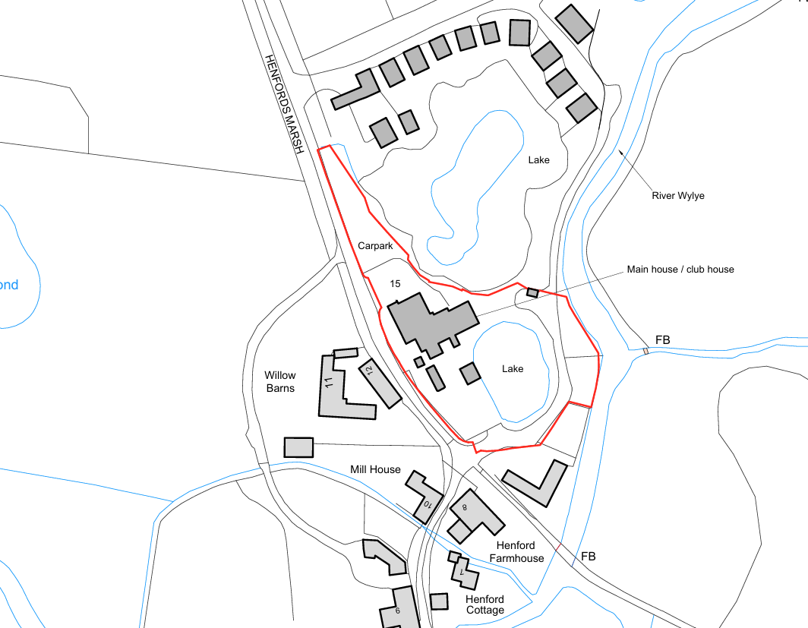

SITE DESCRIPTION/CONTEXT

The application site comprises a detached two-storey building known as The Lodge, Hunters Moon, Henfords Marsh, Warminster. The building has most recently operated as a restaurant and bar with ancillary accommodation at first floor level and is situated within a rural location on the western edge of Warminster. The wider site forms part of an established leisure and tourism complex associated with fishing lakes, holiday accommodation and ancillary facilities.

The site is accessed from Henfords Marsh and is surrounded by a mixture of open countryside, fishing lakes, holiday accommodation, sporadic residential development and areas of mature vegetation. The River Avon lies adjacent to the site and is designated as part of the River Avon SAC and River Avon System SSSI. Following clarification received from Natural England, it has been confirmed that the SAC/SSSI boundary is affected by a mapping anomaly at this location and that, whilst the designated site includes the river corridor, the application site itself is not considered to fall within the SSSI designation but nevertheless remains immediately adjacent to these ecological designations.

The site is also affected by Flood Zones 2 and 3 and lies within the Hampshire Avon Catchment. Existing access and parking arrangements are already established and serve the building.

PROPOSAL

The application seeks prior approval under Schedule 2, Part 3, Class MA of the Town and Country Planning (General Permitted Development) (England) Order 2015 (as amended) for the change of use of the existing building and its curtilage from a Class E commercial use to a single dwellinghouse falling within Class C3.

No significant external alterations are proposed beyond minor works necessary to facilitate the residential use. The existing access, parking and servicing arrangements are to remain unchanged. The proposal would result in the conversion of the former restaurant and associated first floor accommodation into a single self-contained dwelling.

RELEVANT LEGISLATION, POLICY AND GUIDANCE

Under Schedule 2, Part 3, Class MA of the Town and Country Planning (General Permitted Development) (England) Order 2015 (as amended), development consisting of a change of use of a building and any land within its curtilage from a use falling within Class E (commercial, business and service) to a use falling within Class C3 (dwellinghouses) may be permitted development subject to the limitations, conditions and prior approval requirements specified within the Order.

Conservation of Habitats and Species Regulations 2017 (as amended).

RELEVANT PLANNING HISTORY

Proposal / Summary
W/85/00981/FUL - Full planning permission Decision - Approved Date: 29/10/1985 – Creation of small lakes to form amenity features
W/87/00953/FUL - Full planning permission Decision - Approve with Conditions Date: 22/12/1987 – Six fishing chalets
W/88/00347/FUL - Full planning permission Decision - Approve with Conditions Date: 10/5/1988 – Revision of approval 87/00953 chalets and siting changed
W/89/00680/FUL - Full planning permission Decision - Approved Date: 27/6/1989 – Erection of stables and hostel type holiday accommodation
W/89/01868/FUL - Full planning permission Decision - Approve with Conditions Date: 20/11/1990 – Tourist self catering lodges, fishing rod room and store
W/90/00144/FUL - Full planning permission Decision - Approved Date: 13/3/1990 – Amendment to approved hostel accommodation
W/90/01481/FUL - Full planning permission Decision - Approve with Conditions Date: 4/12/1990 – Change of use of first floor storage/staff room to dormitory and staff room
W/92/00968/FUL - Full planning permission Decision - Approve with Conditions Date: 13/10/1992 – Extension to dining room and kitchen, provision of additional car parking
W/93/00018/FUL - Full planning permission Decision - Refused Date: 9/3/1993 – Resiting of approved chalet building and rod room, rod room to have extension of use for occasional functions meetings and seminars, extension to beer store

CONSULTATIONS

Warminster Town Council - No Objection

Highways Officer (Wiltshire Council) - No Objection

Public Protection Officer (Wiltshire Council) - No Objection

Environment Agency - No Objection

ASSESSMENT

This application seeks prior approval under Schedule 2, Part 3, Class MA of the Town and Country Planning (General Permitted Development) (England) Order 2015 (as amended), which permits the change of use of a building and any land within its curtilage from a use falling within Class E (commercial, business and service) to a dwellinghouse falling within Class C3, subject to compliance with the limitations and conditions of the Order.

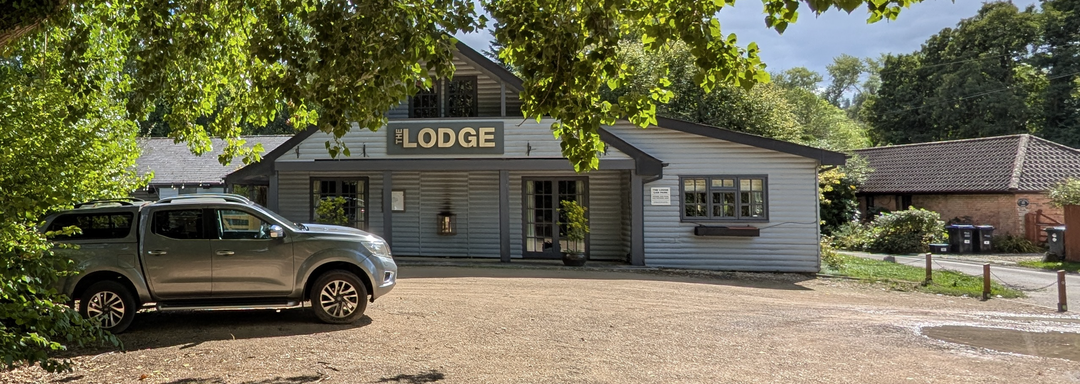
Site Visit Image (Front Elevation)

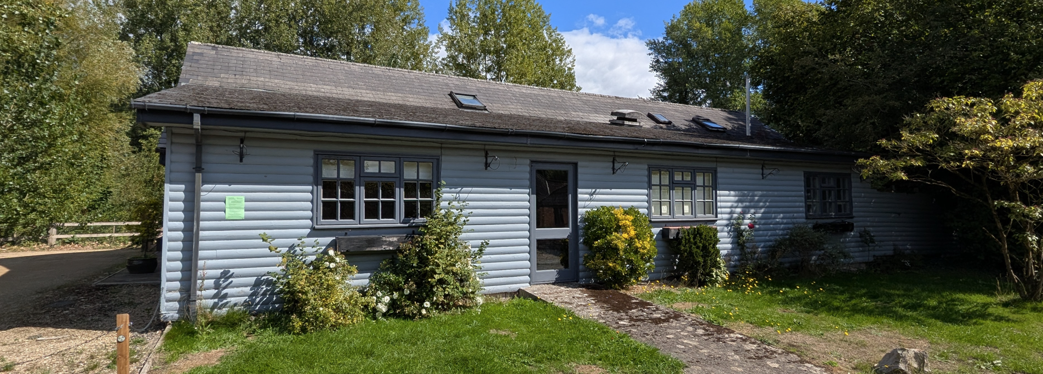
Site Visit Image (Side Elevation)

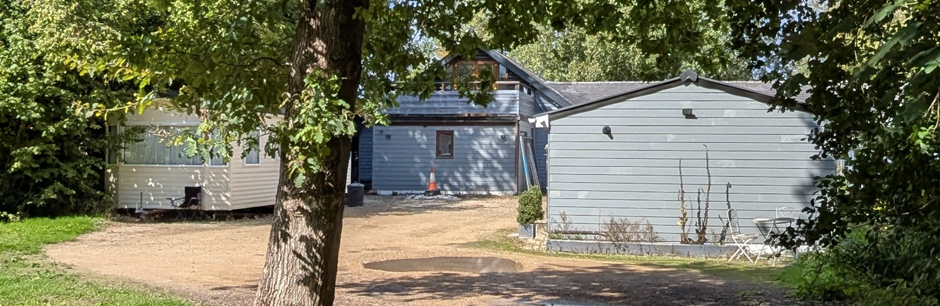
Site Visit Image (Rear Elevation)

Does the Proposal Qualify as Permitted Development?

Development under Class MA is subject to a number of limitations and restrictions. The evidence submitted demonstrates that the building has been in a qualifying commercial use falling within Class E for a continuous period exceeding two years prior to submission of the application. The building most recently operated as a restaurant and bar and this historic use is clearly evidenced through the planning history and publicly available business records.

The application site is not a listed building, scheduled monument, safety hazard area or military explosives storage area and is not located within a National Park, World Heritage Site, National Landscape, the Broads or any other designated area identified within Class MA. The site is not occupied under an agricultural tenancy.

Particular consideration has been given to criterion MA.1(1)(d)(i), which states that development is not permitted where the building or its curtilage is or forms part of a Site of Special Scientific Interest. Following initial concerns, clarification was sought directly from Natural England. Natural England confirmed that the digital mapping is affected by a boundary anomaly at this location and that the SAC/SSSI designation should follow the river corridor. On the basis of that clarification, it is accepted that the application site does not form part of the designated SSSI but instead lies immediately adjacent to it.

Having completed the detailed assessment against the provisions of Class MA, it is concluded that none of the limitations or exclusions apply and therefore the proposal qualifies as permitted development under Schedule 2, Part 3, Class MA of the GPDO.

Is Prior Approval Required?

In this instance prior approval is required in relation to:

- Transport impacts of the development, particularly to ensure safe site access;
- Contamination risks in relation to the building;
- Flooding risks in relation to the building;
- Impacts of noise from commercial premises on intended occupiers;
- Provision of adequate natural light in all habitable rooms of the dwellinghouse;
- Impact on intended occupiers arising from the introduction of residential use in an area important for industry, storage and distribution.

The proposal does not fall within a conservation area, does not involve the loss of a nursery or health centre and does not meet the fire risk condition prescribed by Class MA.

TRANSPORT AND HIGHWAYS

The proposal would utilise the existing vehicular access which currently serves the building. No alterations to the access arrangements are proposed. The Highway Officer has been consulted and raises no objection to the proposal. It is noted that the existing lawful use as a restaurant and bar is capable of generating a significantly greater level of vehicle movements than a single dwellinghouse. Existing parking provision would also remain available.

Having regard to the consultation response and the nature of the development proposed, no adverse impacts on highway safety or the operation of the highway network have been identified.

Conclusion

Prior approval is required in relation to transport and highway matters and is granted.

FLOODING AND DRAINAGE

The application site lies adjacent to the River Wylye and parts of the wider site are located within Flood Zones 2 and 3. A site-specific Flood Risk Assessment has been submitted in support of the application. The assessment confirms that whilst sections of the wider curtilage are affected by flood risk, the building subject to the proposed change of use is located within Flood Zone 1. The proposal comprises only a change of use and does not involve any extension to the building, operational development, alterations to ground levels or changes to existing drainage arrangements.

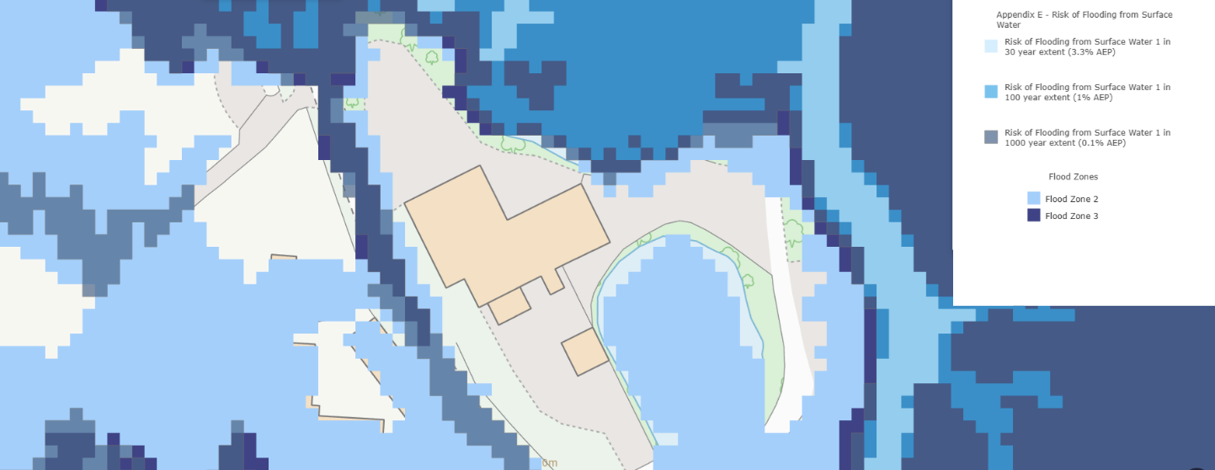
Flood Zones map and Council sFRA surface water flood risk

The Environment Agency has been consulted and raises no objection to the proposal. Whilst noting the site's proximity to Flood Zones 2 and 3 and the potential influence of groundwater flooding within the wider area, the Environment Agency advises only that the Local Planning Authority should satisfy itself regarding safe access and egress arrangements and flood awareness for future occupants.

The submitted Flood Risk Assessment identifies an existing first-floor refuge within the building and confirms that future occupants may register for the Environment Agency Flood Warning Service. The building is already established, and the proposal would not increase flood risk elsewhere. Having regard to the scope of the prior approval assessment under Class MA, which relates specifically to flooding risks in relation to the building, the Local Planning Authority is satisfied that the building can be occupied safely for its intended residential use.

Conclusion

Prior approval is required in relation to flood risk matters and is granted.

NOISE IMPACTS

The site occupies a predominantly rural setting characterised by open countryside, fishing lakes, holiday accommodation and dispersed residential properties. The area is not characterised by intensive commercial or industrial activity.

Public Protection have reviewed the proposal and raise no concerns regarding noise impacts. No evidence has been presented to indicate that future occupiers would be exposed to unacceptable levels of noise and the proposed residential use is considered compatible with the character of the surrounding area.

Conclusion

Prior approval is required in relation to noise matters and is granted.

CONTAMINATION RISKS

Public Protection have reviewed the proposal and raise no concerns regarding contamination. No evidence has been identified suggesting historic uses of the site have resulted in contamination that would render the building unsuitable for residential occupation.

The Local Planning Authority is therefore satisfied that the proposal would not result in the site being classified as contaminated land under Part IIA of the Environmental Protection Act 1990.

Conclusion

Prior approval is required in relation to contamination matters and is granted.

NATURAL LIGHT

The proposal seeks the conversion of an existing restaurant and associated accommodation into a single dwellinghouse. The building already contains a substantial number of external windows reflecting its former commercial use.

The principal habitable rooms, including living rooms, kitchens and bedrooms, are served by appropriately sized external windows providing satisfactory levels of daylight. Whilst a number of ancillary rooms are located internally, these comprise storage areas, toilets and shower facilities rather than habitable accommodation.

Overall, the proposal provides adequate natural light to all habitable rooms and would provide an acceptable standard of accommodation for future occupiers.

Conclusion

Prior approval is required in relation to natural light and is granted.

IMPACT OF SURROUNDING USES

The application site is situated within a rural area characterised by open countryside, fishing lakes, holiday accommodation, agricultural land and low-density residential development. The area is not considered important for general industry, heavy industry, waste management, storage and distribution uses, or a mix of such uses.

The introduction of a residential use would therefore not give rise to conflict with surrounding land uses nor expose future occupants to unacceptable impacts associated with such activities.

Conclusion

Prior approval is required in relation to this matter and is granted.

HABITATS REGULATIONS

Although not a matter for consideration under the Class MA prior approval process, the application site lies within the Hampshire Avon Catchment and immediately adjacent to the River Avon SAC. The proposal therefore remains subject to the provisions of Regulations 75-78 of the Conservation of Habitats and Species Regulations 2017 (as amended).

The proposal involves the change of use of an existing building to a single dwellinghouse and does not introduce additional residential units beyond those assessed as part of this prior approval process. It is nevertheless noted that Article 3(1) of the Town and Country Planning (General Permitted Development) (England) Order 2015 (as amended) requires permitted development to comply with the Habitats Regulations. The applicant is therefore advised accordingly by way of informative and must obtain any necessary approval required under those Regulations before development is begun.

CONCLUSION

The proposed development has been assessed against the provisions, limitations and conditions set out in Schedule 2, Part 3, Class MA of the Town and Country Planning (General Permitted Development) (England) Order 2015 (as amended).

Having undertaken a detailed assessment of the relevant limitations prescribed by Class MA, it is concluded that the proposal qualifies as permitted development. In particular, it has been established that the building has been in a qualifying Class E use for the requisite period and that the site does not fall within a Site of Special Scientific Interest. Clarification received from Natural England confirms that the apparent overlap with the River Avon System SSSI arises from a mapping anomaly and that the application site lies adjacent to, rather than within, the designated site.

Prior approval is required in relation to:

- transport impacts;
- contamination risks;
- flooding risks;
- noise impacts;
- provision of natural light; and
- the impact on intended occupiers arising from the introduction of residential use in the surrounding area.

These matters have been assessed having regard to the submitted application documents and consultation responses received from the relevant technical consultees. No objections have been raised by Warminster Town Council, the Highways Officer, Public Protection Officer or the Environment Agency. The submitted information demonstrates that the proposal would not result in unacceptable transport, contamination, flooding, noise or living condition impacts and would provide an appropriate standard of residential accommodation for future occupiers.

Accordingly, the Local Planning Authority is satisfied that prior approval can be granted in relation to all matters prescribed under Class MA.

RECOMMENDATION

That prior approval is REQUIRED in relation to:

- transport impacts;
- contamination risks;
- flooding risks;
- noise impacts;
- provision of natural light; and
- the impact on intended occupiers arising from the introduction of residential use in the surrounding area.

And that prior approval is GRANTED.

A
APPENDIX 1 – PERMITTED DEVELOPMENT CHECKLIST CLASS MA
Class MA – commercial, business and service uses to dwellinghouses
 |  | Yes / No
MA. | Permitted Development  Note: If the answer is "Yes" to any, proceed to assessment under MA.1. If the answer is "No" to all, the proposal does not qualify as permitted development under this class.
(a) | Does the proposed development involve a change of use of a building and any land within its curtilage from a use falling within Class E (commercial, business and service) to a use falling within Class C3 (dwellinghouses)? | YES
MA.1 | Development is not permitted by Class MA if -  Note: If the answer to any of the questions below is "Yes", the proposed development would not constitute permitted development under this class
(b) | Has the building been in use for less than 2 continuous years as one of the specified use classes before the prior approval application? | No
(d)(i) | Is the land or curtilage part of a Site of Special Scientific Interest (SSSI)? | No
(d)(ii) | Is the building or land part of a listed building or its curtilage? | No
(d)(iii) | Is the building or land part of a scheduled monument or its curtilage? | No
(d)(iv) | Is the building or land within a safety hazard area? | No
(d)(v) | Is the building or land within a military explosives storage area? | No
(e) | Is the building located within any of the following designated areas?  - Area of Outstanding Natural Beauty (AONB)  - Area specified under section 41(3) of the Wildlife and Countryside Act 1981  - The Broads  - A National Park  - A World Heritage Site | No
(f) | Is the site occupied under an agricultural tenancy without the express consent of both the landlord and the tenant? | No
(g) | Was the application made before 1 August 2022 for development that would have fallen under Class O before 1 August 2021, and was restricted by an Article 4 direction still in force? | No

