APPLICATION FOR HOUSEHOLDER PLANNING PERMISSION
DELEGATED REPORT

APPLICATION REFERENCE: | PL/2026/03957
APPLICATION TYPE: | Householder Planning Permission
SITE ADDRESS: | Fairfields, Green Lane, Trowbridge, BA14 6DJ
DEVELOPMENT DESCRIPTION: | Removal of existing 16x12ft shed and erection of a single-storey timber outbuilding in the rear garden to be used as a home office. Extension of existing rectangular patio shed base.
RECOMMENDATION: | That Planning Permission be GRANTED

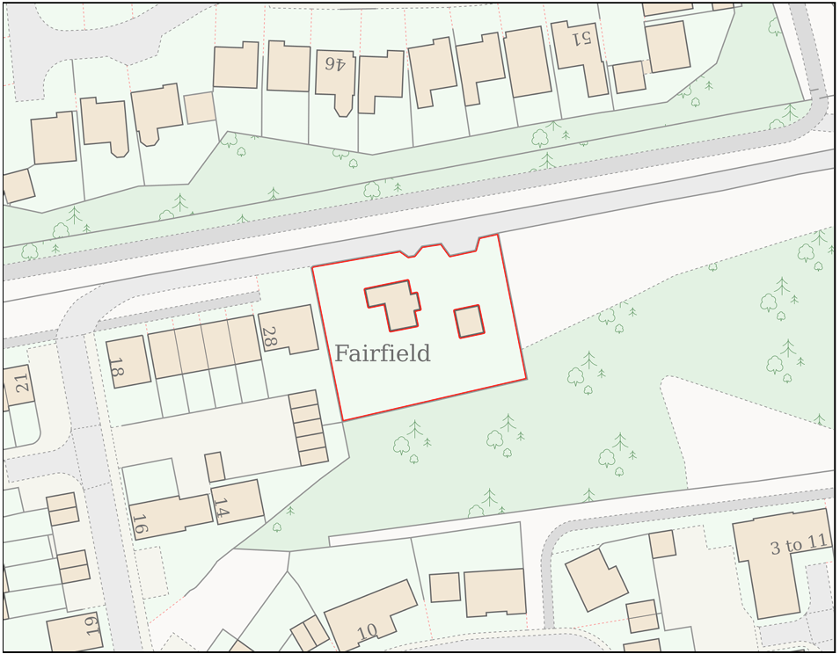
PROPOSAL

The application seeks planning permission for the erection of a single-storey timber garden outbuilding following the removal of an existing shed and extension of the existing patio base. The building adopts an L-shaped form with dual-pitched roofs and timber-clad elevations incorporating areas of glazing. The structure would provide incidental accommodation associated with the host dwelling in the form of a home office and covered veranda area. The outbuilding measures approximately 7.4 metres by 7 metres overall, with an eaves height of approximately 2.3 metres and a maximum ridge height of 3 metres. The development is positioned within the south-western corner of the rear garden and is partly retrospective, with the majority of the structure having already been erected at the time of the site inspection.

SITE DESCRIPTION / CONTEXT

The application site comprises a detached two-storey dwelling known as Fairfields, located within the settlement boundary of Trowbridge. The property occupies a large residential plot at the edge of a modern housing development and benefits from a substantial rear garden. The site lies within Flood Zone 1 and is identified by the Council's Strategic Flood Risk Assessment as being at a generally low risk of flooding, albeit with limited areas subject to low-probability surface water flood risk. Ecologically, the site is located within the Trowbridge and Westbury Bat Mitigation Strategy grey zone and within Bechstein's Bat Core Roost consultation buffers. A small area of Priority Habitat deciduous woodland adjoins the eastern boundary. A public right of way (TROW41A) passes to the north of the site but is physically separated from the development by the host dwelling and associated curtilage.

PLANNING HISTORY

No relevant planning history has been identified for the site subject of this application.

RELEVANT LEGISLATION, POLICIES AND GUIDANCE

Wiltshire Core Strategy:

Core Policy 1 Settlement Strategy;
Core Policy 2 Delivery Strategy;
Core Policy 29 Spatial Strategy: Trowbridge Community Area;
Core Policy 50 Biodiversity and Geodiversity;
Core Policy 51 Landscape;
Core Policy 57 Ensuring High-Quality Design and Place Shaping;
Core Policy 60 Sustainable Transport;
Core Policy 61 Transport and Development;
Core Policy 64 Demand Management;
Core Policy 67 Flood Risk;

The National Planning Policy Framework (NPPF) and The Planning Practice Guidance (PPG)

Wiltshire Design Guide - Appendix D – Design Guidance for Householder extensions

The Wiltshire Local Transport Plan 2011 – 2026: Car Parking Strategy (March 2015).

The Wiltshire Local Transport Plan 4 (LTP4) (March 2025)

New Wiltshire Local Plan

At Full Council on 19 May 2026, the elected members of Wiltshire Council agreed to withdraw the emerging Wiltshire Local Plan. The said Plan has no material weight for the purposes of the application.

In accordance with Regulation 19 of the Town and Country Planning (Local Planning) (England) Regulations 2026, on 30th June 2026 Wiltshire Council published a notice of intention to prepare a new local plan for Wiltshire. The next stage is a Scoping Consultation which commences on 2nd September 2026. This plan is at a very early stage and currently carries no weight for decision making.

CONSULTATION RESPONSES

Trowbridge Town Council – No Comment Received

Ecology Officer (Wiltshire Council) – No Objection
Conditions were requested including a plans list, details of ecological enhancement, and future control on external lighting.

REPRESENTATIONS

Two letters of objection were received raising concerns regarding the retrospective nature of the development, noting that the outbuilding had already been erected prior to the submission of the application. Objections were also raised in relation to the size, height and close proximity of the structure to the shared boundary, with concerns that it appears visually dominant, results in an overbearing presence and adversely affects the outlook from neighbouring properties. Further concerns related to the absence of visible drainage provision and the potential for increased surface water run-off, fire safety risks arising from the timber construction and proximity to boundary features and vegetation, and the impact of the proposed home office use in terms of noise, disturbance and potential overlooking. It was also contended that the scale and L-shaped footprint of the outbuilding adversely affects the character of the rear garden area. One additional representation described the building as a substantial structure and questioned its characterisation as a replacement shed.

ASSESSMENT

Section 38(6) of the Planning and Compulsory Purchase Act 2004 states:

"If regard is to be had to the development plan for the purposes of any determination to be made under the planning Acts, the determination must be made in accordance with the plan unless material considerations indicate otherwise."

In accordance with this statutory requirement, this application has been assessed against the relevant policies of the Development Plan, including the adopted Wiltshire Core Strategy (2015) and, where applicable, any made Neighbourhood Plans.

The proposal relates to the provision of a domestic outbuilding within the residential curtilage of an established dwelling situated within the Principal Settlement of Trowbridge. The building is proposed for purposes incidental to the enjoyment of the dwellinghouse, namely a home office and covered garden space, and does not contain facilities that would facilitate independent residential occupation. As such, the development is considered to represent an appropriate form of domestic development within the existing residential curtilage and raises no objection in principle, subject to consideration of its detailed impacts.

Design and Impact the upon the character and context of the area

Core Policy 57 of the Wiltshire Core Strategy seeks to secure high-quality design which responds positively to local character and distinctiveness. At the national level, Policy DP3 of the National Planning Policy Framework requires development proposals to respond positively to their context and integrate with and enhance their surroundings. Development should also reflect, where relevant, the principles of liveability, climate resilience, nature, movement, built form, public space and local identity. Assessment of design quality therefore requires consideration of the scale, appearance, massing, materials, layout and relationship of the proposal with both the host site and the wider character of the surrounding area.

The proposed outbuilding is typical of domestic garden structures commonly found within residential curtilages and is constructed from materials that are appropriate to its function and setting. Whilst the building is larger than a traditional garden shed, it remains clearly subordinate to the host dwelling and is positioned within the corner of a substantial rear garden, where its visibility from public vantage points is extremely limited. The timber-clad appearance is consistent with the character of domestic outbuildings and boundary treatments typically found within residential environments. Having regard to its scale, massing, design and positioning, the proposal would not appear visually intrusive or incongruous within the site and would preserve the overall character and appearance of the property and surrounding area.

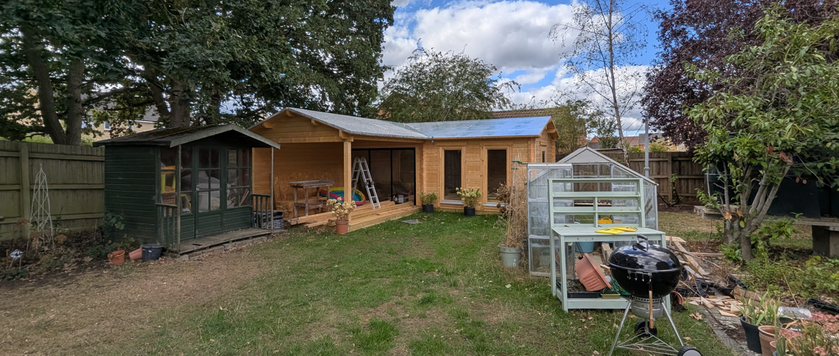
Site Visit Image

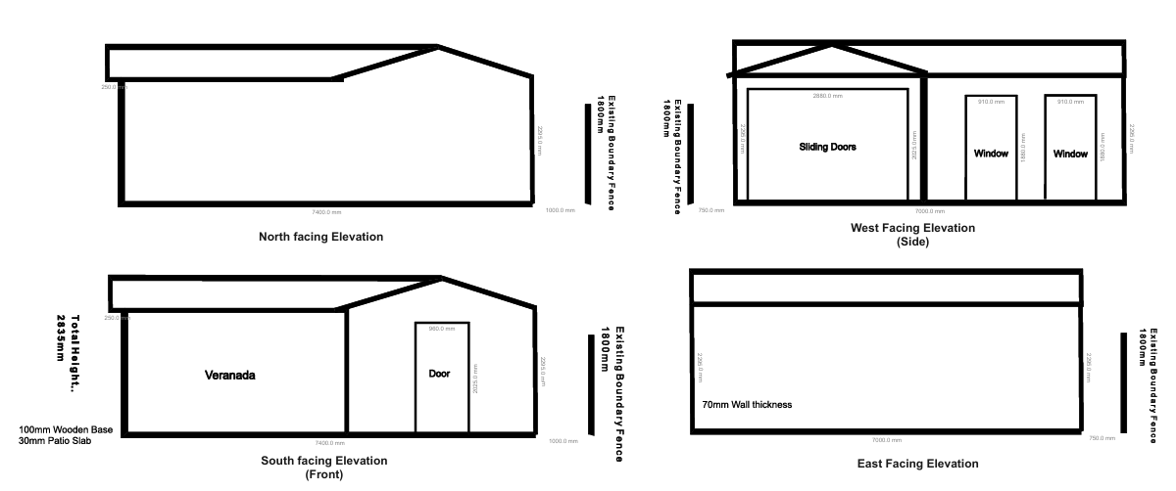
Proposed Elevations

Having regard to the above, the proposal complies with the design principles set out in the NPPF Policy DP3, Core Policy 57 of the Wiltshire Core Strategy, and Appendix D of the Wiltshire Design Guide.

Amenity

Core Policy 57 criterion vii seeks to ensure development does not have an unacceptable impact upon the amenities of neighbouring occupiers. Nationally, Policy P3 requires development proposals to provide healthy living conditions for occupiers and users and to avoid unacceptable impacts arising from loss of light, outlook, privacy, noise, disturbance or other forms of pollution. Policy DP3 additionally requires development to create liveable and attractive places for existing and future users. Accordingly, the assessment below considers the effect of the proposal upon neighbouring occupiers and whether acceptable living conditions would be maintained.

Concern has been raised regarding the scale of the structure and its relationship with the neighbouring property at No. 28 Godley Lane. The outbuilding is positioned adjacent to the shared boundary; however, its eaves height measures approximately 2.3 metres and only a relatively limited proportion of the building projects above the existing boundary treatment. The pitched roof design causes the bulk of the roof form to slope away from the neighbour and assists in reducing its perceived mass when viewed from adjoining land. Having undertaken a site inspection from the neighbouring garden, it is not considered that the proposal gives rise to material overbearing impacts, loss of outlook or unacceptable overshadowing.

The proposed use of the building as a home office and covered veranda area is also not considered likely to result in unacceptable impacts upon neighbouring occupiers. The development remains incidental to the existing residential use of the property and does not materially alter the established pattern or intensity of domestic activity within the garden. Furthermore, the building does not incorporate elevated platforms or window arrangements that would give rise to harmful overlooking or loss of privacy. Having regard to the scale, positioning and proposed use of the development, the proposal is considered to provide an acceptable standard of residential amenity for neighbouring occupiers.

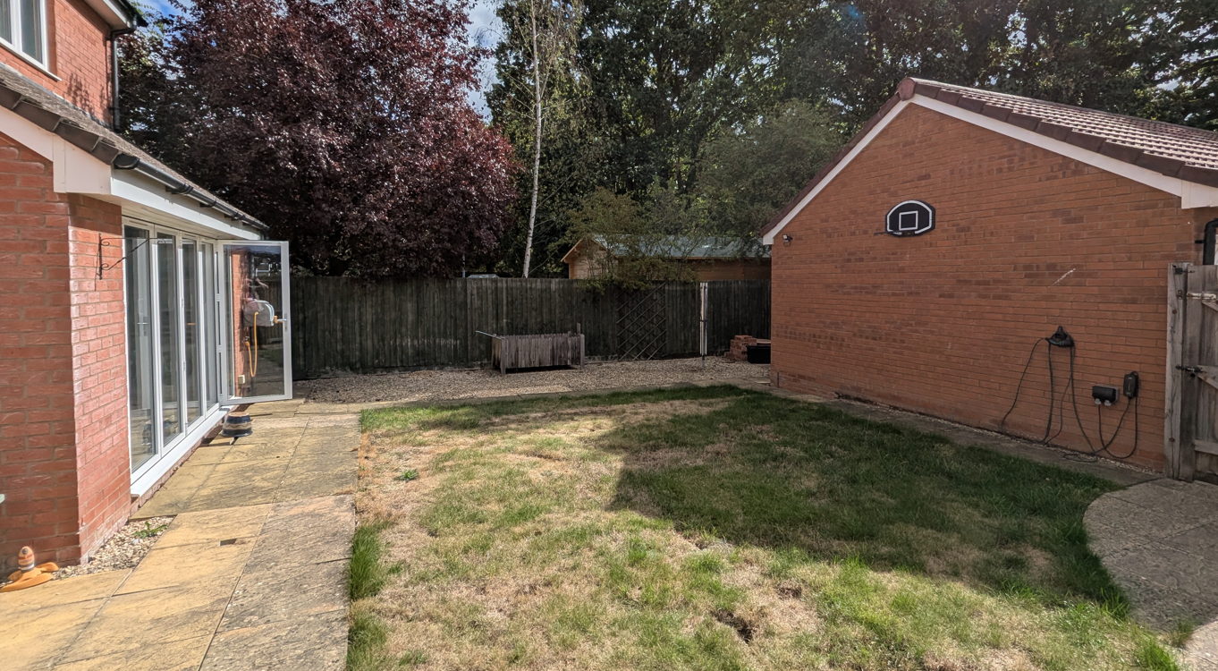
Site Visit Image (from neighbouring garden)

The proposal therefore accords with Core Policy 57 point vii in respect of safeguarding residential amenity and Appendix D of the Wiltshire Design Guide.

Transport and Highways

Core Policies 60, 61 and 64 of the Wiltshire Core Strategy seek to promote sustainable transport, secure safe access arrangements and ensure adequate parking provision. Nationally, Policies TR3 and TR4 of the National Planning Policy Framework require development to be located in sustainable locations where appropriate, provide safe access arrangements, prioritise walking, wheeling and cycling, and provide suitable parking provision having regard to the nature and location of the development. Policy TR6 confirms that development should be refused where it would result in a severe adverse impact on the transport network or an unacceptable impact on highway safety after consideration of any mitigation measures.

The proposal relates solely to the provision of an incidental domestic outbuilding and would not result in the creation of additional residential accommodation or intensification of the established use of the site. No alterations are proposed to the existing access, parking arrangements or highway network. Accordingly, no adverse highway safety or parking impacts are identified.

Ecology

Core Policy 50 of the Wiltshire Core Strategy seeks to protect and enhance biodiversity interests and ensure development avoids unacceptable harm to ecological assets. National policy is set out within Policies N2 and N6 of the National Planning Policy Framework. These policies require development proposals to minimise impacts upon biodiversity, protect important habitats and species, and secure opportunities for biodiversity enhancement where appropriate. Where significant harm to biodiversity cannot be avoided, adequately mitigated or compensated for, development should be refused. Biodiversity Net Gain (BNG) was established as a mandatory aspect of planning evaluation through Schedule 7A of the Town and Country Planning Act 1990 (as amended by the Environment Act 2021 Schedule 14).

The site is subject to a number of ecological constraints, including its location within consultation zones associated with the Bath and Bradford on Avon Bats SAC and proximity to Priority Habitat woodland. The Council's Ecologist has reviewed the proposal and concluded that the development is not likely to result in significant effects upon the SAC and can be screened out from Appropriate Assessment under the Habitats Regulations. Furthermore, no significant impacts upon Bechstein's bats, other bat species, protected habitats or ecological connectivity have been identified. The Ecologist notes that no tree removal is proposed and concludes that no further ecological surveys are necessary.

The proposal relates to the replacement of an existing domestic outbuilding within an established residential garden and occupies an area already influenced by domestic activity. Given the scale and nature of the works, together with the absence of habitat loss and the findings of the Council's Ecologist, it is not considered that the development would result in unacceptable impacts upon protected species or biodiversity interests. The Council's Ecologist has recommended biodiversity enhancement and lighting conditions together with ecology informatives. Whilst the ecological sensitivities of the wider area are acknowledged, the impacts associated with this modest domestic development are considered to be limited and the proposal is, on balance, acceptable in ecological terms.

Flooding and Drainage

Core Policy 67 of the Wiltshire Core Strategy seeks to ensure that development is directed away from areas at greatest risk of flooding and is designed to minimise vulnerability to flooding whilst avoiding any increase in flood risk elsewhere. National planning policy relating to flood risk and drainage is contained within Policies F4 to F8 of the National Planning Policy Framework. Collectively, these policies establish a risk-based approach to the location and assessment of development proposals. The Framework requires flood risk to be properly assessed where necessary, seeks to direct development towards areas at the lowest risk of flooding through the application of the sequential approach where applicable, and ensures that development remains safe for its lifetime without increasing flood risk elsewhere. The policies also support the incorporation of sustainable drainage measures where appropriate in order to manage surface water runoff and reduce the potential for flooding.

The development introduces a relatively modest area of additional built form within a large residential plot. The site is located within Flood Zone 1 and the proposal does not constitute a form of development that would materially increase flood risk either on-site or elsewhere. Whilst limited areas of low-probability surface water flood risk are identified within the wider site, the scale of the development is minor and is not considered capable of generating significant additional runoff or drainage impacts. The proposal is therefore considered acceptable in respect of flood risk and drainage matters.

Other Matters

The retrospective nature of the application has been noted within representations received. However, planning legislation allows applications to be submitted retrospectively and such applications must be determined on their planning merits. The fact that development has commenced or been completed prior to the submission of an application does not, in itself, justify refusal of planning permission.

Objectors have also referred to permitted development limitations relating to the height of outbuildings. Whilst the proposal exceeds certain parameters that would be required to benefit from permitted development rights, the application has been submitted for full planning permission and must therefore be assessed against the adopted development plan and other material planning considerations rather than solely against the provisions of the General Permitted Development Order.

Concerns regarding fire safety, the timber construction of the building and the proximity of existing trees to the boundary have likewise been considered. Fire safety matters are principally controlled through separate legislative regimes, including the Building Regulations, and are not matters that attract significant weight in the determination of this application. Furthermore, the trees referred to within representations do not benefit from statutory protection and do not form part of the development proposal. In the absence of any evidence of unacceptable planning harm arising from these matters, they do not weigh against the proposal.

CONCLUSION

The proposed outbuilding represents an acceptable form of incidental domestic development within the curtilage of an established dwelling. The proposal would not result in unacceptable harm to the character or appearance of the area, neighbouring residential amenity, highway safety, drainage interests or ecological assets. Whilst the development does not fully comply with the dimensional limitations that would ordinarily enable it to be constructed under permitted development rights, the degree of departure is limited and the resulting impacts are not considered harmful. Having regard to the development plan as a whole and all other material considerations, the application is recommended for approval subject to appropriate conditions.

RECOMMENDATION: That Planning Permission be GRANTED subject to conditions

