DELEGATED REPORT

Application Reference: | PL/2026/05146
Application Type: | Prior notification: Demolition
Site Address: | Land at Blackmore Farm, Melksham
Proposal: | Prior Notification for the proposed demolition of agricultural buildings.
Recommendation: | Prior approval required and granted

PROPOSAL

Proposed demolition of agricultural buildings, as shown within the red line plan below, associated with the Outline planning consent ref. PL/2023/11188 for mixed use development. A Reserves Matters Application has been submitted for the Site and is currently pending approval (ref. PL/2026/01555). The demolition of the barns is required to facilitate the wider development.

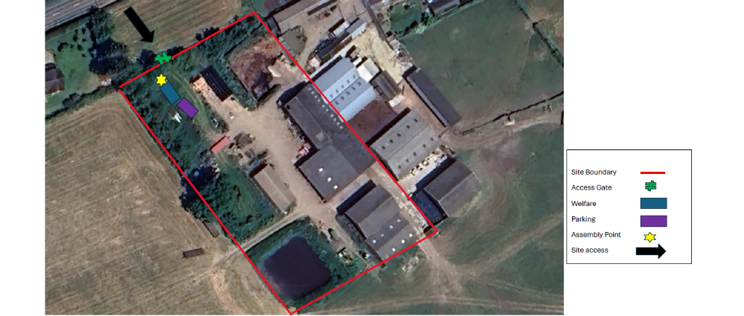

SITE DESCRIPTION/CONTEXT

The application site relates to the most northern part of a wider development site that extends to over 37 hectares. The site is located immediately south of Sandridge Common Road (the A3102) and to the east of Eastern Way.

As shown in the aerial insert above right, Blackmore Farm has a range of agricultural buildings.

To the west, the significant modern town expansion on land to the northeast of Snowberry Lane and south of Sandridge Road is clearly evident – which formed part of a 2004 outline permission for 670 dwellings, which was subject to numerous applications through the years. The site is located just over 2km east of Melksham’s town centre.

The topography of the site is fairly flat and low lying, gently sloping from the north boundary.

Trees are found throughout the site nestling amongst the hedgerows while a small copse of broadleaved trees is located in the southern section of the site.

The site falls within the Avon Open Clay Vale character area while the Wooded Greensand Hill Special Character Area is located approximately 600 metres to the northeast. The site is located within flood zone 1. Some minor areas of the site are subject to surface water flooding associated with Clackers Brook.

PLANNING HISTORY

PL/2023/11188 - Demolition of agricultural buildings and development of up to 500 dwellings; up to 5,000 square metres of employment (class E(g)(i)) & class E(g)(ii)); land for primary school (class F1); land for mixed-use hub (class E / class F); open space; provision of access infrastructure from Sandridge Common (A3102); and provision of all associated infrastructure necessary to facilitate the development of the site (Outline application relating to access) – Approved 12/05/2025

PL/2026/01555 - A reserved matters application (appearance, layout, scale and landscaping) for 229 dwellings and associated infrastructure – Reserved Matters pursuant to Outline permission PL/2023/11188 - Pending

POLICIES

Policy which is relevant to the proposal: Class B of Part 11 of Schedule 2 of The Town and Country Planning (General Permitted Development) (England) Order 2015.

CONSULTATION

None

REPRESENTATIONS

None

ASSESSMENT:
This is an application for prior notification of proposed demolition, submitted under Class B of Part 11 of Schedule 2 of The Town and Country Planning (General Permitted Development) (England) Order 2015 (As amended).
Permitted development rights exist where planning permission is deemed to be granted for demolition without the need to make a formal planning application. Before exercising Permitted development rights, conditions need to be met, including:
• Before demolishing any building, the developer should apply to the local planning authority (LPA) for a determination as to whether the prior approval of the authority will be required as to the method of demolition and any proposed restoration of the site; and
• Where demolition is urgently required in the interests of safety or health, the developer should provide to the LPA, as soon as reasonably practical, a written justification for the demolition.
The legislation indicates that the Local Planning Authority can only consider the proposed method of demolition and the proposed restoration of the site. The purpose of this control is to give local planning authorities the opportunity to regulate the details of demolition to minimise the impact of that activity on local amenity.

LEGISLATION IN FULL BELOW

Part 11, Class B of the GPDO

Permitted development

B. Any building operation consisting of the demolition of a building.

Development not permitted

B.1 Development is not permitted by Class B if

a) the building has been rendered unsafe or otherwise uninhabitable by the action of any person with an interest in the land

b) the demolition is relevant demolition for the purposes of section 196D of the Act (demolition of an unlisted building etc, building in a conservation area)

c) the building is used, or was last used, for a purpose falling within—
(i) article 3(6)(p) (drinking establishments etc.) of the Use Classes Order; or
(ii) article 3(6)(q) (drinking establishments with expanded food provision) of that Order

d) the building is used, or was last used, for the purpose of-
(i) a concert hall
(ii) a venue for live music performance; or
(iii) a theatre: or

e) the demolition relates to a statue, memorial or monument in place for a period of at least 10 years on the date of any proposed demolition, other than a commemorative structure-
(i) that is a listed building
(ii) that is a scheduled monument
(iii) within a cemetery, on consecrated land, or within the curtilage of a place of public worship
(iv) within the grounds of a museum or art gallery; or(v) within the curtilage of a dwelling house

Class B Conditions:

B.2 Development is permitted by Class B subject to the following conditions—

a) where demolition is urgently necessary in the interest of safety or health and the measures immediately necessary in such interest are the demolition of the building, the developer must, as soon as reasonably practicable, give the local planning authority a written justification of the demolition;

b) where demolition does not fall within paragraph (a) and is not excluded demolition:

i) the developer must, before beginning the development, apply for the local planning authority for a determination as to whether the prior approval of the authority will be required as to the method of demolition and any proposed restoration of the site.
ii) an application described in paragraph (b)(i) must be accompanied by a written description of the proposed development, a statement that a notice has been posted in accordance with paragraph (b)
(iv) and any fee required to be paid.
(iv)subject to paragraph (b)(v), the applicant must display a site notice by site display on or near the land on which the building to be demolished is sited and must leave the notice in place for not less than 21 days in the period of 28 days beginning with the date on which the application was submitted to the local planning authority;
(v)where the site notice is, without any fault or intention of the applicant, removed, obscured or defaced before the period of 21 days referred to in paragraph (b)(iv) has elapsed, the applicant is treated as having complied with the requirements of that paragraph if the applicant has taken reasonable steps for protection of the notice and, if need be, its replacement;
(vii) the development must not begin before the occurrence of one of the following—

(aa)the receipt by the applicant from the local planning authority of a written notice of their determination that such prior approval is not required;
(bb)where the local planning authority give the applicant notice within 28 days following the date of receiving the application of their determination that such prior approval is required, the giving of such approval; or
(cc)the expiry of 28 days following the date on which the application was received by the local planning authority without the local planning authority making any determination as to whether such approval is required or notifying the applicant of their determination;

(viii)the development must, except to the extent that the local planning authority otherwise agree in writing, be carried out

(aa)where prior approval is required, in accordance with the details approved;
(bb)where prior approval is not required, in accordance with the details submitted with the application;

(ix) the development must be carried out—

(aa)where approval has been given by the local planning authority, within a period of 5 years from the date on which approval was given;
(bb)in any other case, within a period of 5 years from the date on which the local planning authority were given the information referred to in paragraph (b)(ii);

In respect of the limitations set out at B1 above:

- The subject buildings of this demolition application are currently vacant. These buildings are within the red line site plan for an approved mixed use evelopment (as set out above)
- The buildings need to be demolished for the approved development to take place.
- There is no evidence to suggest that urgent measures are necessary in the interest of safety or health
- The building is not relevant demolition in a Conservation Area.
- The building is not in use or last used as a drinking establishment with/without food provision.
The building is not in use or last used as a concert hall, live music venue or theatre.
The building is not a statue, memorial or monument

In respect of the conditions set out at B2 above:

The application includes a Demolition Method Statement that appropriately considers and deals with all relevant matters, including site arrangements, hazards, site safety, emergency arrangements and waste management.

Confirmation of a site notice being displayed on the 05 August 2026 has been submitted with the application with the appropriate fee. The development has not begun. It is intended to commence on 19th October 2026.

The prior approval application has been submitted for determination in accordance with the requirements.

The site is located within a private agricultural holding away from the public realm. In this instance it is considered that sufficient detail has been provided for the LPA to be satisfied that the method of demolition will be undertaken in an appropriate manner and that the site post demolition will be left in a safe state.

Ecology

The application includes a Technical Note by EA Ecology that supplements bat roost surveys previously undertaken as part of the Outline planning application process referred to above. No bat roosts were identified during the previous inspection and emergence surveys. The update surveys were undertaken as a precaution to ensure that no new roosts had established in the interim, which would necessitate a Natural England Bat Mitigation Licence to be obtained prior to demolition. The Technical Note demonstrates that the buildings proposed for demolition have negligible, low and no bat roost suitability.

CONCLUSION

The legislation states that where prior approval is not required, the development shall be in accordance with the details submitted with the application. To comply with Condition B.2 (vii) (bb) of Class B of Part 11 of Schedule 2 of The Town and Country Planning (General Permitted Development) (England) Order 2015 (as amended).

It is therefore considered that the proposal is permitted development and the proposed method of demolition for the agricultural barns as per the details submitted with the application is considered to be acceptable. Prior approval has therefore been assessed and granted.

RECOMMENDATION: The proposal required prior approval, and prior approval has been granted as sufficient details have been provided to allow assessment.

Conditions:

1 The demolition hereby approved must be carried out in accordance with the following documents and must be completed within a period of 5 years from the date on which this approval was given

- 17/8/2026 - Cover Letter
- 14/8/2026 - Application Form
- 14/8/2026 - BDW Trading Site Notice
- 14/8/2026 - Demolition Method Statement
- 14/8/2026 - Location Plan
- 14/8/2026 - Technical Note - Update Bat Roost Survey
REASON: To comply with the provisions of Schedule 2, Part 11, Class B of the Town and Country Planning (General Permitted Development) Order 2015 (as amended) and for the avoidance of doubt.

Informative

Protected Species
The applicant should note that under the terms of the Wildlife and Countryside Act (1981) and the Habitats Regulations (2017) it is an offence to disturb or harm any protected species including for example, breeding birds and reptiles. The protection offered to some species such as bats, extends beyond the individual animals to the places they use for shelter or resting.

Please note that this consent does not override the statutory protection afforded to any such species. In the event that your proposals could potentially affect a protected species you should seek the advice of a suitably qualified and experienced ecologist and consider the need for a licence from Natural England prior to commencing works. Please see Natural England’s website for further information on protected species.

