APPLICATION FOR HOUSEHOLDER PLANNING PERMISSION
DELEGATED REPORT

APPLICATION REFERENCE: | PL/2026/04341
APPLICATION TYPE: | Householder planning permission
SITE ADDRESS: | 6 Eastbourne Road, Trowbridge, BA14 7HN
DEVELOPMENT DESCRIPTION: | Proposed Single Storey Rear Extension
RECOMMENDATION: | That Planning Permission be GRANTED

SITE DESCRIPTION/CONTEXT
The subject property is a semi-detached, two-storey dwelling, within the urban historic core of Trowbridge, the area characterised by terraces, of varying ages. The subject property is visible on the 1st epoch mapping of 1868-1899.

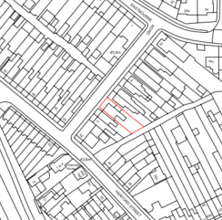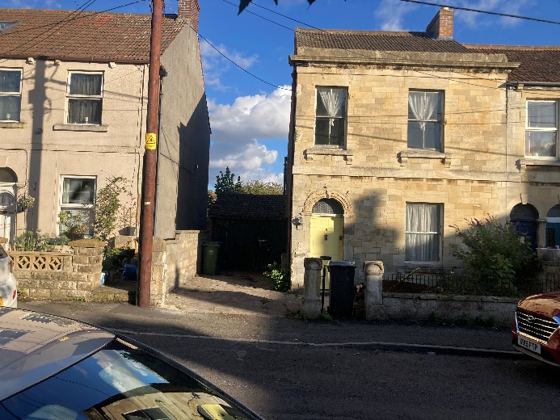
Location Plan and Site Photo

The building has an ashlar stone façade with sash windows, with red brick rear/side elevations, and benefits from a modern attached garage.

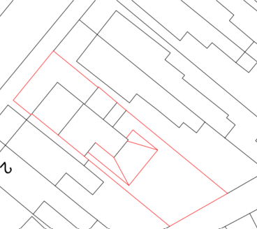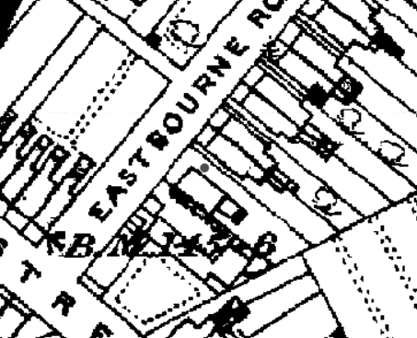
Proposed Block Plan and 1st epoch mapping

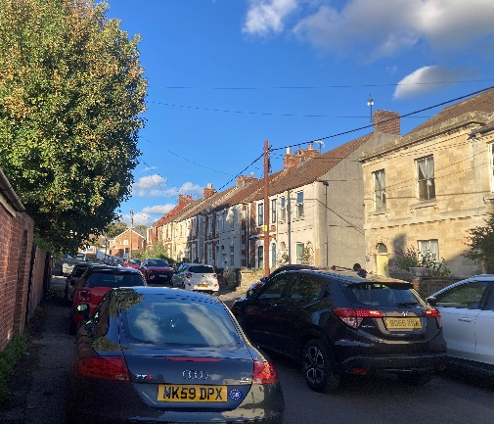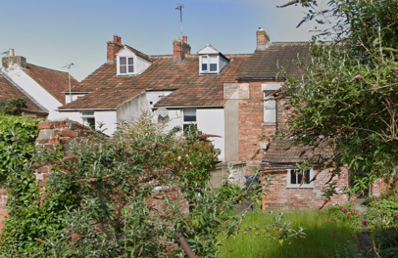
Site Photos

PROPOSAL

The proposal seeks planning permission for:
- Demolition of rear single storey extension
- Erection of narrow side return extension wrapping around to a rear extension
- Knocking through to create an open plan kitchen/living/dining
- Creation of a downstairs WC under the staircase

Proposed materials include red brick to match existing, Redland regent tiles against existing profiled roof tiles and white UPVC to replace existing timber windows/doors.

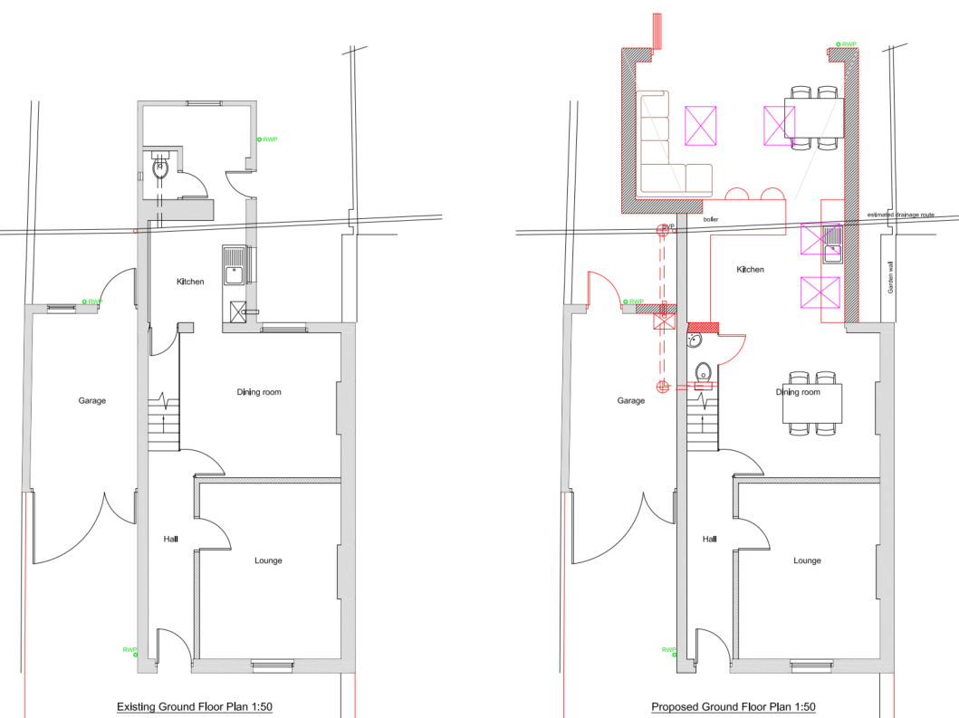

Existing and Proposed Ground Floor Plans

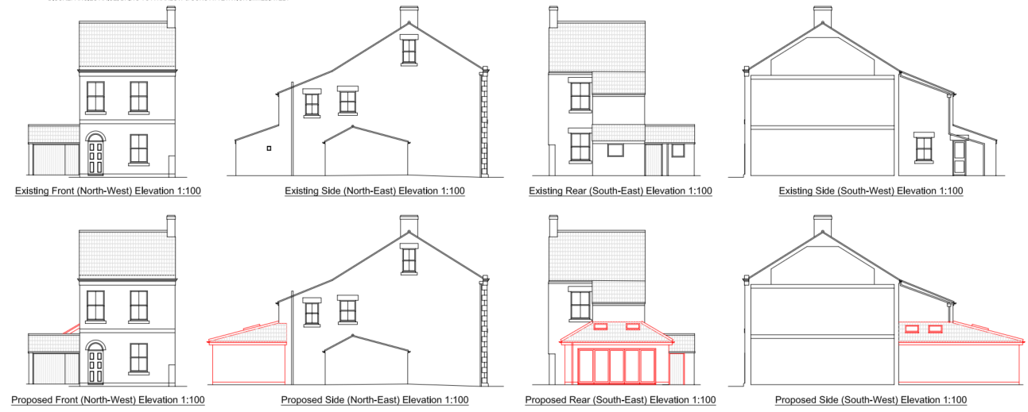

Existing and Proposed Elevations

PLANNING HISTORY
W/81/01275/HIS - Historic apps 1974 to 1983 Decision - Approved Date: 19/1/1982 – Formation of vehicular access to facilitate off Street car parking

RELEVANT POLICIES AND GUIDANCE
The National Planning Policy Framework (NPPF), August 2026
The Planning Practice Guidance
Wiltshire Design Guide: Appendix D – Design Guidance for Householder extensions

Wiltshire Core Strategy:
- Core Policy 57 Ensuring High-Quality Design and Place Shaping

Trowbridge has a designated Neighbourhood Plan area but no made plans as yet

CONSULTATION RESPONSES
Trowbridge Town Council: No objection.

REPRESENTATIONS
No comments were received.

ASSESSMENT
Section 38(6) of the Planning and Compulsory Purchase Act 2004 states:

"If regard is to be had to the development plan for the purposes of any determination to be made under the planning Acts, the determination must be made in accordance with the plan unless material considerations indicate otherwise."

In accordance with this statutory requirement, this application has been assessed against the relevant policies of the Development Plan, including the adopted Wiltshire Core Strategy (2015) and, where applicable, any made Neighbourhood Plans.

Design and Impact upon the character and context of the area
Core Policy 57 - Ensuring High-Quality Design and Place Shaping of the Wiltshire Core Strategy seeks to ensure that all new development is of high design quality, reflecting local context, character, and distinctiveness.

Policies DP3 and DP4 of the National Planning Policy Framework require development to achieve a high standard of design that responds positively to local character and context. In assessing design quality, regard should be had to matters including scale, siting, form, appearance, materials and the relationship of development to its surroundings.

The proposal would result in modest increased side projection to both sides (1.75m to SW/towards no.4, and 1.25m northeast (towards garage), increased rear projection of 0.8m.

At these spatial gaps, and as a single storey extension, the scale is considered proportionate to the host dwelling, with a light touch design to maximise the available space whilst improving functionality. The use of matching materials and roof pitch would ensure successful integration with the host dwelling.

The proposed extension would be to the rear of the property, minimally visible to the streetscape beyond the modern garage.

Having regard to the above, the proposal complies with the design principles set out in Core Policy 57 of the Wiltshire Core Strategy, Appendix D of the Wiltshire Design Guide and the NPPF.

Amenity
Point vii of Core Policy 57 - Ensuring High-Quality Design and Place Shaping of the Wiltshire Core Strategy seeks to ensure that developments do not adversely affect neighbouring properties.

Policy P3 of the National Planning Policy Framework requires development to be appropriate for its location, taking account of its likely effects on health, living conditions and the environment. In particular, Policy P3(2)(b) requires development to avoid giving rise to unacceptable impacts on the living conditions of neighbouring residents and occupiers. In assessing amenity impacts, regard should be had to matters including daylight and sunlight, outlook, privacy, overbearing impacts and other effects on residential amenity.

The proposed development has been assessed in terms of its potential impact on the residential amenity of neighbouring properties, with particular regard to loss of light, overshadowing, loss of privacy, and overbearing effects.

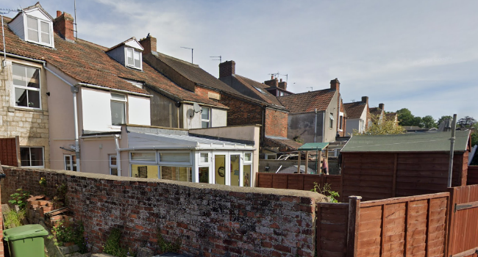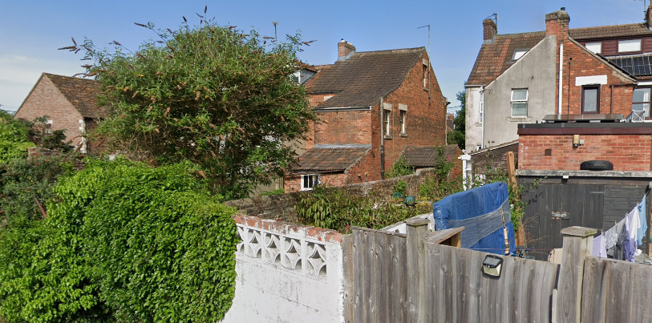
Images from the rear of the site

The images above show the relationship of the site with the existing rear extensions and boundary treatments to the immediately adjacent neighbouring properties. As a single storey extension, with pitched roof, sited off of each side boundary, there are no concerns with overbearing or massing in this context.

The proposal includes 4 rooflights, two facing to the side/SW (this elevation would also see the removal of a window) and rear/SE, all at 1.5m to cill level. At this height, there are no concerns regarding overlooking, especially in view of the removal of a window, and the existing boundary treatments and side walls of existing extensions. Proposed bifold doors would face down the garden, so raising no concerns with overlooking and loss of privacy.

The proposal therefore accords with Core Policy 57 point vii in respect of safeguarding residential amenity, Appendix D of the Wiltshire Design Guide and the NPPF.

Biodiversity Net Gain
Householder planning applications are exempt from the requirement to deliver Biodiversity Net Gain under Schedule 7A, Section 4(2)(a) of the Town and Country Planning Act 1990, as inserted by the Environment Act 2021.

Public Sector Equality Duty (PSED)
In reaching this decision, due regard has been had to the Public Sector Equality Duty under Section 149 of the Equality Act 2010. This requires the Local Planning Authority to have regard to the need to eliminate discrimination, advance equality of opportunity and foster good relations between persons who share a protected characteristic and those who do not.

The Local Planning Authority is satisfied that the proposal would not result in any unlawful discrimination and that any impacts on protected groups have been appropriately considered as part of this assessment.

CONCLUSION
The proposed development is considered to be acceptable in terms of its design, character and appearance, and would not result in any unacceptable harm to the amenities of neighbouring occupiers.

Furthermore, the proposal would not result in any unacceptable impacts in respect of any other material planning considerations.

The proposal is therefore considered to comply with the relevant policies of the Wiltshire Core Strategy, the National Planning Policy Framework and all other relevant material considerations. As such, the application is recommended for approval, subject to conditions.

RECOMMENDATION: That Planning Permission be GRANTED subject to conditions.

