APPLICATION FOR A CERTIFICATE OF LAWFULNESS FOR EXISTING USE OR DEVELOPMENT

APPLICATION REFERENCE: | PL/2026/04434
APPLICATION TYPE: | Lawful development: Existing use
SITE ADDRESS: | 9 Hawkeridge Road, Yarnbrook, Trowbridge, BA14 6AD
DEVELOPMENT DESCRIPTION: | Certificate of Lawfulness for the Existing Use, Conversion and Extension of Outbuilding to Annex
RECOMMENDATION: | Approve with Conditions

SITE DESCRIPTION AND PROPOSAL
This application is for a Certificate of Lawfulness for an Existing Use or Development (CLUED) under Section 191 of the Town and Country Planning Act 1990 (as amended). The applicant seeks to establish the lawfulness of the conversion and extension of an existing outbuilding to an annex, which has been in operation at the site since 2015. The application relates to the conversion of a domestic outbuilding to ancillary accommodation.

The outbuilding was subject to planning consent in 2015 for conversion to ancillary accommodation for the applicant’s elderly parents. The accommodation has been in use as ancillary accommodation between 2016 and 2025.

RELEVANT LEGISLATION AND CONSIDERATIONS
The statutory framework governing Certificates of Lawfulness for Existing Use or Development (CLUED) is primarily set out in Section 191(2) of the Town and Country Planning Act 1990 (as amended). This section establishes that "lawful development" refers to development against which no enforcement action may be taken and where no enforcement notice is in force, or development for which planning permission is not required.

Section 191(4) of the Town and Country Planning Act 1990 (as amended) further stipulates that a Local Planning Authority (LPA) shall issue a Certificate of Lawfulness upon request, provided that, on the balance of probabilities, the LPA is satisfied that the existing development or use described in the application is lawful. The time limits for taking enforcement action are set out in s171B of the Act.

The Planning Practice Guidance (PPG) on Lawful development certificates clarifies that the burden of proof lies with the applicant. It is the applicant's responsibility to provide sufficiently clear, precise, and unambiguous evidence to demonstrate the lawfulness of the existing development or use.

In considering whether the use or development has become immune from enforcement action, the test for granting a Certificate of Lawfulness is whether, on the balance of probabilities:
- the works were substantially completed, or,
- the use has been continuous for the required time period without interruption.

The applicant must prove that the use or development has occurred for the necessary period. A continuous use must be demonstrated without significant interruption.

It is important to note that when determining a CLUED application, the LPA must focus solely on whether, based on the facts and applicable planning law, the specific use or development is lawful. Planning merits or considerations relating to the quality or suitability of the development are not relevant.

REPRESENTATIONS
There is no legal obligation to consult third parties for this type of application, including Town/Parish Councils or neighbouring properties. However, the PPG recognises that it may be reasonable for a local planning authority to seek evidence from these sources, if there is good reason to believe they may possess relevant information about the content of a specific application.

Wiltshire Council Highways were consulted on the scheme and raised no objection in regard to any highway impact or highway safety concerns.

RELEVANT SITE HISTORY
The site has the following relevant planning history:

Proposal / Summary
W/08/03262/FUL - Full planning permission Decision - Approve with Conditions Date: 29/12/2008 – Two storey and single storey extensions to dwelling
15/04413/FUL - Full planning permission Decision - Approve with Conditions Date: 6/8/2015 – Convertion of an existing outbuilding
15/04699/PDENQ - PD Enquiries Decision - PP Required Date: 15/5/2015 – Conversion of outbuilding to provide disabled accommodation for elderly parents

ASSESSMENT
Time Limits for immunity for enforcement action
4 years applies for:
  - Operational development that was substantially completed before 25 April 2024
The applicant has submitted this application seeking confirmation that the works that have been carried out are lawful due to the fact that the works described were substantially completed by December 2015, prior to the date of 25th April 2024 and therefore the 4-year rule applies.

Evidence Submitted by the Applicant
The applicant has submitted the following evidence to support the application:
Planning Statement – setting out the timeline of development containing;
Building Regulations Initial Notice, Site Notes and Approval Notice Certificate - dated 11th September 2015
Aerial photos illustrating the converted building with a timeline from 2017-2025
Invoices and receipts from contractors and suppliers dating from August 2015 – January 2016.
Location Plan
Existing Site Plan
Existing Annex Plans
Existing Annex Elevations

Assessment
Officers are cognisant that the application was subject to consent given in 2015 (15/04413/FUL) for ‘conversion of an existing outbuilding’, The statement within the 2015 submission sets out that the outbuilding would be converted to provide an ancillary annex for the applicant’s elderly parents. The floor plans submitted within the 2015 submission vary slightly from the floor plans submitted within this Lawful Development Certificate application with a conservatory having been added (with receipts indicating it was purchased in 2015) without express planning permission.

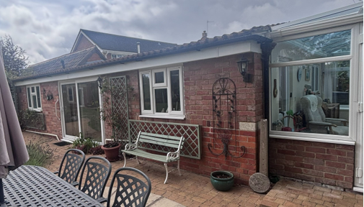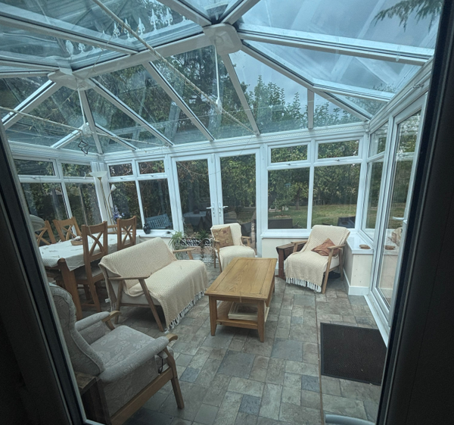
Site visit photos

The evidence submitted by the applicant demonstrates, on the balance of probabilities, that the development (including any associated building works) was substantially completed at least 4 years prior to the application date, and does not contravene any planning conditions or restrictions. The development is therefore lawful under the provisions of the Town and Country Planning Act 1990 (as amended). The application for a Certificate of Lawfulness for an Existing Development is recommended for approval.

Specifically, the evidence submitted confirms that the outbuilding has been functioning as an ancillary annex for a number of years. There are no apparent gaps in the evidence or contradictions that would cast doubt on the lawfulness of the development.

CONCLUSION
On the balance of probability, sufficient evidence has been provided to demonstrate that the conversion and extension of the outbuilding (contained within the private residential curtilage of the host dwelling) to an ancillary annex as identified on the site plan, has been substantially completed at the point of submitting the application for a period in excess of 4 years.

As there is no clear or unambiguous evidence to the contrary submitted to or readily available to the Council, and as no formal enforcement action has been taken by the Council, it is recommended that a certificate of lawfulness be issued for the use of the building as an ancillary annex.

RECOMMENDATION
It is recommended that a Certificate of Lawfulness for Existing Use or Development be granted for the following use/development:

The conversion and extension of an outbuilding to an annex.

Reason for approval: The evidence submitted satisfies the criteria set out in the Town and Country Planning Act 1990 (as amended), and the use meets the relevant time limits and planning law requirements.

