APPLICATION FOR FULL PLANNING PERMISSION CASE OFFICER REPORT

APPLICATION REFERENCE: | PL/2026/04617
APPLICATION TYPE: | Full planning permission
SITE ADDRESS: | Conholt Park, Conholt Lane, Conholt, Andover, SP11 9HA
DEVELOPMENT DESCRIPTION: | Alterations to the design of the main entrance gates
RECOMMENDATION: | Approve with Conditions

SITE DESCRIPTION/CONTEXT

The application site relates to the principal entrance to Conholt Park, a substantial historic estate situated within the North Wessex Downs National Landscape. Conholt House is a Grade II* listed building, with the associated Stable and Carriage House designated Grade II. The estate extends across a significant area of parkland and has been subject to a programme of approved restoration and enhancement works in recent years.

The application specifically relates to the recently approved main entrance off Hungerford Lane, comprising stone and flint gate piers, walls, pedestrian gates and principal vehicular entrance gates. The entrance is located within the wider parkland setting of the estate, approximately 700 metres from the principal listed house.

PROPOSAL

Full planning permission is sought for minor amendments to the design of the approved main entrance gates at Conholt Park.

The proposed changes relate solely to the decorative iron scrollwork positioned above the main vehicular gates and adjoining pedestrian gates. No changes are proposed to the siting, alignment, width, operation, gate piers, walls, access arrangements or overall function of the approved entrance.

Existing front elevation of the gates
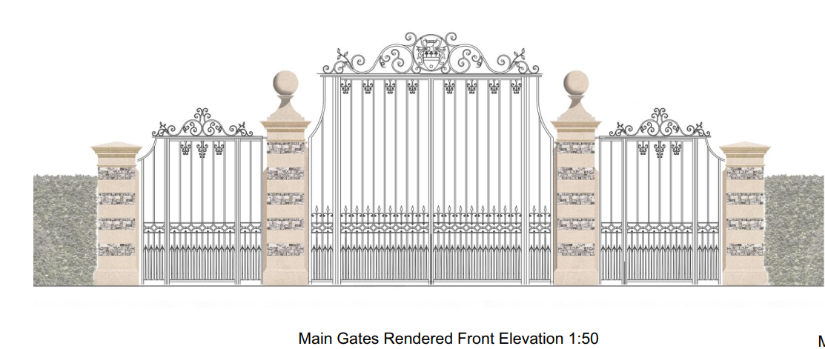

Proposed front elevation of the gates
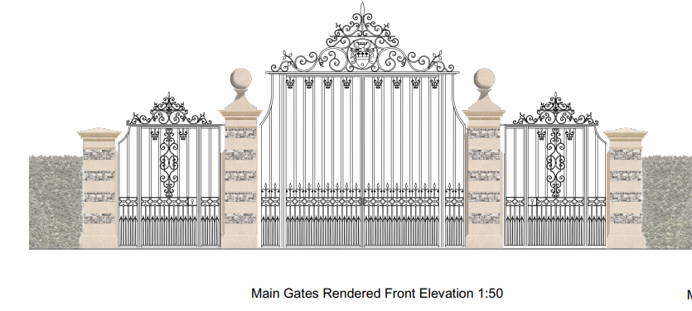

PLANNING HISTORY

The application site has an extensive recent planning history relating to the wider programme of restoration and enhancement works at Conholt Park. The following applications are of particular relevance to the proposals currently under consideration.

Proposal / Summary
PL/2024/02281 - Full planning permission Decision - Approve with Conditions Date: 10/7/2024 – Fourth phase of proposals for the restoration of the designed landscape of Front Park including: the extension of the south lawn with the creation of new ha-ha; the creation of new lake for habitat creation and biodiversity enhancement, water capture and
PL/2024/10026 - Removal/variation of conditions Decision - Approve with Conditions Date: 18/12/2024 – Variation of condition 2 (Approved Plans) of PL/2024/02281 - To facilitate design changes to the main gates
PL/2025/01412 - Approval of details reserved by a condition Decision - Approve Date: 05/05/2025 – Discharge of condition 18 of PL/2024/10026 (entrance gate details and specifications)

RELEVANT LEGISLATION, POLICIES AND GUIDANCE

Statutory Legislation:

Planning (Listed Building and Conservation Areas) Act 1990 - Section 66: Special considerations affecting planning functions

National Planning Policy:
- National Planning Policy Framework (NPPF) 2026
- Planning Practice Guidance (PPG)

Development Plan:

The development plan for Wiltshire comprises the Wiltshire Core Strategy (WCS) (adopted January 2015) and any made neighbourhood plans, which remains the principal statutory planning document guiding development across the county. In line with Section 38(6) of the Planning and Compulsory Purchase Act 2004, planning decisions must be made in accordance with the development plan unless material considerations indicate otherwise.

Though the development plan is considered as a whole, those parts deemed to be particularly relevant to this application are listed below:

Adopted Wiltshire Core Strategy (January 2015):

Core Policy 1 – Settlement Strategy
Core Policy 2 – Delivery Strategy
Core Policy 26 – Development in the Tidworth Community Area
Core Policy 50 - Biodiversity and Geodiversity
Core Policy 51 - Landscape
Core Policy 57 - Ensuring high quality design and place shaping
Core Policy 58 - Ensuring the conservation of the historic environment

Wiltshire Local Transport Plan 2011-2026

SPD:
The North Wessex Downs National Landscape Management Plan
Wiltshire Design Guide
National Design Guide
Conservation of Habitats and Species (Amendment) (EU Exit) Regulations 2019
Chute Design Guide
Wildlife and Countryside Act 1981, as amended

Draft Wiltshire Local Plan
At Full Council on 19 May 2026, the elected members of Wiltshire Council agreed to withdraw the emerging Wiltshire Local Plan. The said Plan has no material weight for the purposes of the application.

In accordance with Regulation 19 of the Town and Country Planning (Local Planning) (England) Regulations 2026, on 30th June 2026 Wiltshire Council published a notice of intention to prepare a new local plan for Wiltshire. The next stage is a Scoping Consultation which commences on 2nd September 2026. This plan is at a very early stage and currently carries no weight for decision making.

ISSUES

The main issues that need to be addressed in this case include: Principle, Design, Landscape and Heritage Impacts

CONSULTATION RESPONSES

Parish Council: None received

Conservation: The gateway is of course a recent introduction. The proposal is solely to revise/aggrandise further the ironwork of the gates while retaining the finely constructed stone and flint piers. This will have no additional or significant impact on the character and setting of Conholt House, in accordance with the aims of section 66 of the PLBCA Act 1990, NPPF and CP58.

Historic England: Historic England provides advice when our engagement can add most value. In this case we are not offering advice. This should not be interpreted as comment on the
merits of the application.

Test Valley: Conholt Park is in the Wiltshire Council area.

REPRESENTATIONS

None received

Principle, Design, Landscape Impacts Heritage Impacts

Section 66(1) of the Planning (Listed Buildings and Conservation Areas) Act 1990 requires special regard to be given to the desirability of preserving listed buildings and their settings. Core Policies 51, 57 and 58 of the Wiltshire Core Strategy seek to ensure that development protects landscape character, achieves a high standard of design and conserves heritage assets.

Policy N2 of the NPPF seeks to conserve and enhance the natural environment and requires development to take account of landscape character, local distinctiveness and the natural beauty of the countryside.

Policies HE4-HE10 of the NPPF recognise heritage assets as an irreplaceable resource and require proposals affecting heritage assets to be assessed having regard to their significance and the contribution made by their setting.

Policies DP1-DP4 of the NPPF seek to ensure that development is well-designed, visually attractive, sustainable and responsive to its surroundings. Development should contribute positively to local character, create high quality places and support healthy and inclusive communities.

The Wiltshire Design Guide provides further guidance on achieving high quality, context-led design and should be taken into account where relevant.

The principle of a new estate entrance and associated gates at this location has already been established through the grant of previous planning permissions and the subsequent approval of detailed gate specifications. The current application therefore relates solely to the acceptability of the proposed design amendments.

The proposed amendments are limited to revisions to the decorative ironwork detailing above the approved gates. The gate piers, walls, access arrangement, positioning and overall function of the entrance would remain unchanged. Whilst the revised detailing would result in a modest increase in height to part of the gate structure, this increase is confined to the decorative ironwork and does not materially alter the overall scale or appearance of the entrance when viewed within its wider setting.

The Council's Conservation Officer has raised no objection and advises that the proposed revisions would have no additional or significant impact upon the character and setting of Conholt House. Historic England has also confirmed that it does not wish to offer specific advice on the application. Given the substantial separation distance between the entrance and the principal listed building and having regard to the nature of the proposed amendments, the development would preserve the significance of the designated heritage assets and their settings.

In landscape terms, the amendments would not alter the approved entrance layout, result in additional encroachment into the surrounding countryside or materially increase the visual prominence of the development. The revised decorative detailing would remain consistent with the character of a traditional estate entrance and would not adversely affect the character, appearance or special qualities of the North Wessex Downs National Landscape.

No changes are proposed to the approved access arrangement and there are therefore no highway safety implications arising from the development.

Accordingly, the proposals are considered to comply with Core Policies 51, 57 and 58 of the Wiltshire Core Strategy and the relevant design, landscape and heritage objectives of the NPPF.

Ecology

Core Policy 50 of the Wiltshire Core Strategy seeks to protect biodiversity and conserve ecological networks. The proposed development is limited to design changes to previously approved gates and does not involve any extension to any building footprint, loss of habitat, vegetation clearance or works affecting ecological features. The proposal is therefore not considered likely to result in adverse effects on biodiversity interests. The development is exempt from the mandatory Biodiversity Net Gain requirements and raises no ecology concerns. The proposal therefore accords with Core Policy 50 of the Wiltshire Core Strategy.

PLANNING BALANCE AND CONCLUSION

The principle of the entrance gates and their location has already been established through previous planning permissions. The current application seeks only minor amendments to the approved decorative ironwork detailing and would not alter the approved access arrangement, footprint, function or overall character of the entrance.

Having regard to the scale and nature of the proposed changes, it is considered that the amendments would preserve the significance and setting of the listed buildings, maintain the character and appearance of the wider landscape and have no adverse impact upon the special qualities of the North Wessex Downs National Landscape.

The proposals are therefore considered to accord with the development plan as a whole and there are no material considerations that indicate planning permission should be refused.

RECOMMENDATION: That Planning Permission be GRANTED, subject to conditions

1. The development hereby permitted shall be begun before the expiration of three years from the date of this permission.
REASON: To comply with the provisions of Section 91 of the Town and Country Planning Act 1990 as amended by the Planning and Compulsory Purchase Act 2004.

2. The development hereby permitted shall be carried out in accordance with the following approved plans and documents.

Application form received 22/07/2026
Main Gate Site Location Plan Drg no 085 received 22/07/2026
Main Gate Block Plan Drg no 084 received 22/07/2026
Main Gate (B32) Proposals Drg no 6369-LS-368 received 22/07/2026

REASON: For the avoidance of doubt and in the interests of proper planning.

Informatives

1. BNG not required

The effect of paragraph 13 of Schedule 7A to the Town and Country Planning Act 1990 is that planning permission granted for development of land in England is deemed to have been granted subject to the condition (biodiversity gain condition) that development may not begin unless:

(a) a Biodiversity Gain Plan has been submitted to the planning authority, and
(b) the planning authority has approved the plan.

The planning authority, for the purposes of determining whether to approve a Biodiversity Gain Plan, if one is required in respect of this permission would be Wiltshire Council.

There are statutory exemptions and transitional arrangements which mean that the biodiversity gain condition does not always apply. For further information on exempt developments please refer to:
https://www.gov.uk/guidance/biodiversity-net-gain-exempt-developments
Based on the information available this permission is considered to be one which will not require the approval of a biodiversity gain plan before development is begun because one or more of the statutory exemptions or transitional arrangements is considered to apply.

