FULL PLANNING APPLICATION
CASE OFFICER REPORT

APPLICATION REFERENCE: | PL/2025/09001
APPLICATION TYPE: | Full Planning Application
SITE ADDRESS: | 46 Priory Close, Bradford on Avon.
DEVELOPMENT DESCRIPTION: | Change of use of land to residential curtilage and siting of garden ‘studio’ outbuilding together with two-storey front and side extensions and single storey extension to rear of existing dwelling.
RECOMMENDATION: | Approve with Conditions.

PROPOSAL
The proposal seeks planning permission for the construction of a two-storey front and side extension and for the siting and construction of an ancillary studio within the dwelling’s residential garden area, the subject of a change of use.

SITE DESCRIPTION/CONTEXT
The site is located within an established residential area of Bradford on Avon, to the north of town and outside of the Conservation Area, with Winsley being close by. The dwelling is a 1950’s two storey end of terrace building, constructed from reconstituted stone. The site includes a plot of land to the west of the original curtilage which has a public footpath running adjacent to it. The footpath is a Public Right of Way (BRAD51).

RELEVANT PLANNING HISTORY

Proposal / Summary
N/A

RELEVANT POLICIES AND GUIDANCE

Wiltshire Core Strategy:

- Core Policy 07 Bradford on Avon Spatial Strategy
- Core Policy 57 Ensuring High Quality Design and Place Shaping
- Core Policy 50: Biodiversity and Geodiversity
- Core Policy 51: Landscape
- Core Policy 58: Ensuring the Conservation of the Historic Environment
- Core Policy 61: Transport and New Development
- Core Policy 64: Demand Management
- Core Policy 67: Flood Risk

Bradford on Avon ‘Made’ Neighbourhood Plan.

Wiltshire Design Guide: Appendix D – Design Guidance for Householder extensions

The National Planning Policy Framework (NPPF)

The Planning Practice Guidance

National Design Guide

Emerging Wiltshire Local Plan:
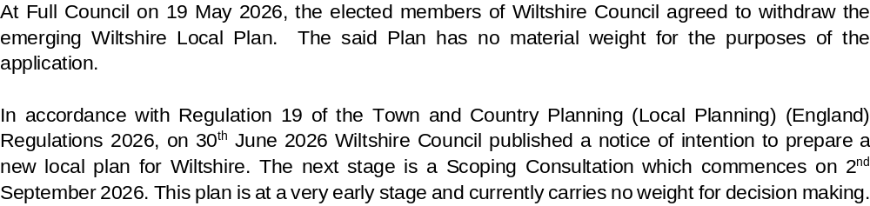

CONSULTATION RESPONSES
Bradford on Avon Town Council: Object to the proposal on the following grounds:

-Proposed studio would be large and visually prominent and out of keeping.
-Projecting extension would be out of keeping with the 1950’s built form.
-Concern over loss of trees.
-Concern over possible business use of the studio.
-Clearly an unsuitable location at the end of a cul-de-sac for what clearly appears to be a business use within the large proposed workshop building for which no change of use is proposed.
The proximity of the new building to the public footpath, which currently has a pleasant open green aspect would be harmful to the character of the area.

Bradford on Avon Preservation Trust. Share and raise objections and concerns identical to the town council, as reported above.

Arboricultural Officer: No objections.

Ecology: No objections, subject to conditions.

Public Right of Way: No objections, subject to conditions/informative.

REPRESENTATIONS
One neighbour representation received:

-Have concerns that the studio would have a business use, as the applicant has his own catering business elsewhere.
-Business use at this location is not appropriate.

ASSESSMENT
Section 38(6) of the Planning and Compulsory Purchase Act 2004 states:

"If regard is to be had to the development plan for the purposes of any determination to be made under the planning Acts, the determination must be made in accordance with the plan unless material considerations indicate otherwise."

In accordance with this statutory requirement, this application has been assessed against the relevant policies of the Development Plan, including the adopted Wiltshire Core Strategy (2015) and the Neighbourhood Plan for Bradford on Avon.

Principle of Development
The proposed extensions would be within the established residential curtilage of the dwelling and would be acceptable in principle. The proposed studio would be sited within an area of land to the side of the property, which is in the applicant’s ownership and control, but does not appear to be part of the established residential curtilage, thereby constituting an associated change of use of land. A relatively small area of the land would be utilised as such with the remainder of the land retaining its natural tree orientated character and use. The proposed detached single storey building would provide ancillary accommodation to the residential use of the dwelling, providing for an office/studio use. Concern has been expressed that the use of the studio is for business purposes. The planning agent advises there would not be any commercial business use of the studio, and it is considered necessary and relevant to condition the use for ancillary, domestic use only.

The principle of the proposed scheme is considered to be acceptable in light of the above and for the reasons as discussed below.

Design and Impact upon the upon the character and context of the area

Core Policy 57 - Ensuring High Quality Design and Place Shaping of the Wiltshire Core Strategy seeks to ensure that all new development is of high design quality, reflecting local context, character, and distinctiveness.

The proposals can be viewed within the plan snippets taken from the submitted plans:

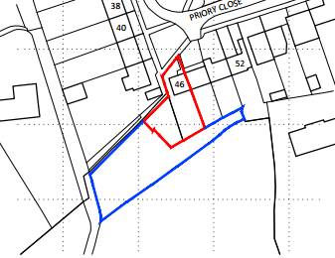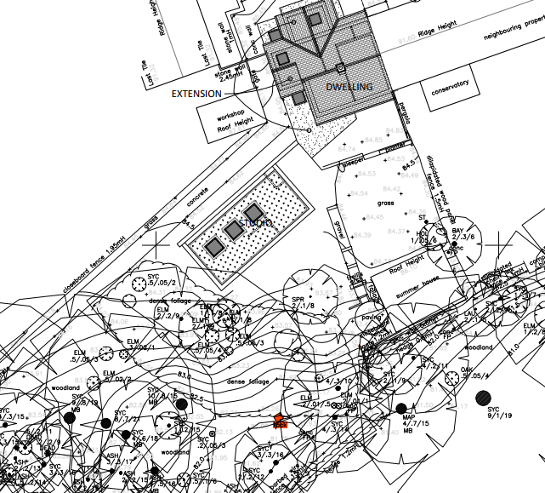
Location Plan Proposed Site Plan

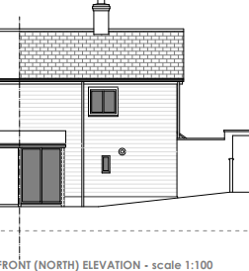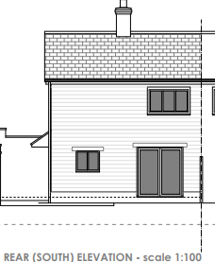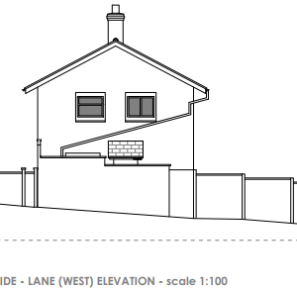
Existing Elevations

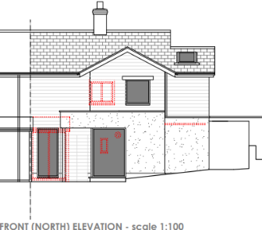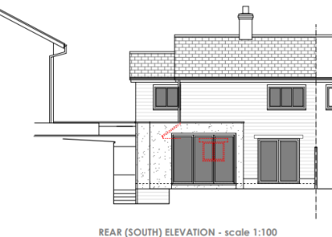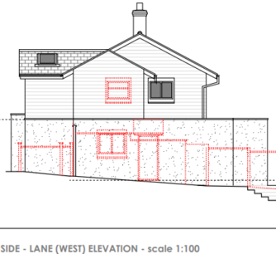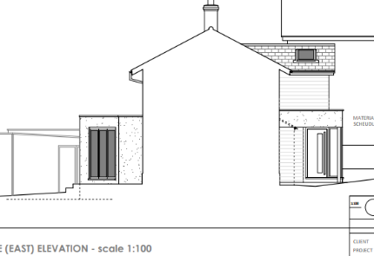
Proposed Elevations

The site is in a secluded corner location of the housing estate, whereby the proposal would see the construction of a two-storey side and front extension, the front aspect would extend 2.1 metres, together with a front single storey extension projecting 2.7m, 0.6m beyond the front of the two-storey element.

The proposed two storey side extension would project by 2 metres, both two storey elements would have their ridge heights located well below that of the main roof ridge, thereby ensuring a subservient element to the scheme. A small single storey flat roof extension is also proposed which would wrap around the side and rear. Materials would consist of matching reconstituted stone, with natural untreated timber cladding with matching roof tiles. The rear single storey extension would have an off-white rendered finish and would serve to provide a garden room that would have bifold doors leading out on the site’s private residential garden area. At ground floor, the proposal would provide an open plan kitchen/dining/garden room, downstairs shower room, entrance hall and porch/bin store and at first floor an additional bedroom and replacement bathroom would be provided. There would be an increase in bedrooms from 2 to 3 in total.

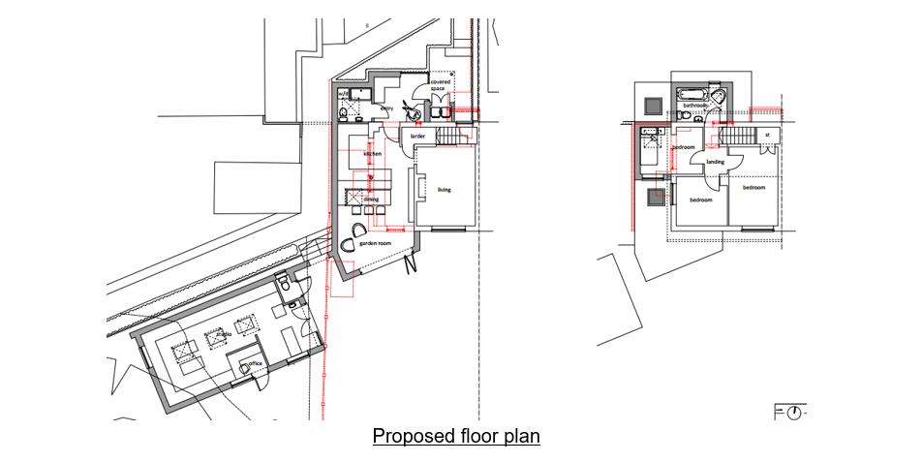

The proposed scheme would also provide a detached single storey ancillary studio on land adjacent to the residential dwelling on the southwest side. The design is of a simple low level natural timber clad structure, with a sedum roof that would sit within the context of its surrounding natural environment.

The initial design and footprint of the studio was considered to be too large, and following negotiations with the agent and applicant, has been substantially reduced in size with revised plans being submitted. The following snippets taken from the submitted plans show the proposal:

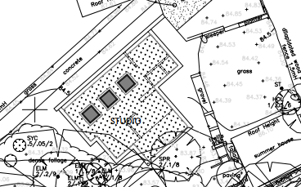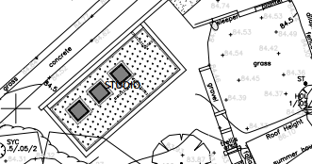
Initial Block Plan of the studio – SUPERSEDED REVISED – Block plan of the studio.

As shown above, the overall size of the studio has been reduced, with the proposed elevations below:

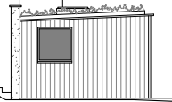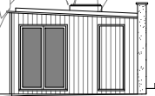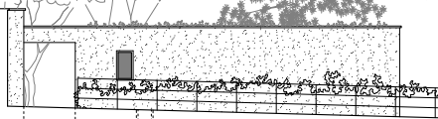
Proposed West, East Sides & front North West Elevations

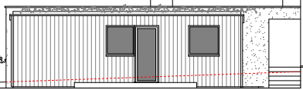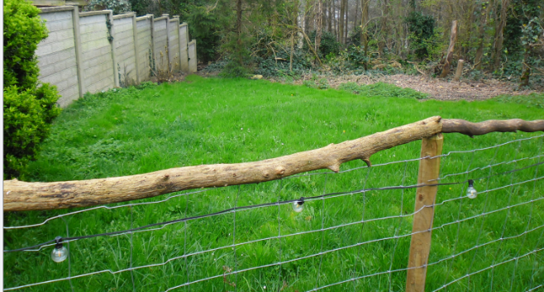
Rear South East elevation. Photograph of the location for the proposed studio.

The proposed studio would have a slightly sloped sedum covered roof whereby at its lowest level it would measure 2.7 metres and 3.1 metres at its highest level. The initial rear canopy area and section of the studio has been removed, resulting in a simpler building form and reduced size and footprint.

The siting of the studio would take advantage of an established grassed area, with only one conifer tree (T10) to be removed to facilitate this element of the scheme. The current condition of the site indicates that any trees on this grassed area were removed some time ago and that the land has been previously landscaped for the purposes of garden area. As the above block plan extract shows, the proposed studio would be closely sited and related to the main house, ensuring an ancillary connection and subservience to the host property. The use of natural materials, untreated timber cladding and sedum roof, would be appropriate to the setting and character of the location and the wooded area would remain unaltered. It is noted that there are no protected trees within the site and which is not within a Conservation Area.

The block plan below shows the studio within the context of the remaining undeveloped land, demonstrating that it would utilise a small area of this land, with the majority of the land remaining unaltered. Calculations show that the proposed studio would use less than 5% of the overall area of the site for the proposed studio. The enlargement of the residential curtilage for this purpose is therefore considered acceptable.
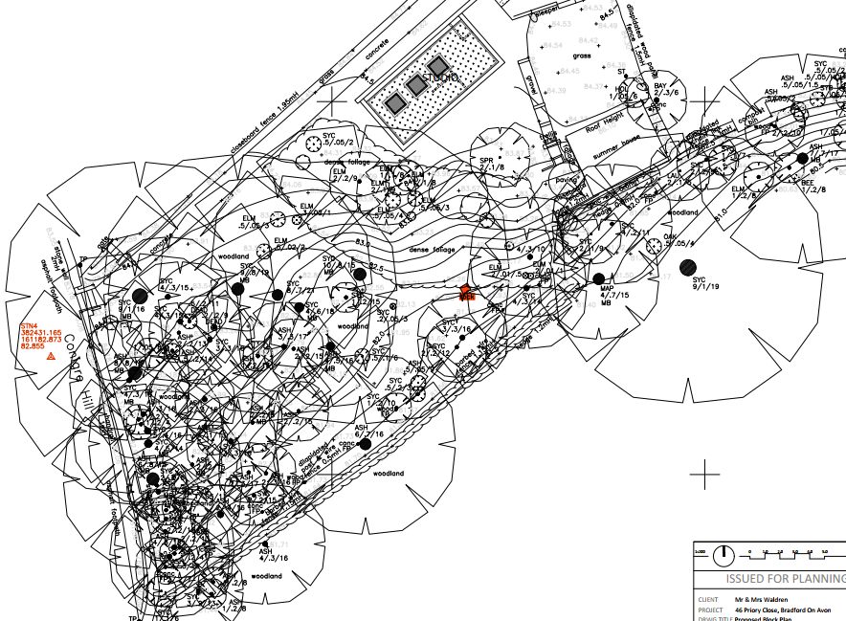

Therefore, in summary, having regard to the above, the proposal complies with the design principles set out in Core Policy 57 of the Wiltshire Core Strategy and Appendix D of the Wiltshire Design Guide.

Arboricultural Matters.
The Council’s tree officer has been consulted on this application, and has not raised any objections, commenting as follows:

‘The Tree Officer is satisfied that the information provided within the Arboricultural Report with Tree Constraints Plan, Impact Assessment, Method Statement and Tree Protection Plan, prepared by Silverback Arboricultural Consultancy Ltd, and dated December 2025, provides sufficient information to ensure the trees on site have been appropriately considered and protected. Please can these reports and plans be added as approved documents, and their compliance conditioned.’

Amenity
Point vii of Core Policy 57 - Ensuring High Quality Design and Place Shaping of the Wiltshire Core Strategy seeks to ensure that developments do not adversely affect neighbouring properties. At the national level, Policy DP3 of the National Planning Policy Framework requires development proposals to respond positively to their context and integrate with and enhance their surroundings.

The proposed extension to the dwelling would be a two-storey addition that would be located to its front and side aspect. The use of high-level windows within developed urban environments is not unusual, as is the case here, with the scheme continuing to look out onto its north facing frontage. The high-level fenestration would continue to look onto the site’s front garden area and highway beyond. There would not be any new side facing windows. The single storey rear facing element would look onto the site’s rear garden and not impact on neighbouring amenity.

Likewise, due to the location, orientation and overall small footprint size of the front two storey element of the proposal, there would not be any significant overshadowing or loss of light to the most immediate neighbour at No.48.

The proposed side extension would not be readily visible from the public realm due to its corner location and vegetation landscaping within the immediate area, as the following site photograph shows:

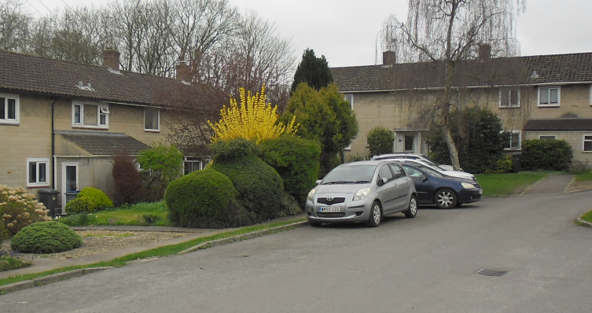

The proposed studio would be located on the plot of land immediately to the south of the curtilage to No. 44, separated by the public footpath. The scale, siting, design and use of the building for ancillary domestic purposes would not give rise to any demonstrable adverse impacts on the amenity of this property having regard to the positioning of the existing outbuilding, single storey height and separation. The sue of the outbuilding would similarly not introduce harmful impacts subject to its use remaining for incidental/ancillary purposes and not for commercial activity, which is secured by condition.

The proposal therefore accords with Core Policy 57 point vii. in respect of safeguarding residential amenity and Appendix D of the Wiltshire Design Guide.

Highway Matters.
Core Policy 57 (xiv) of the Wiltshire Core Strategy seeks to ensure that development must meet the requirements of Core Policy 61. This policy requires proposals to be capable of being served by safe access to the highway network. Core Policy 64 seeks to ensure compliance with parking standards set out in the Local Transport Plan.

The National Planning Policy Framework (NPPF), particularly Paragraph 115 and 116, requires that development proposals do not have an unacceptable impact on highway safety and that safe and suitable access to the site can be achieved for all users.

The site is located within a quiet, residential cul de sac, the property has its own established car parking on the highway at the front of the property, which would continue to be used. There would be an increase in bedroom numbers from 2 to 3, however the parking standard requirement of two spaces is the same for a 3-bedroom dwelling, so the existing parking arrangement would continue to be acceptable.

Public Right of Way.
A PRoW reference: BRAD52 runs alongside the outside the outer boundary of the area of the copse of trees and, as the location plan shows, a section of this land is within the applicant’s ownership and control.

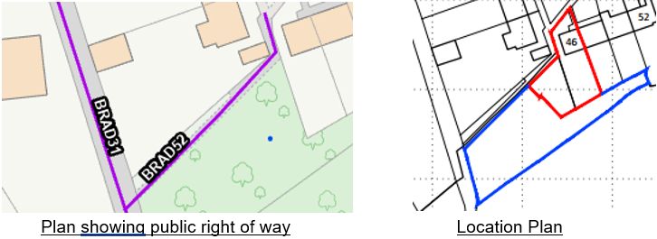

The Council’s PRoW officer has been consulted and has not raised any objections subject to a condition and informative:

‘Public footpath BRAD52 runs alongside the west and north western boundary of the site. The proposed extension should not overhang the footpath or have any doors or gates opening out onto the path. Due to the proximity of the extension to the path, any damage caused to the path during construction should be rectified.
Condition:
No development shall commence on site until a photographic pre-condition survey of the footpath (BRAD52) running alongside the site is submitted to the Local Planning Authority. Any damage caused to the footpath must be repaired to a standard approved by the Highways Officer. A final photographic survey should be undertaken upon completion of the construction phase affecting the footpath, with a copy also submitted to the Local Planning Authority prior to occupation of the dwelling.
REASON: Reason: To ensure any damage to the footpath caused during construction is repaired to its pre-development condition.

The agent has agreed to the use of the pre-commencement condition.
Informative:
The applicant should note that it is a criminal offence to obstruct a public right of way under section 137 of the Highways Act 1980 and therefore no materials, plant, temporary structures or excavations of any kind should be deposited / undertaken which obstruct or adversely affect the public right of way BRAD52 whilst development takes place, without prior consultation with, and the further permission of, the highways authority at Wiltshire council.’

Ecology Impact
CP50 requires no net loss of biodiversity on site. The site lies within the roost buffer zone for the Greater Horseshoe bats associated with the Bath and Bradford-on-Avon Bats SAC which may therefore have the potential for works to result in significant adverse impact on the special features of that site, and accordingly an appropriate Assessment (AA) under Section 63 of the Habitats Regulations was carried out by the relevant Competent Authority (Wiltshire Council) to determine the potential significant effects and the suitability of any measures to avoid or mitigate those effects.

The AA concluded that given the scale and nature of the currently proposed development, which does not propose the removal of any bat habitat or roosts, and does not propose any additional external lighting, such that the proposal could be screened out of Appropriate Assessment.

The submitted ecology report concluded that the existing dwelling had no features potentially suitable for use by roosting bats, and the wider site offers limited foraging opportunities, although it is connected to good habitat (woodland to the south).

A single tree is to be removed for the scheme, which was reported to be of “negligible value and low distinctiveness” and the report recommends that two bat boxes are provided within the site. The Council’s ecologist agrees and supports these aspects.

The surrounding woodland is noted to be in poor condition with no understorey, restricted crown growth and low growing ivy. In accordance with section N2 of the revised NPPF which advises on the improvement of the natural environment, any proposed enhancements to the woodland and/or woodland edge within the application site boundary would be welcomed.

Precautionary working measures have been advised to be implemented to ensure the woodland remains protected from dust and possible pollution during the construction phase, so a Construction Method Statement (CMS) has been requested to be submitted, together with a condition in regard to biodiversity and details for supplementing ecological enhancements. Both conditions are pre-commencement and have been agreed by the agent.

Biodiversity Net Gain:
The householder extensions are exempt from the statutory requirement for BNG, however the application for the change of use and construction of the studio is subject to BNG contributions. A completed small sites statutory metric calculation and map has been submitted by the agent, confirming the baseline units of the site. The Council’s ecologist has been consulted on the matter and have not raised any objections, commenting that the post-development grassland should be entered as “retained” or “enhanced” and which does not alter the calculated baseline.

CONCLUSION
The proposed development is considered acceptable in terms of its design, scale, and relationship with the surrounding area. It would not result in unacceptable or demonstrable harm to the character of the locality, the amenities of neighbouring occupiers, or ecology.

The proposal is therefore considered to comply with the relevant policies of the Wiltshire Core Strategy, and the National Planning Policy Framework. As such, the application is or approval, subject to the conditions set out below.

RECOMMENDATION: Planning Permission be GRANTED subject to conditions.

