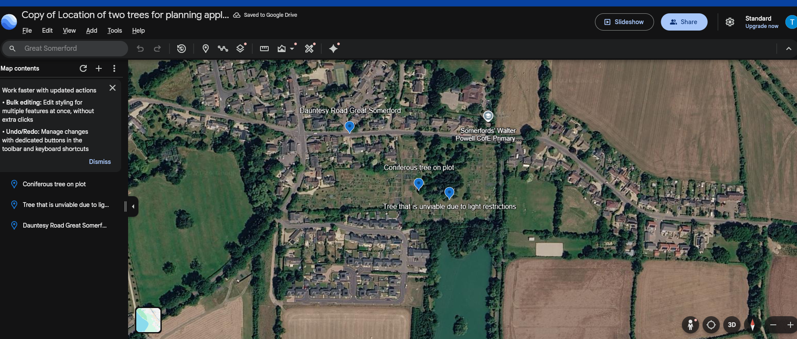
This is a google earth image of the location of the Great Somerford allotments
The blue placemarkers show the location of the two trees that need to be felled – Conifer needs to be felled as it is was planted a s a small pot grown conifer and now has grown and is now taking over an allotment and affecting light either side.
The second plot shows the position of two trees one of which will need to be felled to allow light to the second on that might survive with this intervention.
The photo shows the Dauntsey Road and the location of the School for reference

