APPLICATION FOR ADVERTISEMENT CONSENT
CASE OFFICER REPORT

APPLICATION REFERENCE: | PL/2026/04277
APPLICATION TYPE: | Consent to display an advertisement
SITE ADDRESS: | Land South East of Trowbridge, to the South of Leap Gate and East of West Ashton Road
DEVELOPMENT DESCRIPTION: | Erection of a billboard advertisement promoting the approved residential development (15/04736/OUT).
RECOMMENDATION: | Approve

SITE DESCRIPTION/CONTEXT

The application site comprises the Ashton Park housing scheme site in Trowbridge approved under application 15/04736/OUT.

The local context is that the site is an allocated site for development comprising: residential (up to 2,500 dwellings - Classes C3 & C2); employment (Class E (‘Business’ only), B2, and B8); two local centres (Classes E, C2, and C3); two primary schools, one secondary school, ecological visitor facility, public open space, landscaping and associated highway works including for the ‘Yarnbrook / West Ashton Relief Road’ and the access junctions.

The site lies to the east of Trowbridge, moving towards West Ashton.

The site is not located within a Special Area of Control of Advertisements.

Masterplan from outline consent:
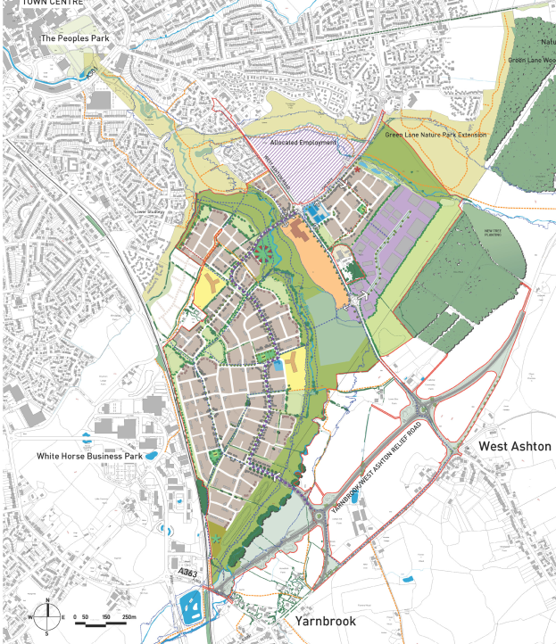

PROPOSAL:

The application seeks advertisement consent for the main signage for the emerging housing parcels. This comprises of a large V shaped billboard sign to be sited near the main roundabout node within the wider site.

The signage would not be illuminated.

The sign would be located approximately 35m from the roundabout.

Billboard sign detail:
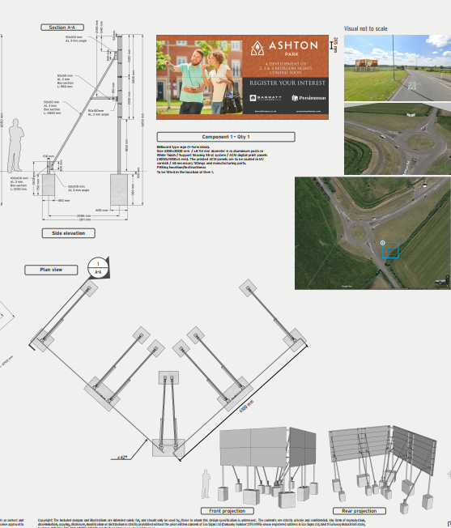

Sign location:
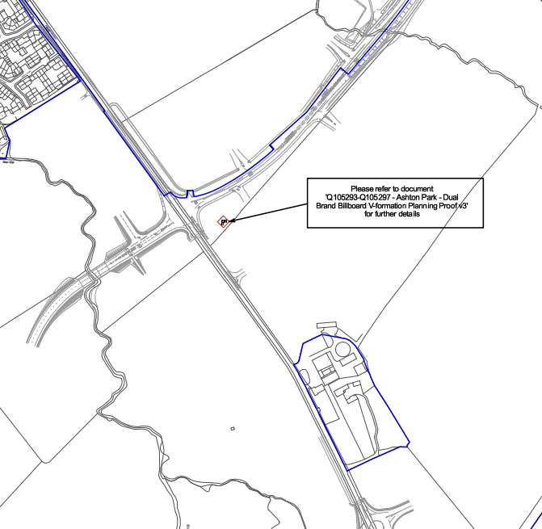

RELEVANT LEGISLATION, POLICIES AND GUIDANCE

The Town and Country Planning (Control of Advertisements) (England) Regulations 2007

National Planning Policy Framework (NPPF)

Planning Practice Guidance (PPG)
- Advertisements

Wiltshire Core Strategy 2015 (WCS):
- Core Policy 51 Landscape
- Core Policy 57 Ensuring High Quality Design & Space Shaping
- Core Policy 62 Development Impacts on the Transport Network

RELEVANT PLANNING HISTORY:

Proposal / Summary
15/04736/OUT – Outline planning permission: Some matters reserved – Approve with Conditions and s106 agreement Date: 02/09/2025 – Outline planning application for mixed use development comprising: residential (up to 2,500 dwellings – Classes C3 & C2); employment (Class E (‘Business’ only), B2, and B8); two local centres (Classes E, C2, and C3); two primary schools, one secondary school, ecological visitor facility, public open space, landscaping and associated highway works including for the ‘Yarnbrook / West Ashton Relief Road’ and the access junctions.

ISSUES

Advertisement applications are subject to a distinct statutory regime. The Local Planning Authority may only consider the effect of the proposal on amenity and public safety. Other matters, including the content of the advertisement or commercial considerations, are not material to the determination of the application.

CONSULTEE RESPONSES

The views of consultees are material considerations in the determination of the application. However, the decision-maker must exercise their own planning judgement. Where consultees raise concerns or recommend conditions, these have been considered and are addressed within the assessment section of this report.

The following consultees were invited to comment on this application:

Town Council:

“No objection, subject to meeting Wiltshire Council’s advertising standards”.

Wiltshire Council’s Highways Engineer:

No objections.

REPRESENTATIONS
Below is a summary of the representations received during the consultation period. Only material planning considerations have been taken into account in the assessment of this application. Non-material issues, such as property values or private legal disputes, cannot be considered in the determination process.

No representations have been received.

ASSESSMENT
Regulation 3 of The Town and Country Planning (Control of Advertisements) (England) Regulations 2007 requires that local planning authorities exercise their powers in relation to the display of advertisements in the interests of amenity and public safety, taking into account the provisions of the development plan, in so far as they are material, and any other relevant factors.

Impact on Amenity:
Policy Context
"Amenity" is not exhaustively defined in the Town and Country Planning (Control of Advertisements) (England) Regulations 2007, but is generally understood to include both visual and aural amenity. Factors relevant to amenity include the general characteristics of the locality, including features of historic, architectural, cultural or landscape interest.

CP57 requires a high standard of design in all proposals, including (x) the sensitive design of advertisements and signage.

Policies DP1-DP4 of the NPPF require development to contribute positively to the quality of places, respond appropriately to local character and context, and achieve a high standard of design. Whilst advertisement applications are determined primarily with regard to amenity and public safety, these policies provide useful context when assessing the impact of signage upon the character and appearance of an area.

Assessment

Amenity:
The design and scale of the proposed signage is commensurate with the scale of the wider development. This is a large housing site, 2500 houses, and a billboard advertisement on the main junction would represent an appropriate signage solution.

Conclusion:
Having regard to the character of the area, the design, scale, siting and lack of illumination of the proposed advertisement, it is considered that the proposal would not cause harm to the visual amenity of the area, either individually or cumulatively, and would therefore comply with the relevant provisions of the Town and Country Planning (Control of Advertisements) Regulations 2007.

Impact on Public Safety:
Policy Context
“Public safety” is not exhaustively defined in the Town and Country Planning (Control of Advertisements) (England) Regulations 2007, but it generally refers to the potential impact of a development or advertisement on the safe use and operation of public spaces, including roads, footpaths, and other areas accessible to the public.

In assessing public safety, the Local Planning Authority (LPA) may consider:
- Whether the proposal would obstruct visibility for road users or pedestrians;
- Whether it could distract, confuse, or mislead drivers, particularly near junctions or crossings;
- Whether it interferes with traffic signs, signals, or street lighting;
- Whether it poses a physical hazard, such as through poor structural integrity or inappropriate siting.

The NPPF supports the creation of safe environments and the protection of public safety. In the context of advertisement control, particular regard should be had to the effect of the advertisement on highway safety and the safe movement of pedestrians and vehicles.

CP62 advises that proposals should provide appropriate mitigating measures to offset any adverse impacts on the transport network at both the implementation and operational stages.

Assessment

The signage would be contained within the site and would not interfere with pedestrian sight lines/visibility.

Similarly, the signs would not have an impact on vehicular/road safety. The signs would be clear and legible, without illumination, and would therefore provide information without distraction.

The Council’s Highways Authority raises no objection.

Having regard to its siting, scale, lack of illumination and relationship with the surrounding highway network, the proposal would not result in an unacceptable impact on public safety, either individually or cumulatively, and would therefore satisfy the relevant provisions of the Town and Country Planning (Control of Advertisements) Regulations 2007.

Public Sector Equality Duty (PSED):

In reaching this decision, due regard has been had to the Public Sector Equality Duty under Section 149 of the Equality Act 2010. This requires the Local Planning Authority to have regard to the need to eliminate discrimination, advance equality of opportunity and foster good relations between persons who share a protected characteristic and those who do not.

The Local Planning Authority is satisfied that the proposal would not result in any unlawful discrimination and that any impacts on protected groups have been appropriately considered as part of this assessment.

CONCLUSION:

The proposed advertisement has been assessed in accordance with the relevant provisions of the Town and Country Planning (Control of Advertisements) (England) Regulations 2007.

It is considered that the advertisement, by reason of its design, scale, siting, and lack of illumination, would not result in harm to the visual amenity of the area. Furthermore, the proposal is not considered to pose a risk to public safety, either individually or cumulatively with other signage in the vicinity.

Subject to the recommended conditions, the proposal is therefore considered acceptable and it is recommended that advertisement consent be granted.

This billboard is required as advertising for the new housing and therefore would be temporary by nature. However, the size of the site means that the build out would take place over several years. Therefore the standard 5 year condition for advertisements is considered to be appropriate.

RECOMMENDATION:
It is recommended that advertisement consent be GRANTED subject to condition(s).

All conditions imposed have been assessed against the tests set out in Policy DM6 of the NPPF and are considered to be necessary, relevant to planning, relevant to the development to be permitted, enforceable, precise and reasonable in all other respects.

