APPLICATION FOR HOUSEHOLDER PLANNING PERMISSION
DELEGATED REPORT

APPLICATION REFERENCE: | PL/2026/03996
APPLICATION TYPE: | Householder planning permission
SITE ADDRESS: | 62 Green Close, Upper South Wraxall, Bradford On Avon, BA15 2SE
DEVELOPMENT DESCRIPTION: | Rebuilding of carport to provide study/gym space and re-roofing of outbuilding.
RECOMMENDATION: | That Planning Permission be GRANTED

PROPOSAL

The proposal seeks planning permission for rebuilding and slight extension of an existing carport to create an office space and gym and a replacement roof on an existing outbuilding.

SITE DESCRIPTION/CONTEXT

This application relates to a domestic property known as 62 Upper South Wraxall, a two-storey rural dwelling accessed by a single-track road (a Public Right of Way SWRA5) to the north of the village of Upper South Wraxall, near Bradford on Avon.

The application site is located in the South/Lower South Wraxall Conservation Area and within the West Wiltshire Green Belt and also falls within the recreational impact zone of the Bath and Bradford on Avon Special Area of Conservation for bats and is located within an area that is subject to surface water flooding. The surrounding area is strongly characterised by a rural countryside appearance.

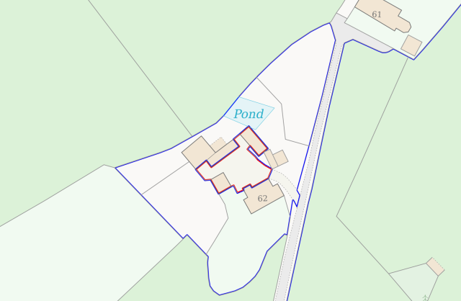

PLANNING HISTORY

Proposal / Summary
PL/2025/06307 - Full planning permission Decision - Approve with Conditions Date: 16/9/2025 – Erection of new field shelter to replace existing
PL/2025/07421 - Householder planning permission Decision - Approve with Conditions Date: 8/12/2025 – Demolition of single storey extension and erection of replacement extension to include first floor in pitched roof gable
PL/2026/02642 - Full planning permission Decision - Approve with Conditions Date: – Demolition and rebuild of existing stables and lean to structures (Barns C and D) and the erection of four timber clad loose boxes and a tack room on a reduced footprint. Current storage buildings F and G are demolished and replaced with Storage building

RELEVANT POLICIES AND GUIDANCE
Wiltshire Core Strategy:
Core Policy 1 Settlement Strategy
Core Policy 2 Delivery Strategy
Core Policy 7 Bradford on Avon Community Area
Core Policy 50 Biodiversity and Geodiversity
Core Policy 51 Landscape
Core Policy 57 Ensuring High-Quality Design and Place Shaping
Core Policy 58 Ensuring the Conservation of the Historic Environment
Core Policy 60 Sustainable Transport
Core Policy 61 Transport & Development
Core Policy 64 Demand Management
Core Policy 67 Flood Risk

New Wiltshire Local Plan
At Full Council on 19 May 2026, the elected members of Wiltshire Council agreed to withdraw the emerging Wiltshire Local Plan. The said Plan has no material weight for the purposes of the application.
In accordance with Regulation 19 of the Town and Country Planning (Local Planning) (England) Regulations 2026, on 30th June 2026 Wiltshire Council published a notice of intention to prepare a new local plan for Wiltshire. The next stage is a Scoping Consultation which commences on 2nd September 2026. This plan is at a very early stage and currently carries no weight for decision making.
Wiltshire Design Guide: Appendix D – Design Guidance for Householder extensions
The National Planning Policy Framework (NPPF) 2026
The Planning Practice Guidance
National Design Guide
Wiltshire Local Transport Plan 3 2011 – 2026 (March 2015)

CONSULTATION RESPONSES
South Wraxall Parish Council: No objection
Wiltshire Council Ecology – No objection

REPRESENTATIONS
No comments were received.

ASSESSMENT
Section 38(6) of the Planning and Compulsory Purchase Act 2004 states:

"If regard is to be had to the development plan for the purposes of any determination to be made under the planning Acts, the determination must be made in accordance with the plan unless material considerations indicate otherwise."

In accordance with this statutory requirement, this application has been assessed against the relevant policies of the Development Plan, including the adopted Wiltshire Core Strategy (2015) and, where applicable, any made Neighbourhood Plans.

Impact on the Green Belt
The fundamental aim of Green Belt policy is to prevent urban sprawl by keeping land permanently open. The essential characteristics of Green Belt are its openness and permanence.
Policies GB6-GB8 of the NPPF afford strong protection to Green Belt land and establish a presumption against inappropriate development. Development within the Green Belt should not be approved except where it falls within one of the categories of development identified as appropriate by national policy or where any applicable Grey Belt provisions are satisfied.
Development that does not meet these policy tests constitutes inappropriate development and is, by definition, harmful to the Green Belt and should not be approved except in very special circumstances.
When considering proposals affecting the Green Belt, substantial weight should be given to any harm to the Green Belt. Very special circumstances will not exist unless the potential harm to the Green Belt, together with any other harm resulting from the proposal, is clearly outweighed by other considerations.
It has previously been determined within recent permissions (consented PL/2025/07421 and consented PL/2026/02642) that the original volume of the host dwelling sat at 642m3. It was concluded that once the two most recent schemes were implemented that the green belt volume would increase to 726m3 (13% above the original volume) which was considered proportionate and acceptable.

This scheme seeks to replace existing built form with an outbuilding of a similar footprint, mass and scale, increasing the width of the office building by 1m. The additional footprint and altered roof design would increase the volume of the office building by c.16m3 and increase the built form on site (once all the schemes were implemented) by 15%. The proposed increase in green belt volume would be minimal, and officers conclude that the development would preserve the openness of the Green Belt by the conversion and utilisation of existing buildings and improvement of visual amenity on site

Officers have analysed the proposal and the site and have concluded that the proposed development would not result in material harm to the openness of the Green Belt given the proposed development would be of limited development within the confines of the application site. As such, Policies GB6-GB8 of the 2026 NPPF would be satisfied, as the facilities would preserve the openness of the Green Belt and would not conflict with the purposes of including land within it, by not materially reducing the open character of the site.

Design and Impact upon the character and context of the area
Core Policy 57 - Ensuring High-Quality Design and Place Shaping of the Wiltshire Core Strategy seeks to ensure that all new development is of high design quality, reflecting local context, character, and distinctiveness.

Policies DP3 and DP4 of the National Planning Policy Framework require development to achieve a high standard of design that responds positively to local character and context. In assessing design quality, regard should be had to matters including scale, siting, form, appearance, materials and the relationship of development to its surroundings.

The existing car port building would be replaced with a single storey outbuilding consisting of stone elevations with a pedestrian door and window on the front elevation facing the driveway area and patio doors and a window on the rear elevation. The building would sit at a similar height to existing and would employ a pitched roof form, extending over the footprint of the existing carport at a matching depth, extending an additional 1m in width closer to the rear elevation of the host dwelling.

The replacement roof on the outbuilding to the northeast would be of matching materials to existing, dark grey corrugated metal, typical to the development type.

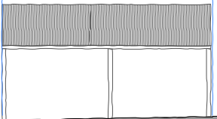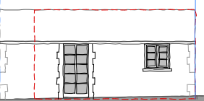
Existing and proposed front elevation of the outbuilding

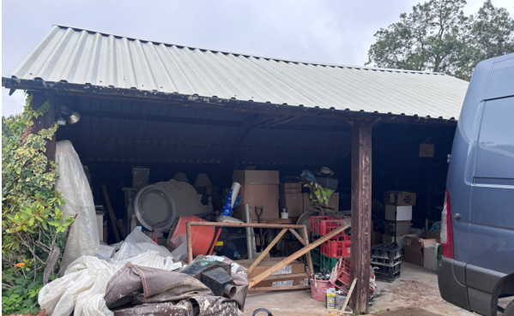
Site photo of the existing carport

The use of matching materials to the host dwelling with matching fenestration would ensure the replacement outbuilding would integrate into the built form of the immediate environment and surrounding setting. It is considered that the proposed development would by virtue of its height, scale and design constitute a complementary addition to the application site that would appear commensurate to the size of the property and plot. Having regard to the above, the proposal complies with the design principles set out in Core Policy 57 of the Wiltshire Core Strategy and Appendix D of the Wiltshire Design Guide.

Amenity
Point vii of Core Policy 57 - Ensuring High Quality Design and Place Shaping of the Wiltshire Core Strategy seeks to ensure that developments do not adversely affect neighbouring properties.

Policy P3 of the National Planning Policy Framework requires development to be appropriate for its location, taking account of its likely effects on health, living conditions and the environment. In particular, Policy P3(2)(b) requires development to avoid giving rise to unacceptable impacts on the living conditions of neighbouring residents and occupiers. In assessing amenity impacts, regard should be had to matters including daylight and sunlight, outlook, privacy, overbearing impacts and other effects on residential amenity.

The proposed development has been assessed in terms of its potential impact on the residential amenity of neighbouring properties, with particular regard to loss of light, overshadowing, loss of privacy, and overbearing effects.

The host dwelling benefits from a semi-rural detached position with the absence of any immediate neighbours. The proposed works relate to the enlargement of an existing outbuilding to create an office space and gym and a replacement roof on another outbuilding. Therefore, due to the nature of the proposal officers are cognisant that no adverse neighbouring amenity impacts would be introduced.

The proposal therefore accords with Core Policy 57 point vii in respect of safeguarding residential amenity, Appendix D of the Wiltshire Design Guide and the NPPF.

Highways Impact
Core Policy 57 (xiv) of the Wiltshire Core Strategy seeks to ensure that development must meet the requirements of Core Policy 61. This policy requires proposals to be capable of being served by safe access to the highway network. Core Policy 64 seeks to ensure compliance with parking standards set out in the Local Transport Plan.

The transport policies of the NPPF seek to ensure that development provides safe and suitable access for all users and that any impacts on highway safety are appropriately considered.

The conversion of the existing car port structure to a habitable office space and gym would remove the provision of a couple of off-road parking spaces from the application site. However, it is acknowledged that sufficient off road parking provision is provided within the large driveway area to the rear of the host dwelling. Therefore, officers raise no concerns in regard to any potential adverse highway impacts.

The proposed development would not result in any adverse impact on highway safety. Adequate parking and turning provision is provided in accordance with Wiltshire’s adopted parking standards, and access arrangements are acceptable.

The proposal is therefore considered to comply with Core Policies 57 (xiv), 61 and 64 of the Wiltshire Core Strategy, the NPPF, and the Wiltshire Local Transport Plan.

Heritage Impact
Section 66(1) of the Planning (Listed Buildings and Conservation Areas) Act 1990 requires special regard to be given to the desirability of preserving listed buildings, their settings and any features of special architectural or historic interest which they possess.

Section 72(1) of the same Act requires special attention to be paid to the desirability of preserving or enhancing the character or appearance of Conservation Areas.

Core Policy 58 of the Wiltshire Core Strategy seeks to conserve and, where appropriate, enhance the significance of designated and non-designated heritage assets and their settings. Core Policy 57 requires development to respond positively to local character and historic context through high-quality design.

Policies HE4-HE10 of the National Planning Policy Framework recognise heritage assets as an irreplaceable resource and require proposals affecting heritage assets to be assessed having regard to their significance and the contribution made by their setting.

As the application site is located within the South Wraxall Conservation Area views into and out of the application site need to be appraised with any potential negative impact of any future development assessed, mindful of Section 72 of the abovementioned Act as well as CP58 of the Wiltshire Core Strategy and the relevant paragraphs of the NPPF.
To the south of the application lies a Grade II listed building, Lower Court Farmhouse, therefore any development has to be appraised in relation to any impact upon the immediate setting of this listed building.
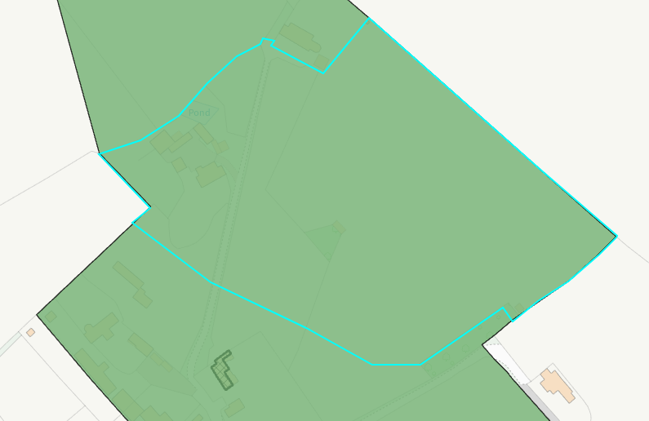
Conservation area (shaded green) and listed buildings (hatched black)

The works to the car port would be utilised with materials to match the host dwelling with natural stone elevations, wooden timber fenestration and matching double roman roof tiles, and the replacement roof on the outbuilding to the northeast of the site would consist of dark grey corrugated sheet metal. The use of the chosen materials would help the development proposals blend into the rural environment.

The height and scale of the development is considered to be commensurate to the size of the generous application site, and the use of the natural sustainable materials is supported. Given the limited works proposed, that would be set within the built envelope of the application site, it is considered that there would be nominal harm to the conservation area and the setting of the listed building nearby.

It would not result in harm to the significance of any heritage assets, and the development is therefore considered to comply with Core Policy 58 of the Wiltshire Core Strategy and Sections 66 and/or 72 of the Planning (Listed Buildings and Conservation Areas) Act 1990, as well as the relevant provisions of the NPPF.

Impact on the Public Right of Way
To the north and south of the access road lies a public right of way (SWRA5) as shown on the map insert below, the footpath runs through the north of the village to access a network of foot paths across the surrounding countryside.

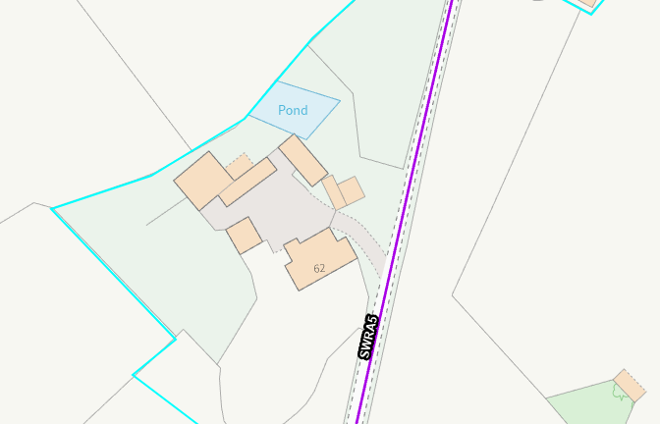

The public right of way would not be altered by any of the works and the development would be set back a distance from the footpath obscured from view by the host dwelling. Therefore, officers do not raise any objections on the basis that there would not be any open views of surrounding countryside that would be obstructed by the proposal. Therefore, the proposed development would not have a detrimental effect to users of the public footpath.

An informative would be added to any permission granted to remind the applicant that it is a criminal offence to obstruct a public right of way under section 137 of the Highways Act 1980

Ecology Impact
Core Policy 50 of the Wiltshire Core Strategy seeks to protect and enhance biodiversity and geodiversity, including through ensuring that development avoids harm to protected species and habitats.

Policy N2 of the NPPF seeks to conserve and enhance biodiversity and support nature recovery. Development proposals should minimise impacts on habitats and species and, where relevant, demonstrate that appropriate mitigation measures are secured where harm cannot be avoided.

The application was subject to consultation with The Council’s Ecology team who raised no objections in relation to the proposed development subject to the scheme being carried out in strict accordance with the supporting ecological documentation, and conditions would be added to ensure this.

Ecology comments:
“The site comprises a car port proposed to be rebuilt. Buildings in the wider site have recently been subject to applications for the replacement of a single-storey extension (PL/2025/07421) and rebuild of the stables (PL/2026/02642) that require mitigation and enhancements for bats.

COMMENTS:
Bath and Bradford-on-Avon Bats Special Area for Conservation (SAC)
The site lies within a core roost buffer, and parcel roost buffer, for Greater Horseshoe bats associated with the Bath and Bradford-on-Avon Bats SAC. It therefore may have the potential to result in significant adverse impact on the special features of that site. Appropriate Assessment (AA) under Section 63 of the Habitats Regulations must be carried out by the relevant Competent Authority (the LPA) to determine the potential significant effects and the suitability of any measures proposed to avoid or mitigate those effects.
A test of likely significance has been carried out by the relevant Competent Authority (Wiltshire Council) as required by Regulation 63 of the Conservation of Habitats and Species Regulations 2017 (as amended). This concluded that given the scale and nature of the currently proposed development which does not propose removal of any bat habitat or Annex II roosts, and with no new lighting proposed, there is no mechanism for adverse impact on the Conservation Objectives of the SAC, and the proposal can be screened out of Appropriate Assessment.

Protected species
The farmhouse is a confirmed common pipistrelle roost (with a maximum count of 1 individual recorded). However, this building will not be affected by the current proposal. The outbuildings to be impacted were also assessed at the time of the original survey (September 2025) and found to possess limited potential for use by roosting bats, with no evidence of roosting bats observed. The applicant should note that under the Conservation of Habitats and Species Regulations 2017 (as amended), it is an offence to harm or disturb bats or damage or destroy their roosts. In the unlikely event that bats are found, works should cease and advice from a professional ecologist must be sought.
The bat survey letter recommends a number of precautionary measures to ensure the risk posed to bats, great, crested newts and nesting birds remains minimal. These should be adhered to and secured via condition.

In line with NPPF and with CP50, applications that do not fall into the category where Biodiversity Net Gain is required must still ensure that no net loss of functional habitat for the benefit of wildlife in the local area will occur as a result of the proposed development. In addition, gains for biodiversity, relevant to local habitats and wildlife populations, should form part of the proposed development. As such, and following email discussions, an enhancement plan has been submitted showing the specification and location of an integrated woodcrete bee brick and a sparrow terrace. Nesting sparrows were observed in dense shrub at the north-west of the main house, as per the bat survey report. Overall, these enhancements are welcomed, and the enhancement/elevation plan should be secured via a compliance condition”

Given the proposal relates to conversion of an existing outbuilding with a slight increase in footprint, and a replacement roof on another outbuilding with limited disruption to any biodiversity and no net loss identified, no concerns are raised in relation to any adverse ecological impacts to be introduced by the proposed scheme. The proposal therefore meets the requirements contained in policy CP50 of the Wiltshire Core Strategy and the relevant provisions of the NPPF.

Drainage and Flood Risk
Core Policy 67 seeks to ensure development does not increase flood risk on-site or elsewhere and includes appropriate drainage where necessary. Policies F7 and F8 of the NPPF seek to ensure flood risk and drainage are appropriately managed.

The application site lies within flood zone 1 so does not trigger a consultation with the Environment Agency, however parts of the site lie within an area with a risk of surface water flooding.
It is noted that the outbuilding that would be reroofed does lie within an area subject to surface water flooding however given the nature of the works, a replacement roof, that would not increase the vulnerability of use, officers raise no concerns in regard to any potential increase in flooding from surface water.

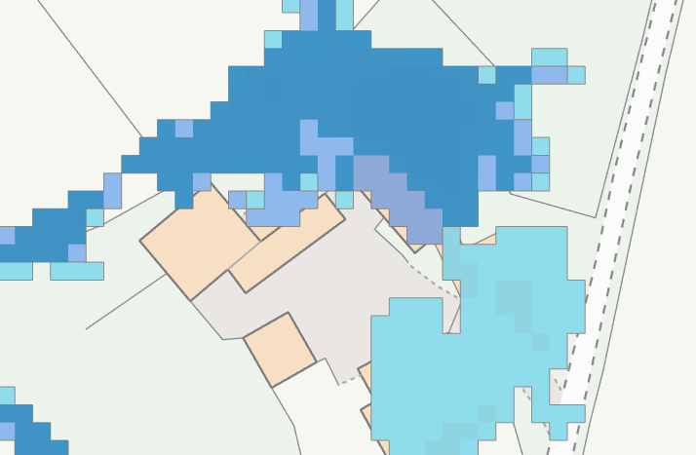
Plan insert illustrating surface water flooding areas
The area where the converted car port sits does not lie within an area with a risk of surface water flooding however the applicant has submitted plans illustrating the proposed surface water drainage systems for the site, and these are deemed acceptable.
The proposal therefore complies with Core Policy 67 of the Wiltshire Core Strategy and the policy in the NPPF, ensuring that flood risk is not increased and that surface water drainage is appropriately managed.

Biodiversity Net Gain
Householder planning applications are exempt from the requirement to deliver Biodiversity Net Gain under Schedule 7A, Section 4(2)(a) of the Town and Country Planning Act 1990, as inserted by the Environment Act 2021.

Public Sector Equality Duty (PSED)
In reaching this decision, due regard has been had to the Public Sector Equality Duty under Section 149 of the Equality Act 2010. This requires the Local Planning Authority to have regard to the need to eliminate discrimination, advance equality of opportunity and foster good relations between persons who share a protected characteristic and those who do not.

The Local Planning Authority is satisfied that the proposal would not result in any unlawful discrimination and that any impacts on protected groups have been appropriately considered as part of this assessment.

CONCLUSION
The proposed development is considered to be acceptable in terms of its design, character and appearance, and would not result in any unacceptable harm to the amenities of neighbouring occupiers.

Furthermore, the proposal would not result in any unacceptable impacts in respect of any other material planning considerations.

The proposal is therefore considered to comply with the relevant policies of the Wiltshire Core Strategy, the National Planning Policy Framework and all other relevant material considerations. As such, the application is recommended for approval, subject to conditions.

RECOMMENDATION: That Planning Permission be GRANTED subject to conditions.

