APPLICATION FOR HOUSEHOLDER PLANNING PERMISSION
DELEGATED REPORT

APPLICATION REFERENCE: | PL/2026/02104
APPLICATION TYPE: | Householder planning permission
SITE ADDRESS: | 31 Marsh Street, Warminster, BA12 9PG
DEVELOPMENT DESCRIPTION: | Proposed Replacement Single Storey Extension
RECOMMENDATION: | That Planning Permission be GRANTED

SITE DESCRIPTION/CONTEXT
The subject property is a semi-detached, two-storeys, 3-bedroom dwelling is visible on 1st epoch mapping, and as such is considered a non-designated heritage asset (NDHA).

The front elevation faces the narrow, one-way Marsh Street, and the land slopes steeply southwards providing views over Warminster. Due to tall hedging and retaining walls abutting the lane, visibility from the streetscape is limited from the east.

The property shares a stepped access from Marsh Street with its attached neighbour no.32.

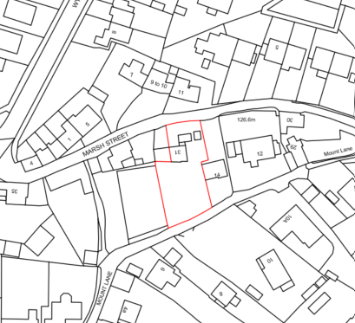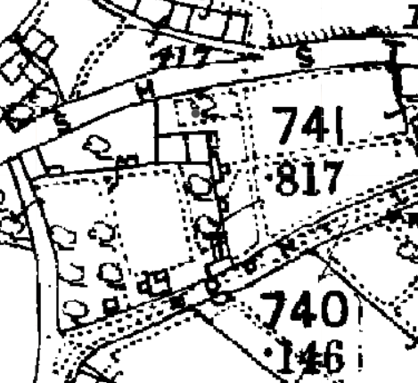

Location Plan and 1st epoch mapping (1868-1899)

showing the two semi-detached cottages and gardens.

Whilst south of Warminster and its Conservation Area, the subject site is located within 30m of the Grade II listed building ‘5 and 6 Marsh Street,’ which ends a terrace of undesignated heritage properties, to the north-west.

The area was a historic residential street, with Thomas Marsh taking a lease of the area in 1765. A small bustling community developed involved in the wool and milling trades, including numerous independent businesses. Neighbouring No.32 was the independent ‘Clark family’s herbalist shop.’ Many tenements were demolished for modern housing, meaning the historic character and historic legibility are being challenged by modern development.

The rear elevation faces Mount Lane across a long, steep, rear garden. In 2018, permission was given for a bungalow to be built in what had originally been the curtilage garden of the host dwelling.

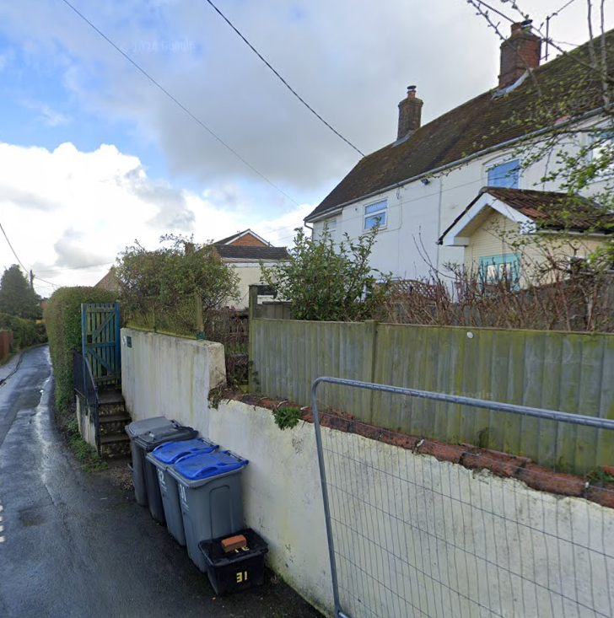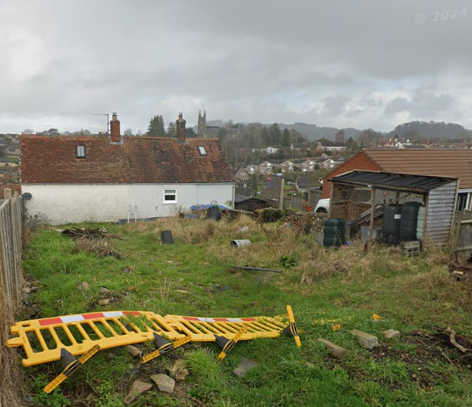

Google Street View images showing views of the subject dwelling from Marsh Lane to the left and from Mount Lane to the right

PROPOSAL

The proposal seeks planning permission for:
- Demolition of attached single storey store rooms
- Replacement with a side two-storey extension and single-storey porch extension, to create a kitchen/dining space and utility, and the creation of an additional en-suite bedroom

Proposed materials include white render, pantiles and uPVC windows to match existing, and Redland regent tiles for the single storey extension, colour to match that of the host dwelling.

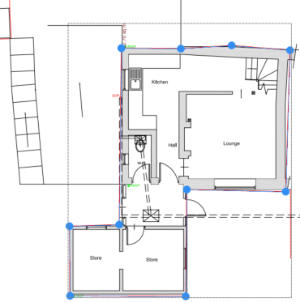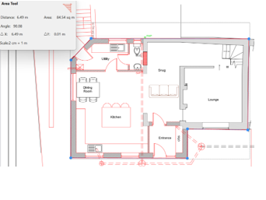

Existing (63m²) and Proposed (85m²) Ground Floor Plans

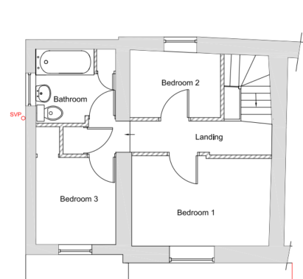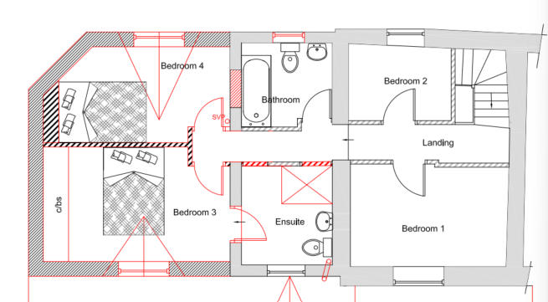

Existing and Proposed First Floor Plans

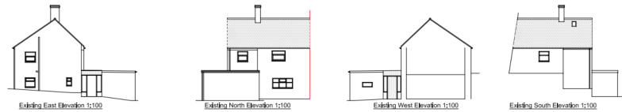

Existing Elevations

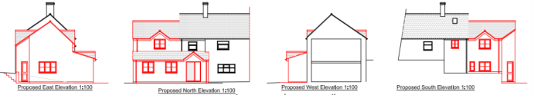

Proposed Elevations

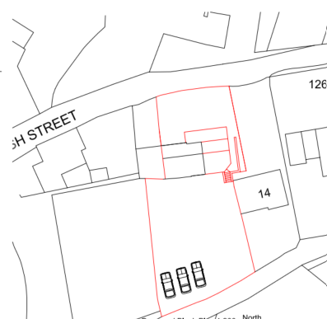

Proposed Block Plan

PLANNING HISTORY
W/84/00091/FUL - Full planning permission Decision - Approved Date: 28/2/1984 – Detached building to be used as utility room and shed – no.31
W/77/00282/HIS - Historic apps 1974 to 1983 Decision - Approved Date: 22/4/1977 – Two storey extension to provide bathroom and kitchen – no.31
18/04733/FUL - Full planning permission Decision - Approve with Conditions Date: 12/7/2018 – Proposed bungalow - Land between 12 Mount Lane and 31 Marsh Street
PL/2023/07643 - Householder planning permission Decision - Approve with Conditions Date: 30/10/2023 – Single storey lean-to side extension – no.33
W/11/01773/FUL - Full planning permission Decision - Refused Date: 24/8/2011 – Single storey rear extension ; first floor extension to existing ;new porch; changes to fenestration and internal alterations; demolition of brick boundary wall to provide access to new on site parking area – no.33
W/12/01297/FUL - Full planning permission Decision - Refused Date: 12/9/2012 – Internal and external alterations including new ground floor porch and WC, first floor rear extension and loft conversion – no.33

RELEVANT POLICIES AND GUIDANCE
The National Planning Policy Framework (NPPF), August 2026
The Planning Practice Guidance
National Design Guide
Wiltshire Design Guide: Appendix D – Design Guidance for Householder extensions

The Planning (Listed Building and Conservation Area) Act 1990
Section 66

Wiltshire Core Strategy:
- Core Policy 57 Ensuring High Quality Design and Place Shaping
- Core Policy 58: Ensuring the Conservation of the Historic Environment
- Core Policy 61: Transport and New Development
- Core Policy 64: Demand Management

Warminster Neighbourhood Plan, made 2016

CONSULTATION RESPONSES
Warminster Town Council: No objection.
Highways Department: No objection, subject to conditions.

REPRESENTATIONS
No comments were received.

ASSESSMENT
Section 38(6) of the Planning and Compulsory Purchase Act 2004 states:

"If regard is to be had to the development plan for the purposes of any determination to be made under the planning Acts, the determination must be made in accordance with the plan unless material considerations indicate otherwise."

In accordance with this statutory requirement, this application has been assessed against the relevant policies of the Development Plan, including the adopted Wiltshire Core Strategy (2015) and, where applicable, any made Neighbourhood Plans.

Heritage, Design and Impact upon the character and context of the area
From the point of view of the historic environment the main statutory tests are set out within the Planning (Listed Building and Conservation Areas) Act 1990.

Section 66 requires that special regard be given to the desirability of preserving listed buildings, their settings or any features of special architectural or historic interest which they possess.

Policy CP58 ‘Ensuring the conservation of the historic environment’ requires that designated and non-designated heritage assets and their settings will be conserved, and where appropriate enhanced, in a manner appropriate to their significance and encourages proposals which improve the condition of heritage assets at risk.

Policy CP57: Ensuring high-quality design requires a high quality of design in all new developments. The policy requires applicants to demonstrate how the proposal will make a positive contribution to the character of Wiltshire through (amongst other things) responding to the value of the natural and historic environment and being sympathetic to and conserving historic buildings and landscapes. Development is required to respond positively to the existing in terms of building layouts, built form, height, mass, scale, building line, plot size, elevational design, materials, streetscape and rooflines to effectively integrate the building into its setting.

The NPPF outlines government policy for planning. Chapter 20 of the NPPF 'Conserving and enhancing the historic environment' sets out the Government's high-level policies concerning heritage and sustainable development.

Section HE7: ‘Decisions on non-designated heritage assets,’ paragraph 1, states that ‘development proposals which would have a positive effect on a non-designated heritage asset should be supported.’

During the lifecycle of this application, revisions have been received which directly responded to concerns regarding heritage and the need for proposals to reflect the local character of the subject NDHA dwelling, respect the setting of the neighbouring listed buildings and respond to the grain of development of the wider historic lane. These revisions were subject to a fresh consultation exercise.

These revisions included revising the design to the now proposed subservient two-storey extension, reduction in forward projection, utilising pitched roof forms, recreating the porch and historic layout, and including matching and appropriate materials.

Visible on 1st epoch mapping, the building is considered a NDHA as part of a cluster of historic buildings in this small area, only one being listed, which narrate the area’s historic character. Substantial development to the front elevation has altered the property’s character and its relationship to its immediate neighbour, yet the proposed development provides the opportunity to better reveal this historic character and marry to the neighbouring semi-detached cottage. Removing the unsightly, poorly built single-storey front extension, would have significant heritage benefits in revealing this character and pairing. Siting the proposed extension to the side, also seeks to protect the rear elevation built into the slope, which is visible from Mount Lane, and also replicates a standard form of C19 extension.

It is considered that the amendments have resulted in a scheme that better preserves the character of the host non-designated heritage asset, matching and enhancing the historic character of the neighbouring property, and setting of the nearby listed building. As such the proposals would have a positive effect on the NDHA, deserving support.

A subservient side extension would highlight the original cottage’s small scale, layout and form. The proposal would also introduce a dormer, and a pitched porch roof, which whilst not evident on the existing dwelling, would reflect the porch of the neighbouring cottage, and details on other neighbouring NDHAs, as a standard historic form of smaller extensions and porches.

Proposed casement window styles are appropriate to the age of property and wider area.

Proposed materials would ensure the extensions successfully integrate with the host dwelling, being compatible with the adjoining pair, and harmonising with the wider area.

The proposal, by virtue of its scale, design, and use of materials, is considered to respond to the character and appearance of the area, preserve the setting of a listed building and character of the NDHA.

The development is therefore considered to comply with Core Policy 57 and 58 of the Wiltshire Core Strategy, and Appendix D of the Wiltshire Design Guide, as well as the relevant provisions of the NPPF.

Amenity
Point vii of CP57 of the adopted WCS seeks to ensure that developments do not adversely affect neighbouring properties.

The proposed development has been assessed in terms of its potential impact on the residential amenity of neighbouring occupiers, with particular regard to loss of light, overshadowing, privacy, and overbearing effects.

The proposal would result in increased built form towards the nearest neighbouring property, the recently constructed bungalow at No. 14 Mount Lane to the east, extending the side building line at both ground and first floor level. However, No. 14 is set back from the host dwelling and occupies higher ground on the slope towards Mount Lane. Given this relationship, the proposed extension is not considered likely to result in any unacceptable overbearing impact or loss of light through overshadowing.

The scheme includes an enlarged ground floor window within the eastern elevation, additional first floor windows to the front elevation, and two rear windows together with a rear access door and ground floor window.

With regard to the additional habitable window on the front (northern) elevation, the existing dwelling already contains first-floor windows serving two of the existing bedrooms and therefore the introduction of one additional window within the proposed extension would not introduce any significant additional overlooking or loss of privacy when compared to the existing situation.

Views from the eastern ground floor window would be obscured by the existing fencing and the proposed south elevation windows would predominantly face across the applicant's rear garden and parking area, with some oblique views towards the on-site car parking of No. 14, where public views are already gained from the existing road.

Furthermore, No. 14 Mount Lane contains no windows within its western side elevation facing the application property, thereby limiting any potential for overlooking between the properties.

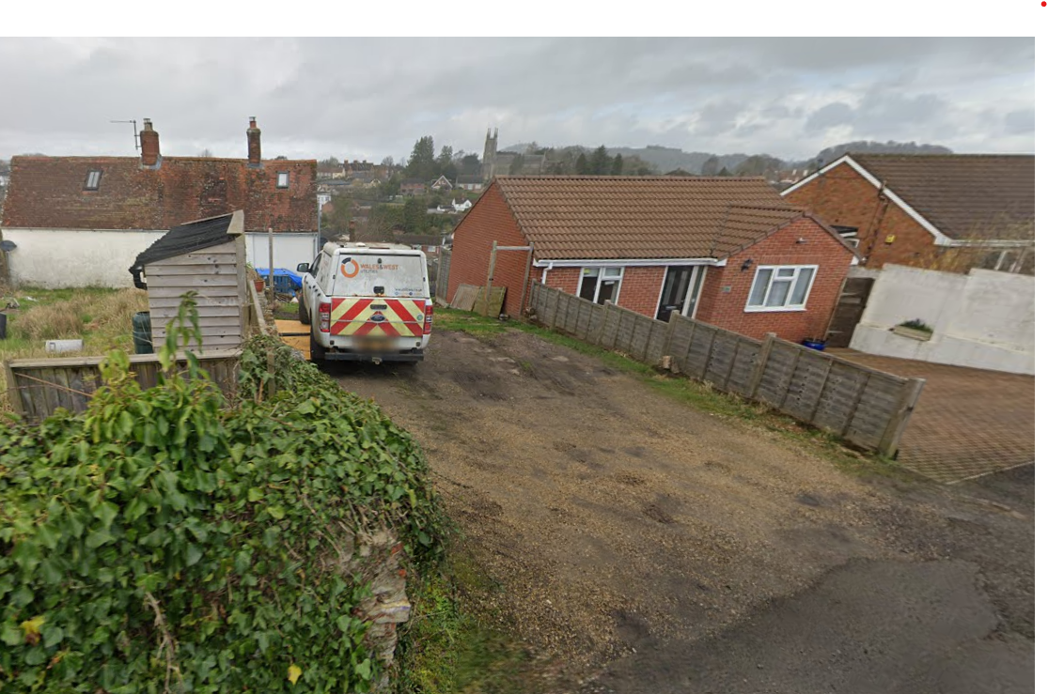

Google Street View image showing no. 14 (the red brick bungalow to the right) and the application site to the left)

Accordingly, the proposal is not considered to give rise to any unacceptable harm to the residential amenities of neighbouring occupiers.

The proposal therefore accords with Core Policy 57 point vii in respect of safeguarding residential amenity and Appendix D of the Wiltshire Design Guide.

Highways Impact
Core Policy 57 (xiv) of the Wiltshire Core Strategy seeks to ensure that development must meet the requirements of Core Policy 61. This policy requires proposals to be capable of being served by safe access to the highway network. Core Policy 64 seeks to ensure compliance with parking standards set out in the Local Transport Plan.

The National Planning Policy Framework (NPPF), section TR2; ‘local parking standards,’ and TR6 ‘Assessing transport impacts’ require that development proposals do not have an unacceptable impact on highway safety and ensure suitable local parking provision.

The proposal includes the creation of an additional 4th bedroom, with increased potential parking demand. The Site Plan shows 3 off-street parking spaces accessed from Mount Lane which conforms with Wiltshire’s Parking Strategy.

It is highlighted that these 3 spaces whilst visible on google maps, remain unregularised as the Vehicle Access team have not had an application to create this vehicle access from Mount Lane, such that an informative must be included highlighting the need for a highway licence.

The proposed development would not result in any adverse impact on highway safety. Adequate parking and turning provision is provided in accordance with Wiltshire’s adopted parking standards, and access arrangements are acceptable.

The proposal is therefore considered to comply with Core Policies 57 (xiv), 61 and 64 of the Wiltshire Core Strategy, the NPPF, and the Wiltshire Local Transport Plan.

Biodiversity Net Gain
Householder planning applications are exempt from the requirement to deliver Biodiversity Net Gain under Schedule 7A, Section 4(2)(a) of the Town and Country Planning Act 1990, as inserted by the Environment Act 2021.

CONCLUSION
The proposed development is considered to be acceptable in terms of its design, scale, and relationship with the surrounding area. It would not result in any unacceptable harm to the character of the locality, the amenities of neighbouring occupiers, or the interests of highway safety, or heritage.

The proposal is therefore considered to comply with the relevant policies of the Wiltshire Core Strategy, the Wiltshire Local Plan, and the National Planning Policy Framework. As such, the application is recommended for approval, subject to conditions.

RECOMMENDATION: That Planning Permission be GRANTED subject to conditions.

