APPLICATION FOR FULL PLANNING PERMISSION
DELEGATED REPORT

APPLICATION REFERENCE: | PL/2025/07781
APPLICATION TYPE: | Full Planning Permission
SITE ADDRESS: | Home Farm. Rood Ashton, West Ashton, Trowbridge, BA14 6BL
DEVELOPMENT DESCRIPTION: | Proposed Glamping Pods (4 No.)
RECOMMENDATION: | That Planning Permission be GRANTED

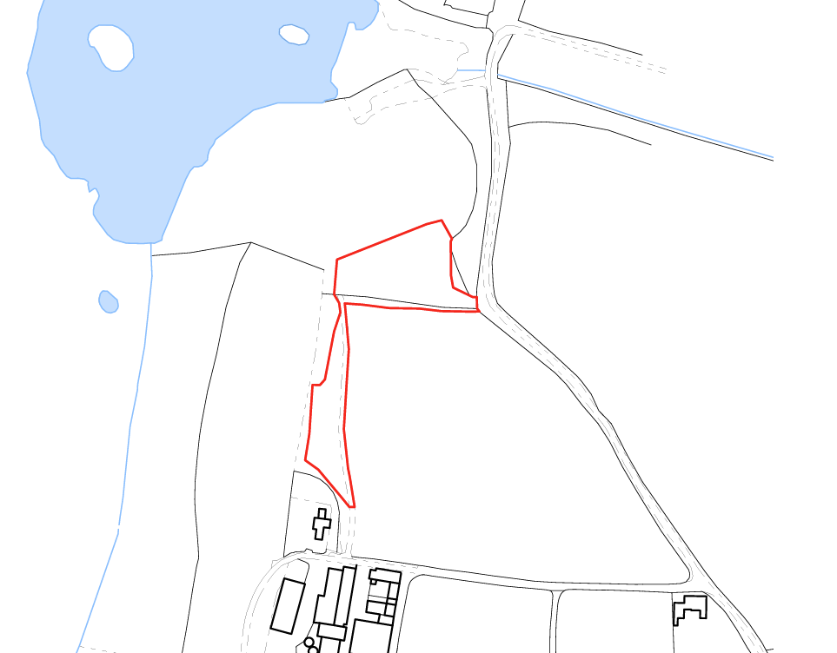

PROPOSAL

The application seeks full planning permission for the erection of four glamping pods on agricultural land at Home Farm, Rood Ashton. The pods would be positioned within a field adjacent to the existing fishing lake and would be accessed via a new vehicular access from Sandpits Lane. Each pod would provide holiday accommodation comprising two bedrooms, a bathroom and an open plan living, dining and kitchen area. The pods would be of a low-profile timber-clad design with curved roof forms and would be set on raised decking supported by a lightweight stilted foundation system. Associated works include the provision of parking, access tracks, landscaping, native hedgerow planting and ecological enhancement measures.

SITE DESCRIPTION / CONTEXT

The application site comprises approximately 0.7 hectares of agricultural land and an existing farm track located within the open countryside between Trowbridge and West Ashton, outside any defined Limits of Development. The site is bordered by agricultural land on all sides and by a fishing lake to the north, with areas of woodland and priority habitat in close proximity. The site lies within the Bath and Bradford on Avon Bats SAC consultation area, including the Trowbridge and Westbury Bat Mitigation Strategy yellow zone and a Bechstein's Bat Core Roost Buffer, and is also within the 6.4km recreational pressure zone for Salisbury Plain SPA. The site is located within Flood Zone 1, has a low risk of fluvial and surface water flooding but is identified as having a moderate groundwater flood risk. A public right of way is present within the wider area and the site is characterised by gently sloping topography falling northwards towards the lake.

PLANNING HISTORY

No relevant planning history has been identified for the site subject of this application.

RELEVANT LEGISLATION, POLICIES AND GUIDANCE

Wiltshire Core Strategy:

Core Policy 1 Settlement Strategy;
Core Policy 2 Delivery Strategy;
Core Policy 29 Spatial Strategy: Trowbridge Community Area;
Core Policy 39 Tourist Development;
Core Policy 50 Biodiversity and Geodiversity;
Core Policy 51 Landscape;
Core Policy 57 Ensuring High-Quality Design and Place Shaping;
Core Policy 58 Ensuring Conservation of the Historic Environment;
Core Policy 60 Sustainable Transport;
Core Policy 61 Transport and Development;
Core Policy 64 Demand Management;
Core Policy 67 Flood Risk;

West Ashton Neighbourhood Development Plan 2018-2026 (June 2021)

The National Planning Policy Framework (NPPF) and The Planning Practice Guidance (PPG)

Wiltshire Design Guide

The Wiltshire Local Transport Plan 2011 – 2026: Car Parking Strategy (March 2015).

The Wiltshire Local Transport Plan 4 (LTP4) (March 2025)

New Wiltshire Local Plan

At Full Council on 19 May 2026, the elected members of Wiltshire Council agreed to withdraw the emerging Wiltshire Local Plan. The said Plan has no material weight for the purposes of the application.

In accordance with Regulation 19 of the Town and Country Planning (Local Planning) (England) Regulations 2026, on 30th June 2026 Wiltshire Council published a notice of intention to prepare a new local plan for Wiltshire. The next stage is a Scoping Consultation which commences on 2nd September 2026. This plan is at a very early stage and currently carries no weight for decision making.

CONSULTATION RESPONSES

West Ashton Parish Council – No Comment

Local Highway Authority (Wiltshire Council) – No Objection (subject to conditions)

Ecology (Wiltshire Council) – No Objection (subject to conditions)

Drainage (Wiltshire Council) – No Objection (subject to conditions)

Archaeology (Wiltshire Council) – No Objection

Natural England – No Objection (subject to conditions)

REPRESENTATIONS

Two public representations were received. One raised no objection to the principle of the development but expressed concerns regarding the increased use and maintenance of the existing private access road serving neighbouring properties, suggesting that an alternative access from Sandpits Lane may be preferable and requesting consideration of a noise curfew to minimise disturbance to nearby residents. The second representation also raised no objection to the principle of the proposed glamping pods or the diversification of the farm business, but objected to the originally proposed location of the access route and parking area, citing concerns relating to traffic movements, noise and light disturbance, loss of privacy, impacts on residential amenity, and potential effects on bats and other wildlife. The representation suggested that the access and parking arrangements be relocated away from nearby dwellings and woodland. It is noted that the applicant subsequently submitted amended plans providing vehicular access directly from the public highway, which addresses the principal objection relating to the location of the access route and parking area.

ASSESSMENT

Section 38(6) of the Planning and Compulsory Purchase Act 2004 states:

"If regard is to be had to the development plan for the purposes of any determination to be made under the planning Acts, the determination must be made in accordance with the plan unless material considerations indicate otherwise."

In accordance with this statutory requirement, this application has been assessed against the relevant policies of the Development Plan, including the adopted Wiltshire Core Strategy (2015) and, where applicable, any made Neighbourhood Plans.

The site lies within the open countryside where Core Policies 1 and 2 of the Wiltshire Core Strategy seek to restrict new development unless otherwise supported by a specific development plan policy. In this case, the proposal falls to be considered principally against Core Policy 39, which supports appropriately located tourist and visitor facilities where they are compatible with their surroundings and where a countryside location can be justified. The proposal seeks to provide four glamping pods as part of a farm diversification enterprise, delivering a form of tourist accommodation that by its nature is intended to utilise and enjoy the surrounding rural environment.

Core Policy 39 recognises that some tourist development may be appropriately located within the countryside where there is a clear relationship with particular attractions and where the development is compatible with its landscape setting. In this instance, the proposed accommodation would be positioned immediately adjacent to an established fishing lake which forms a key component of the visitor experience and provides a clear countryside attraction directly associated with the proposed use. Furthermore, whilst the site is located within the open countryside, it is situated between Trowbridge, West Ashton and Steeple Ashton, all of which are located within a relatively short distance and provide access to services and facilities. The site therefore occupies a sustainable rural location in the context of tourism development.

The proposal must also be assessed against the criteria contained within Core Policy 39. The scale of development is modest, comprising only four units, and as assessed elsewhere within this report would not result in unacceptable impacts upon landscape character, residential amenity, highway safety, ecology or drainage. The development would be served by an appropriate access arrangement and associated infrastructure, including parking provision and drainage measures secured by condition. Having regard to the relationship with the adjacent fishing lake, the scale and nature of the proposal, the availability of infrastructure and the proximity to nearby settlements and services, it is considered that the proposal satisfies the requirements of Core Policy 39 and is therefore acceptable in principle as a form of rural tourist accommodation.

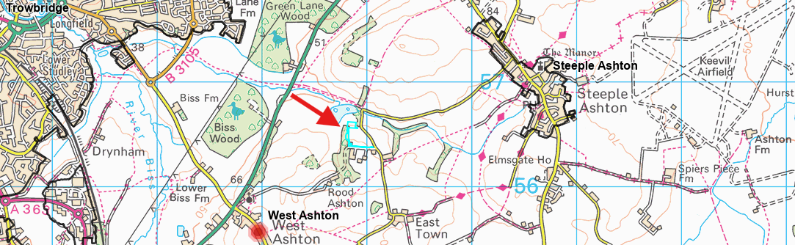
Location of site relative to nearby settlements

Design and Impact the upon the character and context of the area

Core Policy 57 of the Wiltshire Core Strategy seeks to secure high-quality design which responds positively to local character and distinctiveness. At the national level, Policy DP3 of the National Planning Policy Framework requires development proposals to respond positively to their context and integrate with and enhance their surroundings. Development should also reflect, where relevant, the principles of liveability, climate resilience, nature, movement, built form, public space and local identity. Assessment of design quality therefore requires consideration of the scale, appearance, massing, materials, layout and relationship of the proposal with both the host site and the wider character of the surrounding area. Core Policy 51 seeks to protect, conserve and where possible enhance landscape character. The assessment has therefore also considered the extent to which the proposal would preserve the character and appearance of the local landscape.

Whilst the proposal introduces built development into a presently undeveloped agricultural field, significant weight is afforded to the scale, form and appearance of the accommodation proposed. The four pods represent lightweight structures of limited height which sit comfortably within the landscape and avoid the appearance of conventional residential development. The timber-clad elevations and curved roof forms create a distinctly rural, temporary and nature-focused character which is inherently linked to the proposed holiday use. Unlike more substantial forms of built development, the pods would not introduce visually dominant massing or extensive urbanising features into the countryside. The site also benefits from existing topographical characteristics, with land levels generally rising southwards away from the fishing lake, and from surrounding hedgerows and woodland which already provide a degree of enclosure from wider viewpoints. In addition, the proposal incorporates substantial native hedge planting, including new boundary and internal hedgerows which, once established, would further soften and screen the development from surrounding views. The combined effect of the existing landscape framework, proposed planting and the inherently low-profile design of the pods would ensure that the development integrates successfully into its surroundings without resulting in material harm to the rural character of the area. Whilst some localised change to views would inevitably occur, these changes would be limited in extent and would not undermine the wider landscape character of the countryside. The proposal is therefore considered to accord with the objectives of Core Policies 51 and 57 of the Wiltshire Core Strategy.

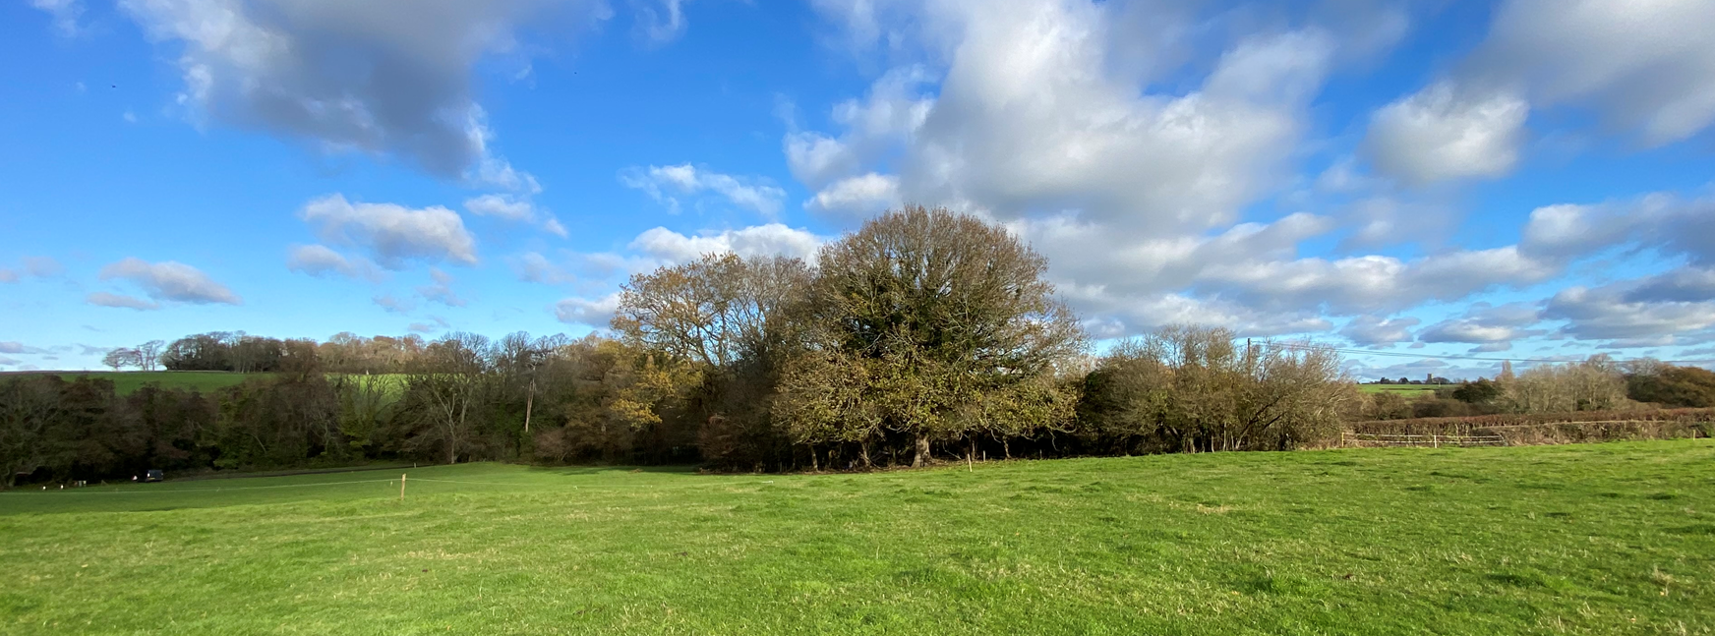
Site Visit Image (Left of image: fishing Lake; Right of image: proposed access)

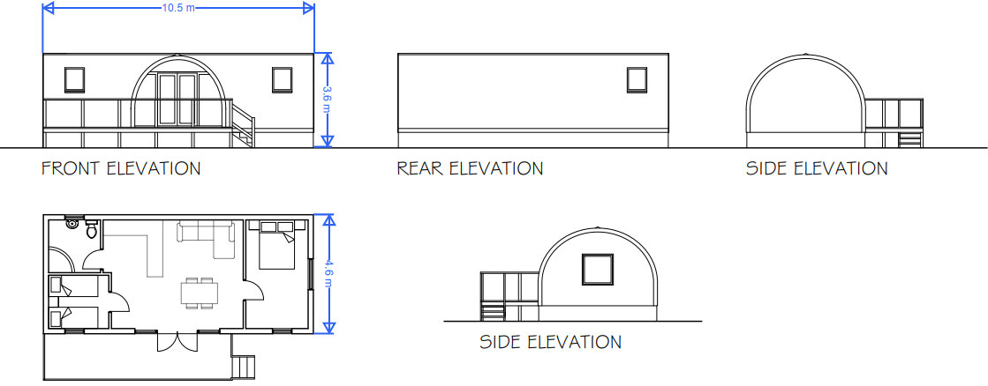
Proposed Elevations

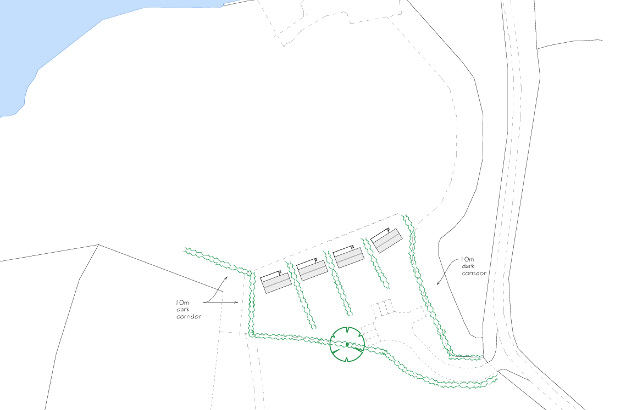
Proposed Site Plan

Amenity

Core Policy 57 criterion vii seeks to ensure development does not have an unacceptable impact upon the amenities of neighbouring occupiers. Nationally, Policy P3 requires development proposals to provide healthy living conditions for occupiers and users and to avoid unacceptable impacts arising from loss of light, outlook, privacy, noise, disturbance or other forms of pollution. Policy DP3 additionally requires development to create liveable and attractive places for existing and future users. Accordingly, the assessment below considers the effect of the proposal upon neighbouring occupiers and whether acceptable living conditions would be maintained.

The principal amenity consideration relates to the introduction of a small-scale holiday accommodation use within an agricultural field and the associated activity that would arise from seasonal occupation of the pods. Whilst it is accepted that activities associated with holiday accommodation, including vehicle movements, outdoor recreation and general day-to-day occupation, would occur on the site, the proposal comprises only four units and therefore represents a relatively modest level of activity. The nearest residential properties are situated approximately 140 metres from the proposed pod locations and are separated by a combination of topography, intervening land and proposed landscaping. Given these separation distances and the limited scale of the development, it is not considered that activity associated with the use would result in unacceptable levels of noise, disturbance or loss of residential amenity.

Particular regard has also been had to concerns raised by neighbouring residents relating to privacy, light pollution, noise and visitor activity. The amended access arrangements remove the primary source of concern originally identified by objectors and significantly reduce the potential for conflict between visitors and neighbouring occupiers. Furthermore, the proposed pods are of limited height and would not result in overlooking, overbearing impacts or loss of light to neighbouring properties. Internally, the proposed hedgerow planting between plots would provide a good degree of privacy for visitors whilst reinforcing the landscaped character of the site. Taking all matters into account, the proposal is considered capable of operating as holiday accommodation without giving rise to material harm to the living conditions enjoyed by neighbouring occupiers and therefore complies with Core Policy 57 and the amenity objectives of the Wiltshire Design Guide.

Transport and Highways

Core Policies 60, 61 and 64 of the Wiltshire Core Strategy seek to promote sustainable transport, secure safe access arrangements and ensure adequate parking provision. Nationally, Policies TR3 and TR4 of the National Planning Policy Framework require development to be located in sustainable locations where appropriate, provide safe access arrangements, prioritise walking, wheeling and cycling, and provide suitable parking provision having regard to the nature and location of the development. Policy TR6 confirms that development should be refused where it would result in a severe adverse impact on the transport network or an unacceptable impact on highway safety after consideration of any mitigation measures.

Following concerns raised during consultation, the applicant revised the scheme to provide a new access directly from Sandpits Lane rather than relying upon the existing private access arrangements. The Local Highway Authority has reviewed the amended proposals and raises no objection, confirming that the revised access achieves improved visibility splays and represents a safer arrangement than the existing access point. Adequate parking and turning facilities are proposed within the site, with sufficient space available to accommodate visitor vehicles without resulting in overspill parking onto the public highway. Subject to conditions securing visibility splays, surfacing works and the completion of the necessary Section 278 agreement, it is considered that the development would not have an unacceptable impact on highway safety or the operation of the surrounding road network and complies with Core Policies 60 and 61.

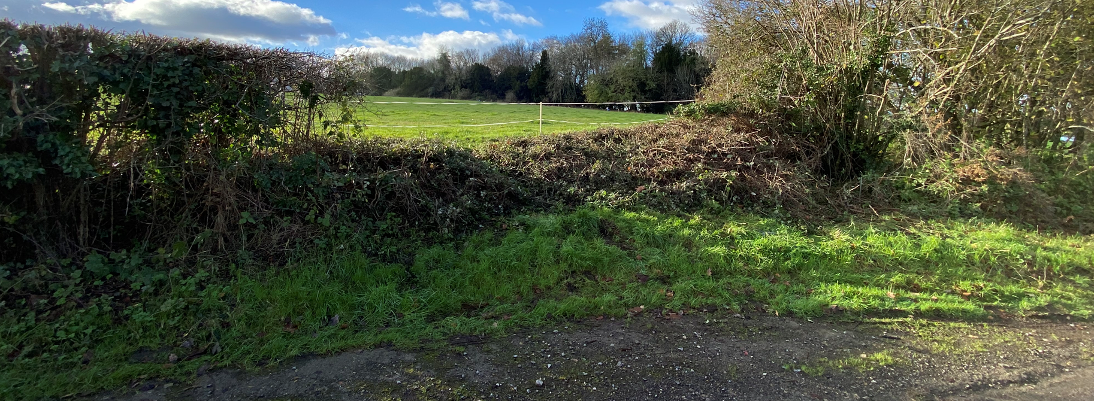
Proposed Access

Ecology

Core Policy 50 of the Wiltshire Core Strategy seeks to protect and enhance biodiversity interests and ensure development avoids unacceptable harm to ecological assets. National policy is set out within Policies N2 and N6 of the National Planning Policy Framework. These policies require development proposals to minimise impacts upon biodiversity, protect important habitats and species, and secure opportunities for biodiversity enhancement where appropriate. Where significant harm to biodiversity cannot be avoided, adequately mitigated or compensated for, development should be refused. Biodiversity Net Gain (BNG) was established as a mandatory aspect of planning evaluation through Schedule 7A of the Town and Country Planning Act 1990 (as amended by the Environment Act 2021 Schedule 14).

The ecological implications of the proposal have been a key consideration in the assessment of this application due to the site's location within the Bath and Bradford on Avon Bats SAC consultation area, the Trowbridge and Westbury Bat Mitigation Strategy (TWBMS) yellow zone, a Bechstein's Bat Core Roost Buffer, and its proximity to priority deciduous woodland habitat. Whilst the site itself comprises predominantly modified grassland of relatively low ecological value, the surrounding woodland network is recognised as important commuting and foraging habitat for SAC qualifying bat species. The Council's Ecologist initially sought further information, including clarification on impacts to bat habitat and biodiversity mitigation measures; however, following the submission of an updated Preliminary Ecological Appraisal, Biodiversity Net Gain Assessment and revised site layout, the Ecologist has confirmed that all outstanding matters have been satisfactorily addressed. The revised scheme incorporates a 10-metre dark corridor, woodland buffers, native species-rich hedgerow planting and habitat connectivity measures which will maintain and enhance bat commuting and foraging opportunities whilst limiting disturbance from the proposed use.

Given the ecological sensitivity of the surrounding area, the Council undertook an Appropriate Assessment under the Habitats Regulations in respect of both the Bath and Bradford on Avon Bats SAC and the Salisbury Plain SPA. The Appropriate Assessment concluded that, subject to the proposed mitigation and management measures being secured, the development would not result in an adverse effect on the integrity of either European site. Natural England has subsequently reviewed the Appropriate Assessment and confirmed that it raises no objection subject to the implementation of the identified mitigation measures. Furthermore, the submitted Biodiversity Net Gain Assessment demonstrates a 15.48% biodiversity net gain, exceeding the statutory 10% requirement, through the creation and enhancement of grassland, scrub, hedgerow and tree habitats. Subject to conditions requiring compliance with the ecological mitigation measures, a lighting strategy, and a Wildlife Mitigation and Enhancement Plan to secure the long-term management of habitat features, it is considered that the proposal complies with Core Policy 50 of the Wiltshire Core Strategy and the requirements of the Habitats Regulations.

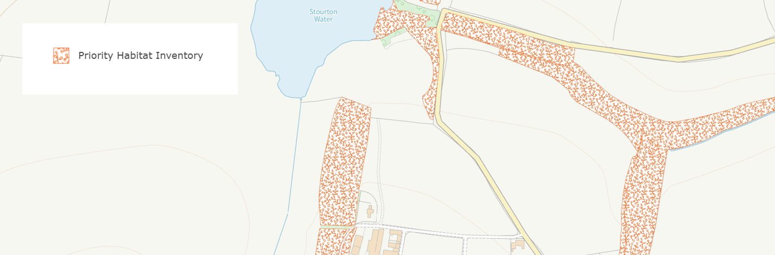
Priority Habitat Inventory

Flooding and Drainage

Core Policy 67 of the Wiltshire Core Strategy seeks to ensure that development is directed away from areas at greatest risk of flooding and is designed to minimise vulnerability to flooding whilst avoiding any increase in flood risk elsewhere. National planning policy relating to flood risk and drainage is contained within Policies F4 to F8 of the National Planning Policy Framework. Collectively, these policies establish a risk-based approach to the location and assessment of development proposals. The Framework requires flood risk to be properly assessed where necessary, seeks to direct development towards areas at the lowest risk of flooding through the application of the sequential approach where applicable, and ensures that development remains safe for its lifetime without increasing flood risk elsewhere. The policies also support the incorporation of sustainable drainage measures where appropriate in order to manage surface water runoff and reduce the potential for flooding.

The application site is located within Flood Zone 1 and is therefore situated within the area of lowest risk of fluvial flooding. The Council's Strategic Flood Risk Assessment identifies a moderate susceptibility to groundwater flooding across the site together with a limited area of surface water flood risk affecting parts of Sandpits Lane; however, no surface water flood risk is identified across the proposed pod locations, parking area or principal areas of development. The applicant submitted a site-specific Flood Risk Assessment which considers the characteristics of the site and the nature of the proposed development. The assessment notes that the development introduces only a very limited amount of impermeable surface area and that the accommodation itself would be raised above ground level on a lightweight stilt and decking arrangement. Furthermore, the site naturally falls northwards towards the fishing lake and is located a significant distance from neighbouring properties, reducing the prospect of any increased flood risk affecting adjoining land.

The National Planning Policy Framework confirms that the sequential test need not be applied where a site-specific Flood Risk Assessment demonstrates that occupiers would remain safe for the lifetime of the development and that flood risk would not increase elsewhere. In this case, the submitted Flood Risk Assessment, together with the characteristics of the site itself, provides sufficient evidence that these requirements can be met. Whilst some localised flood susceptibility has been identified along sections of Sandpits Lane, the proposed point of access itself lies outside the mapped surface water flood risk area and the development benefits from alternative access opportunities through the wider farm holding in the event that emergency arrangements are required. The Lead Local Flood Authority has ultimately raised no objection to the proposal subject to a condition requiring a detailed surface water drainage strategy and an emergency flood plan prior to commencement. Having regard to the evidence before the Council, it is considered that the development would remain safe for its lifetime, would not increase flood risk elsewhere and therefore falls within the circumstances envisaged by Policy F5(2)(b) of the NPPF whereby application of the sequential test is not required. The proposal is consequently considered to comply with Core Policy 67 and national planning policy relating to flooding and drainage.

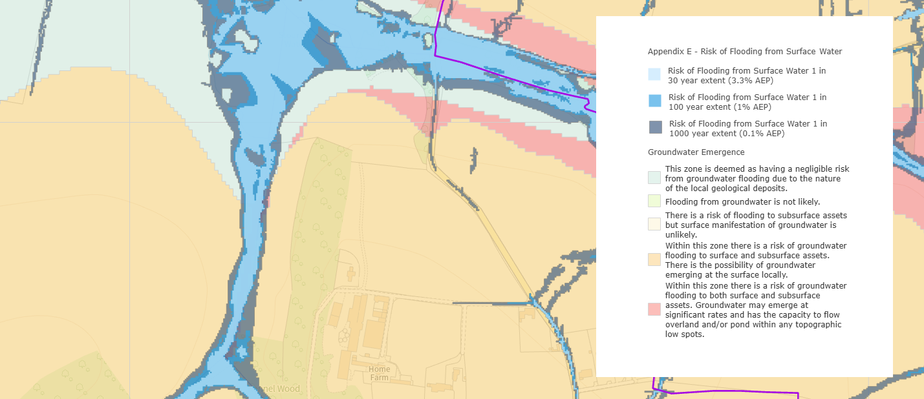
sFRA ground and surface water flood risk

CONCLUSION

The proposal represents a modest rural tourism development comprising four glamping pods associated with an existing countryside attraction and farm diversification opportunity. Whilst located within the open countryside, the proposal satisfies the requirements of Core Policy 39 relating to tourist development and has been demonstrated to be acceptable in respect of landscape impact, design, neighbouring amenity, highway safety, ecology and flood risk. Consultees including the Local Highway Authority, Ecology Officer, Drainage Officer, Archaeology Officer and Natural England raise no objection subject to appropriate conditions. The development would deliver biodiversity enhancements, support rural tourism and contribute to the rural economy without giving rise to significant adverse impacts. Accordingly, the proposal is considered to comply with the Development Plan when read as a whole and is recommended for approval subject to conditions.

RECOMMENDATION: That Planning Permission be GRANTED subject to conditions

