PROPOSED SHED
PLANS AND ELEVATIONS
Westbury Leigh Community Hall
Scale 1:50 @ A4
All dimensions in millimetres

FLOOR PLAN
2000
<---------------->
┌────────────────┐
│ │
1500 │ │
│ │
└────────────────┘

FRONT ELEVATION
2000
<---------------->
┌────────────────┐
│ │
│ DOORS │
2000 │ │
│ │
└────────────────┘

LEFT SIDE ELEVATION
1500
<-------------->
┌───────────────\
│ \
2000 │ │ 1800
│ │
└─────────────────┘

RIGHT SIDE ELEVATION
1500
<-------------->
┌───────────────\
│ \
2000 │ │ 1800
│ │
└─────────────────┘
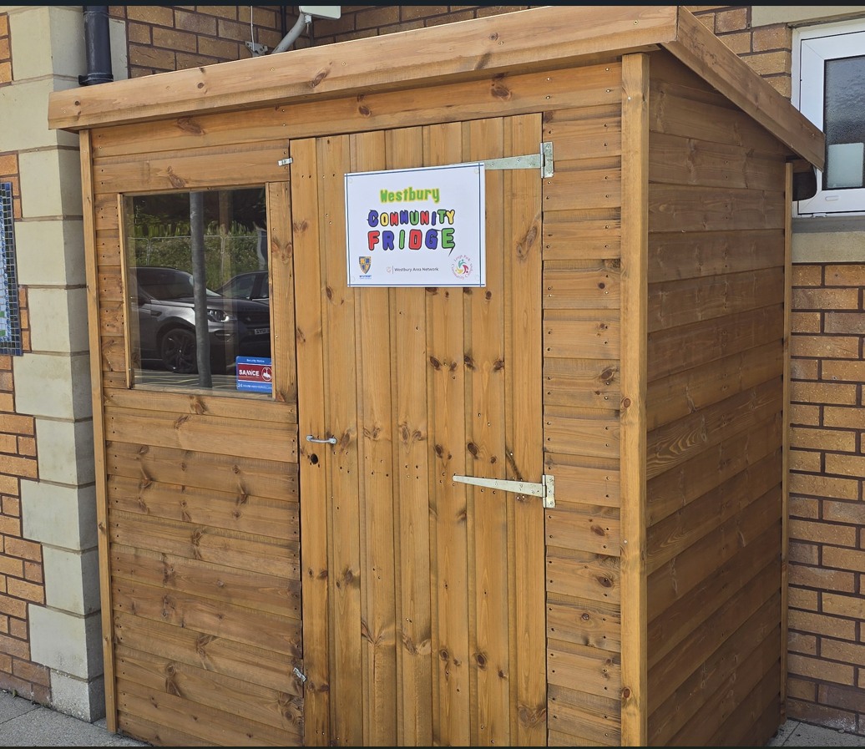

Drawing Notes
Proposed free-standing shed 2000mm wide x 1500mm deep. Mono-pitch roof 2000mm high at front falling to 1800mm at rear. External materials and colour to match submitted photograph.

