Appendices

Appendix 1
a. Photo of north side of entrance showing height of land and relationship of proposed entrance to the Cotes listed west wall.
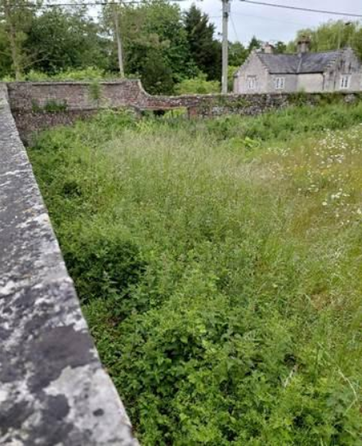
b. Clear picture showing height of land on northern side in front of proposed pedestrian entrance. Major undertaking to lower land to meet pavement level of Boreham Road allowing or increasing water runoff.
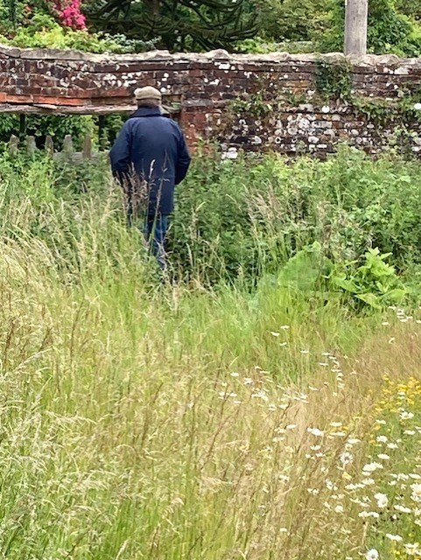

c. Picture of the old agricultural entrance on Boreham Road into Cotes Field. Not a previous pedestrian entrance, as the brick arch above the opening clearly shows 2 previous entrances to the field – a single opening to the left and a larger entrance on the right.
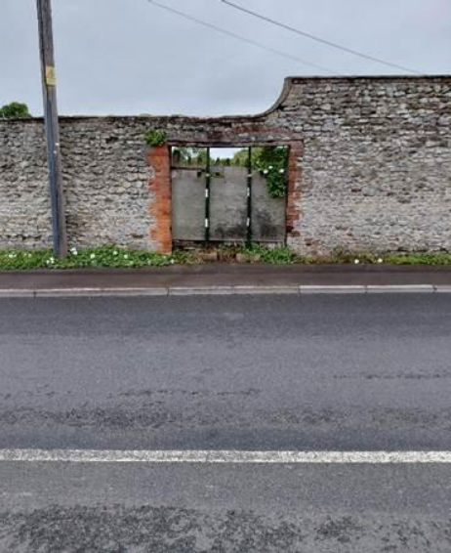
Appendix 2.
Source: EBBRAG Drone Topographical Survey – 23 Dec 25.
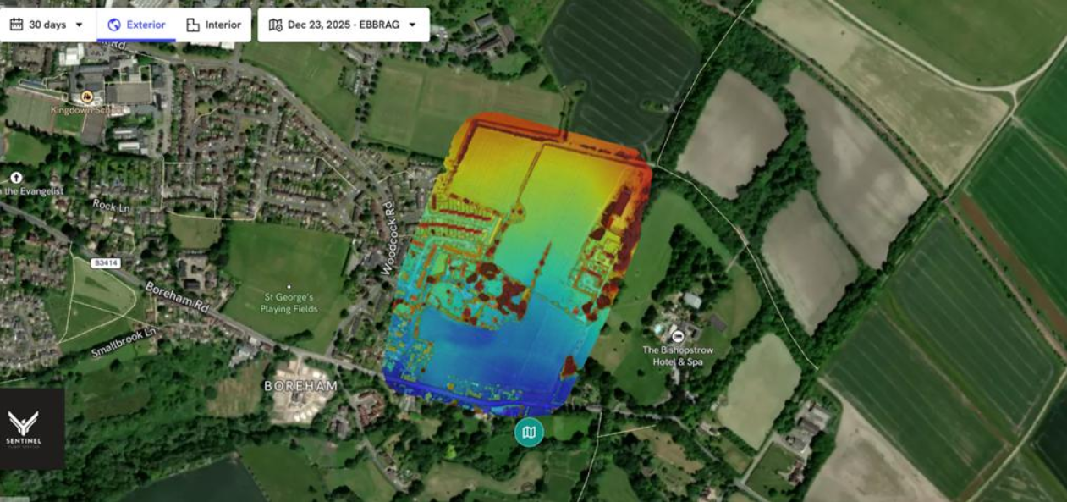
a. Red donates highest point and blue lowest highlighting elevation north to south in relation to the proposed site layout. Note dark blue running along Boreham Road to Woodcock Road. Proposed pedestrian entrance is also dark blue ie lowest elevation on proposed site.

Appendix 3

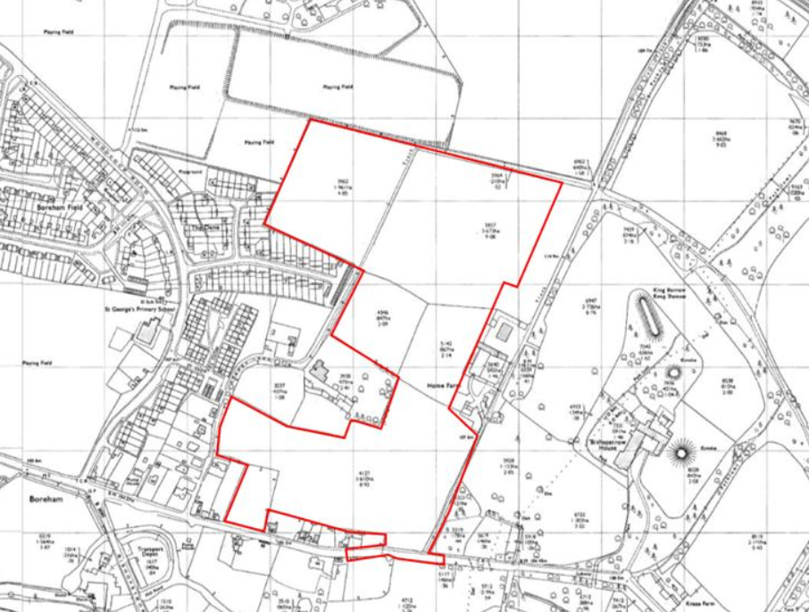
a. Source Promap 1985 showing Cotes Field bounded by walls similar to the west, south and east walls existing today.

