CHANGE OF USE PLANNING PERMISSION
CASE OFFICER REPORT
APPLICATION REFERENCE: | PL/2026/03460
APPLICATION TYPE: | Change of Use
SITE ADDRESS: | Independent Living Centre, St Georges Road, Semington, Trowbridge, BA14 6JQ
DEVELOPMENT DESCRIPTION: | Change of use, from Class E to Sui Generis, from an unused unit to a licensed tattoo studio.
RECOMMENDATION: | Approve with Conditions.

SITE DESCRIPTION/CONTEXT
The application site is a single room within ‘The Independent Living Centre’ (ILC), a substantial two storey building which is of Grade II listed status located within the former St. Georges Hospital site. The ILC consists of a range of commercial and support services at ground floor and rooms/offices at first floor which are let out independently. The proposed use would take place within one of the first-floor rooms, as shown within the plan snippet below. The use of the remainder of the building would remain unchanged.

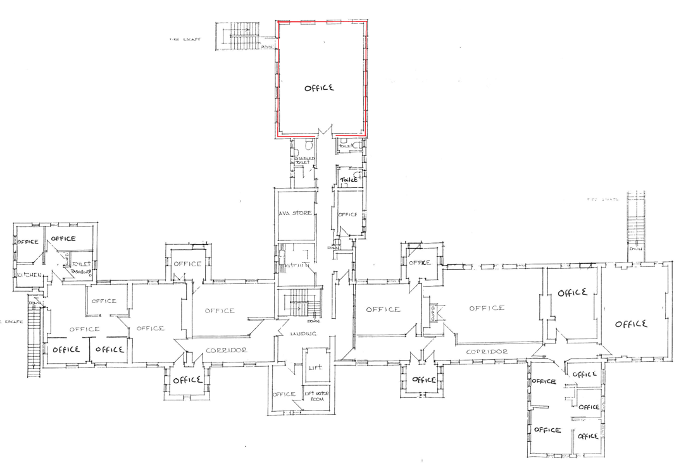
Existing/Proposed First floor plan

The subject building is of Grade II Listed status, but the site is not within a Conservation Area. It is also located within the grey zone of the adopted Trowbridge Westbury Bat Mitigation Strategy (TWBMS) relating to areas at medium risk for habitat loss and increased pressure from recreational impacts. The context of the site is shown in the location plan extract below:

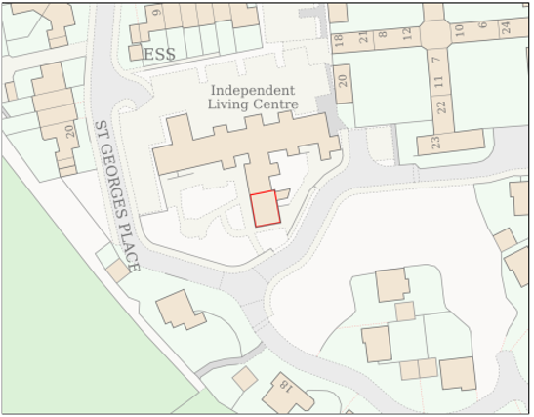
Location Plan

PROPOSAL
The proposal seeks planning permission for the change of use of a single first floor room within The Independent Living Centre building from Use Class E to Sui Generis – Tattoo Studio. No other use would take place within this room. No external alterations are proposed or necessary to facilitate the change of use.

RELEVANT PLANNING HISTORY
Proposal / Summary
W/99/01317/FUL External alterations including flue canopy and doors. Approved.
W/13/05704/LBC & W/13/05582 Proposed new entrance lobby. Approved.
W/16/06639/FUL Change of use of part of premises (first floor, east end) to chiropractic clinic (D1). Approved.
W/16/07164/LBC Internal alterations to facilitate the change of use. Approved.

RELEVANT POLICIES AND GUIDANCE
Wiltshire Core Strategy:

- Core Policy 1 Settlement Strategy;
- Core Policy 2 Delivery Strategy;
- Core Policy 3 Infrastructure Requirements;
- Core Policy 15 Spatial Strategy for the Melksham Community Area
- Core Policy 50: Biodiversity and Geodiversity
- Core Policy 51: Landscape
- Core Policy 57 Ensuring High Quality Design and Place Shaping
- Core Policy 58: Ensuring the Conservation of the Historic Environment
- Core Policy 61: Transport and New Development
- Core Policy 64: Demand Management
- Core Policy 67: Flood Risk

Wiltshire Design Guide: Appendix D – Design Guidance for Householder extensions

The National Planning Policy Framework (NPPF Revised on 17.08.2026)

The Planning Practice Guidance

National Design Guide

Semington ‘Made’ Neighbourhood Plan.

Emerging Wiltshire Local Plan:
At Full Council on 19 May 2026, the elected members of Wiltshire Council agreed to withdraw the emerging Wiltshire Local Plan. The said Plan has no material weight for the purposes of the application.

In accordance with Regulation 19 of the Town and Country Planning (Local Planning) (England) Regulations 2026, on 30th June 2026 Wiltshire Council published a notice of intention to prepare a new local plan for Wiltshire. The next stage is a Scoping Consultation which commences on 2nd September 2026. This plan is at a very early stage and currently carries no weight for decision making.

CONSULTATION RESPONSES
Semington Parish Council: No objections and commented:
‘At a meeting of Semington Parish Council held on 17.06.2026 this matter was discussed and it was resolved to have no objection to this application’.

Highways: No objections raised.

Environmental Public Protection: No response.

REPRESENTATIONS
One email of representation has been received with concerns/comments as below:
- St. Georges is a residential development that commands high council taxes.
- Proposed use is not suited to this location.
- Concerns about noise pollution.
- No parking provisions.

Representations from the Chief Executive of the Independent Living Centre offers comments in response to the objection received. The comments in support of the proposal are discussed below within the following report.

ASSESSMENT
Section 38(6) of the Planning and Compulsory Purchase Act 2004 states:

"If regard is to be had to the development plan for the purposes of any determination to be made under the planning Acts, the determination must be made in accordance with the plan unless material considerations indicate otherwise."

In accordance with this statutory requirement, this application has been assessed against the relevant policies of the Development Plan, including the adopted Wiltshire Core Strategy (2015).

PRINCIPLE OF THE PROPOSAL.

The proposal would see the change of use of an empty unused office room from Use Class E to that of a Sui Generis use of a tattoo studio.

Use Class E of the Use Class Order relates to the following: E(a) Shops: Retail sale or display of goods (except hot food). E(b) Food and Drink: Cafés and restaurants where food is eaten mostly on the premises. E(c) Financial and Professional Services: Banks, estate agents, or professional offices. E(d) Indoor Sport and Recreation: Gyms, fitness studios, and indoor recreation. E(e) Medical Services: Clinics, health centres, and dentists. E(f) Nurseries: Crèches, day nurseries, and day centres. E(g) Offices and Industry: Offices, research and development, and light industrial processes that fit in a residential area without causing noise or smell

The use of a room for tattooing purposes is generally considered to fall outside of the various commercial used in Class E and so is classed as being Sui Generis, meaning that it is in a class of its own.

The current use of the ILC building is commercial and whilst there have been previous permissions pertaining to the conversion of the building to residential units there is no residential occupation of the ILC building. At ground floor level the ILC charity offers service and retail-based facilities, including the provision of information and advice relating to persons with mobility needs, with support and help being on hand for people who may need assistance regarding wheelchairs, electric scooters and general day to day living. At first floor level there are numerous rooms which are used for offices, as shown above in the overall floor plan, from which various businesses and services operate, with the application site currently being unused. The proposed change of use would take place in a vacant office at the end of the corridor set away from the other offices, apart from the one as shown in the plan snippet below:

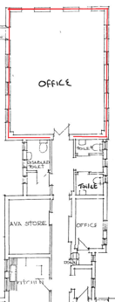
Plan extract

As shown, the proposed use would be separated by numerous toilet facilities, a storeroom and a small office. Due to such separation distances and being set well away from the other offices, it is appraised there would be minimal disturbance relating to these other offices within the first floor, if any at all, when considered in the context of the office/consulting room uses.

The application has received third party comments from one interest party, addressed within the below amenity section. The Chief Executive of the Independent Living Centre, which owns and operates from the building, has respond to these comments as detailed below:

“The Independent Living Centre which owns the building is a registered charity that has been supporting people with disabilities in this location for approximately 35 years. As part of our charitable model, office space is let within the building to a number of organisations, and this rental income helps to sustain our free service as a charity. The building therefore already accommodates a range of occupiers.

This application relates to a single person operating from one existing, currently unused office within the building. The proposed business will operate by appointment only, with one client at a time, and does not involve any alterations to the outside of the building. Consequently, it is expected to generate very little additional traffic or activity beyond the building's current use.

The centre also benefits from a large on-site car park with approximately 40 parking spaces, meaning parking is already available for visitors.

The objection refers to concerns about existing weekend activities and noise. The Independent Living Centre is closed at weekends, and most of the organisations based within the building also operate during weekdays only. Other than an annual garden party, which takes place on one Saturday each year, we are not aware of regular weekend activities taking place at the site. If there are concerns regarding specific instances of weekend noise, I would welcome details so that these can be investigated.”

The above statement sets out the context of the existing and proposed uses in support of the proposed change of use of the vacant office. The site’s planning history also indicates that in 2106 a change of use was approved for a chiropractic clinic to operate from one of the offices within the building. The context for the overall use of the building is that of a mixed use of primarily commercial services to members of the public, in which a number of organisations operate and provide a rental income for the ILC charity. The scope of the change of use of one office to a tattoo studio which would operate appointments during the existing opening hours is therefore considered limited and acceptable in principle in the context of the host building. There is no loss of commercial space as a result of the change to a sui generis use, the approved use would be fully reversible in the event of future occupancy changes.

Design and Impact upon the upon the character and context of the area

Core Policy 57 - Ensuring High Quality Design and Place Shaping of the Wiltshire Core Strategy seeks to ensure that all new development is of high design quality, reflecting local context, character, and distinctiveness.

The proposals can be viewed below within the snippets taken from the submitted plans above and in the photograph below:

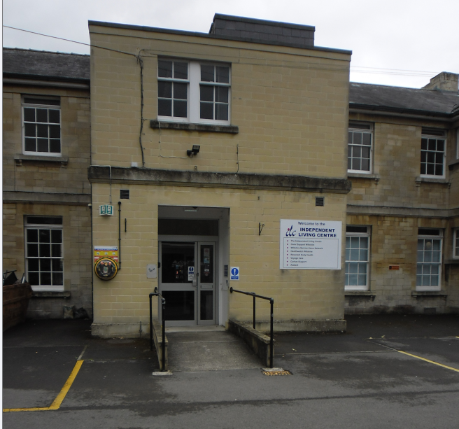
North facing front exterior of the Independent Living Centre

No building operations are proposed for the use. The exterior of the building and interior room layout would not change, with the new proposed use being contained within the single room, therefore apart from any interior signage and lettering on the existing external signage there would be no indication of the use from the exterior of the building.

Therefore, in summary, having regard to the above, the proposal complies with the design principles set out in Core Policy 57 of the Wiltshire Core Strategy and Appendix D of the Wiltshire Design Guide.

Amenity
Point vii of Core Policy 57 - Ensuring high-quality Design and Place Shaping of the Wiltshire Core Strategy seeks to ensure that developments do not adversely affect neighbouring properties.

At the national level, Policy DP3 of the National Planning Policy Framework requires development proposals to respond positively to their context and integrate with and enhance their surroundings. Development should also reflect, where relevant, the principles of liveability, climate resilience, nature, movement, built form, public space and local identity

The proposed use would be contained within the one room and would not be expected generate any significant noise or disturbance noises, as the tattooing processes are generally sufficiently quiet to be unobtrusive from the exterior of a building. The applicant has purposefully chosen this location to carry out his craft in quiet settings and surroundings and would be the sole practitioner and only person carrying out this use up to five days per week operating only during normal working hours of the day, from 10am to 5pm, No staff would be employed.

The proposed use or service would also be by appointment only, within a maximum of up to two clients visiting per day, although it is not necessary to condition the times of use or customers in the interests of allowing flexibility for the operator, which are in any event likely to be limited by the overall hours of operation of the building as a whole. The applicant would be the sole user of this room, with no other uses taking place.

Third party comments have been received in regard to concerns over noise and possible disturbance, being considered unsuitable for the location. The Chief Executive of the Independent Learning Centre responded to those comments and these are set out in full in the above section. The context for the proposal serve to allay concerns regarding the possibility of disturbance to residents since there is no residential use taking place within the Independent Living Centre. Whilst there is residential accommodation within the wider site, the noise from tattooing services is not considered to cause a level of noise and disturbance that would be audible at those properties and the operating hours are limited to daytime hours only. As a business which provide a service to one client at any one time, disturbances from customers visiting the premises would also not be cause for concern.

The proposal is not considered to be incompatible with the nearby neighbouring residential properties and therefore accords with Core Policy 57 point vii. in respect of safeguarding residential amenity and Appendix D of the Wiltshire Design Guide.

Highway Matters.
Core Policy 57 (xiv) of the Wiltshire Core Strategy seeks to ensure that development must meet the requirements of Core Policy 61. This policy requires proposals to be capable of being served by safe access to the highway network. Core Policy 64 seeks to ensure compliance with parking standards set out in the Local Transport Plan.

The National Planning Policy Framework (NPPF), particularly Paragraph 115 and 116, requires that development proposals do not have an unacceptable impact on highway safety and that safe and suitable access to the site can be achieved for all users.

The proposed development would continue to use the established site access which would not be altered and the re-use of the existing office space would not be considered to have any adverse impact on highway safety given the nature of the proposed use and limited number of visits from clients. It is stated that there are 40 parking spaces and it is considered that there is adequate off road car parking and turning provision is provided within the site.

The access arrangements are acceptable, given that the applicant would likely only see a maximum two clients at separate times staggered throughout the day. The number of people visiting the site would be minimal and would not be materially different to other visitors to the site. The Council’s highways officer has been consulted who has not raised any objections.

The proposal is therefore considered to comply with Core Policies 57 (xiv), 61 and 64 of the Wiltshire Core Strategy, the NPPF, and the Wiltshire Local Transport Plan.

Heritage Impact
From the point of view of the historic environment the main statutory tests are set out within the Planning (Listed Building and Conservation Areas) Act 1990. Section 66 requires that special regard be given to the desirability of preserving listed buildings, their settings or any features of special architectural or historic interest which they possess.

Section 20 of the newly revised NPPF deals with the Conservation and Enhancement of the Historic Environment.

The Council’s Core Strategy Policy CP58 ‘Ensuring the conservation of the historic environment’ requires that designated and non-designated heritage assets and their settings will be conserved, and where appropriate enhanced, in a manner appropriate to their significance and encourages proposals which improve the condition of heritage assets at risk.

The significance of the Grade II listed building is considered to lie in its historic past and architectural merits as a building of scale and use of lime ashlar stone.

Section HE6 of the NPPF relates to proposals potentially affecting designated heritage assets, in this instance the proposed use would only take place in the one room within the Grade II listed building and would not involve any works to alter the building apart from the installation of a small sink area to provide running water. Due to the location of the office space being closely related to existing bathroom facilities, running water provision is close by and as such water connections would be unlikely to require any significant alteration to the fabric of the building. The installation of a sink is appraised as being de minimis by the Conservation Officer, who has not raised any objections and has confirmed the neutral impact of the proposal on the significance and character of the listed building, commenting as follows

“I have just read the statement - it confirms that just a sink is needed, to be connected to existing water supply. There are toilets adjacent to the room/office proposed for the studio, so this confirms the supply is close to where it is needed, so that is quite an easy installation for them.

I am satisfied with that - happy for you to take this email as confirmation, to negate the need for another consultation for something minor”.

Consequently, the significance of the listed building would not be harmed and the principles and aims of CP58 would be maintained. An informative can be included with regards to the scope of any internal alterations which may affect the listed building for the avoidance of doubt.

Ecology Impact
CP50 requires no net loss of biodiversity on site. The site is located within the grey hatched zone of the Trowbridge Westbury Bat Mitigation Strategy Area. The proposed change of use of the one room would not result in any operational development or use which would be harmful to bats or their habitat as no works would take place other than the installation of a sink. Accordingly, risk to bats can be rule out having regard to the Habitats Regulations and there is no mechanism for adverse impact with regards residential impacts. The proposal is acceptable in this regard, and the proposed change of use complies with Core Policy 50 of the Wiltshire Core Strategy and the relevant provisions of the NPPF.

Biodiversity Net Gain.
This application is exempt from the requirement to deliver Biodiversity Net Gain under Schedule 7A, Section 4(2)(a) of the Town and Country Planning Act 1990, as inserted by the Environment Act 2021, because the proposal is a de minimis proposal.

CONCLUSION
The proposed use is compatible with the various existing uses within the Independent Living Centre and does not require any alteration to the building’s design and scale. It is also considered compatible with regard to its relationship with the surrounding area. The proposed change of use would not result in any demonstrable or unacceptable harm to the character of the locality, the amenities of neighbours, or the interests of highway safety, heritage, or ecology. The Parish Council, Highways Officer and Conservation Officer are in support/have not raised any objections. The third parties’ concern have been fully assessed and would not sustain reasons for refusal on amenity or highway grounds. The principle of the proposed change of use is acceptable on the basis of the above considerations, with such past changes of use, as that of a chiropractor being acceptable, reinforcing such acceptability.

The proposal is therefore considered to comply with the relevant policies of the Wiltshire Core Strategy, the Wiltshire Local Plan, and the National Planning Policy Framework. As such, the application is recommended for approval, subject to the conditions set out below.

RECOMMENDATION: Planning Permission be GRANTED subject to conditions.

