APPLICATION FOR HOUSEHOLDER PLANNING PERMISSION
DELEGATED REPORT

APPLICATION REFERENCE: | PL/2026/03867
APPLICATION TYPE: | Householder planning permission
SITE ADDRESS: | 23 Wynsome Street, Southwick, Trowbridge, BA14 9RG
DEVELOPMENT DESCRIPTION: | Proposed demolition of existing rear extensions and erecting single storey rear extension. Along with erection of proposed detached double garage to rear of property.
RECOMMENDATION: | That Planning Permission be GRANTED

PROPOSAL

The proposal seeks planning permission for removal of an existing extension on the rear elevation of the host dwelling, erection of a replacement extension, and erection of a detached double garage within the existing driveway area to the rear elevation of the host dwelling.

SITE DESCRIPTION/CONTEXT

This application relates to a semi-detached dwelling, 23 Wynsome Street, located within an established residential area in Southwick near Trowbridge. The host dwelling benefits from an offroad parking area to the rear of the host dwelling, accessed off a private road, serving the host dwelling and some neighbouring occupiers.

The application site sits within the yellow hatched zone of the Trowbridge and Westbury Bat Mitigation Strategy (TWBMS). A public right of way runs along the private road to the north of the application site.

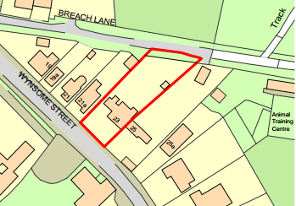

PLANNING HISTORY
Proposal / Summary
W/90/01597/FUL - Full planning permission Decision - Approve with Conditions Date: 18/12/1990 – Rear single storey kitchen extension
W/90/01026/FUL - Full planning permission Decision - Approve with Conditions Date: 28/8/1990 – Rear single storey kitchen extension
PL/2024/04887 - Householder planning permission Decision - Approve with Conditions Date: 11/9/2024 – Proposed rear extension and two storey side extension. Double and single detached garages to the rear of property.

RELEVANT POLICIES AND GUIDANCE

Wiltshire Core Strategy:
CP2 Delivery Strategy
CP29 Spatial Strategy for the Trowbridge Community Area
CP50 Biodiversity and Geodiversity
CP57 Ensuring High Quality Design and Place Shaping
CP58 Ensuring the Conservation of the Historic Environment
CP60 Sustainable Transport
CP61 Transport and Development
CP64 Demand Management

New Wiltshire Local Plan
At Full Council on 19 May 2026, the elected members of Wiltshire Council agreed to withdraw the emerging Wiltshire Local Plan. The said Plan has no material weight for the purposes of the application.

In accordance with Regulation 19 of the Town and Country Planning (Local Planning) (England) Regulations 2026, on 30th June 2026 Wiltshire Council published a notice of intention to prepare a new local plan for Wiltshire. The next stage is a Scoping Consultation which commences on 2nd September 2026. This plan is at a very early stage and currently carries no weight for decision making.

Southwick Neighbourhood Development Plan 2018-2036 Made October 2021

Wiltshire Local Transport Plan 2011 – 2026: Car Parking Strategy (March 2015)

Wiltshire Design Guide: Appendix D – Design Guidance for Householder extensions

The National Planning Policy Framework (NPPF)

The Planning Practice Guidance

National Design Guide

Trowbridge and Westbury Bat Mitigation Strategy (TWBMS).

CONSULTATION RESPONSES
Southwick Parish Council - No comment
Wiltshire Council Public Right of Way team - Comment
Wiltshire Council Highways - No objection

REPRESENTATIONS
No comments were received.

ASSESSMENT
Section 38(6) of the Planning and Compulsory Purchase Act 2004 states:

"If regard is to be had to the development plan for the purposes of any determination to be made under the planning Acts, the determination must be made in accordance with the plan unless material considerations indicate otherwise."

In accordance with this statutory requirement, this application has been assessed against the relevant policies of the Development Plan, including the adopted Wiltshire Core Strategy (2015) and, where applicable, any made Neighbourhood Plans.

Design and Impact upon the upon the character and context of the area
Core Policy 57 - Ensuring High Quality Design and Place Shaping of the Wiltshire Core Strategy seeks to ensure that all new development is of high design quality, reflecting local context, character, and distinctiveness.

The rear extension would be positioned on the north elevation, extending over the footprint of the existing L shaped plan of the existing single storey extensions, which would be removed to facilitate the build. The extension would sit at a similar height to the existing extensions and would employ a flat roof form with a glass roof lantern inserted to illuminate the internal space, a window and patio doors would be inserted on the rear elevation.

The extension would span a width of 8.6m in across the rear elevation of the host dwelling and project a depth of 4.6m, sitting at a height of 3.5m. The extension would consist of red brick elevations (to match the existing built form of the host dwelling) a single ply membrane roof, with matching white uPVC fenestration.

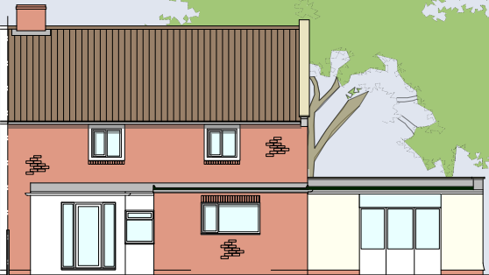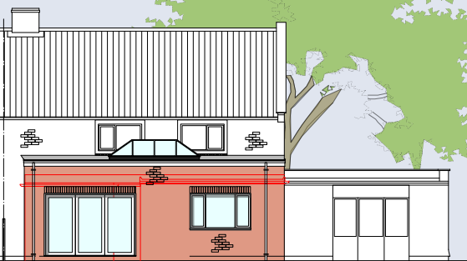
Existing (left) and proposed (right) rear elevation

Within the existing driveway area to the north of the host dwelling a detached garage would be erected that would employ a pitched roof form sitting at a maximum height of 5.7m. The garage would extend over a footprint of 42m2, with a pedestrian door inserted on the south side elevation and two garage doors inserted on the front east elevation. The garage would consist of red brick elevations with concrete profile roof tiles.
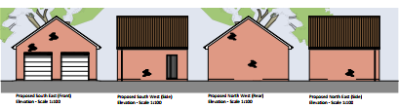
Proposed elevations of the garage building

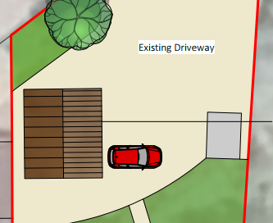
Proposed location of the garage building

It is acknowledged that the application site is subject to an extant planning permission (PL/2024/04887) for a rear extension and two storey side extension, with a double garage and single detached garage to the rear of property. This development was assessed against planning policy and deemed acceptable. The applicant has confirmed that they do not intend to implement the 2024 permission however officers are cognisant that a future occupier may wish to implement both the extant permission and the scheme being proposed here, therefore an appraisal of a potential combined development of the two schemes needs to be undertaken.
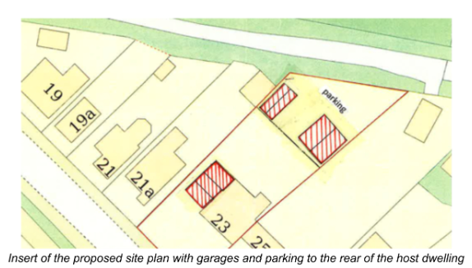
Map insert of the site plan approved under extant application PL/2024/04887

The erection of the two-storey side extension approved under the 2024 permission, together with the single-storey extension proposed as part of the current application, would not give rise to concerns regarding overdevelopment of the site. The extensions would maintain an adequate degree of separation and the application site benefits from a generous private residential curtilage to the side and rear. Furthermore, there is an absence of any previous large-scale development within the site.

Accordingly, the development is considered proportionate and commensurate with the size of both the dwelling and its plot. The proposed architectural detailing and external materials are also considered acceptable and would accord with the design principles set out in Core Policy 57 of the Wiltshire Core Strategy and Appendix D of the Wiltshire Design Guide.

It is acknowledged that the larger of the two garage buildings approved under the 2024 permission could be constructed, and that the garage building proposed under the current application could subsequently be erected in place of the smaller garage building previously approved.

Officers are mindful that, in such a scenario, vehicular access to the larger garage may become constrained, with manoeuvring and turning movements within the site proving more difficult. However, this is considered to be a matter for the applicant rather than one that would result in demonstrable planning harm.

Overall, whether both schemes are implemented in full, or elements of each are carried forward, it is considered that the resulting development would not constitute overdevelopment of the site nor would it cause harm to the character and appearance of the area sufficient to warrant a recommendation for refusal.

The use of matching materials would ensure the proposal would integrate into the surrounding setting and existing street scene, and it is considered that the extensions would by virtue of their height, scale and design constitute complementary additions to the host dwelling that would appear commensurate to the size of the property and plot.

Having regard to the above, the proposal complies with the design principles set out in Core Policy 57 of the Wiltshire Core Strategy and Appendix D of the Wiltshire Design Guide.

Amenity
Point vii of Core Policy 57 - Ensuring High Quality Design and Place Shaping of the Wiltshire Core Strategy seeks to ensure that developments do not adversely affect neighbouring properties.

The National Planning Policy Framework (NPPF), particularly Paragraph 135(f), stresses that planning decisions should ensure developments provide a high standard of amenity for existing and future users.

The proposed development has been assessed in terms of its potential impact on the residential amenity of neighbouring properties, with particular regard to loss of light, overshadowing, loss of privacy, and overbearing effects.

All windows proposed on the rear extension would overlook the applicant’s private residential rear curtilage, replicating the existing fenestration arrangement, therefore no overlooking concerns are raised.

The extension would be erected over the footprint of existing built form and would be limited in height due to the single storey nature of the build. Therefore, officers raise no concerns in regard to any adverse overbearing, overshadowing impacts or loss of light to the attached neighbour at No.25 Wynsome Street.

The garage would be erected within the existing driveway area to the rear of the host dwelling immediately adjacent to an existing garage building on the common shared boundary with the adjacent dwelling at No.21 Wynsome Street. The proposal does not give rise to any adverse neighbouring amenity impacts given the nature of the build, a single storey domestic garage building, and separation distance to neighbouring properties.

The proposal therefore accords with Core Policy 57 point vii in respect of safeguarding residential amenity and Appendix D of the Wiltshire Design Guide.

Highways Impact
Core Policy 57 (xiv) of the Wiltshire Core Strategy seeks to ensure that development must meet the requirements of Core Policy 61. This policy requires proposals to be capable of being served by safe access to the highway network.

The National Planning Policy Framework (NPPF), particularly Paragraph 115 and 116, requires that development proposals do not have an unacceptable impact on highway safety and that safe and suitable access to the site can be achieved for all users.

Impact on parking provision – Core Policy 64 (Demand Management) seeks to manage the demand for vehicle parking and confirms that residential parking standards are to be based on minimum parking standards.
In order to comply with the Wiltshire Local Transport Plan 2011 – 2026: Car Parking Strategy (March 2015) two on site car parking spaces would be required for a 3- bed dwelling (standard min. size 2.4m x 4.8m) and for a 4+ dwelling, three off road parking spaces. The proposal would not introduce any additional bedrooms therefore the existing off site car parking criteria would remain, and the driveway is considered to adequately provide sufficient off-road parking for several cars.
The proposal would introduce a detached garage within the existing private driveway area to the rear of the host dwelling, the existing access arrangements would remain, and the site would continue to be accessed via the private right of way to the north of the properties lining this section of Wynsome Street.

The Council’s Highway officer was consulted on the scheme and offered the following comments.
“I refer to the above planning application for the demolition of the existing rear extensions and the erection of a single storey rear extension. Along with erection of proposed detached double garage to rear of property. The site is accessed via Bridleway SWCK59 and as such I understand that the Rights of Way Team have also been consulted.
It is considered that the proposal is not detrimental to highway safety and I therefore raise no highway objection”

The proposed development would not result in any adverse impact on highway safety. Adequate parking and turning provision is provided in accordance with Wiltshire’s adopted parking standards, and access arrangements are acceptable. The proposal is therefore considered to comply with Core Policies 57 (xiv), 61 and 64 of the Wiltshire Core Strategy, the NPPF, and the Wiltshire Local Transport Plan.

Heritage Impact
From the point of view of the historic environment the main statutory tests are set out within the Planning (Listed Building and Conservation Areas) Act 1990.

Section 66 requires that special regard be given to the desirability of preserving listed buildings, their settings or any features of special architectural or historic interest which they possess.

The Council’s Core Strategy Policy CP58 ‘Ensuring the conservation of the historic environment’ requires that designated and non-designated heritage assets and their settings will be conserved, and where appropriate enhanced, in a manner appropriate to their significance and encourages proposals which improve the condition of heritage assets at risk.

The Council’s Core Strategy CP 57: Ensuring high quality design requires a high quality of design in all new developments. The policy requires applicants to “demonstrate how the proposal will make a positive contribution to the character of Wiltshire through (amongst other things) responding to the value of the natural and historic environment and being sympathetic to and conserving historic buildings and landscapes. Development is required to respond positively to the existing in terms of building layouts, built form, height, mass, scale, building line, plot size, elevational design, materials, streetscape and rooflines to effectively integrate the building into its setting.

The NPPF outlines government policy for planning. Chapter 16 of the NPPF 'Conserving and enhancing the historic environment' sets out the Government's high-level policies concerning heritage and sustainable development.

The host dwelling is located off one of the main routes through Southwick and to the south of the property lies the Grade II listed Southwick Baptist Church with the Grade II listed railings, gates, and gate piers fronting the public highway, as illustrated by the black hatching in the map insert below. Therefore, due consideration has to be given on how any proposed development would affect the setting of these heritage assets.

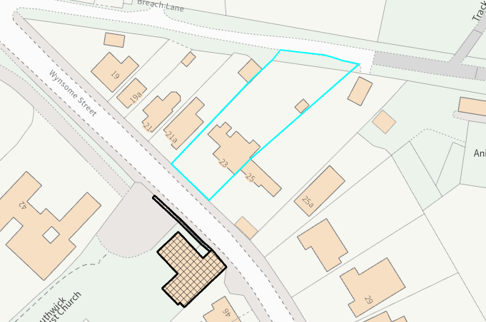

The extension and garage building proposed would be positioned to the rear of the host dwelling, set back from the public highway, set within the confines of the application site and would be obscured from view from the public realm.

It is observed that the works would utilise materials typical to the development type, and the height and scale of the development is considered to be commensurate to the size of the application site and would therefore not adversely impact the setting of the listed buildings nearby.

It is considered that given the separation distances to the adjacent listed buildings and the limited development on site, proposed within the built envelope of the application site, any harm to the setting of the listed buildings would be nominal. The proposal, by virtue of its scale, design, and use of materials, is considered to preserve the setting of the listed building and it would not result in harm to the significance of any heritage assets.

The development is therefore considered to comply with Core Policy 58 of the Wiltshire Core Strategy and Section 66 of the Planning (Listed Buildings and Conservation Areas) Act 1990, as well as the relevant provisions of the NPPF.

Ecology Impact
Core Policy 50 of the Wiltshire Core Strategy seeks to protect and enhance biodiversity and geodiversity, including through ensuring that development avoids harm to protected species and habitats.

The National Planning Policy Framework (NPPF), in Paragraphs 193, requires that development minimises impacts on and provides net gains for biodiversity, including ensuring mitigation is secured where harm cannot be avoided.

The site lies within the Trowbridge and Westbury Bat Mitigation Strategy Yellow Zone. The Council’s Ecology team were consulted on the proposal and raised no objections stating

“The small section of the site within the yellow zone comprises hardstanding with a small ornamental hedgerow at the boundary. However, no alteration to the hedgerow is proposed, and the garage will be erected on an area of existing artificial surfacing. The house extension will also largely fall on an area of existing hardstanding, with some potential minor encroachment onto amenity grassland. The site and surrounding areas are already subject to disturbance from human activities, and the proposals do not represent a significant increase in human disturbance in this area. As such, the principles of the TWBMS are not considered further and the application is screened out of Appropriate Assessment with respect to the Bath and Bradford-on-Avon Bat SAC. The HRA has concluded that the application is not likely to have significant impacts on the SAC and Appropriate Assessment is not required”

As a precautionary measure an informative would be added to any decision that in event any evidence of bat activity is detected that the applicant should follow the advice of a professional ecologist or contact Natural England.

As such, the development complies with Core Policy 50 of the Wiltshire Core Strategy and the relevant provisions of the NPPF.

Impact on the Public Right of Way
A Public Right of Way (SWCK59). runs along the private road to the north of the application site and the existing parking area is accessed via this path. The proposal seeks to retain this
arrangement with the erection of the garage within the existing parking area.

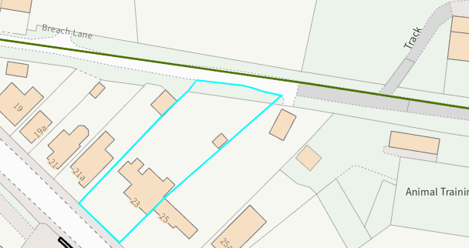
Map insert illustrating location of the PROW to the rear of the dwellings

The Council’s Public Rights of Way officer was consulted on the proposal and offered the following comments

“The site is accessed via a bridleway (SWCK59) over which there is no recorded public vehicular right of way.

As this is an existing property and access, I am making an assumption that the applicant has a private vehicular right of access. The bridleway is a highway maintainable at public expense. It should be noted that it is the responsibility of the Highway Authority to maintain the surface of the path only to a standard suitable for bridleway users and not for motorised vehicles.

The applicant will be responsible for the repair of any damage caused to the bridleway during construction. I have no objection subject to informatives"

The agent has submitted a solicitor’s letter confirming that the vehicular use of the bridleway has been ongoing for a period of approximately 40 years, demonstrating long term use consistent with a claim for prescriptive rights.

In order to access the site with a mechanically propelled vehicle (MPV), the applicants will require a private right of vehicular access. Without this private right they would be committing an offence under Section 34 of the Road Traffic Act 1988. The granting of planning permission does not give the applicant or householder a vehicular right of access over the bridleway. Therefore, the applicant is advised to take legal advice to ensure they have a right of access.

Informatives would be added to make the applicant aware that it is a criminal offence to obstruct a public right of way under section 137 of the Highways Act 1980 and that any damage caused to public right of way SWCK59 as a result of construction or demolition activities must be fully repaired by the applicant and reinstated to the satisfaction of the Highway Authority.

The development proposed would only serve the existing household and therefore no additional vehicle movements are anticipated. Therefore, no objections are raised in relation to any adverse impacts to the enjoyment of the users of the public right of way.

Biodiversity Net Gain
Householder planning applications are exempt from the requirement to deliver Biodiversity Net Gain under Schedule 7A, Section 4(2)(a) of the Town and Country Planning Act 1990, as inserted by the Environment Act 2021.

CONCLUSION
The proposed development is considered to be acceptable in terms of its design, scale, and relationship with the surrounding area. It would not result in any unacceptable harm to the character of the locality, the amenities of neighbouring occupiers, or the interests of highway safety, heritage, or ecology.

The proposal is therefore considered to comply with the relevant policies of the Wiltshire Core Strategy, the Wiltshire Local Plan, and the National Planning Policy Framework. As such, the application is recommended for approval, subject to the conditions set out below.

RECOMMENDATION: That Planning Permission be GRANTED subject to conditions.

