Public Protection objects to this application on the grounds that there is a significant adverse impact on amenity due to odour from nearby waste management operations, particularly the Lower Compton Landfill.
The application seeks outline permission for up to 210 residential dwellings, together with employment land and associated infrastructure. The proposed residential element constitutes highly sensitive receptors and must be demonstrated to be capable of achieving an acceptable level of residential amenity throughout the lifetime of the development.
The applicant's odour assessment acknowledges that the site lies in close proximity to a number of waste management facilities including the Lower Compton Landfill, which is identified as a "large" odour source and located approximately 1,080m from the proposed residential development. The assessment also confirms that significant numbers of odour complaints have been received in 2025 and that some complaints have been substantiated by the Environment Agency as originating from the landfill.
Of particular concern is the acknowledgement within the applicant's assessment that over 1,000 odour complaint events were recorded by the Environment Agency during 2025, many attributed to the landfill, together with multiple complaints received by Wiltshire Council. The report further states that the operator has implemented remedial measures, but complaints have continued to be received.
Public Protection does not agree that the current situation can simply be disregarded on the basis that permitting controls are expected to operate effectively. Whilst paragraph 201 of the NPPF requires planning authorities to avoid duplicating pollution control regimes, it does not remove the requirement under paragraph 200 and Core Policy 57 to ensure that new residential development can achieve an acceptable standard of amenity and is compatible with surrounding land uses.
The applicant's assessment relies heavily upon the assumption that the current odour issues are temporary and that future conditions will revert to historic levels once remediation works are completed. However, Public Protection is currently investigating complaints relating to odour in the area and there are ongoing concerns regarding potential statutory nuisance. The EA are investigating alleged breaches of environmental permit conditions associated with landfill operations. These matters demonstrate that odour impacts are not merely theoretical but are being experienced by residents across the wider area. It is important to note that compliance with an Environmental Permit does not necessarily preclude a significant adverse effect on residential amenity, nor does it rule out the potential for a statutory nuisance. The thresholds and assessment criteria for these matters are different. In particular, the threshold for a significant adverse impact on residential amenity is generally lower than that applied when determining compliance with an Environmental Permit or the existence of a statutory nuisance. Consequently, an activity may comply with its permit requirements whilst still giving rise to unacceptable amenity impacts for nearby residents.
Public Protection has undertaken approximately 80 out-of-hours site visits and investigations in response to complaints. During these visits officers have repeatedly detected and verified landfill-type odours affecting the local area. This represents direct observational evidence of odour impact which raises significant concerns regarding the suitability of introducing a substantial number of additional sensitive receptors into the vicinity.
The applicant's assessment correctly identifies the proposed residential use as being a receptor of high sensitivity to odour. The proposed development would therefore place a significant number of new residents within an area that is currently experiencing ongoing odour problems and where regulatory investigations remain active.
Furthermore, the site context is clearly illustrated within the applicant's assessment, showing the proposed development and its relationship to the landfill and associated waste management facilities.
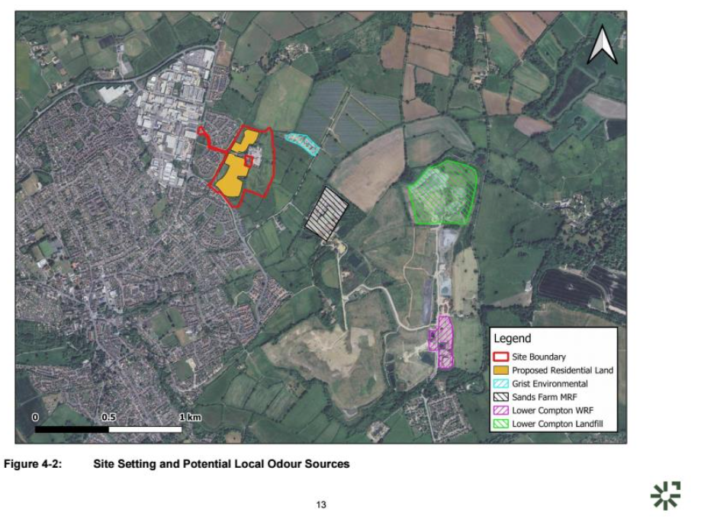
On top of this the UKHSA have released a public health risk assessment of the Environment Agency (EA) Study of Ambient Air Quality at Lower Compton from 15 October 2025 to 16 April 2026, published in June 2026 version AAM/TR/2026/05.
The UKHSA report was commissioned following increased community concerns regarding odour from the landfill and explicitly acknowledges that the monitoring location may not represent the highest levels experienced in the area, noting that concentrations experienced closer to the source may be higher
The findings of the UK Health Security Agency (UKHSA) Public Health Risk Assessment published on 6 July 2026 demonstrate that odour impacts arising from the landfill remain a current and evidenced concern for the local community.
As well as this the report found:
- Hydrogen sulphide concentrations exceeded the World Health Organisation odour annoyance guideline on 106 separate occasions during the monitoring period.
- Concentrations exceeded the WHO odour annoyance threshold for 1.3% of the total monitoring period, increasing to 4.9% during March 2026 and 3.1% during April 2026.
- Monitoring demonstrated intermittent exceedances throughout December 2025, January 2026, February 2026, March 2026 and April 2026.
- Directional analysis concluded that the highest concentrations of hydrogen sulphide originated from the direction of Lower Compton Landfill
Importantly, whilst UKHSA concluded that toxicological health standards had not been exceeded, it specifically warned that where hydrogen sulphide concentrations exceed the WHO odour annoyance guideline there is potential for significant community impact. The report states:
"Odours can become a nuisance and start to affect people, causing temporary symptoms including headache, nausea, dizziness, watery eyes, stuffy nose, irritated throat, cough, particularly if a person has a pre-existing respiratory condition, sleep problems and stress."
The report further states:
- The more exposure time spent above the guideline, the greater the likelihood of symptoms being experienced and impacting on people's health and wellbeing
- UKHSA additionally recognises that individuals with asthma, COPD and other respiratory conditions may experience increased frequency and severity of symptoms as a result of odour exposure.
The data indicates that the mobile monitoring facility location was affected by both intermittent and relatively continuous sources of H₂S from Lower Compton landfill site.
Taken together, the UKHSA findings, the ongoing regulatory investigations, the significant complaint history, and Public Protection's own observations demonstrate that odour impacts are not historical or merely theoretical. They are current, measurable, attributable to the landfill, and are already affecting the health, wellbeing and amenity of existing residents.
In the opinion of Public Protection, the submitted odour assessment does not adequately reflect the current odour climate experienced by residents in Calne and places undue reliance upon assumptions regarding future operational performance of the landfill. The assessment therefore fails to provide sufficient confidence that future occupiers would not be exposed to recurring odour events and consequent loss of amenity.
Accordingly, Public Protection considers that the application conflicts with:
- Wiltshire Core Policy 57, which requires development to secure appropriate levels of amenity for future occupants.
- Wiltshire Core Policy 55, which seeks to protect public health, environmental quality and amenity.
- Paragraph 200 of the NPPF, which requires planning decisions to ensure that new development is integrated effectively with existing uses and does not result in unacceptable impacts upon future occupants.
For these reasons Public Protection objects to the application and considers the site unsuitable for residential development until it can be robustly demonstrated, using evidence representative of current conditions, that future occupiers will not be subject to unacceptable odour impacts arising from nearby waste management operations, including the Lower Compton Landfill for the lifetime of the development.
It is acknowledged that comments on the odour assessment were provided by Peter Nobes in February 2026, and our current position differs from those earlier comments. However, the circumstances and evidence base have developed significantly over the intervening six months. Since that time, further information has become available, including findings from odour monitoring visits undertaken by Environmental Protection and the UKHSA Public Health Assessment. These are material considerations that must be taken into account as part of the current planning consultation.
It would be inappropriate to disregard this additional evidence when responding to the application. The National Planning Policy Framework makes clear that the planning system should contribute to the achievement of sustainable development, including the creation of healthy and safe places, and should ensure that development is appropriate for its location having regard to the effects of pollution on health, living conditions and the natural environment. The planning process is intended to balance the economic, social and environmental objectives of sustainable development and to ensure that decisions are based on all relevant and up-to-date evidence available at the time they are made.
In this case, the additional monitoring evidence and the conclusions of the UKHSA assessment provide important information regarding the potential effects of odour on the amenity and wellbeing of existing and future occupants. It is therefore necessary and appropriate that this evidence informs our consultation response and is given due weight in the determination of the application.

