APPLICATION FOR LISTED BUILDING CONSENT
OFFICER DELGATED REPORT

APPLICATION REFERENCE: | PL/2026/04221
APPLICATION TYPE: | Listed building consent (Alt/Ext)
SITE ADDRESS: | Crossways, The Headlands, Downton, Salisbury, SP5 3HP
DEVELOPMENT DESCRIPTION: | Re-location of kitchen and associated works
RECOMMENDATION: | Approve with Conditions

SITE DESCRIPTION/CONTEXT

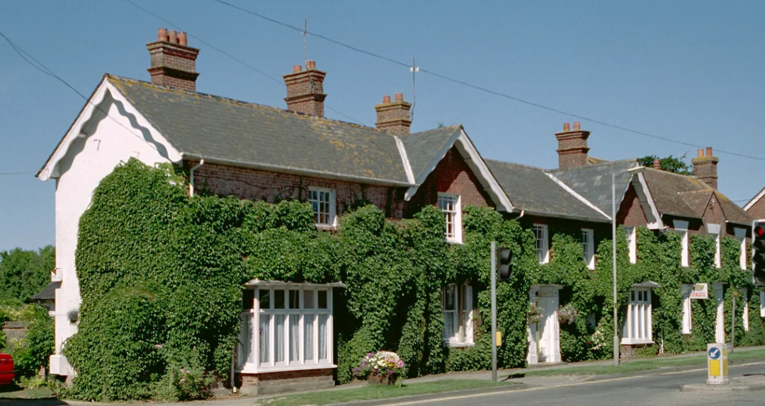

Crossways is listed at grade II together with Headland House. The list entry, for means of identification purposes only, provides the following description:

Semi-detached house. Mid-C19. Flemish bond brick, Welsh slate roof with brick stacks. L-plan, 2-storey, 5-window front. 4-panelled door in panelled case with cornice to right of centre, to right is 9-pane sash with margin panes and square bay window, to left is tripartite sash and square bay window. First floor has four 9-pane sashes with margin panes and flat arches, and one 2-light casement to left. Brick pilasters with simple capitals to left and right. Two gables have wavy barge-boards, brick stacks with moulded capping and decorated pots. Left return has same barge-boards and no windows. Rear has wrought-iron glazed verandah to ground floor, tripartite sashes and sashes with margin panes, attached to right is single-storey extension with barge-boards, attached to left is 2-storey wing with margin-pane sashes. Interior not inspected.

The site is in the Downton conservation area.

PROPOSAL
The applicant’s proposal is to relocate the kitchen into the existing living room.

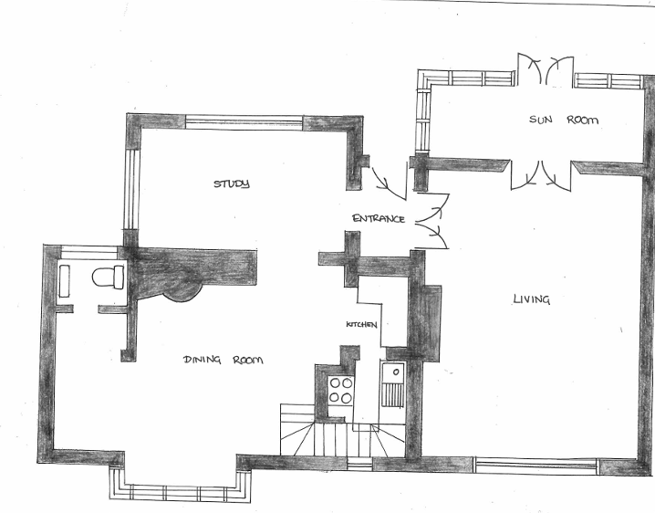
New kitchen units and pipework to be relocated to this space.

Kitchen units removed from current kitchen and space converted to a study

RELEVANT PLANNING HISTORY

Proposal / Summary
19/00514/ENF - Unauthorised signage/advertising (listed building) - Crossways The Headlands Downton Salisbury Wiltshire SP5 3HP –
2009/9622 - Tree felled which is subject of TPO - CROSSWAYS, THE HEADLANDS, DOWNTON, SP5 3HP –
20/01777/FUL - Full planning permission Decision - Approve with Conditions Date: 27/4/2020 – Proposed alterations, extensions and additions to bungalow
ENQ/2023/01079 - Pre-Application enquiry Decision - Pre-App Response Date: 20/9/2023 – House is Grade II Listed and currently has a pair of bathrooms, adjacent and separated by a modern stud wall (see red outlined rooms on floor plan). Proposed to remove the modern wall only and combine the bathrooms with a new layout (see proposed new flo
PL/2022/01137 - Full planning permission Decision - Refuse Date: 5/4/2022 – TWO STOREY FOUR BEDROOM HOUSE WITH DOUBLE GARAGE
PL/2022/05522 - Householder planning permission Decision - Approve with Conditions Date: 21/10/2022 – Installation of a timber summer house, for occasional home office use onto a dry base foundation
PL/2024/03321 - Listed building consent (Alt/Ext) Decision - Approve with Conditions Date: 11/10/2024 – Internal renovation and alterations to merge together two existing adjacent bathrooms which are separated by a modern stud wall and fit new bathroom furniture.
PL/2026/03458 - Listed building consent (Alt/Ext) Decision - Withdrawn by Applicant Date: 7/7/2026 – 'Internal alterations and refurbishment including installation of a kitchen within the lounge, formation of a utility room, new flooring throughout the ground floor, and reconfiguration/repairs to the upstairs bathroom. External works including roof and c
PL/2026/04221 - Listed building consent (Alt/Ext) – Re-location of kitchen and associated works
S/1986/1225 - Full planning permission Decision - Approve with Conditions Date: 17/9/1986 – CHANGE OF USE FROM HOTEL TO 2NO. DWELLINGS
S/1986/1226 - Listed building consent Decision - Approve with Conditions Date: 17/9/1986 – L/B APPLICATION - CHANGE OF USE OF HOTEL TO 2NO. DWELLINGS
S/1989/0462 - Full planning permission Decision - Refused Date: 10/5/1989 – EXTERNAL FIRE ESCAPE STAIRCASE AT REAR
S/1989/0588 - Listed building consent Decision - Refused Date: 10/5/1989 – L/B APPLICATION - EXTERNAL FIRE ESCAPE STAIRCASE AT REAR
S/1989/1955 - Full planning permission Decision - Approve with Conditions Date: 3/1/1990 – ERECT EXTERNAL FIRE ESCAPE STAIRCASE AT REAR
S/1989/1956 - Listed building consent Decision - Approve with Conditions Date: 3/1/1990 – L/B APPLICATION - TO ERECT AN EXTERNAL FIRE ESCAPE STAIRCASE AT REAR OF HOUSE AND CONVERT WINDOW INTO DOOR
S/1994/0833 - Listed building consent Decision - Approve with Conditions Date: 2/8/1994 – L/B APPLICATION - REPLACEMENT OF BAY WINDOW WITH NEW THE SAME EXCEPT FOR THE USE OF DOUBLE INSTEAD OF SINGLE GLAZING
S/1994/1800 - Full planning permission Decision - Approve with Conditions Date: 19/1/1995 – ERECTION OF HOUSE AND GARAGE
S/1999/1316 - Full planning permission Decision - Approve with Conditions Date: 30/9/1999 – SINGLE STOREY EXTENSION
S/2001/1576 - Work to Trees in a Cons Area Decision - Approved Date: 27/9/2001 – FELL EUCALIPTUS AND CUPPRESSUS TREES
S/2001/2273 - Work to Trees in a Cons Area Decision - Approved Date: 28/1/2002 – FELL ONE EUCALIPTUS TREE
S/2002/1635 - Full planning permission Decision - Approve with Conditions Date: 8/10/2002 – DETACHED 2 CAR GARAGE (RETROSPECTIVE)
S/2004/2047 - Full planning permission Decision - Approve with Conditions Date: 16/11/2004 – TWO STOREY SIDE ADDITION
S/2005/0626 - Full planning permission Decision - Approve with Conditions Date: 18/5/2005 – TWO STOREY EXTENSION TO REAR
S/2007/1649 - Work to TPO Trees Decision - Approve with Conditions Date: 3/10/2007 – Crown lift Cupressus macrocarpa to 6.75 m above ground level
S/2008/0482 - Listed building consent Decision - Approve with Conditions Date: 2/5/2008 – PROPOSED INSTALLATION OF TWO X 1.3SQM SOLAR THERMAL COLLECTORS TO BE LOCATED ONTO THE REAR SOUTHERLY INCLINED ROOF SURFACE AND TWO 1.3SQM SOLAR THERMAL COLLECTORS TO BE LOCATED ONTO THE REAR WESTERLY INCLINED ROOF SURFACE
S/2008/1597 - Listed building consent Decision - Approve with Conditions Date: 19/12/2008 – REPLACE WINDOW AT REAR OF HOUSE WITH FRENCH DOORS. INSTALL STAIRCASE TO PROVIDE ACCESS TO FIRST FLOOR ROOM.
S/2013/0302 - Wiltshire Council R4 Decision - Approve with Conditions Date: 3/5/2013 – T1 Maple tree - fell, T2 &T3 Maple tree - repollard. T4 Thuja hedge -remove. T5 Thuja tree - crown reduce by up to 25%

RELEVANT LEGISLATION, POLICIES AND GUIDANCE

Legislation
From the point of view of the historic environment the main statutory tests are set out within the Planning (Listed Building and Conservation Areas) Act 1990. Section 16 requires that special regard be given to the desirability of preserving listed buildings, their settings or any features of special architectural or historic interest which they possess.

Section 72(1) of the Planning (Listed Building and Conservation Areas) Act 1990 also requires the Council to pay special attention to the desirability of preserving or enhancing the character or appearance of designated Conservation Areas.

National Policy and Guidance
The National Planning Policy Framework (NPPF) August 2026 sets out government policy, including in respect of the historic environment.

Chapter 20 - Conserving and enhancing the historic environment, recognises heritage assets as an irreplaceable resource. Heritage assets should be conserved in a manner appropriate to their significance, with harm avoided unless there is a clear and convincing justification. Decision-makers are required to apply a balanced approach, giving substantial weight to the conservation of heritage assets and weighing any harm to significance against the public benefits of the proposal.

Chapter 5 of the NPPF sets out policies for Meeting the challenge of climate change and gives substantial weight to the benefits of improving the energy efficiency of existing buildings and/or drawing energy from district heat networks, renewable and low carbon sources (including through the installation of heat pumps and solar panels where these do not already benefit from permitted development rights).

National Planning Practice Guidance provides guidance on interpreting the NPPF.

Historic England’s Conservation Principles, Policies and Guidance (2008) provides policy and guidance for the “sustainable management of the historic environment”. Additional guidance on the application of policies set out in the NPPF is contained within their publications:
- Historic Environment Good Practice Planning Advice Note 2 – Managing Significance in Decision-Taking in the Historic Environment (2015)
- Historic Environment Good Practice Planning Advice Note 3 – The Setting of Heritage Assets 2nd edition (2017)
- Historic England Advice Note 2 – Making changes to Heritage Assets (2025)
- Historic England Advice Note 18 – Adapting Historic Buildings for Energy and Carbon Efficiency (2026)
- Traditional Windows: their care, repair and upgrading (2017)

Wiltshire Core Strategy:
Whilst not directly relevant to listed building consent applications, the below policies give an indication of the Council’s approach to development affecting heritage assets:

- Core Policy 57 ‘Ensuring high quality design and place shaping’: A high standard of design is required in all new developments, including extensions, alterations, and changes of use of existing buildings. Development is expected to create a strong sense of place through drawing on the local context and being complementary to the locality.

- Core Policy 58 ‘Ensuring the conservation of the historic environment’ requires that “designated heritage assets and their settings will be conserved, and where appropriate enhanced, in a manner appropriate to their significance.”

ISSUES

Impact upon the preservation of the listed building or its setting or any features of special architectural and/or historic interest.

CONSULTATION RESPONSES

Downton Parish Council: support

REPRESENTATIONS

In accordance with the requirements of Section 5(3)(a) of the Planning (Listed Buildings and Conservation Areas) Regulations 1990 (as amended) publicity is not required for listed building consent to carry out works affecting only the interior of a Grade II (unstarred) listed building.

ASSESSMENT
In accordance with Section 16(2) of the Planning (Listed Buildings and Conservation Areas) Act 1990, special regard has been given to the significance of the listed building, including its architectural and historic interest, and the desirability of preserving both the building and its setting. Relevant policies within the National Planning Policy Framework (NPPF), particularly Section 20: Conserving and Enhancing the Historic Environment, have also been taken into account. These policies require that any harm to the significance of a designated heritage asset must be clearly justified and weighed against the public benefits of the proposal.

In order to be acceptable, the application needs to be assessed against the following criteria:

Information considered/submitted
Policy HE5 of the NPPF requires applicants to assess the significance of any heritage assets affected by a proposal, including the contribution made by their setting, and to identify the likely effects of the development on that significance. Sufficient information should be provided to enable a clear understanding of the significance of the heritage asset and its setting, and the impact of the proposal upon it.

Decision-makers must be satisfied that assessments accurately reflect the effects on heritage assets caused by development proposals. In this case, the application was supported by a heritage statement which was insufficient to understand the impact of the proposals.

The following heritage recommendations are therefore made on the basis of the local planning authority's own assessment of the significance of the heritage asset and the impact of the proposals.

Assessment of significance:
According to the National Planning Policy Framework (NPPF), significance is defined as:

“The value of a heritage asset to this and future generations because of its heritage interest. The interest may be archaeological, architectural, artistic or historic. Significance derives not only from a heritage asset’s physical presence, but also from its setting.”

Historic England further categorises significance into four key values:

- Evidential – the potential of the asset to yield evidence about past human activity.
- Historic – the ways in which the asset illustrates aspects of history.
- Aesthetic – the sensory and design qualities of the asset.
- Communal – the meanings and associations attached to the asset by people.

In this case the significance of the building lies largely with:

- Its prominent position within the Downton conservation area;
- Its relationship with the adjacent, attached, listed building (forming a group);
- The use of the local red brick;
- The use of slate for the roof, brick chimney stacks and traditional wooden windows and doors;
- Internally, the floorplan and proportions of the rooms;
- In respect of the existing dining room, the deep skirting boards, lathe and plaster ceiling, fireplace and hearth and the timber bay window.

Impact of proposals on the significance and setting of the building/structure:
Understanding the impact of proposed works on a listed building requires a careful and proportionate assessment of how those changes affect the asset’s heritage significance and its setting. This includes both the physical alterations to the building itself and any changes to its spatial or visual relationship with surrounding structures or spaces.

The significance of a heritage asset is not static; it is shaped by its architectural, historic, and communal values, and by how these are experienced in context. Therefore, any intervention must be considered in light of the asset’s identified significance, with attention given to both potential harm and benefits. Benefits may include repairs that support the long-term conservation of the building, improved energy performance, or enhanced public access and understanding.

This assessment is grounded in the statutory duty under Section 16 of the Planning (Listed Buildings and Conservation Areas) Act 1990, which requires special regard to be given to the desirability of preserving the building and its features of special interest. It is also informed by national policy, particularly policies HE4-9 of the National Planning Policy Framework (NPPF), and relevant local heritage policies and guidance.

The proposal is to relocate the kitchen to the existing dining room. The applicant has confirmed that the existing floorboards will be overlaid with a new wooden floor. They have confirmed that the fireplace and hearth will remain unaffected and unaltered by the proposals.

The new kitchen cupboards will sit below window cill level.

A proposed water ingress/drainage plan is provided. There will be no new pipework on the front of the building.

The lighting proposals have been amended during the course of the application to omit the proposed recessed ceiling lights on the basis that the existing ceiling may be lathe and plaster which could be damaged by such an installation. A revised lighting plan has been supplied.

The proposals will result in some very slight harm to the building in respect of new pipework and the installation of an engineered floor (necessitating routing the shirting board and architraves). However, the harm is very slight and it is noted that the building has been the subject of degree of change having served as a hotel in the past. The existing kitchen is enclosed within a tiny space below of the stairs and is disproportionately small for the scale of the other accommodation.

It is considered that the new location for the kitchen would better reflect the scale of the other accommodation and meet current modern living requirements where there is a much greater focus on kitchens. As such, any harm is considered to be justified.

Impact on Ecology
While Sections 16 and 72 of the Planning (Listed Buildings and Conservation Areas) Act 1990 do not explicitly reference protected species, Local Planning Authorities have a statutory duty to consider potential impacts on protected species when determining applications. This responsibility arises from broader environmental legislation and national planning policy, and must be taken into account where relevant.

Does the site or proposed development possess/impact on any of the features where
protected species are likely to be present (assessed against Natural England’s standing
advice) and where species are likely to be found?
 |  | Y / N / NA
(a) | Does the site or proposed development possess/impact on any of the features where protected species are likely to be present (assessed against Natural England’s standing advice) and where species are likely to be found? | N/A
(b) | If yes, has a protected species survey been submitted?
(c) | If yes, does the survey show a detailed consideration of ecological impacts, wildlife mitigation and the creation, restoration and enhancement of wildlife corridors to preserve and enhance biodiversity in accordance with the standing advice?

Comments (if any):

CONCLUSION

In this case the proposals will have no effect on the significance of the heritage asse. On this basis no specific justification is required however it is considered the works will assist in securing the future use of a heritage asset in support of its long-term conservation.

The works are therefore considered to be in accordance with Section 16 of the Act, Chapter 20 of the National Planning Policy Framework and CP58.

In respect of the Downton conservation area, the proposals are internal and as such, the works would preserve the character of the area in accordance with section 72 of the Act, Chapter 20 of the National Planning Policy Framework and CP58.

RECOMMENDATION:
That Listed Building Consent be GRANTED, subject to the following conditions:

Standard 3 years
Approved plans
Notwithstanding the approved drawings, no recessed ceiling lights shall be installed unless agreed in writing with the LPA
Any new pipework shall run parallel with the floor joists to minimise cutting into the joists
That the fireplace, fire surround and hearth shall remain in situ and be protected during the course of works

