APPLICATION FOR HOUSEHOLDER PLANNING PERMISSION
DELEGATED REPORT

APPLICATION REFERENCE: | PL/2026/04213
APPLICATION TYPE: | Householder planning permission
SITE ADDRESS: | 193 BATH ROAD, BRADFORD ON AVON, BA15 1SP
DEVELOPMENT DESCRIPTION: | Proposed Porch
RECOMMENDATION: | That Planning Permission be GRANTED

PROPOSAL

The proposal seeks planning permission for the erection of a single storey porch on the front elevation of the host dwelling.

SITE DESCRIPTION/CONTEXT
This application relates to a semi-detached dwelling, 193 Bath Road located within an established residential area in Bradford on Avon. The application site lies just outside of the conservation area, with some listed buildings located within the vicinity. The host dwelling benefits from an off-road parking area to the front elevation and a detached garage.

The application site sits within the Bath and Bradford on Avon Special Area of Conservation for bats.

PLANNING HISTORY

N/a

RELEVANT POLICIES AND GUIDANCE
The Wiltshire Core Strategy (WCS) 2015
Core Policy 2 Delivery Strategy
Core Policy 7 – Spatial Strategy for the Bradford on Avon Community Area
Core Policy 50 – Biodiversity and Geodiversity
Core Policy 57 - Ensuring High-Quality Design and Place Shaping
Core Policy 58 - Ensuring the Conservation of the Historic Environment
New Wiltshire Local Plan
At Full Council on 19 May 2026, the elected members of Wiltshire Council agreed to withdraw the emerging Wiltshire Local Plan. The said Plan has no material weight for the purposes of the application.

In accordance with Regulation 19 of the Town and Country Planning (Local Planning) (England) Regulations 2026, on 30th June 2026 Wiltshire Council published a notice of intention to prepare a new local plan for Wiltshire. The next stage is a Scoping Consultation which commences on 2nd September 2026. This plan is at a very early stage and currently carries no weight for decision making.

Bradford on Avon Conservation Area Statement
Bradford on Avon Neighbourhood Plan 2013 – 2026 Made October 2017

Wiltshire Design Guide: Appendix D – Design Guidance for Householder extensions

The National Planning Policy Framework (NPPF)

The Planning Practice Guidance

CONSULTATION RESPONSES
Bradford on Avon Town Council: ‘No objection. Proposal is not within the BOA Conservation Area or the Greenbelt’

REPRESENTATIONS
No comments were received.

ASSESSMENT
Section 38(6) of the Planning and Compulsory Purchase Act 2004 states:

"If regard is to be had to the development plan for the purposes of any determination to be made under the planning Acts, the determination must be made in accordance with the plan unless material considerations indicate otherwise."

In accordance with this statutory requirement, this application has been assessed against the relevant policies of the Development Plan, including the adopted Wiltshire Core Strategy (2015) and, where applicable, any made Neighbourhood Plans.

Heritage, Design and Impact upon the character and context of the area
From the point of view of the historic environment the main statutory tests are set out within the Planning (Listed Building and Conservation Areas) Act 1990.

Section 66 requires that special regard be given to the desirability of preserving listed buildings, their settings or any features of special architectural or historic interest which they possess.

Section 72(1) of the Act requires the Council to pay special attention to the desirability of preserving or enhancing the character or appearance of designated Conservation Areas.

The Council’s Core Strategy Policy CP58 ‘Ensuring the conservation of the historic environment’ requires that designated and non-designated heritage assets and their settings will be conserved, and where appropriate enhanced, in a manner appropriate to their significance and encourages proposals which improve the condition of heritage assets at risk.

The Council’s Core Strategy CP 57: Ensuring high quality design requires a high quality of design in all new developments. The policy requires applicants to “demonstrate how the proposal will make a positive contribution to the character of Wiltshire through (amongst other things) responding to the value of the natural and historic environment and being sympathetic to and conserving historic buildings and landscapes. Development is required to respond positively to the existing in terms of building layouts, built form, height, mass, scale, building line, plot size, elevational design, materials, streetscape and rooflines to effectively integrate the building into its setting.

The NPPF outlines government policy for planning. Chapter 20 of the 2026 NPPF 'Conserving and enhancing the historic environment' sets out the Government's high-level policies concerning heritage and sustainable development.

The application site lies just outside of the Bradford on Avon Conservation Area (green wash in the map insert below) and to the east and southeast of the host dwelling lie two grade II listed buildings (illustrated by the black hatching in the map insert below). Therefore, due consideration needs to be given to any impact of the proposed development on these heritage assets.
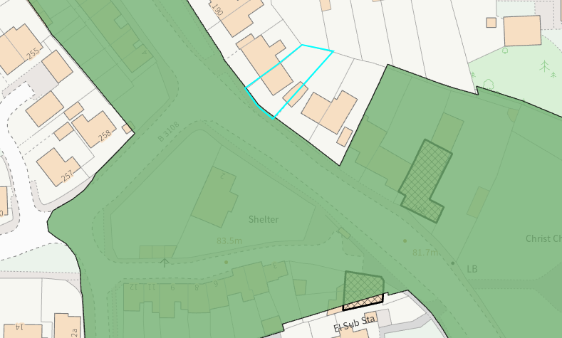

The proposal seeks to erect a single storey porch on the front elevation of the host dwelling. The elevations on the extension would consist of reconstituted stone to match existing with white uPVC fenestration and a rubber membrane roof. To the front elevation a window would be inserted, and the pedestrian door would be inserted on the southeast side elevation accessed via the existing steps.

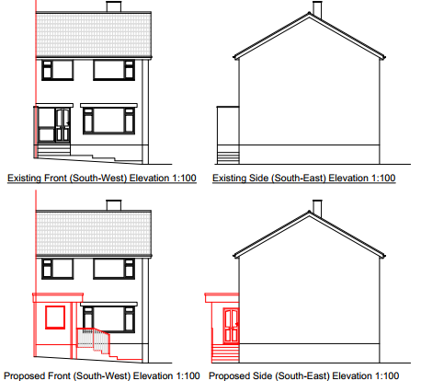

The use of appropriate materials would ensure the proposal would integrate into the surrounding setting and existing street scene and would not result in any harm to the prevailing character and appearance of the area. It is considered that the extension would by virtue of its height, scale and design constitute a complementary addition to the host dwelling that would appear commensurate to the size of the property and plot.
Given the limited works proposed, that would be set within the built envelope of the application site, it is considered that there would be no harm to the conservation area. The proposal, by virtue of its scale, design, and use of materials, is considered to preserve the character and appearance of the conservation area and the setting of the listed buildings nearby.

Having regard to the above, the proposal complies with the design principles set out in Core Policies 57 and 58 of the Wiltshire Core Strategy, Section 66 and Section 72 of the Planning (Listed Buildings and Conservation Areas) Act 1990, as well as the relevant provisions of the NPPF and the Wiltshire Design Guide.

Amenity
Point vii of Core Policy 57 - Ensuring High Quality Design and Place Shaping of the Wiltshire Core Strategy seeks to ensure that developments do not adversely affect neighbouring properties.

Policy P3 of the National Planning Policy Framework requires development to be appropriate for its location, taking account of its likely effects on health, living conditions and the environment. In particular, Policy P3(2)(b) requires development to avoid giving rise to unacceptable impacts on the living conditions of neighbouring residents and occupiers. In assessing amenity impacts, regard should be had to matters including daylight and sunlight, outlook, privacy, overbearing impacts and other effects on residential amenity.

The proposed development has been assessed in terms of its potential impact on the residential amenity of neighbouring properties, with particular regard to loss of light, overshadowing, loss of privacy, and overbearing effects.

The proposal relates to a small-scale extension that would not serve as a habitable room, erected on the front elevation of the host dwelling. The window proposed would overlook the applicant’s front garden and driveway area, therefore no overlooking concerns are raised.

Given the limited scale and mass of the proposed porch officers raise no concerns in regard to any potential overbearing or overshadowing impacts or loss of light to neighbouring occupiers.

The proposal therefore accords with Core Policy 57 point vii in respect of safeguarding residential amenity, Appendix D of the Wiltshire Design Guide and the NPPF.

Ecology Impact
Core Policy 50 of the Wiltshire Core Strategy seeks to protect and enhance biodiversity and geodiversity, including through ensuring that development avoids harm to protected species and habitats.

Policy N2 of the NPPF seeks to conserve and enhance biodiversity and support nature recovery. Development proposals should minimise impacts on habitats and species and, where relevant, demonstrate that appropriate mitigation measures are secured where harm cannot be avoided.

The application site sits within the Bath and Bradford on Avon Special Area of Conservation for bats and as this application involves disturbance to the host dwelling with the erection of an extension within the application site due consideration has to be given to the potential disturbance of any bats because of the proposed development.

The proposed development relates to an extension of existing residential development consisting of limited built form close to the existing dwelling which does not involve works to the roof. Given the nature of works and established high density urban residential nature of the location, it is considered highly unlikely that any bats would be affected and significant effects relating to the disturbance to bats can be ruled out having regard to the requirements of the Habitats Regulations.

As a precautionary measure an informative would be added to any decision that in event any evidence of bat activity is detected that the applicant should follow the advice of a professional ecologist or contact Natural England. As such, the development complies with Core Policy 50 of the Wiltshire Core Strategy and the relevant provisions of the NPPF.

Biodiversity Net Gain
Householder planning applications are exempt from the requirement to deliver Biodiversity Net Gain under Schedule 7A, Section 4(2)(a) of the Town and Country Planning Act 1990, as inserted by the Environment Act 2021.

Public Sector Equality Duty (PSED)
In reaching this decision, due regard has been had to the Public Sector Equality Duty under Section 149 of the Equality Act 2010. This requires the Local Planning Authority to have regard to the need to eliminate discrimination, advance equality of opportunity and foster good relations between persons who share a protected characteristic and those who do not.

The Local Planning Authority is satisfied that the proposal would not result in any unlawful discrimination and that any impacts on protected groups have been appropriately considered as part of this assessment.

CONCLUSION
The proposed development is considered to be acceptable in terms of its design, character and appearance, and would not result in any unacceptable harm to the amenities of neighbouring occupiers. Furthermore, the proposal would not result in any unacceptable impacts in respect of any other material planning considerations.

The proposal is therefore considered to comply with the relevant policies of the Wiltshire Core Strategy, the National Planning Policy Framework and all other relevant material considerations. As such, the application is recommended for approval, subject to conditions.

RECOMMENDATION: That Planning Permission be GRANTED subject to conditions.

