APPLICATION FOR FULL PLANNING PERMISSION
DELEGATED REPORT

APPLICATION REFERENCE: | PL/2026/02955
APPLICATION TYPE: | Full Planning Permission
SITE ADDRESS: | Conkwell Grange, Conkwell, Limpley Stoke, Bath, BA2 7FD
DEVELOPMENT DESCRIPTION: | Proposed Agricultural Building
RECOMMENDATION: | That Planning Permission be GRANTED

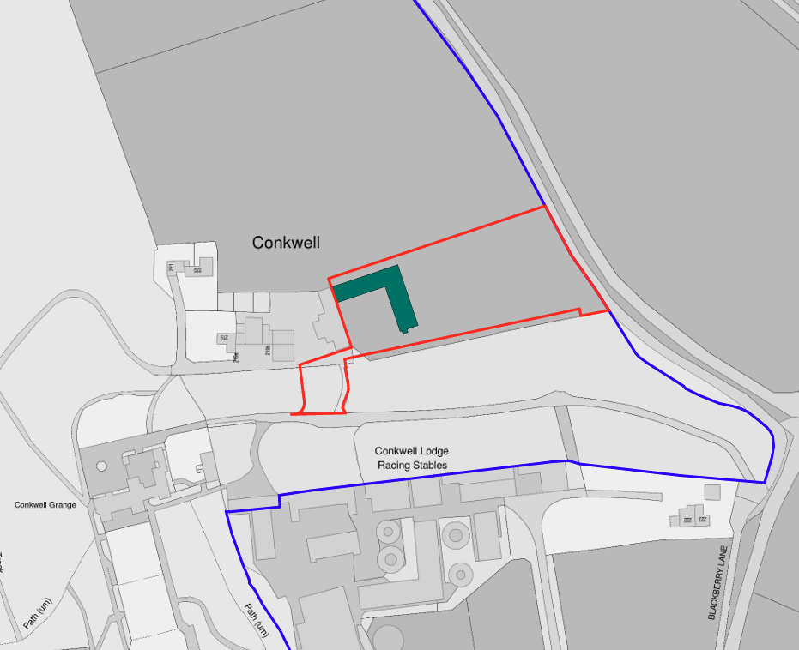

PROPOSAL

The application seeks full planning permission for the erection of a new agricultural building associated with the management of the wider Conkwell Grange Estate. The proposed building would adjoin an existing building currently used for residential storage and would create a U-shaped courtyard arrangement. The development comprises a series of agricultural storage bays and workshop space for the storage, servicing and maintenance of machinery and equipment associated with estate and agricultural land management, including tractors, trailers, mowers, forestry equipment and associated machinery. The building would be constructed using natural stone to match the existing adjoining barn, clay tile roofing, timber cladding and areas of corrugated metal roofing. The proposal also includes associated courtyard space, photovoltaic panels on sections of the roof, and new landscaping including extensive tree planting to the east of the development.

SITE DESCRIPTION / CONTEXT

The application site comprises agricultural grassland situated within the wider Conkwell Grange Estate, a holding extending to approximately 125 acres comprising pasture, woodland and residential curtilages. The site lies outside any defined settlement boundary within open countryside approximately 930m north-east of Winsley. The proposed building is positioned adjacent to an existing former agricultural building now used for residential storage and is accessed via an existing track from Blackberry Lane. The site lies within the West Wiltshire Green Belt and the Cotswolds National Landscape and is located within an area subject to bat consultation zones associated with the Bath and Bradford-on-Avon Bats SAC. Ancient Woodland lies approximately 70m to the west and woodland habitat is present adjacent to the wider site. Conkwell Grange, a Grade II listed building (List Entry 1180870), is situated approximately 110m to the south-west. The site lies within Flood Zone 1 and is not identified as being at risk from surface water flooding.

PLANNING HISTORY

Reference No. | Proposal / Summary | Decision
W/87/00360/FUL | Conversion of existing steel structure barn into one dwelling | Approved with Conditions
17/06689/FUL | Internal and external alterations to a listed building, including strip out works, forming of new openings, creating new partitions and forming new external openings. | Approved with Conditions
18/07078/FUL | Demolition of existing residential units (Nos. 219, 219a, 219b, 219c and 219d) and erection of No.3 replacement housing units, ancillary garaging, a new Courtyard, access driveway and associated landscaping, including variations to partially implemented consent ref. W87/0360/FUL; and full retention of No 220 and 221 | Approved with Conditions
19/11295/VAR | Particulars of Development: Demolition of existing residential units (Nos. 219, 219a, 219b, 219c and 219d) and erection of No.3 replacement housing units, ancillary garaging, a new Courtyard, access driveway and associated landscaping, including variations to partially implemented consent ref. W87/0360/FUL; and full retention of No 220 and 221 | Approved with Conditions
18/05560/FUL | Demolition & replacement of existing boundary walling between Conkwell Grange & Conkwell Courtyard. Removal of existing driveway and vehicular connection. | Approved with Conditions
19/04532/FUL | Variation of application W87/0360/FUL to include extension following demolition of existing store building, substation and adjacent garage, amended internal layout and revised fenestration | Approved with Conditions
17/07218/LBC | Internal and external alterations to a listed building, including strip out works, forming of new openings, creating new partitions and forming new external openings. | Approved

RELEVANT LEGISLATION, POLICIES AND GUIDANCE

Wiltshire Core Strategy:

Core Policy 1 Settlement Strategy;
Core Policy 2 Delivery Strategy;
Core Policy 7 Spatial Strategy: Bradford on Avon Community Area;
Core Policy 34 Additional Employment Land;
Core Policy 50 Biodiversity and Geodiversity;
Core Policy 51 Landscape;
Core Policy 57 Ensuring High-Quality Design and Place Shaping;
Core Policy 58 Ensuring Conservation of the Historic Environment;
Core Policy 60 Sustainable Transport;
Core Policy 61 Transport and Development;
Core Policy 64 Demand Management;
Core Policy 67 Flood Risk;

The National Planning Policy Framework (NPPF) and The Planning Practice Guidance (PPG)

Wiltshire Design Guide

The Wiltshire Local Transport Plan 2011 – 2026: Car Parking Strategy (March 2015).

The Wiltshire Local Transport Plan 4 (LTP4) (March 2025)

New Wiltshire Local Plan

At Full Council on 19 May 2026, the elected members of Wiltshire Council agreed to withdraw the emerging Wiltshire Local Plan. The said Plan has no material weight for the purposes of the application.

In accordance with Regulation 19 of the Town and Country Planning (Local Planning) (England) Regulations 2026, on 30th June 2026 Wiltshire Council published a notice of intention to prepare a new local plan for Wiltshire. The next stage is a Scoping Consultation which commences on 2nd September 2026. This plan is at a very early stage and currently carries no weight for decision making.

CONSULTATION RESPONSES

Winsley Parish Council – No Objection

Ecology (Wiltshire Council) – No Objection (subject to conditions)

Landscape (Wiltshire Council) – No Objection (subject to conditions)

REPRESENTATIONS

No comments received.

ASSESSMENT

Section 38(6) of the Planning and Compulsory Purchase Act 2004 states:

"If regard is to be had to the development plan for the purposes of any determination to be made under the planning Acts, the determination must be made in accordance with the plan unless material considerations indicate otherwise."

In accordance with this statutory requirement, this application has been assessed against the relevant policies of the Development Plan, including the adopted Wiltshire Core Strategy (2015) and, where applicable, any made Neighbourhood Plans.

Core Policies 1 and 2 of the Wiltshire Core Strategy direct the majority of new development towards sustainable settlements within defined limits of development. The application site lies outside any settlement boundary and therefore falls to be assessed against those policies which support development in the countryside.

Whilst the proposal does not fall neatly within one specific exception policy, the development is considered to accord with the objectives of Core Policy 34 in that it supports an agricultural and land-based enterprise requiring a countryside location. The building is proposed to facilitate the ongoing management of approximately 125 acres of agricultural land and woodland and therefore supports sustainable agricultural and land management activities. The submitted plans provide a detailed breakdown of the machinery and equipment to be housed within the building and demonstrate a clear agricultural function.

The proposal would utilise an existing access arrangement and would be physically related to an existing cluster of buildings. Subject to compliance with other relevant development plan policies, including those relating to landscape, design, ecology, amenity and Green Belt considerations, the principle of development is considered acceptable.

Greenbelt and National Landscape

The application site lies within the Green Belt. Policy GB6 of the National Planning Policy Framework states that development in the Green Belt is inappropriate unless it falls within one of the categories identified in Policy GB7. Inappropriate development is, by definition, harmful to the Green Belt and should not be approved except in very special circumstances. Substantial weight should be given to any harm arising to the Green Belt, including harm to openness. It is therefore necessary to consider whether the proposal falls within one of the exceptions identified under Policy GB7 and, if not, whether very special circumstances exist that clearly outweigh any resulting harm.

Policy GB7 (a) of the Framework identifies buildings for agriculture, horticulture and forestry as a form of development that is not inappropriate within the Green Belt. Having regard to the submitted plans, supporting information and the nature of the development proposed, the Local Planning Authority is satisfied that the building would serve a genuine agricultural and estate management function. Accordingly, the proposal falls within one of the exceptions set out by policy GB7 and is not inappropriate development within the Green Belt.

Whilst not inappropriate development, the proposal nevertheless introduces a substantial new built form into the countryside and therefore results in some localised reduction in openness through its physical presence. This harm is limited by the location adjacent to an existing building group, the agricultural character of the development, and the absence of any significant increase in activity or vehicle movements beyond those associated with existing estate operations.

The site also lies within the Cotswolds National Landscape. In exercising its duties under Section 85 of the Countryside and Rights of Way Act 2000, the Local Planning Authority must seek to further the purpose of conserving and enhancing the natural beauty of the National Landscape. Policy N4 of the NPPF further requires that proposals within protected landscapes should be limited in scale, extent, and sensitively located with substantial weight placed on the conservation and enhancement of natural beauty. Additionally, Core Policy 51 of the WCS states that development should conserve and protect existing landscape character. It also states that local features such as hedgerows and watercourses must be considered as part of any analysis, as well as other matters which relate to the overall distinctive quality of the specific locality in question.

The proposed building has been carefully positioned adjacent to an existing group of rural buildings rather than appearing as isolated development within the landscape. Its form, scale and appearance draw heavily upon the adjacent building and rural vernacular with substantial native tree planting proposed around the eastern extent of the site. Whilst the proposal will inevitably alter the appearance of part of the site, it is considered that the development would conserve the character and scenic qualities of the landscape through its sensitive siting, agricultural function, use of traditional materials and reinforcement of the existing building group. The associated landscaping proposals would additionally provide ecological and visual enhancements over time.

The Council's Landscape Officer was consulted and raised no objection in principle to the proposed development. The officer considered that the proposal represents agricultural development associated with an existing farmstead, that the scale and location of the building reflects the established pattern of development on the site, and that the use of vernacular materials and additional landscape planting would assist the development in assimilating into the surrounding landscape. The officer requested that the proposed hedgerow be repositioned away from the existing stone wall to avoid potential harm to this landscape feature and recommended that a detailed landscaping scheme, including native species planting, specification, implementation and management details, be secured by condition. On this basis, no landscape objection was raised subject to appropriate conditions.

The proposal is therefore considered to accord with Core Policy 51, the statutory duty under Section 85 of the CROW Act and relevant provisions of the Framework.

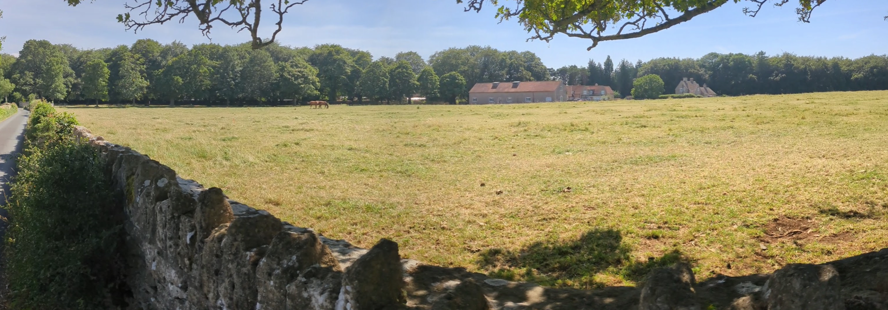
Site Image

Design and Impact the upon the character and context of the area

Core Policy 57 of the Wiltshire Core Strategy seeks to secure high-quality design which responds positively to local character and distinctiveness. At the national level, Policy DP3 of the National Planning Policy Framework requires development proposals to respond positively to their context and integrate with and enhance their surroundings. Development should also reflect, where relevant, the principles of liveability, climate resilience, nature, movement, built form, public space and local identity. Assessment of design quality therefore requires consideration of the scale, appearance, massing, materials, layout and relationship of the proposal with both the host site and the wider character of the surrounding area.

The proposed development adopts a form and appearance that reflects the character of the existing adjoining building. The eastern wing effectively mirrors the scale, proportions and roof form of the existing barn, creating a coherent courtyard arrangement. The use of natural stone walls, clay tile roofing, timber cladding and agricultural detailing is considered appropriate within the context of the surrounding estate and wider rural landscape.

Although the development is substantial in footprint, the scale primarily reflects the operational requirements of storing agricultural and estate management equipment. The proposal adopts a relatively low-profile form which assists in reducing visual prominence when compared with a potentially taller and more intensive storage building.

Views from Blackberry Lane would primarily be experienced in the context of the existing group of rural buildings and associated landscape features. Taking account of the siting, materials, landscaping proposals and agricultural character of the development, the proposal is considered to represent a high-quality design response which respects the character of both the immediate site and wider landscape setting.

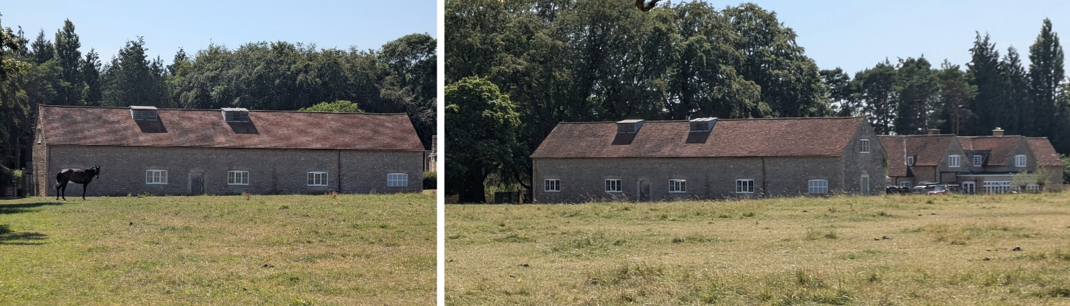
Existing Barn

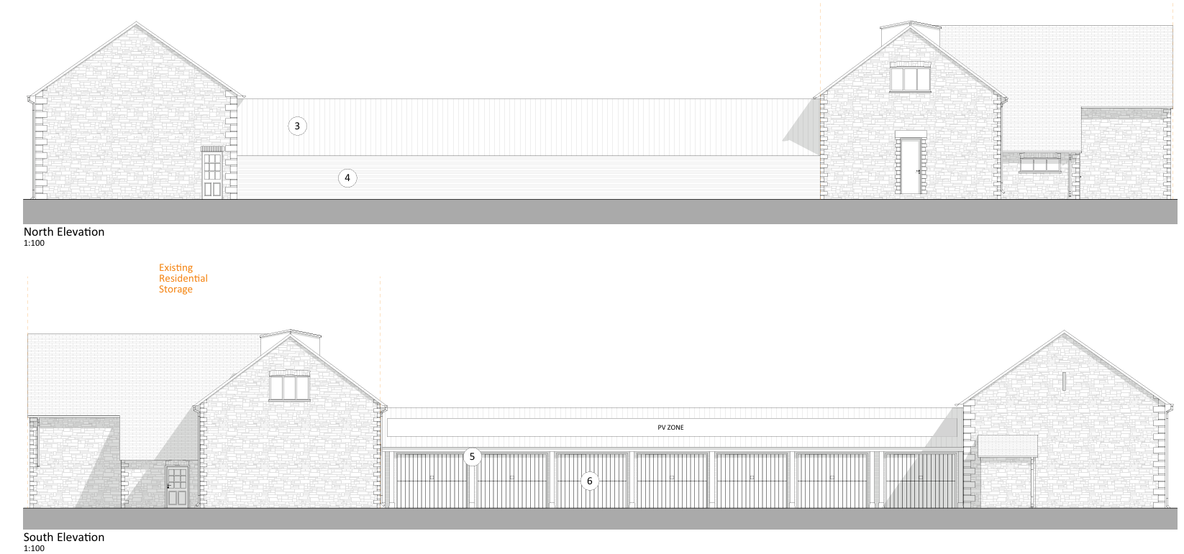
Proposed North and South Elevations

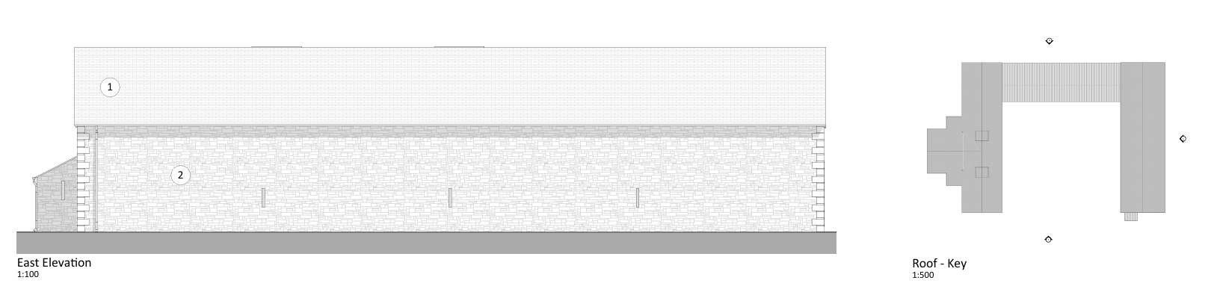
Proposed East Elevation and Roof Plan

Having regard to the above, the proposal complies with the design principles set out in Core Policy 57 of the Wiltshire Core Strategy, the Wiltshire Design Guide, and the NPPF.

Conservation and Heritage

Core Policy 58 of the Wiltshire Core Strategy requires designated and non-designated heritage assets, and their settings, to be conserved in a manner appropriate to their significance. In addition, Section 66(1) of the Planning (Listed Buildings and Conservation Areas) Act 1990 requires special regard to be paid to the desirability of preserving listed buildings and their settings. National policy is set out in Chapter 20 of the National Planning Policy Framework (NPPF), which recognises heritage assets as an irreplaceable resource and requires great weight to be given to their conservation. The NPPF further requires local planning authorities to assess the significance of any heritage assets affected by a proposal and to have regard to the impact of development upon that significance when determining applications.

The nearest designated heritage asset is Conkwell Grange, a Grade II listed building located approximately 110m to the south-west of the application site. Due to the separation distance, intervening landform, vegetation and existing built development, there is limited intervisibility between the application site and the listed building.

The proposed development would be read within the context of the existing building cluster and would not intrude upon important views towards or from the listed building. Furthermore, the traditional materials and agricultural character of the proposal are consistent with the established rural character of the estate. The proposal would therefore preserve the setting and significance of the Grade II listed building and would result in no harm to designated heritage assets.

Amenity

Core Policy 57 criterion vii seeks to ensure development does not have an unacceptable impact upon the amenities of neighbouring occupiers. Nationally, Policy P3 requires development proposals to provide healthy living conditions for occupiers and users and to avoid unacceptable impacts arising from loss of light, outlook, privacy, noise, disturbance or other forms of pollution. Policy DP3 additionally requires development to create liveable and attractive places for existing and future users. Accordingly, the assessment below considers the effect of the proposal upon neighbouring occupiers and whether acceptable living conditions would be maintained.

The nearest residential properties are located approximately 30m west of the proposed building. Between those properties and the proposed development sits the existing storage barn, which provides substantial physical screening. Given the relationship between the buildings, the proposal would not give rise to unacceptable overlooking, loss of privacy, overbearing impacts or loss of light.

The proposal incorporates workshop and machinery storage functions which have the potential to generate noise associated with agricultural activities. However, the workshop and servicing areas are positioned on the eastern side of the development, furthest from nearby residential properties, whilst the courtyard layout and intervening building provide further mitigation. Having regard to the separation distance, intervening building and agricultural context of the site, it is not considered that the proposal would result in unacceptable disturbance from operational noise

It is also relevant that the proposal facilitates activities associated with agricultural and estate management within a rural environment where machinery movement and agricultural operations form part of the established character of the area.

Overall it is considered that the proposal is appropriately sited, designed, and oriented to ensure that it would not result in unacceptable impact upon/to the amenities or living conditions of neighbouring residential occupiers, particularly in terms of outlook, privacy, or access to natural light. The proposal therefore accords with Core Policy 57 point vii in respect of safeguarding residential amenity, the Wiltshire Design Guide, and the NPPF.

Transport and Highways

Core Policies 60, 61 and 64 of the Wiltshire Core Strategy seek to promote sustainable transport, secure safe access arrangements and ensure adequate parking provision. Nationally, Policies TR3 and TR4 of the National Planning Policy Framework require development to be located in sustainable locations where appropriate, provide safe access arrangements, prioritise walking, wheeling and cycling, and provide suitable parking provision having regard to the nature and location of the development. Policy TR6 confirms that development should be refused where it would result in a severe adverse impact on the transport network or an unacceptable impact on highway safety after consideration of any mitigation measures.

The proposal would utilise an existing access from Blackberry Lane and would not create a new access onto the public highway. The development is intended to support an established agricultural holding and estate operation and would not be expected to generate significant additional traffic movements beyond those already associated with management of the land. Sufficient space is provided within the site for turning, manoeuvring and parking of agricultural machinery and supporting vehicles. In the absence of any identified highway safety concerns, the proposal is considered acceptable from a highway perspective.

Ecology

Core Policy 50 of the Wiltshire Core Strategy seeks to protect and enhance biodiversity interests and ensure development avoids unacceptable harm to ecological assets. National policy is set out within Policies N2 and N6 of the National Planning Policy Framework. These policies require development proposals to minimise impacts upon biodiversity, protect important habitats and species, and secure opportunities for biodiversity enhancement where appropriate. Where significant harm to biodiversity cannot be avoided, adequately mitigated or compensated for, development should be refused. Biodiversity Net Gain (BNG) was established as a mandatory aspect of planning evaluation through Schedule 7A of the Town and Country Planning Act 1990 (as amended by the Environment Act 2021 Schedule 14).

The application site comprises an area of grassland adjacent to an existing building and woodland habitats and lies within multiple consultation zones associated with the Bath and Bradford-on-Avon Bats SAC. The site is also located in close proximity to Priority Habitat and Ancient Woodland, with Conkwell Wood County Wildlife Site situated nearby. Ecology is therefore a significant material consideration in the assessment of the proposal.

The application is supported by a Preliminary Ecological Appraisal, Preliminary Roost Assessment, Biodiversity Metric and associated habitat plans. The ecological assessment identifies that the site is principally comprised of modified grassland which provides some ecological value for species including bats, reptiles, nesting birds, hedgehogs and badgers. The existing building was assessed as having negligible bat roosting potential and the proposed development would not result in alterations to the existing roof structure. No direct impacts upon bat roosts, Priority Habitat or Ancient Woodland have been identified.

The proposal would result in the loss of a relatively small area of modified grassland associated with the building footprint and courtyard area. Whilst this habitat provides some ecological value, it forms part of a wider network of grassland and is not considered to represent a significant ecological resource in its own right. The Council's Ecologist has reviewed the submitted information and raises no objection to the proposal subject to conditions.

An Appropriate Assessment has been undertaken by the Local Planning Authority in respect of the Bath and Bradford-on-Avon Bats SAC. The assessment considered the loss of a limited area of foraging habitat together with potential disturbance associated with construction activity and future lighting. Having regard to the scale of development, retention of key habitats, absence of external lighting and proposed mitigation measures, the assessment concludes that the development would not adversely affect the integrity of the SAC, either alone or in combination with other plans and projects. Natural England has agreed with that conclusion.

In addition to mitigating impacts, the proposal incorporates significant biodiversity enhancements. The submitted Biodiversity Metric demonstrates a habitat unit increase of 10.62%, exceeding the statutory requirement for a 10% Biodiversity Net Gain. This would be achieved through the creation of new native hedgerow planting, the planting of approximately 57 native trees and the enhancement of existing modified grassland to higher value neutral grassland habitat, principally within the paddock to the east of the proposed development and adjacent areas of the wider site. These measures would strengthen ecological connectivity and provide enhanced foraging and commuting opportunities for wildlife, including bats.

The Council Ecologist has recommended conditions requiring a Construction Method Statement, biodiversity enhancements and controls over external lighting. These conditions are considered necessary given the site's proximity to sensitive habitats and the potential presence of protected species including bats, nesting birds, reptiles, hedgehogs and badgers. The conditions will ensure appropriate mitigation measures are secured throughout the construction and operational phases of the development and will safeguard the conclusions of the Appropriate Assessment.

Subject to the recommended conditions, the proposal is considered to accord with Core Policy 50 of the Wiltshire Core Strategy, the Conservation of Habitats and Species Regulations 2017 and the relevant provisions of the National Planning Policy Framework

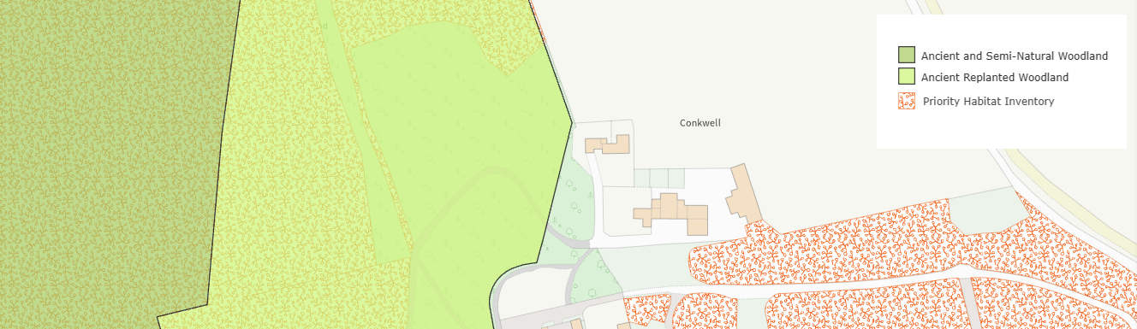
Ancient Woodland and Priority Habitat

Flooding and Drainage

Core Policy 67 of the Wiltshire Core Strategy seeks to ensure that development is directed away from areas at greatest risk of flooding and is designed to minimise vulnerability to flooding whilst avoiding any increase in flood risk elsewhere. National planning policy relating to flood risk and drainage is contained within Policies F4 to F8 of the National Planning Policy Framework. Collectively, these policies establish a risk-based approach to the location and assessment of development proposals. The Framework requires flood risk to be properly assessed where necessary, seeks to direct development towards areas at the lowest risk of flooding through the application of the sequential approach where applicable, and ensures that development remains safe for its lifetime without increasing flood risk elsewhere. The policies also support the incorporation of sustainable drainage measures where appropriate in order to manage surface water runoff and reduce the potential for flooding.

The site lies within Flood Zone 1 and is not identified as being subject to significant flooding constraints. Notwithstanding this, the proposal involves a substantial increase in built form and hard surfaced areas. In the absence of detailed drainage information, it is necessary to ensure that surface water arising from the development is appropriately managed and that flood risk is not increased elsewhere. Subject to the imposition of a condition requiring the submission and approval of a surface water drainage scheme prior to commencement of development, the proposal is considered to provide an acceptable means of surface water management and would comply with the requirements of Core Policy 67 of the Wiltshire Core Strategy and the provisions of the NPPF.

CONCLUSION

The proposal seeks the erection of an agricultural building to facilitate the ongoing management of the wider Conkwell Grange Estate. The development is considered acceptable in principle as agricultural development in the countryside and represents a form of development that is not inappropriate within the Green Belt.

The proposal would conserve the character and scenic beauty of the Cotswolds National Landscape, would preserve the setting of nearby heritage assets, would not result in unacceptable impacts upon residential amenity, highway safety, ecology or drainage, and would provide ecological and landscape enhancements.

Subject to the recommended planning conditions, the proposal is considered to accord with the provisions of the Wiltshire Core Strategy, the National Planning Policy Framework and all other material considerations. Accordingly, planning permission is recommended for approval.

RECOMMENDATION: That Planning Permission be GRANTED subject to the following conditions:

1.
The development hereby permitted shall be begun before the expiration of three years from the date of this permission.
REASON: To comply with the provisions of Section 91 of the Town and Country Planning Act 1990 as amended by the Planning and Compulsory Purchase Act 2004.

2.
The development hereby permitted shall be carried out in accordance with the following approved plans and documents:

- Proposed East, North and South Elevations 1745 051-106.3 PL-02
- Proposed Sections C, D & E 1745 051-106.4 PL-02
- Proposed Site Plan 022-101 PL-01
- Proposed Ground Floor 051-106.1 PL-01
- Location Plan 010-100 PL-01
- Proposed Roof Plan 051-106-2 PL-01
- Arboricultural Impact Assessment GHA Trees March 2026

REASON: For the avoidance of doubt and in the interests of proper planning.
3.
The development will be carried out in strict accordance with the following documents:

- Proposed Site Plan, Holland Green, April 2026
- Preliminary Ecological Appraisal and Preliminary Roost Appraisal, Wildwood Ecology, 2026
- Post-development habitat plan, Wildwood Ecology, April 2026

REASON: For the avoidance of doubt and for the protection, mitigation and enhancement of biodiversity.

4.
The building hereby approved shall be used solely for agriculture and estate management purposes associated with Conkwell Grange and shall not be used for any separate commercial, industrial or storage and distribution use without the prior grant of planning permission.

REASON: To ensure the development remains compatible with the rural character of the area, Green Belt designation and National Landscape.

5.
No development shall commence on site (including any vegetation removal or works to existing structures), until a Construction Method Statement has been submitted to, and approved in writing by the Local Planning Authority. The Construction Method Statement shall include all precautionary measures to be implemented during the construction period, for the protection of sensitive habitats and species known to be present within or adjacent the site, with particular reference to bats, nesting birds, badgers, reptiles and Conkwell Wood. The development shall be carried out in strict accordance with the approved Construction Method Statement.

REASON: To ensure adequate protection, mitigation and compensation for protected species and priority habitats throughout the construction period.

6.
No development above damp-proof course level shall take place until a surface water drainage scheme for the site has been submitted to and approved in writing by the Local Planning Authority.

The scheme shall include:

- Details of the means of surface water disposal from all roof and hard surfaced areas;
- Calculations demonstrating the capacity of the proposed drainage system;
- Details of any infiltration testing undertaken;
- Details of exceedance flow routes;
- A timetable for implementation; and
- Arrangements for the future maintenance and management of the drainage system.

The development shall be carried out in accordance with the approved scheme prior to the first use of the building and thereafter retained and maintained in accordance with the approved details.

REASON: To ensure the satisfactory management of surface water runoff and to prevent increased flood risk on or off site, in accordance with Core Policy 67 of the Wiltshire Core Strategy.

7.
No development above damp-proof course level shall take place until details of the number, design and locations of ecological enhancements – including the type and locations of bat roosting and bird nesting opportunities – shall be submitted to the local authority for approval. The approved details shall be implemented before occupation of the final works.

REASON: To provide mitigation/enhancement for biodiversity.

8.
No development above damp-proof course level shall take place until details and samples of all external materials to be used in the construction of the development have been submitted to and approved in writing by the Local Planning Authority. The details shall include, but not be limited to:

- Natural stone walling;
- Roofing materials;
- Timber cladding;
- Garage doors and external joinery; and
- Photovoltaic panels.

The development shall thereafter be carried out in accordance with the approved details.

REASON: In the interests of securing a high-quality form of development that respects the character and appearance of the existing building group, the rural character of the area and the special qualities of the Cotswolds National Landscape, in accordance with Core Policies 51 and 57 of the Wiltshire Core Strategy.

9.
No development above damp-proof course level shall take place until a detailed hard and soft landscaping scheme has been submitted to and approved in writing by the Local Planning Authority.

The scheme shall include:

- Existing and proposed finished levels;
- Means of enclosure;
- Hard surfacing materials;
- Planting plans and specifications;
- Written specifications for cultivation and maintenance operations;
- Schedules of all trees, shrubs and hedgerows to be planted, including species, sizes, densities and numbers;
- Details of all ecological planting and habitat creation measures;
- Details demonstrating that the proposed hedgerow planting adjacent to the eastern boundary stone wall has been relocated away from the wall and positioned adjacent to the proposed grassland area;
- A timetable for implementation; and
- A landscape management and maintenance plan.

The scheme shall utilise native species unless otherwise first agreed in writing by the Local Planning Authority.

The approved landscaping scheme shall be carried out in full during the first planting season following completion of the development or first use of the building, whichever occurs first.

Any trees, shrubs or hedgerows which, within a period of five years from the completion of the approved landscaping scheme, die, are removed, become seriously damaged or diseased shall be replaced during the next planting season with others of similar size and species unless otherwise agreed in writing by the Local Planning Authority.

REASON: To ensure a satisfactory landscaping scheme which conserves and enhances the character and appearance of the site and the Cotswolds National Landscape, whilst contributing to biodiversity enhancement, in accordance with Core Policies 50, 51 and 57 of the Wiltshire Core Strategy and the National Planning Policy Framework.

10.
No external light fixture or fitting will be installed within the application site unless details of existing and proposed new lighting have been submitted to and approved by the Local Planning Authority in writing. The submitted details will demonstrate how the proposed lighting will impact on bat habitat compared to the existing situation. The plans will be in accordance with the appropriate Environmental Zone standards set out by the Institution of Lighting Professionals (ILP) Guidance Notes on the Avoidance of Obtrusive Light (GN 01/2021) and Guidance note GN08/23 “Bats and artificial lighting at night”, issued by the Bat Conservation Trust and Institution of Lighting Professionals.

REASON: To avoid illumination of habitat used by bats.

