APPLICATION FOR A CERTIFICATE OF LAWFULNESS FOR EXISTING USE OR DEVELOPMENT

APPLICATION REFERENCE: | PL/2026/03435
APPLICATION TYPE: | Lawful development: Existing use
SITE ADDRESS: | Serenity Wood, Wessex Water Lane, Bradford Road, Trowbridge, BA14 9AX
DEVELOPMENT DESCRIPTION: | Certificate of lawfulness for the erection of a barn used for keeping of livestock and associated storage
RECOMMENDATION: | To Grant the Certificate of Lawful Development

SITE DESCRIPTION AND PROPOSAL
This application is for a Certificate of Lawfulness for an Existing Use or Development (CLUED) under Section 191 of the Town and Country Planning Act 1990 (as amended). The applicant seeks to establish the lawfulness of the erection of a barn used for livestock and associated storage, which it is claimed was erected on site in August/September 2021 and in use for livestock accommodation since January 2022. The barn is identified as the building edged in red on the site plan below:

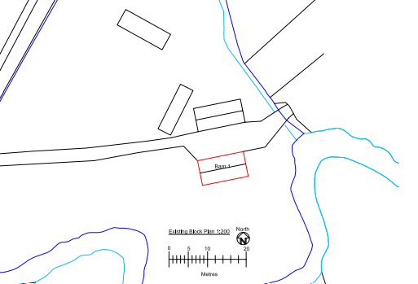
Site plan extract

A site visit was undertaken to verify the location and description of the barn for comparison with the photographs and details provided. As the time of the visit the building was in use for accommodating pigs.

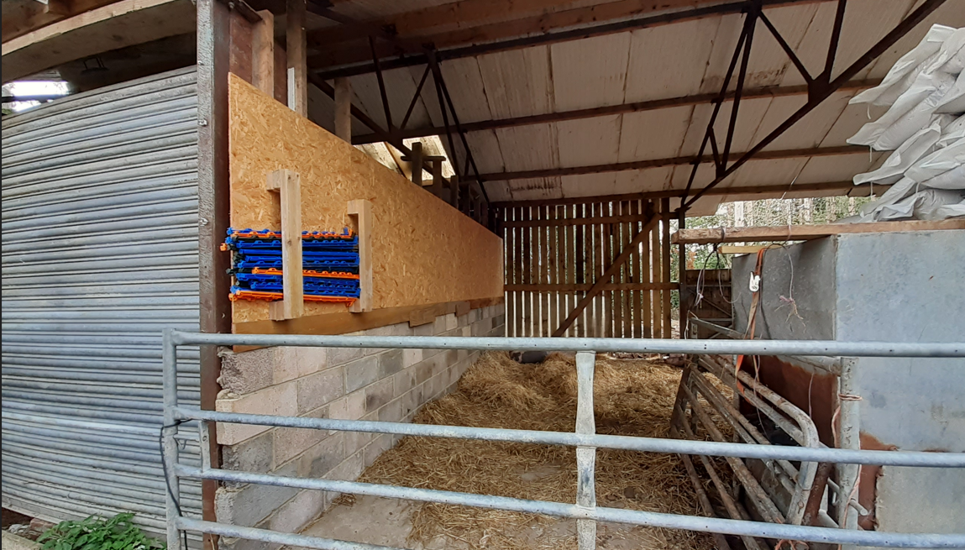
Site photo of the barn
RELEVANT LEGISLATION AND CONSIDERATIONS

The statutory framework governing Certificates of Lawfulness for Existing Use or Development (CLUED) is primarily set out in Section 191(2) of the Town and Country Planning Act 1990 (as amended). This section establishes that "lawful development" refers to development against which no enforcement action may be taken and where no enforcement notice is in force, or development for which planning permission is not required.

Section 191(4) of the Town and Country Planning Act 1990 (as amended) further stipulates that a Local Planning Authority (LPA) shall issue a Certificate of Lawfulness upon request, provided that, on the balance of probabilities, the LPA is satisfied that the existing development or use described in the application is lawful. The time limits for taking enforcement action are set out in s171B of the Act.

The Planning Practice Guidance (PPG) on Lawful development certificates clarifies that the burden of proof lies with the applicant. It is the applicant's responsibility to provide sufficiently clear, precise, and unambiguous evidence to demonstrate the lawfulness of the existing development or use.

In considering whether the use or development has become immune from enforcement action, the test for granting a Certificate of Lawfulness is whether, on the balance of probabilities:
- the works were substantially completed, or,
- the use has been continuous for the required time period without interruption.

The applicant must prove that the use or development has occurred for the necessary period. A continuous use must be demonstrated without significant interruption.

It is important to note that when determining a CLUED application, the LPA must focus solely on whether, based on the facts and applicable planning law, the specific use or development is lawful. Planning merits or considerations relating to the quality or suitability of the development are not relevant.

REPRESENTATIONS

There is no legal obligation to consult third parties for this type of application, including Town/Parish Councils or neighbouring properties. However, the PPG recognises that it may be reasonable for a local planning authority to seek evidence from these sources, if there is good reason to believe they may possess relevant information about the content of a specific application.

Trowbridge Town Council – No objection
Wiltshire Council Highways – No objection
Wiltshire Council Ecology – No comment on type of application – informative setting out legal obligations in relation to protected species provided.
Wiltshire Council Arboricultural Officer - Having looked at historical aerial maps of the site, it shows that a significant amount of trees have been removed. When these trees in their entirety were removed is not clear, however it is likely that a felling license may have been required from the Forestry Commission.

No third party representations have been received.

RELEVANT SITE HISTORY
The site has the following relevant planning history:

Proposal / Summary
PL/2022/05092 - Erection of a temporary rural workers accommodation Unit and Stable Building, with associated vehicular access, for an existing equestrian business and rare breeds small holding – refused

ASSESSMENT
The time limits for immunity for enforcement action for operational development are subject to change in legislation. Ten years applies for operational development that was not substantially completed before 25 April 2024 and 4 years applies for operational development that was substantially completed before 25 April 2024. In this case it is asserted that the building operations were complete before 25 April 2024, such that the time period for immunity from enforcement is 4 years. The date of submission of the application was 1 June 2026, meaning that sufficient evidence to demonstrate that the subject building was substantially complete on or before 1 June 2022 would need to be provided, with the onus of proof being on the applicant.

The term ‘substantially complete’ must be taken as having the meaning established by Lord Hobhouse in Sage v SSETR & Maidstone BC [2003]. What is required is “a fully detailed building of a certain character”. It was held that a building could not be regarded as substantially completed for the purposes of Section 171B(1) of the Town and County Planning Act 1990 even if outstanding works affected only the interior. The applicant must demonstrate with unambiguous evidence, on the balance of probabilities, that the development is lawful by providing sufficient and clear evidence. Planning merits are not considered during this process—only the lawfulness of the existing development.

Evidence Submitted by the Applicant
The applicant has submitted the following evidence to support the application:

Supporting Letter – Nick Webb dated 1 July 2026
Supporting Letter – Tom Johnson dated 30 June 2026
Scottish & Southern Electricity Networks Job Sheet – Plot Date 05/08/2020
Preliminary Ecological Appraisal – Chalkhill Environmental Consultants dated 20 May 2022
Design and Access Statement - AGM Ltd dated June 2022 (prepared in support of a planning application)
Agricultural Appraisal APA/03/0165 – AM Coke dated 7 October 2022
Photographs taken inside/outside of the barn dated 19 March 2022, 5 October 2022, 11 March 2023, 23 July 2023, 25 August 2023, 24 March 2025, 1 June 2025 3 June 2025
Planning Statement by applicant
Elevations and Floor Plan of building
Site Plan

Assessment

There is no statutory declaration from the applicant to support the evidence in this case. The planning statement sets out that the building was erected in August 2021 and mains electric was installed into the building in September 2021. It is stated that the building was completed by January 2022, at which time young calves were being reared in it. It concludes that “During the dates of planning application PL/2022/05092, Gen Collins who was the officer in charge of the application had 2 site meetings, which this barn was clearly visible, as well as all of the noted paperwork above. There was never a mention of the barn not currently having permission, and I think its clearly obvious that I have never tried to conceal this barn being erected and used for rearing livestock, Since January 2022 this barn has been used consistently to raise a range of livestock from birthing lambs and pigs, to rearing bottle fed beef calf’s in the 2 bays suitable for livestock, the third bay has always been used for a range of storage purposes, including feed and small hand tools that you would normally associate with an agricultural business”. Whilst not being witnessed as a signed declaration, the planning statement is evidently a written statement by the applicant which provides the key dates of when the construction took place.

The SSE Job Sheet identifies the approximate site of the building. It does not include a date of the visit but includes a Plot Date of 5 August 2020. It does not confirm the installation date of September 2021, and the plan to install electricity supply predates the erection of the building in August 2021 by 12 months, however it is consistent with the evidence in respect of an electricity supply being planned for the building. The applicant was able to provide email correspondence confirming the subsequent installation arrangements for the avoidance of doubt.

The ecological survey, prepared to support a submission for a planning application, was carried out in May 2022. The report includes that “A galvanised metal and blockwork open fronted shed with a shallowing sloping corrugated metal roof was split into interior compartments and was used for the rearing of young livestock. Lambs, calves and young cattle were present at the time of survey. The roof was unlined and the walls single skinned. This building will be retained”. There are no photographs of this building and it is not identified on the existing or proposed site layout, although its description matches the barn which is the subject of this application. The ecological appraisal does not suggest that the building was incomplete at the time of the inspection but provides evidence that there was a building which fits the description of the subject building on site prior to 1 June 2022. At a site visit, the siting of the building was confirmed. A second building had been erected on site which the applicant confirmed was not present when the ecological survey was undertaken and, therefore, was not subject to the application for certificate of lawful development.

The design and access statement, dated June 2022, also prepared to support a planning application submission, states that “The Proposed Stable Building is to provide three stabling boxes as well as a separate Tack and Feed store. This would allow for the rural enterprise to expand and improve on its existing horse breeding programme, which is often critical to the future livelihood of the stock. This element of the Proposals is part-retrospective and was part-erected in February 2022”. The proposed stable building described in the design and access statement is on the site of the subject building. There are no photographs of the existing building in the statement. Whilst the description of ‘part retrospective’ suggests that the existing building may have been incomplete, it is understood from other evidence that the stable building was to form an adaptation of the existing building rather than its ‘completion’. The date of the document provides evidence that there was a building which fits the description of the subject building on site prior to “June 2022”, although the exact date of any visit to the site is not known.

The agricultural appraisal, which was undertaken in respect of the previous application for a mobile home to support the holding, states that “The largest building at the holding is a three-bay shed, currently in use for storage and livestock. There are a number of field shelters and cages for the raptors”. There are no photographs of the building and it is not identified by way of a plan but is understood to relate to the barn which is the subject of this application. The appraisal does not suggest that the building was incomplete at the time of the inspection undertaken in October 2022. This evidence does not provide confirmation that the building described was present on 1 June 2022 since the visit was undertaken after this date, however officers are satisfied from visual inspection that the barn described relates to the subject building.

Photographs of the building are mainly internal and therefore it is difficult to identify specifically that they relate to the same/subject building. Most are provided within the required 4 year period, but the first image dated 19 March 2022 is dated more than 4 years from the date of the application showing that the building in the image was in use and therefore that the building in the image was substantially complete at the time of the photograph. The quality of the photograph makes it difficult to confirm with any certainty that the building is the subject building, however from visual inspection officers are satisfied that the building in the image is the building that was inspected on site. The photographs dated after 1 June 2022 do not confirm the presence of a substantially complete building on 1 June 2022.

Nick Webb’s supporting letter states that he has helped with livestock in the barn ‘for the last 4 years’. Tom Johnson’s supporting letter states that he has assisted with TB testing cattle ‘for the last 3-4 years’. The evidence alone is not sufficiently precise to confirm the date of the completion of the building, however it is consistent with the assertions of the applicant and other evidence and does not cast doubt on the case made by the applicant.

Much of the evidence provided is partial and inconclusive when considered individually. For the most part, the written evidence of the presence of the barn does not confirm that the barn that is described is the same barn as forms the subject of this application, or that it was present on 1 June 2022 where inspections were undertaken after this date. However, from visual inspection, officers are satisfied that the subject building is the building as described and as such, cumulatively, the evidence points to the various descriptions being of the subject building and some of that evidence is prior to the qualifying date of 1 June 2022.

In terms of other evidence, the case officer report for PL/2022/05092 does not confirm or refute the presence of an existing building in the site description or assessment of the impact of the stable building. As this application was received by Wiltshire Council on 1 July 2022 any evidence gathered at the time of the application or site visits would not have confirmed the presence of a substantially completed building on site on 1 June 2022. The development is not contrary to a planning condition (which would alter the time limit for enforcement to 10 years).

No third party evidence has been provided which supports or disputes the facts as presented by the applicant’s planning statement.

The test for granting a certificate is the balance of probability, that is therefore is it more likely than not that the building was substantially complete at least 4 years prior to the application date. Whilst the evidence is partial and includes evidence after the qualifying date, the evidence submitted by the applicant is cumulatively sufficient to demonstrate, on the balance of probabilities, that the development was substantially completed on or before 1 June 2022 in the absence of no evidence or contradictions that would cast doubt on the applicant’s evidence. The development is therefore lawful under the provisions of the Town and Country Planning Act 1990 (as amended). The application for a Certificate of Lawfulness for an Existing Development is recommended for approval.

CONCLUSION
On the balance of probability, sufficient evidence has been provided to demonstrate that the building used for livestock and storage identified on the site plan was substantially complete at the point of submitting the application for a period in excess of 4 years. As there is no clear or unambiguous evidence to the contrary submitted to or readily available to the Council, and as no formal enforcement action has been taken by the Council, it is recommended that a certificate of lawfulness be issued for the use of the building for the keeping of livestock and associated storage on the balance of probability that the building is now immune from enforcement action.

RECOMMENDATION
It is recommended that a Certificate of Lawfulness for Existing Use or Development be granted for the following development:

Erection of a barn used for keeping of livestock and associated storage.

Reason for approval: The evidence submitted satisfies the criteria set out in the Town and Country Planning Act 1990 (as amended), and the development meets the relevant time limits and planning law requirements.

