APPLICATION FOR HOUSEHOLDER PLANNING PERMISSION
DELEGATED REPORT

APPLICATION REFERENCE: | PL/2026/04090
APPLICATION TYPE: | Full Planning Permission
SITE ADDRESS: | Honeysuckle Cottage, Back Street, Great Hinton, Trowbridge, BA14 6BT
DEVELOPMENT DESCRIPTION: | Change of use and conversion of a detached double garage to accommodation annexe to the main house.
RECOMMENDATION: | That Planning Permission be GRANTED

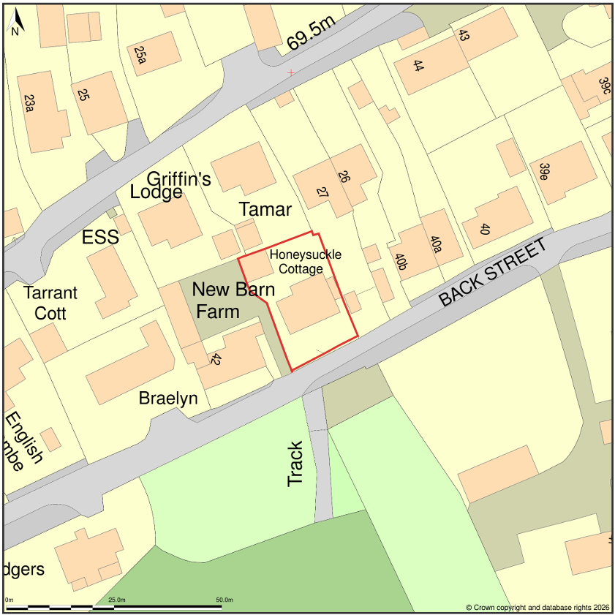

PROPOSAL

The application seeks planning permission for the conversion of an existing detached double garage within the residential curtilage of Honeysuckle Cottage to provide ancillary residential accommodation comprising a bedroom, bathroom, kitchen/living space and home office. External alterations are limited to the replacement of the existing garage door with glazing and associated infill works, with no alterations proposed to the roof structure, external cladding, footprint, scale or overall form of the building.

SITE DESCRIPTION / CONTEXT

The application site relates to Honeysuckle Cottage, a detached dwelling located within the Small Village of Great Hinton. The property occupies a generous residential plot accessed from Back Street and includes a detached double garage positioned to the side of the dwelling. The site lies within the Trowbridge and Westbury Bat Mitigation Strategy Grey Zone and within a 2km Core Roost Buffer associated with designated bat habitat. It is also located within an area identified as being susceptible to groundwater flooding, although the site lies within Flood Zone 1. The site is adjacent to the Grade II listed New Barn Farmhouse immediately to the west. Relevant planning history includes outline permission for residential development under reference W/91/00345/OUT and subsequent reserved matters approval under W/96/00312/REM.

PLANNING HISTORY

Reference | Development | Decision
W/91/00345/OUT | Three dwellings | Approved
W/96/00312/REM | Erection of one dwelling | Approved

RELEVANT LEGISLATION, POLICIES AND GUIDANCE

Wiltshire Core Strategy:

Core Policy 1 Settlement Strategy;
Core Policy 2 Delivery Strategy;
Core Policy 15 Spatial Strategy: Melksham Community Area;
Core Policy 50 Biodiversity and Geodiversity;
Core Policy 57 Ensuring High-Quality Design and Place Shaping;
Core Policy 58 Ensuring Conservation of the Historic Environment;
Core Policy 60 Sustainable Transport;
Core Policy 61 Transport and Development;
Core Policy 64 Demand Management;
Core Policy 67 Flood Risk;

The National Planning Policy Framework (NPPF) and The Planning Practice Guidance (PPG)

Wiltshire Design Guide - Appendix D – Design Guidance for Householder extensions

The Wiltshire Local Transport Plan 2011 – 2026: Car Parking Strategy (March 2015).

The Wiltshire Local Transport Plan 4 (LTP4) (March 2025)

New Wiltshire Local Plan

At Full Council on 19 May 2026, the elected members of Wiltshire Council agreed to withdraw the emerging Wiltshire Local Plan. The said Plan has no material weight for the purposes of the application.

In accordance with Regulation 19 of the Town and Country Planning (Local Planning) (England) Regulations 2026, on 30th June 2026 Wiltshire Council published a notice of intention to prepare a new local plan for Wiltshire. The next stage is a Scoping Consultation which commences on 2nd September 2026. This plan is at a very early stage and currently carries no weight for decision making.

CONSULTATION RESPONSES

Great Hinton Parish Council – No Objection (subject to condition)
Condition requested to restrict use as ancillary only.

Local Highway Authority (Wiltshire Council) – No Objection (subject to condition)
Condition requested to restrict use as ancillary only.

REPRESENTATIONS

Five letters of representation have been received from three neighbouring households objecting to the proposal. The concerns raised can be summarised as follows: the potential for the building to function as a self-contained dwelling rather than ancillary accommodation; impacts upon neighbouring residential amenity through increased activity, noise and disturbance; potential impacts upon bats and the absence of ecological surveys; concerns regarding parking provision; concerns regarding the capacity of the local foul drainage network; and matters relating to the Party Wall Act and potential damage during construction works. These matters have been carefully considered in the assessment of the application.

The above concerns will be addressed throughout the following report however matters relating to the Party Wall Act are civil issues falling outside the remit of the planning system.

ASSESSMENT

Section 38(6) of the Planning and Compulsory Purchase Act 2004 states:

"If regard is to be had to the development plan for the purposes of any determination to be made under the planning Acts, the determination must be made in accordance with the plan unless material considerations indicate otherwise."

In accordance with this statutory requirement, this application has been assessed against the relevant policies of the Development Plan, including the adopted Wiltshire Core Strategy (2015) and, where applicable, any made Neighbourhood Plans.

The proposal comprises the conversion of an existing domestic outbuilding located within the established residential curtilage of the host dwelling. No operational development resulting in an increase in built form is proposed. Whilst the accommodation includes facilities capable of providing for basic day-to-day living, the application has been presented as ancillary accommodation associated with the host dwelling rather than as a separate planning unit. The accommodation comprises a single room providing bedroom, living area and kitchen with partition walls to create a separate shower room. The proposal is therefore suited to ancillary accommodation rather than comprising a unit designed and likely to be occupied as an independent unit. The proposal is therefore considered acceptable in principle subject to a condition restricting occupation and use of the accommodation to purposes ancillary to Honeysuckle Cottage and preventing its use as an independent dwelling.

Design and Impact the upon the character and context of the area

Core Policy 57 of the Wiltshire Core Strategy seeks to secure high-quality design which responds positively to local character and distinctiveness. At the national level, Policy DP3 of the National Planning Policy Framework requires development proposals to respond positively to their context and integrate with and enhance their surroundings. Development should also reflect, where relevant, the principles of liveability, climate resilience, nature, movement, built form, public space and local identity. Assessment of design quality therefore requires consideration of the scale, appearance, massing, materials, layout and relationship of the proposal with both the host site and the wider character of the surrounding area.

The proposed external alterations are limited in extent and comprise the replacement of the existing garage door with glazing and associated infill. The existing scale, form, roof profile, external cladding and materials are otherwise retained. Given the modest nature of the works, the existing domestic appearance of the building would be preserved and the garage would continue to read as a subordinate structure within the curtilage of the dwelling. The proposal would therefore have no adverse impact upon the character or appearance of the site or wider street scene and accords with the aims of Core Policy 57. As occupiers would share the facilities of the main dwelling, including garden and parking areas, the suitability for independent occupation has not been assess

Having regard to the above, the proposal complies with the design principles set out in the NPPF Policy DP3, Core Policy 57 of the Wiltshire Core Strategy, and Appendix D of the Wiltshire Design Guide.

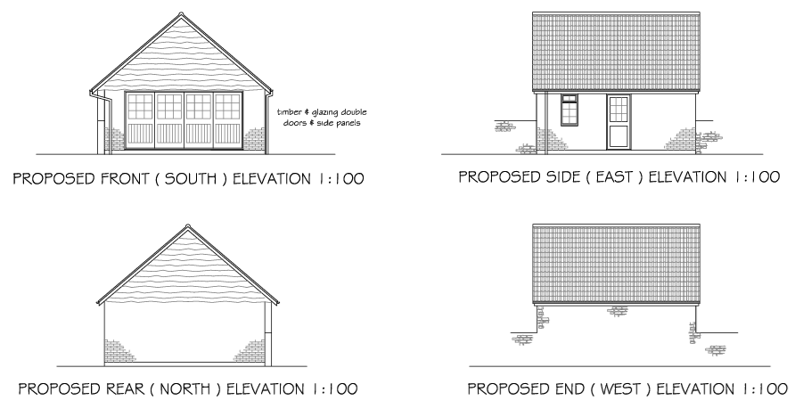
Proposed Elevations

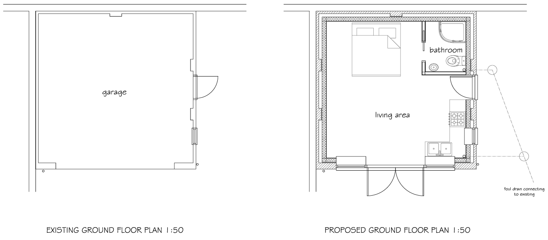
Existing and Proposed Floor Plans

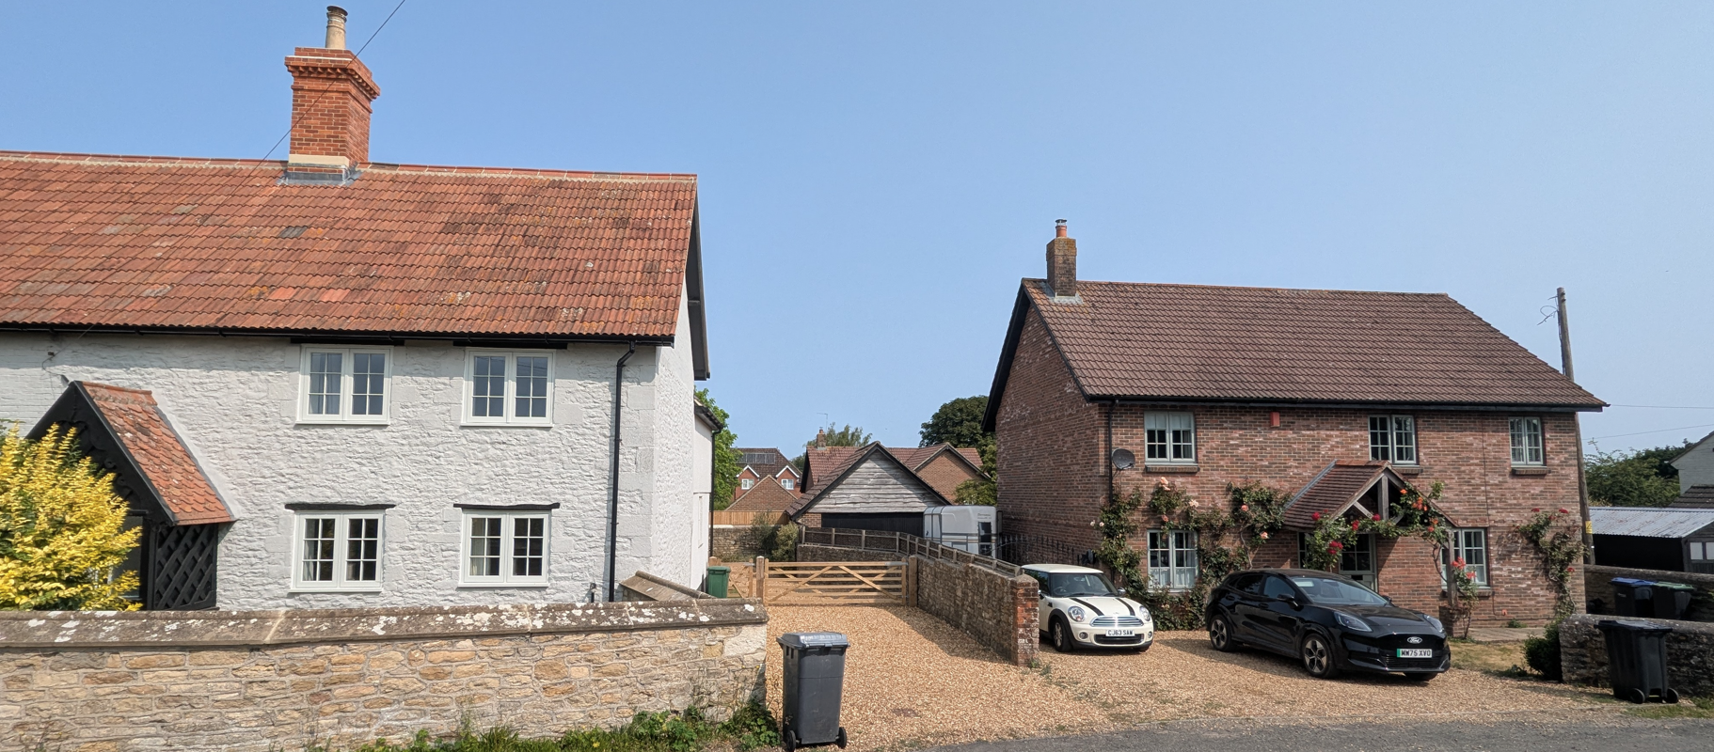
Site Image
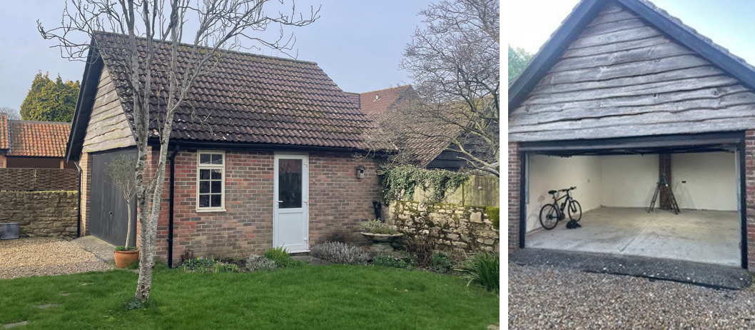
Site Images

Conservation and Heritage

Core Policy 58 of the Wiltshire Core Strategy seeks to protect, conserve and where possible enhance the historic environment, including designated heritage assets and their settings. The National Planning Policy Framework recognises heritage assets as an irreplaceable resource and requires decision-makers to assess the significance of affected assets and the impact of a proposal upon that significance.

In addition, Section 66(1) of the Planning (Listed Buildings and Conservation Areas) Act 1990 places a statutory duty on decision-makers to have special regard to the desirability of preserving listed buildings and their settings. Great weight should be given to the conservation of designated heritage assets when considering development proposals that may affect their significance.

The site lies adjacent to the Grade II listed New Barn Farmhouse. In accordance with Section 66 of the Planning (Listed Buildings and Conservation Areas) Act 1990, special regard has been given to the desirability of preserving the setting of the listed building. The proposal relates to an existing modern garage building and involves only minor alterations to a single elevation. No increase in scale, massing or footprint would occur and the building would continue to appear as a subordinate domestic structure within the curtilage of Honeysuckle Cottage. The development would not affect important views, the spatial relationship between buildings, or the significance of the listed building. It is therefore concluded that the proposal would preserve the setting of the Grade II listed asset and accords with Core Policy 58 and the heritage provisions of the NPPF.

Amenity

Core Policy 57 criterion vii seeks to ensure development does not have an unacceptable impact upon the amenities of neighbouring occupiers. Nationally, Policy P3 requires development proposals to provide healthy living conditions for occupiers and users and to avoid unacceptable impacts arising from loss of light, outlook, privacy, noise, disturbance or other forms of pollution. Policy DP3 additionally requires development to create liveable and attractive places for existing and future users. Accordingly, the assessment below considers the effect of the proposal upon neighbouring occupiers and whether acceptable living conditions would be maintained.

The proposal does not involve any extensions or alterations which would materially alter the scale, massing or relationship of the building with neighbouring properties. Whilst concerns have been raised regarding increased activity, noise and disturbance from future occupants, the accommodation would remain ancillary to the host dwelling and would not function as a separate dwellinghouse. The site already operates as a family dwelling and the level of activity associated with ancillary residential accommodation comprising of a single room accommodation is not considered likely to result in material harm to neighbouring living conditions over and above the current use as a domestic garage. No unacceptable overlooking, overshadowing or overbearing impacts would arise from the proposed development.

The proposal therefore accords with Core Policy 57 point vii in respect of safeguarding residential amenity and Appendix D of the Wiltshire Design Guide.

Transport and Highways

Core Policies 60, 61 and 64 of the Wiltshire Core Strategy seek to promote sustainable transport, secure safe access arrangements and ensure adequate parking provision. Nationally, Policies TR3 and TR4 of the National Planning Policy Framework require development to be located in sustainable locations where appropriate, provide safe access arrangements, prioritise walking, wheeling and cycling, and provide suitable parking provision having regard to the nature and location of the development. Policy TR6 confirms that development should be refused where it would result in a severe adverse impact on the transport network or an unacceptable impact on highway safety after consideration of any mitigation measures.

The proposal would not alter the existing vehicular access arrangements onto Back Street. Although the conversion would result in the loss of internal garage parking, the site benefits from extensive hardstanding capable of accommodating multiple vehicles within the curtilage. Sufficient off-street parking would remain available to serve the host dwelling and ancillary accommodation. As the suggested condition would ensure the annex would remain ancillary to the main dwelling and would not constitute a separate planning unit, the proposal is not considered likely to generate a material increase in vehicle movements. No highway safety concerns are therefore identified.

Ecology

Core Policy 50 of the Wiltshire Core Strategy seeks to protect and enhance biodiversity interests and ensure development avoids unacceptable harm to ecological assets. National policy is set out within Policies N2 and N6 of the National Planning Policy Framework. These policies require development proposals to minimise impacts upon biodiversity, protect important habitats and species, and secure opportunities for biodiversity enhancement where appropriate. Where significant harm to biodiversity cannot be avoided, adequately mitigated or compensated for, development should be refused. Biodiversity Net Gain (BNG) was established as a mandatory aspect of planning evaluation through Schedule 7A of the Town and Country Planning Act 1990 (as amended by the Environment Act 2021 Schedule 14). Householder development is exempt from the statutory Biodiversity Net Gain requirements introduced through Schedule 7A of the Town and Country Planning Act 1990 (as amended). Nevertheless, proposals should seek to avoid ecological harm and incorporate biodiversity enhancements where appropriate.

A number of representations raise concerns regarding the potential presence of bats within the garage and the wider locality. The site lies within the Trowbridge and Westbury Bat Mitigation Strategy Grey Zone and within a 2km Core Roost Buffer, and the ecological sensitivity of the surrounding area is acknowledged. The proposal, however, comprises primarily internal conversion works together with infill of the existing garage door opening. Additional information provided by the applicant confirms that no alterations are proposed to the roof structure, roof coverings, felt, external cladding or other features that may have potential to support crevice-dwelling bats. Having regard to the nature of the structure, the presence of an existing side window providing daylight to the roof void, and the lack of any works to those external features most likely to support bat roosting opportunities, it is considered that the proposal is unlikely to adversely affect protected species. Ecological surveys are not considered necessary or proportionate in this instance. On this basis the application is screened out of significant effects with regards the requirements of the Habitat Regulations Assessment. Nevertheless, given the ecological sensitivity of the area, an informative is recommended reminding the applicant that all works must cease and appropriate advice sought should bats or evidence of bats be discovered during construction. The proposal is therefore considered compliant with Core Policy 50.

Flooding and Drainage

Core Policy 67 of the Wiltshire Core Strategy seeks to ensure that development is directed away from areas at greatest risk of flooding and is designed to minimise vulnerability to flooding whilst avoiding any increase in flood risk elsewhere. National planning policy relating to flood risk and drainage is contained within Policies F4 to F8 of the National Planning Policy Framework. Collectively, these policies establish a risk-based approach to the location and assessment of development proposals. The Framework requires flood risk to be properly assessed where necessary, seeks to direct development towards areas at the lowest risk of flooding through the application of the sequential approach where applicable, and ensures that development remains safe for its lifetime without increasing flood risk elsewhere. The policies also support the incorporation of sustainable drainage measures where appropriate in order to manage surface water runoff and reduce the potential for flooding.

The site lies within Flood Zone 1 and the proposal does not involve any increase in building footprint or impermeable surfacing. As such, no increased risk of flooding would arise and the development does not conflict with the objectives of Core Policy 67. Representations have raised concerns regarding the capacity of the local foul drainage network. The proposal, however, relates to the conversion of an existing garage to ancillary accommodation associated with the host dwelling and does not create a new residential planning unit. The submitted plans indicate the introduction of a bathroom within the converted building, however the installation and connection of domestic drainage infrastructure would be subject to the requirements of the Building Regulations and any relevant requirements of the statutory sewerage undertaker. Given the limited scale of the proposal and its ancillary relationship to the existing dwelling, it is not considered that the development would give rise to material planning concerns in respect of foul drainage capacity and the issue attracts limited weight in the determination of this application.

CONCLUSION

The proposal represents a modest conversion of an existing detached garage to provide ancillary residential accommodation associated with Honeysuckle Cottage. The development would not result in any significant changes to the building's external appearance, would preserve the setting of the adjacent Grade II listed New Barn Farmhouse, would not give rise to unacceptable impacts upon neighbouring amenity, highway safety, biodiversity interests, drainage or flood risk, and accords with the relevant provisions of the Wiltshire Core Strategy and the National Planning Policy Framework. Subject to conditions, including a restriction ensuring the accommodation remains ancillary to the host dwelling, the application is considered to represent sustainable development and is recommended for approval.

RECOMMENDATION: That Planning Permission be GRANTED subject to the following conditions:

1.
The development hereby permitted shall be begun before the expiration of three years from the date of this permission.
REASON: To comply with the provisions of Section 91 of the Town and Country Planning Act 1990 as amended by the Planning and Compulsory Purchase Act 2004.

2.
The development hereby permitted shall be carried out in accordance with the following approved plans and documents:

Existing and Proposed Elevations and Floor Plans (2617-1)
Proposed Block Plan (2612-2)
Location Plan (29 June 2026)

REASON: For the avoidance of doubt and in the interests of proper planning.

3.
The annexe hereby permitted shall not be occupied at any time other than for purposes ancillary to the residential use of the main dwelling, known as Honeysuckle Cottage, and it shall remain within the same planning unit as the main dwelling.

REASON: The additional accommodation is sited in a position where the Local Planning Authority, having regard to the reasonable standards of residential amenity, access, and planning policies pertaining to the area, would not permit a wholly separate dwelling.

