APPLICATION FOR VARIATION/REMOVAL OF CONDITION
CASE OFFICER REPORT

APPLICATION REFERENCE: | PL/2026/03491
APPLICATION TYPE: | Removal/variation of conditions
SITE ADDRESS: | Holt Farm, Ground Corner, Holt, Trowbridge, BA14 6RT
DEVELOPMENT DESCRIPTION: | Variation of Condition 2 (Approved plans and documents) of PL/2026/00705 to allow for changes to the mounting system and an increase in 1 panel
RECOMMENDATION: | That Planning Permission be GRANTED

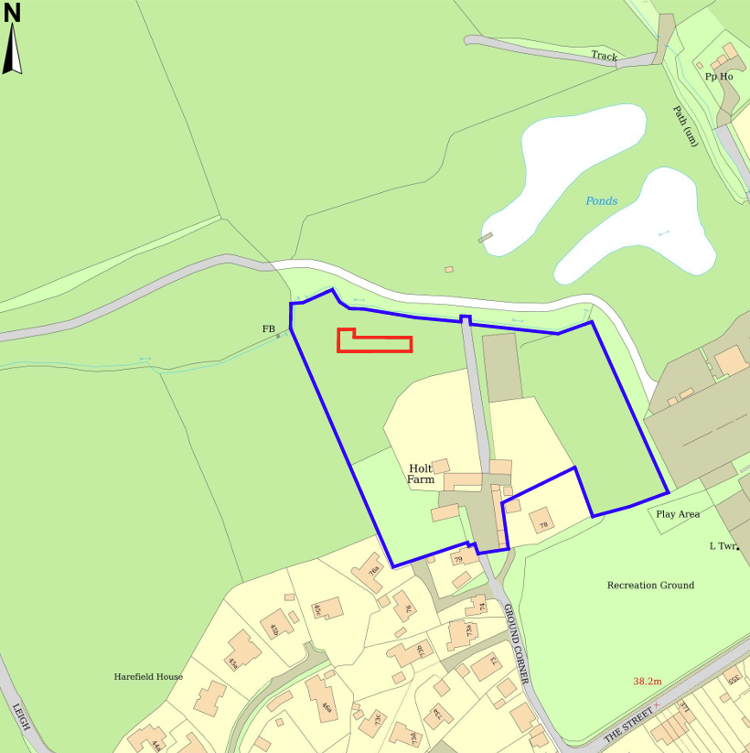

SITE DESCRIPTION/CONTEXT

The application site comprises an agricultural field forming part of the landholding associated with Holt Farmhouse, located to the south of Holt village. The field is enclosed by established hedgerow and tree cover and lies just south of a small watercourse. Holt Farmhouse, a Grade II listed building, lies approximately 80m to the southeast, marking the start of the Holt Conservation Area, although the proposed development falls just outside its boundary (the wider landholding extends into it). Public Rights of Way HOLT16 runs directly adjacent to the western boundary, with HOLT25 and HOLT18 connecting nearby. The site lies within Flood Zone 1, is not identified as being at risk of surface or groundwater flooding in the Strategic Flood Risk Assessment, and sits outside the Holt Settlement Boundary by approximately 110m. The land also falls within the 4km Core Roost Buffer for the Bath and Bradford on Avon Bats SAC.

PROPOSAL

This report considers a Section 73 application for the variation of Condition 2 (Approved Plans and Documents) attached to planning permission PL/2026/00705. The application relates to Holt Farm, Ground Corner, Holt, Trowbridge, BA14 6RT, and seeks to vary Condition 2 to allow amendments to the approved solar panel mounting system and an increase in the number of solar photovoltaic panels from 95 to 96. The revised mounting system would support the panels at an increased angle of approximately 25 degrees, resulting in a higher overall panel height, and is proposed on the basis that it would improve the energy generation and efficiency of the installation.

RELEVANT PLANNING HISTORY

Reference No. | Proposal / Summary | Decision
21/01854/FUL | Installation of ground-mounted Solar PV panels for residential power generation | Approved
13/01777/FUL | Conversion of cow byre into an artist's studio and storage | Approved
13/01797/LBC | Conversion of cow byre into an artist's studio and storage | Approved
W/05/02736/LBC | Replace current white aluminium double glazed units within the stone mullion surrounds with black metal windows | Approved
PL/2026/00705 | Proposed installation of 95 panels mounted via a low profile ground mounted racking system. | Approved
PL/2026/04964 | Non-material amendment to change the description of development of PL/2026/00705 to “Proposed installation of solar panels mounted via a low profile ground mounted racking system.” | Approved

RELEVANT LEGISLATION, POLICIES AND GUIDANCE

Town and Country Planning Act. 1990 (as amended)

Section 73 of the Town and Country Planning Act. 1990 (as amended) relates to the determination of applications to develop land without compliance with conditions previously attached. It states that:

(2) On such an application the local planning authority shall consider only the question of the conditions subject to which planning permission should be granted, and—

- if they decide that planning permission should be granted subject to conditions differing from those subject to which the previous permission was granted, or that it should be granted unconditionally, they shall grant planning permission accordingly, and

- if they decide that planning permission should be granted subject to the same conditions as those subject to which the previous permission was granted, they shall refuse the application.

The National Planning Practice Guidance (PPG) states the following:

- Nature of the Application: A Section 73 application is treated as a new planning permission, although it does not alter the original permission itself. The original permission remains intact and can still be implemented unless it has expired or been superseded.
- Limitations:
  - Section 73 cannot be used to change the description of development or the operative part of the permission (e.g. the nature or extent of the approved use).
  - It cannot be used to extend the time limit for implementing the original permission.
  - If the proposed changes go beyond what can reasonably be considered under Section 73, a new planning application under Section 70 would be required.
- Decision-making: The local planning authority must consider the application only in relation to the conditions subject to which the original permission was granted. However, it may impose new or revised conditions if granting a new permission.
- Legal Agreements: Because a Section 73 application results in a new permission, any existing Section 106 agreement may need to be varied or replaced via a deed of variation to ensure obligations continue to apply to the new permission.

Wiltshire Core Strategy

Core Policy 1 Settlement Strategy;
Core Policy 2 Delivery Strategy;
Core Policy 7 Spatial Strategy: Bradford on Avon Community Area;
Core Policy 41 Sustainable Construction and Low-Carbon Energy;
Core Policy 42 Standalone Renewable Energy Installations;
Core Policy 50 Biodiversity and Geodiversity;
Core Policy 51 Landscape;
Core Policy 57 Ensuring High-Quality Design and Place Shaping;
Core Policy 58 Ensuring Conservation of the Historic Environment;
Core Policy 60 Sustainable Transport;
Core Policy 61 Transport and Development;
Core Policy 64 Demand Management;
Core Policy 67 Flood Risk;

Holt Neighbourhood Plan 2016 to 2026 (January 2017)

The National Planning Policy Framework (NPPF)

The Planning Practice Guidance (PPG)

Wiltshire Design Guide

New Wiltshire Local Plan

At Full Council on 19 May 2026, the elected members of Wiltshire Council agreed to withdraw the emerging Wiltshire Local Plan. The said Plan has no material weight for the purposes of the application.

In accordance with Regulation 19 of the Town and Country Planning (Local Planning) (England) Regulations 2026, on 30th June 2026 Wiltshire Council published a notice of intention to prepare a new local plan for Wiltshire. The next stage is a Scoping Consultation which commences on 2nd September 2026. This plan is at a very early stage and currently carries no weight for decision making.

ISSUES

The key considerations in the assessment of this application are as follows:

- Whether the proposed amendments, comprising a revised mounting/racking system and the installation of one additional solar panel, fall within the scope of a Section 73 application seeking to vary Condition 2 (approved plans and documents) of planning permission PL/2026/00705.

- Whether the amended arrangement would give rise to any material changes in landscape character, visual amenity, heritage impacts, ecological interests, residential amenity, highway safety, or flood risk when compared to the previously approved development.

CONSULTATION RESPONSES

Holt Parish Council:

Holt Parish Council raised concerns regarding the proposed amendments. The Parish Council noted that the originally approved scheme comprised a low-profile solar array with a maximum height of approximately 0.4m above ground level, whereas the revised proposal would increase the height of the panels to approximately 2m. It considered this to represent a significant change from the approved development and expressed concern that the increased height could result in a greater visual impact, particularly when viewed from Public Right of Way HOLT16 adjacent to the site. The Parish Council therefore requested that the Local Planning Authority carefully assess the visual and landscape implications of the revised proposal and consider whether the amendments affect the reasons why the original scheme was found acceptable.

Ecology (Wiltshire Council) – No Objection

REPRESENTATIONS
Below is a summary of the representations received during the consultation period. Only material planning considerations have been taken into account in the assessment of this application. Non-material issues, such as property values or private legal disputes, cannot be considered in the determination process.

ASSESSMENT
Section 38(6) of the Planning and Compulsory Purchase Act 2004 states:

"If regard is to be had to the development plan for the purposes of any determination to be made under the planning Acts, the determination must be made in accordance with the plan unless material considerations indicate otherwise."

In accordance with this statutory requirement, this application has been assessed against the relevant policies of the Development Plan, including the Wiltshire Core Strategy (2015) and, where applicable, any made Neighbourhood Plans. Consideration has also been given to the policies of the National Planning Policy Framework (NPPF) as a material consideration in the assessment.

Principle of the Development – Do the proposed amendments fall within the scope of s73?

The application seeks to vary Condition 2 of planning permission PL/2026/00705 to substitute a revised set of approved drawings showing amendments to the solar panel mounting system and an increase in the number of panels from 95 to 96. Following the approval of non-material amendment application PL/2026/04964, the description of development is no longer tied to a specific panel number and therefore the proposed changes do not seek to amend the description of development itself. The amendments relate solely to the approved plans secured through Condition 2 and do not result in a fundamentally different form of development. The proposal is therefore considered to fall within the scope of Section 73 of the Town and Country Planning Act 1990 and can be determined accordingly.

Compliance with the Development Plan

The proposal has been assessed having regard to the conclusions reached under the original planning permission. The principal changes comprise an increase in the panel pitch to approximately 25 degrees, a revised mounting arrangement, and the reconfiguration of the array from three sections to four sections, together with the addition of a single solar panel. Notwithstanding these amendments, the development remains contained within essentially the same footprint, occupies the same location within the field, and would continue to benefit from the same degree of screening identified under the original application. Whilst the amended racking system results in a greater overall height, the array remains a modest and visually recessive form of development within a well-enclosed site. Having undertaken a comparative assessment of the approved and amended schemes, officers consider that the changes would not give rise to any materially different impacts in respect of landscape character, visual amenity, heritage assets, ecology, residential amenity, transport matters or flood risk.

Given that the amended development remains within the same location and overall extent as previously approved, the increased height of the panels would not materially alter the relationship between the development and Holt Farmhouse or the Holt Conservation Area, and the heritage conclusions reached under planning permission PL/2026/00705 remain unchanged.
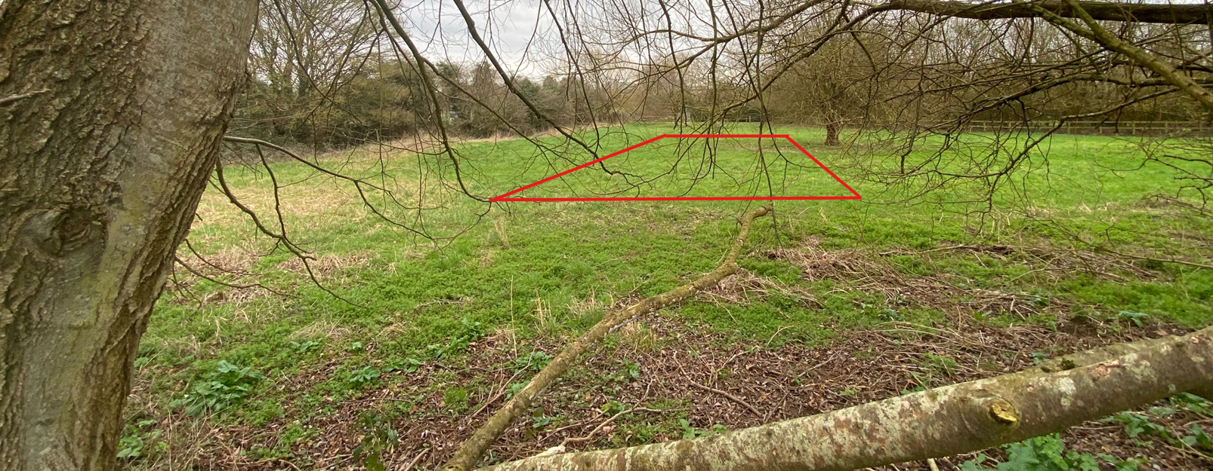
Site visit Image from PROW (HOLT16) and indicative location

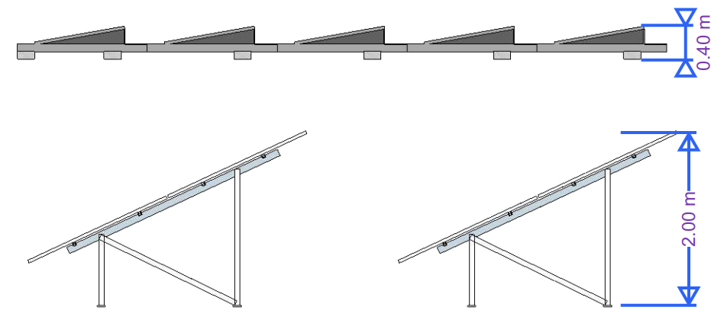
Top: as approved; Bottom: as proposed

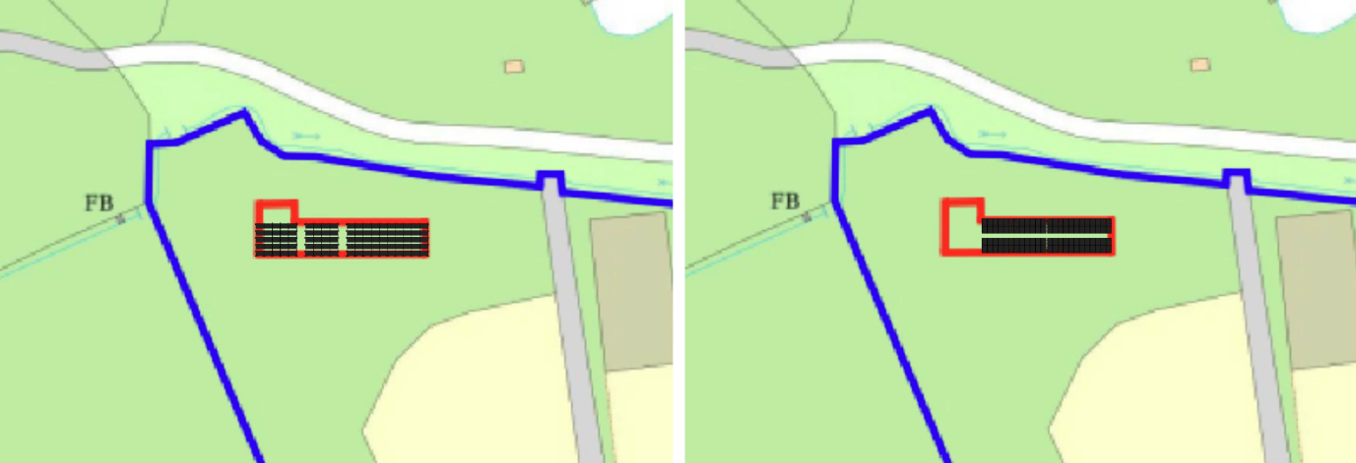
Right: as approved; Left: as proposed

The concerns raised by Holt Parish Council regarding the increased height of the solar array have been carefully considered. In contrast to the approved scheme, where the panels were mounted close to ground level at an approximate height of 0.4m, the amended proposal would result in a maximum height of approximately 2m through the use of an alternative mounting system and steeper panel pitch. Officers acknowledge that this represents a noticeable alteration to the form and appearance of the development and as such the proposal cannot be regarded as visually identical to that previously approved. Nevertheless, the development would remain within the same field parcel, occupy a comparable area of land, and continue to be viewed within the context of a rural field enclosed by established hedgerows and tree belts. The majority of public views into the site remain heavily filtered or prevented entirely by existing boundary vegetation, with the principal opportunity for visibility continuing to arise from Public Right of Way HOLT16 immediately adjacent to the site.

In assessing the amended scheme, particular regard has been given to whether the increase in height would result in a materially greater adverse effect upon landscape character or visual amenity. Whilst the panels would be more readily perceptible from sections of the adjacent public right of way, the increased height is principally attributable to the supporting framework beneath the panels, which by its nature is visually permeable and would not appear as a solid or continuous built form within the landscape. Furthermore, the revised arrangement reduces the extent of development closest to the boundary, such that views of the array continue to be experienced through and alongside existing vegetation rather than as an exposed or dominant feature. The orientation of the public right of way and boundary vegetation means that many views are oblique and filtered, with the most direct views occurring only over relatively short sections of the route. Having regard to the temporary and lightweight appearance of the development, the continued containment afforded by existing vegetation, and the limited extent of public visibility, officers conclude that whilst the amended proposal would have a somewhat greater visual presence than the approved scheme, this increase is not of a degree that would give rise to unacceptable harm to landscape character, visual amenity or the wider rural character of the area. The proposal therefore remains consistent with the relevant policies of the Wiltshire Core Strategy, Holt Neighbourhood Plan and the National Planning Policy Framework.

Assessment of Conditions

The application seeks to vary Condition 2 of planning permission PL/2026/00705 to substitute an amended set of approved plans reflecting the revised panel layout, mounting system and increase of one solar panel. The proposed variation is considered reasonable and necessary to facilitate the amended development assessed under this application. Condition 1, which secures the statutory time limit for implementation, remains relevant and necessary and should be reimposed. Condition 3, restricting construction hours in the interests of residential amenity, also remains relevant and should be carried forward unchanged. No conditions have been discharged or rendered obsolete as a result of the proposed amendments. Subject to the replacement of Condition 2 with an updated approved plans list, the revised suite of conditions is considered complete, enforceable and appropriate to the amended development.

PLANNING BALANCE AND CONCLUSION

In determining this application under Section 73 of the Town and Country Planning Act 1990, the Local Planning Authority has considered the extent to which the proposed amendments alter the impacts of the development previously approved under PL/2026/00705. The revised mounting system would improve the efficiency and renewable energy output of the installation, whilst the addition of a single panel represents only a negligible increase in the overall scale of the development. The amended arrangement remains confined to the same site and results in no materially different impacts upon the character and appearance of the area, heritage assets, ecology, residential amenity, highway safety or flood risk. As such, the proposal continues to comply with the development plan and relevant national guidance. The benefits associated with enhanced renewable energy generation are afforded positive weight and are not outweighed by any identified planning harm. Planning permission can therefore be granted subject to a revised Condition 2 referencing the amended approved plans.

RECOMMENDATION:
That Planning Permission be GRANTED subject to the following conditions:

It is noted that a number of the revised drawings submitted in support of the current application utilise the same drawing references and revision identifiers as those approved under planning permission PL/2026/00705. In order to ensure clarity and avoid ambiguity, Condition 2 has been amended to identify the approved plans by reference to both the drawing number and the date on which the relevant documents were received by the Local Planning Authority. This approach ensures that the permission relates solely to the amended plans considered under the current application and clearly distinguishes them from the drawings approved under the earlier permission.

1.
The development hereby permitted shall be begun before the expiration of three years from the date of this permission.

REASON: To comply with the provisions of Section 91 of the Town and Country Planning Act 1990 as amended by the Planning and Compulsory Purchase Act 2004.

2.
The development hereby permitted shall be carried out in accordance with the following approved plans and documents:

Top Plan – Proposed 40621-3 A (29 May 2026)
Trenching Details 40621-6 A (29 May 2026)
Block Plan 40621-1 A (29 May 2026)
Trees and Hedges 40621-7 A (29 May 2026)
Front Plan – Proposed 40621-4 A (29 May 2026)
Location Plan (2 Feb 2026)

REASON: For the avoidance of doubt and in the interests of proper planning.

3.
Construction hours shall be limited to 0800 to 1800 hrs Monday to Friday, 0800 to 1300 hrs Saturday and no working on Sundays or Bank Holidays.

REASON: To ensure the creation/retention of an environment free from intrusive levels of noise and activity in the interests of the amenity of the area.

