APPLICATION FOR HOUSEHOLDER PLANNING PERMISSION DELEGATED REPORT

APPLICATION REFERENCE: | PL/2026/04476
APPLICATION TYPE: | Householder planning permission
SITE ADDRESS: | Jays Cottage, Winterbourne Gunner, Salisbury, SP4 6EE
DEVELOPMENT DESCRIPTION: | Two storey side extension replacing existing side kitchen extension and single storey rear extension
RECOMMENDATION: | That Planning Permission be GRANTED

PROPOSAL

The proposal seeks planning permission for the erection of a two storey side extension replacing the existing side kitchen extension and single storey rear extension.

Existing elevations

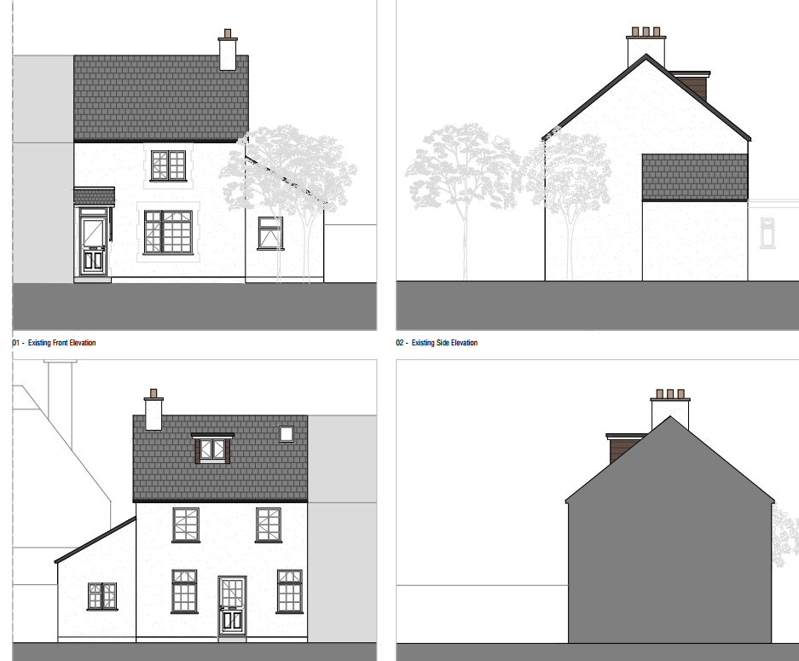

Proposed elevations

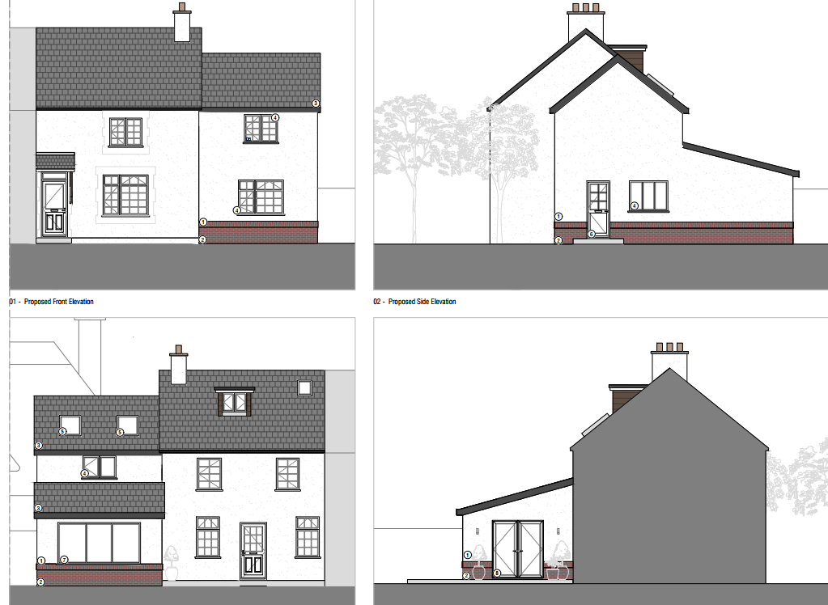

Existing floor plans

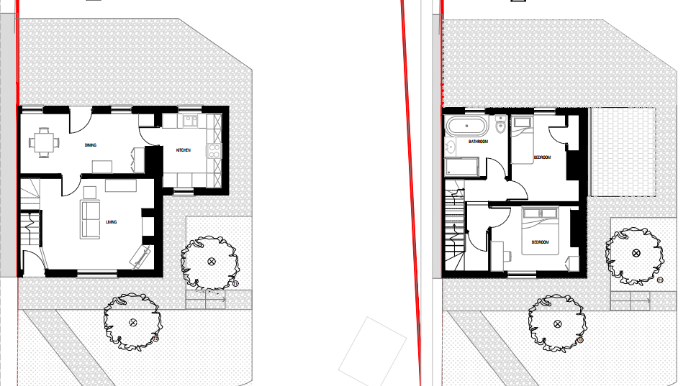

Proposed floor plans

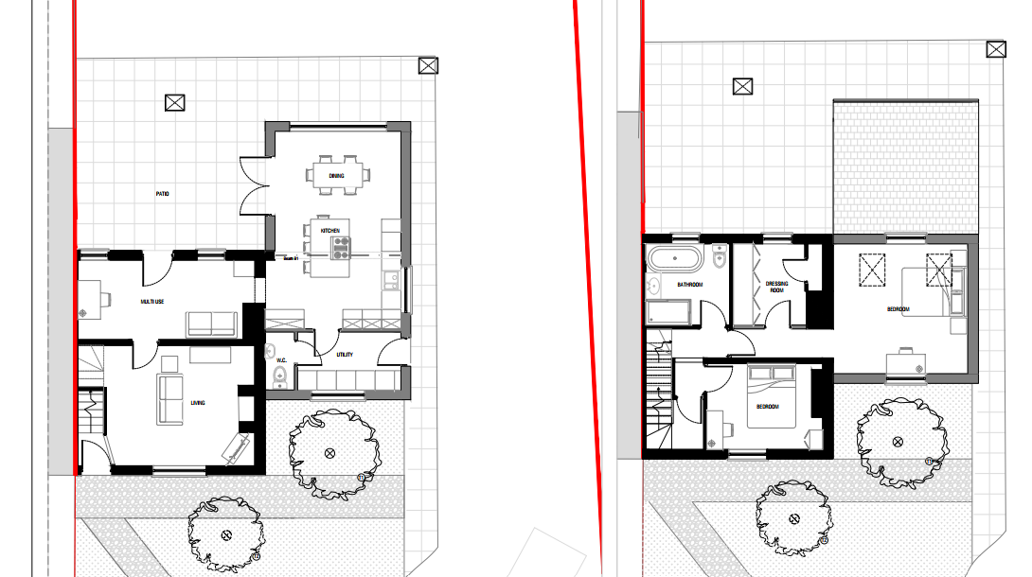

Revised plans were received during the application process to replace the two proposed first floor windows on the front elevation with a single central window to match the two storey extension at the other end of the terrace.

SITE DESCRIPTION/CONTEXT

The application site relates to an end of terrace two storey dwelling, located on the north east side of the A338 in Winterbourne Gunner. The property is set back from the road with gardens and parking to the front with an enclosed garden to the rear. Winterbourne Gunner together with Winterbourne Earls, Winterbourne Dauntsey and Hurdcott, are villages collectively defined as a Large Village by Wiltshire Core Strategy (WCS) policies CP1 (Settlement Strategy), CP2 (Delivery Strategy) and CP4 (Amesbury Community Area) and are known as The Winterbournes. The property is located within the Winterbournes Conservation Area and is adjacent to grade 2 listed dwelling known as Mellow Thatch.

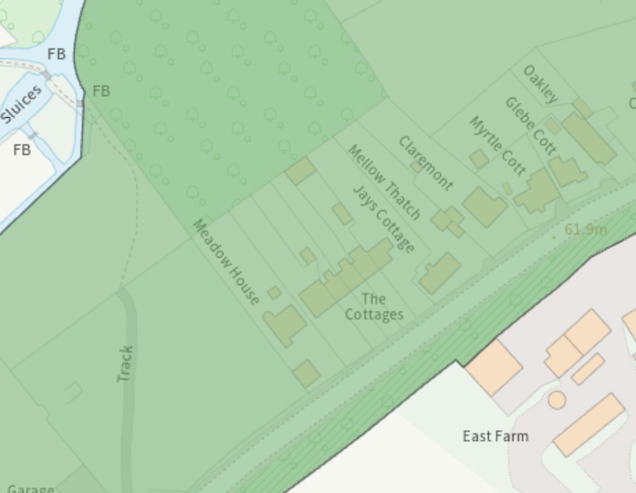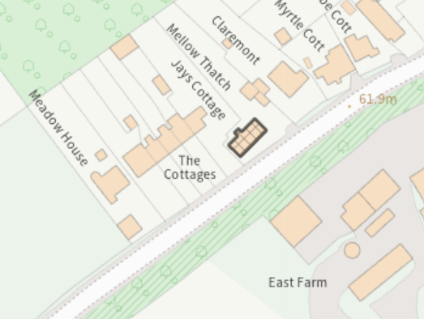

The site is also within the Special Landscape Area (saved policy C6 of the Salisbury District Local Plan).

According to the strategic flood risk assessment 2024, it is located within Flood Zone 1 with a risk of flooding to subsurface assets, but surface manifestation of groundwater is unlikely. The site is also located within the Hampshire River Avon Catchment Area and the New Forest Protected Sites 15km recreation zone of influence. However, these designations have no implication to this householder planning permission due to the nature of the proposed works.

PLANNING HISTORY

16/05927/FUL Loft conversion with roof light and dormer window to rear of property. Approved.

RELEVANT POLICIES AND GUIDANCE

The National Planning Policy Framework (NPPF)
The Planning Practice Guidance
National Design Guide

Wiltshire Core Strategy:

Core Policy 1: Settlement Strategy
Core Policy 2: Delivery Strategy
Core Policy 4: Spatial Strategy: Amesbury Community Area
Core Policy 50: Biodiversity and Geodiversity
Core Policy 51: Landscape
Core Policy 57: Ensuring High Quality Design and Place Shaping
Core Policy 58: Ensuring the Conservation of the Historic Environment
Core Policy 61: Transport and New Development
Core Policy 64: Demand Management
Core Policy 69: Hampshire River Avon SAC

Salisbury District Local Plan, saved policy C6 - Special Landscape Area

The Winterbourne’s Neighbourhood Plan
Wiltshire Design Guide: Appendix D – Design Guidance for Householder extensions
Creating Places Design Guide SPG (April 2006)
Achieving Sustainable Development SPG (April 2005)
Wiltshire Local Transport Plan – Car Parking Strategy

CONSULTATION RESPONSES

Parish Council: None received

Highways: No objections

REPRESENTATIONS

No comments were received.

ASSESSMENT

Section 38(6) of the Planning and Compulsory Purchase Act 2004 states:

"If regard is to be had to the development plan for the purposes of any determination to be made under the planning Acts, the determination must be made in accordance with the plan unless material considerations indicate otherwise."

In accordance with this statutory requirement, this application has been assessed against the relevant policies of the Development Plan, including the adopted Wiltshire Core Strategy (2015) and, where applicable, any made Neighbourhood Plans.

Character, Design, Heritage Impacts and impacts on special landscape area.

Section 66(1) of the Planning (Listed Buildings and Conservation Areas) Act 1990 requires special regard to be given to the desirability of preserving listed buildings, their settings and any features of special architectural or historic interest which they possess.

Section 72(1) of the same Act requires special attention to be paid to the desirability of preserving or enhancing the character or appearance of Conservation Areas.

Core Policy 58 of the Wiltshire Core Strategy seeks to conserve and, where appropriate, enhance the significance of designated and non-designated heritage assets and their settings.

Core Policy 57 requires development to respond positively to local character and historic context through high quality design.

Policies HE4-HE10 of the National Planning Policy Framework recognise heritage assets as an irreplaceable resource and require proposals affecting heritage assets to be assessed having regard to their significance and the contribution made by their setting.

Policies DP3 and DP4 of the National Planning Policy Framework require development to achieve a high standard of design that responds positively to local character and context. In assessing design quality, regard should be had to matters including scale, siting, form, appearance, materials and the relationship of development to its surroundings.

The proposed two storey side extension has been designed as a subservient addition to the host dwelling. The extension would be set back from the principal elevation and would incorporate a lowered ridge height, ensuring that it remains visually subordinate to the original dwelling and clearly identifiable as a later addition. Whilst replacing an existing single storey side extension, the proposal would not project any further forward than the structure it replaces, thereby maintaining the established building line and relationship with the street scene.

The proposed single storey rear extension would be located to the rear of the dwelling and would not be readily visible from the public realm. Given its modest scale, simple design and subordinate relationship with the host dwelling, no concerns are raised in respect of this element of the proposal. The rear extension would not appear visually intrusive or out of keeping with the character and appearance of the dwelling or surrounding area.

The proposed materials are considered appropriate and would complement the appearance of the existing dwelling, helping to ensure the extensions integrate successfully with the host property and wider terrace. A condition can reasonably be imposed to secure the use of the materials as detailed within the application submission in the interests of visual amenity.

In terms of its scale, form and appearance, the extension is considered proportionate to the host dwelling and would integrate satisfactorily with the existing property. The proposal reflects the approach taken in the extension approved to the dwelling at the opposite end of the terrace, helping to maintain a coherent and balanced appearance across the terrace group. Subject to the use of matching external materials, the development would preserve the character and appearance of the dwelling, the wider street scene and the Winterbournes Conservation Area.

The proposal has also been assessed in respect of its impact on the setting of the adjacent Grade II listed building, Mellow Thatch. Given the setback position of the extension, its subservient scale and design, and the separation distance maintained between the two properties, the proposal would preserve the setting and significance of the Grade II listed building. The proposal would therefore preserve the setting of the heritage asset in accordance with Core Policy 58 and the statutory duty set out in Section 66(1) of the Planning (Listed Buildings and Conservation Areas) Act 1990.

Accordingly, the proposal is considered to accord with Core Policies 57 and 58 of the Wiltshire Core Strategy, saved Policy C6 of the Salisbury District Local Plan, the design guidance contained within Appendix D of the Wiltshire Design Guide, and Policies DP3 and DP4 of the NPPF.

Amenity

Point vii of Core Policy 57 - Ensuring High Quality Design and Place Shaping of the Wiltshire Core Strategy seeks to ensure that developments do not adversely affect neighbouring properties.

Policy P3 of the National Planning Policy Framework requires development to be appropriate for its location, taking account of its likely effects on health, living conditions and the environment. In particular, Policy P3(2)(b) requires development to avoid giving rise to unacceptable impacts on the living conditions of neighbouring residents and occupiers. In assessing amenity impacts, regard should be had to matters including daylight and sunlight, outlook, privacy, overbearing impacts and other effects on residential amenity.

The proposed development has been assessed having particular regard to potential impacts in terms of overlooking, loss of privacy, overshadowing and overbearing effects on neighbouring occupiers. By reason of its siting, scale and design, the proposed extensions are not considered to result in any unacceptable overbearing impacts or loss of light to neighbouring properties. The development would remain proportionate to the host dwelling and would not give create any significant overshadowing of neighbouring gardens or habitable rooms.

In respect of privacy, it is acknowledged that the proposed first floor window within the front elevation would provide additional views towards the rear of the neighbouring property known as Mellow Thatch. However, Mellow Thatch also contains first floor windows within its rear elevation and, having regard to the existing relationship between the properties, the separation distance maintained and the nature of the views available, the level of additional overlooking is not considered to be so significant as to warrant refusal of the application in this instance.

Furthermore, no first floor windows are proposed within either side elevation of the extension and therefore no direct overlooking of properties to the east would arise as a result of the development. In the interests of safeguarding neighbouring amenity, a condition can be imposed on any permission given removing permitted development rights for the insertion of additional first floor windows or other openings within the side elevation without the prior written approval of the Local Planning Authority.

The proposal is therefore considered to comply with Core Policy 57 of the Wiltshire Core Strategy, Appendix D of the Wiltshire Design Guide and Policy P3 of the NPPF

Highways Impact

Core Policy 57 (xiv) of the Wiltshire Core Strategy seeks to ensure that development must meet the requirements of Core Policy 61. This policy requires proposals to be capable of being served by safe access to the highway network. Core Policy 64 seeks to ensure compliance with parking standards set out in the Local Transport Plan.

The transport policies of the NPPF seek to ensure that development provides safe and suitable access for all users and that any impacts on highway safety are appropriately considered.

The proposed development will retain the property as a two bedroomed dwelling and will not therefore necessitate any additional parking provision on the site. The existing vehicle access is not proposed to be altered.

The proposed development would not result in any adverse impact on highway safety. Adequate parking and turning provision is provided in accordance with Wiltshire’s adopted parking standards, and access arrangements are acceptable.

The proposal is therefore considered to comply with Core Policies 57 (xiv), 61 and 64 of the Wiltshire Core Strategy, the NPPF, and the Wiltshire Local Transport Plan.

Ecology Impact
Core Policy 50 of the Wiltshire Core Strategy seeks to protect and enhance biodiversity and geodiversity, including through ensuring that development avoids harm to protected species and habitats.

Policy N2 of the NPPF seeks to conserve and enhance biodiversity and support nature recovery. Development proposals should minimise impacts on habitats and species and, where relevant, demonstrate that appropriate mitigation measures are secured where harm cannot be avoided.

The application site is not subject to any statutory or non-statutory ecological designations, and the scale and nature of development is such that significant harm to biodiversity is unlikely.

Biodiversity Net Gain - Householder planning applications are exempt from the requirement to deliver Biodiversity Net Gain under Schedule 7A, Section 4(2)(a) of the Town and Country Planning Act 1990, as inserted by the Environment Act 2021.

As such, the development complies with Core Policy 50 of the Wiltshire Core Strategy and the relevant provisions of the NPPF.

CONCLUSION

The proposed extensions are considered acceptable in terms of their scale, design and appearance and would preserve the character and appearance of the dwelling, surrounding area, Winterbournes Conservation Area and the setting of the adjacent Grade II listed building. The proposal would not result in any unacceptable impact on neighbouring residential amenity or any other material planning consideration. The development therefore accords with the relevant provisions of the Wiltshire Core Strategy, the National Planning Policy Framework and other material considerations and is recommended for approval subject to conditions

RECOMMENDATION: That Planning Permission be GRANTED subject to conditions.

1.The development hereby permitted shall be begun before the expiration of three years from the date of this permission.

Reason: To comply with the provisions of Section 91 of the Town and Country Planning Act 1990, as amended by the Planning and Compulsory Purchase Act 2004.

2. The development hereby permitted shall be carried out in accordance with the following approved plans and documents.

Application form received 17/07/2026
Location plan Drg no 00-001 Rev P1 received 17/07/2026
Proposed site plan Drg no 10-002 Rev P1 received 17/07/2026
Proposed elevations Drg no 10-200 Rev P3 received 25/08/2026
Proposed ground floor plan and first floor plan Drg no 10-100 Rev P3 received 25/08/2026
Proposed loft plan and roof plan Drg no 101 Rev P2 received 31/07/2026

REASON: For the avoidance of doubt and in the interests of proper planning.

3. Materials to be used in the development hereby permitted shall be as stated on the application form and approved plans and to match the existing dwelling.

REASON: In the interests of visual amenity and the character and appearance of the area.

4. Notwithstanding the provisions of the Town and Country Planning (General Permitted Development) (England) Order 2015 (or any Order revoking or reenacting or amending that Order with or without modification), no windows, doors or other form of openings other than those shown on the approved plans, shall be inserted in the north east or south east elevations above ground floor ceiling level of the development hereby permitted.

REASON: In the interests of residential amenity and privacy.

