APPLICATION FOR FULL-PLANNING PERMISSION CASE OFFICER REPORT

APPLICATION REFERENCE: | PL/2026/04305
APPLICATION TYPE: | Full planning permission
SITE ADDRESS: | Coombe Down Farm, Blandford Road, Coombe Bissett, SP5 4LJ
DEVELOPMENT DESCRIPTION: | Change of use of land to ancillary garden land associated with the existing residential accommodation.
RECOMMENDATION: | Refuse

SITE DESCRIPTION/CONTEXT

The application site relates to Coombe Down Farm, a primarily agricultural property with approx. 7.86 hectares of agricultural land and associated agricultural buildings; mixed with a B2 commercial use to provide engineering workshop facilities to serve a rural land-based industry with associated one bedroom flat above. The residential flat is tied by condition for occupation solely by a person(s) employed in the B2 use of the property. The site is located on the west side of the A354, accessed direct from the A354 via a sloping private driveway. The land rises steeply to the west, and the site is located in a prominent location within the Coombe Bissett valley.

The application site is located outside of the settlement boundary for Coombe Bissett which is defined as a large village through Core Polices 1, 2 and 23 of the Wiltshire Core Strategy and is therefore considered to be in the open countryside.

The application site is located within the Cranborne Chase & West Wiltshire Downs National Landscape formerly (AONB); the Hampshire River Avon Catchment, it is also within the 13.8 kilometres recreational zone of influence for the New Forest SAC, Special Protection Area (SPA) and Ramsar site.

PROPOSAL

The application is seeking retrospective consent for the change of use of an area of agricultural land to ancillary residential garden land associated with the existing first-floor one bedroom residential unit. The area of land seeking permission is shown outlined red on the applicants submitted red line plan below.

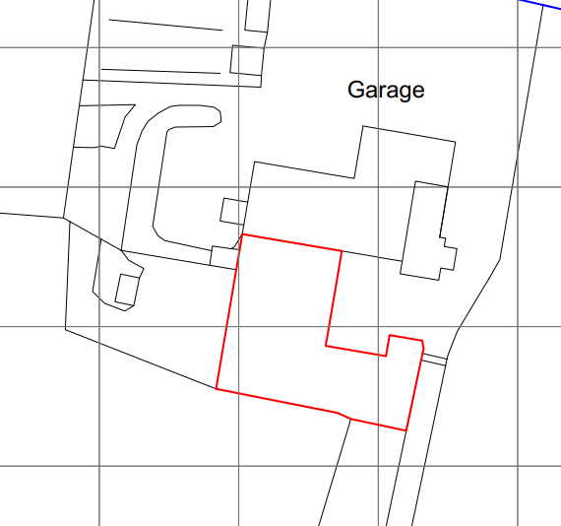

The application has been submitted following the refusal of planning application PL/2025/09304 and proposes a revised application boundary intended to reflect the extent of land currently in domestic use. The previous red line as submitted with application PL/2025/09304 is shown below.

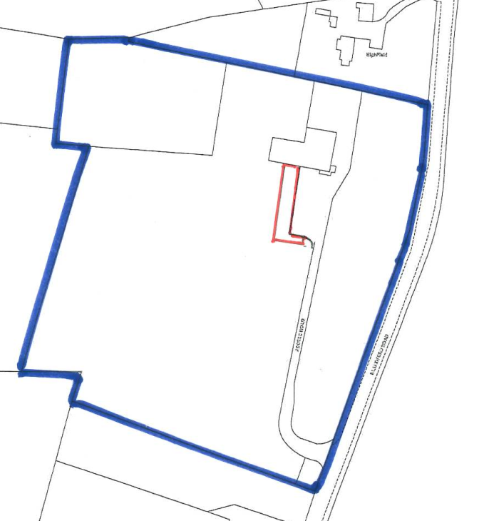
Photo of garden area included below taken from the balcony of the residential flat.

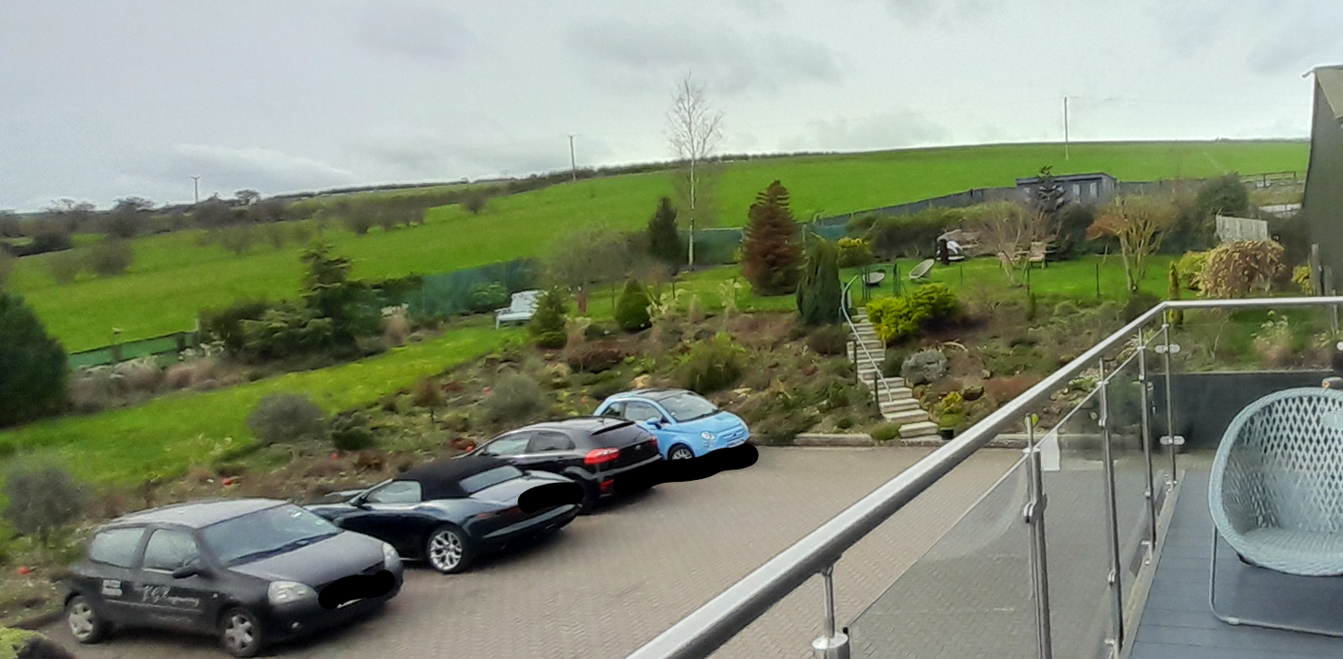

PLANNING HISTORY

Proposal / Summary
PL/2025/09224 - Full planning permission Decision - Withdrawn by Applicant Date: 20/4/2026 – Addition of external door on first floor and extension of landing area to existing balcony
PL/2026/02380 - Lawful development: Existing use Decision - Withdrawn by Applicant Date: 7/5/2026 – Erection of two goat sheds and two storage containers
PL/2026/04443 - Full planning permission – Addition of an external door at first-floor level, extension of the landing area to the existing balcony and associated external access works serving the approved ancillary residential accommodation. LIVE APPLICATION UNDER CONSIDERATION
13/01037/ADV - Consent to display an advertisement Decision - Approve with Conditions Date: 13/6/2014 – Retrospective application for the erection of 6 non illuminated signs (relating to the business) situated near vehicular access to site
PL/2022/02111 - Full planning permission Decision - Approve with Conditions Date: 2/8/2022 – Change of use of first floor store into small living accommodation.
PL/2023/03919 - Full planning permission Decision - Refuse Date: 9/8/2023 – Erection of bungalow
PL/2023/07449 - Full planning permission Decision - Approve with Conditions Date: 8/11/2023 – Formation of balcony with external stairs and two new windows.
PL/2025/09295 - Full planning permission Decision - Refuse Date: 21/4/2026 – Retrospective Application for Farm Office
PL/2025/09300 - Full planning permission Decision - Refuse Date: 21/4/2026 – Retrospective Application for Creation of a Vehicle Ramp
PL/2025/09304 - Full planning permission Decision - Refuse Date: 21/4/2026 – Retrospective Change of Use of Farmland to Domestic Garden Area
S/2009/0853 - Full planning permission Decision - Withdrawn Date: 10/8/2009 – demolition of corrugated iron structure. change of use of redundant agricultural buildings to commercial (b1) use, alterations and extensions to building together with formation of replacement highway access and track and associated landscaping works
S/2009/1806 – Full planning permission Decision – Approve with Conditions Date: 15/02/2010 - Change of use of redundant agricultural buildings to B2 commercial use to provide engineering workshop facilities to serve rural land-based industry. demolition of corrugated iron structure, alterations and extension to existing buildings together with formation of a new highway access and associated landscaping works

RELEVANT LEGISLATION, POLICIES AND GUIDANCE

Statutory Legislation:

National Planning Policy:
- National Planning Policy Framework (NPPF) 2026
- Planning Practice Guidance (PPG)

Development Plan:

The development plan for Wiltshire comprises the Wiltshire Core Strategy (WCS) (adopted January 2015) and any made neighbourhood plans, which remains the principal statutory planning document guiding development across the county. In line with Section 38(6) of the Planning and Compulsory Purchase Act 2004, planning decisions must be made in accordance with the development plan unless material considerations indicate otherwise.

Though the development plan is considered as a whole, those parts deemed to be particularly relevant to this application are listed below:

The adopted Wiltshire Core Strategy (WCS), with particular regard to:
- Core Policy 1 Settlement Strategy;
- Core Policy 2 Delivery Strategy;
- Core Policy 3 Infrastructure Requirements;
- Core Policy 23 Southern Wiltshire Spatial Strategy Community Area;
- Core Policy 35 Existing Employment Land;
- Core Policy 48 Supporting Rural Life;
- Core Policy 50 Biodiversity and Geodiversity;
- Core Policy 51 Landscape;
- Core Policy 57 Ensuring High Quality Design and Place Shaping;
- Core Policy 60-64 Transport;
- Core Policy 69 River Avon SAC;

Draft Wiltshire Local Plan Policies

At Full Council on 19 May 2026, the elected members of Wiltshire Council agreed to withdraw the emerging Wiltshire Local Plan. The said Plan has no material weight for the purposes of the application.

In accordance with Regulation 19 of the Town and Country Planning (Local Planning) (England) Regulations 2026, on 30th June 2026 Wiltshire Council published a notice of intention to prepare a new local plan for Wiltshire. The next stage is a Scoping Consultation which commences on 2nd September 2026. This plan is at a very early stage and currently carries no weight for decision making

Supplementary Planning Documents and other Guidance:

Wiltshire Design Guide (adopted April 2024)
Wiltshire Local Transport Plan 2011-2026, adopted 2015 - including the Car Parking Strategy and Cycling Strategy, adopted 2015
Creating Places Design Guide
Cranborne Chase & West Wiltshire Downs National Landscape formerly (AONB) Management Plan
National Design Guide

Neighbourhood Plan:

Coombe Bissett and Homington Neighbourhood Plan 2023-2038, Made January 2026

Since the previous application (PL/2025/09304 ) was determined, the NPPF has been updated (August 2026), this report therefore considers the new NPPF and not the NPPF 2024 which was considered as part of the assessment of refused application PL/2025/09304.

It is also noted that the Coombe Bissett and Homington Neighbourhood Plan has been considered as part of this current assessment.

ISSUES

Principle, Character and Landscape impacts.
Amenity
Highway safety
Ecology

CONSULTATION RESPONSES

Parish Council: No objection

REPRESENTATIONS

In accordance with the requirements of the Town and Country Planning (Development Management Procedure) (England) Order 2015 (as amended), the application was publicised by way of:

- Neighbour notification letters sent to adjoining and nearby properties;
- A site notice displayed near the site;

These methods were used to inform interested parties and provide a period of 21 days for comments to be submitted.

Below is a summary of the representations received during the consultation period. Only material planning considerations have been taken into account in the assessment of this application; non-material planning issues, cannot be considered in the determination process.

- Petition containing 160 signatures in support of the application

- 80 letters of support – noting the stance made ranges from support/object/comment/no objection as it appears that third parties misunderstood how to complete the Council’s on line comments box; the contents of the comments received have been considered not the stance made, points raised include -

- Garden enhances the appearance and character of the site and its surroundings.
- Calm, welcoming environment
- The established planting, trees, shrubs and flowers provide biodiversity benefits, habitats and support a range of wildlife, including birds, bees, butterflies, hedgehogs and other pollinating insects.
- Opposite Coombe Bissett Down Nature Reserve, complements this site
- The land has limited agricultural value due to its steep gradient and size.
- Retention of the landscaped area is preferable to restoring the land to agricultural use.
- The garden provides a pleasant and attractive environment for customers visiting the adjoining garage business while waiting for vehicle repairs and MOT testing.
- Applicants put in a lot of time, effort and financial investment in establishing and maintaining the landscaped garden over a number of years
- Landscaped garden has become an established feature of the site and contributes positively to the setting of the existing business premises.
- Is not detrimental to the area
- Must remain
- No houses should be built
- The garden is associated with the residential approved accommodation, which is on the first floor, why would you not want a garden to enjoy and enhance your living conditions, welfare and amenity
- Can’t be seen from outside of the site
- Is not permanent, next person may not want a garden and could change it
- Unreasonable to remove the garden
- Bureaucratic nonsense
- Should be encourage not discouraged
- Noone is using the agricultural field

ASSESSMENT

Section 38(6) of the Planning and Compulsory Purchase Act 2004 states:

"If regard is to be had to the development plan for the purposes of any determination to be made under the planning Acts, the determination must be made in accordance with the plan unless material considerations indicate otherwise."

In accordance with this statutory requirement, this application has been assessed against the relevant policies of the Development Plan, including the Wiltshire Core Strategy (2015) and, where applicable, any made Neighbourhood Plans. Consideration has also been given to the policies of the National Planning Policy Framework (NPPF) as a material consideration in the assessment.

The assessment below considers each of the main issues identified above. Each topic is assessed in turn with reference to the relevant policy context, the evidence submitted, consultee responses, and all other material considerations, before a conclusion is reached.

Principle, Character and Landscape impacts

Policy S5 of the National Planning Policy Framework (2026) sets out that only certain forms of development should generally be approved outside settlements.

Policies DP1-DP4 of the NPPF seek to ensure that development is well-designed, visually attractive, sustainable and responsive to its surroundings. Development should contribute positively to local character, create high quality places and support healthy and inclusive communities.

Policy N2 of the NPPF seeks to conserve and enhance the natural environment and requires development to take account of landscape character, local distinctiveness and the natural beauty of the countryside.

Policy N4 of the NPPF affords significant protection to National Landscapes and requires development proposals to conserve and enhance their natural beauty and special qualities.

At a local level, WCS policy CP57 (Ensuring High Quality Design & Place Shaping), further requires a high standard of design in all new developments through, in particular, enhancing local distinctiveness; retaining and enhancing existing important landscaping and natural features; being sympathetic to and conserving historic buildings and landscapes in terms of layouts, massing, building heights and plot sizes; and making efficient use of land whilst taking into account the local context and surrounding uses.

Core Policy CP51 of the WCS requires development to protect, conserve and where possible enhance landscape character and must not have a harmful impact upon landscape character, while any negative impacts must be mitigated as far as possible through sensitive design and landscape measures.

Under Section 245 of the Levelling-up and Regeneration Act 2023, the Council must seek to further the purposes of National Landscapes when exercising its planning functions.

The Wiltshire Design Guide provides further guidance on achieving high quality, context-led design and should be taken into account where relevant, supporting development that integrates with landscape features and local character.

Coombe Bissett Neighbourhood Plan Made January 2026, of relevance are policies

- EDH1 - Views and Landscape Character - Development proposals should give the highest priority to conservation and enhancement of the scenic beauty of the parish
- EDH3 – Design - Development proposals should be in keeping with the rural character of the neighbourhood area
- EM2 - Business in the Countryside - Requires business development to be without detriment to the visual qualities of the National Landscape

The application seeks retrospective consent for the change of use of agricultural land to residential garden associated with a one-bedroom flat that is physically separated from the land and subject to an occupancy tie linked to the commercial use of the site. The area of land subject to the change of use under application S/2009/1806 for the original conversion of the existing agricultural buildings to commercial/workshop is shown as landscaped and “to establish a rough meadow”.

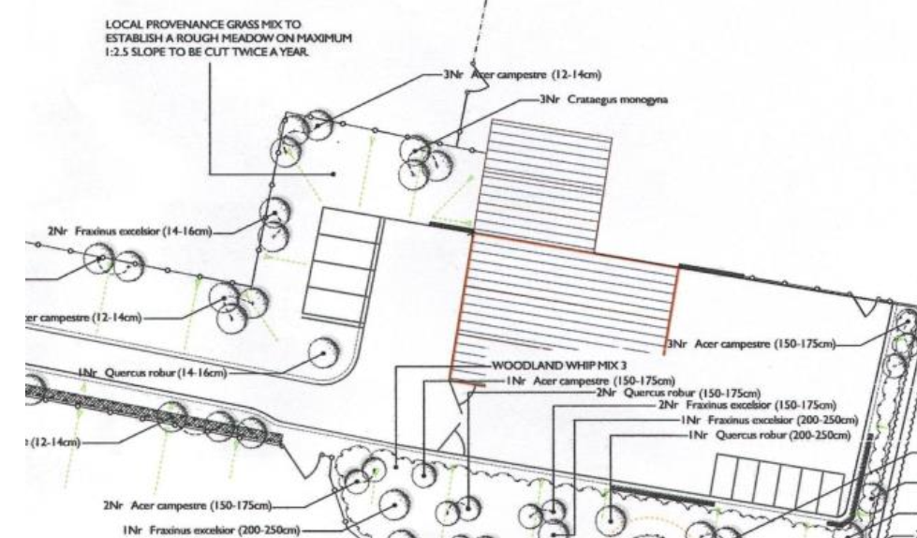

This approved landscaping scheme associated with planning permission S/2009/1806 is relevant to the assessment because it demonstrates that, whilst landscaping formed part of the approved redevelopment of the site, the land was not intended to function as domestic garden land. The approved permission related to the conversion of redundant agricultural buildings to a commercial workshop use and pre-dated the introduction of the ancillary residential accommodation approved under planning permission PL/2022/02111. The approved plans identify the area as landscaped land and "rough meadow", reflecting its role in assimilating the commercial development into the surrounding countryside and contributing to the wider landscape setting of the site. The subsequent use of the land as domestic garden associated with residential occupation therefore represents a material change from the character, function and purpose of the landscaping originally approved.

As mentioned above, the application boundary has been amended from the previously refused application to better reflect the extent of land the applicant currently considers to be in domestic use. The area of land subject to the change of use now shown within the red line area appears to comprise a materially larger area than that assessed under the recently refused application PL/2025/09304. However, whilst this amendment does not materially alter the planning assessment or overcome the concerns that led to the previous refusal, in fact, it exacerbates the concerns given the greater extent of potential residential incursion into the rural landscape.

The site lies outside the defined settlement boundary for Coombe Bissett and is therefore located within the open countryside. Policy S5 of the National Planning Policy Framework is therefore applicable. The proposal would result in the extension of a residential use into the countryside through the creation of a substantial area of domestic garden land associated with the approved one-bedroom flat. The proposal does not fall within any of the categories of development identified within Policy S5(1) as potentially acceptable outside settlements and must therefore be considered against Policy S5(4). In this instance, no exceptional circumstances have been demonstrated, and the benefits of the proposal are not considered to substantially outweigh the adverse effects, including the identified harm to the character and appearance of the countryside and National Landscape.

In terms of this current application, the proposal would change the use of agricultural land to residential garden associated with a one-bedroom flat that is physically separated from the land and subject to an occupancy tie linked to the site’s commercial use. The land currently forms part of the agricultural setting surrounding the commercial complex at Coombe Down Farm and contributes to the transition between the developed elements of the site and the wider rural landscape. Its use as residential garden land would introduce a distinctly domestic character and activity into an area that presently performs a countryside and landscape function, resulting in the erosion of rural character and the encroachment of residential use into the National Landscape.

Limited weight is afforded to the need for domestic garden land in this location. The associated accommodation comprises a modest one-bedroom flat which remains subject to an occupancy restriction linking occupation to the commercial use. The proposed garden area is extensive in scale relative to the accommodation it is intended to serve and is physically separated from the flat by the operational yard and commercial activities. The application has therefore failed to demonstrate why an area of domestic curtilage of this size is reasonably required or justified particularly having regard to the modest scale of the associated one-bedroom accommodation and its ancillary relationship to the commercial use.

Whilst it is acknowledged that the site forms part of a wider mixed-use complex containing agricultural, commercial and ancillary residential uses, this does not alter the fact that the application land remains agricultural land in planning terms. The use of the land as a private residential garden would materially change its character and function from agricultural land to domestic curtilage. The planning harm identified arises from that change of use itself and the resultant domestication of the land, irrespective of whether the land is physically adjacent to other developed parts of the site.

The applicants planning statement confirms that there are no operational works involved, however, the absence of operational development does not negate the planning consequences of the proposal. The harm identified arises from the change in the character and function of the land itself from agricultural land to domestic curtilage, rather than from the erection of any buildings or structures.

Whilst representations received in support of the application largely indicate that the land is used by customers waiting for vehicles to be repaired at the adjoining garage, the application before the Council seeks planning permission for the change of use of the land to residential garden associated with the approved residential accommodation. Limited evidence has been provided regarding the frequency or extent of customer use, or whether customers instead utilise the existing waiting facilities available on site. As such, the claimed use of the land by garage customers is afforded limited weight in the assessment of the ancillary residential garden use rather than an extension of the business side of the overall site.

In the absence of compelling justification for this ancillary garden area to serve a one bed flat, the proposal represents an unjustified extension of residential use into the countryside, resulting in harm to the character, appearance and special qualities of the National Landscape, contrary to Core Policy 51 (Landscape) and failing to demonstrate a contextually responsive design approach as required by Core Policy 57 (Ensuring High Quality Design and Place Shaping) of the Wiltshire Core Strategy.

The proposal is also considered to conflict with Policy EDH1 of the Coombe Bissett and Homington Neighbourhood Plan which seeks to give the highest priority to the conservation and enhancement of the scenic beauty of the parish and the safeguarding of open countryside. The proposal further conflicts with Policy EDH3 which requires development to be in keeping with the rural character of the neighbourhood area.

Amenity

Point vii of Core Policy 57 - Ensuring High Quality Design and Place Shaping of the Wiltshire Core Strategy seeks to ensure that developments do not adversely affect neighbouring properties.

Policy P3 of the NPPF requires development to be appropriate for its location, taking account of its likely effects on health, living conditions and the environment. In particular, Policy P3(2)(b) requires development to avoid giving rise to unacceptable impacts on the living conditions of neighbouring residents and occupiers. In assessing amenity impacts, regard should be had to matters including daylight and sunlight, outlook, privacy, overbearing impacts and other effects on residential amenity.

There are no immediate neighbouring residential properties that will be affected by the residential garden use given its siting within the Coombe Down Farm site.

Highways Impacts and Parking

Policies TR3-TR8 of the NPPF seek to ensure that development is supported by safe, suitable and sustainable transport arrangements. Development should provide appropriate access, promote sustainable travel choices where possible and avoid unacceptable impacts on highway safety and the operation of the transport network.

Core Policies 60-64 of the Wiltshire Core Strategy require development to provide safe access, promote sustainable transport, minimise transport impacts and provide appropriate parking arrangements.

The development relates to the creation of a garden for use by the occupant(s) of the residential one bedroomed flat. The garden area was originally agricultural land and has not resulted in any loss of existing parking space or the creation of additional residential units. There is also adequate parking within the wider site noting the applicant already parks vehicles on site. There are therefore no highway safety concerns raised.

Ecology and Biodiversity

Core Policy 50 of the Wiltshire Core Strategy and the National Planning Policy Framework requires that the planning authority ensures protection of important habitats and species in relation to development and seeks enhancement for the benefit of biodiversity through the planning system.

Policy N2 of the NPPF seeks to conserve and enhance biodiversity, support nature recovery, protect habitats and species, and strengthen ecological networks.

BNG - From 12 February 2024 Biodiversity Net Gain (BNG) became mandatory under Schedule 7A of the Town and Country Planning Act 1990 (as inserted by Schedule 14 of the Environment Act 2021). Based on the information available the biodiversity gain planning condition is not considered to apply to this application as the application is for retrospective consent and BNG does not apply to retrospective development.

River Avon SAC - This development falls within the catchment of the River Avon SAC and has potential to cause adverse effects alone or in combination with other developments through discharge of phosphorus in wastewater. A test of likely significance has been carried out by the relevant Competent Authority (Wiltshire Council) as required by Regulation 63 of the Conservation of Habitats and Species Regulations 2017 (as amended). Given that technically there will be no net increase in overnight accommodation (the proposed works are not to add a new dwelling, but to retain land which has been changed from agricultural to residential garden use), it can be considered that there would be no overall mechanism for adverse effect. The HRA has concluded that the application is not likely to have significant impacts on the SAC and subsequently the application is screened out of Appropriate Assessment.

New Forest SPA, New Forest SAC and New Forest Ramsar site -The site is located within the 13.8km zone of influence for the New Forest internationally protected sites, which comprises the New Forest SPA, New Forest SAC and New Forest Ramsar site. Any applications within this area are screened into appropriate assessment under the Conservation of Habitats and Species Regulations 2017 (as amended) on account of its potential to cause adverse effects on the New Forest protected sites through increased recreational pressure which may occur alone and in-combination with other plans and projects. Many of the special features of the New Forest protected sites afforded protection are vulnerable to adverse effects associated with an increase in recreation as demonstrated in Natural England’s supplementary advice issued for the SPA on 19 March 2019 and for the SAC on 18 March 2019. Following a Cabinet decision on 7 May 2024, Wiltshire Council’s “Interim recreation mitigation strategy for the New Forest internationally protected sites” (Version 1.1, 21 March 2023) is being revised. However, as the development relates to the change of use from agricultural land to residential garden and does not involve new overnight accommodation, nor will it be bringing additional people to the locality which will impact on the New Forest protected sites it can be screened out of Appropriate Assessment.

Whilst the established landscaping may provide some biodiversity interest, this does not outweigh the planning harm arising from the unjustified domestication of agricultural land within the National Landscape. Furthermore, the application seeks retention of a residential use rather than the protection of ecological features and no evidence has been provided to demonstrate that refusal would necessarily result in the removal of established planting.

PLANNING BALANCE AND CONCLUSION

On balance, the proposal would result in the unjustified change of use of agricultural land to residential garden land associated with a modest one-bedroom flat that is ancillary to the wider commercial use of the site and subject to an occupancy restriction. The proposed garden area is extensive relative to the accommodation it is intended to serve and is physically separated from it by the operational yard and commercial activities.

Whilst the site forms part of a wider mixed-use complex and the benefits associated with the existing landscaping, planting, biodiversity benefits and general upkeep of the land are acknowledged, these considerations are not considered sufficient to outweigh the harm identified. The proposal would result in the domestication of agricultural land and the unjustified encroachment of residential use into the countryside, to the detriment of rural character, landscape character and the scenic quality of the Cranborne Chase National Landscape.

For these reasons the proposal is considered contrary to Core Policies 51 and 57 of the Wiltshire Core Strategy, Policies EDH1 and EDH3 of the Coombe Bissett and Homington Neighbourhood Plan and Policies S5, N2, N4 and DP3 of the National Planning Policy Framework (2026), and is therefore recommended for refusal

RECOMMENDATION: That Planning Permission be REFUSED.

The change of use of agricultural land to residential garden land would result in the unjustified encroachment of domestic use, activity and associated domestic paraphernalia into the open countryside and the Cranborne Chase National Landscape, to the detriment of its existing undomesticated character. The only dwelling on the site is a one-bedroom flat that is tied to the associated commercial use, and no justification has been provided to demonstrate a need for a garden of the scale proposed, particularly given its physical separation from the associated residential accommodation. The proposal would erode the rural character and scenic quality of the landscape, fail to conserve and enhance the natural beauty and special qualities of the National Landscape and represent an unjustified extension of residential curtilage into the countryside. The proposal also fails to demonstrate exceptional circumstances or benefits that would substantially outweigh the identified harm. The proposal is therefore contrary to Core Policies 51 and 57 of the Wiltshire Core Strategy, Policies EDH1 and EDH3 of the Coombe Bissett and Homington Neighbourhood Plan and Policies S5, N2, N4 and DP3 of the National Planning Policy Framework (2026)

Informative

For the avoidance of doubt the documents and plans considered in reaching the above decision

Application form
Planning Statement
Location plan and site plan Drg no 26/56/D1

