APPLICATION FOR HOUSEHOLDER PLANNING PERMISSION
DELEGATED REPORT

APPLICATION REFERENCE: | PL/2026/03907
APPLICATION TYPE: | Householder planning permission
SITE ADDRESS: | 23 Whitehill, Bradford On Avon, BA15 1SQ
DEVELOPMENT DESCRIPTION: | Refurbish existing garage to garden studio and storage including an A frame roof, wood cladding and new window.
RECOMMENDATION: | That Planning Permission be GRANTED

PROPOSAL

The proposal seeks planning permission for the alteration to the roof of an existing garage building. The works would involve raising the roof height and converting the internal space to a storage area and studio room.

SITE DESCRIPTION/CONTEXT

The proposal relates to a mid-terraced dwelling positioned in Whitehill in Bradford on Avon. The host dwelling lies within the Bradford on Avon Conservation Area and within the vicinity of the application site lie some listed buildings. The garage building is positioned to the south of the host dwelling accessed off a driveway to the south. The application site sits within the Bath and Bradford on Avon Special Area of Conservation for bats.

PLANNING HISTORY

Proposal / Summary
W/98/00923/FUL - Full planning permission Decision - Approve with Conditions Date: 3/8/1998 – Demolish existing garage and build stone store
W/88/00575/FUL - Full planning permission Decision - Approve with Conditions Date: 7/6/1988 – Extension

RELEVANT POLICIES AND GUIDANCE

Wiltshire Core Strategy:
The Wiltshire Core Strategy (WCS) 2015
Core Policy 2 Delivery Strategy
Core Policy 7 – Spatial Strategy for the Bradford on Avon Community Area
Core Policy 50 – Biodiversity and Geodiversity
Core Policy 57 - Ensuring High Quality Design and Place Shaping
Core Policy 58 - Ensuring the Conservation of the Historic Environment
Core Policy 60 – Sustainable Transport
Core Policy 61 – Transport and Development
Core Policy 64 – Demand Management

New Wiltshire Local Plan
At Full Council on 19 May 2026, the elected members of Wiltshire Council agreed to withdraw the emerging Wiltshire Local Plan. The said Plan has no material weight for the purposes of the application.

In accordance with Regulation 19 of the Town and Country Planning (Local Planning) (England) Regulations 2026, on 30th June 2026 Wiltshire Council published a notice of intention to prepare a new local plan for Wiltshire. The next stage is a Scoping Consultation which commences on 2nd September 2026. This plan is at a very early stage and currently carries no weight for decision making.

Bradford on Avon Neighbourhood Plan 2013 – 2026 Made October 2017
Bradford on Avon Conservation Area Statement
Wiltshire Local Transport Plan 3 2011-2026 (March 2015)

Wiltshire Design Guide: Appendix D – Design Guidance for Householder extensions

The National Planning Policy Framework (NPPF)

The Planning Practice Guidance
National Design Guide

CONSULTATION RESPONSES
Bradford on Avon Town Council: No objection
Wiltshire Council Highways: No objection

REPRESENTATIONS
No comments were received.

ASSESSMENT
Section 38(6) of the Planning and Compulsory Purchase Act 2004 states:

"If regard is to be had to the development plan for the purposes of any determination to be made under the planning Acts, the determination must be made in accordance with the plan unless material considerations indicate otherwise."

In accordance with this statutory requirement, this application has been assessed against the relevant policies of the Development Plan, including the adopted Wiltshire Core Strategy (2015) and, where applicable, any made Neighbourhood Plans.

Heritage Design and Impact upon the character and context of the area
From the point of view of the historic environment the main statutory tests are set out within the Planning (Listed Building and Conservation Areas) Act 1990.

Section 66 requires that special regard be given to the desirability of preserving listed buildings, their settings or any features of special architectural or historic interest which they possess.

Section 72(1) of the Act requires the Council to pay special attention to the desirability of preserving or enhancing the character or appearance of designated Conservation Areas.

The Council’s Core Strategy Policy CP58 ‘Ensuring the conservation of the historic environment’ requires that designated and non-designated heritage assets and their settings will be conserved, and where appropriate enhanced, in a manner appropriate to their significance and encourages proposals which improve the condition of heritage assets at risk.

The Council’s Core Strategy CP 57: Ensuring high quality design requires a high quality of design in all new developments. The policy requires applicants to “demonstrate how the proposal will make a positive contribution to the character of Wiltshire through (amongst other things) responding to the value of the natural and historic environment and being sympathetic to and conserving historic buildings and landscapes. Development is required to respond positively to the existing in terms of building layouts, built form, height, mass, scale, building line, plot size, elevational design, materials, streetscape and rooflines to effectively integrate the building into its setting.

The NPPF heritage policies (HE4-HE10) recognise heritage assets as an irreplaceable resource that should be conserved in a manner appropriate to their significance. Development proposals affecting heritage assets should be accompanied by sufficient information to understand the significance of the asset, including the contribution made by its setting, and the potential effect of the proposal on that significance.

When determining applications affecting designated heritage assets, substantial weight should be given to their conservation, with the weight increasing according to the importance of the asset affected. Any harm to, or loss of, the significance of a designated heritage asset must have a clear and convincing justification.

Where a proposal would affect the significance of a heritage asset, the effect should be identified and assessed, having regard to whether it would result in a positive effect, no effect, harm, substantial harm, or total loss of significance. Harm to heritage assets should be weighed against the public benefits of the proposal in accordance with the relevant heritage policies of the Framework.

The application site lies just within the Bradford Avon Conservation Area, and some listed buildings lie within the vicinity of the application site. Therefore, any proposal has to be appraised mindful of any impact upon these heritage assets. The conservation area is illustrated by the green shading, and the listed buildings by the black hatching, in the map insert below.
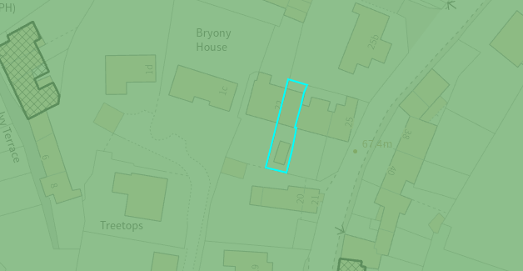

The garage building is positioned to the south of the row of terraced dwellings and is accessed via an existing driveway off the public highway off Whitehill to the east. The applicant seeks to raise the height of the existing detached garage building and convert it to a garden studio and storage area.

The existing monopitch roof would be removed and a pitched roof added, the eaves height would remain as existing, and the footprint of the building would remain as existing. The garage door on the front south elevation would be removed and a pedestrian door inserted along with two windows inserted on the west side elevation. A rooflight would be inserted on either side of the roofscape. The applicant seeks to clad the external block work with wood cladding and utilise concrete roof tiles with wooden fenestration.

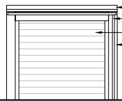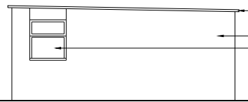
Existing front and west side elevation of the garage building

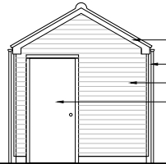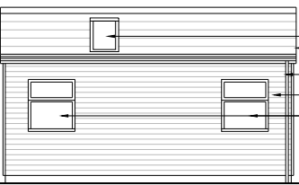
Proposed front and west side elevation of the garage building

The works would be small scale and would be commensurate to the size of the property and plot. The proposal, by virtue of its scale, design, and use of materials, is considered to preserve the character and appearance of the conservation area and setting of the listed buildings nearby. It would not result in harm to the significance of any heritage assets, and the use of the natural sustainable materials is supported.

The development is therefore considered to comply with Core Policies 57 and 58 of the Wiltshire Core Strategy and Sections 66 and 72 of the Planning (Listed Buildings and Conservation Areas) Act 1990, as well as the relevant provisions of the NPPF.

Amenity
Point vii of Core Policy 57 - Ensuring High Quality Design and Place Shaping of the Wiltshire Core Strategy seeks to ensure that developments do not adversely affect neighbouring properties.

Policy P3 of the NPPF requires development to contribute positively to the creation of healthy, safe and inclusive places. In particular, Policy P3(b) seeks to ensure that development provides a high standard of amenity for existing and future users and safeguards the reasonable living conditions of neighbouring occupiers. In assessing amenity impacts, regard should be had to matters including privacy, outlook, daylight and sunlight, overbearing impacts, noise and disturbance, and the overall quality of the living environment created by the development.

The proposed development has been assessed in terms of its potential impact on the residential amenity of neighbouring properties, with particular regard to loss of light, overshadowing, loss of privacy, and overbearing effects.

The proposal seeks small scale works to an existing detached garage building with the raising of the roof height. The existing building maintains extended separation distances to any immediate neighbours and the increase in height would be limited. Therefore, officers raise no concerns in regard to any adverse overbearing or overshadowing impacts to neighbouring properties.

The windows proposed would be positioned on the west elevation of the outbuilding, overlooking the gardens to the west, however given the single storey nature of the building and proposed use, no overlooking concerns are raised.

The proposal therefore accords with Core Policy 57 point vii in respect of safeguarding residential amenity and Appendix D of the Wiltshire Design Guide.

Highways Impact
Core Policy 57 (xiv) of the Wiltshire Core Strategy seeks to ensure that development must meet the requirements of Core Policy 61. This policy requires proposals to be capable of being served by safe access to the highway network. Core Policy 64 seeks to ensure compliance with parking standards set out in the Local Transport Plan.

The transport policies of the NPPF seek to ensure that development provides safe and suitable access for all users and that any impacts on highway safety are appropriately considered.

The conversion of the garage would remove the building as a potential parking space for the host dwelling. However, in order to comply with the Wiltshire Local Transport Plan 2011 – 2026: Car Parking Strategy (March 2015) a parking space should have internal dimensions of 3m x 6m, to count as an off-road parking space. The existing garage building does not meet this criterion, and therefore the conversion of the garage building would not adversely impact the existing off road car parking arrangement.

The existing car parking space to the south of the garage building would remain and the access arrangement would not be altered. The Council’s Highway officer was consulted and offered no objections to the scheme.

The proposed development would not result in any adverse impact on highway safety. Adequate parking and turning provision is provided in accordance with Wiltshire’s adopted parking standards, and access arrangements are acceptable.

The proposal is therefore considered to comply with Core Policies 57 (xiv), 61 and 64 of the Wiltshire Core Strategy, the NPPF, and the Wiltshire Local Transport Plan.

Ecology Impact
Core Policy 50 of the Wiltshire Core Strategy seeks to protect and enhance biodiversity and geodiversity, including through ensuring that development avoids harm to protected species and habitats.

Policy N2 of the NPPF seeks to conserve and enhance biodiversity and support nature recovery. Development proposals should minimise impacts on habitats and species and, where relevant, demonstrate that appropriate mitigation measures are secured where harm cannot be avoided.

The application site sits within the Bath and Bradford on Avon Special Area of Conservation for bats and as this application involves disturbance to the existing roof due consideration has to be given to the potential disturbance of any bats because of the proposed development.

The proposal relates solely to alterations to an existing outbuilding and does not involve the removal of habitat features, trees or vegetation. The submitted information indicates that the garage building is currently used for storage and therefore functions as part of the existing domestic environment.

Given the established high density urban residential nature of the location, the limited scale and nature of the works, together with the absence of evidence indicating the presence of protected species, the proposal is not considered likely to result in adverse ecological impacts.

As a precautionary measure an informative would be added to any decision that in event any evidence of bat activity is detected that the applicant should follow the advice of a professional ecologist or contact Natural England.

As such, the development complies with Core Policy 50 of the Wiltshire Core Strategy and the relevant provisions of the NPPF.

Biodiversity Net Gain
Householder planning applications are exempt from the requirement to deliver Biodiversity Net Gain under Schedule 7A, Section 4(2)(a) of the Town and Country Planning Act 1990, as inserted by the Environment Act 2021.

Public Sector Equality Duty (PSED)
In reaching this decision, due regard has been had to the Public Sector Equality Duty under Section 149 of the Equality Act 2010. This requires the Local Planning Authority to have regard to the need to eliminate discrimination, advance equality of opportunity and foster good relations between persons who share a protected characteristic and those who do not.

The Local Planning Authority is satisfied that the proposal would not result in any unlawful discrimination and that any impacts on protected groups have been appropriately considered as part of this assessment.

CONCLUSION
The proposed development is considered to be acceptable in terms of its design, character and appearance, and would not result in any unacceptable harm to the amenities of neighbouring occupiers. Furthermore, the proposal would not result in any unacceptable impacts in respect of highway safety, heritage assets, ecology or biodiversity.

The proposal is therefore considered to comply with the relevant policies of the Wiltshire Core Strategy, the National Planning Policy Framework and all other relevant material considerations. As such, the application is recommended for approval, subject to conditions.

RECOMMENDATION: That Planning Permission be GRANTED subject to conditions.

