Design and Access Statement
  - Greystones, Becketts Lane, Chilmark, Wiltshire SP3 5BD
The property is located on the western side of Becketts Lane, adjacent to the Reading Room, and comprises a detached stone cottage with later modern extensions set within a mature plot.
The property has vehicular access from Becketts Lane via a driveway with established parking.
The property is Grade II listed and lies within the Cranborne Chase Area of Outstanding Natural Beauty.

Proposal
The proposal is to raise the height of the chimney to above 1.8 metres to meet house insurance criteria. This will be achieved by fitting a chimney pot with birdguard cowl to the existing working chimney. The photo, below, is the existing chimney of Greystones.

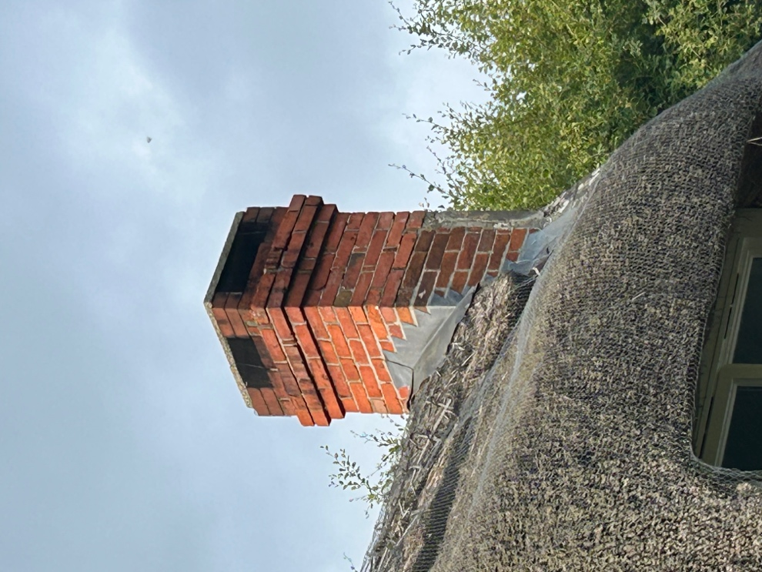

Appearance
This approach is in keeping with the surrounding area, as a number of houses in the village have similarly adapted their chimneys to meet insurance requirements.
Photographs of similar chimneys fitted with a chimney pot to other thatched buildings (mostly grade II listed) in Chilmark of a comparable age are shown in photos below.
