Design, Access & Heritage Statement

Waterside Mill,
High Street,
Downton,
Wiltshire.
SP5 3PE

Introduction

This statement is produced in support of an application for listed building consent to install an EV charger at the address above.

Overview

Waterside Mill is a Grade II listed former watermill located on High Street in Downton, Wiltshire. The building originates from the 18th century, reflecting the village’s historic reliance on water-powered industry along the River Avon. Originally constructed as a corn mill, the building was later adapted for industrial use, notably converted into a power station in 1929 by the Southern Tannery Company. It has since been converted into residential use and is now a semi-detached dwelling. Architecturally, the structure is built in brick (English and Flemish bond) with a tiled roof, arranged over three storeys, and retains characteristic mill proportions.

Proposal

The proposal for this listed building application is to install a Myenergi Zappi EV charger on the outside of the front face of the building, in the void space under the front door. There is no charger currently fitted.

Waterside Mill has two parking spaces in on the land at the front of the property and the charger will allow vehicles in either space to be charged.

Appearance

The charger (see image) is the subtlest we could find on the market and will be largely obscured from view by a wooden screen that forms part of the front steps.



Scope of Works

A black 240v cable capable of carrying 7kw will be run through the wall in which the garage door is fitted, along an exterior wall for 1.6m and under the front steps to the charger. The wall currently hosts a horizontal gas pipe and some black electrical conduit to support the exterior light. The addition of a horizontal black cable should not detract further from the appearance of the property.

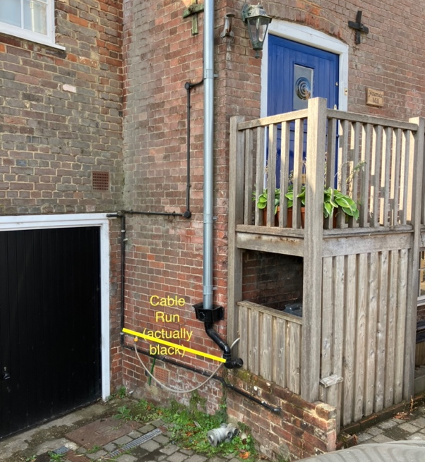

The charger will be attached to the front face of the building, under the front door. It will therefore be largely screened from view from the road.

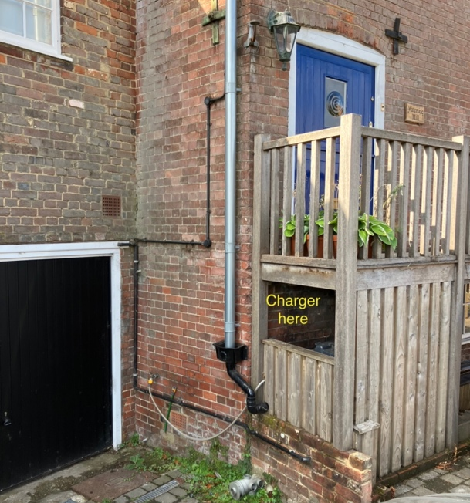

Access

The charger can be accessed from either side including by a person in a wheelchair.

Prepared by Alan Cole (owner)
30 August 2026

