APPLICATION FOR ADVERTISEMENT CONSENT
CASE OFFICER REPORT

APPLICATION REFERENCE: | PL/2026/04227
APPLICATION TYPE: | Consent to display an advertisement
SITE ADDRESS: | Bradford Avon Service Station, 47 Woolley Street, Bradford-on-Avon, BA15 1AF
DEVELOPMENT DESCRIPTION: | Retrospective application for:  4 No. forecourt canopy fascia's  1 No. freestanding flag type sign  2 No. pump island spreader boxes
RECOMMENDATION: | APPROVE

SITE DESCRIPTION/CONTEXT: This application relates to an existing petrol filling station and Londis shop located along Woolley Street in Bradford on Avon. The application site comprises existing petrol filling stations, the shop and signage associated with these existing uses, with an area of on-site car parking.

The immediate area is predominantly characterised by residential uses, modern in appearance, with more historic properties to the south and north-east. The site is not located within a Special Area of Control of Advertisements.

A Grade II listed building, Weaverhoult (No. 20 Woolley Street) is located within 25m south-west of the site. The application site is located within the settlement boundary for Bradford on Avon and within various consultation buffer zones associated with the Bath & Bradford on Avon Bats. The application site is located outside of but within 37m of the Bradford on Avon No.2 Conservation Area, which is located to the north-east of the subject site.

PROPOSAL: This application seeks retrospective advertisement consent for the erection of:

- 4 No. forecourt canopy fascias - The internally lit fascia signs have been completed in plastic and metal, with blue and yellow coloured text on a white background. These have been illuminated with static lighting at 400cd/m2.
- 1 No. freestanding flag type sign – This measures 5.25m in height, completed in plastic and metal and is internally illuminated with static lighting at 150cd/m2
- 2 No. pump island spreader boxes – These have been installed on the pumps, under the forecourt canopy.

The change in signage has occurred following a new fuel brand, 'Valero', operating from the site, resulting in replacement forecourt canopy fascias, pump islands and roadside flag sign. With reference to the completed application form, this change occurred on 23 June 2026.

The extract below (taken from drawing no. FPL-VEL-1656-CTD-02) illustrates the location of the advertisements that have been installed, with a site photograph of the forecourt taken by the officer in August 2026:
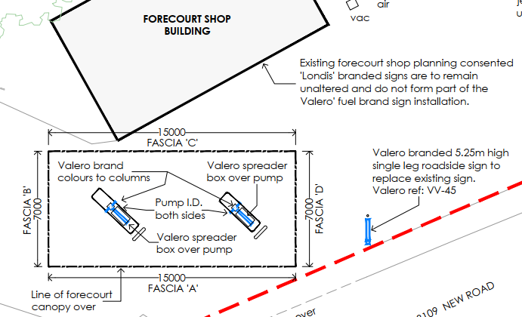
Location of advertisements

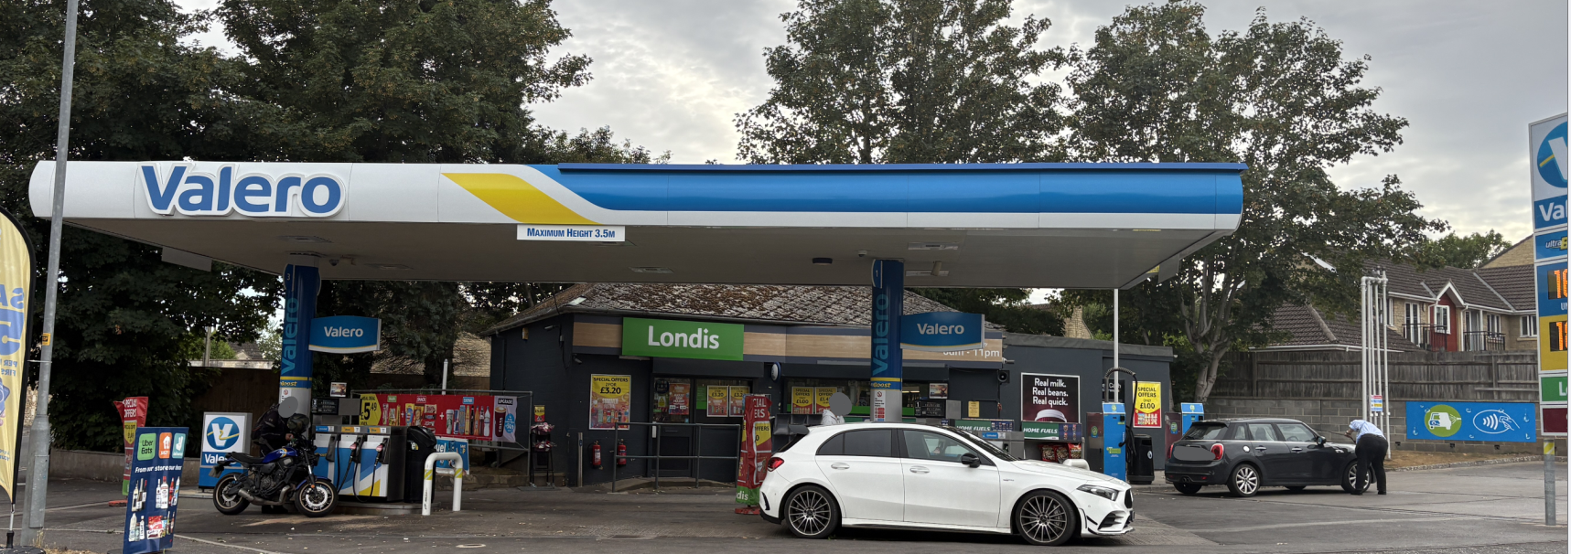
Site photograph of installed signs

For comparison purposes, the following image has been taken from Google Street View to show the previous extent of signage:
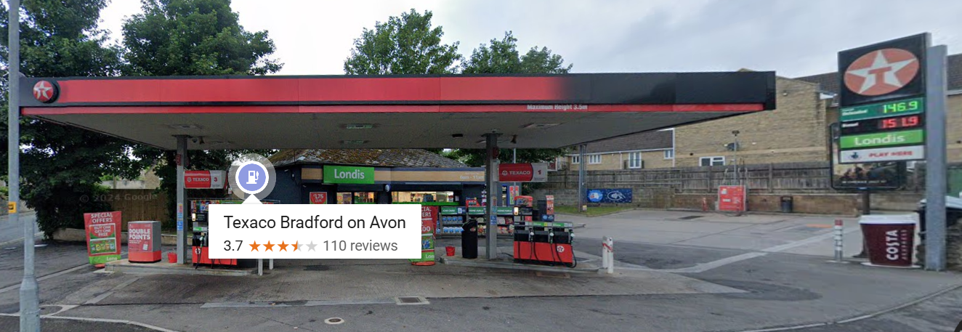
Google Street View image of previous signage

Over the course of the application’s determination period, revised plans were submitted to show a reduction to the level of illumination of the fascia signs around the forecourt canopy, to reduce the lighting level from the originally submitted 400cd/m² to 300cd/m² to accord with the guidance contained within the Institution of Lighting Professionals publication PLG05, “The Brightness of Illuminated Advertisements” (published 2023).

RELEVANT LEGISLATION, POLICIES AND GUIDANCE

Statutory Instruments: The Town and Country Planning (Control of Advertisements) (England) Regulations 2007; Planning (Listed Buildings and Conservation Areas) Act 1990

National Context: Planning Practice Guidance (PPG) on advertisements

It is important to mention that the revised NPPF that was released in August 2026 represents a substantially restructured document and no longer contains a standalone advertisements policy. Therefore, in determining advertisement consent applications, decision makers must assess the application against the separate statutory advertisement consent legislation, associated guidance and any local policies, rather than a specific NPPF policy.

Wiltshire Core Strategy 2015 (WCS):
- Core Policy 51 Landscape
- Core Policy 57 Ensuring High Quality Design & Space Shaping
- Core Policy 58 Ensuring the Conservation of the Historic Environment
- Core Policy 62 Development Impacts on the Transport Network

Neighbourhood Plan: The made Bradford on Avon Neighbourhood Plan, made in October 2017

Supplementary Planning Documents: Institute of Lighting Professionals (ILP), ‘The Brightness of Illuminated Advertisements’ (2023) PLG05/26.

RELEVANT PLANNING HISTORY:

W/81/00062/FUL - Full planning permission – Decision: Approved with conditions on 3/3/1981 – Proposed Garage workshop at Saxon Garage

W/83/00672/FUL - Full planning permission – Decision: Approved on 2/8/1983 – Erection of canopy, repositioning of petrol pumps and provision of self-service facilities

W/85/01108/FUL - Full planning permission – Decision: Approved with conditions on 12/11/1985 – Change of use of dwelling to shop/office for garage and ancillary car parking

W/90/01679/ADV - Consent to display an advertisement – Decision: Approved with conditions on 8/1/1991 – Illuminated fascia sign

W/93/00145/FUL - Full planning permission – Decision: Approved with conditions on 6/4/1993 – Alterations to existing building and forecourt alterations

W/93/00476/ADV - Consent to display an advertisement – Decision: Approved on 10/6/1993 – Kiosk fascia sign

W/93/00477/ADV - Consent to display an advertisement – Decision: Approved on 10/6/1993 – Canopy fascia signs

W/93/00478/ADV - Consent to display an advertisement – Decision: Approved with conditions on 15/6/1993 – Replacement illuminated pole sign

W/94/01458/ADV - Consent to display an advertisement – Decision: Refused on 12/1/1995 – Pole mounted price board

W/09/02527/ADV - Consent to display an advertisement – Decision: Approved on 23/10/2009 – 1no. internally illuminated double-sided pole-mounted display unit

16/06551/FUL - Full planning permission – Decision: Approved with conditions on 26/8/2016 – Retention of an ATM installed through the existing brickwork

16/07087/ADV - Consent to display an advertisement – Decision: Approved with conditions on 26/8/2016 – Retention of an ATM installed through the existing brickwork incorporating the ATM fascia with black bezel surround and white illuminated lettering Free Cash Withdrawals out of black background. Blue LED halo illumination to ATM surround.

ISSUES: The Town and Country Planning (Control of Advertisement) (England) Regulations 2007 (as amended) set out that the Local Planning Authority can only consider the effect of a proposal in the interests of amenity and public safety, taking into account the provisions of the development plan, so far as they are material, and any other relevant factors.

However, matters such as the content of the advertisement or commercial considerations are not material to the determination of the application.

CONSULTEE RESPONSES: The views of consultees are material considerations in the determination of the application. However, the decision-maker must exercise their own planning judgement. Where consultees raise concerns or recommend conditions, these have been considered and are addressed within the assessment section of this report.

The following consultees were invited to comment on this application:

Bradford on Avon Town Council: No comments received

Wiltshire Council’s Highways Department: No objections subject to conditions

REPRESENTATIONS: Below is a summary of the representations received during the consultation period. Only material planning considerations have been taken into account in the assessment of this application. Non-material issues, such as property values or private legal disputes, cannot be considered in the determination process.

Third-party Representations: One representation was received raising the following summarised objections:

- New branding and signage are significantly more extensive than previous signage;
- Increase in both the amount of signage and illuminated advertising on the site;
- The cumulative amount of signage is viewed as excessive;
- Close to the Bradford on Avon Conservation Area boundary;
- Light spill affecting nearby properties;
- Impact on bats

ASSESSMENT: Regulation 3 of The Town and Country Planning (Control of Advertisements) (England) Regulations 2007 requires that local planning authorities exercise their powers in relation to the display of advertisements in the interests of amenity and public safety, taking into account the provisions of the development plan, in so far as they are material, and any other relevant factors.

Impact on Amenity: The Town and Country Planning (Control of Advertisement) (England) Regulations 2007 do not explicitly define “amenity” but it is generally understood to include both visual and aural amenity. Factors relevant to amenity include the general characteristics of the locality, such as the presence of features of historic, architectural, cultural, or similar interest.

The PPG states in Paragraph: 079 Reference ID: 18b-079-20140306 that:

“amenity” is usually understood to mean the effect on visual and aural amenity in the immediate neighbourhood of an advertisement or site for the display of advertisements, where residents or passers-by will be aware of the advertisement.

So, in assessing amenity, the local planning authority would always consider the local characteristics of the neighbourhood: for example, if the locality where the advertisement is to be displayed has important scenic, historic, architectural or cultural features, the local planning authority would consider whether it is in scale and in keeping with these features.

In addition to the above, CP57 of the adopted WCS requires a high standard of design in all proposals, including (x) the sensitive design of advertisements and signage.

Whilst the retrospective nature of this application is disappointing, it is appreciated that the proposal relates to an established petrol station that has existed on this site since the 1980s, with reference to the above-listed planning history and given the nature of the use of the site, there has been existing signage on the site.

The signage that has been erected replaces the previous branding of the former operator. Whilst third party representations indicate that there is an increase in signage, it is not considered that the signs would be demonstrably more intrusive or overbearing in terms of their siting, scale, size and design.

The site's proximity to nearby listed buildings and the conservation area boundary is acknowledged. Also, the concerns raised within the third-party representations regarding the increased prominence of the proposed Valero signage are noted. Whilst the signage is more noticeable than the previous Texaco branding due to its brighter colour palette, the site has long been occupied by a petrol filling station and associated retail use, with signage forming an established component of the site's commercial and retail appearance.

The overall scale, form and function of the signage remain consistent with the established commercial character of the site. Having regard to the existing lawful use and previously approved signage, it is considered that the proposals would result in only a limited change to the character and appearance of the area and would not give rise to any material harm to the setting of nearby heritage assets or the character of the conservation area.

In terms of the level of illuminance, with reference to the ILP’s PLG05/23 guidance on the brightness of illuminated advertisements, the subject site is considered to be located within Environmental Zone E3 (‘suburban’ with a medium level of brightness) as defined by Table 10.1 of PLG05/23. The proposed freestanding flag sign, with a stated luminance of 150 cd/m², falls below the recommended maximum night-time luminance level of 300cd/m².

As previously mentioned, the canopy fascia signs originally submitted were shown to have a luminance level of 400 cd/m² which was considered to exceed that recommended in E3 zones, where there should be a maximum illuminance of 300cd/m² for signs that have a surface area of between 5m² to 20m².

Revised drawings were received in August to show a reduction in the lighting levels for the canopy fascia signs to 300cd/m2, which complies with the PLG05/23 guidance.

Having regard to the character of the area, the extent of previously consented signage, the design, scale, siting and illumination of the proposed advertisement, it is considered that the proposal would not cause harm to the visual amenity of the area, either individually or cumulatively, including the setting of any heritage assets, and would therefore comply with the relevant provisions of the Town and Country Planning (Control of Advertisements) Regulations 2007.

Furthermore, in giving special regard to the desirability of preserving the setting of nearby listed buildings and paying special attention to the desirability of preserving the character or appearance of the nearby conservation area, it is considered that the overall scale, form and function of the signage remain consistent with the established commercial character of the site.

Impact on Public Safety: “Public safety” is not exhaustively defined in the Town and Country Planning (Control of Advertisements) (England) Regulations 2007, but it generally refers to the potential impact of a development or advertisement on the safe use and operation of public spaces, including roads, footpaths, and other areas accessible to the public.

In assessing public safety, the Local Planning Authority (LPA) may consider:
- Whether the proposal would obstruct visibility for road users or pedestrians;
- Whether it could distract, confuse, or mislead drivers, particularly near junctions or crossings;
- Whether it interferes with traffic signs, signals, or street lighting;
- Whether it poses a physical hazard, such as through poor structural integrity or inappropriate siting.

CP62 advises that proposals should provide appropriate mitigating measures to offset any adverse impacts on the transport network at both the implementation and operational stages.

The application site comprises an existing petrol filling station located on Woolley Street (off the B3109), which is considered to be a well-used route through Bradford-on-Avon. The site directly fronts the public highway and is located within an established commercial petrol station. The advertisements have been positioned within the existing forecourt area, including on the canopy fascia and an existing roadside sign adjacent to the highway.

The signage does not project over the public highway, obstruct footways, or prejudice visibility splays for vehicles entering or leaving the site. The advertisements would be viewed in the context of an existing petrol filling station where roadside branding and fuel price displays have already been an established feature of the street scene.

The signage would comprise static, internally illuminated corporate branding and fuel pricing displays. The advertisements do not incorporate digital screens, flashing displays, scrolling text, video content etc that could have the potential to distract drivers. The illumination levels are annotated on the submitted drawings and have been reduced through negotiation, with the canopy logo illumination limited to 300cd/m² and other illuminated elements operating at significantly lower luminance levels.

Given the scale and siting of the display advertising fuel prices, it is not considered that this would distract motorists to a degree that would adversely affect highway safety. Furthermore, the Council’s highways department have no raised any objections to the proposal, subject to conditions.

Whilst the site contains a number of signs associated with the operation of the petrol filling station, the proposal represents the replacement and updating of existing signage rather than the introduction of substantial additional advertising. The cumulative presence of the advertisements is not considered likely to distract motorists or otherwise prejudice highway safety.

Having regard to the location, scale, design and method of illumination of the advertisements, it is considered that the development would not prejudice public safety. The proposal therefore complies with the public safety provisions of the Town and Country Planning (Control of Advertisements) (England) Regulations 2007. Subject to the standard advertisement conditions, no additional controls are considered necessary in the interests of public safety.

Other Matters: Concerns have been raised within the submitted representations regarding the impact of the signage on bats. The application relates to the replacement of existing advertisement signage at an established and operational petrol filling station in a predominantly lit residential environment. Having regard to the scale of the development and the revised illumination levels that have been secured through the submission of amended drawings, no evidence has been provided to demonstrate that the advertisements would give rise to harm to protected species beyond what has been previously experienced.

Public Sector Equality Duty (PSED): In reaching this decision, due regard has been had to the Public Sector Equality Duty under Section 149 of the Equality Act 2010. This requires the Local Planning Authority to have regard to the need to eliminate discrimination, advance equality of opportunity and foster good relations between persons who share a protected characteristic and those who do not.

The Local Planning Authority is satisfied that the proposal would not result in any unlawful discrimination and that any impacts on protected groups have been appropriately considered as part of this assessment.

CONCLUSION: The proposed advertisement has been assessed in accordance with the relevant provisions of the Town and Country Planning (Control of Advertisements) (England) Regulations 2007.

It is considered that the advertisement, by reason of its design, scale, siting, and method of illumination, would not result in harm to the visual amenity of the area, including the setting of any nearby heritage assets. Furthermore, the proposal is not considered to pose a risk to public safety, either individually or cumulatively with other signage in the vicinity.

Subject to the recommended conditions, the proposal is therefore considered acceptable, and it is recommended that advertisement consent be granted.

RECOMMENDATION: It is recommended that advertisement consent be GRANTED subject to conditions.

Advertisements - GOV.UK

