

Design and Access Statement

Replacement Domestic Garage

At: 23 The Stocks, Seend, Melksham, Wiltshire, SN12 6PA

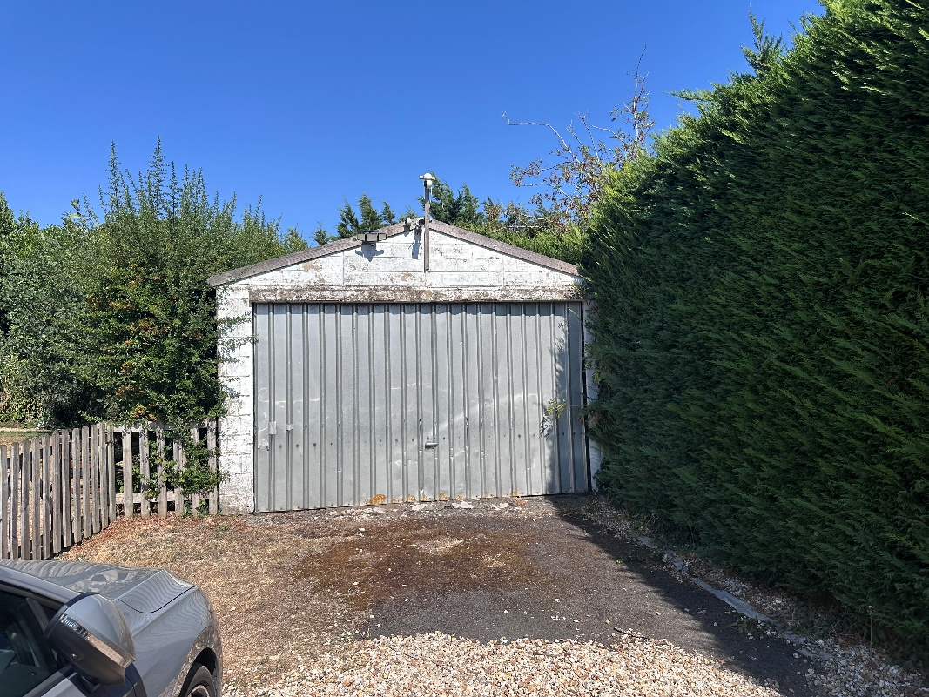
Prepared by:
Equestrian Blueprint
enquiries@equestrianblueprint.co.uk
https://equestrianblueprint.co.uk/
Date August 2026

Contents
1. Introduction 3
2. Site and surroundings 3
3. The proposal 3
4. Design and appearance 3
5. Residential amenity 4
6. Access and parking 4
7. Application boundary and ownership 4
8. Trees, drainage and biodiversity 4
9. Conclusion 4

1. Introduction
This Design and Access Statement accompanies a householder application for the replacement of an existing domestic garage at 23 The Stocks. It should be read alongside the submitted location plan, existing and proposed block plans, and existing and proposed elevations.

2. Site and surroundings
The application property is a dwelling with an established garden, driveway and parking area. The existing garage stands within the rear part of the domestic curtilage and is reached using the established shared access from the highway. The immediate surroundings are predominantly residential, with outbuildings and garden structures forming part of the established character of the plots.
The existing garage is a single-storey prefabricated concrete sectional building measuring approximately 7.4 m by 3.9 m. It has an eaves height of approximately 2.2 m, an overall height of approximately 2.76 m, a metal vehicular door and a corrugated cement-sheet roof.

3. The proposal
The proposal is to remove the existing sectional concrete garage and replace it with a timber sectional domestic garage in broadly the same position. The new building will use the existing concrete base where practicable, with localised additional concrete provided where required to suit the revised footprint and alignment.
The replacement garage will measure approximately 7.2 m by 3.6 m. It will remain single storey, with an eaves height of approximately 2.135 m and a ridge height of approximately 2.617 m. Its overall footprint and height will therefore be slightly less than those of the existing garage.
The garage will have horizontal shiplap timber cladding, a black Onduline pitched roof, timber double vehicular doors, a separate pedestrian door and modest windows as shown on Drawing P3. It will remain ancillary to the dwelling and will be used for normal domestic garaging and storage purposes.

4. Design and appearance
The replacement adopts a simple, traditional outbuilding form. Timber cladding provides a softer and more domestic appearance than the existing concrete panels, while the dark roof finish will be visually recessive. The modest ridge and eaves heights, together with the established siting and surrounding garden boundaries, will limit views of the building and avoid an overbearing effect.
Because the replacement is smaller and lower than the existing structure and remains in substantially the same location, it will not materially change the scale or pattern of development on the site. The proposal is considered proportionate to the dwelling and compatible with the residential character of the locality.

5. Residential amenity
The garage is an established form of domestic development. Its reduced dimensions, single-storey form and retained garden setting mean that it will not result in unacceptable overlooking, loss of privacy, loss of daylight or an overbearing impact on neighbouring occupiers. The windows are limited in scale and serve the ancillary garage use.

6. Access and parking
No alteration is proposed to the existing highway access, shared driveway or on-site parking arrangements. The replacement will continue to be served by the established access and will not intensify the residential use of the property or generate a material increase in vehicle movements.
The shared access is in separate ownership. The relevant owner, Doreen Arnold, will be notified using the appropriate Householder Development Notice and the application will be accompanied by the appropriate ownership certificate.

7. Application boundary and ownership
The location plan uses separate coloured hatching to explain the unusually complex pattern of ownership around the property and its access. This notation distinguishes the applicant's land from the separately owned shared-access land and from land associated with No. 21 The Stocks. Land at No. 21 is shown to make the ownership arrangement intelligible and does not form part of the proposed development. No works are proposed on that land.

8. Trees, drainage and biodiversity
The retained Oak T1 shown on the block plan is separated from the replacement building. Tree T2 Fig, will be removed. No material change is proposed to the established drainage arrangements: roof water will continue to be managed within the domestic site using the existing arrangements, with the limited new concrete confined to that required around the replacement base.
The proposal is a householder development and is therefore exempt from the statutory biodiversity net gain requirement. Given the replacement nature, domestic setting and modest scale of the works, no significant ecological effects are anticipated. Both trees are below 75mm diameter at 1.5m high.

9. Conclusion
The proposal replaces an ageing sectional concrete garage with a smaller, lower and more visually sympathetic timber garage. It retains the established domestic use, siting, access and parking arrangements and will not harm the character of the area, highway safety or neighbouring amenity. Householder planning permission is therefore respectfully requested.

