PORTON BAPTIST CHURCH
PORTON
SALISBURY
WILTSHIRE
SP4 0LJ

ECOLOGICAL SURVEY REPORT (BATS)
(Preliminary Roost Assessment/DBW)

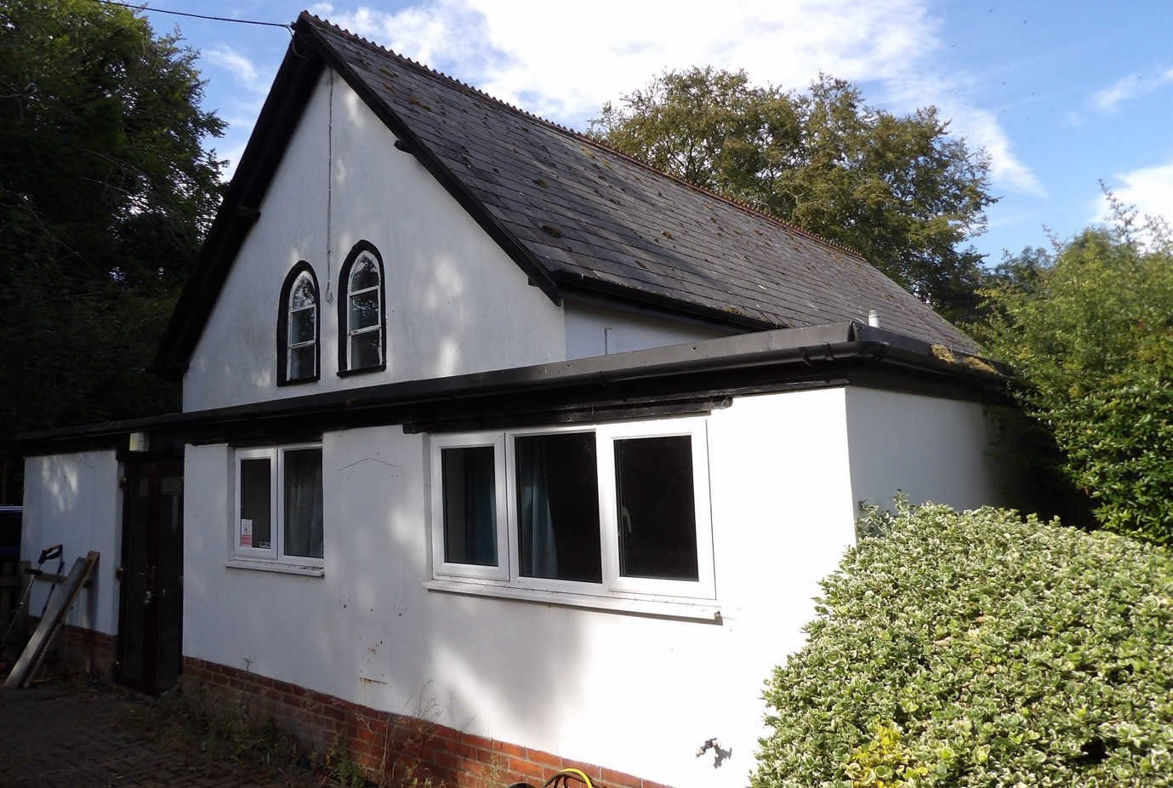

Prepared for:
Mr C. FLAY.
Date: 25/7/26.
Ref: NWP/ESR-25/7/26-version 2.

CONTENTS
Executive Summary
- Introduction
1.1 Instruction
1.2 Aims and Objectives
1.3 Proposed works
1.4 Surveyor Background and Experience
- Legislation and Planning Policy
2.1 Legislative Background
- Site Location and Description
3.1 Site Location 3.2 Site Description
- Survey Methodology
4.1 Pre-Survey Data Search
4.2 Daylight Survey
4.3 Constraints
- Survey Findings
5.1 External Inspection 5.2 Internal Inspection 5.3 Incidentals.
- Evaluation
- Conclusions
  - Interpretation
  - Contingency plan
9.References
9.Queries
Appendix 1

EXECUTIVE SUMMARY
BatCraft was commissioned by Mr C. FLAY to conduct a preliminary ecological appraisal (daytime bat walkover [DBW]), of PORTON BAPTIST CHURCH, PORTON, SALISBURY, WILTSHIRE SP4 0LJ.
This is to support a forthcoming planning application.
The site visit was carried out on the 25/7/26, during daylight hours. An internal and external inspection of the property took place to look for signs of bats. The preliminary ecological appraisal consists of a desk top study prior to the survey to review existing information about the site and its surroundings and to inform the design of subsequent bat surveys, if required.
The desk top study was conducted based upon a 2km search radius and it revealed 3 designations over 4 sites, these are:
RIVER AVON- Special Area of Conservation (SAC).
RIVER AVON SYSTEM- Site of Special Scientific Interest (SSSI).
PORTON DOWN- Site of Special Scientific Interest (SSSI)
-Special Protection Area (SPA).
PORTON MEADOWS- Site of Special Scientific Interest (SSSI).
There is 0 current European Protected Species Licences (EPSLs) for bats and there is 0 expired EPSLs for bats within 2km of the proposed development site.
The proposed development is in what could be described as a rural setting, the adjoining gardens with trees/shrubs/hedges which lead onto open countryside would allow excellent ecological connectivity to the wider landscape.
The DBW comprised a detailed search of the exterior and interior of the building for bats identifying signs of bats and features suitable for use by roosting bats. This includes droppings, scratch marks, rubbing and staining at exit holes, live or dead bats and other features such as missing tiles, this list is not exhaustive.

The buildings suitability to support roosting bats was assessed, no evidence of bats was identified during the preliminary inspection.

When the findings are combined the building was characterised as having negligible potential1 to support roosting bats, in line with best practice guidelines2; no further survey effort is required.

1-Table 4.1 Guidelines for assessing the potential suitability of proposed development sites for bats. Bat Surveys for Professional Ecologists Good Practice Guidelines 4th Edition. Page 44.
2- Collins, J. (ed) (2023) Bat Surveys for Professional Ecologists Good Practice Guidelines (4th Edition).

1.INTRODUCTION

  - Instruction
BatCraft was instructed by Mr C. FLAY to conduct a DBW of PORTON BAPTIST CHURCH, PORTON, SALISBURY, WILTSHIRE SP4 0LJ to support a forthcoming planning application.

1.2 Aims and Objectives
The DBW is designed to:
• Identify the presence/likely absence of bats within the building.
• Provide information on previous bat ecological surveys/reports.
• Provide information on the status of bats using the buildings currently or previously.
• To add confidence where no bats are found, or to categorise the nature of a roost where evidence of bats are found.
• To establish whether further surveys, mitigation or an EPSL is required.
The preliminary ecological appraisal (bats) and report writing were carried out in accordance with Bat Surveys for Professional Ecologists Good Practice Guidelines 4th edition.
  - Proposed Works
The survey was commissioned in connection with a forthcoming planning application, final plans were not available.

1.4 Surveyor Background and Experience
The preliminary ecological appraisal for bats was undertaken and the report written by Nicholas Powell. Nicholas holds a Class 2 Bat License (CLS-11742) and has received training in bat ecology and surveying, bat detector use, acoustic monitoring/sonogram analysis, architectural terms for bat workers, bats and development, H & S awareness for bat workers, legislation for bat workers, British bats their ecology and conservation, surveying trees for bats, Bat ID and handling, bat biology.

PORTON BAPTIST CHURCH, PORTON, SALISBURY, WILTSHIRE SP4 0LJ
2.Legislation and Planning Policy
2.1 Legislative Background
All species of British bat are protected under the Conservation of Habitats and Species Regulations 2017 and the Wildlife and Countryside Act 1981, as amended. Under this legislation it is an offence to kill or injure a bat or interfere with any roosting or resting site. A bat roost is interpreted as “any structure or place used for shelter or protection” whether bats are present at the time. A summary of the main legislation and planning considerations are included at Appendix 1.
Seven species of bat are also Species of Principal Importance for nature conservation in England under Section 41 of the Natural Environment and Rural Communities Act 2006. This places a duty on all government departments to have regard for the conservation of these species and on the Secretary of State to further, or promote others to further, the conservation of these species.
All rights in this report are reserved. No part of it may be reproduced, edited or transmitted, in any form or by any means, electronic, mechanical, photocopying, recording or otherwise, or stored in any retrieval system of any nature, without our written permission. Its content and format are for the exclusive use of MR C. FLAY and their agents in dealing with this site. It may not be sold, lent, hired out or divulged to any third party not directly involved in this site without the written consent of BatCraft It may be reproduced as part of a planning application.
This report is valid for 12 months from the site inspection. The lifespan of this report may be subject to change if the site conditions change due to unspecified works that affect the site.

PORTON BAPTIST CHURCH, PORTON, SALISBURY, WILTSHIRE SP4 0LJ.
3. Site Location and Description
3.1 Site Location
The building is located at Grid Reference SU 1870 3632, see Figure 1 below- image used under licence from OS Maps.
An overview of the immediate area is shown on Figure 2, image courtesy of Bing Maps.

Figure 1.
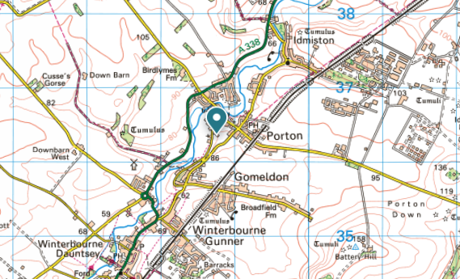

Figure 2.
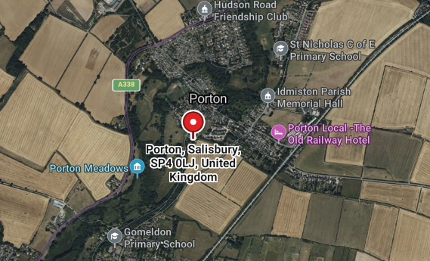

PORTON BAPTIST CHURCH, PORTON, SALISBURY, WILTSHIRE SP4 0LJ
3.2 Site Description
The application site comprises of a detached brick-built rendered former place of worship with a single storey extension. Figure 1/2.
On the eastern aspect, immediately to the front of the dwelling is a small, paved area allowing pedestrian access to the premises, this joins the highway.
To the side is a gravelled driveway allowing access to the rear/western aspect which is also gravelled allowing parking for multiple cars. Figure 3/4.
The site has an area of c440 metres sq.
The site itself offers a negligible amount of foraging and commuting habitat for bats, there is excellent ecological connectivity to the wider landscape including the designated areas due to the adjoining farmland.

Figure 1. Figure 2.
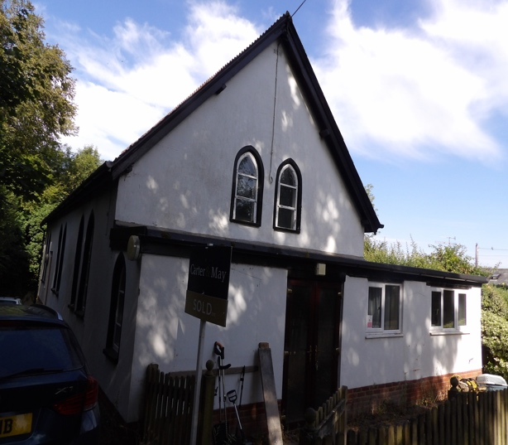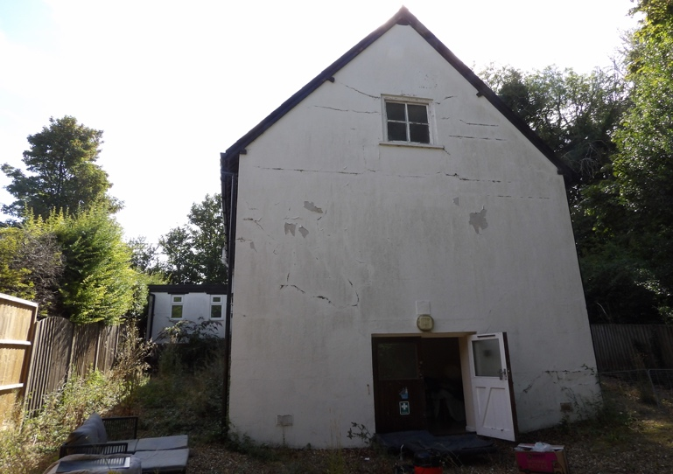
Figure 3. Figure 4.
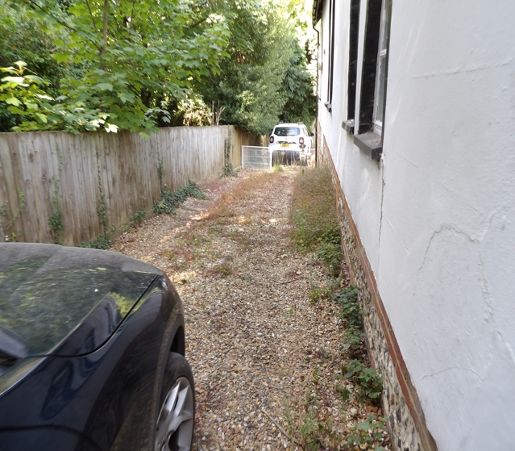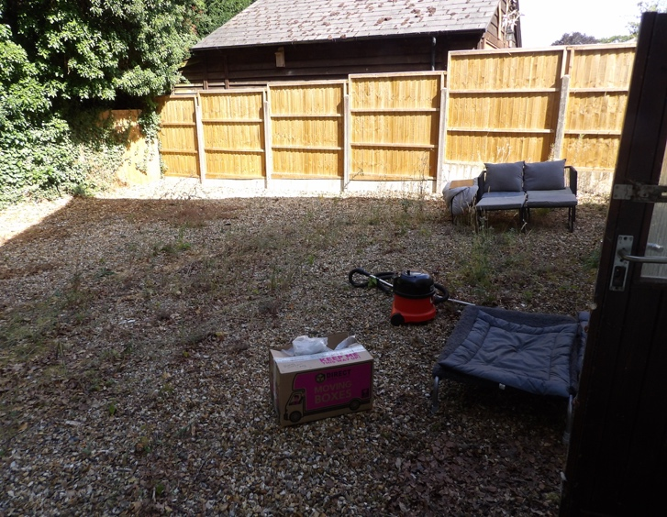

PORTON BAPTIST CHURCH, PORTON, SALISBURY, WILTSHIRE SP4 0LJ
4.1 Pre-Survey Data Search
The client has advised that no previous bat survey had been undertaken on the site.
Google Earth and MAGIC maps (magic.defra.gov.uk) websites were used prior to the survey to determine the suitability of the surrounding habitat to support roosting bats and to identify any statutory designated sites or EPSLs within 2km of the site. No data was sought from the local records centre at this time.
The preliminary ecological appraisal consists of a desk top study prior to the survey to review existing information about the site and its surroundings and to inform the design of subsequent bat surveys, if required.
The desk top study was conducted based upon a 2km search radius and it revealed 3 designations over 4 sites, these are:
RIVER AVON- Special Area of Conservation (SAC).
RIVER AVON SYSTEM- Site of Special Scientific Interest (SSSI).
PORTON DOWN- Site of Special Scientific Interest (SSSI)
-Special Protection Area (SPA).
PORTON MEADOWS- Site of Special Scientific Interest (SSSI).
There is 0 current European Protected Species Licences (EPSLs) for bats and there is 0 expired EPSLs for bats within 2km of the proposed development site.
The proposed development is in what could be described as a rural setting along a through road on the western edge of Porton. Porton is a village in the Bourne Valley about 5 miles northeast of the city of Salisbury.
Directly to the north crossing c200 metres of farmland is the village of Porton.
To the west, adjoining the proposed development site is mixed farmland broken up by hedgerows and the River Avon System (SSSI), River Avon (SAC) and Porton Meadows (SSSI).
To the south is mixed farmland broken up by hedgerows.
To the east crossing c250 metres of farmland is the village of Porton, beyond this is mixed farmland broken up by hedgerows.
The adjoining countryside/farmland would allow excellent ecological connectivity to the wider landscape including the designated areas.

Figure 1 shows the proposed development site and its relation to the EPSL, courtesy of Magic maps, the legend is Figure 1 in appendix.

Figure 1.
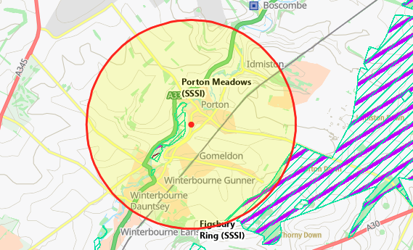

PORTON BAPTIST CHURCH, PORTON, SALISBURY, WILTSHIRE SP4 0LJ
4.2 Daylight Survey
The DBW of DBW of PORTON BAPTIST CHURCH, PORTON, SALISBURY, WILTSHIRE SP4 0LJ was carried out by Nicholas Powell on the 25/7/26 at 9.30 am. The weather conditions for the survey were clear with no rain, occasional gusts of wind up to Beaufort 1 and a temperature of 20.6 degrees. Equipment used included a high-powered torch, a digital camera, a digital camera on a telescopic pole, an endoscope and a ladder. During the DBW an external inspection of the property was carried out to identify any signs of occupation by bats and features that could offer potential roosting sites following standard survey guidelines.
Features investigated included:
• Construction of the building– soffits, loft space, tiles/slates, lead flashings etc.
• Building condition – structure of roof and walls.
• Access points – potential entry and exit points for bats.
• Roosting points – cracks and crevices, between underlay and roofing tiles/slates.
Field signs that would indicate the presence of bats were searched for. These included:
• Bat droppings on the floor and walls of the building.
• Feeding remains (particularly butterfly and moth wings).
• Evidence of urine and/or oily staining around possible roost entrance
• Presence of areas cleared of cobwebs.
• Where a breathable roofing membrane has been fitted staining on the membrane may suggest use by bats.
• Odour can sometimes suggest the present of bats.
• Squeaking and chattering can reveal bats roosting between the tiles and roofing underlay.

4.3 Constraints
Full access to the site during the visit was made possible by the client.
The access hatch to the roof void was small, access was not possible, this was not considered a significant constraint due to no visible opportunities on the exterior that bats could exploit.

PORTON BAPTIST CHURCH, PORTON, SALISBURY, WILTSHIRE SP4 0LJ
5. Survey Findings
5.1 External inspection
The external features of the property were examined for signs described in section 4.2. Windowsills, exposed features around the windows, fascia and walls were inspected for any evidence of bat droppings or staining.

Baptist Church.
The ridge tiles were in good condition with no visible areas of missing mortar. Figure 1.
The slates covering the roof were in good condition with none visibly missing/broken/slipped.
Figure 2/3.
The eaves slates were complete, they were close fitting to the fascia with no significant gaps that bats could exploit. Figure 4.
The soffits and fascia were wooden, they were in good condition, with no splits/openings/gaps that bats could exploit. Figure 5/6.
The flat roof was covered in a composite material, It was in good condition with no visible rips/tears/sagging. Figure 7.
The vents on the gable ends were filled with insulation. Figure 8/9/10.
No bats or evidence of bats was recorded during the external inspection of the main dwelling.

Figure1.
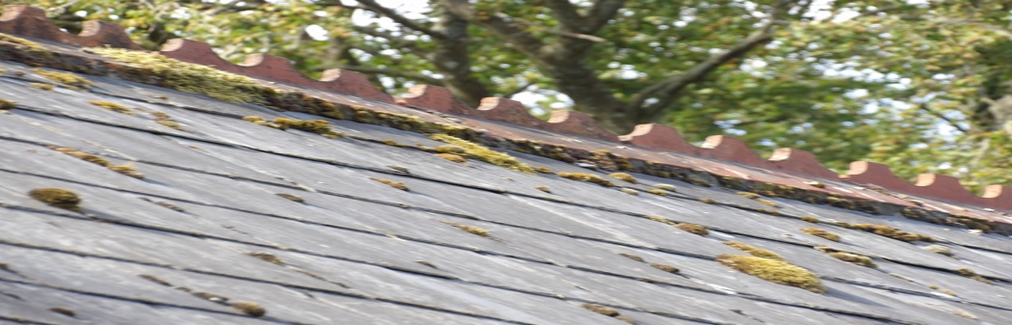
Figure 2. Figure 3.
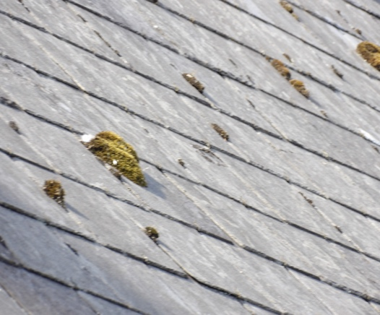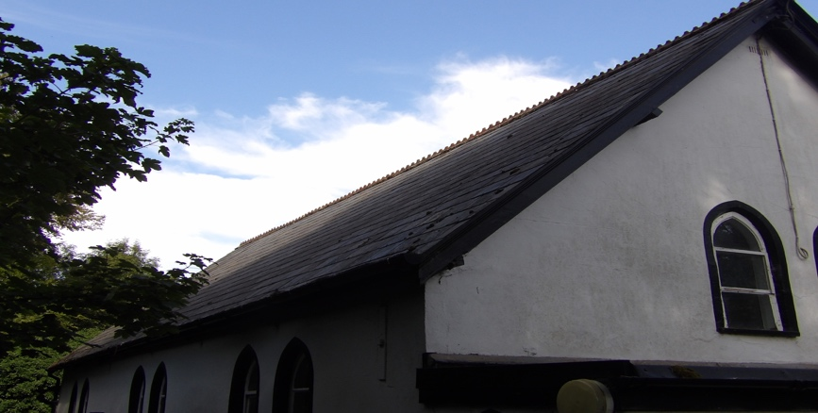
Figure 4.
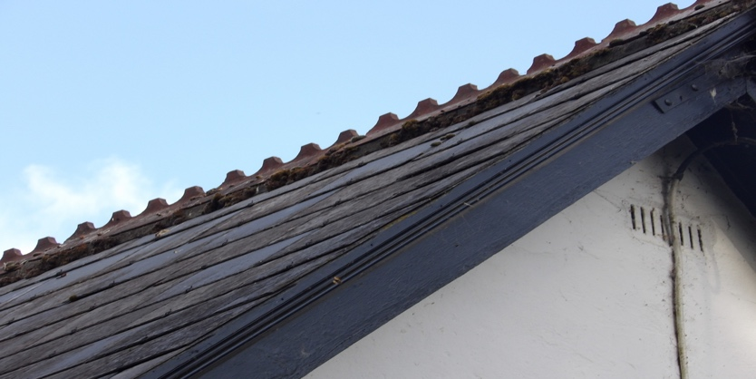
PORTON BAPTIST CHURCH, PORTON, SALISBURY, WILTSHIRE SP4 0LJ
Figure 5. Figure 6.
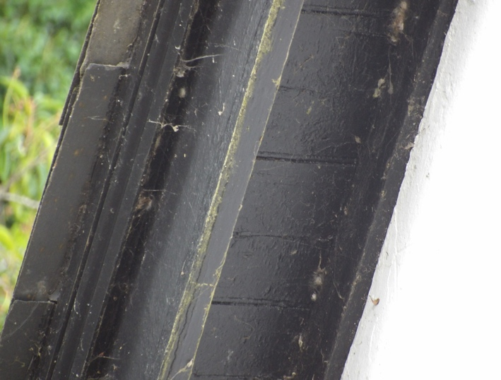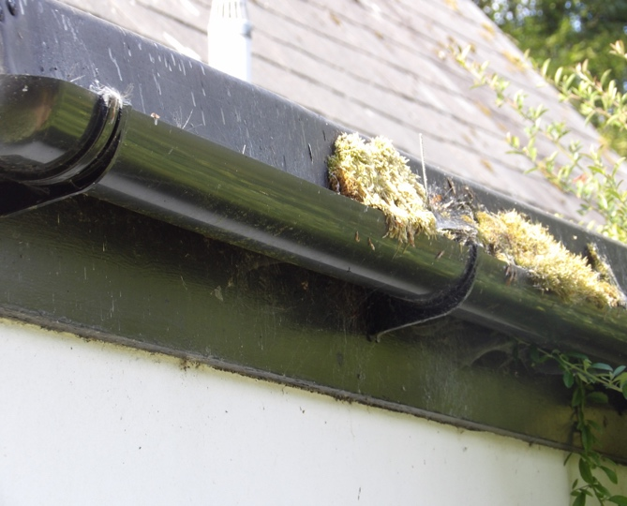
Figure 7.
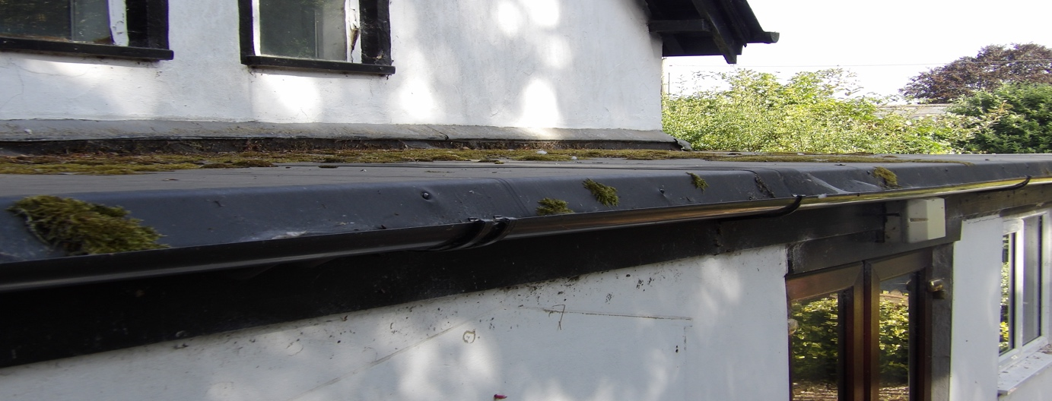
Figure 8. Figure 9. Figure 10.
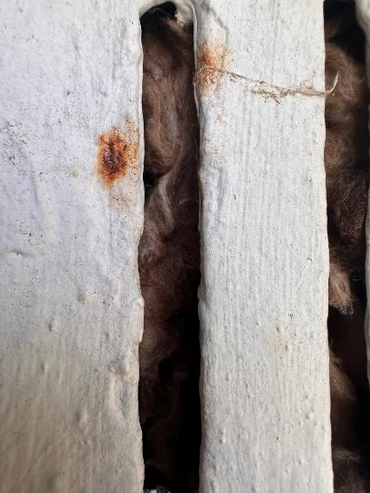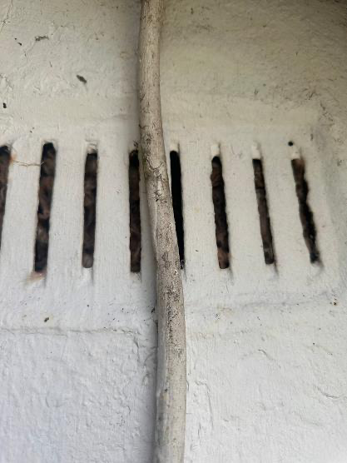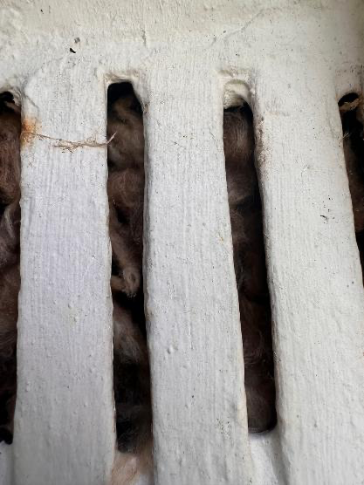

PORTON BAPTIST CHURCH, PORTON, SALISBURY, WILTSHIRE SP4 0LJ
5.2 Internal Inspection
An internal inspection of the property was undertaken and was examined for any signs of bats, (described in section 4.2)

Baptist Church.
The roof void was not accessible.
There was no roof void under the flat roof.
Figure 1 shows size of access hatch.
Figure 1.
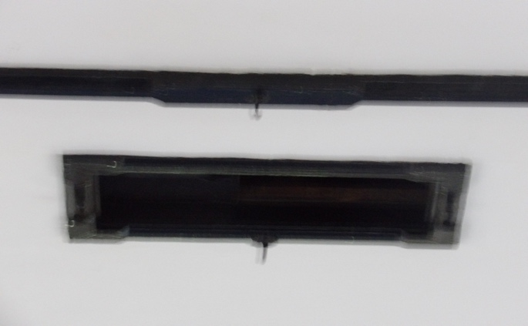
5.3 Incidentals.
(Incidentals such as wasp’s nests, birds’ nests, vermin nests, evidence such as rodent faeces)
None noted
6. Evaluation
The bat roost potential of the features within the site have been assessed with reference to the following criteria and include seasonal variation where increased or decreased probability may arise. Where features are present, they are highlighted in bold.

The likelihood of bat roosts being present will be higher where structures:
• are of a pre-20th Century construction;
• are in a lowland rural setting;
• have woodland, mature trees, species-rich grassland and/or water nearby.
•have large dimension roof timbers with cracks, joints and holes,
• have an uneven roof covering with gaps, though not too draughty.
have numerous crevices in stonework and structures;
• have hanging tiles or roof cladding, especially on south-facing walls;
• have a roof warmed by the sun;
• are disused or little used; largely undisturbed;
• provide appropriate hibernation conditions, such as abandoned mines, tunnels, kilns, or fortifications; or
• Recent and historical records of bat roosts in the general area.
The likelihood of bat roosts being present will be lower where structures:
• are in an urban setting with little green space;
• are subject to heavy disturbance (constant movement due to draughts and noise, also unstable microclimate);
• have a small, cluttered roof void (particularly for brown long-eared);
• are of a modern construction with few gaps or crevices that bats can fly or crawl through (though pipistrelle bats may still be present);
• are comprised of prefabricated steel or sheet materials; (some sections);
• are active industrial premises.
Please note that the above list provides generic screening criteria only and there are exceptions to consider.
PORTON BAPTIST CHURCH, PORTON, SALISBURY, WILTSHIRE SP4 0LJ
7.Conclusion
7.1 Interpretation
The combined evidence from the desktop study and the external/internal inspection of the property provides a high level of confidence in support of the opinions set out in this report.
Baptist Church- Informed by the results of the survey and the factors highlighted in Section 6, it is concluded that there is negligible potential for roosting bats within the building, based on recommendations in the Bat Workers Manual and the Bat Surveys Good Practice Guidelines, no further survey effort is required.

7.2 Contingency Plan.
If, for whatever reason, there is a time delay of greater than 12 months between this survey and the commencement of works then this survey should be repeated as the condition of the buildings may change.

9. References
Collins, J (ed.) (2023). Bat Surveys for Professional Ecologists: Good Practice Guidelines (4th Edition). The Bat Conservation Trust, London.
HM Government (2017) Conservation of Habitats and Species Regulations as (amended).
HM Government (1981) The Wildlife and Countryside Act (as amended). HM Government (2006) Natural Environment and Rural Communities Act.
Mitchell-Jones, A.J. & McLeish, A.P. (2004). Bat Workers' Manual (3rd Edition). Joint Nature Conservation Committee.
9.Queries
Any queries regarding this report should be addressed in the first instance to BatCraft.
Telephone; 07960 351558. Email: info@batcraft.co.uk
1 The Chestnuts, East Grimstead, Salisbury, Wiltshire SP5 3RU.

PORTON BAPTIST CHURCH, PORTON, SALISBURY, WILTSHIRE SP4 0LJ
APPENDIX 1
In summary, the legislation combined makes it an offence to:
- • Intentionally or recklessly damage, destroy or obstruct access to a structure or place used for shelter by a bat.
- • Intentionally or recklessly disturb bats; in particular any disturbance which is likely to impair the ability of bats to survive, breed or reproduce or nurture their young; or in the case of hibernating or migrating bats, to hibernate or migrate.
- • Intentionally or deliberately kill, injure or take any bat.
Planning Considerations:
Government guidance to Local Planning Authorities stipulates the need to consider biodiversity and protected species during the consideration of planning applications. The NPPF makes clear that the planning system should help minimise the impacts that development can have on biodiversity and provide net gains in biodiversity where possible. In addition, the ODPM Circular 04/2005 states “It is essential that the presence or otherwise of protected species, and the extent that they may be affected by the proposed development, is established before the planning permission is granted, otherwise all relevant material considerations may not have been addressed in making the decision”.
Developments that compromise the protection afforded to bats or roosts under the provisions of the Conservation of Habitats and Species Regulations 2017 and the Wildlife and Countryside Act 1981 will require a European Protected Species (EPS) licence from Natural England (NE).
NE, the government’s statutory conservation advisory organisation, is responsible for issuing EPS licences that would permit activities that would otherwise lead to an infringement of the Habitat Regulations.
Three tests must be satisfied before this licence (to permit otherwise prohibited acts) can be issued:
- • Reg 44(2)(e) – the derogation is “in the interests of public health and public safety, or for other imperative reasons of overriding public interest, including those of a social or economic nature and beneficial consequences of primary importance for the environment”.
- • Reg 44(3)(a) – there is “no satisfactory alternative” to the derogation.
- • Reg 44(3)(b) –the derogation is “not detrimental to the maintenance of the populations of the species concerned at a favourable conservation status in their natural range”.
Tests (a) and (e) can be met with the issue of planning permission for the proposed works. Test (b) is determined by NE’s ecology department that requires the development of a suitable mitigation strategy that would ensure that any bats present on site, are retained at the same population level or better.

FIGURE 1.
Magic

Designations
Land-Based Designations
Statutory
Areas of Outstanding Natural Beauty (England)
Limestone Pavement Orders (England)
Local Nature Reserves (England)
Local Nature Reserves (England)
National Nature Reserves (England)
National Nature Reserves (England)
National Parks (England)
Ramsar Sites (England)
Ramsar Sites (England)
Sites of Special Scientific Interest (England)
Sites of Special Scientific Interest (England)
Special Areas of Conservation (England)
Special Areas of Conservation (England)
Special Protection Areas (England)
Special Protection Areas (England)
Biosphere Reserves (England)
Biosphere Reserves (England)

Habitats and Species
Species
European Protected Species Licensing
Granted European Protected Species Applications (England)
Amphibian
Bat
Cetacean
Invertebrate
Other Mammal
Plant

